View Documents in Finance Self Service

- Log into Banner Self Service, click on the Finance Tab.
- In the Finance Information Channel, click on Finance Dashboard. This will take you to the “My Finance” page.

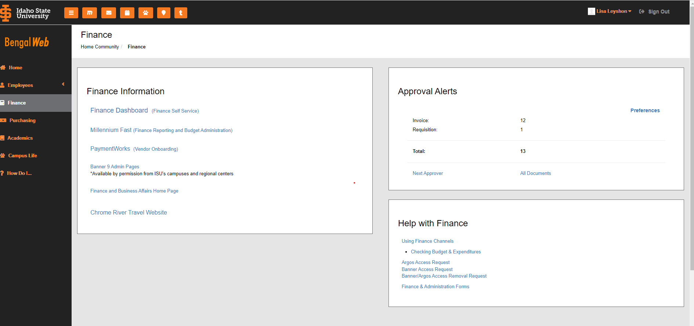

- Click on My Finance Query

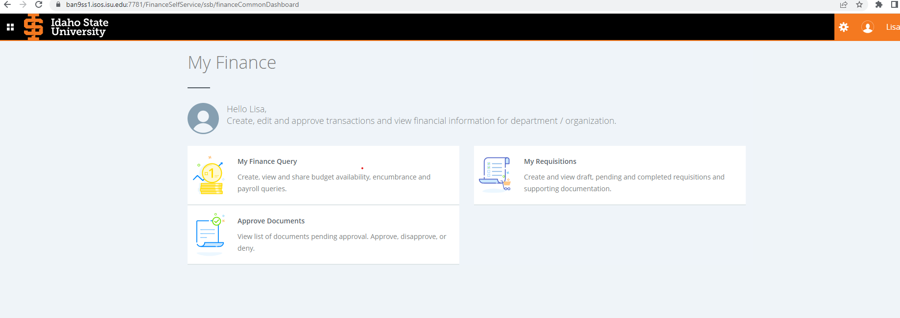

- Click on the document icon in the right corner under the Search Query

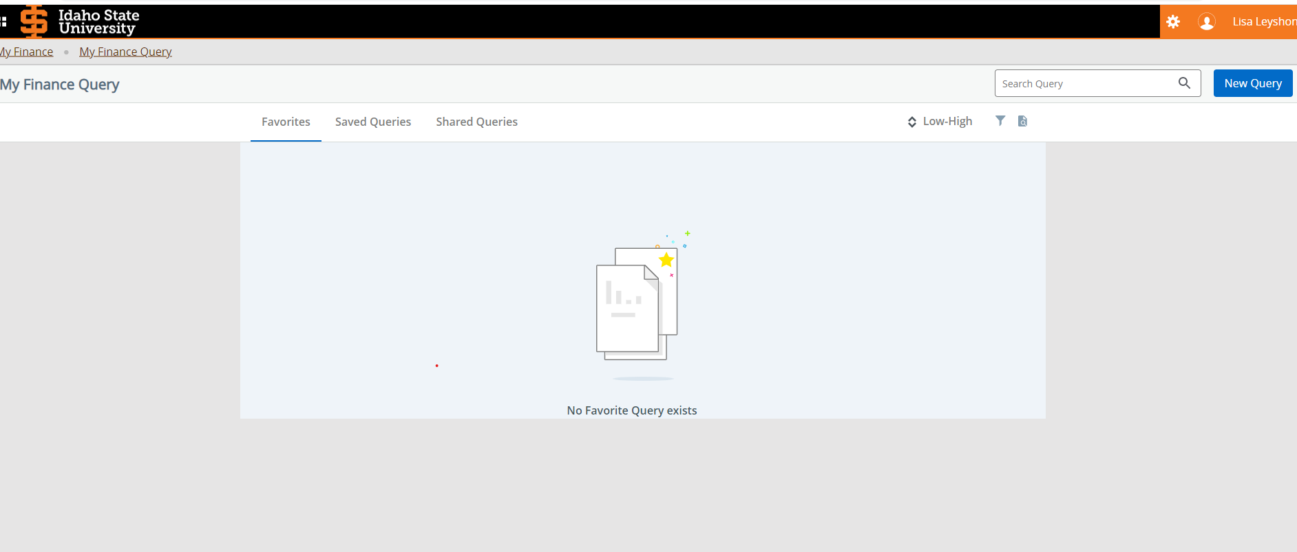

- Choose the document type in the first dropdown.
- Enter the document number you are searching for in the third box labeled Document Number.
- To see the document, click “View Document”, to see the approvals and other related documents click “Approvals & Related Documents”.
  - Related documents include, requisitions, purchase orders, invoices, checks and receiving documents.
  - Documents that are scanned into BDM can be viewed under Attachments.

