

Public Health Graduate Certificate Student Handbook

Department of Community and Public Health

College of Health

Kasiska Division of Health Sciences

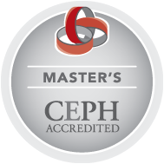

Table of Contents

WELCOME FROM THE DIRECTOR 3
ABOUT THE UNIVERSITY 4
Idaho State University's Land Acknowledgment Statement 4
THE DEPARTMENT OF COMMUNITY AND PUBLIC HEALTH 5
About the Department of Community and Public Health 5
Department of Community and Public Health Mission 5
MPH FACULTY 6
PROGRAM INFORMATION 9
Program Delivery 9
Faculty Availability 9
Advising 10
GPA Requirements and Dismissal from the Program 10
Grievance procedures 10
Incompletes and Withdrawals 11
Transfer Credits and Course Substitutions 11
GRADUATE CERTIFICATE COURSES 12
PROGRAM CURRICULUM & SCHEDULE 13
APPENDIX A. COURSE CHECKLIST 14
APPENDIX B. MASTER OF PUBLIC HEALTH 15
APPENDIX C. ETHICS 16
APPENDIX D. CAMPUS RESOURCES 20
APPENDIX E. EQUAL OPPORTUNITY AND AFFIRMATIVE ACTION 24
ISU Policies, Guides, and Forms 24
Title IX 25
Request for Religious Accommodations in the Classroom 25

WELCOME FROM THE DIRECTOR

Welcome to the Public Health Graduate Certificate program at ISU! We're thrilled to embark on this journey with you, and are dedicated to supporting your success throughout your studies. Our faculty, with diverse expertise in areas such as rural health, food insecurity, tobacco exposure, maternal and child health, and barriers to care, are eager to see you thrive. I encourage you to engage with your instructors and learn about their work.
This handbook contains essential information to help you navigate your program. Familiarize yourself with its contents to understand important processes and deadlines. I also encourage you to talk with your advisor before signing up for course work about course order, what you want out of the certificate, and your career goals.
Our recent graduates have excelled in various roles across government agencies (e.g., Public Health Districts, Idaho Department of Health and Welfare), non-governmental organizations (e.g., national and state associations, non-profits), and health systems (e.g., hospitals, clinics, research, quality improvement, data analysis, and infection prevention). It's inspiring to see our alumni making significant impacts in their communities, and I look forward to hearing about your own journey.
You are welcome to connect with us now and after graduation through LinkedIn, Facebook, Instagram, email, and our symposiums. I wish you the very best in your Certificate program and am here to help with any questions or concerns you may have. If you encounter any difficulties, don’t hesitate to reach out so we can provide assistance.
Best,
Irene van Woerden, PhD

Best,
Irene van Woerden, PhD

ABOUT THE UNIVERSITY

Founded in 1901, Idaho State University is one of the most comprehensive higher education institutions in the country. Idaho State is one of six universities in the US offering programs from technical certificates through graduate and professional degrees. The Carnegie-classified doctoral research institution attracts students from around the world to its main campus in Pocatello and locations in Meridian, Idaho Falls, and Twin Falls. Since 1966, the University has been Idaho's designated leader for training and educating health care professionals.

ISU Mission | We engage students through learning and research opportunities that improve the intellectual vigor, cultural vitality, and health of our communities.
ISU Vision | We inspire a passion for knowledge and discovery.
ISU Values | Integrity - Honesty in our actions and words
 | Community - Fostering connections
 | Inclusivity - Valuing all and building a culture of belonging
 | Teamwork - Collaborating with compassion and respect
 | Shared Responsibility - All contributing to our success
 | Learning - Continuous growth and development

Idaho State University's Land Acknowledgment Statement
Acknowledging Native lands is an important way to honor and respect Indigenous peoples and their traditional territories. The land on which Idaho State University’s Pocatello campus sits is within the original Fort Hall Reservation boundaries and is the traditional and ancestral home of the Shoshone and Bannock peoples. We acknowledge the Fort Hall Shoshone and Bannock peoples, their elders past and present, their future generations, and all Indigenous peoples, including those upon whose land the University is located. We offer gratitude for the land itself and the original caretakers of it.
As a public research university, it is our ongoing commitment and responsibility to teach accurate histories of the regional Indigenous people and of our institutional relationship with them. It is our commitment to the Shoshone-Bannock Tribes and to ISU’s citizens that we will collaborate on future educational discourse and activities in our communities.

THE DEPARTMENT OF COMMUNITY AND PUBLIC HEALTH

About the Department of Community and Public Health
Our graduates work at the frontlines of emerging health issues, and strategically guide organizations and communities through evidence-based decision-making and cultural humility. Each of our programs prepares students in areas with projected job growth as organizations and communities recognize the need for better programs, healthcare, and environments that foster healthy people and communities.
Our degree programs include master's degrees in Health Education, Health Informatics, and Public Health. In addition, we offer an undergraduate degree in Community and Public Health with emphasis areas in Community/Worksite Wellness, Addiction Studies, and School Health.
Our academic certificate offerings include two graduate certificates in Public Health and Rural Health, and an undergraduate Community Health Worker certificate. Both of these certificate programs have reduced credits for focused training and can be completed in-person or online.

Department of Community and Public Health Mission
We advance health for all through collaborative learning and scholarly activities, enabling students and communities to thrive.

MPH FACULTY
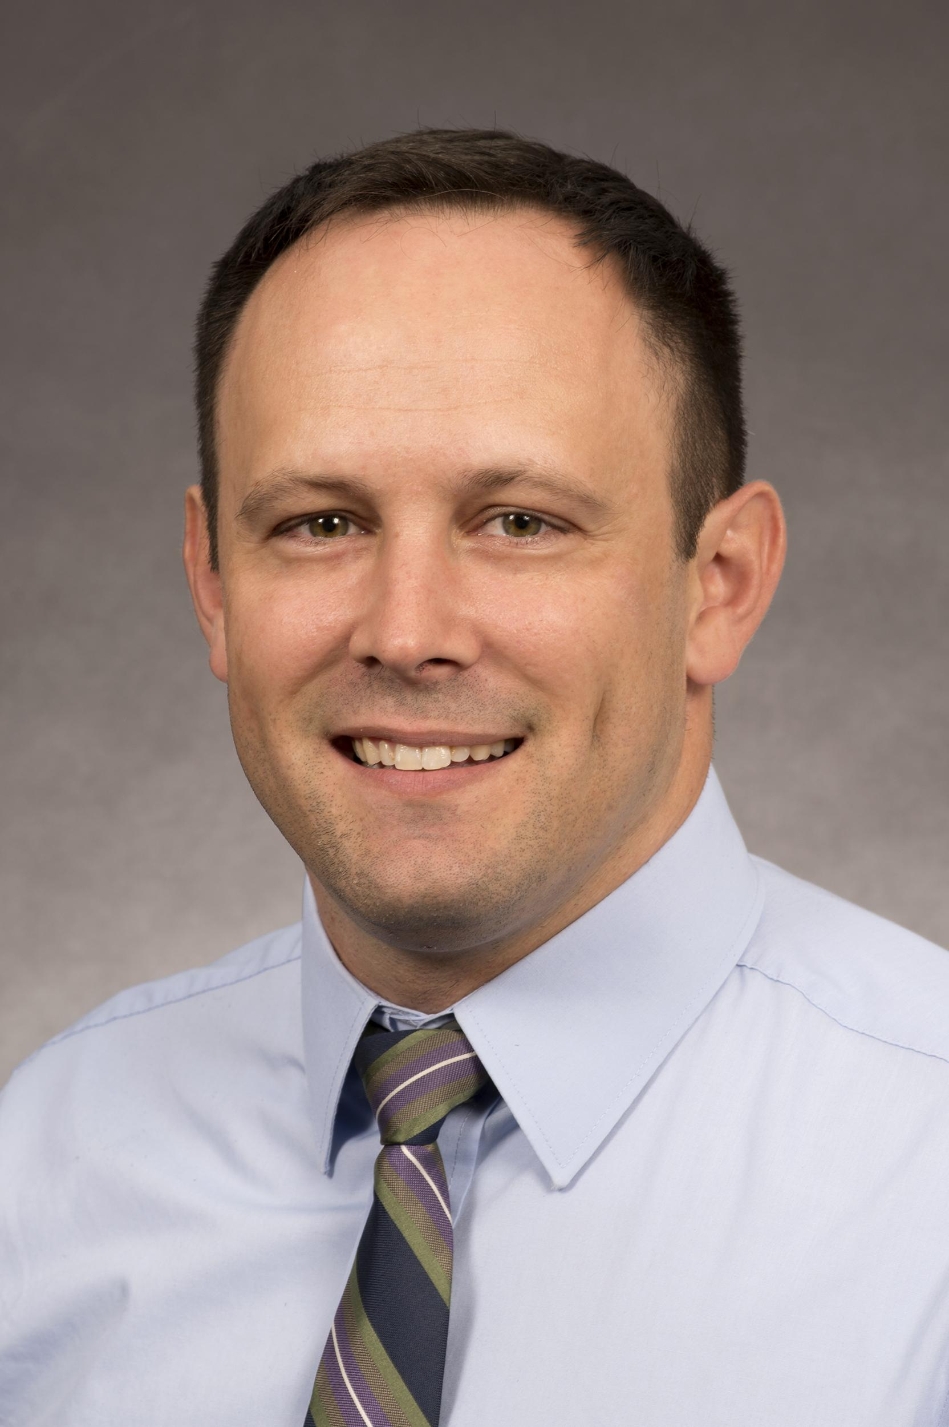
Ryan Lindsay (Associate Professor)
Meridian: 1311 E. Central Dr., Meridian, ID 83642 Office 669 | ryanlindsay@isu.edu
Courses typically taught: MPH 5507, MPH 6640, MPH 6601
Dr. Lindsay is interested in global health and how substance use, including smoking, influences HIV and tuberculosis. His research has highlighted the plight of people living with HIV/AIDS and/or addiction, people experiencing homelessness or disability, immigrants, and sex worker populations. He has worked in Community Health Worker workforce development programming in Idaho since 2016.


Nnamdi Moeteke (Clinical Assistant Professor and Interim Director of Undergraduate Programs)
Pocatello: Reed Gym, #242 | nnamdimoeteke@isu.edu
Course typically taught: MPH 6601
Dr. Moeteke is a public health physician committed to working with underserved communities for health development. Most of his practice and research has focused on strengthening health systems especially with respect to primary healthcare, and training of health workforce for improvement in service delivery and enhancement of population health in Nigeria. He is a Member of the West African College of Physicians (Faculty of Community Health), and a Fellow of the Royal Society for Public Health.
Lisa Salazar (Clinical Assistant Professor)
Pocatello: Reed Gym, #242 | lisasalazar@isu.edu

Courses typically taught: MPH 6605, MPH 6606, MPH 6660
Dr. Salazar is a proud graduate of the ISU MPH Program. She has a personal interest in environmental health, as well as humanitarian causes, social justice, and health literacy. She is also working on providing training solutions in areas of mental health and resiliency and explores the use of technology to solve some of the disparities in these areas. Dr. Salazar has both experienced cancer and has seen others dying of cancer well before their time, which motivates her to help people lead healthier lives. Her favorite thing to teach students is to question everything, so they can find the root cause and systems that really need to be addressed.

Diana Schow (Associate Professor and Coordinator for the Rural Health Certificate and Director of Idaho AHEC in the School of Nursing at ISU)
Pocatello: Reed Gym, #243B | dianaschow@isu.edu
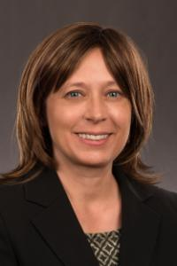
Courses typically taught: MPH 5503, 6660, 6609, 6606
Dr. Schow completes mixed-methods action research projects to improve health status, social justice and wellness of individuals, communities and organizations in rural and underserved areas. Her work has involved direct services, program administration, research and volunteerism. Populations of focus in southeast Idaho and Montana have included victims of child abuse, victims of domestic violence and sexual assault, Hispanic agricultural workers, Native American populations, persons in poverty and individuals receiving and applying for disability, food stamps, Medicaid and emergency assistance. Her international experience includes working with rural programs in Peru and 13 European countries

Kristin Van De Griend (Assistant Professor and Chair of the Department of Community and Public Health)
Pocatello: Reed Gym, #242 | kristinvandegrien@isu.edu
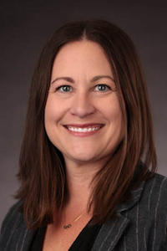
Courses typically taught: MPH 6660, MPH 6640
Dr. Van De Griend engages in public health research and practice with the intent to promote health equity. Whenever possible, she employs community-based, mixed methods research. Her work is grounded within social justice and intersectionality frameworks and she prioritizes transdisciplinary teamwork. Most of her global and local research has focused on maternal and child health, violence prevention, water insecurity, and community development. Dr. Van De Griend is especially interested in translating research to practice and policy through implementation science.

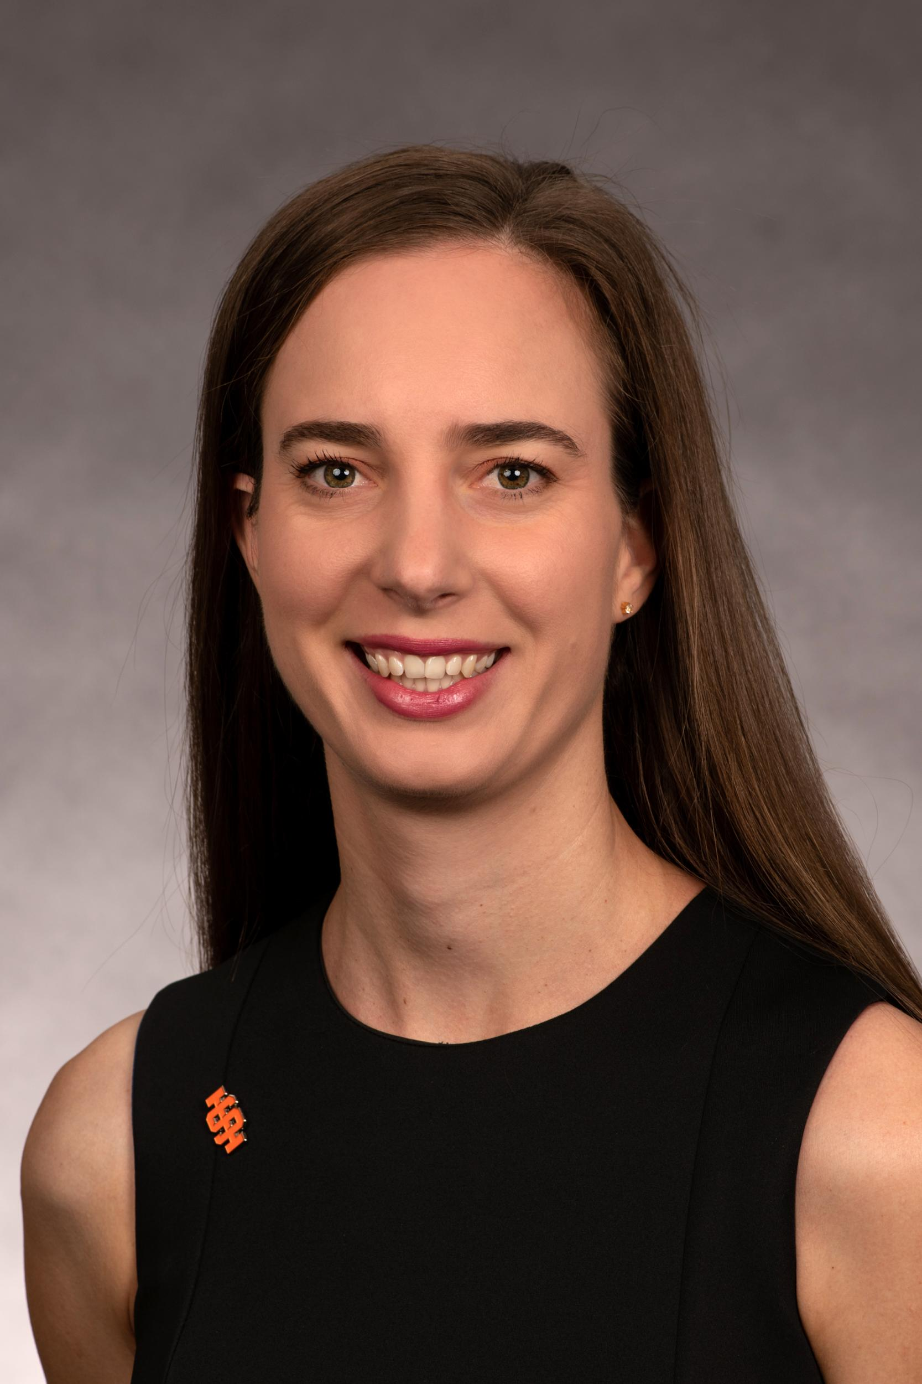
Irene van Woerden (Associate Professor and MPH Director)
Pocatello: Reed Gym, #301 | irenevanwoerden@isu.edu
Courses typically taught: MPH 6602 and MPH 5599
Dr. van Woerden’s main research interests are health behaviors and outcomes, with a focus on social networks, food insecurity, and body size. Dr. van Woerden also examines environmental issues, such as bisphenols, phthalates, and nuclear energy.

PROGRAM INFORMATION

The goal of public health is to improve the health of populations through planning, implementing, and evaluating health promotion and disease prevention programs. Public health professionals design these intervention programs by using a combination of health education and related organizational, economic, legislative, and environmental supports to enhance the probability of creating a healthier populace.
The Public Health Graduate Certificate curriculum prepares individuals to carry out the following core public health functions as defined by the American Public Health Association: assess both the health needs and resources available in a community, assist in health policy development that supports programs in prevention, and assure that necessary, high quality, effective services including education are available to every citizen.
Courses focus on a community health emphasis and include an acquisition of requisite public health knowledge and skills in the areas of epidemiology, biostatistics, leadership policy and administration, environmental and occupational health, health program planning and evaluation, and behavior change theory and applications.
Students pursuing the Public Health Graduate Certificate must complete six specific courses (a minimum of 18 credits of coursework), with a GPA of 3.0 or better in each course.
Students desiring to enroll in the MPH program while completing courses for the Graduate Certificate in Public Health must apply to the MPH program prior to completing all 18 credits of coursework, and prior to applying to graduate with the Graduate Certificate in Public Health. Admission or completion of the certificate does not guarantee admission into the MPH program. Students who complete and are awarded the Graduate Certificate in Public Health may transfer up to 12 credits from the certificate program into the MPH program. Courses completed in the certificate program must have a grade of B or above to transfer into the MPH program.

Program Delivery
With all online classes, this program is designed to meet the needs of working individuals as well as those in rural areas.

Faculty Availability
All full-time faculty maintain regular office hours and are available to assist and advise students. Appointments may be requested outside of regular office hours. Graduate students are strongly encouraged to meet regularly with their advisors. If a faculty member is not being responsive, reach out to the Program Director, and if that doesn’t resolve the issue to reach out to the Department Chair.

Advising
You will be assigned an academic advisor to guide you in selecting courses that satisfy program requirements and provide the foundation for your professional goals. Your advisor can help you by: providing information about research and service opportunities, communicating program requirements and, program approval, graduation procedures, and helping you succeed through guidance and support.
Students may request a different academic advisor by contacting the MPH Program Director. Once the request has been approved, the student will notify the prior advisor.
Students are expected to meet with their academic advisor prior to registering for their first semester of coursework. Your academic advisor is the best person to reach out to if you have questions about course selection and progress.

GPA Requirements and Dismissal from the Program
All students must maintain a satisfactory record of scholarship. A 3.0 grade point average (GPA) or better is required for any graduate degree or certification at Idaho State University. A grade below B- is essentially failing at the graduate level. Students who earn a grade below a B- in a core course will be required to retake that course. Students who earn grades below a B- in two courses will be dismissed from the program. Students’ must also conduct themselves in an ethical and professional manner (See Appendix B).

Grievance procedures
The following is from the ISU student handbook (v. edited 09/27/2022):
Students who feel they have been discriminated against based upon a disability and wish to file a grievance shall file such complaints with the Office of Equity and Inclusion. The investigation and grievance procedures established for acts of illegal discrimination shall apply.
For a grade appeal, please refer to the Scholastic Appeals Policy on page 13 of the ISU student handbook. See also the “Appealing a Course Grade” section on page 10.
For an Equal Opportunity/Affirmative Action complaint or grievance, please contact the ISU Office of Equity and Inclusion or view the policy online here.
For all other complaints/grievances: A student should first attempt to resolve the complaint informally by meeting with the University instructor and/or official responsible for the rule, policy, procedure, or decision that results in the student’s complaint or grievance. Students seeking advocacy or guidance on this process may consult with the Director of Student Life or delegate.
To file a formal complaint based on sexual and gender-based discrimination, harassment and/or other sexual misconduct, contact us at: (http://www.isu.edu/aaction/title-ix-notice-of-non-discrimination/).
Complaints regarding allegations of unfair competition or deceptive business practices and the violation of Idaho consumer protection laws may be made to the Office of the Attorney General, Consumer Protection Division of the State of Idaho, at: (http://www.ag.idaho.gov).

Incompletes and Withdrawals
If you are unable to complete the semester, for instance through illness or other excusable absence, you may be able to work with your instructors to obtain an incomplete and then complete the work later. See the course catalog for more information. If you are likely to fail a class, withdrawing from the class is an option. See here for more information on withdrawals. If you need to withdraw from a class, depending on the circumstances you may be eligible for a partial tuition and fee refund, see here for more information.

Transfer Credits and Course Substitutions
A student can submit up to 6 units worth of graduate level courses to apply toward their program of study. A student must obtain approval for any graduate courses transferred to ISU from another accredited university, and must show proficiency (this may include taking an exam, completing an assignment, or demonstration in another way) in any competencies that are linked to that class. To do transfer credits and substitute a course, send a copy of the transcripts outlining the courses and grade received from another accredited university, and the courses you wish to substitute with these credits to the Program Director and major advisor for review for approval.

GRADUATE CERTIFICATE COURSES

MPH 6601 Applications in Epidemiology: 3 semester hours. Required.
Facilitates an epidemiological approach to problem solving in the health sciences through practical application of field epidemiology concepts and methods.
MPH 6602 Biostatistics: 3 semester hours. Required.
This course will equip students with a conceptual understanding of the calculation and interpretation of inferential statistics in public health research.

MPH 6605 Leadership Policy and Administration: 3 semester hours. Required.
Development of leadership and administrative skills which contribute to implementation of effective public health policies and programs. Students will learn strategic planning, facilitation techniques, communication strategies, budget development, and management

MPH 6606 Environmental and Occupational Health: 3 semester hours. Required.
Understanding the interaction of humans with their environment and the implications of human actions. Learn about assessment and control of health risks posed by chemical and biological contaminants and physical exposures (noise, heat, and radiation) in occupational and non-occupational environments.

MPH 6620 Health Program Planning and Evaluation: 3 semester hours. Required.
Theory and processes of assessment, planning, implementing, and evaluating health education, promotion, and disease prevention programs. Principles taught in this course will be applied to community situations. Pre-requisite: MPH 6660.

MPH 6660 Behavior Change Theory and Applications: 3 semester hours. Required.
Provides a basic understanding of the social, emotional, and lifestyle factors related to health behavior. Strategies designed to identify barriers to behavior and to enhance the health of selected populations are examined.

PROGRAM CURRICULUM & SCHEDULE

 | Fall Semester | Fall | Spring | Summer
MPH 6601 | Applications in Epidemiology |  | X
MPH 6602 | Biostatistics | X |  | X
MPH 6605 | Leadership Policy & Administration | X
MPH 6606 | Environmental & Occupational Health |  | X | X
MPH 6620 | Health Program Planning & Evaluation | X | X *
MPH 6660 | Health Behavior Change Theory & Application | X * | X
This course schedule is subject to change.

APPENDIX A. COURSE CHECKLIST

Core Requirements (18 credits) | Credits | Semester | Grade
MPH 6601 - Applications in Epidemiology | 3
MPH 6602 - Biostatistics | 3
MPH 6605 - Leadership and Administration | 3
MPH 6606 - Environmental & Occupational Health | 3
MPH 6620 - Health Program Planning | 3
MPH 6660 - Health Behavior Change Theory & App. | 3
TOTAL | 18

APPENDIX B. MASTER OF PUBLIC HEALTH
The Graduate Certificate in Public Health is six classes from the MPH curriculum (18 credits of the required 42 credits for an MPH). As such, with another 24 (or 18 credits if you have other graduate-level courses that you can transfer in as electives) you could obtain an MPH. If you are interested in the MPH, please discuss this with your academic advisor before you graduate from your Graduate Certificate in Public Health.
Below is the suggested order for taking the MPH courses. The Public Health Graduate Certificate courses (starred and highlighted) are taken early on. This means if you want to transfer from the Graduate Certificate in Public Health to the MPH, it is typically easy to do so.
 | Class | Offered | Note
Take first
MPH 5540 | Research & Writing in Health 1 | Fall, and potentially Spring and Summer (check catalog) | Mandatory first semester course
MPH 6601* | Applications in Epidemiology | Spring | Pre-req for MPH 6640
MPH 6602* | Biostatistics | Fall and Summer | Pre-req for MPH 6640
MPH 6605* | Leadership Policy & Administration | Fall
MPH 6606* | Environmental & Occupational Health | Spring and Summer
MPH 6660* | Health Behavior Change Theory & Application | Potentially Fall (check catalog) and Spring | Pre-req for MPH 6620 and 6640
Take in the middle
MPH 5507 | Rural Health Systems | Fall
MPH 6604 | Social & Cultural Perspectives in Public Health | Spring
MPH 6609 | Seminar in Public & Community Health | Fall and Summer
TBD | 12 credits of Approved Electives | Fall, Spring, Summer (check catalog for availability of relevant classes)
Take near the end
MPH 6620* | Health Program Planning & Evaluation | Fall and potentially Spring (check catalog) | Pre-req = MPH 6660.
Take in last semester
MPH 6640 | Research & Writing in Health 2 | Fall | Pre-req = MPH 6601, 6602, 6620, and 6640

APPENDIX C. ETHICS
Graduate students are expected to conduct themselves in an ethical and professional manner. The following statements of common values (Adapted from Code of Ethics for the Health Education Profession, AAHE and SOPHE) may serve as guidance for general decision making during our professional studies.
Article I: Responsibility to the Public
Public Health Professionals:
- support the right of individuals to make informed decisions regarding health, as long as such decisions pose no threat to the health of others.
- encourage actions and social policies that support and facilitate the best balance of benefits over harm for all affected parties.
- accurately communicate the potential benefits and consequences of the services and programs with which they are associated.
- accept the responsibility to act on issues that can adversely affect the health of individuals, families, and communities.
- are truthful about their qualifications and the limitations of their expertise and provide services consistent with their competencies.
- protect the privacy and dignity of individuals.
- actively involve individuals, groups, and communities in the entire educational process so that all aspects of the process are clearly understood by those who may be affected.
- respect and acknowledge the rights of others to hold diverse values, attitudes, and opinions.
- provide services equitably to all people.
Article II: Responsibility to the Profession
Public Health Professionals are responsible for their professional behavior, for the reputation of their profession, and for promoting ethical conduct among their colleagues.
Public Health Professionals:
- maintain, improve, and expand their professional competence through continued study and education; membership, participation, and leadership in professional organizations; and involvement in issues related to the health of the public.
- model and encourage nondiscriminatory standards of behavior in their interactions with others.
- encourage and accept responsible critical discourse to protect and enhance the profession.
- contribute to the development of the profession by sharing the processes and outcomes of their work.
- are aware of possible professional conflicts of interest, exercise integrity in conflict situations, and do not manipulate or violate the rights of others.
- give appropriate recognition to others for their professional contributions and achievements.
Article III: Responsibility to Employers
Public Health Professionals recognize the boundaries of their professional competence and are accountable for their professional activities and actions.
Public Health Professionals:
- accurately represent their qualifications and the qualifications of others whom they recommend.
- use appropriate standards, theories, and guidelines as criteria when carrying out their professional responsibilities.
- accurately represent potential service and program outcomes to employers.
- anticipate and disclose competing commitments, conflicts of interest, and endorsement of products.
- openly communicate to employers, expectations of job-related assignments that conflict with their professional ethics.
- maintain competence in their areas of professional practice.
Article IV: Responsibility in the Delivery of Health Education
Public Health Professionals promote integrity in the delivery of health education. They respect the rights, dignity, confidentiality, and worth of all people by adapting strategies and methods to meet the needs of diverse populations and communities.
Public Health Professionals:
- are sensitive to social and cultural diversity and are in accord with the law, when planning and implementing programs.
- are informed of the latest advances in theory, research, and practice, and use strategies and methods that are grounded in and contribute to development of professional standards, theories, guidelines, statistics, and experience.
- are committed to rigorous evaluation of both program effectiveness and the methods used to achieve results.
- empower individuals to adopt healthy lifestyles through informed choice rather than by coercion or intimidation.
- communicate the potential outcomes of proposed services, strategies, and pending decisions to all individuals who will be affected.
Article V: Responsibility in Research and Evaluation
Public Health Professionals contribute to the health of the population and to the profession through research and evaluation activities. When planning and conducting research or evaluation, Public Health Professionals do so in accordance with federal and state laws and regulations, organizational and institutional policies, and professional standards.
Public Health Professionals:
- support principles and practices of research and evaluation that do no harm to individuals, groups, society, or the environment.
- ensure that participation in research is voluntary and is based upon the informed consent of the participants.
- respect the privacy, rights, and dignity of research participants, and honor commitments made to those participants.
- treat all information obtained from participants as confidential unless otherwise required by law.
- take credit, including authorship, only for work they have actually performed and give credit to the contributions of others.
- who serve as research or evaluation consultants discuss their results only with those to whom they are providing service, unless maintaining such confidentiality would jeopardize the health or safety of others.
- report the results of their research and evaluation objectively, accurately and in a timely fashion.
Article VI: Responsibility in Professional Preparation
Those involved in the preparation and training of Public Health Professionals have an obligation to accord learners the same respect and treatment given other groups by providing quality education that benefits the profession and the public.
Public Health Professionals:
- select students for professional preparation programs based upon equal opportunity for all, and the individual's academic performance, abilities, and potential contribution to the profession and the public's health.
- strive to make the educational environment and culture conducive to the health of all involved, and free from sexual harassment and all forms of discrimination.
- involved in professional preparation and professional development engage in careful preparation; present material that is accurate, up-to-date, and timely; provide reasonable and timely feedback; state clear and reasonable expectations; and conduct fair assessments and evaluations of learners.
- provide objective and accurate counseling to learners about career opportunities, development, and advancement, and assist learners to secure professional employment.
- provide adequate supervision and meaningful opportunities for the professional development of learners.

APPENDIX D. CAMPUS RESOURCES
Academic Success Center
Alumni Association
American Indian Tuition Fee Program
Art Galleries and Events
Associated Students of Idaho State University
The Associated Students of Idaho State University (ASISU) is committed to providing effective student participation and representation in all areas of student life, that we may participate in the improvement of educational programs, co-curricular activities, and services, and advance the common interests and concerns of the student body.
Association of Black Professionals
Athletics
Benny’s Pantry
Benny's Pantry seeks to alleviate food insecurity where it exists at ISU through the distribution of free food assistance. The pantry's two locations are located in Pocatello and Idaho Falls.
Bengal Pharmacy
Bengal Theater
Bengal Web
Bookstore
Center for New Directions
The Center for New Directions assists men and women in transition to overcome personal and economic barriers to education and employment, to access training programs and job opportunities, and to become personally and economically self-sufficient.
College of Health
Computer Lab Directory
A list of all computer labs and related information for the Pocatello Campus, Idaho Falls Campus, and the Sam and Aline Skaggs Health Science Center in Meridian.
Copy Center
Dining and Food Options
Directory
Diversity Resource Center
Division of Health Sciences
Educational Technology Services
Located on the lower level of the Eli M Oboler Library, Educational Technology Services provides ISU faculty and staff access to a variety of instructional and communications technologies along with professional assistance.
Gender Center
Health Center
Idaho Center for Health Research
Information Technology Services
Institute of Rural Health
ISU University Libraries
Idaho Health Sciences Library
Eli M. Oboler Library - Pocatello | ISU Library - Meridian | ISU Library - Idaho Falls
Phone: (208) 282-2958 | Phone: (208) 373-1817 | Phone: (208) 282-7906
Physical address: | Physical address: | Physical address:
850 S. 9th Avenue | 1311 E. Central Drive | 1784 Science Center Drive Room 225
Pocatello, Idaho 83209 | Meridian, Idaho 83642 | Idaho Falls, Idaho 83402

Mail Center
Moodle
Native American Student Service Center
Research
Ombuds Program
Outdoor Adventure Center
Parking
Qualtrics
ROTC (Reserve Officers’ Training Corps)
Single Parent Student Assistance Program
Stephens Performing Arts Center
Stress Management and Biofeedback
Student Affairs Departments
Advising
Admissions
Bennion Student Union - Idaho Falls
Campus Recreation
Career Center
Counseling and Testing
Counseling and Testing Service offers individual counseling, group counseling, and biofeedback services. All clinical services are free of charge and students do not require medical insurance to seek our services. If your concerns require resources or competencies other than what we can provide, we will refer you to appropriate services, which may be in the community.
Pocatello: (208) 282-2130 | Idaho Falls: (208) 282-7750 | Meridian: (208) 373-1732
If you are in urgent need, please call the crisis line 1-800-273-TALK(8255)
If your concerns are life threatening, call 911.
Dean of Students
Student Care and Assistance
Student Conduct
Advocacy Services
Disability Services
The mission of Disability Services (DS) is to increase equal access and opportunities to all programs and services sponsored or funded by Idaho State University. DS is dedicated to creating an accessible environment for students, employees, and community members with disabilities.
Early Learning Center
The Early Learning Center (ELC) seeks to support ISU students in their pursuit of higher education by providing quality child care for their children as well as for those of faculty, staff, and community members.
Equity & Inclusion
The Office of Equity and Inclusion strives to create an environment where all individuals feel welcome and safe. A campus where every student is treated with dignity and respect.
Financial Aid
Housing
International Programs Office
Registrar's Office
Pond Student Union
Scholarships
Student Leadership and Engagement Center
Trio Student Services
Veterans Student Service Center
Student Expression
New Student Orientation
University Tutoring
University Tutoring provides FREE academic support for all Idaho State University students currently enrolled in courses.
Math Support
Writing Support for any paper in any class, scholarship essays, and more
Content Support for a wide variety of courses
Wellness Center

APPENDIX E. EQUAL OPPORTUNITY AND AFFIRMATIVE ACTION
Idaho State University is committed to providing a positive education for all students. The university has a legal and ethical responsibility to ensure that all students and employees can learn and work in an environment free of harassment and discrimination. It is the ISU policy to prohibit and eliminate discrimination on the basis of race, color, national origin, religion, sex, age, or disability. This policy applies to all programs, services, and facilities, and includes, but is not limited to, recruitment, applications, admissions, and access to programs, services, and employment. For additional information and specific contact information, see: https://www.isu.edu/aaction/.
The Office of Equity and Inclusion strives to create an environment where all individuals feel welcome and safe. A campus where every student is treated with dignity and respect.
The University is committed to creating and maintaining a learning environment that is free of discrimination and harassment against an individual on the basis of that person’s race, color, religion, gender, age, sexual orientation, national origin, ancestry, physical or mental disability, or veteran status. Harassment and discrimination will not be tolerated and should be reported to the Office of Equity and Inclusion.
Office of Equity and Inclusion
Rendezvous Bldg. Rm. 151C
921 S. 8th, Stop 8315
Pocatello, ID. 83209
(208) 282-3964
FAX (208) 282-5829

ISU Policies, Guides, and Forms
Sexual Orientation and Gender Identity Policy
Policy on Equal Opportunity, Harassment and Non-discrimination
Relationship Violence Policy Guide
Sexual Assault Policy Guide
Stalking Policy Guide
Student Conduct Code
Equal Opportunity and Affirmative Action Policy

Title IX
ISU is committed to providing a safe educational and work environment. As a university community, we value compassion and the safety of all employees and students. Sex- and gender- based discrimination (including sexual harassment, sexual violence, dating/domestic violence, and stalking) limit access to education and work opportunities. ISU will follow the guidelines set forth in Title IX of the Education Amendments of 1972 to stop, remedy, and prevent negative effects of sex- and gender-based discrimination.
ISU is dedicated to ensuring a prompt, effective, and compassionate response to any report of sex- or gender-based discrimination. To report possible discrimination, ask questions, or communicate concerns, contact the ISU Title IX Coordinator at 208-282-1439.
To report online, use the secure online incident form
For more information, visit the Title IX Office.

Request for Religious Accommodations in the Classroom
Idaho State University is required to reasonably accommodate a student's sincerely held religious belief which conflicts with an academic requirement, unless providing the accommodation would create an undue hardship to the Univers

