Price and others -- Lemhi and Beaverhead Mountain Ranges
335

Field Guide Along the Northern Edge of the Eastern Snake River Plain, and the Lemhi and Beaverhead Mountain Ranges Bordering Birch Creek Valley, Idaho

Kathleen B. Price
Department of Geology, Ricks College, Rexburg, Idaho, 83440
Glenn Embree
Department of Geology, Ricks College, Rexburg, Idaho, 83440
Roger Hoggan
Department of Geology, Ricks College, Rexburg, Idaho, 83440
Steve Hansen
Department of Geology, Ricks College, Rexburg, Idaho, 83440

LOCATION AND ACCESSIBILITY
The Lemhi and Beaverhead Mountain Ranges are two of the three northwest trending, block-fault ranges along the northeast- ern margin of the eastern Snake River Plain (Fig. 1). The southern end of the Beaverhead Range is approximately 26 miles from Dubois, Idaho, which would be the nearest location for fuel and food. The entire area of the field guide is covered by 1:250,000 topographic maps (Delorme Mapping, 1992). These maps or oth- ers that are similar are needed for detailed planning of access.
Access to the field stops 1 and 2 is from paved highway roads. Other stops and the side trip to Skull Canyon require high-clear- ance vehicles. Four-wheel drive vehicles are recommended, but not always necessary. Much of the field trip area can be viewed from Highways 22 and 28 during most of the year, but access into the Spring Mountain Canyon and Meadow Lake area is only pos- sible during late summer (July through September).

Significance
This region of Idaho contains the north margin of the Eastern Snake River Plain bordered by block-faulted mountain ranges. The mountain ranges contain fairly well-exposed stratigraphic sections of Proterozoic and Paleozoic rocks extending from Mesoproterozoic through Permian time. Sevier thrust faulting and associated complex folds with Neogene Basin and Range normal faults are exposed throughout the Beaverhead and Lemhi Moun- tains in the field guide area. Exposures of Eastern Snake River Plain Tertiary caldera rhyolites and Tertiary and Quaternary basalts

are also included in the guide. Quaternary glaciation and valley fill deposits and structures are evident throughout the area as well.

ROADLOG
This road log begins at the intersection of Interstate Highway 15 and State Highway 22 at the west edge of the town of Dubois, Idaho (refer to map).

Mileage
0.0 Set odometer beginning from the overpass on I-15. Drive west on Highway 22.
3.6 Cedar Butte, to the left (south) is a typical example of a Snake River Plain shield volcano.
5.9 Medicine Lodge junction at the base of the Beaverhead Mountain Range. On the right is Indian Creek Butte. This is a rhyolite dome at the east edge of the Spencer-High Point Rift Zone (Kuntz et al., 1992), which extends from here to the west rim of the Henrys Fork Caldera. The rift zone is the locus of numerous basalt vents, but at this west end several small, rhyolite domes have also been ex- truded. Here the rift coincides with the range front fault system at the base of the Beaverhead Mountains.
In the foothills ahead and to the right are some of the best exposures of the major ash-flow tuff sheets of the Heise Volcanic

Price, K.B., Embree, G., Hoggan, R., and Hansen, S., 1999, Field guide along the northern edge of the eastern Snake River Plain , and the Lemhi and Beaverhead mountain ranges bordering Birch Creek Valley, Idaho, in Hughes, S.S., and Thackray, G.D., eds., Guidebook to the Geology of Eastern Idaho: Idaho Museum of Natural History, p. 335-342.

33 uide oo to the eo og o astern daho

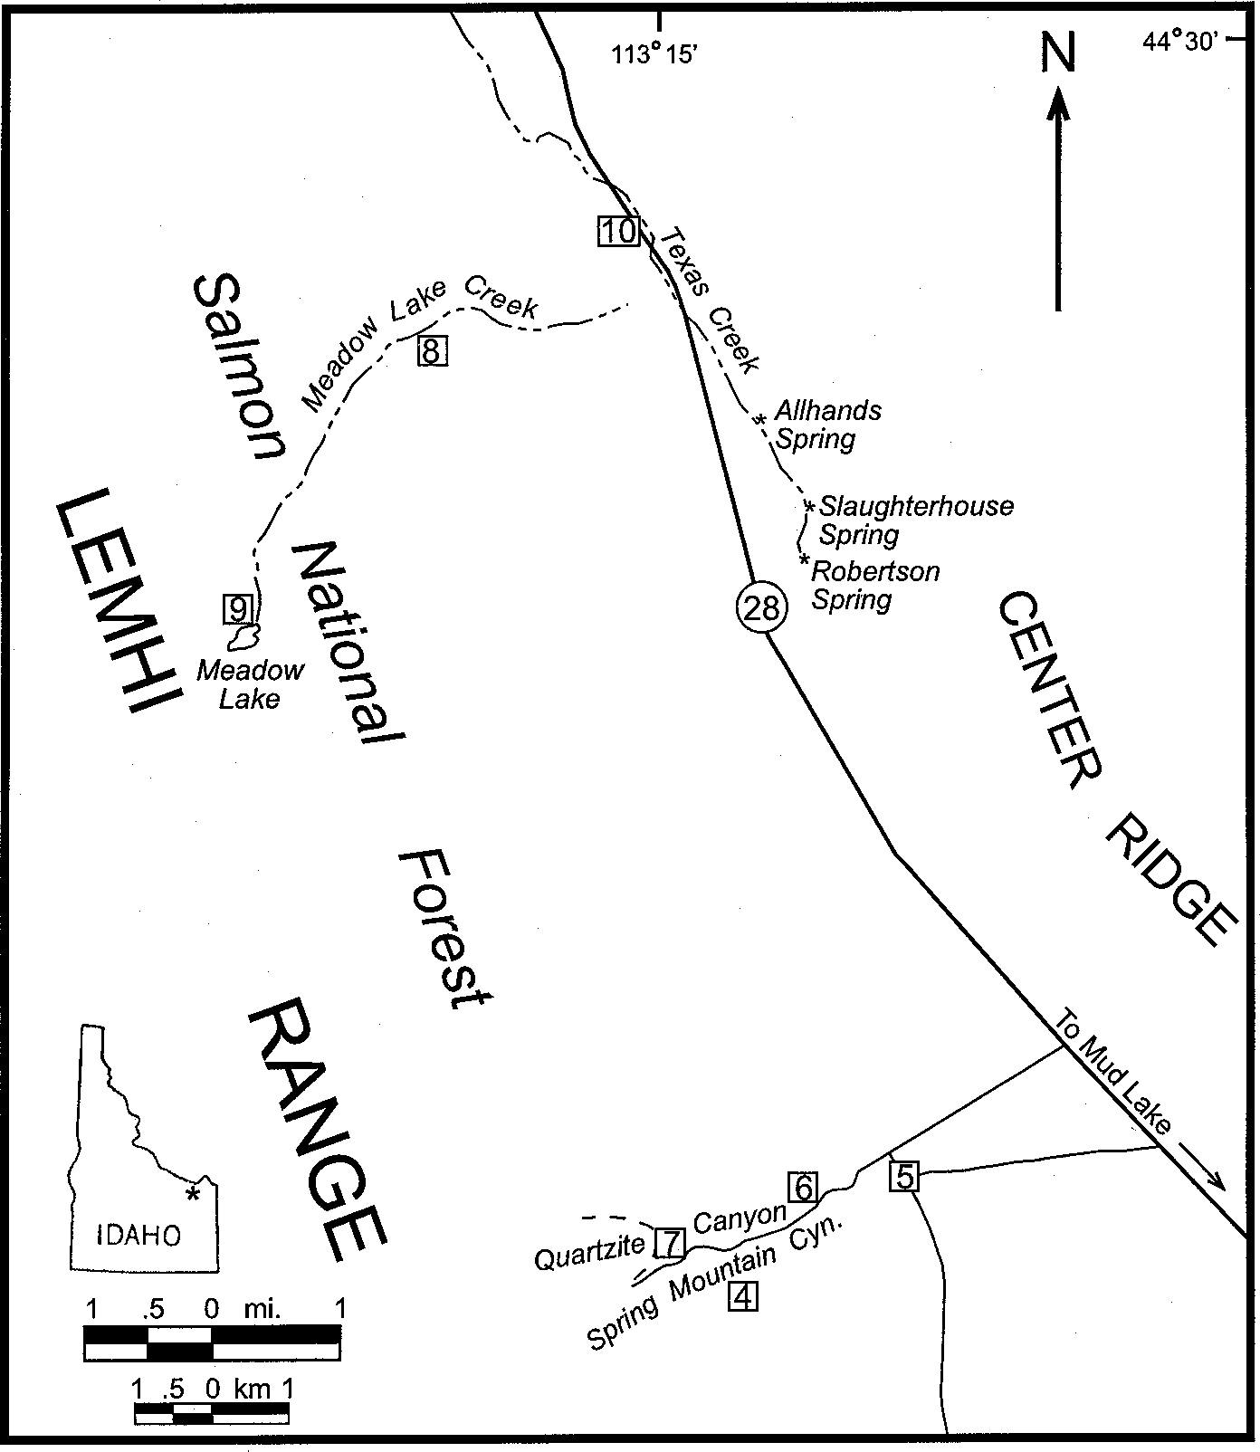

Figure 1. Road map showing general locality of the field guide and field guide stops.

Group on the north edge of the Eastern Snake River Plain (Embree et al., 1982). The prominent dip slope in the foreground is com- posed of the 4.3 Ma tuff of Kilgore. This tuff overlies the 6.0 Ma tuff of Blue Creek and 6.5 Ma tuff of Blacktail Creek (Morgan, 1992) which are interbedded with local rhyolite flows and tuffs, and basalts. These overlie the Miocene Medicine Lodge Forma- tion. Appendix A contains descriptions of stratigraphic units.
14.0 The massive outcrops on the left are the tuff of Blacktail Creek and the white exposures in the hills and valleys be- yond are the Medicine Lodge Formation. The tuffaceous, lacustrine deposits of the Medicine Lodge Formation are quite incompetent and prone to landsliding in this area.

Stop 1. Rhyolite Lava Flow Overlain by the tuff of Kilgore
15.4 Park along the roadside at the west end of the road cut At the east end of this cut is an excellent exposure of the rhyolite of Lidy Hot Springs.

This rhyolite lava flow shows strong flow banding consisting of intensely folded, alternating layers of perlitic vitrophyre and devitrified rhyolite. The flow contains numerous lithophysae, some of which are several centimeters in diameter. This flow has a K-Ar age of 5.4 Ma (G.B. Dalrymple, U.S. Geological Survey,written communication, 1978). This date and proximity of the Blue Creek Caldera rim (Fig.2) suggests that this flow is related to post-col- lapse activity at the margin of that caldera.
At the west end of the cut on the south side of the road, the
tuff of Kilgore overlies the rhyolite flow. The contact between the two units represents a paleo-slope against which the tuff was deposited. In this fresh cut, the zonation at the base of the tuff is well exposed. The coarse, light-colored, non-welded ash at the contact shows excellent shard structure, which can be easily seen under a hand lens. Within a meter or so of the contact the ash grades into a dark, densely welded basal vitrophyre. A few meters farther to the west is the central lithophysal-zone of the tuff This zone forms the most typical exposures of the tuff of Kilgore in this area, because of its more resistant nature.
Note there are two breccia zones associated with the contact. One at the top (westside) of the lava flow is colluvium that accu- mulated on the paleo-slope prior to the deposition of the tuff. Below the lithophysal zone, within the tuff, large blocks of rhyo- lite can also be found. The source of the tuff of Kilgore is the Rexburg Caldera, ~40 km to the southeast. It appears as though these blocks were intercalated into the ash-flow as it advanced over the rhyolite hill. This may represent a rock avalanche trig- gered by the ash-flow on the steep, lee side of the hill.
A well-developed caliche layer is visible at the top of the road-cut on the north side of the road.

16.9 The ridge on the left consists of a cap of the tuff of Blue Creek overlying the Medicine Lodge Formation.
21.0 Ahead and to the right is the southern end of the Beaverhead Range. The high part of the range in the dis- tance is composed primarily of Mississippian to Permian carbonates and clastic sedimentary rocks. The level area at the base of the range is a series of Tertiary basalt flows that overlie the Heise Group rhyolites. Topographically above the basalts is a knob formed by the rhyolite of Reno Gulch. This whole sequence is cut by a fault bounding the south end of the range.

Stop 2. Rhyolite of Reno Gulch
26.1 Park along the right side of the road and look to the north at the ridge marking the southern end of the Beaverhead Range. The stratigraphic and structural relationships in this area are shown in Figures 2 and 3. The rocks at the west end of the ridge are interbedded limestone and sand- stone of the Pennsylvanian-Permian Snaky Canyon For- mation (Skipp et al., 1979).

These rocks dip ~25° southeast and are unconformibly over- lain by the Miocene rhyolite flow of Reno Gulch. The black vitrophyre marking the base of the flow can be followed to the east along the length of the ridge. At the east end of the ridge are a series of basalt flows, the remnants of which can be seen below and in front of the main part of the rhyolite flow directly north of our location. The red slopes near the base of the rhyolite are tephra deposits representing one or more basalt vents. These basalts are overlain by the rhyolite and were deposited against the fault scarp along the east edge of the Snaky Canyon Forma- tion. To the north, on the back side of this ridge the tuff of Kilgore overlies the basalts and laps onto the rhyolite flow indicating that it is >4.3 Ma old.
The hills to the left and right, in the foreground, are also com-

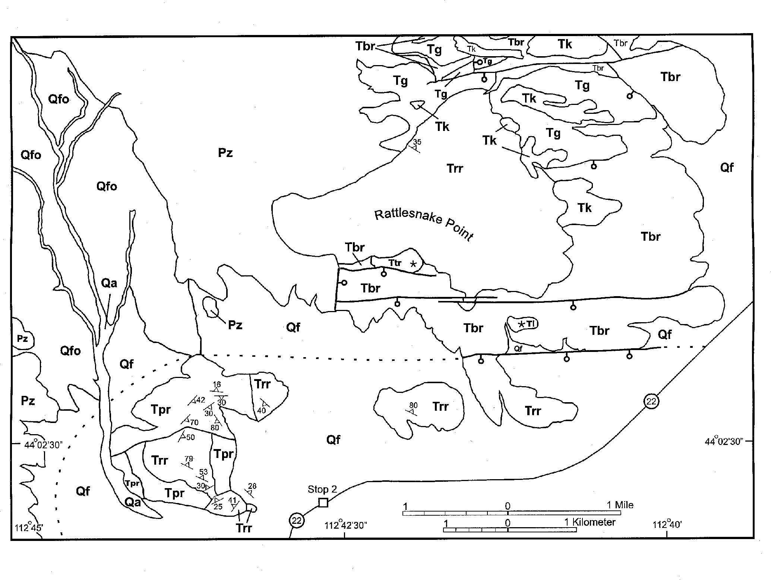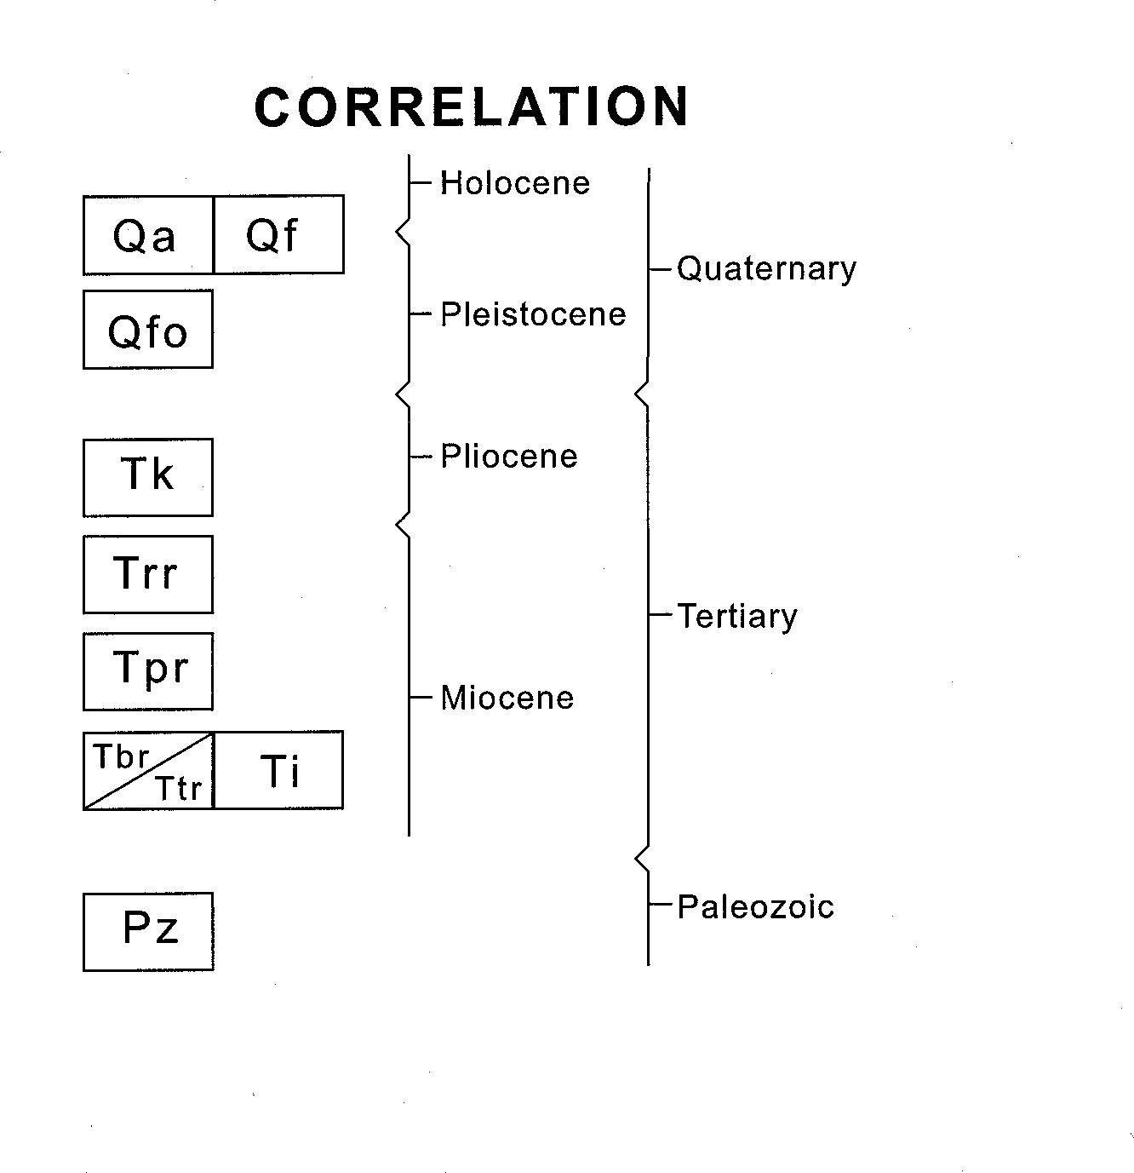Price and others -- Lemhi and Beaverhead Mountain Ranges
337

area.Pz-Sedimentary rocks, undivided Paleozoic, Tbr-Mi- ocene basalt of Rattlesnake Pt., Ttr-Miocene basalt tephra of Rattlesnake Point, Ti-Miocene gabbro, Tpr-Miocene pyroclas- tic rhyolites of Reno Gulch, Trr-Miocene rhyolite of Reno Gulch, Tk-Pliocen tuff of Kilgore, Tg-Pliocene & Miocene gravel, Qfo-Quaternary, Qf-Quaternary alluvial-fan depos- its, Qa-Quaternary alluvium.
Figure 2. Geologic map of the Reno Gulch, Rattlesnake Point

Snaky Canyon Formation, which lies to the east. The thrust runs northwest up Reno Gulch (Skipp and Hait, 1977).
0.0 Reset the odometer at the intersection of the gravel road with Highway 28 and turn north.
0.7 Sign marking the boundary of the INEEL.
1.5 To the right is the southernmost of several small basalt- capped buttes, which are erosion remnants of flows. These flows apparently erupted along the range-front fault at the western foot of the Beaverhead Range.

tional tuff units, and have been dropped by at least two faults at the base of the ridge (Fig.3). These faults may represent a seg- ment of the Blue Creek Caldera rim fault (Fig.2).
posed primarily of the rhyolite of Reno Gulch with some addi-

26.8 Turn right on the gravel road to reach Highway 28.
27.0 The Mississippian rocks of the Scott Peak Formation (Skipp et al., 1980) at the right dip west. Folding within this unit can be seen along the strike to the north. Here the Scott Peak Formation is thrust over the Permian/Pennsylvanian
Stop 3. Tectonic Activity and Basalt Flows
1.9 Pull off on the right. Two more basalt-capped buttes are seen to the right. The northern-most butte is Scott Butte and is capped by several east-dipping flows. Note that the dip on the top flow is less than that of the flows beneath (Fig.4). This indicates an extended period of basalt extru- sion accompanied by intermittent activity on the range- front faults. There is evidence of at least two faults, one immediately east and the other to the west of Scott Butte. The smallest butte just to the south of Scott Butte is ap-

33 uide oo to the eo og o astern daho
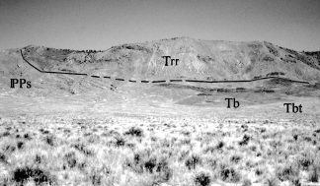

Figure 3. Photo of the southern end of the Beaverhead Range showing the stratigraphic relationship of PPs-Snaky Can- yon Formation, Tb-Tertiary basalt, Tbt-Tertiary basalt te- phra, and Trr-rhyolite of Reno Gulch.
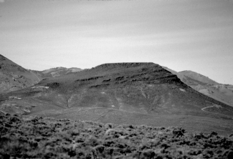
Figure 4. Photo of Scott Butte showing the change in dip of the basalt remnants indicating an extended period of extrusion and intermittent fault activity on the range-front.

parently located near a basalt vent along the eastern fault. It has cinders on top of the flow and a small feeder dike at its base on the east side of the butte.

To the west is the Lemhi Range. Close examination of the upper part of this section of the mountainside reveals some large recumbent isoclinal folds. These folds are associated with thrust- ing and were produced during the Late Cretaceous Sevier Orog- eny (Skipp and Hait, 1977). See Figure 5.

  - Note the immense alluvial fans filling the valley from the mountains on both sides as you drive up Birch Creek Val- ley from here.
  - Birch Creek Terraces have truncated the alluvial fans on the east side of the road and small secondary fans at the mouths of gullies were produced by headward erosion of gullies into the ends of the fans.

The cliff on the right is composed of limestone of the Missis- sippian Surrett Canyon and South Creek Formations and is part

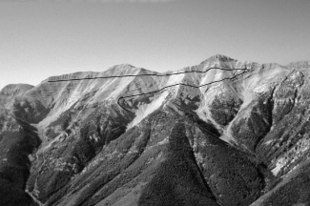
Figure 5. Isoclinal folding in the southern Lemhi Range; associated with thrusting during the Late Cretaceous Sevier Orogeny.

of the large Blue Dome fault block set out from the main range front (Skipp and Hait, 1977).

Side Trip to Skull Canyon
This side trip is mainly to describe the Mesoproterozoic through Devonian section to compare with thicker strat in the Lemhi Range at Meadow lake.
The Blue Dome block is a large anticline, which can be seen by driving up Skull Canyon. At the head of the canyon, Middle Proterozoic quartzite of the Lemhi Group (Skipp and Link, 1992) is unconformably overlain by <10 m of Ordovician Kinnikinic Quartz- ite, which pinches out to the south. The Kinnikinic is overlain by
~70 m of Devonian Jefferson Formation which in turn is overlain by >2000 m of Mississippian to Permian rocks (Embree et al., 1983). The absence of Cambrian and Silurian rocks and the thin Ordovician and Devonian sections in this area is attributed to the presence of the Lemhi Arch, a topographic high that developed in this region during the early Paleozoic (Ruppel & Lopez, 1981). About 45 km farther to the north in the vicinity of Gilmore, the Kinnikinic has thickened to ~300m. the Silurian to ~100 m, and the Devonian to 700-900 m.

0.0 Reset odometer at the Skull Canyon Road.
2.1 At Lone Pine the highway enters a canyon cut into Mi- ocene valley fill basalts.
~5.0 Turn right just before crossing Birch Creek.
0.0 Reset the odometer and follow the dirt road ~6 miles to the mouth of Pierce Canyon.
0.8 Take the right fork and continue up the canyon.
2.7 Keep to the right and continue straight ahead up the main canyon.
4.6 Turn left up Pierce Canyon at the pump jack.
4.8 Range fence.
5.0 The break in slope on the alluvial fans on either side of the canyon ~0.2 mile ahead marks the scarp produced by the last movement on the Beaverhead Range front fault. The fault also displaced the valley fill ahead. A line of large white Kinnikinic boulders crossing the valley floor marks the scarp in the alluvium.

Price and others -- Lemhi and Beaverhead Mountain Ranges
339

5.2 Road crosses the Beaverhead fault scarp.
  - Exposures of Mesoproterozoic Lemhi Group quartzite are on the left.
  - Ahead, on the north side of the canyon, the Late Ordovi- cian Kinnikinic Quartzite forms a prominent ~20 m cliff above the unconformity on top of the Mesoproterozoic quartzite.

Turn around and return to the highway. Note the most recent fault scarp crossing the fans along the mountain front to the east. Springs in this area are the main headwaters for Birch Creek.
The natural drainage of Birch Creek flows out onto the Snake River Plain where it sinks into the lava flows to help feed the Snake River Aquifer.

~11.7 The turn off for Nicolia can be seen ahead and to the right. The oldest mining activity in this part of Idaho was at the Viola mine in the Nicholia district. The mine operated from 1882 to 1890 with an estimated production value of $2.5 million in 1913 dollars (Umpleby, 1913). The large cavern- like deposit fits the description of a Mississippi Valley type lead-zinc deposit. The ore carried 10 to 12 ounces of silver per ton. Prospecting after the main cavern was mined out found no other deposits.
21.5 Turn left on the road leading to Spring Mountain Canyon. Reset the odometer.

Note the terminal moraine at the mouth of the canyon ahead. The road ascends the moraine and then proceeds up the bottom of the canyon. This road is quite rough and steep in places.

4.1 Turn right and climb the lateral moraine.

Stop 4. Stratigraphy, Structure, and Glacial Features of Spring Mountain and Horseshoe Canyon Cirques
4.4 The cirque walls of Horseshoe Canyon (due south) and Spring Mountain Canyon (southwest) combine to form an excellent exposure of the stratigraphic and structural rela- tionships of this part of the Lemhi Range (Fig.6). The main part of the cirque walls consist of gray, eastward dipping Devonian carbonates of the Jefferson Formation.

At the base of the Horseshoe Canyon cirque the Silurian Laketown Dolomite and Ordovician Saturday Mountain Forma- tion are exposed below the Jefferson. To the right of the high point in the Horseshoe Canyon cirque wall, steeply dipping and folded rocks of the Saturday Mountain Formation have been thrust over the Devonian section. This same relationship can be seen along the ridge top at the head of Spring Mountain Canyon, ex- cept there, the Ordovician rocks dip gently west. Note how much thicker the Devonian section is in this area compared to the south- ern Beaverhead Range section where it is only ~10 m thick.
In Horseshoe Canyon the thrust fault is cut by a steep normal fault which is downdropped on the west. The highest point, just east of this fault is a small klippe of Saturday Mountain Forma- tion, which shows the amount of throw on the normal fault.
The massive, gray rock at the point, which separates Spring

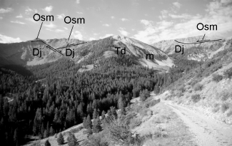
Figure 6. Cirque walls of Horseshoe Canyon (left) and Spring Mountain Canyon showing stratigraphic and structural re- lationship in this part of the Lemhi Range. Osm-Ordovician Saturday Mountain Formation, D}-Devonian Jefferson Do- lomite, Td-Tertiary diorite stock, m-Quaternary dolomite marble are all exposed. Thrusting and normal faults are shown in both canyons.
Mountain and Horseshoe canyons, is part of a diorite stock. The diorite intrusions in this area are Eocene in age, and are younger than the thrust faults (Ruppel and Lopez, 1981). One diorite dike, located in Long Canyon ~7 km to the north of here, produced a date of 45.4 Ma. Above and on both sides of this stock, the white exposures are dolomitic marble from the contact aureole.
The low, tree-covered ridge extending downstream from the diorite stock is the medial moraine marking the juncture of the two glacial valleys. The lateral moraine upon which you are standing continues east to become the main part of the end moraine at the mouth of the canyon. Between this moraine ridge and the road at the bottom of the valley is a much smaller recessional moraine, and beyond it, at the mouth of the canyon, are remnants of earlier moraines.
Drive ~0.2 miles up the road. Just around the point is a small flat area on the left where you can turn around. Drive back to the bottom of the canyon, reset the odometer, turn right, and proceed upstream.

Stop 5. Devonian Tidal Channel, Contact Zone of Diorite Stock
0.5 At the top of the cirque wall to the west is a distinctive orange lens shaped deposit (Fig.7). This is a tidal channel, which occurs at below the middle Devonian Jefferson For- mation and was cut into the underlying Silurian Laketown Dolomite (see Gradee & Denler, this volume).

The lower part of the channel fill consists mostly of shale and siltstone with plant fragments and occasional gastropod fossils. The middle part is crossbedded sandstone and conglomerate and contains fragments of Psephaspis ostracoderm fishplates. The upper part is interbedded sandstone and dolomite. The channel represents tidal deposition on a pre-Jefferson erosion surface with a general, transgressive sequence. Coarse clastics accumu- lated in the channel during storms or high energy fluctuations in tidal currents. Fish remains appear to be both fresh and marine in origin. Other channels occur in the region below the base of the

3 uide oo to the eo og o astern daho

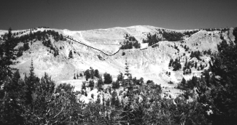
Figure 7. Devonian tidal channel which occurs below the base of the middle Devonian Jefferson Dolomite and cuts into the underlying Silurian Laketown Dolomite.

Jefferson Formation.
Diorite and marble are exposed along the south and north sides of the canyon in this area. To the left of the road, the contact is well-exposed. Several small dikes and sills penetrate the marble to the right of the contact. A short walk to the base of the talus slope below the contact provides an opportunity to examine skarn mineralization in blocks shed from the cliff above. Several differ- ent assemblages can be found. Typical minerals include tremolite, grossular garnet, magnetite, sphene, serpentine, chlorite, diop- side, calcite, dolomite, etc. Please collect sparingly to preserve this location for others.
  - The road turns sharply left at the unloading station for a cable tram used by the early miners in this Spring Moun- tain District. Most of the claims were located in the early 1880's as prospectors spread out from the Nicholia dis- trict. A smelter was built at the Hahn townsite (located at the mouth of Spring Mountain Canyon), which operated for a few days in 1909 and 1910. Charcoal kilns used in this activity still exist ~7 km to the south at the mouth of Coal Kiln Canyon. Total tonnage is not known but Umpleby (1913) gives an estimate of $50,000.00 value. The ore is similar to that at Gilmore, which is oxidized and was mined for lead and silver. Building in the district indicates more recent activity, but no production records are available.

Stop 6. View of Devonian Channel
  - Stop just past the second right bend, after passing the tram station. This is the best place to see the entire expo- sure of the Devonian channel described at the last stop.
1.8 To the left above the top of the talus slope a 5-10 m thick dike cuts the Devonian strata. The talus along the road- side affords an opportunity to look at several lithologies typical of the Devonian carbonates in this area.

The road is much steeper beyond this point. Overloaded or underpowered vehicles may have difficulty. Four wheel drive is not necessary, but is recommended.

Stop 7. Contact Metamorphic Aureole
2.4 Turn around and stop at the second switchback. The road above this point is blocked by several large rock falls. From this position the east wall of the cirque can be seen. The
Devonian carbonates at the south end of the cirque grade into marbles in the proximity of the stock to the north. Return to the highway.
0.0 Reset odometer at the highway and turn left (north).
1.0 Ahead and to the left is a large, terminal moraine at the mouth of Long Canyon.
3.7 Gilmore summit. From here, north, the drainage flows into the Lemhi River, which in turn enters the Salmon River at the town of Salmon.
5.7 Turn left on the gravel road to Gilmore and Meadow Lake. Reset the odometer. To the right is a large moraine at the mouth of Meadow Lake Canyon, just north of the Gilmore ghost town. Follow the main road through Gilmore and the mining area above the town.

Stop 8. Gilmore Mining District
3.3 There is a sharp left turn where the road leaves the moun- tain front and heads up Meadow Lake Canyon. Park on the right where the road widens at the turn. Walk ~20 meters back down the road for a panoramic view of Gilmore and the valley beyond.

The Texas Mining District (Gilmore) was discovered as pros- pectors searched for another Viola mine. Claims were located first in 1902; and major, vein-type ore bodies up to 50 feet wide and vertical stopes of over 600 feet were developed. One vein, at Gilmore, was mined almost exclusively for gold. Lead and silver were the main metals recovered from the district (Umpleby, 1913). Mining continued in the Gilmore area until just before the stock market crash of 1929. The major boiler for the mine blew up and because of the market crash it was never replaced. The mines stopped operating because of the depression. Limited contract mining has gone on from time to time up through the 1980's. The mining during this time was mainly of oxidized ore. Reports from the last deep activity, indicate that primary sulfide ore was ex- posed in the bottom of the deeper shafts. These shafts are now filled with water. Total production values are estimated to have
exceeded $9 million in pre-World War II dollars.
Drilling in the Texas Creek drainage, in front of the terminal moraine at the mouth of Meadow Creek Canyon, has identified a granite-porphyry intrusion. This suggests the mineralization at Gilmore and the smaller surrounding mines fits the pattern of ore deposits forming around a large intrusion, as seen at Bingham and other well- known mining areas.
Center Ridge, on the east side of the highway, is an uplifted fault-block, which exposes valley fill deposits.
Along the highway and old railroad grade that serviced Gilmore are excellent exposures of air-fall and water-lain tuffs. These tuffs are described at Stop 10.
Return to the car and continue up the road to the Meadow Lake Campground.

Stop 9. Meadow Lake Cirque
6.6 Park at the small lot at the west end of the campground loop and walk to the edge of the lake. This is a small tarn or cirque lake. Across the lake is the south wall of the cirque that is carved entirely into Ordovician Kinnikinic Quartz-

Price and others -- Lemhi and Beaverhead Mountain Ranges
3 1

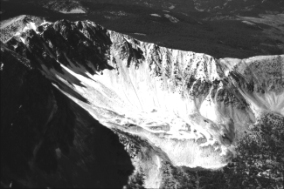
Figure 8. Oblique aerial photograph of the large rock glacier extending from the south wall of Meadow Lake Cirque.

ite. Here, this formation is ~300 m thick, in contrast to its thickness of <10 m in Skull Canyon 45 km to the southeast.

From the parking area take the well-developed trail toward the west end of the cirque. This trail is about 500 m long. Up the trail is a sign marking the Lemhi Divide Fork. Take this less-well devel- oped fork to the left and follow it up the stream to a small pond at its source. Note the glacial boulders of Kinnikinic Quartzite and Mesoproterozoic quartzite along the trail. Some of these clasts show excellent glacial striations.
The steep wall of Kinnikinic Quartzite rubble across the pond is the face of a large rock glacier which extend ~400 m out from the south wall of the cirque (Fig.8). Water emerges from the foot of the rock glacier to form the pond, which feeds the inlet stream to Meadow Lake.
You may return to the parking lot by following the trail back or take a more direct, cross-country route. The later option affords an opportunity to examine glacially polished, striated, and plucked roche moutonnee outcrops of Kinnikinic Quartzite. Return to the highway.

13.0 Turn left on Highway 28 to drive toward Salmon. Reset the odometer.

Stop 10. Ash-fall Deposits
Approximately 1 to 2 miles north of Gilmore are several road cuts on the east side of the road. These road cuts contain excel- lent exposures of air-fall and water-lain tuffs with ripple marks, cross beds etc. According to Ruppel and Lopez (1981) fresh wa- ter limestone in this unit contain gastropods and diatoms of Pliocene (?) age.

ACKNOWLEDGMENTS
Embree, Hoggan & Williams are indebted to Steve Oriel for his encouragement and supervision, and the U.S. Geological Survey for field support during several summers of mapping in the Beaverhead and Lemhi ranges during the 1970s. We gratefully acknowledge other U.S. Geological Survey personnel who were instrumental in this work. These include, Hal Prostka for his pio-
neering work on the stratigraphic framework of the Tertiary volca- nic rocks of the northern margin of the Eastern Snake River Plain, and Tim Hait and Betty Skipp for introducing us to the Paleozoic stratigraphy and supervising our mapping in the Lemhi and Beaverhead Ranges. Tim Hait and Vic Dunn introduced us to the geology of the Spring Mountain Canyon and Gilmore areas.

REFERENCES
Delorme Mapping, 1992, Idaho Atlas and Gazetteer, pp.40, 47,48.
1:250,000
Embree, G.F., Hoggan, R.D., and Williams, E.J., 1983, Preliminary Recon- naissance Geologic Map of the Copper Mountain Quadrangle, Lemhi County, Idaho: Open-file Report 83-599, U.S. Geological Survey. 1:24,000.
Embree, G. F., McBroome, L.A., Doherty, D.J., 1982, Preliminary stratographic framework of the Pliocene and Miocene rhyolite, east- ern Snake River Plain, Idaho, in Bonnichsen, B. and Breckenridge, R.M., eds., Cenozoic Geology of Idaho: Idaho Bureau of Mines and Geology Bulletin 26, pp. 333-343.
Kuntz, M.A., Covington, H.R., & Schorr, L.J., 1992, An overview of basal- tic volcanism of the eastern Snake River Plain, Idaho, in Link, P.K., Kuntz, M.A., & Platt, L.B., eds., Regional Geology of Eastern Idaho, and Western Wyoming: Geological Society of America Memoir, 179.
Morgan, L.A., 1992, Stratigraphic relations and paleomagnetic and geochemical correlation of ignimbrites of the Heise volocanic field, eastern Stake River Plain, Eastern Idaho and Western Wyoming, in Link, P.K., Kuntz, M.A., & Platt, L.B., eds., Regional Geology of Eastern Idaho and Western Wyoming: Geological Society of America Memoir 179.
Ruppel, E.T & Lopez, D.A., 1981, Geologic Map of the Gilmore Quad- rangle, Lemhi and Custer Counties, Idaho, U.S. Geological Survey, Den- ver, Colorado1:62500 scale.
Skipp, Betty, & Hait, M.H., Jr.,1977, Allochthons of the Northeast margin of the Snake river Plain, Idaho, in Hersey, E.L.(Roy), Lauson, D.E., Norwood, E.R., Wach, P.H., Hale, L.A., eds., Wyoming Geological Association, Rocky Mountain Thrust Belt, Geology and Resources, Teton Village, Wyoming.
Skipp, Betty, Hoggan, R.D., Schliecher, D.L. & Douglass, R.C., 1979, Up- per Paleozoic Carbonate Bank in East Central Idaho, Snaky Canyon, Bluebird Mountain and Arco Hills Formations, and their Paleotectonic significance: U.S. Geological Survey Bulletin 1486, Washington D.C.
Skipp, Betty, & Link, P.K., 1992, Middle and Late Proterozoic Rocks and Late Proterozoic Tectonics in the Southern Beaverhead Mountains, Idaho and Montana: A preliminary report, in Link, P.K., Kuntz, M.A., Platt, L.B., eds., Regional Geology of Eastern Idaho and Western Wyo- ming: Geological Society of America Memoir 179.
Skipp, Betty, Sando, W.J., & Hall, W.E., 1980, the Mississippian and Penn- sylvanian (Carboniferous) Systems in the U.S.- Idaho, Idaho Bureau of Mines and Geology, Moscow, Idaho: US Geological Survey Professional Paper 1110-AA (1979) pp. 29-30.
Umpleby, J.B., 1913, Geology and Ore Deposits of Lemhi County, Idaho,
U.S. Geological Survey Bulletin, p. 528.

APPENDIX A -- STRATIGRAPHIC DESCRIP- TIONS
Alluvium -Unconsolidated deposits of silt, sand and gravel in channels and flood plains.
Colluvium -Unconsolidated, unsorted rock debris mainly on slopes.
Landslide deposits -Unconsolidated, unsorted, and unstratified debris derived from local bedrock.
Kilgore tuff (Pliocene) -Formerly called the tuff of Spencer (Skipp et al., 1979); K-Ar age = 4.3 Ma (Embree et al., 1982). Rhyolitic ash-flow tuff, densely to moderately welded. The following zones are generally present: a black and red basal vitrophyre; a lithophysal zone consisting of 50% white lithophysae in a gray devitrified matrix; and a gray, pink, and maroon devitrified zone. An upper vitric unit is often missing due to erosion.

3 uide oo to the eo og o astern daho

rhyolite of Lidy Hot Springs (Miocene) -Pinkish to medium gray flow: pervasive, highly contorted flow banding perlitic to devitrified con- tains 15% phenocrysts of sanidine and quartz. K-Ar age = 5.43 Ma (Embree et al., 1982).
rhyolite of Reno Gulch (Miocene) -White to dark gray, pumiceous to devitrified, flow-banded rhyolitic lava flow/flows and minor pyroclastic units. Zircon fission track-age = 6.2 Ma (Embree et al., 1982).
rhyolites of Reno Gulch (Miocene) -White to gray altered rhyolite airfall and ashflow tuffs are eutaxitic and dentrified with considerable vapor phase crystallization. Air fall tuffs are thin bedded and deformed. tuff of Blue Creek (Miocene) -Gray, devitrified, platy, densely welded
tuff with phenocrysts of plagioclase.
tuff of Blacktail Creek (Miocene) -Rhyolitic ash-flow tuff, purple, brown, crystal rich, densely welded Zircon fission track dates of 6.3 to
6.5 Ma (Embree et al., 1982). Unit formerly called Edie School rhyo- lites of Pliocene age.
Medicine Lodge Formation (Miocene) -White, tuffaceous, lacustrine deposit. Very incompetent and prone to landsliding.
Snaky Canyon Formation (lower Permian to lower Pennsylvanian) - Medium to light gray, medium to thin bedded, microcrystalline to me- dium grained limestone and dolomite, commonly containing fossils interbedded with thin calcareous sandstone.
Surrett Canyon and South Creek Formations (undivided, upper Mis- sissippian) -Surrett Canyon is dark, fossiliferous limestone. The South Creek Formation is gray, thin-bedded limestone containing no fossils. Scott Peak Formation (Mississippian) -Very thick bedded units of fossil-
iferous, crinoidal and pelletal limestone.
Jefferson Formation (Devonian) -Dark gray to brown, fine grained dolomite, some areas include a limestone unit at the top.
Channel sandstones (Devonian) -Light to medium brown, fine to me- dium grained dolomitic sandstone, siltstone and shale with sparse thin interbeds of pebble conglomerate Contain abundant fragments of fresh and/or brackish water fish.
Laketown Dolomite (Silurian) -Light green, gray, medium crystalline, granular, vuggy dolomite.
Saturday Mountain Formation (Ordovician) -Medium gray, crystal- line, partly fossiliferous dolomite; contains irregular nodules of black chert.
Kinnikinic Quartzite (Ordovician) -White fine to medium grained, quartzite.
Lemhi Group (Mesoproterozoic) -Quartzite and siltite in unconform- able contact below the younger Paleozoic formations.

