Geology of East-Central Idaho: Geologic Roadlogs for the Big and Little Lost River, Lemhi, and Salmon River Valleys

Paul Karl Link

Department of Geology, Idaho State University, Pocatello ID 83209
Susanne U. Janecke
Department of Geology, Utah State University, Logan UT 84322

INTRODUCTION
This article contains a discussion of the regional geology and historical geography of east-central Idaho, north of the Snake River Plain and southeast of the Salmon River, and four roadlogs for the main highways in this huge (15,000-km2) area. The roadlogs progress from south to north and west to east. They include:
- Big Lost River Valley,
- Little Lost River-Pahsimeroi Valley,
- Birch Creek-Lemhi Valley, and
- Stanley to Salmon along the Salmon River.
This article covers much of the same country described by Ross (1963) in the first geologic roadlog of east-central Idaho, and is a companion to field trip descriptions of south-central Idaho to the west, from Arco to Ketchum (Link et al., 1988), and of the central Lost River Range (Janecke, 1995a). With those papers, it completes an updated set of geologic descriptions of east- and south-central Idaho. Our intention is to provide more precise and fully referenced information than available in the Roadside Ge- ology of Idaho (Alt and Hyndman, 1989). Our intended audience includes all manner of geologists and those interested in the in- teraction of Idaho geology, geography and history.
Regional geologic map references for the present discussions include Challis National Forest (Wilson and Skipp, 1994), Idaho National Engineering Laboratory (Kuntz et al., 1994); Challis 1° x 2° sheet (Fisher et al., 1992); Dillon 1° x 2° sheet (Ruppel et al., 1993); Hailey and western Idaho Falls 1° x 2° sheets (Worl et al., 1991); and the surficial map of the eastern Snake River Plain (Scott, 1982). One of our agendas is to promote use of those maps. Without a geologic map, many of our descriptions lose context. Another important standard reference are stratigraphic correla- tion charts for Idaho (Isaacson et al., 1983 and Ballard et al., 1983).

As part of this introduction we present several summary fig- ures. First is a regional geographic map (Fig. 1), and a simplified geologic map on the same base (Fig. 2). The Proterozoic and Paleozoic stratigraphic correlation diagram (Fig. 3) also shows thrust fault relations. Figure 4 shows major structures and basins of the Trans-Challis fault zone and Figure 5 shows the Challis Volcanic field. Photographs in the road log section illustrate many of the field localities. In the introductory summary we cite (out- of-sequence with their position in the text) several photographs in which specific stratigraphic features are present.
East-central Idaho contains diverse and economically impor- tant, mineral deposits. Specific areas of mineralization are dis- cussed in the roadlogs. More general discussions include Hall (1985), Ruppel and Lopez (1988), Fisher and Johnson (1995a), and Worl et al., (1995), and papers therein.

GEOLOGIC HISTORY OF EASTERN IDAHO

Summary
East-central Idaho (Figs. 1 & 2) lies within the Cordilleran fold and thrust belt, and in the Basin-and-Range province. Rocks and structures within this region reflect a long and complex his- tory of deformation. Strata were deposited here in the Mesoproterozoic Belt intracratonic rift basin, and episodically in the late Neoproterozoic and Paleozoic Cordilleran miogeocline. The Early Neoproterozoic Beaverhead Impact caused shock de- formation and may have controlled subsequent tectonic instabil- ity in the southern Beaverhead and Lemhi Mountains. During the Paleozoic, marginal basins and uplifts formed, rather than the regionally extensive Paleozoic passive-margin succession that is present south of the Snake River Plain. Paleozoic tectonostratigraphic events include: transpressional latest Devo- nian and Mississippian Antler deformation, Early Mississippian

Link, P.K. and Janecke, S.U., 1999, Geology of East-Central Idaho: Geologic Roadlogs for the Big and Little Lost River, Lemhi, and Salmon River Valleys, in
Hughes, S.S., and Thackray, G.D., eds., Guidebook to the Geology of Eastern Idaho: Pocatello, Idaho Museum of Natural History, p. 295-334.

114°

93

0 5 10 20

miies
Leesburg
Saimon River Mountains 0 5 10 20
Saimon kiiometers
93 28
Biackbird Mt.

Baker
Road log #3
45° Yeiiowjacket
Middie Tendoy Lemhi
ork Moyer Peak Pass Montana
Peak

Fort Bannock
Lemhi PassBannock Pass

Saimon River Mountains
29
Eiiis Leadore

May Road log #2
113°
Grouse
Peak Gilmore
Chaiiis Patterson Medicine
Gilmore
Road Log # 4 Summit
Bayhorse Big 28
Windy
Goidburg Peak
Lone Pine Nicholia
Peak 93 Summit
Malm Cr. Pass
Sunbeam Clayton Gulch Donkey
Willow Hiiis Lone Pine Creek Doubies ring
Stanley Summit Pass Bell Mt.
Warm
Spring Creek
Hawiey Mt. Diamond Peak
Borah Peak Blue ome
Chiiiy Leatherman Peak
Borah
44° Peak Mt. McCaleb Pass Creek
Horst Summit

Mackay Mackay Saddie Mt.
Res. ₂₂
Lesiie
Boulder
Mountains Arco Pass Howe
Antelope
Creek

26

Arco 20
Road log #1 93
115° 114° 113°
21

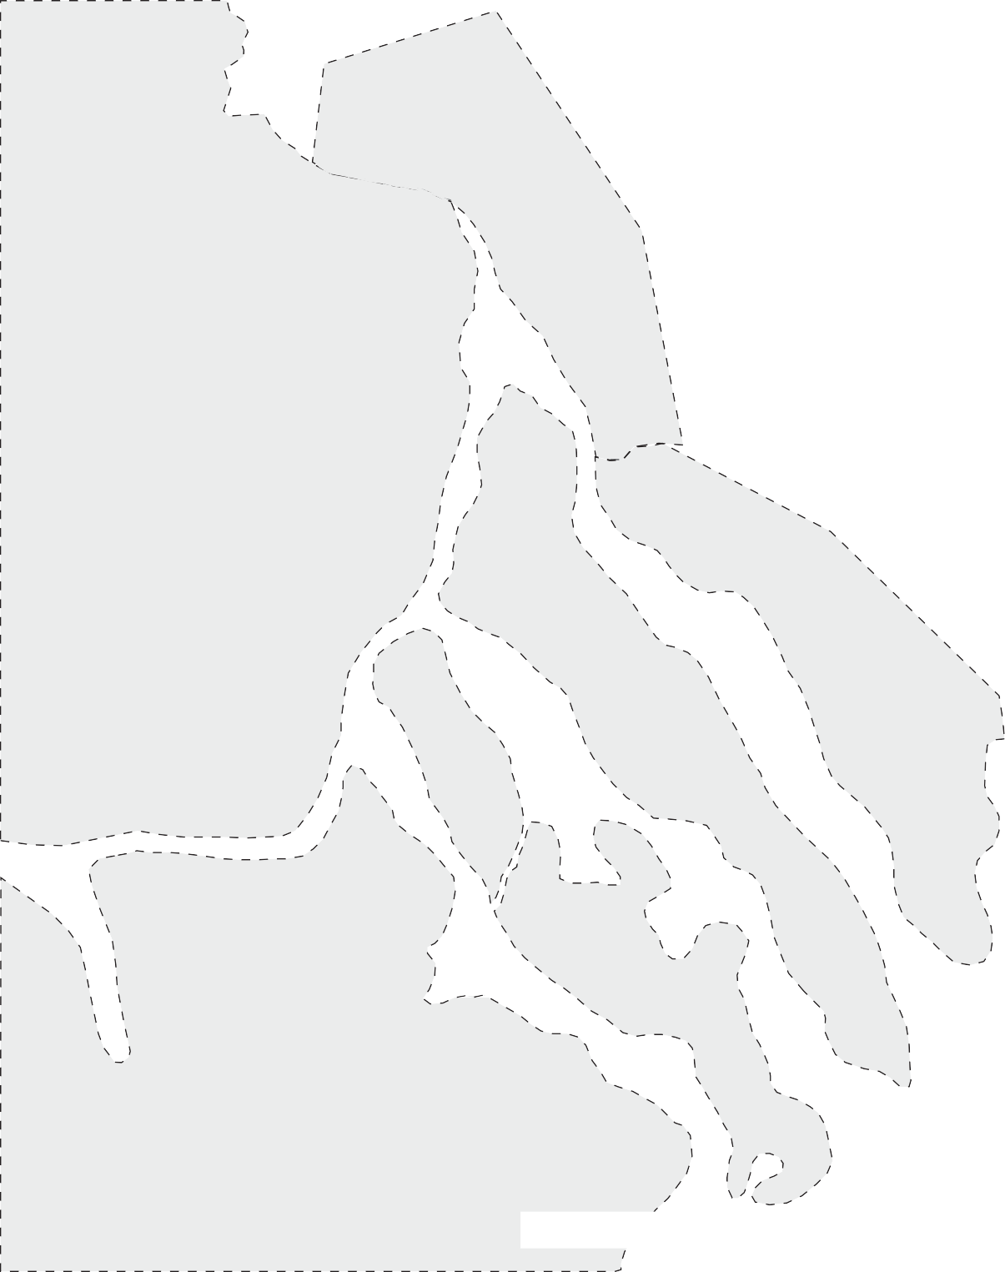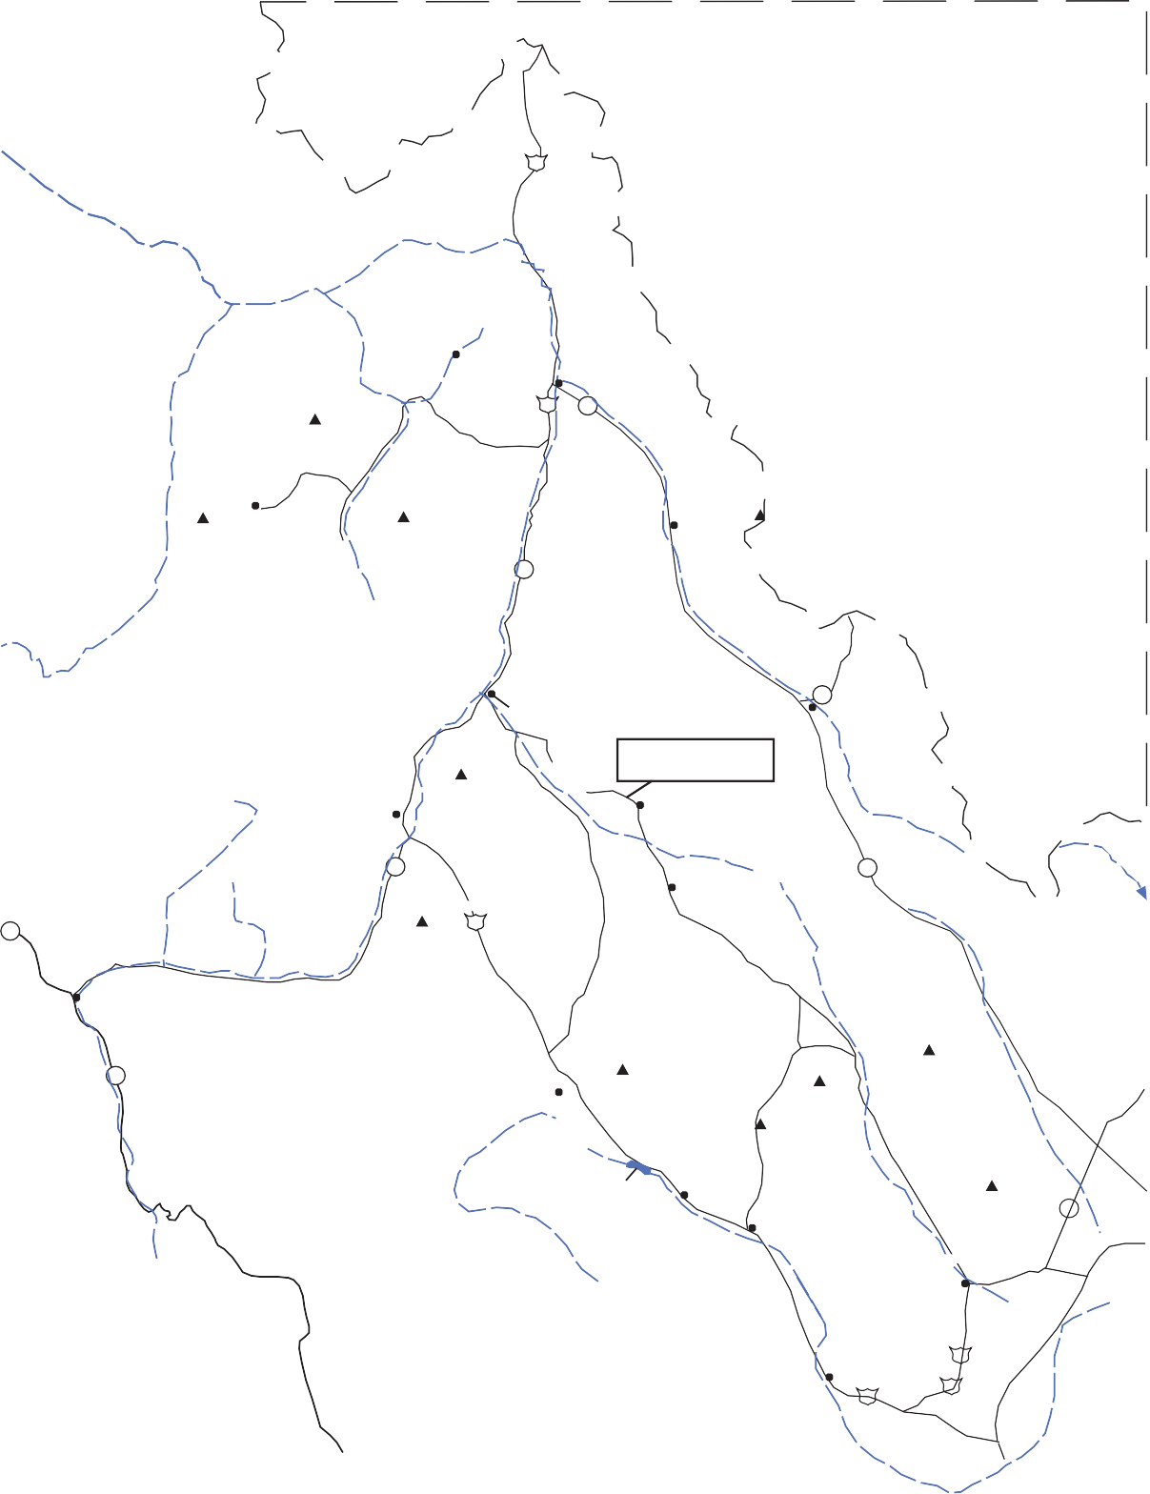Figure 1. Map showing geography of east-central Idaho, with some of the localities mentioned in this article. Route of segments 1,2,3, and 4 are shown. Figure 2 is at the same scale.

faulted foreland-basin deposition east of the Antler belt, and in- version tectonics during the Pennsylvanian and Permian Ances- tral Rockies orogeny. Large carbonate bank systems were present in Silurian, Late Devonian, and Late Mississippian time. In the central-Idaho black-shale mineral belt, syngenetic sedimentary- exhalative base-metal deposits of the Devonian Milligen Forma-
Lemhi Pass
o
tion formed in normal-fault bounded marginal-basins. The Early Mississippian Madison Group carbonate bank did not prograde west into east-central Idaho.
Deformation and intrusion of the Mesozoic Cordilleran oro- genic belt produced regional northeast-vergent thrust faults, nu- merous folds (Ross, 1947), and, in the western part of the area,

Kib
Yag
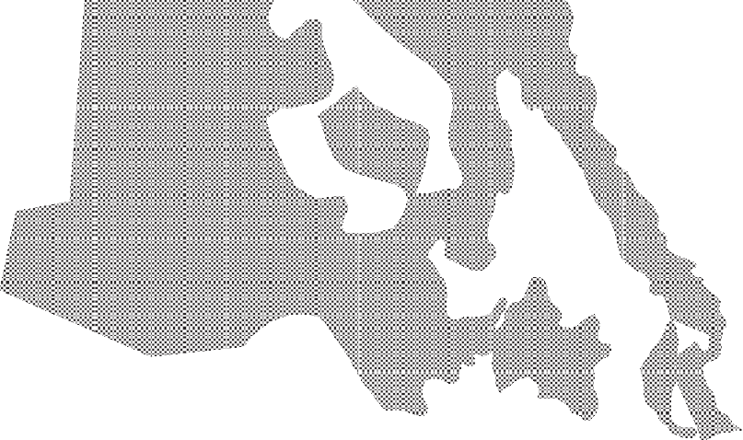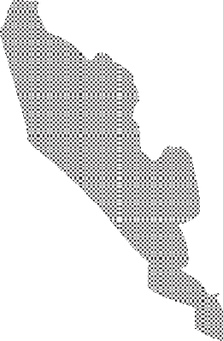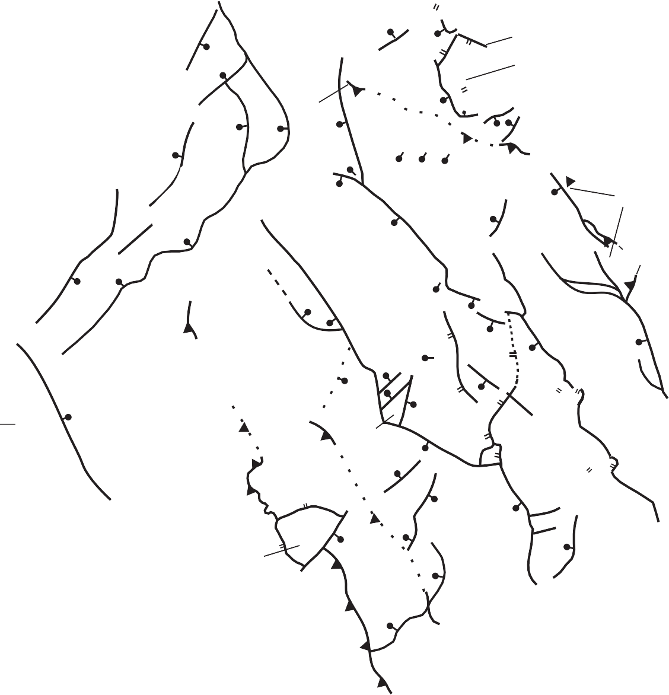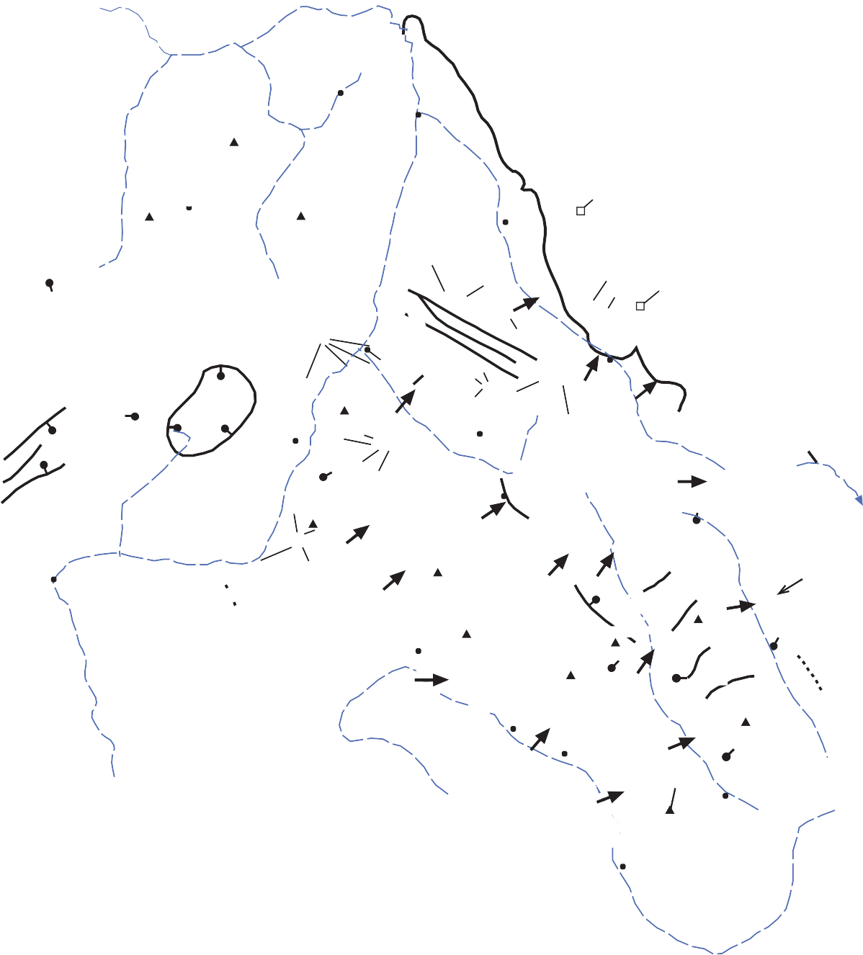Yb

Yag

45°

Thunder Mountain Cauldron Complex
TMCC

Ti

Yellowjacket Middle
o
Fork Peak

Ti

Yag

Blackbird Mt.

Leesburg

Yb

Moyer Peak

Salmon

Yb

Tendoy

LM

0 5 10 20
miles

0 5 10 20

kilometers

Salmon Basin Detatchment Fault

Yb Lemhi Pass
Lemhi Pass Fault

Agency-Yearian Fault

Pzs

Twin Peaks
Poison Creek Thrust
Yb

Ellis

E
Pzs

Yb

Pzc

Yb
MG

Pzc
Yb Bannock Pass

Pzs

Beaverhead Pluton

Caldera

Challis

Pzc
Grouse
Peak
Pzc
C

Lone Pine Peak
WS

Pzc

Patterson

M
Goldburg

G
Yb
BM
Yb

Pzc
Medicine
Lodge Cr.
MT
Hawley Creek Thrust
ID

N

44°

Stanley

Ti

Kib

Pzbs

Kib

Pzc

TS

Chilly
Doublespring Pass

Borah Peak

Pzc
S
Pzc

WC
Hawley Mt.

Pzc
Pass Creek Summit

Diamond Peak

Pzc BD

Ti

Kib

Eocene Challis volcanic Group and QT sediments
Intrusive rocks

Idaho Batholith

Pzbs Pioneer

Pzc

WPz
Borah Peak Horst
MK

Pzc

Leslie

PC

Pzc

Pzc
FS

Arco Pass

Pzc

Saddle Mt.

H
Howe

Pzbs Black shale assemblage
Mountains Core Complex

Pzc

Pzc
A
Arco

Pzc Pzs Yag Og
Yb
Carbonate assemblage Shelf assemblage Augen gneiss Beaverhead pluton Belt Supergroup

Normal fault
Thrust fault
Detachment fault

Pzc

WPz Pioneer Core Complex Fault-segment boundary

115°

114°

113°

Figure 2. Regional geological map of pre-Tertiary rocks of east-central Idaho. Map compiled from Bond (1978) and modified after Wilson and Skipp (1994), Schmidt et al. (1994) and Janecke et al. (1997; 1998). Segment boundaries on normal faults are indicated by heavy arrows and are named as follows (from Janecke, 1993 and references therein): Lost River fault; A=Arco; PC=Pass Creek; MK=Mackay; TS=Thousand Springs; WS=Warm Spring; C=Challis; Lemhi Fault, H=Howe; FS=Fallert Springs; S=Sawmill Gulch; G=Goldburg; P=Patterson; M=May; Beaverhead fault, BD=Blue Dome; N=Nicholia; BM=Baldy Mountain; L=Leadore; MG=Mollie Gulch; LM=Lemhi.

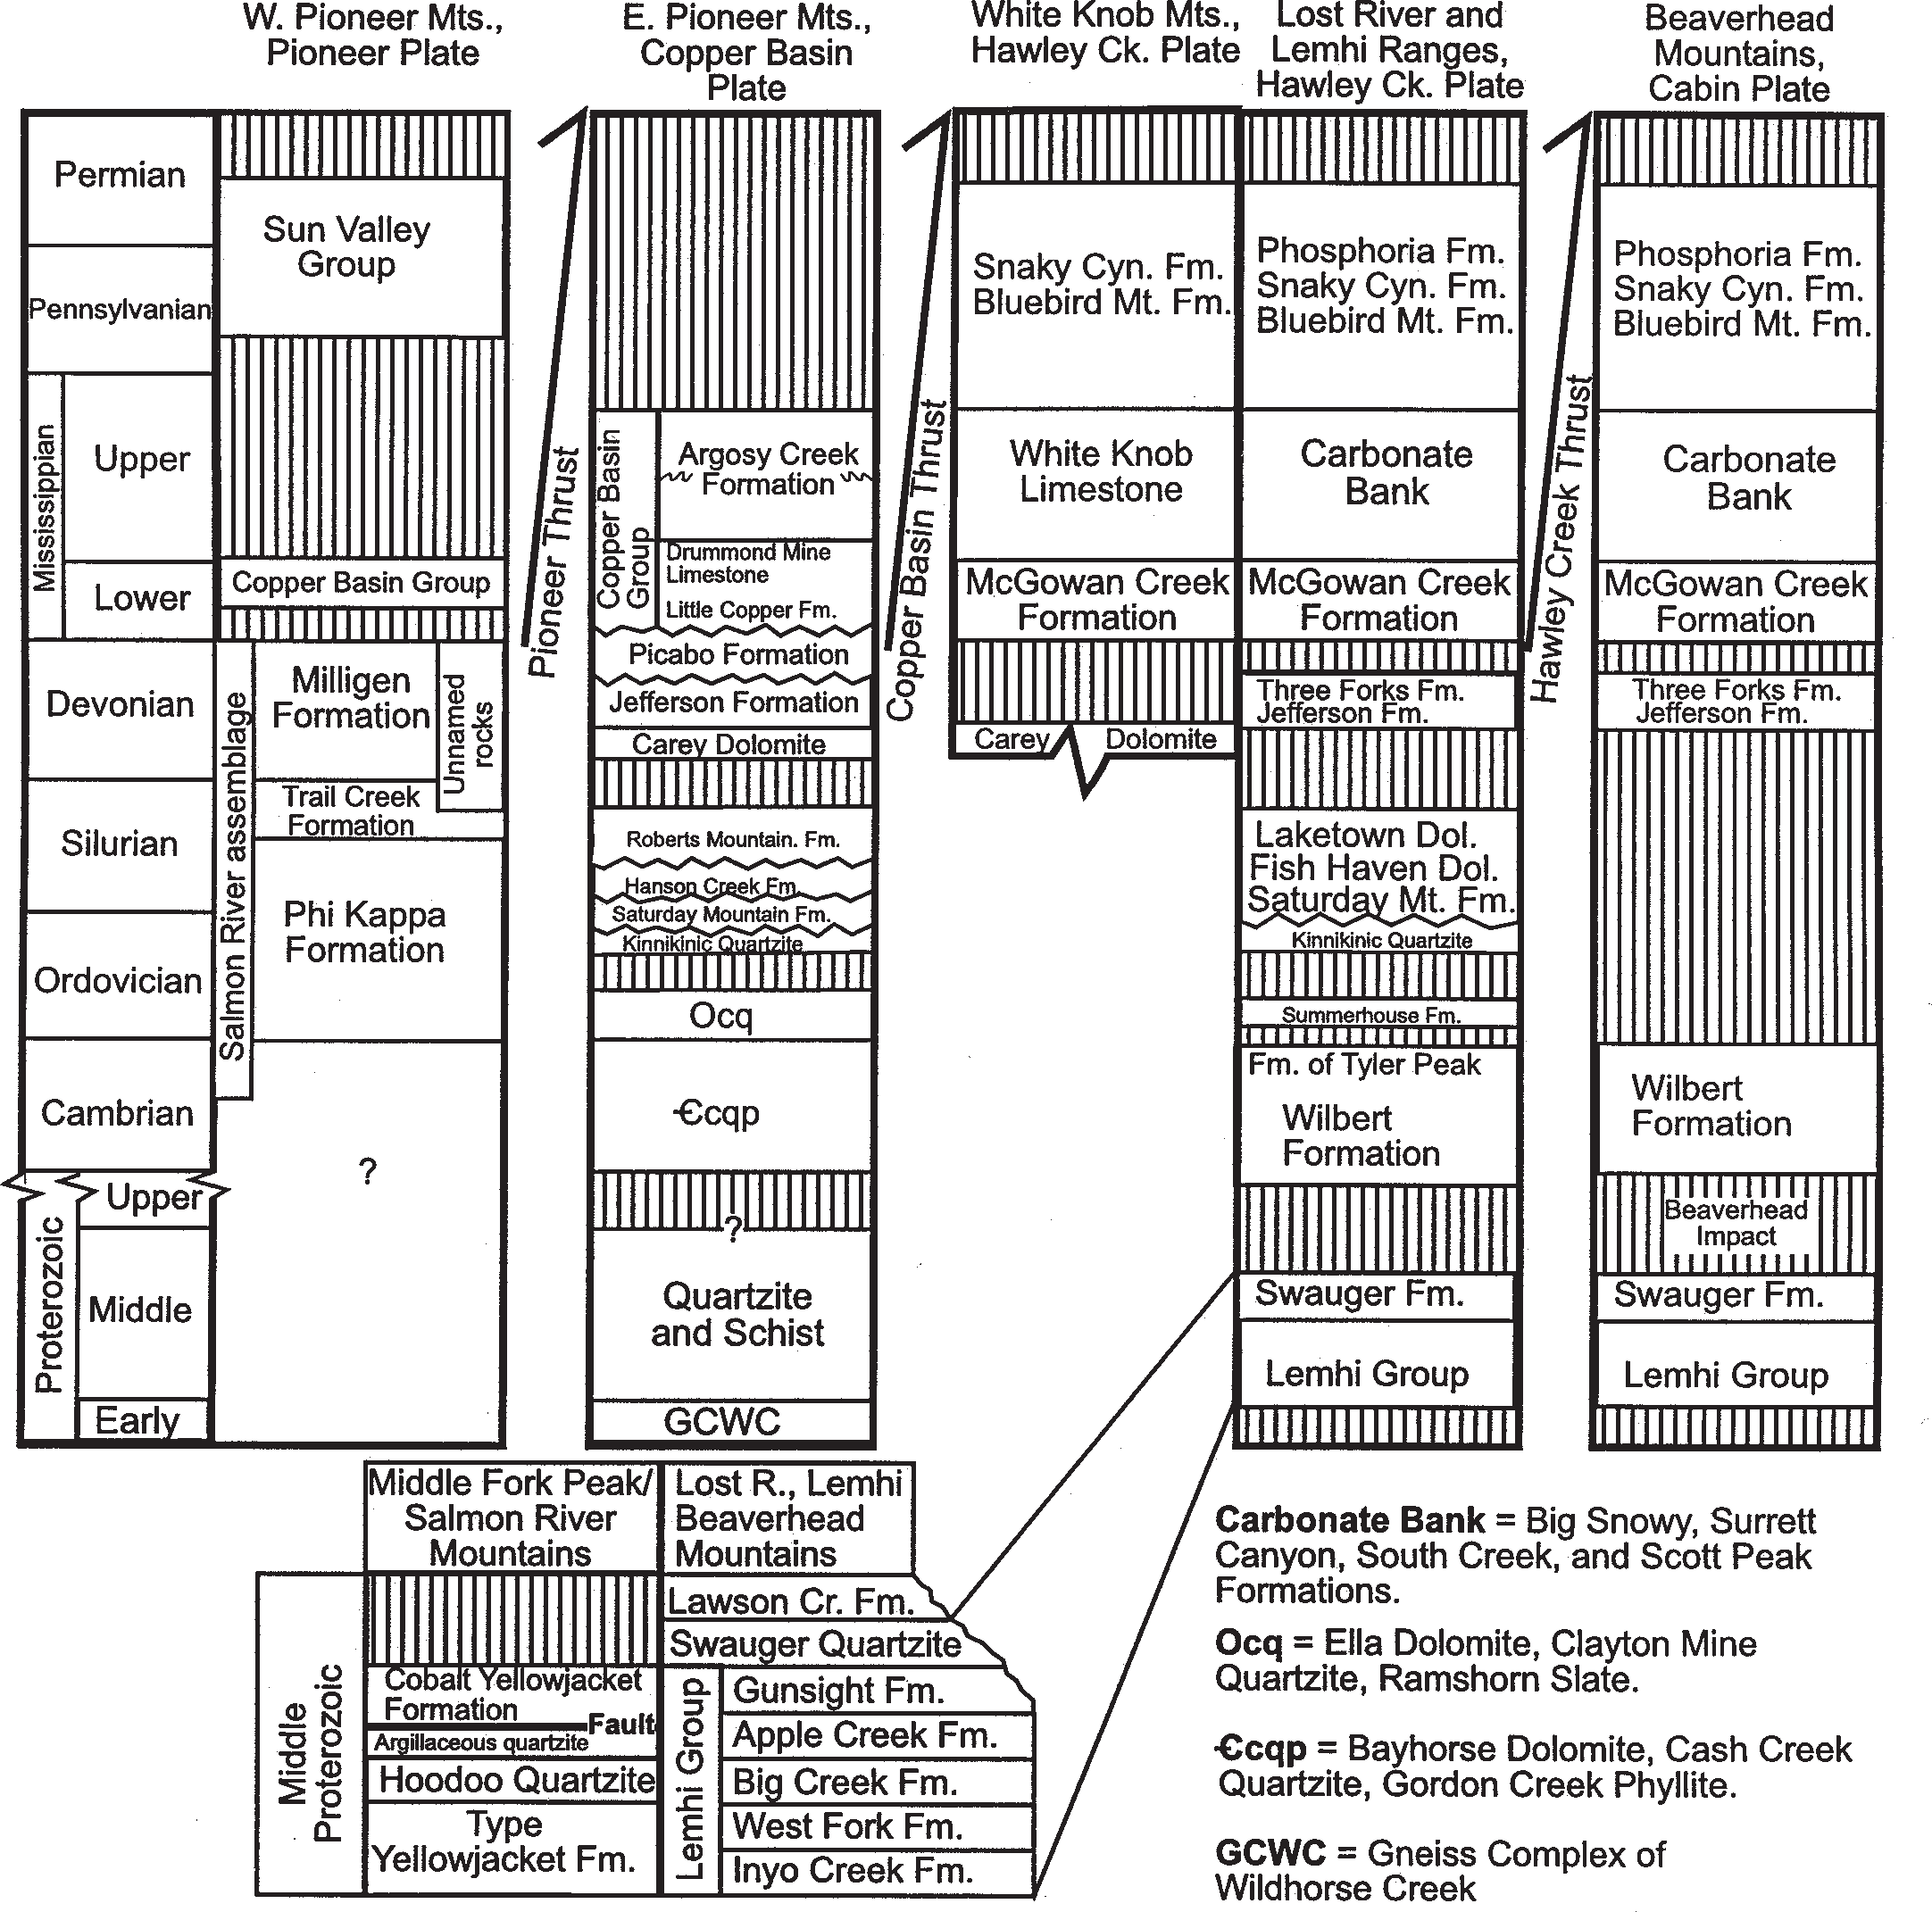

Figure 3. Stratigraphic units present in several thrust sheets and mountain ranges of east-central Idaho, after Skipp (1988a), Wilson and Skipp (1994), Link et al. (1995; 1996).

the extensive, mainly Late Cretaceous, Atlanta lobe of the Idaho batholith. Extension along several sets of normal faults began before Middle Eocene Challis volcanism, exhumed the Pioneer metamorphic core complex, and produced numerous Tertiary half- grabens in a system of north-trending Paleogene basins. The Challis Volcanic Group and associated shallow plutons covered and intruded much of the northern and western parts of the area, and produced diverse mineral deposits.
The area is part of the northern Basin-and-Range province,
and is actively extending along a system of dominantly north- northwest-striking normal faults. The magnitude 7.3 Borah Peak earthquake in 1983 provoked interest in the neotectonics and earth- quake hazards of the area. Today, east-central Idaho is on the northern flank of the late Cenozoic track of the Yellowstone-Snake River Plain hotspot, which has produced bimodal volcanic rocks along the plain and an east-northeast-trending topographic bulge.

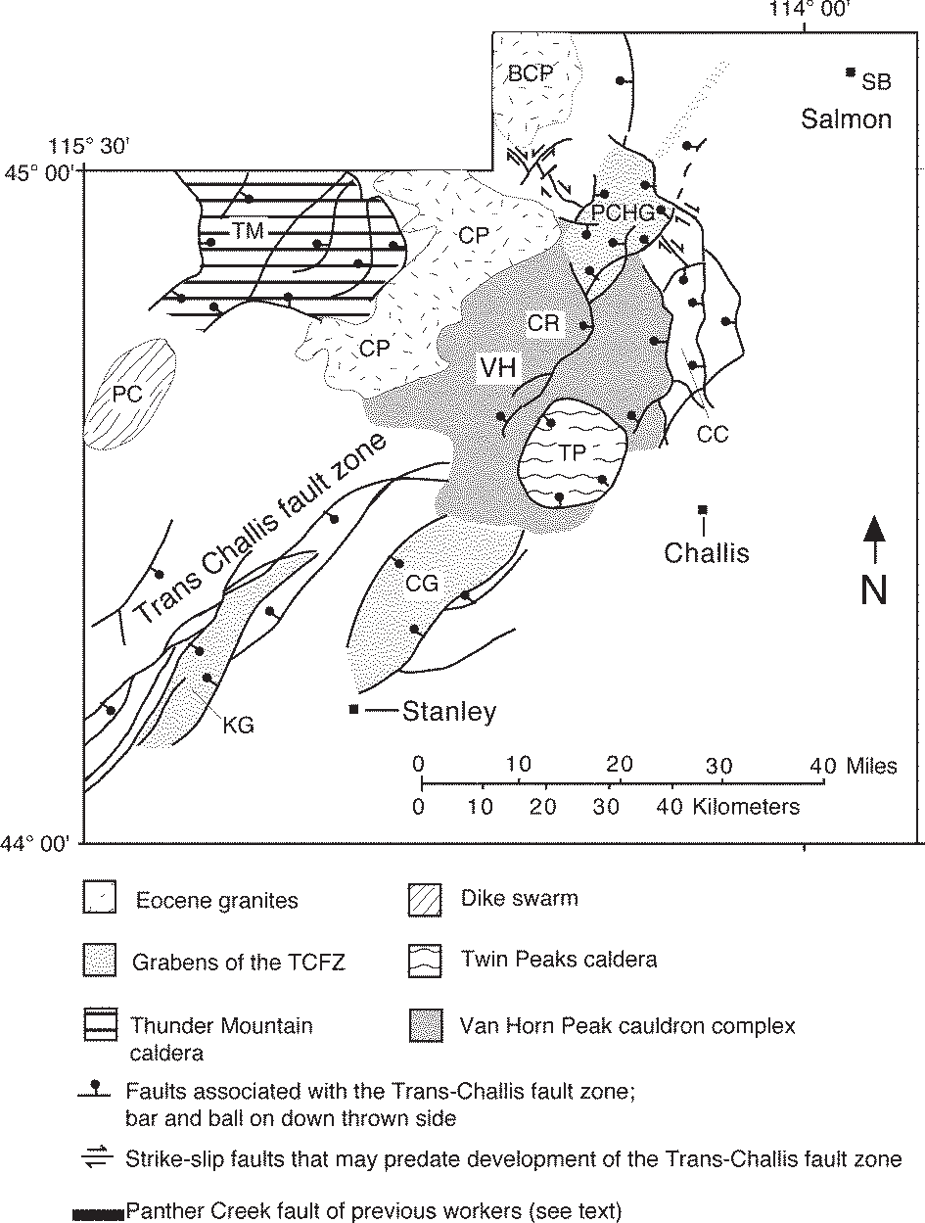

Figure 4. Challis Volcanic Field and Trans-Challis Fault Zone. Regional map of the main calderas of the Challis Volcanic field, the Trans-Challis fault zone (TCFZ) and younger nor- mal faults. BCP=Bighorn Crag pluton; CC=Corral Creek cauldron segment; CG=Custer graben; CP=Casto pluton, CR=Castle Rock cauldron segment; KG=Knapp Creek gra- ben; PC=Pistol Creek dike swarm; PCHG=Panther Creek half graben; TM=Thunder Mountain cauldron complex; TP=Twin Peaks caldera; VH=Van Horn Peak cauldron complex. Sources: Shockey (1957); Bennett (1977); Harrison (1985); Ekren (1988); Janecke (1994); Evans and Connor
(1993); Fisher et al. (1992); Janecke and Snee (1993); Modreski (1985). (Modified from Janecke et al., 1997, Fig- ure 1).

Proterozoic and Paleozoic Events

Paleogeography
Proterozoic and Paleozoic rocks of east-central Idaho are part of three major Cordilleran thrust plates, from west to east the Pioneer, Hawley Creek, and Cabin plates. Horizontal separation on the bounding thrust faults is not well known, but there are no exotic terranes within this area. All the Paleozoic rocks were de- posited in basins marginal to or connected with the Wyoming craton. As we discuss the stratigraphic units we make specific mention, when necessary, to the presence of a feature in a spe- cific thrust plate, which we define and describe in the succeeding section. As demonstrated in the central and southern Basin-and- Range province (Levy and Christie-Blick, 1989), Neogene ex- tension generally acted to reverse Mesozoic shortening. Thus, a palinspastic map of east-central Idaho would likely reflect no more than 50 km of northeast shortening from depositional sites of Pro-
terozoic and Paleozoic rocks. This rough estimate is more con- servative than some older, more mobilist estimates (Skipp and Hait, 1977; Ruppel, 1978)

Belt Supergroup
Middle Proterozoic metasedimentary rocks in the Salmon River Mountains, and northern parts of the Lost River, Lemhi and Beaverhead ranges include meta-sandstones and siltites of the Yellowjacket Formation, Lemhi Group, and Swauger Forma- tion of the 1470-1390 Ma Belt Supergroup (Figs. 3, 23, 48-50) (Ruppel, 1975; Aleinikoff et al., 1996; Sears et al., 1998; Win- ston et al., 1999, this volume). The Belt Supergroup rift basin formed across much of east-central Idaho and western Montana (Winston and Link, 1993). Its irregular but roughly north-trend- ing eastern margin lies about 150 mi east of the Beaverhead Moun- tains in southwest Montana. The southwest margin is less well defined, but must lie northeast of the Pioneer metamorphic core complex and southwest of the Lost River Range.
In general, the Belt Supergroup contains quartzose sandstone and mudrock derived from highlands to the southwest, that are now part of a Pacific continent, possibly Australia or Siberia (Sears and Price, 1978; Ross et al., 1991a; 1992). The Lemhi Group and Yellowjacket Formation were generally deposited in alluvial aprons and marginal mudflats on the edges of the great Belt intracratonic sea or lake (Winston and Link, 1993; Winston et al., 1999, this volume). These rocks are generally poor in carbonate, but the upper part of the Apple Creek Formation, of the Lemhi Group (Fig. 48), contains the same depositional cycles as the Middle Belt carbonate (Helena Formation) of southwestern Mon- tana.
Northwest of Salmon, Idaho, a bimodal suite of granitic plu- tons and mafic rocks invaded the Belt basin about 1370 Ma (Evans and Zartman, 1990; Doughty and Chamberlain, 1996), a time that is now thought to immediately post-date Belt deposition (Aleinikoff et al., 1996). Shearing and metamorphism of these rocks northwest of Salmon, Idaho increases northward (Doughty and Chamberlain, 1996).
Modern paleogeographic analyses of the Belt basin have not identified a medial Belt Island or Salmon River Arch (Skipp and Link, 1992; Link et al., 1993; Winston et al., 1999, this volume). The concept that during deposition of the Belt Supergroup there was a highland between the Lemhi Group in Idaho and the Belt Supergroup in Montana, plus the notion that the regional Medi- cine Lodge thrust fault structurally separated the Lemhi Group from the Yellowjacket Formation and Belt Supergroup (Armstrong, 1975; Ruppel and Lopez, 1978; Ruppel, 1986; Ruppel et al., 1993), are stratigraphically and structurally unnec- essary, and were based on inaccurate K-Ar geochronology (Aleinikoff et al., 1996; Evans, 1999).

Beaverhead Impact
A large bolide struck east-central Idaho in early Neoproterozoic time (850-900 Ma) and produced a crater 75- 150 km in diameter (Hargraves et al., 1990; Kellogg et al., 1999). The Beaverhead Impact produced shatter cones, breccia, and pseudotachylite in Mesoproterozoic quartzite and Archean gneiss on the east side of the Beaverhead Mountains in southwest Mon-

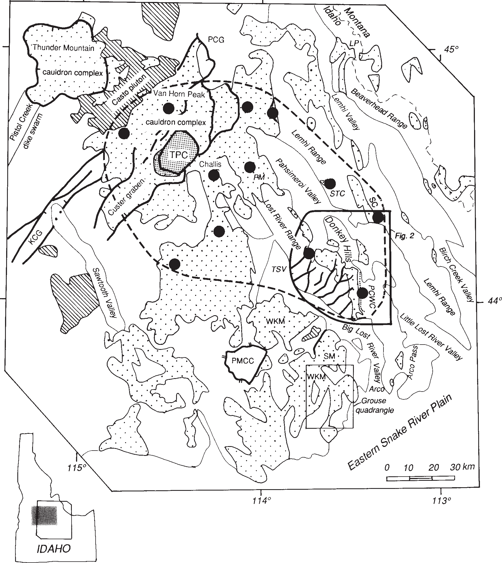
Figure 5. Map of Challis volcanic field, Idaho, showing the distributions of volcanic rocks (coarse dots) and selected large plutons (diagonal rule). The tuff of Challis Creek in the Twin Peaks caldera (TPC) is shown with fine dots and exposures of the tuff outside the caldera are large solid dots. The presently known maximum extent of the tuff of Challis Creek is dashed. For clarity, only selected Eocene normal faults are shown. Abbreviations: PMCC=Pioneer metamorphic core complex; WKM=White Knob Mountains; TSV=Thousand Springs Valley; LP=Lemhi Pass; PCG=Panther Creek graben; PM=Pahsimeroi Mountains; STC=Stinking Creek; SC=Sawmill Canyon; KCG=Knapp Creek graben; SM=Sheep Mountain; and PCWC=Pass Creek-Wet Creek reentrant. Challis 1° x 2° sheet is shaded on index map. Sources: Bond (1978); Fisher (1985); Fisher et al. (1992); Hardyman (1985); Hardyman and Fisher (1985). (Reproduced from Janecke and Snee, 1993, Figure 1). Area labeled as Fig. 2 shows the outline of Figure 8.

tana (Hargraves et al., 1990; 1994). Farther west, overlapping,

midcrustal geophysical anomalies are centered south of Challis, Idaho in the central Lost River Range and are attributed to the impact (McCafferty, 1995). If reconstructions are correct, this is one of the eight largest impacts known in earth history. Carr and Link (1999, this volume) describe breccia and conglomerate in the Neoproterozoic formation of Leaton Gulch south of Challis, Idaho, which they connect with the Beaverhead Impact. Long- term effects of the Beaverhead Impact may include Neoproterozoic
and Paleozoic recurrent uplift of the Lemhi Arch (Hargraves et al., 1994).

Wilbert Rift Basin and the Missing Miogeocline
In latest Neoproterozoic and Cambrian time, the Wilbert For- mation and overlying formation of Tyler Peak (McCandless, 1982) were deposited in an interpreted depositional rift basin which broadened southward into southeastern Idaho (Skipp and Link,

1992). Pebbly sandstones of the Wilbert Formation are present in the Borah Peak horst of the central Lost River Range, and in the southern Lemhi and southernmost Beaverhead ranges, across sev- eral thrust sheets (Fig. 3). Areas farther north in the Beaverhead Mountains that contain shatter cones of the Beaverhead Impact were inferred by Skipp and Link (1992) to be part of the Wilbert Formation but are now correlated to the Lemhi Group (Belt Su- pergroup) (Ruppel, 1998; Kellogg et al., 1999).
Thick (up to 6 km) basal strata of the Cordilleran miogeocline, present near Pocatello south of the Snake River Plain, include Neoproterozoic diamictite and quartzose rocks (Pocatello For- mation and Brigham Group) and overlying Cambrian carbonate rocks (Link et al., 1993). However, north of the eastern Snake River Plain, this time interval is represented only by 150 m of the Wilbert and Tyler Peak formations in the southern Lemhi Range (McCandless, 1982) and at most several hundred meters of Wilbert Formation in the southern Beaverhead Range (Skipp and Link, 1992). In the Bayhorse area west of Challis, however, thick siliciclastic Cambrian rocks are present (Hobbs et al., 1991; Hobbs, 1995). These thick Cambrian rocks are far west of their expected positions based on facies patterns to the south.
Scattered small occurrences of Neoproterozoic rocks are present in west-central Idaho, as pendants in the Idaho batholith (Lund, 1999), but relations and correlations are sketchy due to subsequent metamorphism and intrusion. Pope and Sears (1997) suggest that some of the Neoproterozoic and Cambrian miogeoclinal rocks that are missing from central Idaho may have been translated north to British Columbia during Mesozoic con- tinental truncation.

Lemhi Arch and Beaverhead Mountain Pluton
In the Lost River, Lemhi and southern Beaverhead Ranges, pebbly Lower Ordovician sandstones (Summerhouse Formation) unconformably overlie Mesoproterozoic or Neoproterozoic to Cambrian strata. In the southern Beaverhead Mountains, this unconformity was attributed to the Skull Canyon disturbance by Scholten (1957). This disturbance and the sub-Ordovician unconformity are manifestations of the Salmon River/Lemhi Arch, a westward projecting promontory or uplift within the Cordille- ran miogeocline, whose original concept as a recurrent Paleozoic feature (Sloss, 1954) is still sound. This feature may also explain the near absence of Neoproterozoic to Cambrian rocks in east- central Idaho (Burchfiel et al., 1992). Extension of the feature into Mesoproterozoic time (Armstrong, 1975; Ruppel, 1986) is incorrect however, mainly because such extension was based on inaccurate K-Ar geochronology (Armstrong, 1975) that suggested there was intrusion and metamorphism northwest of Salmon Idaho near 1500 Ma, prior to, or during formation of the Belt basin (Skipp, 1987; Skipp and Link, 1992; Winston et al., 1999, this volume). These intrusive rocks have been redated at 1370 Ma and clearly postdate much or all of the Belt Supergroup (Evans and Zartman, 1990; Doughty and Chamberlain, 1996). The ab- sence of thick Neoproterozoic and Cambrian strata in the Lost River, Lemhi, and Beaverhead ranges, and the unique Ordovi- cian Beaverhead Mountains pluton (see below) are regional anomalies within the miogeocline whose origin remains elusive. Temporary tectonic stability and depositional continuity be-
tween east-central Idaho and the miogeocline were first estab- lished in Middle Ordovician time, with deposition of the north- derived shallow marine quartz arenite sheet of the Kinnikinic Quartzite (Figs. 27 and 44), whose equivalents (Swan Peak and Eureka quartzites) are present south to southern Nevada (Ross, 1977; Oaks et al., 1977). The Kinnikinic Quartzite thins east- ward to a feather edge west of the Cabin thrust; it is missing in the Cabin plate (Fig. 3) (James and Oaks, 1977; Skipp, 1988). Oaks et al. (1977) interpreted Kinnikinic deposition to have been con- trolled by the exposed, northwest-trending, Lemhi Arch along the Idaho/Montana border, and a mainly submerged, northeast- trending, Arco Arch along the present eastern Snake River Plain. Shortly after Middle Ordovician deposition of the Kinnikinic Quartzite, granite and syenite of the Beaverhead Mountains plu- ton invaded the western Beaverhead Mountains (~483 Ma, Rb- Sr) (Scholten, 1957; Scholten and Ramspott, 1968; Lucchitta, 1966; Evans and Zartman, 1988). Two small intrusions in the Salmon River Mountains, west of Salmon, also date from this time (Evans and Zartman, 1988). The relationship, if any, be- tween these early Paleozoic plutons and the unstable and unconformity-riddled early Paleozoic section of east-central Idaho is uncertain. In the Lost River Range and in most of southeastern Idaho, distant from the early Paleozoic intrusions, Ordovician to Silurian dolostones of the Saturday Mountain, Fish Haven and Laketown formations conformably to disconformably overlie the Kinnikinic Quartzite (Oaks et al., 1977; James and Oaks, 1977). The “western assemblage” fine-grained Phi Kappa and Trail Creek formations of the Pioneer thrust plate contain Ordovician grapto- lites of an open-ocean warm-water Pacific province, significantly different from coeval western North American assemblages (Berry,
1998).

Silurian and Devonian Carbonate Banks and Basins
During Silurian time the Lost River and Lemhi Ranges (Hawley Creek thrust plate) were part of the regional carbonate platform now represented by the Laketown Dolomite and equiva- lents (Figs. 3 and 14) (Poole et al., 1977; Sheehan et al., 1991). Silurian strata thin to the east to a feather edge below Devonian carbonates in the southern Lemhi Range. The thickest Silurian carbonate platform succession is in the Lone Pine Peak area south of Challis (Fig. 2) where the Lone Mountain dolomite is about 800 m thick (Hays et al., 1978; 1980, Hobbs et al., 1991). In the Hawley Creek-Copper Basin thrust plate of the Pioneer Moun- tains, Silurian platy calcareous siltstones are assigned to the Rob- erts Mountains Formation (600 m) (Skipp and Sandberg, 1975; Dover, 1983). Areas to the west of the Pioneer thrust expose “west- ern assemblage” Silurian Trail Creek Formation which contains slope-facies cherty argillite and siltite (Dover, 1983; Link et al., 1995).
Lower and Middle Devonian strata of the Hawley Creek and Copper Basin plate include restricted shallow marine Carey Do- lomite and incised valley deposits of the estuarine Beartooth Butte Formation that contain a rich fossil-fish fauna (Johnson et al., 1988; Grader and Dehler, 1999, this volume). A regional upper Devonian carbonate ramp was deposited during the eustatic sea level rise manifested in the Taghanic onlap (Johnson et al., 1991). It extended to western Montana and is represented by the Jefferson

and Three Forks formations (Sandberg et al., 1988; Dorobek, 1991). The Grandview Member of the Jefferson contains bioherms at Grandview Canyon south of Challis (Fig. 15) (Isaacson et al., 1988; Isaacson and Dorobek, 1988). Late Paleozoic uplift of the Lemhi Arch (sensu Sloss, 1954) is manifested in the Lemhi Range by southward thinning of the Jefferson Formation from 900 m in the central part to 100 m at the south end of the range (Grader and Dehler, 1999, this volume). Dorobek et al. (1991), in contrast, argued that such differential subsidence was due to reactivation of preexisting structures during vertical and horizontal loading by the Antler orogenic belt.
On the Pioneer thrust sheet, Devonian carbonaceous, argilla- ceous and locally calcareous strata of the Milligen Formation and equivalent (?) Salmon River assemblage make up the central-Idaho Black Shale Mineral Belt (Fig. 42, 43) (Link et al., 1995). In the southern Wood River Valley, and at the head of Slate Creek in the White Cloud Mountains, these strata contain syngenetic Ag-Pb- Zn mineral deposits formed in inferred exhalative rift-basins (Hall, 1985; Turner and Otto, 1995). Rocks of the black-shale belt were deformed and uplifted by the Antler orogen, though specific non- reactivated Antler structures are elusive (Skipp and Sandberg, 1975; Skipp and Hait, 1977; Skipp and Hall, 1980; Dover, 1980; Hall, 1985; Wilson et al., 1994; Link et al., 1996).

Antler Flysch Trough
Early Mississippian rapid subsidence and normal faulting of the Antler orogen is manifested in thick conglomeratic foreland- basin deposits of the Copper Basin Group in the White Knob and Pioneer Mountains, and the coeval fine-grained McGowan Creek Formation in the Lost River and Lemhi Ranges (Fig. 9) (Paull et al., 1972; Paull and Gruber, 1977; Nilsen, 1977). The anomalous thickness of the Copper Basin Group, the coarse and proximal recycled sedimentary detritus, and evidence for syn-sedimentary growth faults suggest a transpressional or transtensional setting for Antler deformation in Idaho (Wilson et al., 1994; Rodgers et al., 1995; Link et al., 1995; 1996).
Mississippian strata are largely missing from the Pioneer thrust plate, which was presumably part of the uplifted Antler highland and a source terrane for Copper Basin strata. Age populations of detrital zircons in the Argosy Creek Formation, Copper Basin Group are dominated by 2000 to 1700 Ma grains (Preacher et al. 1995; Link et al., 1996). This signature is similar to that in the Middle Ordovician Valmy Formation of the Roberts Mountains allochthon, Nevada (Smith and Gehrels, 1994). The data suggest that Ordovician sandstones of the Basin Gulch Member, Phi Kappa Formation (Valmy equivalent in the Pioneer thrust plate) or Kinnikinic Quartzite (Hawley Creek thrust plate) were a major source for sand and quartzite cobbles in the Copper Basin Group. The ultimate source for the ~1800 Ma Paleoproterozoic sand grains was the Peace River-Athabasca Arch in northern Canada (Ketner, 1968; Ross et al., 1991b).

Upper Mississippian and Pennsylvanian Carbonate Bank East of the Copper Basin-McGowan Creek flysch trough, two major Mississippian shallow-subtidal to intertidal carbonate bank complexes prograded westward from the Wyoming-Montana shelf (Poole and Sandberg, 1977; 1991; Skipp, Sando, and Hall, 1979).
The Lower Mississippian (Kinderhookian and Osagean) Madi- son Group comprises the lower complex, but these well-known limestones of the western Wyoming area did not extend west- ward across the Montana border to east-central Idaho. In the Cabin thrust plate of the southern Beaverhead Mountains, thin (150 m) argillaceous strata of the McGowan Creek Formation represent this time interval (Skipp, 1988a). The McGowan Creek Forma- tion thickens westward and makes up huge talus slopes in the Lost River Range (Fig. 9, right side of Fig. 10), where it was initially incorrectly mapped as the Devonian Milligen Formation (Ross, 1947; Sandberg, 1975).
The upper carbonate bank complex, of Late Mississippian (Meramecian and Chesterian) age, prograded rapidly across what had been the Antler flysch trough, and is represented by thick and prominent carbonate bank strata (Middle Canyon, Scott Peak, South Creek, and Surrett Canyon formations, Huh, 1967; Skipp, Sando and Hall, 1979) of the Beaverhead, Lemhi and Lost River Ranges (Figs. 9, 13, 21, 25 and 26) and the White Knob Lime- stone of the White Knob Mountains (Link et al., 1996).
In the Hawley Creek, Fritz Creek, and Cabin thrust plates, Upper Mississippian, Pennsylvanian, and Permian mixed carbon- ate and siliciclastic rocks of the Snaky Canyon, Bluebird Moun- tain, Arco Hills, and locally, the Phosphoria formations are the youngest exposed strata (Skipp, Hoggan et al., 1979; Skipp, 1988a). The Snaky Canyon Formation was deposited on a car- bonate platform that at times received fine-grained, likely aeolian, quartzose silt from the craton to the north and east, and which developed local Palaeoaplysina bioherms near Howe (Fig. 16, 17)(Breuninger et al., 1988; Canter and Isaacson, 1991).

Wood River Basin
On the Pioneer thrust plate, the Oquirrh-Wood River basin, a regional north-northwest-trending, Middle Pennsylvanian to Early Permian mixed carbonate-siliciclastic turbidite basin, formed above deformed strata of the Antler highland. It has been inter- preted as the most distant manifestation of the Ancestral Rockies orogen, and its subsidence has been attributed to crustal loading by reactivation of a segment of the Antler thrust load in south- western Idaho (Geslin, 1998), or to inversion of the Antler foreland basin in the Pioneer Mountains (Skipp and Hall, 1980). The mixed carbonate-siliciclastic Sun Valley Group filled this basin, with sources to the west for chert-pebbles, north for quartzose sand and east for carbonate material (Hall et al., 1974; Hall, 1985; Mahoney et al., 1991; Burton and Link, 1992). The central part of the basin was periodically oxygen-starved at the sediment-water interface, and organic-rich mudrocks of the Dollarhide Forma- tion were deposited (Hall, 1985; Link et al., 1995).

Missing Mesozoic Record
The early Mesozoic history of east-central Idaho is little known, as no rocks are preserved, except for isolated Mesozoic strata in the southern Lemhi Range and Beaverhead Mountains (Lucchitta, 1966; Skipp, Hoggan et al., 1979). Mesozoic strata were either never deposited or, more likely, have since been eroded from the rest of east-central Idaho.

Mesozoic Deformation: Cordilleran Orogenic Belt
In the Cretaceous, east-central Idaho shortened in an east- northeast to west-southwest direction as part of the Sevier fold- and-thrust belt (Ruppel, 1978; Skipp, 1988a; Allmendinger, 1992). Rocks of the Pioneer thrust sheet on its western edge were in- vaded by the Late Cretaceous Atlanta lobe of the Idaho batholith (Lewis and Kiilsgaard, 1987).
Many contacts previously mapped as regional thrust faults in east-central Idaho (e.g. Skipp and Hait, 1977; Ruppel, 1978; Hall, 1985; Hobbs, 1995) are stratigraphic contacts or small faults (Rodgers and Janecke, 1992). The Glide Mountain thrust in the Pioneer Mountains (Dover, 1981), for example, was shown to be a mix of sheared stratigraphic contacts and Eocene normal faults (Wilson et al., 1994). Other “major” thrust faults (e.g. Dover, 1983; Ruppel et al., 1993), have been reinterpreted as decollements associated with folds, ductility contrasts in the strati- graphic package, or deformation zones produced during bedding- parallel shear (Burton and Link, 1995; Rodgers et al., 1995; Win- ston et al., 1999, this volume). Small local thrust faults duplicate the Paleozoic strata throughout this region (Beutner, 1968; Hait, 1987; Susong et al., 1990; Fisher and Anastasio, 1994).
Folds in east-central Idaho occur at a range of scales from outcrop to mountain. They deform Middle Proterozoic to Trias- sic rocks, trend generally north-northwest, and are upright to east- northeast-vergent (Ross, 1947; Beutner, 1968; Dover, 1981; 1983;
Garmezy, 1981; Skipp, 1984; 1998; Mapel et al., 1965; Mapel and Shropshire, 1973; Fisher and Anastasio, 1994; Rodgers et al., 1995; Jeppson and Janecke, 1995).

Pioneer Thrust Plate
The west-dipping Pioneer thrust fault strikes northward through the central Pioneer Mountains (Dover, 1983) (Fig. 2). Rocks west of the fault are lower Paleozoic “western-facies” cherty and argillitic strata, unconformably overlain by the Pennsylva- nian and Permian Sun Valley Group deposited in the southwest- ward-deepening Wood River Basin (Skipp and Hall, 1980; Mahoney et al., 1991; Link et al., 1995; Geslin, 1998) (Fig. 3). These rocks are intruded along the Salmon River and in the White Cloud Peaks by Late Cretaceous granitoids of the Idaho batholith (Fisher et al., 1992; Worl et al., 1991). The Pioneer thrust is ex- posed north and south of the Pioneer metamorphic core complex (Dover, 1981) (Figs. 1 and 2).

Hawley Creek-Copper Basin Thrust Plate
East of the Pioneer thrust, the Hawley Creek thrust plate com- prises the rocks exposed in the eastern White Knob Mountains, Lost River, central and southern Lemhi and westernmost Beaverhead ranges (Skipp, 1987; Tietbohl, 1986; Rodgers and Janecke, 1992; Tysdal and Moye, 1996; Tysdal, 1996a). The tec- tonic significance of the Copper Basin thrust fault, in the White Knob Mountains (Skipp and Hait, 1977) is uncertain because the fault is high-angle and juxtaposes rocks of different facies but of essentially the same age (Skipp and Bollmann, 1992). The Hawley Creek-Copper Basin thrust plate contains Mesoproterozoic Belt rocks, pre-upper Devonian stratigraphic thinning associated with the Lemhi Arch, the Lower Mississippian Antler flysch trough, and the Upper Mississippian carbonate bank (Fig. 3). The Hawley
Creek thrust fault is exposed in the western Beaverhead Moun- tains and the northern Lemhi Range (Lucchitta, 1966; Skipp, 1987; 1988a)(Fig. 2).

Fritz Creek and Cabin Thrust Plates
East of the Hawley Creek thrust fault in the Fritz Creek and Cabin thrust plates of the Beaverhead Mountains (Fig. 3) are strata of the Mesoproterozoic Belt Supergroup rift basin that contain shattercones of the Beaverhead Impact Event (Hargraves et al., 1994; Lucchitta, 1966), the eastern edge of the Neoproterozoic Wilbert Formation rift basin (Skipp, 1988a; Skipp and Link, 1992), and eastward-thinning strata of the Paleozoic miogeocline. Or- dovician rocks are missing from the Cabin Plate, and Devonian carbonates overlie Neoproterozoic to Cambrian, Mesoproterozoic, or Archean rocks (Fig. 3) (Skipp, 1988a). This unconformity is attributed to Ordovician uplift of the Lemhi Arch (Oaks et al., 1977).

Paleogene Uplift and Pre-Challis Tectonism
Crustal thickening in the western part of the Sevier thrust belt accompanied intrusion of the Idaho batholith, mainly in Late Cre- taceous time (Lewis et al., 1987; Johnson et al., 1988; Lewis and Kiilsgaard, 1991; Kiilsgaard et al., 1995). The Atlanta lobe of the Idaho batholith was tilted eastward, exhumed and uplifted 12-19 km after emplacement in the Late Cretaceous but before Middle Eocene time (Jordan, 1994; Rodgers et al., 1995).
Analysis of the pre-Tertiary subcrop in the Lost River and Lemhi Ranges shows that progressively older rocks crop out be- neath the Eocene unconformity northward from the eastern Snake River Plain (Rodgers and Janecke, 1992). This pattern is in part due to uplift of hanging wall rocks over frontal and lateral ramps in underlying thrust faults (Skipp, 1987; 1988a; Rodgers and Janecke, 1992), but Neoproterozoic to Devonian recurrent uplift along the Lemhi arch may also contribute (Sloss, 1954; Scholten, 1957; Burchfiel et al., 1992; Ruppel, 1986; Skipp and Link, 1992). Locally preserved beneath the Challis Volcanic Group are conglomeratic deposits (Smiley Creek conglomerate and equiva- lent units), many of which grade upsection into the volcanic rocks (Anderson, 1961; Ross, 1962; Staatz, 1979; Dover, 1983; Burton and Blakley, 1988; Janecke, 1992d; 1995b; VanDenburg, 1997; Anastasio and Schmitt, 1998, Blankenau, in press). Clasts typi- cally reflect a local provenance, or western or northern source
areas (Vandenburg, 1997; Blankenau in press).

Tertiary Extensional Deformation and Magmatism
The number of well-documented geometrically and tempo- rally distinct episodes of extension in eastern Idaho and adjacent parts of Montana has grown in recent years from two (Wust; 1986; O’Neill and Pavlis, 1988), to three (Janecke et al. 1991; Janecke 1992), to four (Huerta and Rodgers, 1996; Tysdal 1996a; 1996b) or five (Sears and Fritz, 1998; VanDenburg et al., 1998). It is clear that the directions of extension in eastern Idaho and south- west Montana have changed dramatically during the Cenozoic. The initial, pre-volcanic episode of extension, the main post-vol- canic, Paleogene basin-forming episode and the youngest Basin- and-Range episode of extension, extended the crust in a north- east-southwest direction, but intervening syn-volcanic and early

Miocene extension was in a northwest-southeast direction (McIntyre et al., 1982; O’Neill and Pavlis, 1988; Janecke, 1992a; 1995a; Fritz and Sears, 1993; Sears and Fritz, 1998; VanDenburg et al., 1998). Whereas gravitational collapse can readily account for northeast-southwest extension, the causes of northwest-south- east extension are less certain (c.f. VanDenburg et al., 1998).
Pre-Challis volcanic extensional to transtensional deforma- tion was localized along southwest-dipping normal and normal- oblique faults, and affected the Pioneer Mountains, and the Lemhi and Beaverhead ranges. In the Pioneer Mountains, younger-on- older strike-slip deformation on a southwest-dipping low-angle fault predates emplacement of Challis-related dikes (Burton and Link, 1995; Rodgers et al., 1995; Huerta and Rodgers, 1996). In the southern Beaverhead Mountains, Skipp (1984, 1985) first interpreted the younger-on-older Divide Creek fault as a pre- Challis normal fault. She traced the normal fault 35-40 km to the northwest into the Hawley Creek area, and suggested a similar origin for normal faults in the Goat Mountain area of the Beaverhead Mountains, north of Leadore (Staatz, 1973, 1979) (Fig. 2). VanDenburg (1997; VanDenburg et al., 1998) confirmed that one of the normal faults north of Leadore predates the Challis Volcanic Group, and showed that the folded fault originally dipped gently to the southwest. Strikingly similar southwest-dipping nor- mal faults in the northern Lemhi Range are also interpreted to predate the Eocene Challis Volcanic Group (Tysdal, 1996a, 1996b, Tysdal and Moye, 1996). Southwest-directed shearing in the south- west part of the Pioneer metamorphic core complex is kinemati- cally like these pre-Challis structures, but isotopic analyses indi- cate a slightly younger age (49 to 45 Ma, syn-Challis)(Silverberg, 1990)

Trans-Challis Fault System
Extension on the Trans-Challis system was synchronous with Middle Eocene Challis volcanism (McIntyre et al., 1982; Kiilsgaard et al., 1986; Janecke, 1992a). Evidence for synchro- nous magmatism and deformation includes growth fault relation- ships along the Trans-Challis fault zone (Hammond, 1994; Janecke et al., 1997), intrusive rocks emplaced along northeast-striking normal faults (Hardyman and Fisher, 1985; Ekren, 1985), cross- cutting relationships between northeast-striking faults and volca- nic rocks in the Lost River Range (Janecke, 1992a), and the con- sistent northeast strike of Eocene dikes in the region (Fisher et al., 1992; Nelson and Ross, 1968; Doughty and Sheriff, 1992). In the Lost River and Lemhi Ranges, the Trans-Challis system in- cludes both high-angle and low-angle normal faults, with displace- ments of a few hundreds of meters to a few kilometers (Ross, 1947; Baldwin, 1951; Janecke, 1992a). Although the dominant structural trend is northeast during Challis volcanism, coeval north- east and north-northwest-striking normal faults have been docu- mented in the White Knob Mountains (Snider, 1995) and the Pan- ther Creek half graben (Janecke et al., 1997) near the end of Challis volcanism.
Some of the ductile deformation and uplift of the Pioneer core complex (Fig. 1), dates from this syn-Challis episode of exten- sion (Wust, 1986; O’Neill and Pavlis, 1988; Silverberg, 1990) but the kinematics and timing of this event are controversial (com- pare Silverberg and Wust).

Challis Magmatic Episode
Beginning about 50 Ma lava flows, tuffs and intrusive rocks of the Challis Volcanic Group (Figs. 4 and 5) were deposited across central Idaho during an intense and voluminous volcanic episode that ended abruptly about 5 m.y. later (McIntyre et al., 1982; Janecke and Snee, 1993; Fisher et al., 1992; Snider, 1995; M’Gonigle and Dalrymple, 1996). The volcanic vents, dikes, mineralization, and normal faults during Challis magmatism were focused along the northeast-trending Trans Challis fault zone (Kiilsgaard et al., 1986). Eocene dacite porphyry and pink gran- ite intrusive rocks are most voluminous along the eastern margin of the Idaho batholith (Lewis and Kiilsgaard, 1991; Stewart et al., 1992; Mahoney, 1992; Mahoney and Link, 1992; Schmidt,
1997)
Explosive volcanism was focused in large calderas northwest of Challis, Idaho (Fig. 5), whereas lava flows erupted from fis- sures and a few central vents scattered across central Idaho. A small caldera south of Salmon, Idaho (Ruppel et al., 1993; Blankenau, in press) and a volcanic-tectonic depression in the White Knob Mountains west of Mackay (Snider and Moye, 1989; Snider, 1995) are the only documented source areas of ash-flow tuffs outside the large Van Horn Peak cauldron complex north of Challis (Figs. 2, 4, 41 and 46)(McIntyre et al., 1982).
In the Lost River and Lemhi ranges, and the Pioneer Moun- tains, andesitic and dacitic lava flows dominate the volcanic stratigraphy and tuffs are mostly small-volume and derived from distant sources (Ross, 1947; Mapel and Shropshire, 1973; Janecke and Snee, 1993). Farther north in the Salmon River Mountains, and the White Knob Mountains, ash flow tuffs dominate the vol- canic stratigraphy (McIntyre et al., 1982; Fisher et al., 1992; Ekren, 1988; Skipp, 1988b; 1989; Skipp et al., 1990; Skipp and Bollmann, 1992; Snider, 1995; Palmer, 1997; Palmer and Shawkey, 1997; Blankenau, in press).
By the end of the Challis volcanic episode, most of the locally significant prevolcanic topography had been buried beneath vol- canic rocks in the central part of the field (Janecke and Snee, 1993). Only in those areas where large offsets occurred on synvolcanic normal faults, such as along the eastern margin of the Panther Creek half-graben (Fig. 4, 5) (Hammond, 1994; Janecke et al., 1997), were pre-Tertiary rocks exposed at the end of Challis volcanism.

Paleogene Basin-Forming Event
Paleogene sedimentary rocks deposited after the end of Challis volcanism are localized in north-northwest-trending half grabens (Fig. 2) (Janecke, 1994) and range in age from about 46 to less than 30 Ma (Harrison, 1985; Janecke and Snee, 1993; Axelrod, 1998, VanDenburg et al., 1998; Blankenau, in press). We refer to this phase of east-northeast to west-southwest extension as the “Paleogene basin-forming event”. Faults of this third Tertiary episode of extension are more widely spaced than the older syn- Challis normal faults, and they accommodated much more slip. The Tertiary sedimentary rocks in the hanging walls of the west- southwest-dipping normal faults are coeval to slip along the faults (Janecke, 1992a, 1994; VanDenburg, 1997; Blankenau, in press). In east-central Idaho and southwest Montana, the presence of thin silicic tuffs beneath or interbedded in the lowest part of many

basin-fill sequences shows that extension in the Eocene-Oligocene rift zone began during the final phases of Challis volcanism (Janecke, 1994; Janecke et al., in press).
Faults known or inferred to date from this time include, from south to north (Fig. 2, 4), Arco Pass fault system, Pass Creek-Wet Creek fault system, Donkey fault, Sawmill Canyon fault, Allison Creek fault (Janecke, 1992a, 1993, 1994)(it was later called the Salmon River fault by Tysdal and Moye, 1996), Agency-Yearian fault, Lemhi Pass fault, and Salmon basin detachment fault (Janecke, 1994; 1995a; VanDenburg, 1997; VanDenburg et al., 1998; Janecke et al., 1998; Blankenau, in press). Each dips west or west-southwest and places east-tilted Tertiary sedimentary rocks in the hanging wall over Proterozoic to Paleozoic bedrock in the footwall. Slip estimates range up to ~ 11 km for portions of the Pass Creek and Donkey faults (Janecke, 1992a).
Evidence presented in Janecke (1994) suggests that the half grabens formed during the Paleogene basin-forming event were laterally restricted to a 100 ± 25 km wide corridor of extension. The western boundary of the rift is west of the Pioneer and Bitter- root core complexes. To the east, in southwest Montana, coeval dominantly fine-grained tuffaceous sedimentary rocks of the Renova Formation were being deposited in a broad basin (Fritz and Sears, 1993; Sears and Fritz, 1998). Janecke (1994, 1995a) hypothesized the presence of an uplifted rift shoulder in the Tendoy Range of southwest Montana between this broad Renova basin and the coeval half grabens of east-central Idaho. More recent work in the Salmon basin and the adjacent Horse Prairie basin of southwest Montana shows that the Paleogene basin-forming event was protracted and characterized by distinct sub-phases of defor- mation along west-southwest to south-southwest-dipping low- angle normal faults (VanDenburg, 1997; VanDenburg et al., 1998; Blankenau, in press).
The north-northwest trends of many of the known and inferred Paleogene half grabens parallel the regional north-northwest trend- ing folds and thrusts north of the eastern Snake River Plain. Some normal faults in the eastern part of the rift zone probably sole into preexisting thrust faults (Constenius, 1982; Ponton, 1983; Janecke et al., in press). These characteristics are consistent with gravita- tional collapse models for the origin of the rift zone (Janecke, 1994).

Miocene Northeast-Striking Normal Faults
In southwest Montana, late Early Miocene normal faults with northeast strikes postdate the Paleogene basin-forming event and predate active Basin-and-Range extension (Fritz and Sears, 1993; VanDenburg et al., 1998; Sears and Fritz, 1998). To date, only one such fault has been identified in eastern Idaho (the Little Eightmile Creek fault north of Leadore; Staatz, 1979; VanDenburg et al., 1998) but others are likely.

Basin-and-Range Extension
Basin-and-Range faulting is the final episode of extension north of the eastern Snake River Plain. Its initiation is poorly dated and may range from about 17 to <5 Ma (Rodgers and Anders, 1990; Janecke, 1992a, 1993, 1994; Fritz and Sears, 1993; Anders et al., 1993; Sears and Fritz, 1998). This episode of extension produced the majestic Sawtooth, Lost River, Lemhi and
Beaverhead ranges in east-central Idaho, and spawned the 1983 Ms 7.3 Borah Peak earthquake along the Lost River fault (Crone et al., 1987; Crone and Haller, 1991). Basin-and-Range faults generally strike north-northwest to northwest and accommodated northeast-southwest extension (Stickney and Bartholomew, 1987), but locally the faults strike north and west (Scott et al., 1985; Janecke, 1993). Round Valley south of Challis and the Big Lost River Valley separate mostly northeast-dipping Basin-and-Range normal faults to the west from southwest-dipping normal faults to the east (Fig. 2).
Late Cenozoic extension of east-central Idaho along a north- east-southwest cross section through the center of the Lost River, Lemhi and Beaverhead faults is about 10 to 20% (Janecke, 1992a; Anders et al., 1993). Dip slip across the Beaverhead fault at Blue Dome has been estimated at 2.5 km (Rodgers and Anders, 1990). Heave (the horizontal component of slip) across segments of the Lost River fault ranges from 1.8 to 3.9 km (Janecke et al., 1991). Tilted late Cenozoic volcanic rocks suggest cumulative horizon- tal slip components across the center of the Lost River, Lemhi and Beaverhead faults between 6.5 and 10.3 km (Anders et al., 1993).

Active Basin-and-Range Faulting: Seismic Parabola
Active Basin-and-Range normal faults in eastern Idaho lie in the northern arm of a southwest-opening parabola centered on the Yellowstone volcanic plateau, which is characterized by a marked concentration of seismicity, a topographic rim, and ac- tive normal faults (Scott et al., 1985; Anders et al., 1989; Pierce and Morgan, 1992). The Basin-and-Range faults are divided into segments (Fig. 2) 11 to 43 km long (averaging 14 km) that rup- ture during individual large earthquakes (Crone and Haller, 1991). Boundaries between segments coincide with bends, bedrock ridges, preexisting faults, or relay ramps along the faults (Crone and Haller, 1991; Turko and Knuepfer, 1991; Janecke, 1993)(Fig. 2). Locations and or/existence of persistent segment boundaries along the southern Lost River and Lemhi faults may be reconsid- ered in light of recent trenching studies (Hemphill-Haley et al., 1994). The central segments of the normal faults in the parabola have been active more recently than adjacent segments, and nor- mal faulting appears to young away from the eastern Snake River Plain (Anders et al., 1989; Crone and Haller, 1991; Pierce and Morgan, 1992). A drainage divide in the hanging walls of the Beaverhead, Lemhi and Lost River faults coincides roughly with the axis of the seismic parabola.
The Borah Peak earthquake in 1983 ruptured the Thousand Springs and part of the Warm Springs segment of the Lost River fault (Scott et al., 1985; Crone et al., 1987). The earthquake nucle- ated at the southern end of the Thousand Springs segment, in a segment boundary (Susong et al. 1990) and ruptured to the north- northwest. Aftershocks defined a planar southwest-dipping fault to a depth of 16 km (Richins et al., 1987). Geodetic data showed that the hanging wall subsided 1.2 m and the footwall was up- lifted 0.2 m (Stein and Barrientos, 1985). The complex fault pat- terns documented in the segment boundary between the Thou- sand Springs and Mackay segments of the Lost River fault are typical of many segment boundaries (Susong et al., 1990; Machette et al., 1991; Janecke, 1993).

ROADLOG 1: INEEL TO ARCO TO CHALLIS: BIG LOST RIVER VALLEY
The simplified geologic map of Wilson and Skipp (1994) is an essential reference for this road log. Set odometer to zero at the junction between Highway 26 and Highway 20 near the Cen- tral Facilities Area of the Idaho National Engineering and Envi- ronmental Laboratory, (INEEL, formerly INEL and NRTS). This area is shown on the geologic maps of Scott (1982) and Kuntz et al. (1994).

Snake River Plain
In general the INEEL is located on a Pleistocene basalt lava plain (Hackett and Smith, 1992; Hughes et al., 1997; 1999; McCurry et al., 1999, this volume), locally pierced by Pleistocene rhyolite domes, and locally covered by a thin veneer of sediment derived from streams and deposited as channel, overbank, aeolian, and playa/lacustrine deposits (Geslin et al., 1999). To the west are Big Southern Butte and the route of the Goodale Cutoff of the Oregon Trail (Link and Phoenix, 1996). Big Southern Butte is a Pleistocene composite rhyolite dome that tilts Snake River Plain basalt flows northward (Spear, 1979, Spear and King, 1982; Fishel, 1993; Kuntz et al., 1994; Hackett and Smith, 1992).
The Big Lost River Rest Area is reached about seven miles north of the highway junction. In most years the Big Lost River here is dry, due to irrigation diversions. However it flowed dur- ing the mid-late 1990s, due to a wet climatic cycle. The Big Lost River flood (Rathburn, 1993; Cerling et al., 1994) scoured this area during the late Pleistocene, and produced scabland topogra- phy near Box Canyon (Fig. 6). The flood originated about 50 mi upstream along the East Fork of the Big Lost River, as a jökulhlaup (Rathburn, 1993).
Heading northward from the Big Lost River the road crests a lava rise and the view in all directions is grand. Folded Paleozoic rocks of the Arco Hills are to the north. The flat area to the north and east is the Big Lost Trough, a Pliocene and Pleistocene sedi- mentary basin on the north side of the Axial Volcanic Zone of the eastern Snake River Plain (Gianniny et al., 1997; Geslin et al., 1997; 1999). On a clear day one can see northeast to the west side of the Teton Mountains.

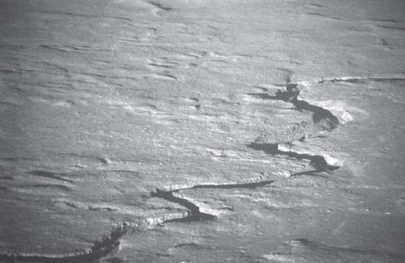
Figure 6. Photograph of Box Canyon, area of Big Lost River flood, looking northwest up the Big Lost River. The canyon is carved into basalts of the eastern Snake River Plain.

Butte City Area
Leave INEEL and reset mileage to zero at junction between Highway 26 to Arco and Highways 22 and 33 to east toward Howe and Rexburg. Stay on Highway 26 to the west. The Little Lost River roadlog (Roadlog #2) starts here and heads northeast to Howe and then north to the Pahsimeroi Valley. Butte City, popu- lation 59, is 3.9 miles west of the junction.
Near Butte City, in the immediate hills to the north are tight folds in thin-bedded Pennsylvanian and Permian Snaky Canyon Formation. The old Blackfoot to Mackay railroad grade is crossed just west of Butte City. Appendicitis Hill is in the middle distance to the northwest. West of it are folded upper Paleozoic sedimen- tary rocks in the southern Pioneer Mountains, with prominent Blizzard Mountain (site of a ski lift), where the Copper Basin thrust fault is exposed (Nilsen, 1977; Skipp, 1988b; 1989; Skipp et al., 1989, Skipp and Bollmann, 1992). Immediately to the south of Blizzard Mountain are the basaltic cinder cones of Craters of the Moon, which follow a northwest-trending rift system. The parallelism of rift zones on the eastern Snake River Plain and Basin-and-Range normal faults to the north shows that both areas are extending in a roughly northeast-southwest direction (Kuntz, 1992).

Arco Hills
The southern end of the Lost River Range and the Arco Hills are north of the road (Fig. 1). These consist of folded, but gener- ally eastward-younging middle and upper Paleozoic strata, Eocene Challis volcanic rocks, Paleogene sedimentary rocks and Neo- gene ashflow tuffs cut by both east-northeast striking and west to west-northwest dipping normal faults (Fig. 7) (Kuntz et al., 1994; Janecke, 1995a). The type section of the Mississippian Arco Hills Formation (Skipp, Hoggan, et al., 1979) is at the southernmost end of the range.
The east-tilted Arco Pass half-graben (see map Fig. 7) occu- pies the low pass between the Arco Hills to the east and the south end of the Lost River Range to the west (Janecke, 1992e; 1992f; 1995a). It is part of the north-trending middle Eocene to early Miocene extensional system (the Paleogene basin-forming event) (Janecke, 1994).

Arco
The intersection with Highway 20 and 26 in Arco is at mile
7.7. Mississippian Scott Peak Formation forms vertical cliffs north- east of town painted with the graduation year of all the high school classes of the 20th century. A measured section of the upper part of this sequence is described by Skipp, Hoggan, et al. (1979). The field trip of Link et al. (1988) describes the geology from here west to Sun Valley.
Arco is near the southern end of the Lost River Range. The active Lost River fault bounds the west-southwest side of the range and extends about 90 mi northward to Challis. Six segments along the Lost River fault are identified (Scott et al., 1985; Crone and Haller, 1991; Janecke, 1993). Locations of segment boundaries and names of segments are shown on Figure 2. The central seg- ments of the Lost River fault, like those of the adjacent Lemhi and Beaverhead faults, were more recently active (Pierce and

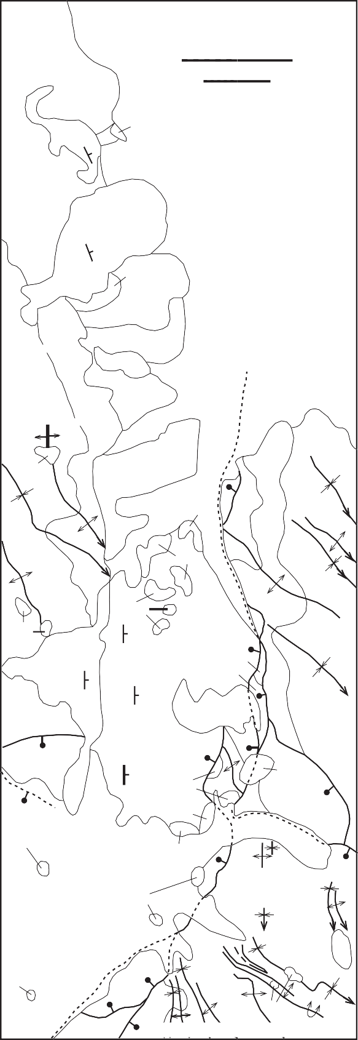113 42' 113
Howe NW quadrangle
P1P
1
0
1 mile
1 0 1 kilometer
Tg
Tu
Q
P1P
Tu
Arco Pass quadrangle
Tcv?
Qls
P1P
QTu
Q
Qls
M
QTu
M
Tg
QTu

Q
Tv O O
P1P
M
M

P1P
Tg M
Tgl
Tcv P1P
M

M
Tgu
M
P1P
M
Tgl
Tgu
P1P
Qls
M

M
Tv
Tv
Q
Q
Tv
M
Tv
Tv

M
Tv
O
Arco Hills quadrangle
44
OS1
Arco
Arco Pass
Mackay
LR

43 30'

Contact
Normal fault, dashed where uncertain, dotted where concealed
Anticline Syncline
Strike and dip of bedding Slide Block

Q
Qls QTu

Tv Tu

Tgu Tgl Tcv
Tg

P1P M
O
QUATERNARY
Alluvial fan deposits Landslide deposits
Quaternary and Tertiary deposits, undivided

NEOGENE, PLUS POSSIBLE OLIGOCENE ROCKS
Neogene ash flow tuffs
Neogene ash flow tuffs, basalt flows, gravels and lacustrine limestones. Probably includes some older (Oligocene?) rocks.
PALEOGENE(?)
Conglomerates and gravels, upper unit Conglomerates and gravels, lower unit
Challis volcanic Group. acite lava flows and ash flow tuffs. Middle Eocene (?)
Conglomerate and gravel, prevolcanic
PALEO OIC
Snaky Canyon Formation Misissippian rocks, undivided
evonian rocks, undivided Ordovician rocks, undivided

Figure 7. Simplified geologic map of the Arco Pass, and parts of the Howe NW and Arco Hills 7.5’ quadrangles, Idaho. Sources of data: Janecke, 1992c and unpublished mapping; B. Skipp, unpublished mapping in extreme northern and southern part of area. Some northeast- striking faults in the west-central part of the map are not shown. (Reproduced from Janecke, 1995a, Figure 5).

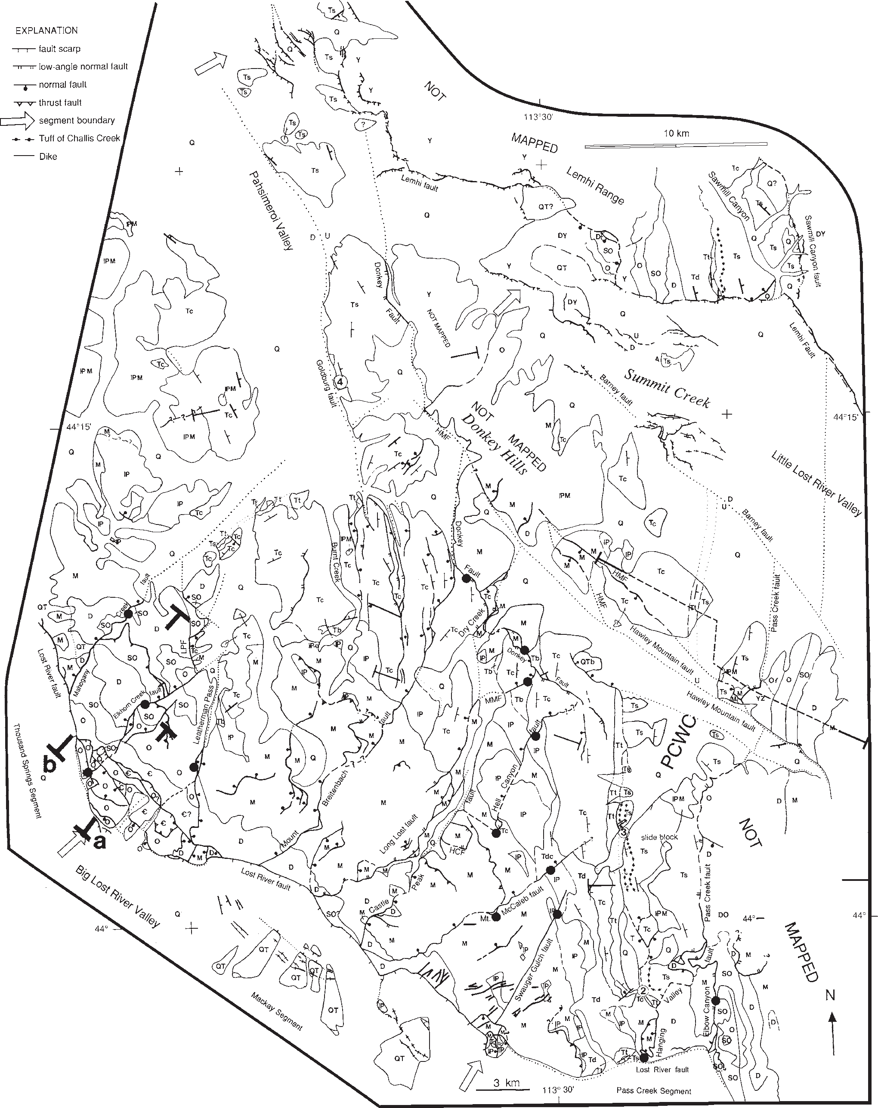

Morgan, 1992). The southernmost, Arco segment produced more than seven surface faulting earthquakes between 140,000 and 20,000 years ago and shows strong temporal clustering of events (Olig et al., 1995). The Pass Creek segment, to the north, had a cluster of activity around 17 to 18 ka (Olig et al., 1995). Janecke et al. (1991) document 4.5 to 6 km of dip separation across this part of the Lost River fault.
Figure 8 is a simplified geologic map of the central and south- ern Lost River Range, whose western side we will follow all the way to Challis. The range contains many north northwest-trend- ing folds cut by a complex three-dimensional array of normal faults. The King Mountain Hang glider launch site turnoff is at mile 15.5. At mile 16.9 is a nice view of an anticline-syncline pair in Carboniferous limestones of the southern Lost River Range to the east. Moore (formerly Lost River) is reached at mile 18.8. The usually-dry Big Lost River is crossed at mile 20.3. Cot- tonwood trees along the river died in the late 1980s due to dry years and groundwater withdrawal for irrigation. Water-related
resentment remains rife in the valley.

Antelope Creek and Pioneer Mountains
The Antelope Creek Road is on the left at mile 18.9. South of Antelope Creek is Appendicitis Hill, which contains folded but generally eastward-younging Mississippian, Pennsylvanian and Permian limestones overlain by east-dipping lava flows of the Eocene Challis Volcanic Group (Skipp et al., 1979; Skipp et al., 1979; Skipp and Hall, 1980; Link et al., 1988; Snider, 1995). Skipp and Hait (1977) inferred a thrust fault between Appendici- tis Hill and the Lost River Range but Rodgers and Janecke (1992) showed that a thrust in this position would have less offset than the thickness of the Mississippian rocks. Cirque exposures in the high Pioneer Mountains, above Iron Bog Campground, 18 miles to the west up the Antelope Creek road, expose conglomeratic turbidites of the Mississippian Copper Basin Group (Paull et al., 1972; Nilsen, 1977; Wilson et al., 1994; Link et al., 1996). These rocks were deposited in a fault-bounded, rapidly subsiding basin east of the Antler highland.

Lost River Range
At mile 24.1 the road crosses the Big Lost River. To the east is the Lost River Range. Figures 9 to 14 are photographs and cross sections in this area.
The Butte County line is crossed at mile 21.6 as the road en- ters the village of Darlington. King Mountain is the high point to
the east, with Beaverland Pass south of it, and the southern end of the Lost River Range farther southeast.

Leslie and Pass Creek
The Pass Creek road is on the right, just north of the village of Leslie, and 26.8 miles south of Mackay. A west-dipping low-angle normal fault cuts the range east of Pass Creek (Fig. 2, 8) (Janecke, 1992a; 1992d; 1995a). Challis lava flows were erupted from a vent complex west of Pass Creek (Janecke and Snee, 1993). North- west of there at the mouth of Crows Nest Canyon is an enormous debris flow cut by the Pass Creek segment of the Lost River fault. Concentric pressure ridges are developed in the toe of this land- slide. About mile 30.5, southeast of Mackay, prominent dip slopes in Mississippian Scott Peak Formation (Fig. 3) can be seen in Mahogany Gulch to the north (Janecke, 1992e).
The Leslie Hills to the south of the road contain folded Car- boniferous limestones (Davis, 1983). Farther to the south are the hills north of Antelope Creek, including Sheep Mountain. This was a Challis eruptive center in middle Eocene time (Moye et al., 1988; Snider, 1995).

Mackay and White Knob Mountains
Reset odometer to zero at the main intersection in downtown Mackay, population 547. To the northeast the prominent cliffed summit is Mt. McCaleb (Fig. 9). The peak is held up by subhorizontal and clifff-forming limestones of the Mississippian Scott Peak Formation (Janecke, 1992d).
To the southwest in the White Knob Mountains is the Empire Copper mine, whose copper skarn deposits, related to the Eocene White Knob granite, were productive from 1907 into the 1970s (Nelson and Ross, 1969; Wilson et al., 1995). The original town- site here was Houston, located south of Mackay on the Big Lost River at the mouth of Alder Creek.
Mackay is near the northeast end of a northeast-trending horst of Paleozoic rocks in the White Knob Mountains (Fig. 2). The Eocene White Knob intrusive suite and northeast-trending dike swarms occupy the central axis of the horst and invade the Mis- sissippian McGowan Creek Formation and White Knob Lime- stone (Nelson and Ross, 1968; 1969; Snider, 1995). Eocene Challis volcanic rocks which underlie most of the lower foothills in the hanging wall of the horst south of the Empire Mine, were depos- ited across an irregular erosion surface cut into folded upper Pa- leozoic carbonate rocks (Snider, 1995).
At mile 7.5 is the north end of Mackay Reservoir on the left. The dam is anchored in White Knob Limestone (Nelson and Ross, 1969). East-dipping tuffs in the Challis Volcanic Group crop out

Figure 8. Simplified geologic map of the central part of the Lost River Range and adjoining areas. Hingelines of the numerous folds in the area are omitted for clarity. LPF = Leatherman Pass fault, HCF = Hell Canyon fault. The large black dots are sample locations for fault slip data in Janecke (1992a). Strike and dip symbols show the attitude of Tertiary rocks in the area. Figure reproduced from Janecke (1995a, Figure 3). Map units are as follows:
Post-Eocene rocks: Q=Quaternary deposits; QT=Quaternary and Tertiary deposits; Qtb=Late Cenozoic cinder cone; Ts=Paleogene sedimentary rocks.
Challis Volcanic Group-Eocene: Tt=Tuffaceous rocks; Tc=Andesitic lava flows; Td=Dacitic lava flows and tuffs; Tdc=Lava flows.
Pre-Tertiary rocks: lPM=Mississippian and Pennsylvanian rocks; lP=Snaky Canyon Formation; M=Three Forks, McGowan Creek, Middle Can- yon, Scott Peak, South Creek, Surrett Canyon, Arco Hills and Bluebird Mountain formations; D=Jefferson Formation; DO=Ordovician and Devonian rocks; DY=Devonian to Proterozoic rocks; SO=Laketown and Fish Haven formations; O=Kinnikinic and Summerhouse formations; OY=Ordovician to Proterozoic rocks; C=Tyler Peak and Wilbert Formations; Y=Swauger Formation; YZ=Proterozoic Rocks.

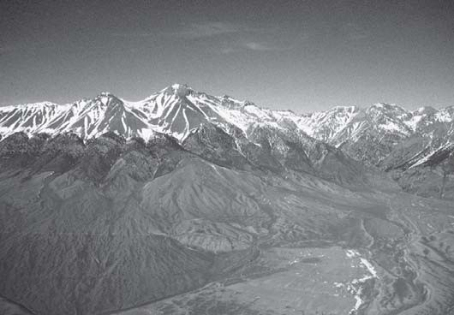
Figure 9. Aerial view looking east at the Lost River Range from north of Mackay. Mt. McCaleb is the high peak. Low hills in front center are Pennsylvanian and Permian Snaky Canyon Formation. Cross section thorough here shows 4.5 to 4.9 km of dip separation and 3.5 to 3.8 km of heave (Janecke et al., 1991). Trees are on Ordovician to Devonian rocks. Smooth slopes above treeline are underlain by the Mississippian McGowan Creek Formation, grading upsection into the Middle Canyon Forma- tion. Multiple generations of alluvial fans are cut by strands of the Lost River fault in this area (Janecke, 1992e). The Mt. McCaleb normal fault dips northwest and projects though the lowest saddle on the right shoulder (south) of Mt. McCaleb (Janecke, 1992e).
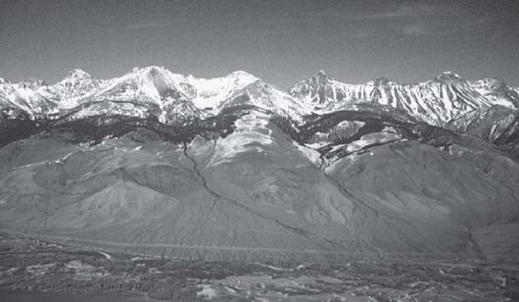
Figure 10. Aerial view looking northeast toward the trace of Leatherman Pass fault which bounds the east side of the Borah Peak horst. Leatherman Peak, underlain by Mississippian lime- stone, is the pointed peak just right of center, and Leatherman Pass is immediately to the left (west) of it. The Mackay segment of the Lost River fault forms the mountain-front scarp to the right of this view. The segment boundary to the Thousand Springs segment to the north is near the left edge of the photograph. Susong et al. (1990) discuss the complex array of normal faults in the segment boundary zone. Wilson et al., (1990) detail the geology of the lower part of the mountain front. Janecke and Wilson (1992) detail the geology of the whole area.
west of the reservoir (Snider, 1995).
At mile 10.1 is the turnoff to the west that leads to the Fish Hatchery and the Burma Road, which affords a spectacular drive over the White Knob Mountains to Copper Basin, with views to the east of the central Lost River Range (Figs. 9 and 10). This
road climbs through a Challis volcanic center that includes lava flows, tuffs, and intrusive domes (Moye et al., 1988; Snider, 1995).

Leatherman Peak
At mile 14.5 is a view to the northeast of Leatherman Peak (Fig. 10), a sharp horn carved from the Mississippian Scott Peak Formation (Ross, 1947; Janecke and Wilson, 1992). The Leatherman Pass normal fault, a major east-dipping normal fault of syn- to pre-Challis age, places Mississippian rocks on Ordovi- cian rocks at Leatherman Pass west of the peak. The prominent white patches in the limestones on Leatherman Peak are baked zones around Eocene dikes. Flourite veins are associated with the dikes. Other mineral deposits in the Lost River Range include stratabound barite in the Devonian Jefferson Formation (Wilson et al., 1990). To the north is the segment boundary between the Mackay and Thousand Springs segments of the Lost River fault (Susong et al., 1990; Bruhn et al., 1991; Janecke, 1993). Figure 11 is a cross section of the range north of here.

East Fork, Big Lost River
The Trail Creek road, on the left at 16.3 miles follows the East Fork of the Big Lost River over the Pioneer Mountains and down to Sun Valley on their western side. The primary source for alluvium in half-graben country like this is the hanging wall of the master normal fault (Leeder and Gawthorpe, 1987, 1993). The extensive Big Lost River drainage system to the west pro- vides much more sediment to this valley than the alluvial fans and short, ephemeral streams draining the steep west front of the Lost River Range.

Borah Peak
The road to the Birch Springs trailhead, that provides access to Borah Peak, is on the right at mile 20.9. The steep west front of the Lost River Range is bordered by the Thousand Springs seg- ment of the Lost River fault, that last moved in October, 1983 (Fig. 12). The Borah Peak earthquake prompted many geologic and geophysical studies (Stein and Barrientos, 1985; Crone et al., 1987; Richins et al., 1987; Susong et al., 1990; Bruhn et al., 1991; Turko and Knuepfer, 1991; Crone and Haller, 1991). The earthquake produced scarps up to 5m high (most were 2 m) and accomodated both left and normal slip (Crone, 1988).
The Borah Peak horst, folded and internally thrusted (Fisher and Anastasio, 1994), contains generally northeast-younging Neoproterozoic to Mississippian rocks (Ross, 1947; Skipp and Harding, 1985; Janecke and Wilson, 1992). This Eocene horst is uplifted on the east-dipping Leatherman Pass normal fault on the east side, and on the northwest-dipping Mahogany Gulch fault on the northwest side. The northwest-dipping Elkhorn Creek fault further extends the horst block. Borah Peak itself is on the east limb of a map-scale syncline and in the hanging wall of a small thrust fault (Figs. 8, 11 and 13).
The Doublespring Pass road is on the right at mile 23.0. This intersection is the site of the (former) town of Chilly. To the north over Doublespring Pass is the route to the east side of the Lost River Range, the Upper Pahsimeroi River, and the towns of Patterson and May. The road crosses several folds in upper Pa- leozoic rocks of the Lost River Range (Fig. 13). Fisher and

NE SW

A
Os3
Os2 Os1
Ct
Ct
Cw
?
Cw
Os1 Q
Ct
Cw
Os3Os2
Os1
?
Ct Os3Q
Os3
Cw
Basin
? Os2 Fill
3500 m

3000 m

2500 m

2000 m

1500 m
A'
3500 m

3000 m

2500 m

2000 m

1500 m

1 km

B
t Mmg
Of
j
j
j
Sl
j
Q
j
Qt
? Sl
?
Of
Ok
Sl
Of
Basin
Fill

3500 m

3000 m
Borah Peak

B'

3500 m

3000 m

2500 m

2000 m

1500 m
2500 m

2000 m

1500 m

1 km

Figure 11. Cross sections through the Borah Peak horst. Compare the complex geometry of the Lost River fault in the segment boundary between the Mackay and Thousand Springs segments (A-A’) with the single fault strand along the southernmost part of the Thousand Springs segment (B-B’). Reproduced from Susong et al. (1990, Figure 3). See Figure 8 for locations of cross sections.

Anastasio (1994) and Anastasio et al. (1997) performed detailed strain analyses of these folds.

Pioneer Mountains
Coming up out of the Lost River Valley at mile 28.2 the view to the southwest is of the high peaks of the Pioneer Mountains. The Devil’s Bedstead is the prominent peak on the north side of the metamorphic core of the range, and Hyndman Peak is the prominent peak in the central part of the range. The Pioneer Moun- tains contain a metamorphic core complex which contains Paleoproterozoic gneiss, metamorphosed Paleozoic sedimentary rocks, and foliated Eocene intrusive rocks in the footwall of the Wildhorse detachment fault (Dover, 1981; 1983; Wust, 1986; O’Neill and Pavlis, 1988; Wust and Link, 1988; Silverberg, 1990). The upper plate of the detachment contains folded and thrust faulted Paleozoic sedimentary rocks and Eocene Challis volca- nic rocks (Worl et al., 1991; Link et al., 1995; 1996; Rodgers et al., 1995). The Mississippian Copper Basin Group forms many of the slopes on the south and east sides of the metamorphic core. Mixed fine-grained sandstone and carbonate strata of the Penn- sylvanian and Permian Sun Valley Group makes up the summits north of the complex. The lower eastern and northern part of the range and the Boulder Mountains to the north are mantled by Challis Volcanic Group. To the south and east are the White Knob Mountains described above (Nelson and Ross, 1968; Wilson et al., 1995).

Willow Creek Summit
Willow Creek Summit, elev. 7160, is reached at mile 30.4. This is a bedrock ridge in the hanging wall of the Lost River fault. It corresponds to a persistent segment boundary between the Thou- sand Springs and Warm Springs segments (Fig. 2). The 1983 Borah Peak earthquake ruptured through the segment boundary into the southern end of the Warm Springs segment (Crone et al., 1987). The geology of this area is shown on the Challis 1° x 2° sheet (Fisher et al., 1992) and at larger scale on the Bayhorse area map of Hobbs et al. (1991) and the Challis 1o x 2o quadrangle of McIntyre and Hobbs (1987).
Figure 14 is the view to the south toward Borah Peak and the syncline to the west (Figs. 11 and 14) (Ross, 1947; Janecke and Wilson, 1992). The view to the north is of talus-strewn bare slopes of the Pahsimeroi Mountains (Lost River Range north of Doublespring Pass). These contain a large north-northwest trend- ing syncline with Mississippian to Permian rocks in the core and Ordovician to Devonian rocks along the flanks (Mapel et al., 1965; Rodgers and Janecke, 1992). The syncline may reflect a footwall ramp in an underlying thrust fault (Rodgers and Janecke, 1992). Many closely spaced Sevier-aged folds deform the core of this regional-scale syncline (Fig. 13).

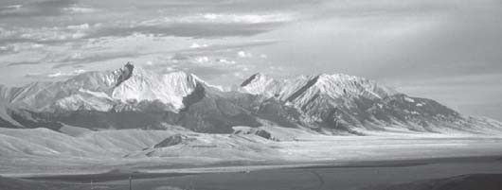

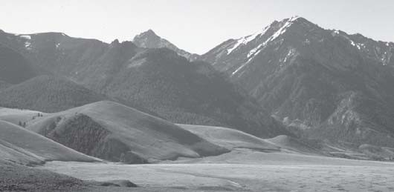
Figure 12. View of the Thousand Springs segment of Lost River fault scarp, looking southeast toward Cedar Creek (large canyon on right side of view). Rock Creek is the narrow can- yon on the left side of view.

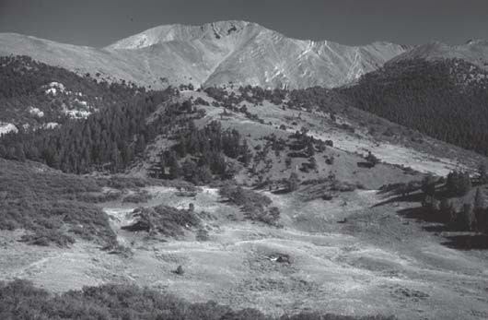
Figure 13. Syncline (at highest peak) and anticline (at right edge) in Mississippian and Pennsylvanian limestones, view to the southeast from road, just northeast of Doublespring Pass. Ribbed outcrops on skyline belong to the Mississippian, Penn- sylvanian and Permian Snaky Canyon Formation. Below it are talus-covered outcrops of the Mississippian Bluebird Mountain Formation and massive limestone cliffs of the Surrett Canyon Formation (canyon on left side of view) (Janecke and Wilson, 1992). Glacial deposits mantle the foreground (Cluer, 1989). Fisher and Anastasio (1994) and Anastasio et al. (1997) studied folds in this area.

Antelope Flat, Grandview Canyon
Heading down the north side of Willow Creek Summit, at mile 34.8 the Lost River fault cuts alluvial fans to the east. The highway joins the main canyon of Dry Gulch and Broken Wagon Creek to the southwest. Outcrops on the west of the road at mile
33.9 are Mississippian White Knob Limestone (Hobbs et al., 1991; Link et al., 1996).
To the west, at mile 37.0, is the Spar Canyon road. This af- fords access to extensive exposures of the Bayhorse assemblage of Paleozoic carbonate rocks in the Bradshaw Basin and Spar Canyon areas (Hays et al., 1980; McFaddan et al., 1988; Hobbs et al., 1991; Grader and Dehler, 1999, this volume). The lacus- trine and fluvial deposition of Eocene Challis Group synvolcanic sedimentary rocks along the Spar Canyon road have been de- scribed by Palmer (1997) and Palmer and Shawkey (1997).
The road to McGowan Creek is on the east at mile 38.9. This road affords access to the tightly folded Mississippian rocks of
Figure 14. View southeast from Willow Creek Summit of Borah Peak (high peak on left skyline). The two bands on west end of flat ridge to the west (right) of Borah Peak are sandstones at the base of the Jefferson Formation. The underlying Sil- urian Laketown Dolomite is light in color. At Borah Peak light-colored Ordovician and Silurian rocks are thrust over darker Devonian Jefferson Formation (Janecke and Wilson, 1992) (Fig. 11). A northwest-trending syncline coincides roughly with the lowest pass on the skyline.
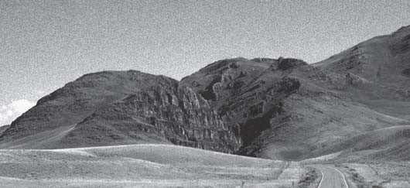
Figure 15. Grandview Canyon is cut in the Grandview Dolo- mite Member of Jefferson Formation. The view is to the north along Highway 93.

the Pahsimeroi Mountains (Mapel et al., 1965). The type section of the McGowan Creek Formation, Lower Mississippian distal flysch formerly mapped as Milligen Formation (Ross, 1947), is up this road (Sandberg et al., 1967; Sandberg, 1975).
At mile 38.6 the highway enters superposed Grandview Can- yon (Fig. 15), cut in the Grandview Member of the Devonian Jefferson Dolomite. The road to a bioherm/biostrome complex in the dark dolomite member of the Jefferson Dolomite is on the left at mile 42.2 (Isaacson et al., 1988; Isaacson and Dorobek, 1988, Grader and Dehler, 1999, this volume). This Frasnian buildup is dominated by corals, and overlies a thick sequence of slope to deep ramp deposits. It has been proposed to represent, among other things, shallowing related to an early phase of Antler tec- tonism (Dorobek et al., 1991).

Lone Pine Peak
Past Grandview Canyon the highway proceeds northward down Warm Springs Creek. The topography is controlled by north- northwest striking basin and range faults. Lone Pine Peak ridge to the west is on the footwall of an east-dipping normal fault, antithetic to the main Lost River fault. On the Lone Pine Peak range, Silurian to Mississippian strata strike northwestward, par- allel to the range, and dip northeast and southwest. Folding and thrusting complicate the geology (Hays et al., 1978; 1980; Hobbs et al., 1991; Fisher et al., 1992).

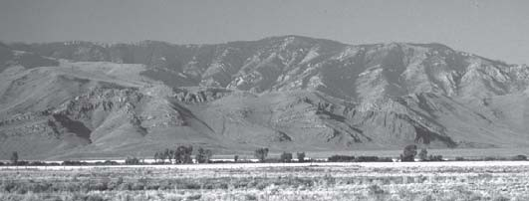

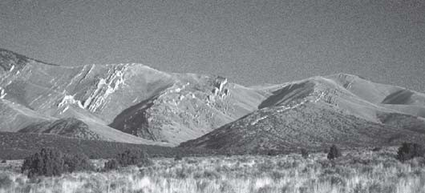
Figure 16. Howe Peak and ribbed outcrops of Pennsylvanian and Permian Snaky Canyon Formation, view to north from Highway 22 southwest of Howe. Beds at left and right edge dip west, whereas the central spur contains some east-dip- ping beds.

Round Valley and Challis Area
The Challis Hot Springs turnoff is at on the right at mile 51.0. The road to the east over Grouse Peak to the Pahsimeroi Valley begins here. The Neoproterozoic breccias described by Carr and Link (1999, this volume) are in the canyon of Leaton Gulch, be- low Grouse Peak. The view to the west is of the Salmon River Canyon (see Figs. 45 and 47). To the east is the north end of the Lost River Range; to the west and south is the Paleozoic carbon- ate ridge of Lone Pine Peak. Challis Volcanic Group lavas form the low hills east of road below Grouse Peak (McIntyre and Hobbs, 1987). The northern and east-central parts of the Lost River Range contain thick sections of Challis volcanic rocks.
Roadlog #1 ends at the intersection of Highways 93 and 75 just south of Challis, near the Yankee Fork Mining Museum. Roadlog #4 along the Salmon River joins here.

ROADLOG #2: GEOLOGIC GUIDE UP THE LITTLE LOST RIVER VALLEY.
This road log begins at the northern border of the INEEL, east of Butte City, at the intersection of U.S. Highway 20/26 with Highway 22/33. Take Idaho Highway 22/33 to the northeast to Howe.

Arco Hills
The Arco Hills, northwest of the road, are a roughly north- northeast trending fault block in the hanging wall of the Lemhi fault and the footwall of the Arco Pass fault (Fig. 2). Visible on their southern front are an anticline-syncline-anticline fold train in Mississippian McGowan Creek and carbonate bank strata (Figs. 2 and 7) (see maps of Skipp and Hait, 1977; Wilson and Skipp, 1994 and Kuntz et al., 1994). McQuarrie and Rodgers (1998) argue that the south-southeast plunge of the folds in this area and elsewhere adjacent to the eastern Snake River Plain is due to flex- ure toward the plain. Many folds distant from the eastern Snake River Plain also plunge to the southeast (Rodgers et al., 1995; Jeppson and Janecke, 1995), making it difficult to uniqely deter- mine the origin of the southeast plunges.
The large canyon on the left is Deadman Canyon, with Penn- sylvanian and Permian Snaky Canyon strata in its headwaters. There is a west-dipping normal fault on the east side of the drain- age. Snaky Canyon Formation rocks are in the hanging wall of
Figure 17. View westward from just north of Howe toward folded Snaky Canyon Formation in the Howe Hills in the foreground and the Lost River Range in the background. King Moun- tain is the highest peak in this part of the Lost River Range.

this fault. The Mississippian carbonate bank sequence is brought up in the footwall. Upsection in the footwall are spectacular north northwest-trending folds in Snaky Canyon strata under Howe Peak (5 miles from intersection) (Fig. 16). The highway goes northeast for 7 miles from the intersection and then bends to the north, parallel to the strike of the Snaky Canyon Formation (Cantor and Isaacson, 1991; Kuntz et al. 1994).

Howe
Howe is reached at 15 miles. To the west are the Snaky Can- yon beds, that contain Palaeoaplysina reefs studied by Breuninger et al. (1988) (Figs. 16 and 17). To the east is the southern end of the Lemhi Range, which also contains a folded and thrusted east- ward-younging section of Mesoproterozoic to Permian rocks lo- cally overlain by Tertiary Challis Volcanic Group, younger sedi- mentary rocks, and Neogene volcanic rocks (Hait, 1987; Kuntz et al., 1994). Strata under the pre-Tertiary unconformity become younger to the south in the Lemhi Range (Rodgers and Janecke, 1992). The prominent peak is Saddle Mountain (Fig. 18). Howe Point, at the south end of the Lemhi Range, exposes several of the rhyolite ash-flow tuffs produced by the Snake River Plain- Yellowstone hotspot (Morgan, 1992; Pierce and Morgan, 1992). These are cut by older east-west striking normal faults and the younger Lemhi fault (Kuntz et al., 1994).

Little Lost River Valley
Reset mileage to zero at Howe. Go north on Little Lost River Road. To the west is the Lost River Range, with many tight folds in Pennsylvanian and Permian Snaky Canyon Formation (Fig. 17). The southern Lost River Range contains a folded but generally eastward-younging succession of Ordovician to Permian carbon- ate rocks overlain by Eocene volcanic rocks, Paleogene sedimen- tary rocks and Neogene tuffs and basalt flows of the eastern Snake River Plain (Skipp and Hait, 1977) (Fig. 18). At least three gen- erations of Eocene to Recent normal faults cut the range (Janecke, 1992a; 1992c; 1995a). To the west and north proceeding clock- wise in the Lost River Range are the Arco Hills, King Mountain, and Hawley Mountain (Fig. 1).

Lemhi Range
To the east is the steep faulted front of the Lemhi Range (Fig. 18). The South Canyon bedrock block juts out into the Little Lost River Valley about ten miles north of Howe. The block contains east-dipping Neoproterozoic to Upper Mississippian strata (Wil-

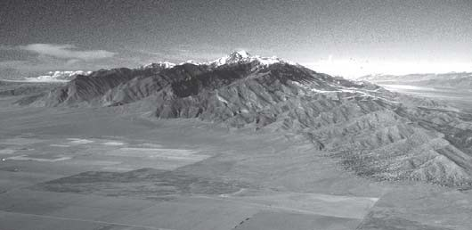
Figure 18. Aerial view of south end of Lemhi Range. Saddle Mountain is high peak. Geology of this area is described by Hait (1987), and includes strata from Mesoproterozoic to Permian age, cut by the Howe segment of the Lemhi Fault. The South Creek “slide block” of Beutner (1972) is barely visible at the extreme left edge of the photograph.
son and Skipp, 1994). The type section of the Neoproterozoic and Cambrian Wilbert Formation is reached up South Creek Can- yon, south and east of the block (Ruppel et al., 1985; McCandless, 1982).
Beutner (1968, 1972) interpreted this block as a landslide that slid westward from the Lemhi Range to the east. A second simi- lar block is present about 15 miles northward along the front of the Lemhi Range, west of Diamond Peak (Ross, 1961). Alterna- tively, the blocks may be underlain by low-angle normal faults that persist beneath the Little Lost River valley rather than being landslide blocks whose lower bounding surface ultimately inter- sects the earth’s surface at both the up- and down-dip ends.
The southern Lemhi Range contains a generally eastward- younging package with Mesoproterozoic Lemhi Group at the base, on the west side of the range, and Permian rocks on the northeast side (Fig. 3) (Ross, 1961; Beutner, 1968; 1972; Skipp and Hait, 1977; Hait, 1987). The section contains local thrust faults and folds, but is basically a coherent block within the Hawley Creek thrust plate (Rodgers and Janecke, 1992). West-vergent normal- fault blocks formed during tectonic denudation of the Lemhi Range in both Paleogene and Late Miocene to Recent time (Janecke, 1992a).
To the northeast in the Lemhi Range one can see Saddle Moun- tain and the Wilbert Mine, which was a major silver and lead producer from 1906 to 1931 (Ross, 1961). The ore bodies are sulfide replacements in quartzitic dolomite of the Mesoproterozoic Swauger Formation, likely formed during Eocene Challis mag- matic activity (Ruppel and Lopez, 1988).

Paleogene Half-Graben
A huge alluvial fan drains north from Hurst Canyon to the left, out of the low pass between the Arco Hills and the Lost River Range. The drainage follows a west-dipping middle Eocene to Oligocene fault which defines a half-graben through Arco Pass (Fig. 7). Sawmill Canyon in the Lemhi Range about 40 miles north of Howe and the Pass Creek-Wet Creek half graben in the Lost River Range to the west are dismembered parts of a coeval middle Eocene to Oligocene half-graben system (Fig. 8). (Janecke and Snee, 1993; Janecke, 1992a, 1992d; 1994; 1995a). The Don- key fault system, which cuts the Donkey Hills (Janecke, 1992b), also formed during this extensional phase.

Diamond Peak
At 25 miles from Howe the road crosses the Little Lost River. Diamond Peak can be seen in the Lemhi Range to the east (Fig. 25 is a view from the other, east, side of the range), and Hawley Mountain can be seen to the northwest. The rocks west of Dia- mond Peak are a landslide (?) block of Mississippian carbonates, dropped down to the west against Mesoproterozoic Swauger For- mation in the footwall (Beutner, 1972). Earlier studies suggested that this block, and the South Canyon block, to the south, coin- cided with segment boundaries along the Lemhi fault (Crone and Haller, 1991) but more recent analysis shows that they may not be persistent barriers to rupture (Hemphill-Haley et al., 1991, 1994).

Wet Creek-Hawley Mountain
The Wet Creek Road is reached on the left at mile 34. This is the north end of the Pass Creek-Wet Creek half graben (Fig. 5, 8) documented by Janecke (1992a; 1992b; 1994). There is a spec- tacular view to the northwest of the high Lost River Range. The road turns to gravel.
Hawley Mountain, the prominent peak to the southwest in the Lost River Range, exposes a complete southeast-dipping strati- graphic section of Mesoproterozoic to Pennsylvanian and Per- mian rocks (Mapel and Shropshire, 1972). Hawley Mountain is near the southeast end of a small horst block (Fig. 2 and 8). The northeast-dipping Barney fault bounds the horst on the northeast side, and the Hawley Creek fault is on the southwest side. (Figs. 2 and 8)(Janecke, 1993). The Barney fault is antithetic to the Lemhi fault. The Custer County line is crossed at mile 38.

Sawmill Canyon
The Sawmill Canyon area in the Lemhi Range is directly north (Fig. 19). At mile 40 there is a major road junction to Sawmill Canyon on the right. Sawmill Canyon coincides with a prominent north-trending reentrant in the Lemhi Range, and with a major bend in the range-front fault (Fig. 2). Similar sharp bends also occur in the Lost River and Beaverhead faults, and may have a similar origin (Janecke, 1993). At Sawmill Canyon the bend ap- pears to coincide with a segment boundary along the Lemhi fault (Turko and Knuepfer, 1991; Janecke, 1993). A side trip up Saw- mill Canyon affords a view of the Lemhi fault scarp cutting allu- vial fans along the range front (Fig. 19). The Sawmill Canyon fault, a west-dipping middle Eocene to Oligocene(?) normal fault controls the trend of Sawmill Canyon (Janecke, 1992a, 1992c). The geologic map of the Sawmill Canyon area of Janecke (1992c) documents that Challis lava flows and ash flow tuffs of the Saw- mill Canyon half graben are overlain and intercalated with syntectonic conglomerates and gravels (Janecke and Snee, 1993; Janecke, 1995a). Unroofing sequences of clasts in these sedimen- tary rocks show that they were shed from the footwall of the Saw- mill Canyon fault (Janecke, 1994).
Pre-Tertiary strata also dip east in the central Lemhi Range, with Mesoproterozoic rocks making the high peaks west of Saw- mill Canyon and Ordovician to Devonian strata making up the crest of the range east of Sawmill Canyon (Ross; 1947; Ruppel and Lopez, 1981). Eocene porphyritic intrusive rocks intrude the Paleozoic limestones. Tertiary rocks overlie a southeast-dipping

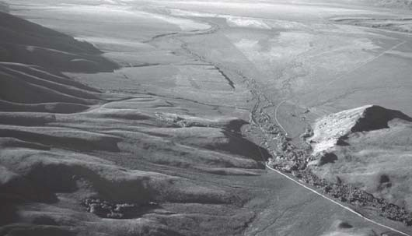
Figure 19. View south of the mouth of Sawmill Creek. Scarps along the Sawmill Gulch-East segment of the Lemhi Fault cut alluvial fan surfaces in from the center of the photograph to the farthest right extent of shadow in the upper left. A prominent terrace scarp in central distance is a fluvial scarp. Bedrock at the right edge of photograph is the Ordovician Kinnikinic Quartzite cut by a northeast-striking normal fault that dips northwest, parallel with shadow line near middle right edge. It places Tertiary sedimentary rocks down against the Kinnikinic Quartzite (Janecke, 1992c) (See Fig. 8 for more details).

lateral ramp in the footwall of an underlying thrust fault (Rodgers and Janecke, 1992). Challis strata lie on Pennsylvanian and Per- mian Snaky Canyon Formation in the southern Lost River and Lemhi Ranges, but overlie uplifted Mesoproterozoic Lemhi Group north-northwest of Sawmill Canyon.

Summit Creek-Goldburg Area
Two miles north of the turnoff to Sawmill Canyon (mile 40) the road crosses a prominent gravel terrace (Unit Qtf1 of Janecke, 1992b) dotted with small mounds and circles of lush vegetation around a barren center. The origin of these features (“mima mounds”) is uncertain but their density and degree of develop- ment appears to measure the antiquity of Holocene and Quater- nary surfaces. Some coincide with large ant colonies.
At mile 45 is the Summit Creek recreation site. Fault scarps developed in alluvial fan deposits northeast and southwest of the road reflect recent surface-faulting earthquakes along the Lemhi fault and the antithetic Barney fault (Janecke, 1993; Janecke 1992c and 1992d). The pattern of faulting is quite complex in the nar- row bedrock ridge two miles northwest of here, and probably reflects the presence of a segment boundary along the Lemhi fault (Janecke, 1993).
A large old alluvial fan comes from the Donkey Hills on the left, draining the footwall of the Donkey fault (Figs. 5 and 8). Outwash from Late Pleistocene glaciers along Dry Creek likely contributed to this fan (Mapel and Shropshire, 1973; Janecke, 1992d).
Ordovician Kinnikinic Quartzite is exposed at the dam, with Mesoproterozoic Swauger Formation to the north (Ruppel, 1980). At mile 48, at Goldburg Summit, pink quartzite of the Mesoproterozoic Swauger Formation is exposed on the right be- low an alluvial fan. The Swauger Ranch, for which the unit is named (Ross, 1947) is 5 miles north of here.

Pahsimeroi Valley
At mile 53 the road on the left goes to the Upper Pahsimeroi River (Figs. 20 and 21), and to the right is the Swauger Ranch. The buried north-trending trace of the Donkey fault is crossed here. To the south the hills in the hanging wall of the west-dip- ping Donkey fault are underlain by Eocene to lower Miocene(?) Donkey Fanglomerate, which filled a basin that formed during the Paleogene basin forming event (Janecke, 1992a; 1994; 1995a). These deposits are > 2 km thick and are syntectonic to slip on the low-angle Donkey fault.
At mile 55 is the Goldburg townsite and a major road junc- tion. Doublespring Road is to the left. There is a panoramic view to the west here of the Lost River Range, Borah Peak, Doublespring Pass, and the Pahsimeroi Mountains (Fig. 20).

Big Creek to Patterson
The turnoff to the Big Creek Campground is on the right at mile 59. Big Creek is a major access route to the high Lemhi Range to the east (Fig. 22). Crone and Haller (1991) place the segment boundary between the Goldburg and Patterson segments of the Lemhi fault at Big Creek. The presence of an orthorhombic array of fault scarps in this area (Janecke, 1993) supports this placement. There is a big view to the left to central Pahsimeroi Valley and Pahsimeroi Mountains beyond. To the east is the Lemhi Range and type sections of several of the Lemhi Group units (Ruppel, 1975; Winston et al., 1999, this volume).
Continuing north toward Patterson (reached at mile 64), former site of a smelter and mining complex, the west side of the Lemhi Range is east of the road. Triangular facets are particularly well- developed along this northern half of the Lemhi fault (Fig. 23). The rocks at the range front are Mesoproterozoic Big Creek and Apple Creek formations, cut and mineralized by the concealed Eocene Ima stock (Ruppel, 1980). The tree- and scree-covered slopes do not reveal the structure, but up Patterson Creek can be seen the generally east-dipping Mesoproterozoic strata of the Lemhi Group. The Lemhi fault cuts alluvial fans at the mouth of Patterson Creek (Fig. 23) (Crone and Haller, 1991; Turko and Knuepfer, 1991). Scarps up to 1.7 m high are preserved in this area (Haller, 1988).

Lower Pahsimeroi Valley Near May
The road heads northwest, down off the alluvial fan at mile 69, five miles north of Patterson. The irrigated part of the Pahsimeroi Valley is to the north (Fig. 24). Mahogany Creek road is on the left. To the northwest, Grouse Peak can be seen at the north end of Pahsimeroi Mountains. Here the Mesoproterozoic Lawson Creek Formation is locally overlain by the Neoproterozoic formation of Leaton Gulch and Eocene Challis Volcanic Group (Hobbs, 1980; McIntyre and Hobbs, 1987). Southward in the Pahsimeroi Mountains, a west-southwest-dipping panel of Or- dovician to Mississippian rocks forms Mahogany Hill, at the head of Grouse Creek. To the south of a south-dipping normal fault are tightly folded Mississippian to Pennsylvanian limestone, which underlie Grouse Creek Mountain and continue southward to Doublespring Pass (Mapel et al., 1965).
At mile 75, eleven miles north of Patterson, Hooper Lane is on the left. Doublespring Pass is 24 miles up Hooper Lane. His-

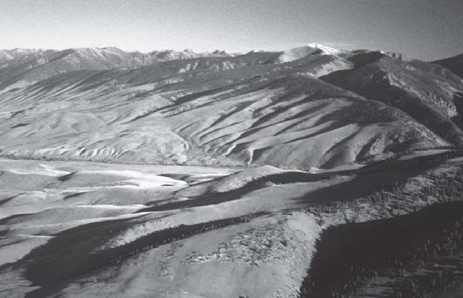
Figure 20. View southwest of Upper Pahsimeroi River, with Borah Peak on right skyline, and Idaho’s only glacier below, in shadow. The prominent low point on the center skyline ridge is Leatherman Pass, cut by the east-dipping Leatherman Pass normal fault, with Leatherman Peak east (left) of it. Figure 10 shows this saddle from the other side of the Lost River Range. The Goldburg Hills are in left front and the northern- most end of the Donkey Hills in left center. The Goldburg normal fault follows the west edge of the Donkey and Goldburg hills (Figs. 2 and 8). Photograph taken from high in the Lake Fork of the Big Creek drainage in the Lemhi Range.
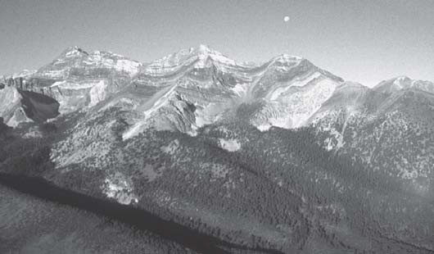
Figure 21. Aerial view of folded Ordovician to Mississippian rocks in the Borah Peak horst west of the headwaters of the Pahsimeroi River. The peak on the left skyline is Borah Peak. The Borah Peak thrust, which here places Ordovician to Sil- urian carbonates on the Devonian Jefferson Formation, dips to the left, or south, and is found in the bench to the right of Borah Peak (Janecke and Wilson, 1992). Some apparent folds are due to interaction of topography and structures. The beds are less folded than they appear in this view. Tree covered Pinedale lateral moraines in the lower part of the photograph slope down to the right. The area in the left-hand (south) side of the view was mapped by Skipp et al. (1988b).

toric May is on the left at mile 76.
The northern Lemhi Range to the east contains an essentially northeast-dipping section of Lemhi Group and Swauger Forma- tion. The Patterson quadrangle map of Ruppel (1980) shows a maze of thrust faults. Some of them may exist, but regionally, they do not significantly disrupt the stratigraphic sequence (Win- ston et al., 1999, this volume). Tysdal (1996a and b; Tysdal and
Figure 22. Looking north across the mouth of Big Creek at the Lemhi Fault. The fault runs up the small canyon in the middle of the view and then up to the left edge of photograph. Hang- ing wall rocks to the southwest of the fault are Tertiary sedi- mentary rocks of the Donkey Fanglomerate. Names and inter- pretation of locations of segments and boundaries are slightly different between Janecke (1993) and Crone and Haller (1991). Fault pattern is very complex in this area and includes a net- work of west to west-southwest-dipping normal faults (Fig. 8) (Janecke, 1992b).
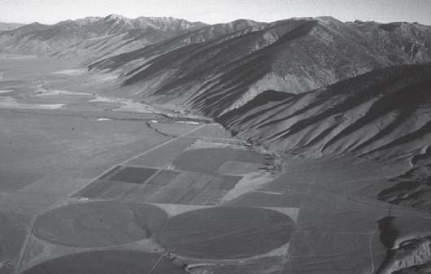
Figure 23. View north of the west front of the Lemhi Range at Patterson, the town at the mouth of the narrow canyon in the center of the view. White sand dunes accumulated at the mouth of Patterson Creek. The Patterson segment of the Lemhi fault here cuts Pleistocene fan deposits and bounds well-developed faceted spurs (Haller, 1988). Type sections of Mesoproterozoic Lemhi Group rocks are found at the head of Inyo Creek and West Fork of Big Creek, south and east of Patterson.

Moye, 1996) show that southwest-dipping normal faults may be more important structures in this part of the range. Figure 24 is a view to the northern Lemhi Range and the Allison Creek (Salmon River) fault, that bounds a Paleogene half-graben east of the Salmon River (Janecke, 1995a; Janecke et al., 1998).
On the left at mile 80 are outcrops of the Swauger Formation, Lawson Creek Formation, and Kinnikinic Quartzite along a road that snakes up and over the summit of Grouse Peak in the north- ern Pahsimeroi Range to the breccia outcrops in the formation of Leaton Gulch (Hobbs, 1982; Carr and Link, 1999, this volume).

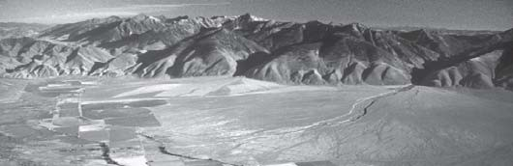
Figure 24. View north from north of May of the northern Pahsimeroi Valley, the northern Lemhi Range, and a large alluvial fan at mouth of Morse Creek. The range-front fault includes the May and Patterson segments of the Lemhi fault. Janecke (1993, Fig- ure 6) shows a map of this area. The Allison Creek normal fault, a west-southwest-dipping high angle normal fault that bounded a Paleogene half-graben, intersects the Lemhi fault at the first major canyon left of the center. The Allison Creek fault separates the tree-covered bedrock in the main part of the Lemhi Range from the sage-covered Tertiary rocks in the lower left part of the range. Tysdal and Moye (1996) mapped the Allison Creek fault to the north. Note the large size of the alluvial fan issuing from the footwall on the right. In this part of the Pahsimeroi Valley fans derived from the footwall of the Lemhi fault rival those shed from the hanging wall, contrary to the predictions of most rift models.

Ellis and the Salmon River
Ellis is reached 82 miles north of Howe, 25 miles north of Patterson. East of the road is a mudcracked outcrop of the Mesoproterozoic Apple Creek Formation (Fig. 48). This is the end of the roadlog. Roadlog #4, along the Salmon River joins here.

ROAD LOG #3: MUD LAKE TO SALMON: BIRCH CREEK AND THE LEMHI VALLEY

Mud Lake Area
Head north to Salmon at the Junction of Idaho Highway 28 and 33 west of Mud Lake (Fig. 1) and set odometer to 0.0. We are heading northwest across the northeastern Snake River Plain. Mud Lake is to the northeast, and the Circular Butte eruptive center to the west. The Lemhi Range is to the west, the Beaverhead Moun- tains to the east, and the continental divide to the north. The Lost River Range is visible west of the Lemhi Range (Figs. 1 and 2). Price et al (1999, this volume) describe the geology of the south- ern Beaverhead Range at Reno Point. The regional geology is shown on the maps of Scott (1982) and Kuntz et al. (1994).
At the junction with Highway 22, Howe Point can be seen at the extreme southern tip of the Lemhi Range, to the left (north- west). Diamond Peak is to the northwest (Fig. 25), and the Beaverhead Mountains are to the right.
At mile 18.2 is the northern INEEL boundary. The road to the west is to Kyle Canyon and Snaky Canyon in the southeastern Lemhi Range. Gently east-dipping ash-flow tuffs of the Upper Miocene and Pliocene Heise Group are exposed up the canyon (Morgan, 1992). Farther up the canyon is the type section of the Snaky Canyon Formation plus outcrops of the Permian Phosphoria Formation and Triassic Dinwoody Formation (Skipp, Hoggan, et al., 1979).

Birch Creek Valley

Long Canyon and Southern Beaverhead Mountains
At mile 27.3 is the turnoff to Long Canyon to the east. The southern Beaverhead Mountains have been mapped by Garmezy (1981) and Skipp (1984, 1988a), and are composed of Mesoproterozoic to Permian rocks of the Hawley Creek, Fritz Creek and Cabin thrust plates. Pennsylvanian to Permian rocks of the Snaky Canyon Formation are faulted onto the Neoproterozoic and Cambrian Wilbert Formation along the Beaverhead normal fault north of here. This intrabasinal high coincides with a segment boundary along the Beaverhead fault (Crone and Haller, 1991)(Fig. 2). The Neoproterozoic and Cam- brian Wilbert Formation is exposed up Long Canyon, and thick- ens eastward from the southern Lemhi Range to the Beaverhead Mountains (Skipp and Link, 1992).
At mile 29.3 on the left is a Prehistoric Man Historic Site. Paleo Indians camped and hunted along Birch Creek (Dereg, 1996). At mile 30.5 is the road to Skull Canyon on the right (folded Mississippian Scott Peak Formation, Figure 26). This was the site of Blue Dome, a now-demolished hotel that had a blue roof visible for miles around. Garmezy (1981) mapped the folded but eastward-younging rocks of the southernmost Beaverhead Moun- tains.
At mile 31.5 is the Pass Creek road to the left, providing ac- cess to the southern Lemhi Range, including the area south of Diamond Peak (Fig. 25). This prominent horn on the crest of the Lemhi Range to the west is underlain by Upper Mississippian carbonate-bank strata. The area is shown on the geologic map of Ross (1961). Beutner (1968) mapped the numerous north north- west-trending, east-vergent folds of the southern Lemhi Range in great detail. The origin and the age of several northeast-striking faults (Fig. 2) that cross the range is uncertain. They have up to 3 miles of left separation and may be tear faults to the adjacent thrust faults (Beutner, 1968).

Lone Pine Area
North of Blue Dome the road passes through the Birch Creek Canyon near Lone Pine (mile 32.8), named for a solitary grand limber pine south of town. In the Lone Pine area, the “Medicine Lodge” volcanics (probably Challis equivalent) are overlain by the 6-16 Ma Medicine Lodge limestone, the basalt of Lone Pine, and the 6.5 Ma tuff of Blacktail (Rodgers and Anders, 1990).
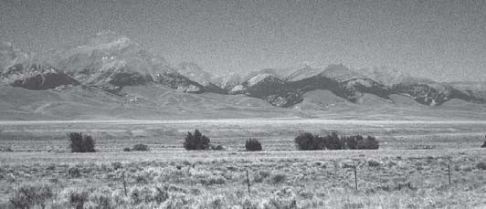
Figure 25. View west to Diamond Peak and the southern Lemhi Range from Blue Dome. Birch Creek is in the middle dis- tance, lined by the only trees for miles around. Diamond Peak is underlain by Mississippian limestone.

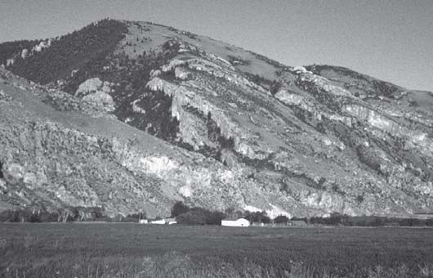
Figure 26. View of the mouth of Skull Canyon, looking southeast from south of Lone Pine. The cliffs are composed of a dip slope of Mississippian limestone of the Hawley Creek thrust plate (Garmezy, 1981; Skipp, 1988a). This bedrock ridge is in the hanging wall of the Beaverhead fault and coincides with the boundary between the Nicholia and Blue Dome seg- ments (Crone and Haller, 1991).
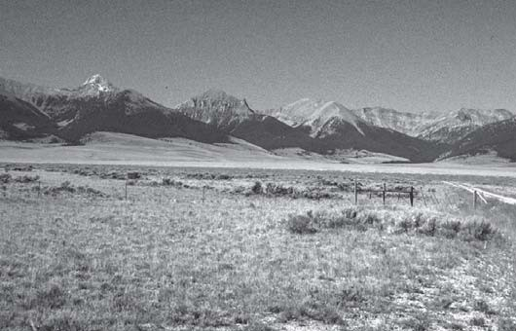
Figure 27. Westward view of Bell Mountain and the central Lemhi Range from north of Lone Pine. The glaciated horn of Bell Mountain (the southern high peak) is underlain by Ordovi- cian Kinnikinic Quartzite, repeated on a thrust fault (Beutner, 1968; Wilson and Skipp, 1994). Rocks on the skyline north of Bell Mountain are tightly folded but eastward younging De- vonian to Mississippian carbonate strata.
These rocks dip about 7 to 15° to the east-northeast (Rodgers and Anders, 1990; Anders et al., 1993).

Nicholia and Viola Mine
The highway ascends to the marshy headwaters of Birch Creek in the five miles north of Lone Pine. The historic town of Reno is east of the road at mile 39. Reno was a settlement during mining booms at Nicholia in the Beaverhead Range to the north. At Nicholia a rich silver deposit of the Viola mine operated between 1882 and 1887 supporting a lead smelter and in 1886, a town of 1,000 people (Dereg, 1986). The smelter closed in 1889. Ore was produced from stratabound deposits in Devonian dolostone (Skipp et al., 1988). Price et al. (1999, this volume) describe a side trip to this area.
North of Nicholia the road skirts along the southwest edge of
Middle Ridge, a north-northwest trending high in the middle of the basin between the Lemhi Range and Beaverhead Mountains. The ridge consists of Miocene to Pliocene sedimentary rocks of the Medicine Lodge beds (Scholten and Ramspott, 1968). Te- phras within the section had sources in the eastern Snake River Plain (M. Perkins, University of Utah, pers. comm.). Northwest- trending extensional folds deform the sequence, and a strand of the Beaverhead fault has uplifted these rocks in its footwall (Scholten and Ramspott, 1968; Crone and Haller, 1991). Spotty exposures of the interbedded gravel, limestone and tephras per- sist much of the way to Leadore.
At mile 45 is the charcoal kilns road to the left into the Lemhi Range. The prominent horn to the west is Bell Mountain, carved in Ordovician Kinnikinic Quartzite (Fig. 27). A small thrust at Bell Mountain repeats lower Paleozoic rocks (Beutner, 1968). At mile 51 is the Hahn townsite, the site of a lead smelter built in 1908. At mile 52 is the turnoff to the left to Spring Mountain Canyon, draining Big Windy Peak (Fig. 28). Price et al. (1999, this volume) describe a field trip to Spring Mountain Canyon where skarn mineralization and an incised Lower Devonian val- ley fill system can be seen (Grader and Dehler, 1999, this vol- ume) (Fig. 28). The area is on the Gilmore 15 minute quadrangle map of Ruppel and Lopez (1981).

Lemhi River Valley

Gilmore Area
Gilmore Summit is reached at mile 56. This intrabasinal drain- age divide is roughly aligned with similar, anomalous drainage divides in the hanging wall of the Lemhi and Lost River faults. These divides are probably related to the passage of North America over the Yellowstone hotspot because the topographic highs co- incide with a seismic and neotectonic parabola centered on the present position of the hot spot (Anders et al., 1989; Pierce and Morgan, 1992). Two miles past the summit (mile 58) is the road to Gilmore. The Texas mining district caused Gilmore to be a thriving mining community, reached by the Gilmore and Pitts- burgh Railroad in 1910 (Figs. 29 and 30). The district contains lead-silver veins and replacements related to Eocene stocks in- truding Paleozoic limestone (Ruppel and Lopez, 1988). Stratabound Mississippi Valley type lead-silver-zinc deposits in the Devonian Jefferson Formation may also be present, and may provide the source of the metals (Skipp et al., 1983; 1988).
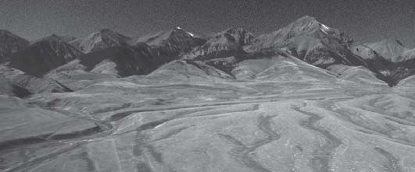
Figure 28. Aerial view to the southwest of Big Windy Peak on the eastern side of the Lemhi Range south of Gilmore. Bedrock is Paleozoic carbonate. Extensive glacio-fluvial deposits in the foreground are derived from Spring Mountain Canyon (see Price et al., 1999, this volume). The origin of the light specks on the alluvial/outwash fans is uncertain.

The Gilmore area grew rapidly after 1902. Most mining ac- tivity was finished by 1925. The Gilmore and Pittsburgh railroad allowed transportation of ore from the several mines in the area, but never was solvent. Service was stopped in 1939 and the tracks were ripped up for salvage in 1940. The railroad was built too late into the 20th Century, too close to the depression that fol- lowed World War I, and into an area too topographically severe and too limited in mineral and lumber resources to support a rail- road (Myers, 1981; Dereg, 1996). The latest phase of mining ac- tivity in the Texas district was from 1943 to 1961. Lead-silver- gold replacement orebodies at the Hilltop mine were developed (Ruppel and Lopez, 1988).

Eighteenmile Road
At mile 66.5 is the Eighteenmile Road on right. This affords access to the high Beaverhead Mountains to the south, that were mapped and studied by Skipp (1984; 1985; 1988a). The Clear Creek gypsum deposit, in hydrothermally altered Scott Peak For- mation, is reached up this road (Skipp et al., 1988a). This area
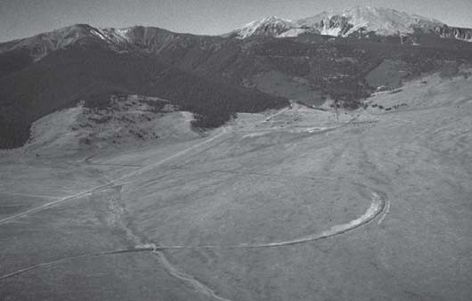
Figure 29. Aerial view of abandoned Gilmore and Pittsburgh railroad grade curving up toward townsite of Gilmore in middle right center. The canyon in right center is Meadow Lake Creek.
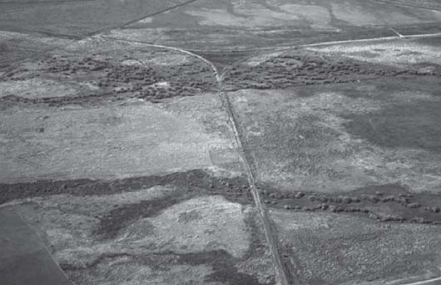
Figure 30. Wye in abandoned Gilmore and Pittsburgh railroad grade immediately southeast of Leadore. The view is to the west. The grade heads east at bottom of photograph toward view shown in Figure 31. The grade headed south on left side of view toward Gilmore (Fig. 29).
contains the southern part of the Hawley Creek thrust fault (Lucchitta, 1966; Skipp, 1988a) the first major thrust east of the Pioneer Mountains (Rodgers and Janecke, 1992). The red rocks at Eighteenmile Peak are the granite and syenites of the Ordovi- cian (about 483 Ma) Beaverhead Pluton (Ramspott, 1962; Evans and Zartman, 1988).
East-southeast of Leadore, at Hawley Creek, the Hawley Creek thrust fault places Ordovician Beaverhead Mountains Pluton over Permian and Triassic rocks (Lucchitta, 1966; Scholten and Ramspott, 1968; Skipp, 1984, 1988a; Skipp et al., 1988). East of Leadore, the fault trace places Beaverhead Mountains pluton over upper Paleozoic to Mesozoic rocks (Lucchitta, 1966; Ruppel, 1969; and Skipp, 1988a). The concealed trace heads northwest across the Lemhi Valley into the northern Lemhi Range. The Poi- son Creek thrust of Tysdal (1996a, b) is on strike to the northwest in the northern Lemhi Range (Skipp, 1987; 1988a). Probable westward continuations into the Salmon River Mountains are dis- cussed in Skipp (1987) and Evans (1999).

Leadore
At mile 65 is the village of Leadore, open, windy, cold, and hunkered-down. The Gilmore and Pittsburgh railroad reached here in 1910 and times were good. The Junction and Little Eightmile mining district on Grizzly Hill to the north (Fig. 31) produced lead and silver ores from Paleozoic limestones. The Texas dis- trict to the southwest near Gilmore was far more productive (Ruppel and Lopez, 1988). North of Leadore the highway de- scends the flood plain of the Lemhi Valley. Tertiary volcanic and sedimentary rocks become increasingly more apparent northward from Leadore.
A low pass in the Beaverhead Mountains about half way be- tween Leadore and Lemhi exposes a major southeast-dipping low-
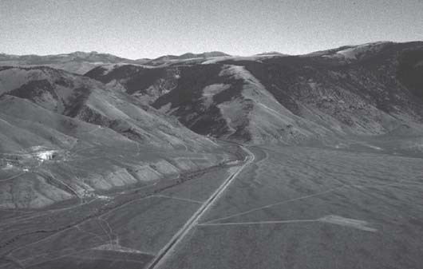
Figure 31. View east-northeast toward Railroad Canyon in the Beaverhead Mountains. The skyline ridge is on the continen- tal divide and along the Montana-Idaho border. Slices of the Hawley Creek thrust sheet are preserved on the lower part of the mountain (Skipp, 1988a). An abandoned railroad grade is the thin line on the right middle of view. The mountain front is bounded by the Beaverhead fault. Crone and Haller (1991) place the segment boundary between the Leadore and Mollie Gulch segments just west (left of this view). A west-dipping normal fault in the footwall of the Beaverhead fault intersects the range front here and probably helped to localize the rup- tures along it (Janecke, 1993, Figure 1).

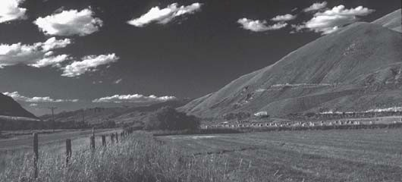

Figure 32. Bulldozer cuts in Mesoproterozoic Apple Creek For- mation east of the highway, at the southwest edge of the Lemhi Pass Thorium District, between Lemhi and Tendoy. The Salmon basin and Beaverhead Mountains are visible in the left distance.
angle normal fault (the Goat Mountain thrust of Staatz, 1979) (Figs. 1 and 2). VanDenburg (1997; VanDenburg et al., 1998) showed that the thrust is a major pre-Challis normal fault. Rollover in the hanging wall of the younger Miocene northwest-dipping, Little Eightmile Creek normal fault folded the pre-Challis nor- mal fault (VanDenburg et al., 1998). Grizzly Peak exposes an- other segment of the pre-Challis normal fault (Staatz, 1973; VanDenburg et al., 1998).

Northern Lemhi Range
At mile 93 is the Hayden Creek road. Hayden Creek affords access to the northern Lemhi Range (Fig. 33), that has been mapped recently by Tysdal (1996a; b). The Hayden Creek diamictite, once thought to represent a fault breccia (Ruppel, 1978) is a sedimentary unit in the Apple Creek Formation (Tietbohl, 1986; Tysdal, 1996a; 1996b). At mile 94 is the village of Lemhi. The Apple Creek Formation is exposed in roadcuts north of Lemhi (Fig. 32). The Poison Creek thrust, which puts Mesoproterozoic Apple Creek Formation over Ordovician Saturday Mountain For- mation trends northwesterly through the northern headwaters of Hayden Creek (Tysdal, 1996a).

Lemhi Pass Area
The village of Tendoy is at mile 100. The mountains to the east of Tendoy are part of the Lemhi Pass thorium district (Staatz, 1972; 1973; 1979) (Fig. 32). The area is underlain by Mesoproterozoic Apple Creek Formation (shown by Ruppel et al., 1993 as Yellowjacket Formation) (Winston et al., 1999, this volume), and cut by the south-southwest dipping low-angle Lemhi Pass normal fault (Fig. 2) (VanDenburg et al., in press). Some right-separation occurred across this fault. A thick and variable sequence of Eocene volcanic rocks, interbedded sedimentary rocks, and at least two unconformity-bounded sequences of Eocene to Oligocene sedimentary rocks overlie the Mesoproterozoic rocks in this region (Blankenau, in press; VanDenburg, 1997; Axelrod, 1998).

Salmon Basin Detachment and Extensional Folds
The Salmon basin detachment fault bounds the east side of the Salmon basin north of here and ends southward at the Lemhi Pass fault (Fig. 2). The Salmon basin fault and associated half- graben were active during the Paleogene basin-forming event

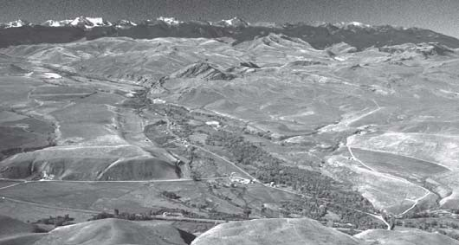
Figure 33. View west-southwest up the valley of Hayden Creek with the northern Lemhi Range in the background. Foreground contains a very thick section of mostly northeast-dipping Challis Volcanic Group lava flows overlain by a thin sequence of gently folded Tertiary sedimentary rocks. One or more major west- to southwest-dipping normal faults repeat the Tertiary rocks. Some of the northernmost Paleozoic rocks at this lon- gitude are in horst blocks to the right of Hayden Creek (Tietbohl, 1986). The high peaks are mainly Mesoproterozoic Lemhi Group (Tysdal, 1996b).

(Tucker, 1975; Harrison, 1985; Janecke, 1994; Blankenau, in press). Notable within the half graben are large, map scale anti- clines and synclines (with fold heights > 2 km) and locally over- turned folds that formed during extension (Janecke et al., 1998; Blankenau, in press). The paleo-elevations of fossil flora in these sedimentary rocks are controversial (Wolfe and Wehr, 1987; Axelrod, 1998).
At least three generations of normal faults extended the south- east margin of the Salmon basin, around Tendoy during the Ceno- zoic (Blankenau, in press). The history of the Horse Prairie half graben to the east in Montana, is even more complex, and reflects at least five generations of normal faults (VanDenburg et al., 1998). East northeast-west southwest extension dominated over north- west-southeast extension in both areas. The Beaverhead normal fault does not persist north of Tendoy (Crone and Haller, 1991; Blankenau, in press).

Lewis and Clark Trail
The Lewis and Clark trail came down the mountains from Lemhi Pass to near the village of Tendoy. Lewis and Clark, led by Sacagawea, whose brother was the chief of the local Shoshone tribe, came through here in 1805. Among many other versions, Robertson (1998) describes this place and event succinctly.

Fort Lemhi
Two miles north of Tendoy, at mile 102, is the Historical Marker for Fort Lemhi (Fig. 34), which, in 1855 was the first Mormon settlement in Idaho (Snook et al., 1992). The site, at the mouth of Pattee Creek, was abandoned in 1858, and the Mor- mons retreated southward to Zion. This was a retrenchment of the grand plans for a Mormon State of Deseret that would have spanned much of the interior western United States (Morgan, 1987).
At mile 111 is Baker. The steep front of the Beaverhead Moun- tains looms to the north (Fig. 35). The mountains are bounded by

the Paleogene Salmon basin detachment fault (Janecke et al., 1998; Blankenau, in press), and are composed of a generally east-dip- ping section of Apple Creek, Gunsight, and Swauger Formations. Late Pleistocene alpine glaciers sculpted the range. The maze of thrust faults shown on the Dillon 1° x 2° sheet geologic map (Ruppel et al., 1993) is probably not present (see Umpleby, 1913; Anderson, 1956; 1961; Winston et al., 1999, this volume). Free- man Peak is the prominent horn north of Salmon (Figs. 35 and 36). Wimpey Creek, northeast of Baker provides a view of the Salmon basin detachment, whereas a drive up Withington Creek, south of Baker, provides access to the Eocene Withington Creek caldera (Ruppel et al., 1993; Blankenau, in press). This caldera is one of the few calderas outside the central cauldron complex of the Challis volcanic field. Quartzite-bearing, ash flow tuffs filled the caldera in Middle Eocene time (S.U. Janecke, unpublished data). Harrison (1985) described the lithology and depositional environment of the fluvial to lacustrine basin-fill deposits of the Salmon area in detail. Excellent exposures of these rocks are present along the Lemhi River between Baker and Salmon. Ac- cess is provided by frontage roads on both sides of the highway. Studies in the southeast part of the Salmon basin (Blankenau and Janecke, 1997) suggest a far more complex stratigraphic and tec-
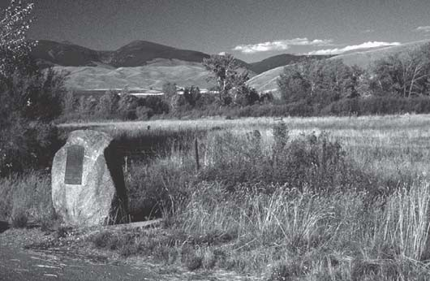
Figure 34. Historical marker for site of Fort Lemhi, first Mor- mon settlement in Idaho, located along Lemhi Creek in middle distance.

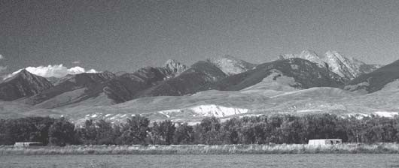
Figure 35. View to the northeast of the front of the Beaverhead Mountains just south of Salmon. The high peaks are com- posed of Mesoproterozoic Lemhi Group and Swauger Quartz- ite. Freeman Peak is the prominent peak in the left middle. White rocks in foothills are Paleogene basin-fill deposits (prob- ably lacustrine deposits). The Salmon basin detachment fault separates the tree-covered mountains in the distance from the sage-covered foothills in the middle distance.
tonic evolution than envisioned by Harrison (1985).

Salmon
Salmon is reached at mile 119 (Fig. 37). The city was orga- nized in 1869, after discovery of gold at Leesburg in 1866. George
- Shoup, Idaho’s last territorial governor, was one of the leading County Commissioners of the new Lemhi County (Snook et al., 1992). Sheared 1370 Ma porphyritic granites northwest of Salmon intruded the Yellowjacket Formation (Evans and Zartman, 1990; Doughty and Chamberlain, 1996) (Fig. 2). This metamorphism
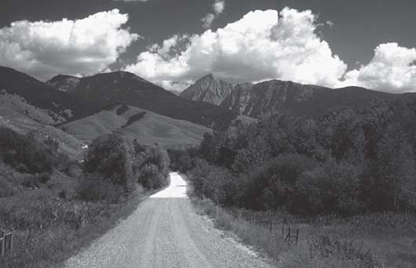
Figure 36. View north up Carmen Creek to Freeman Peak, under- lain by Mesoproterozoic Lemhi Group and Swauger Forma- tion. The Miner Lake-Beaverhead Divide fault zone, an enig- matic, steeply southwest-dipping fault, is directly behind Free- man Peak.
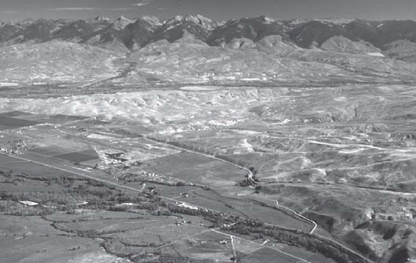
Figure 37. View looking northeast across the Salmon basin from south of Salmon. The Salmon airport is left of center. The Lemhi River flows from right to left and joins the Salmon River (bot- tom) just left of the edge of the photograph. Harrison (1985) most recently described the Paleogene basin-fill deposits in low eroded hills between tributaries of the Lemhi and Salmon rivers. She described conglomerates along the basin margin that interfinger with fine tuffaceous lacustrine deposits in the center of the basin. Blankenau and Janecke (1997) found at least two unconformity-bounded sequences of sedimentary rocks in the southeast part of this basin, several miles to the right of this photograph. The sedimentary rocks here are not well dated but may be as old as Middle Eocene to younger than 30 Ma (Axelrod, 1998; Blankenau, in press). Trees cover Mesoproterozoic rocks of the Beaverhead Mountains.

was initially thought to be 1500 Ma (K-Ar, Armstrong, 1975), and formed the incorrect basis for the concept of a Mesoproterozoic Salmon River Arch. This is the end of Roadlog #3. Roadlog #4 joins here.

ROADLOG #4: STANLEY TO CHALLIS ALONG THE SALMON RIVER

The Salmon River Canyon

Stanley to Yankee Fork
This road guide starts in Stanley, Idaho, and heads north and east along the Salmon River on Idaho Highway 75 toward Challis. As such, it crosses the strike of the orogenic belt rather than go- ing more-or-less parallel to strike as do Roadlogs #1-3. The Challis 1° x 2° geologic map of Fisher et al. (1992) is a critical reference for the first two-thirds of this road log. Set odometer to 0.0 miles at the intersection of Highway 75 and 21 in Upper Stanley. Johnson et al. (1988) describe the geology along this road between Stanley and Thompson Creek. From Stanley eastward, the Salmon River first passes through Late Cretaceous granodiorite of the Idaho batholith, then into Paleozoic wallrocks of the batholith, includ- ing the Pennsylvanian and Permian Grand Prize Formation (Sun Valley Group), and the lower Paleozoic Salmon River Assem- blage (Milligen Formation equivalent) (Fisher et al., 1992; Link et al., 1995).
The Stanley Basin, a west-tilted Basin-and-Range half-gra- ben, is south and west of Stanley, bordered by the Sawtooth Moun- tains on the west (Fig. 38) and the White Cloud Peaks to the east. The Sawtooth normal fault is antithetic to the dominantly west- southwest dipping Basin-and-Range normal faults to the east. The floor of Stanley basin is almost completely mantled by till. The glacial geology of this area is described by Breckenridge et al. (1988) and Borgert et al. (1999, this volume). Eocene granite is exposed in the Sawtooth Range south of Redfish Lake (Fisher et al., 1992).
Radiometric dates (mainly K-Ar) in biotite granodiorite of the Idaho yield ages of 85 to 70 Ma (Kiilsgaard and Lewis, 1985; Lewis et al., 1987; Criss and Fleck, 1987; Johnson et al., 1988). Hot springs along Idaho Highway 75 coincide with normal faults of the northeast-striking Trans-Challis system. These Eocene faults cut the granitic rocks, and controlled mineralization and topogra- phy during Challis volcanism (Kiilsgaard et al., 1986; Bennett, 1986). Placer workings in older alluvium can be seen at several points. About 8 miles from Stanley is the Basin Creek road to the left. Basin Creek is near the southwest end of the Custer graben, a northeast-trending synvolcanic basin (Fig. 4).

Sunbeam and Yankee Fork
Thirteen miles past Stanley is the town of Sunbeam and the mouth of the Yankee Fork river. The Yankee Fork was site of a major gold rush in the 1870’s. Peak production, from Challis- related epithermal deposits and their placers, was in the 1880s.
A power dam built on the Salmon River here in 1910 was sabotaged in 1934 (Fig. 39). “It is uncertain.who is entitled to an accolade for dynamiting the south abutment. However, there is no limit to what can be accomplished if no one cares who gets the credit” (Carrey and Conley, 1978, p. 66). This sabotage allowed
salmon, at least until dams on the lower Snake River dealt the species-fatal blow (Fig. 40), to return to Redfish Lake and the Stanley Basin.
The historic gold-placer dredge ten miles up Yankee Fork creek now is a mining museum. Hecla Mining Co. operated the Grouse Peak gold mine near the western headwaters of the Yankee Fork, in the early 1990s (Fig. 41). The Grouse Peak deposit is located in Eocene lake beds, and contains gold deposited by shallow hy- drothermal systems (Allen and Hahn, 1994). The upper course of the Yankee Fork follows the southern boundary of the syn-Challis Custer Graben (Fig. 4) (Fisher et al., 1992).

Paleozoic Black-Shale Mineral Belt
The mouth of Warm Spring Creek, a major tributary from the south is reached about 16 miles beyond Stanley. East of here the uplands above road level pass into steeply west-dipping Paleo- zoic sedimentary rocks of the Black Shale Terrane of Hall and Hobbs (1995). An apophysis of the Idaho batholith persists at road level for about 5 more miles. The black-shale belt includes the structurally complex Cambrian, Devonian, and Mississippian Salmon River Assemblage (Hall, 1985; Fisher et al., 1992), that forms dark-colored talus-covered shaley outcrops (Fig. 42). Part of it probably correlates with the Devonian Milligen Formation that contains syngenetic stratiform silver-lead-zinc deposits near Sun Valley (Hall, 1985; Turner and Otto, 1988; Turner and Otto, 1995).
North of the road and river about 23 miles from Stanley is a major steeply west-dipping Mesozoic(?) gouge zone in the Salmon River Assemblage. Slate Creek, at 24 miles from Stanley coin- cides with the eastern edge of the Idaho batholith. It is a major drainage of the glacially sculpted White Cloud Peaks area to the south, which contain Grand Prize Formation overlying Salmon River Assemblage, intruded by Cretaceous granodiorite. About ten miles up Slate Creek is the Livingston Mine, that contains syngenetic stratiform mineral deposits in the Salmon River As- semblage (Hall, 1985). Eocene volcanic rocks cap the highest ridges eastward from Slate Creek on both sides of the Salmon River (Fisher et al., 1992).
Twenty-six miles from Stanley is the Thompson Creek Road. The Thompson Creek molybdenum mine is 4.1 miles up the road to the north. It contains a low-fluorine stockwork molybdenum deposit with a few base-metal lead and silver veins hosted by the Salmon River Assemblage (Fig. 43). The deposit formed during Late Cretaceous hydrothermal alteration associated with the Idaho batholith. Extensive associated potassic alteration produced mus- covite mica with 40Ar-39Ar ages of 87.4 to 87.6 Ma (Hall; 1985; Johnson et al., 1988).
The Yankee Fork Ranger station is one mile east of Thomp- son Creek, about 28 miles from Stanley. Iron-stained Salmon River Assemblage forms cliffs on both sides of road. The geologic map of the Bayhorse area (Hobbs et al., 1991) shows the geology be- tween here and Challis in more detail than Fisher et al. (1992).

Bayhorse Assemblage
East of Sullivan Hot Springs, 31 miles from Stanley, the Salmon River Assemblage structurally overlies Cambrian to Or- dovician strata of the Bayhorse district (Hobbs et al., 1991) (Fig.

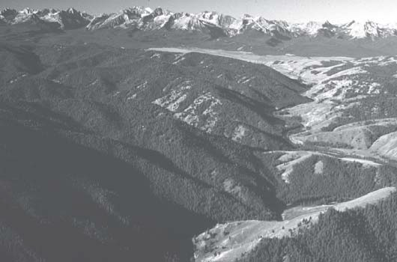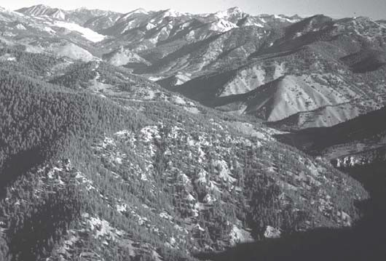

Figure 38. Aerial view to the west of front of Sawtooth Moun- tains in distance, Stanley Basin in middle distance and lower part of Salmon River Canyon in right foreground. Glaciated northern Sawtooth Mountains are made of mainly Cretaceous intrusive rocks on north and Eocene granite on south (left side of view).
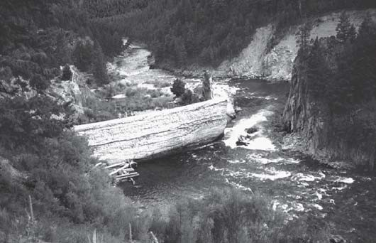
Figure 39. Dam across the Salmon River at the mouth of the Yan- kee Fork. It was sabotaged in 1934.

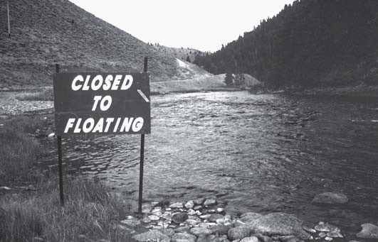

Figure 40. The Salmon River was closed to floating on a short stretch between Stanley and Sunbeam in August 1998, due to (futile?) efforts to protect salmon spawning beds.
Figure 41. Aerial view looking north up the Yankee Fork to the Grouse Creek open-pit gold mine. Peaks on skyline are Twin Peaks, part of the Eocene Twin Peaks Caldera. The mine is located in a northeast-trending Eocene graben bounded by faults of the Trans-Challis fault zone (Fig. 4).

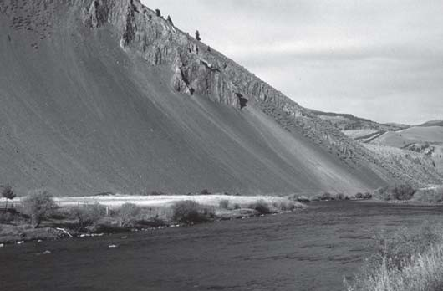
Figure 42. Talus-covered slopes of dark argillaceous rocks of the Paleozoic Salmon River Assemblage on the north side of Salmon River at Clayton. The age and tectonic significance of these rocks is obscure.

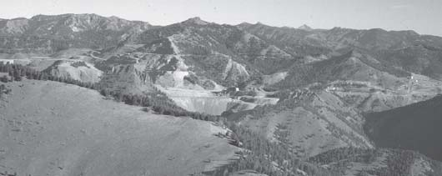

Figure 43. Aerial view looking northeast at the Thompson Creek open-pit molybdenum mine. The bare ridge in the foreground is underlain by Paleozoic Salmon River assemblage, which hosts the mineral deposit, near a Cretaceous intrusive body. The skyline behind mine is underlain by dacite lava flows of the Eocene Challis Volcanic Group.

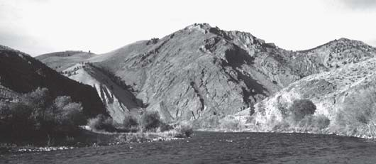

Figure 44. Flatirons of lower Paleozoic rocks of the Bayhorse sequence, looking northeast, below Clayton. Kinnikinic Quartzite makes up the massive cliff.

44). The fault here carries tightly folded lower Paleozoic and Milligen-equivalent Salmon River Assemblage over Ordovician Saturday Mountain Formation (see Hobbs et al., 1991, west end of cross section D-D’). Depending on the age of the Salmon River Assemblage immediately above the west-southwest dipping fault, the contact could be a low-angle normal fault. East of (below) this fault, whose movement history has been much debated (Do- ver, 1978; Hall, 1985; Link et al., 1995) the road enters the miogeoclinal Carbonate Terrane of Hobbs (1995).
Hobbs’ (1995) Carbonate Terrane contains the Ordovician and Cambrian Bayhorse Dolomite, the Ordovician Ella Dolomite, Kinnikinic Quartzite and Saturday Mountain Formation, over- lain by thick Silurian to Mississippian carbonate strata (Fig. 3). Within these rocks north of the Salmon River is the Bayhorse mining district (Ross, 1937; Hobbs et al., 1991).
Thirty-three miles from Stanley, east of Sullivan Hot Springs, the road crosses through a map-scale anticline with Ordovician Clayton Mine Quartzite in the core and at mile 34 enters Clayton, population 26. Below Clayton is a big vista of Kinnikinic Creek on the north, with Ordovician Kinnikinic Quartzite overlain by orange-weathering carbonate of the Saturday Mountain Forma- tion (Fig. 44). To the east is open country underlain by the Or- dovician Ramshorn Slate along the flanks of another major, north- south trending anticline (Hobbs et al., 1991). Challis lava flows, tuffs and intrusive rocks are south of the river high on the ridge tops.
Several outcrops of Jurassic gabbro are just west of the mouth of the East Fork of the Salmon River, and near the Clayton Mine, up Kinnikinic Creek (Hobbs et al., 1991; Fisher et al., 1992). This is the only Jurassic intrusive rock in eastern Idaho. The gab- bro intruded preferentially into the Ramshorn Slate (Hobbs et al., 1991).

East Fork Salmon River
Just east of Clayton, thirty seven miles from Stanley, the East Fork of the Salmon River enters from the south. The East Fork road provides access to a thick succession of Eocene Challis Vol- canic Group (Fisher and Johnson, 1995b) including sedimentary rocks along Spar Canyon (Palmer, 1997; Palmer and Shawkey, 1997). It also affords access to the Spar Canyon Paleozoic car- bonate succession.
The river and highway head off to the north, changing from their eastward course. From here to Challis the canyon is mainly

Figure 45. Aerial view looking south up the Salmon River canyon west of Challis. High skyline peak is Castle Peak in the White Cloud Peaks (the “heart of Idaho”). Most of the bare slopes west of the river are underlain by Challis Volcanic Group. Paleozoic rocks underlie the tree-covered ridge above the bare slopes, and are also found as inliers along the Salmon River canyon (Hobbs et al., 1991).
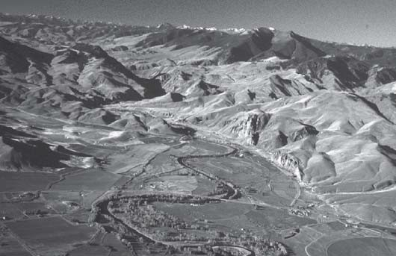
in Challis Volcanic Group with hills of folded Ordovician or older Clayton Mine Quartzite poking through (Hobbs et al., 1991). The bedrock ridge of Lone Pine Peak, east of the roads, contains Sil- urian to Mississippian Carbonate Terrane strata studied by Hays et al. (1980) and McFaddan et al. (1988). Notable are reef com- plexes in the Jefferson Formation and underlying Devonian chan- nel-fill facies (Isaacson and Dorobek, 1988; Isaacson et al., 1988; Grader and Dehler, 1999, this volume).
Forty-six miles from Stanley is Malm Gulch on the right. Up Malm Gulch are extensive outcrops of Challis Group volcaniclastic sediments, including ash-flow tuff, volcanic sand- stone, conglomerate and diamictite. A petrified forest of in situ Metasequoia stumps in Challis sandstones and conglomerates here was described by Ross (1937).
Fifty-two miles from Stanley the road comes out of the Salmon River canyon (Fig. 45). The country opens up to Basin-and-Range country of Round Valley, with the Pahsimeroi Mountains uplifted to the east at the northern end of the Lost River Range. Along the road between here and the northernmost end of the Pahsimeroi Mountains are Challis Volcanics. The Junction with US Highway 93 is reached 56 miles from Stanley. The Land of the Yankee Fork Mining Museum is just north of the road. The Big Lost River roadlog #1 joins here.

Challis to Salmon
Start at intersection of US 93 and Idaho Highway 75 on the south edge of Challis, Idaho. Proceed north on US 93. Set odom- eter to zero.
The city of Challis overlooks Round Valley, between the Salmon River Mountains and the north end of the Lost River Range (Figs. 45 and 46). Challis was laid out in 1876, and settled by cattle ranchers and then miners supplying the Yankee Fork gold mines (Carrey and Conley, 1978; Dereg, 1996). The rocks south and west of town belong to the Challis Volcanic Group, and con- sist of dacite and andesite lavas and ashflow tuffs, erupted mainly from centers in the Twin Peaks Caldera and Van Horn Peak caul-

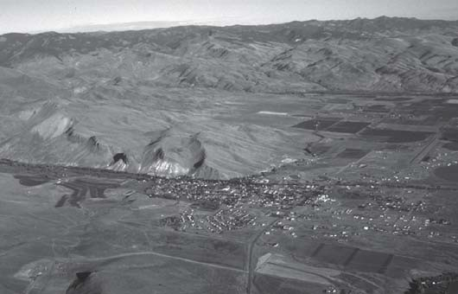

Figure 46. Aerial view of city of Challis, looking north. Densely welded Tuff of Challis Creek is repeated by west-dipping normal faults in the low hills north of town. The underlying white unit is the Tuff of Pennal Gulch (McIntyre and Hobbs, 1987). Janecke et al. (1997) report an 40Ar/39Ar date for the tuff of Challis Creek from these exposures of 45.70 ± 0.08 Ma. The tuffs are very accessible from a side street in Challis. The owners nearby don’t want rocks rolled on their houses, however.

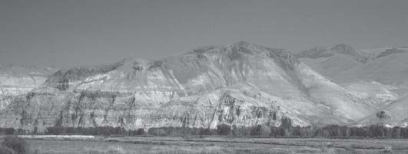

Figure 47. View of pyroclastic rocks at the northwest edge of the Pahsimeroi Mountains from north of Challis. The dark-col- ored rocks that underlie the skyline in the middle distance are densely welded Tuff of Challis Creek sitting on top of the bedded white tuff of Pennal Gulch (McIntyre and Hobbs, 1987). There was erosion between deposition of the two units so the base of the Tuff of Challis Creek is inset into paleo- lows in the underlying tuffaceous sedimentary rocks of Pennal Gulch. Janecke (1992a) interpreted the erosion to reflect ini- tial slip on Paleogene normal faults. Subsequent small nor- mal faults disrupted the once continuous tuff of Challis Creek here. The Twin Peaks caldera northwest of Challis was the source for the tuff of Challis Creek (Hardyman, 1985).

dron complex north and west of town (Fig. 4) (McIntyre et al., 1982; Hardyman, 1985; McIntyre and Hobbs, 1987; Fisher et al., 1992; Janecke and Snee, 1993). North-south side roads off the main east-west street through Challis provide access to a section of east-dipping ashflow tuffs on the northwest side of town (McIntyre and Hobbs, 1987).

Pahsimeroi Mountains
The north end of the Pahsimeroi Mountains, at Grouse Peak east of the Salmon River and east of town (Fig. 47), is underlain by Eocene lava flows and Neoproterozoic strata of the formation
of Leaton Gulch (McIntyre and Hobbs, 1987; Carr and Link, 1999, this volume). Southward in the Pahsimeroi Mountains progres- sively younger Paleozoic strata crop out, until Pennsylvanian rocks form the ridges near Doublespring Pass (Mapel et al., 1965; Janecke and Wilson, 1992; Fisher and Anastasio, 1994). Challis volcanics extensively cover the northern portion and east side of the range (Janecke and Snee, 1993).
Highway 93 runs north-south, following the Salmon River, and crossing the local northeasterly strike of the Neoproterozoic bedrock in the Pahsimeroi Mountains. North of Challis the road crosses through the northern end of the Lost River Range, Pahsimeroi Valley, and the northern end of the Lemhi Range (Fig. 4, 50). The Salmon River alternately cuts through narrow bed- rock canyons and more open country underlain by Challis Volca- nic Group.
On the left, seven miles north of Challis is the mouth of Challis Creek and ten miles north is Morgan Creek. A few miles up Mor- gan Creek Mesoproterozoic Swauger Formation forms the steep cliffs west of the road (McIntyre and Hobbs, 1987).

Canyon North of Challis
In general the Salmon River canyon cuts thick and variable sections of Eocene Challis Volcanic Group rocks overlying Mesoproterozoic strata, including the Lemhi Group and Swauger Quartzite (Hobbs and Cookro, 1995; Winston et al., 1999, this volume). These Mesoproterozoic rocks are locally tightly folded but form an overall south-west dipping homocline (McIntyre and Hobbs, 1987). Repetition by gently southwest-dipping normal faults is likely. The volcanic rocks are cut by many north to north- west-striking Basin-and-Range normal faults and vary in their attitude. Gentle tilts on the volcanic rocks are most common (McIntyre and Hobbs, 1987). The first bedrock canyon is reached 16 miles north of Challis, north of Shep Creek on the south. Here the Mesoproterozoic Swauger Formation forms south-southwest- dipping flatirons through which the river flows. Some exposures of pre-Tertiary rocks between Challis and Salmon are uplifted along Cenozoic normal faults but many bedrock ridges reflect exhumed pre-Tertiary paleotopography.

Mouth of the Pahsimeroi Valley
The mouth of the Pahsimeroi River is about 20 miles north of Challis. The Little Lost River roadlog #2 joins here.
East of the road at Ellis are mud-cracked beds of the Mesoproterozoic Apple Creek Formation (Fig. 48). To the north is the north end of the Lemhi Range (Fig. 49). Two miles to the north the river cuts through younger west-dipping Swauger For- mation (Fig. 50). A buried southwest-dipping thrust fault prob- ably separates these exposures and continues north toward an older-on-younger fault along Moyer Creek that Ekren (1988) mapped as a normal-right slip fault (S.U. Janecke, unpublished data). The southern extent of this thrust fault is not known.

Northern Lemhi Range
Twenty five miles from Challis the Swauger Formation is unconformably overlain by Challis Volcanic Group strata, dropped down on the west-dipping Salmon River fault (=Allison Creek fault) that cuts the northwest end of the Lemhi Range (Janecke,

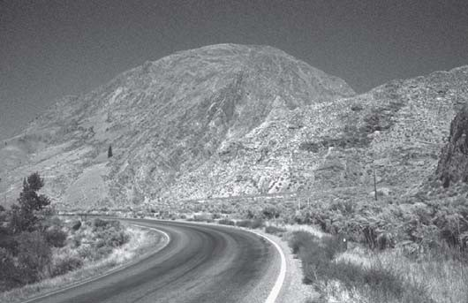

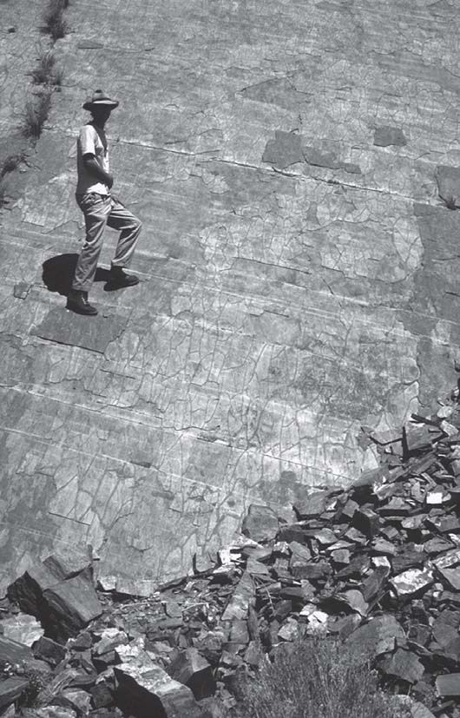
Figure 48. Large mud cracks on bedding plane of Mesoproterozoic Apple Creek Formation on east side of Salmon River at Ellis. Traces of prominent spaced cleavage dip to the right.

1993, 1994; Tysdal and Moye, 1996) (Fig. 24). An east-tilted Paleogene half graben formed in the hanging wall (Janecke, 1994). From Allison Creek (26 miles from Challis) north to McKim Creek (29 miles from Challis) the greenish dacite ash-flow tuff of Ellis Creek on both sides of the river. This ashflow tuff is thick and widespread in the Challis volcanic field and its eruption produced the enormous Van Horn Peak cauldron complex (Fig. 4; McIntyre et al., 1983). The canyon of the river parallels the Salmon River fault and stays mainly in Challis volcanic rocks (Fig. 2).
North of McKim Creek the canyon enters again into Apple Creek Formation, including the Apple Creek diamictite unit, that contains cleaved argillite and siltite with pebbles of coarse siltite and coarse-grained metasandstone (Tysdal and Moye, 1996). The high Lemhi Range to the east contains steeply northeast-dipping, locally overturned beds of the Lemhi Group and Swauger For- mation. These are repeated by southwest-dipping normal faults of pre-Challis age (Tysdal and Moye, 1996; Tysdal, 1996a and 1996b). South of Ringle Creek (34 miles from Challis) is a cliff of Apple Creek Formation, folded to a north-trending syncline, east of the road. To the north at Ringle Creek the Apple Creek is
Figure 49. West-dipping flatirons of Mesoproterozoic Swauger Formation on the north end of Lemhi Range, east of the Salmon River.
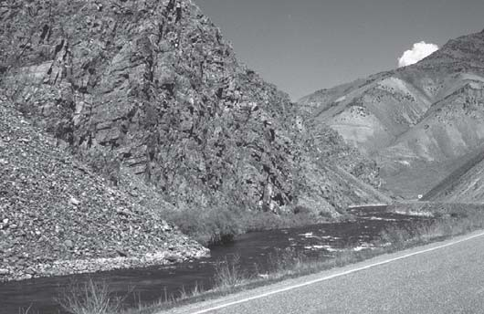
Figure 50. Northeast-dipping Mesoproterozoic Swauger For- mation along Salmon River north of Ellis. The light colored rocks in the distance are east-dipping tuff of Ellis Creek over- lain by lava flows (McIntyre and Hobbs, 1987). This ridge of Swauger Formation was a paleohigh prior to Challis volcanism.

unconformably overlain by dacite and basalt lava flows of the Challis Volcanic Group (Tysdal and Moye, 1996).
On the right about 35 miles from Challis, is Poison Creek. The lower 2.5 miles of Poison Creek cross Challis volcanic rocks in the hanging wall of the Salmon River (=Allison Creek) normal fault. In the footwall, the south-dipping Poison Creek thrust places the Mesoproterozoic Apple Creek Formation on Ordovician Sat- urday Mountain Formation and older rocks (Soregaroli, 1961; Tysdal and Moye, 1996; Tysdal, 1996a; Evans, 1999). This thrust is the westward continuation of the Hawley Creek thrust and may extend to the west of the Salmon River into the Rattlesnake Creek area (Starr, 1955; Landreth, 1964; Ekren, 1988; Skipp, 1987).
The road remains in Challis Group to about a mile north of the turnoff up Rattlesnake Creek to the Twin Peaks Guest Ranch (41 miles from Challis) where it again enters the Apple Creek Formation, dipping vertically, and making big talus cones east of the road. The 45th parallel is in Apple Creek Formation. The Challis Volcanic Group overlies it unconformably about one mile to the north.

At 12 mile road (50 miles from Challis) the rocks are Challis volcanics, but then the road enters Apple Creek Formation again, forming very steeply dipping flatirons. The last bedrock is reached near 10 Mile Creek. From here north to Salmon, the rocks are northeast-dipping Challis volcanics and overlying gently folded Tertiary sedimentary rocks of the Salmon basin (Ruppel et al., 1993). See Roadlog #3 for a description of this Paleogene rift basin.

Salmon Valley
Fifty-five miles from Challis is the Williams Creek road on the west. This main Forest Service road affords access to the Pan- ther Creek area (Janecke et al., 1997), including the Meridian Gold Corporation BearTrack gold mine.
Coming into the Salmon Valley the Beaverhead Mountains loom to the northeast, in the footwall of the Salmon Basin de- tachment (Figs. 35 and 37). These peaks are made of Lemhi Group and Swauger Formation of the Belt Supergroup (Umpleby, 1913; Anderson, 1956; 1961; Tucker, 1975; Winston and Link, 1993). Tertiary lacustrine and fluvial beds occupy the low country east of Salmon, with Challis volcanics west and south of Williams Creek and in the northern Lemhi Range. Northwest of there is Yellowjacket Formation intruded by 1370 Ma granite (Evans and Zartman, 1990; Ruppel et al., 1993; Doughty and Chamberlain, 1996).

Panther Creek Half-Graben
The geology of the Challis Volcanic Group in the Panther Creek half graben has recently been reviewed by Janecke et al. (1997). They conclude that the half graben formed between about
47.7 and 44.5 Ma, during which time as much as 6.5 km of rocks were deposited. Rates of volcanic activity kept up with basin sub- sidence, so that the basin was mainly filled with ash-flow tuffs. Post-volcanic conglomerate and reworked ash make up a small part of the fill of the half graben.

Salmon to North Fork
Reset odometer to zero at intersection of US Highway 93 and Idaho Highway 28 in Salmon. Head north on 93. North of Salmon the road cuts through Tertiary rocks until just north of Tower Creek (11 miles from Salmon). There the road and river enter a canyon cut in siltites of Apple Creek (Yellowjacket) Formation, with Ter- tiary volcanic rocks and conglomerate unconformably overlying it. Harrison (1985) showed that these conglomerates had a source to the west in the Salmon River Mountains and interfinger to the east and south with lacustrine deposits. Excellent exposures of cobble to boulder conglomerates of the Kriley Gulch Formation (the proximal Tertiary basin fill) in the vicinity of Tower Creek show that the unit depositionally overlies the Apple Creek For- mation (Harrison, 1985). This, and the irregular trace of the con- tact between the Tertiary and Mesoproterozoic rocks to the south suggests that the western boundary of the Salmon basin is an an- gular unconformity. Most previous workers mapped a major nor- mal fault in this location (Ruppel et al., 1993; Harrison, 1985). The road remains in Yellowjacket (likely Apple Creek, Winston et al., 1999, this volume) Formation to North Fork, where the
Salmon River heads west across the River of No Return Wilder- ness.

ACKNOWLEDGMENTS
Our associations with the U.S. Geological Survey, in particu- lar Wayne Hall, Betty Skipp, Warren Hobbs, Ed Ruppel, Anna Wilson and Ron Worl during the Hailey CUSMAP project intro- duced us to east-central Idaho and to the geologic complexity of the area. The hard work of Jim Blankenau, Brian Hammond, and Colby VanDenburg, Masters students under Janecke at Utah State University, helped clarify the Tertiary history of the Salmon re- gion. This manuscript was drastically improved by reviews from Betty Skipp and Dave Rodgers. Link is very grateful for drafting help by Jim Riesterer and Vita Taube.

REFERENCES CITED
Aleinikoff, J. N., Evans, K. V., Fanning, C. M., Obradovich, J. D., Ruppel, E. T., Zieg, J. A., and Steinmetz, J. C., 1996, Shrimp U-Pb ages of felsic igneous rocks, Belt Supergroup, western Montana: Geological Society of America Abstracts with Programs, v. 28, p. 376.
Allen, K.D., and Hahn, G.A., 1994, Geology of the Sunbeam and Grouse Creek gold-silver deposits, Yankee Fork mining district, Eocene Challis volcanic field, Idaho: A volcanic dome- and volcaniclastic-hosted epithermal sys- tem: Economic Geology, v. 89, p. 1964-1982.
Allmendinger, R. W., 1992, Fold and thrust tectonics of the Western United States exclusive of the accreted terranes, in Burchfiel, B. C., Lipman, P. W., and Zoback, M. L., eds., The Cordilleran Orogen; conterminous U.S.: Cam- bridge, MA, Massachusetts Institute of Technology, Department of Earth, Atmospheric, and Planetary Sciences, p. 583-607.
Alt, D.D. and Hyndman, D.W., 1989, Roadside geology of Idaho: Missoula, MT, Mountain Press Publishing Co. 393 p.
Anastasio, D.J., and Schmitt, J.G., 1998, Early Eocene upper crustal shortening coincident with midcrustal extension during gravitational collapse of the Sevier hinterland, Idaho-Montana thrust belt: Geological Society of America Abstracts with Programs, v. 30, no. 7, p. A-73.
Anastasio, D. J., Fisher, D. M., Messina, T. A., and Holl, J. E., 1997, Kinematics of decollement folding in the Lost River Range, Idaho: Journal of Structural Geology, v. 19, p. 355-368.
Anders, M.H., Geissman, J.W., Piety, L.A., and Sullivan, J.T., 1989, Parabolic distribution of circum-eastern Snake River Plain seismicity and latest Qua- ternary faulting: Migratory pattern and association with the Yellowstone hotspot: Journal of Geophysical Research, v. 94, p. 1589-1621.
Anders, M.H., Spiegelman, M., Rodgers, D.W., and Hagstrum, J.T., 1993, The growth of fault-bounded tilt blocks: Tectonics, v. 12, p. 1451-1459.
Anderson, A.L., 1956, Geology and mineral resources of the Salmon quadrangle, Lemhi County, Idaho: Idaho Bureau of Mines and Geology Pamphlet 106, 102 p.
Anderson, A.L., 1961, Geology and mineral resources of the Lemhi quadrangle, Lemhi County, Idaho: Idaho Bureau of Mines and Geology Pamphlet 124, 111 p.
Armstrong, R.L., 1975, Precambrian (1500 m.y. old) rocks of central Idaho— The Salmon River Arch and its role in Cordilleran sedimentation and tec- tonics: American Journal of Science, v. 275-A, p. 437-467.
Armstrong, R.L., Leeman, W.P., and Malde, H.E., 1975, K-Ar dating, Quater- nary and Neogene volcanic rocks of the Snake River Plain, Idaho: Ameri- can Journal of Science, v. 275, p. 225-251.
Axelrod, D. I., 1998, The Oligocene Haynes Creek Flora: University of Califor- nia Publications Geological Sciences, v. 143, p. 99 pp.
Baldwin, E.W., 1951, Faulting in the Lost River Range area of Idaho: American Journal of Science, v. 249, p. 884-902.
Ballard, W.W., Bluemle, J.P., and Gerhard, L.C., coordinators, 1983, Northern Rockies-Williston Basin Correlation Chart: AAPG Correlation of Strati- graphic Units of North America (COSUNA), Chart NRW.
Bennett, E.H., 1977, Reconnaissance geology and geochemistry of the Black- bird Mountain-Panther Creek region, Lemhi County, Idaho: Idaho Bureau of Mines and Geology Pamphlet 167, 108 p.

Bennett, E.H., 1986, Relationship of the Trans-Challis fault system in central Idaho to Eocene and Basin-and-Range extensions: Geology, v. 14, p. 481- 484.
Berry, W.B.N., 1998, Ordovician-Silurian Phi Kappa-Trail Creek-unnamed silt- stone suite: An exotic Nappe?: Geological Society of America Abstracts with Programs, v. 30, no. 7, p. A-151.
Beutner, 1972, Reverse gravitative movement on earlier overthrusts, Lemhi Range, Idaho: Geological Society of America Bulletin, v. 83, p. 839-846.
Beutner, E.C., 1968, Structure and tectonics of the southern Lemhi Range, Idaho [Ph.D. thesis]: University Park, Pennsylvania State University, University Park, 106 p.
Blankenau, J. J. and Janecke, S. U., 1997, Three-dimensional structure of a Pa- leogene rift basin and its effects on synextensional sedimentation, Salmon basin ID: Geological Society of America Abstracts with Programs. v. 29, p. 221.
Blankenau, J. J. and Janecke, S. U., 1997, Three-dimensional structure of a Pa- leogene rift basin and its effects on synextensional sedimentation, Salmon basin ID: Geological Society of America Abstracts with Programs. v. 29, p. 221.
Blankenau, J. J., 1999, in press, Cenozoic structure and stratigraphy of the south- east Salmon basin, east-central Idaho [M.S. Thesis]: Logan, Utah, Utah State University, 142 pp. 2 plates.
Bond, J.G., 1978, Geologic map of Idaho: Idaho Bureau of Mines and Geology, scale 1:500,000.
Borgert, J.A., Lundeen, K.A., and Thackray, G.D., 1999, Glacial geology of the southeastern Sawtooth Mountains: Evidence for multiple advances during the last glacial cycle: in Hughes, S.S., and Thackray, G.D., eds., Guidebook to the Geology of Eastern Idaho: Idaho Museum of Natural History, this volume.
Breckenridge, R.M., Stanford, L.R., Cotter, J.F.P., Bloomfield, J.M., and Evenson, E.B., 1988, Glacial Geology of the Stanley Basin, in Link, P.K., and Hackett, W.R., eds., Guidebook to the geology of central and southern Idaho, Idaho Geological Survey Bulletin 27, p. 209-222.
Breuninger, R.H., Canter, K.L., and Isaacson, P.E., 1988, Pennsylvanian-Per- mian Palaeoaplysina and algal buildups, Snaky Canyon Formation, east- central Idaho: U.S.A., in Geldsetzer, H.H.J, James, N.P., and Tebbutt, G.E., eds., Reefs: Canada and adjacent area: Canadian Society of Petroleum Ge- ologists Memoir 13, p. 631-637.
Bruhn, R.L., Yang, Z., Wu, D., and Yonkee, W.A., 1991, Structure of the Warm Springs and northern Thousand Springs fault segments, Lost River fault zone, Idaho: Possible effects on rupturing during the 1983 Borah Peak earth- quake, Tectonophysics, v. 200, p. 33-49.
Burchfiel, B.C., Cowan, D.S., and Davis, G.A., 1992, Tectonic overview of the Cordilleran orogen in the western United States, in Burchfiel, B.C., Lipman, P.W., and Zoback, M.L., eds., The Cordilleran orogen: Conterminous U.S.: Boulder Colorado, Geological Society of America, The Geology of North America, v. G-3, p. 407-479.
Burton, B.R., and Blakley, J.B., 1988, The basal Challis conglomerate, Custer County, south-central Idaho—Implications for the initiation of Challis vol- canism: Geological Society of America Abstracts with Programs, v. 20, no. 6, p. 408-409.
Burton, B.R., and Link, P.K., 1991, Ichnology of fine-grained mixed carbonate- siliciclastic turbidites, Wood River Formation, Pennsylvanian-Permian, south-central Idaho: Palaios, v. 6, p. 291-301.
Burton, B.R., and Link, P.K., 1995, Structural setting of ore deposits in the Lake Creek Mineralized area, Blaine County, south-central Idaho: U.S. Geologi- cal Survey Bulletin 2064-F, 15 p.
Burton, B.R., Link, P.K., and Rodgers, D.W., 1989, Death of the Wood River thrust—Structural relations in the Pioneer and Boulder Mountains, south- central Idaho: Geological Society of America Abstracts with Programs, v. 21, no. 5, p. 62.
Canter, K.L., and Isaacson, P.E., 1991, Depositional history and paleogeographic setting of the Juniper Gulch Member of the Middle Pennsylvanian-Lower Permian Snaky Canyon Formation of central Idaho, in Cooper, J.D., and Stevens, C.H., eds., Paleozoic Paleogeography of the Western United States- II; Pacific Section, Society of Economic Paleontologists and Mineralogists, Publication 67, p. 543-550.
Carr, J. and Link, P.K., 1999, Neoproterozoic Sedimentary Breccias in the For- mation of Leaton Gulch Grouse Peak, Northern Lost River Range, Idaho: Possible Relation to Beaverhead Impact Structure , in Hughes, S.S. and Thackray, G.D., eds., Guidebook to the Geology of Eastern Idaho, Idaho Museum of Natural History, this volume.
Carrey, Johnny and Conley, Cort, 1978, River of No Return: Backeddy Books,
P.O. Box 301, Cambridge, Idaho 83610, 319 p.
Cerling, T.E., Poreda, R.J., and Rathburn, S.L., 1994; Cosmogenic 3He and 21Ne age of the Big Lost River flood, Snake River Plain, Idaho: Geology, v. 22, p. 227-230.
Cluer, J.K., 1989, Surficial geology and geomorphology of the Doublespring Pass area, Lost River Range, east-central Idaho: Contributions to Geology, v. 27, no. 2, p. 55-62.
Criss, R.E., and Fleck, R.J., 1987, Petrogenesis, geochronology, and hydrother- mal systems of the northern Idaho batholith and adjacent areas based on 18O/16O, D/H, 87Sr/86Sr, K-Ar, and 40Ar/39Ar studies, in Vallier, T.L., and Brooks, H.C., eds., Geology of the Blue Mountains region of Oregon, Idaho and Washington: The Idaho Batholith and its border zone: U.S. Geological Survey Professional Paper 1436, p. 95-137.
Constenius, K.N., 1982, Relationships between the Kishenehn basin and the Flathead listric fault system and Lewis thrust salient, in Powers, R.B., ed., Geologic Studies of the Cordilleran Thrust Belt: Rocky Mountain Associa- tion of Geologists, p. 817-830.
Crone, A.J., 1988, Surface faulting and groundwater eruptions associated with the 1983 Borah Peak earthquake, in Link, P.K., and Hackett, W.R., eds., Guidebook to the geology of central and southern Idaho, Idaho Geological Survey Bulletin 27, p. 227-232.
Crone, A.J., and Haller, K.M., 1991, Sedimentation and coseismic behavior of Basin-and-Range normal faults: Examples from east-central Idaho and south- western Montana, U.S.A.: Journal of Structural Geology, v. 13, p. 151-164. Crone, A.J., Machette, M.N., Bonilla M.G., Lienkaemper, J.J., Pierce, K.L., Scott, W.E., and Bucknam, R.C., 1987, Surface faulting accompanying the Borah Peak earthquake and segmentation of the Lost River Fault, central Idaho:
Bulletin of the Seismological Society of America, v. 77, p. 739-770.
Davis, J.E., Jr., 1983, Geology of the Darlington quadrangle, south-central Idaho [M.S. Thesis]: University of Southern Mississippi, 75 p. scale 1:24,000.
Dereg, Betty, 1996, Roadside history of Idaho: Missoula, Montana, Mountain Press, 362 p.
Dorobek, S. L., 1991, Cyclic platform carbonates of the Devonian Jefferson For- mation, southwestern Montana, in Cooper, J. D., and Stevens, C. H., eds., Paleozoic Paleogeography of the Western United States-II, Pacific Section, Society of Economic Paleontologists and Mineralogists, Publication 67, v. 2, p. 509-526.
Dorobek, S.L., Reid, S.K., and Elrick, M., 1991. Antler foreland stratigraphy of Montana and Idaho: The stratigraphic record of eustatic fluctuations and episodic tectonic events, in Cooper, J.D., and Stevens, C.H., eds., Paleozoic Paleogeography of the Western United States-II, Pacific Section, Society of Economic Paleontologists and Mineralogists, p. 487-507.
Doughty, P.T., and Chamberlain, K.R., 1996, The Salmon River arch revisited: new evidence for 1370 Ma rifting near the end of deposition in the Middle Proterozoic Belt basin: Canadian Journal of Earth Sciences, v. 33, p. 1037- 1052.
Doughty, P.T., and Sheriff, S.D., 1992, Paleomagnetic evidence for en echelon crustal extension and crustal rotations in western Montana and Idaho: Tec- tonics: v. 11, p. 663-671.
Dover, J.H., 1980, Status of the Antler orogeny in central Idaho—Clarifications and constraints from the Pioneer Mountains, in Fouch, T.D., and Magathan E.R., eds., Paleozoic paleogeography of western United States. Society of Economic Paleontologists and Mineralogists, Rocky Mountain Section, West- central United States Paleogeography Symposium I, p. 275-299.
Dover, J.H., 1981, Geology of the Boulder-Pioneer Wilderness Study Area, Blaine and Custer Counties, Idaho. Mineral resources of the Boulder-Pioneer Wil- derness Study Area, Blaine and Custer Counties, Idaho. U.S. Geological Survey Bulletin 1497, p. 1-75.
Dover, J.H., 1983, Geologic map and sections of the central Pioneer Mountains, Blaine and Custer Counties, central Idaho. U.S. Geological Survey Miscel- laneous Investigations Series, Map I-1319, scale 1:48,000.
Ekren, E.B., 1985, Eocene caldron-related volcanic events in the Challis quad- rangle, in McIntyre, D.H., ed., Symposium on the Geology and Mineral Resources of the Challis 1°x 2° Quadrangle, Idaho, U.S. Geological Survey Bulletin 1658-C, p. 43-58.
Ekren, E.B., 1988, Stratigraphic and structural relations of the Hoodoo Quartz- ite and Yellowjacket Formation of Middle Proterozoic age from Hoodoo Creek eastward to Mount Taylor, central Idaho: U.S. Geological Survey Bulletin 1570, 17 p.

Evans, K.V., 1999, The Yellowjacket Formation of east-central Idaho: Proceed- ings of Belt Symposium III-1993: Montana Bureau of Mines and Geology, in press.
Evans, K.V. and Zartman, R.E., 1988, Early Paleozoic alkalic plutonism in east- central Idaho: Geological Society of America Bulletin, v. 100, p. 1981-1987. Evans, K.V., and Connor, J.J., 1993, Geologic map of the Blackbird Mountain 15-min. quadrangle, Lemhi County, Idaho: U.S. Geological Survey Miscel-
laneous Field Studies Map MF-2234, scale 1:62,500.
Evans, K.V., and Zartman, R.E., 1990, U-Th-Pb and Rb-Sr geochronology of Middle Proterozoic granite and augen gneiss, Salmon River Mountains, east- central Idaho: Geological Society of America Bulletin, v. 102, p. 63-73.
Fillipone, J.A., Yin, A., Harrison, T.M., Gehrels, G., Smith, M., and Sample, J.C., 1995, Age and magnitude of dip-slip faulting deduced from differen- tial cooling histories; An example from the Hope fault, northwest Montana: Journal of Geology, v. 103, p. 199-211.
Fishel, M.L., 1993, The geology of uplifted rocks on Big Southern Butte: Impli- cations for the stratigraphy and geochemistry of the Eastern Snake River Plain [M.S. thesis]: Pocatello, Idaho State University, 178 p.
Fisher, D.M., and Anastasio, D.J., 1994, Kinematic analysis of a large-scale leading edge fold, Lost River Range, Idaho: Journal of Structural Geology, v. 16, p. 337-354.
Fisher, F.S., 1985, Summary of the geology, mineral deposits, and resource po- tential for selected commodities in the Challis quadrangle, in McIntyre, D.H., ed., Symposium on the geology and mineral deposits of the Challis 1° x 2° quadrangle, Idaho: U.S. Geological Survey Bulletin 1658-A, p. 1-28.
Fisher, F.S. and Johnson, K.M., eds., 1995a, Geology and Mineral Resource Assessment of the Challis 1° x 2° Quadrangle, Idaho: U.S. Geological Sur- vey Professional Paper 1525, 204 p.
Fisher, F.S., and Johnson, K.M., 1995b, Challis Volcanic Terrane, in Fisher, F.S. and Johnson, K.M., eds., Geology and Mineral Resource Assessment of the Challis 1° x 2° Quadrangle, Idaho: U.S. Geological Survey Professional Paper 1525, p. 41-47.
Fisher, F.S., McIntyre, D.H., and Johnson, K.M., 1992, Geologic map of the Challis 1° x 2° quadrangle, Idaho: U.S. Geological Survey Miscellaneous Investigations Series Map I-1819, scale 1:250,000.
Fritz, W.J., and Sears, J.W., 1993, Tectonics of the Yellowstone hotspot wake in southwestern Montana: Geology, v. 21, p. 427-430.
Garmezy, L., 1981, Geology and tectonic evolution of the southern Beaverhead Range, east-central Idaho [M.S. thesis]: University Park, The Pennsylvania State University, 155 p.
Geslin, J.K., 1998, Distal Ancestral Rocky Mountains tectonism: Evolution of the Pennsylvanian-Permian Oquirrh-Wood River basin, southern Idaho: Geological Society of America Bulletin, v. 110, p. 644-663.
Geslin, J.K., Gianniny, G.L., Link, P.K., and Riesterer, J.W., 1997, Subsurface sedimentary facies and Pleistocene stratigraphy of the northern Idaho Na- tional Engineering Laboratory: Controls on hydrogeology in Sharma, S. and Hardcastle, J.H., eds., Proceedings of the 32nd symposium on engineering geology and geotechnical engineering, Boise, Idaho, p. 15-28.
Geslin, J.K., Link, P.K., and Fanning, C.M., 1999, High precision provenance determination using detrital zircon ages and petrography of Quaternary sands on the eastern Snake River Plain, Idaho: Geology, v. 27, in press.
Gianniny, G.L, Geslin, J.K., Riesterer, J.W., Link, P.K., and Thackray, G.D., 1997, Quaternary surficial sediments near Test Area North (TAN), north- eastern Snake River Plain: an actualistic guide to aquifer characterization in Sharma, S. and Hardcastle, J.H., eds., Proceedings of the 32nd sympo- sium on engineering geology and geotechnical engineering, Boise, Idaho, p. 29-44.
Grader, G.W., and Dehler, C.M., 1999, Devonian stratigraphy in east-central Idaho: New Perspectives from the Lemhi Range and Bayhorse area, in Hughes, S.S. and Thackray, G.D., eds., Guidebook to the Geology of East- ern Idaho, Idaho Museum of Natural History., this volume.
Hackett, W.R., and Smith, R.P., 1992, Quaternary volcanism, tectonics and sedi- mentation in the Idaho National Engineering Laboratory area, in Wilson, J.R., ed., Field Guide to Geologic Excursions in Utah and Adjacent Areas of Nevada, Idaho, and Wyoming: Salt Lake City, Utah Geological Survey, p. 1-18.
Hait, M.H., 1987, Southern Lemhi Range, east-central Idaho, in Beus, S.S., ed., Centennial Field Guide Volume 2, Geological Society of America, Rocky Mountain Section, p. 99-102.
Hall, W.E., 1985. Stratigraphy and mineral deposits in middle and upper Paleo- zoic rocks of black-shale mineral belt, central Idaho, in McIntyre, D.H., ed., Symposium on the Geology and Mineral Resources of the Challis 1°x 2°
Quadrangle, Idaho, U.S. Geological Survey Bulletin 1658, chapter J, p. 117- 132.
Hall, W.E., and Hobbs, S.W., 1995, Black Shale Terrane, in Fisher, F.S. and Johnson, K.M., eds., Geology and Mineral Resource Assessment of the Challis 1° x 2° Quadrangle, Idaho: U.S. Geological Survey Professional Paper 1525, p. 25-35.
Haller, K. M., 1988, Segmentation of the Lemhi, and Beaverhead faults, east- central Idaho and Red rock fault, southwest Montana, during the Late Qua- ternary [MS thesis]: University of Colorado.
Hammond, B.F., 1994, The tectonic evolution of the Panther Creek half-graben in east-central Idaho [M.S. thesis]: Logan, Utah State University, 101 p.
Hardyman, R.F., 1985, The Twin Peaks Caldera and associated ore deposits, in McIntyre, D.H., ed., Symposium on the geology and mineral deposits of the Challis 1° x 2° quadrangle, Idaho: U.S. Geological Survey Bulletin 1658-G, p. 97-105.
Hardyman, R.F., and Fisher, F.S., 1985, Rhyolite intrusions and associated min- eral deposits in the Challis volcanic field, Challis quadrangle, in McIntyre, D.H., ed., Symposium on the geology and mineral deposits of the Challis 1° x 2° quadrangle, Idaho: U.S. Geological Survey Bulletin 1658-N, p. 167- 180.
Hargraves, R.B., Cullicott, C.E., Deffeyes, K.S., Hougen, S.B., Christiansen, P.P., and Fiske, P.S., 1990, Shatter cones and shocked rocks in southwestern Montana: The Beaverhead impact structure: Geology, v. 18, p. 832-834.
Hargraves, R.B., Kellogg, K.S., Fiske, P.S., and Hougen, S.B., 1994, Allochthonous impact-shocked rocks and superposed deformations at the Beaverhead site, southwest Montana—possible crater roots buried in south- central Idaho, in Dressler, B.O., Grieve, R.A.F., and Sharpton, V.L., eds., Large Meteorite Impacts and Planetary Evolution: Boulder, Colorado, Geo- logical Society of America Special Paper 293, p. 225-236.
Harrison, S., 1985, Sedimentology of Tertiary rocks near Salmon, Idaho [Ph.D. dissert.]: Missoula, University of Montana, 175 p.
Hays, W.H., McIntyre, D.H., and Hobbs, S.W., 1978, Geologic map of the Lone Pine Peak quadrangle, Custer County, Idaho: U.S. Geological Survey Open- File report, 78-106.
Hays, W.H., Harris, A.G., Dutro, J.R., Jr., and Ross, R.J., Jr., 1980, Stratigraphic sections of Middle Paleozoic rocks in the vicinity of Spar Canyon, Custer County, Idaho: U.S. Geological Survey Open-File report 80-1097, 82 p.
Hemphill-Haley, M.A., Sawyer, T.L., Knuepfer, P.L.K., Forman, S.L., and Wong, I.G., 1994, Late Quaternary paleoseismicity and segmentation along the southern Lemhi fault, southeastern Idaho, in Proceedings of the Workshop on Paleoseismology: U.S. Geological Survey Open-File Report 94-568, p. 81-83.
Hemphill-Haley, M.A., Sawyer, T.L., Knuepfer, P.L.K., Forman, S.L., Smith, R. P., and Wong, I.G., 1991, Multiple Late Quaternary surface faulting events along the southern Lemhi fault, southeastern Idaho: Proceedings, Ninth Utah Conference on Engineering Geology, p. 27-1 to 27-16.
Hobbs, S.W. and Cookro, T.M., 1995, Proterozoic terrane, in Fisher, F.S. and Johnson, K.M., eds., Geology and Mineral Resource Assessment of the Challis 1° x 2° Quadrangle, Idaho: U.S. Geological Survey Professional Paper 1525, p. 12-17.
Hobbs, S.W., 1980, The Lawson Creek Formation of middle Proterozoic age in east-central Idaho: U.S. Geological Survey Bulletin 1482-E, 12 p.
Hobbs, S.W., Hays, W.H., and McIntyre, D.H., 1991, Geologic map of the Bayhorse area, central Custer County, Idaho: U.S. Geological Survey Mis- cellaneous Investigations Series Map I-1882, scale 1:62,500.
Hobbs., S.W., 1995, Carbonate Terrane, in Fisher, F.S. and Johnson, K.M., eds., Geology and Mineral Resource Assessment of the Challis 1° x 2° Quad- rangle, Idaho: U.S. Geological Survey Professional Paper 1525, p. 18-24.
Hodges, K.V., and Applegate, J.D., 1993, Age of Tertiary extension in the Bitter- root metamorphic core complex, Montana and Idaho: Geology, v. 21, p. 161-164.
Huh, O.K., 1967, The Mississippian System across the Wasatch line, east-cen- tral Idaho and extreme southwestern Montana, in Centennial basin of south- west Montana: Montana Geological Society 18th Annual Field Conference Guidebook, p. 31-62.
Huerta, A.D., and Rodgers, D.W., 1996, Kinematic and Dynamic Analysis of a low-angle strike-slip fault: The Lake Creek fault of south-central Idaho: Jour- nal of Structural Geology, v. 18, no. 5, p 585-593.
Hughes, S.S., Smith, R.P., Hackett, W.R., McCurry, M., Anderson, S.R., and Ferdock, G.C., 1997, Bimodal magmatism, basaltic volcanic styles, tecton- ics and geomorphic processes of the Eastern Snake River Plain, Idaho: Brigham Young University Geology Studies, v. 42, Part I, p. 423-458.

Hughes, S.S., Smith, R.P., Hackett, W.R., and Anderson, S.R., 1999, Mafic vol- canism and environmental geology of the eastern Snake River Plain, Idaho, in Hughes, S.S., and Thackray, G.D., eds., Guidebook to the Geology of Eastern Idaho: Idaho Museum of Natural History, this volume.
Isaacson, P.E., and Dorobek, S.L., 1988, Regional significance and interpreta- tion of a coral-stromatoporoid carbonate buildup succession, Jefferson For- mation (Upper Devonian), east-central Idaho, in McMillan, N.J., Embry, A.F., and Glass, D.J., eds., 1988, Devonian of the World, Canadian Society of Petroleum Geologists, v. ii, p. 581-590.
Isaacson, P.E., Bachtel, S.L., and McFaddan, M.D., 1983, Stratigraphic correla- tion of the Paleozoic and Mesozoic rocks of Idaho: Idaho Bureau of Mines and Geology Information Circular No. 37.
Isaacson, P.E., McFaddan, M.D., Measures, E.A., and Dorobek, S.L., 1988, Coral- stromatoporoid carbonate buildup succession, Jefferson Formation (Late Devonian), central Idaho: U.S.A., in Geldsetzer, H.H.J, James, N.P., and Tebbutt, G.E., eds., Reefs: Canada and adjacent area: Canadian Society of Petroleum Geologists Memoir 13, p. 471-477.
James, W.C., and Oaks, R.Q., Jr., 1977, Petrology of the Kinnikinic Quartzite (Middle Ordovician), east-central Idaho: Journal of Sedimentary Petrology, v. 47, p. 1491-1511.
Janecke, S.U., 1992a; Kinematics and timing of three superposed extensional systems, east central Idaho: Evidence for an Eocene tectonic transition: Tec- tonics, v. 11, p. 1121-1138.
Janecke, S.U., 1992b, Geologic map of the Donkey Hills and part of the Doublespring 15-minute quadrangles, Custer and Lemhi Counties, Idaho: Idaho Geological Survey Technical Report 92-4, scale 1:24,000.
Janecke, S.U., 1992c, Geologic map of the Big Windy Peak and Moffett Springs 7.5-Minute quadrangles, Lemhi and Custer Counties, Idaho: Idaho Geo- logical Survey Technical Report 92-6, scale 1:24,000.
Janecke, S.U., 1992d, Geologic map of the Warren Mountain, most of the Red Hills, Short Creek, and Massacre Mountain and some of the Mulkey Bar and Hawley Mountain 7.5-minute quadrangles, Custer and Butte Counties, Idaho: Idaho Geological Survey Technical Report 92-7, scale 1:24,000.
Janecke, S.U., 1992e, Geologic map of the northern two-thirds of the Methodist Creek and Mackay and some of the Mackay Reservoir and Sunset Peak 7.5- Minute quadrangles, Custer and Butte Counties, Idaho: Idaho Geological Survey Technical Report 92-8, scale 1:24,000.
Janecke, S.U., 1992f, Geologic map of the northern part of the Arco Hills and southern part of the Arco Pass 7.5-minute quadrangles, Butte County, Idaho: Idaho Geological Survey Technical Report 92-9, scale 1:24,000.
Janecke, S.U., 1993, Structures in segment boundary zones of the Lost River and Lemhi faults, east-central Idaho: Journal of Geophysical Research, v. 98, p. 16,223-16,238.
Janecke, S.U., 1994, Sedimentation and paleogeography of an Eocene to Oli- gocene rift zone, Idaho and Montana: Geological Society of America Bulle- tin, v. 106, p. 1083-1095.
Janecke, S.U., 1995a, Eocene to Oligocene half grabens of east-central Idaho: Structure, stratigraphy, age, and tectonics: Northwest Geology, v. 24, p. 159- 199.
Janecke, S. U., 1995b, Possible late Cretaceous to Eocene sediment dispersal along structurally controlled paleovalleys in the MT/ID thrust belt: Geologi- cal Society of America Abstracts with Programs, v. 27, p.16.
Janecke, S.U., and Snee, L.W., 1993, Timing and episodicity of middle Eocene volcanism and onset of conglomerate deposition, Idaho: Journal of Geol- ogy, v. 101, p. 603-621.
Janecke, S.U., and Wilson, E., 1992, Geologic and photogeologic map of the Borah Peak, Elkhorn Creek, Burnt Creek, Leatherman Peak 7.5’ quadrangles, Custer County Idaho: Idaho Geological Survey Technical Report 92-5, scale 1:24,000.
Janecke, S.U., Geissman, J.W., and Bruhn, R.L., 1991, Localized rotation dur- ing Paleogene extension in east-central Idaho: paleomagnetic and geologic evidence: Tectonics, v. 10, p. 403-432.
Janecke, S.U., Hammond, B.F., Snee, L.W., and Geissman, J.W., 1997, Rapid extension in an Eocene volcanic are: Structure and paleogeography of an intra-arc half graben in central Idaho: Geological Society of America Bulle- tin, v. 109, p. 253-267.
Janecke, S.U., Vandenburg, C.J., and Blankenau, J.J., 1998, Geometry, mecha- nisms and significance of extensional folds from examples in the Rocky Mountain Basin-and-Range province, U.S.A., Journal of Structural Geol- ogy, v. 20, no. 7., p. 841-856.
Janecke, S. U., McIntosh, W., and Good, S., in press, Structure and stratigraphy of an Eocene-Oligocene supra-detachment basin, Muddy Creek half gra-
ben, southwest Montana: testing supradetachment basin models: Basin Re- search.
Jeppson, M., and Janecke, S. U., 1995, Geometric analysis of folds in central Idaho and southwest Montana: Geological Society of America Abstracts with Programs, v. 27, no. 4, p.16.
Johnson, J.G., Sandberg, C.A., and Poole, F.G., 1988, Early and Middle Devo- nian paleogeography of the western United States, in McMillan, N.J., Embry, A.F., and Glass, D.J., eds., Devonian of the World, Volume 1, Regional Syn- theses, Canadian Society of Petroleum Geologists, p. 161-182.
Johnson, J.G., Sandberg, C.A., and Poole, F.G., 1991, Devonian lithofacies of western United States, in Cooper, J.D., and Stevens, C.H., eds., Paleozoic Paleogeography of the western United States-II: Pacific Section SEPM, Book 67, p. 83-105.
Johnson, K.M., Lewis, R.S., Bennett, E.H., and Kiilsgaard, T.H., 1988, Creta- ceous and Tertiary intrusive rocks of south-central Idaho, in Link, P.K., and Hackett, W.R., eds., Guidebook to the geology of central and southern Idaho, Idaho Geological Survey Bulletin 27, p. 55-86.
Jordan, Brennan, T., 1994, Emplacement and exhumation of the southeastern Atlanta lobe of the Idaho batholith and outlying stocks, south-central Idaho (M.S. thesis): Pocatello, Idaho State University, 110p.
Ketner, K.B., 1968, Origin of Ordovician quartzite in the Cordilleran miogeosyncline: U.S. Geological Survey Professional Paper 660-B, p. 169- 177.
Kiilsgaard, T.H., and Lewis, R.S., 1985, Plutonic rocks of Cretaceous age and faults in the Atlanta lobe of the Idaho batholith, in McIntyre, D.H., ed., Symposium on the geology and mineral deposits of the Challis 1° x 2° quad- rangle, Idaho: U.S. Geological Survey Bulletin 1658-R, p. 29-42.
Kiilsgaard, T.H., and Bennett, E.H., 1995, Idaho batholith terrane, in Fisher, F.S. and Johnson, K.M., eds., Geology and Mineral Resource Assessment of the Challis 1° x 2° Quadrangle, Idaho: U.S. Geological Survey Professional Paper 1525, p. 36-40.
Kiilsgaard, T.H., Fisher, F.S., and Bennett, E.H., 1986, The Trans-Challis fault system and associated precious metal deposits, Idaho, Economic Geology, v. 81, p. 721-724.
Kuntz, M.A., 1992, A model-based perspective of basaltic volcanism, eastern Snake River Plain, Idaho, in Link, P.K., Kuntz, M.A. and Platt, L.B., eds., Regional Geology of eastern Idaho and western Wyoming, Geological Soci- ety of America Memoir 179, p. 289-304.
Kuntz, M.A., Skipp, Betty, Lanphere, M.A., Scott, W.E., Pierce, K.L., Dalrymple, G.B., Champion, D.E., Embree, G.F., Page, W.R., Morgan, L.A., Smith, R.P., Hackett, W.R., and Rodgers, D.W., 1994, Geologic map of the Idaho National Engineering Laboratory and adjoining areas, Eastern Idaho: U.S. Geological Survey Miscellaneous Investigations Series Map I-2330, scale 1:100,000.
Landreth, J.O., 1964, Geology of the Rattlesnake Creek area, Lemhi County, Idaho [Master’s Thesis], Moscow, University of Idaho.
Leeder, M.R., and Gawthorpe, R.L., 1987, Sedimentary models for extensional tilt-block/half-graben basin: Geological Society of London Special Publica- tion 28, p. 139-152.
Leeder, M.R., and Gawthorpe, R.L., 1993, The interaction between normal fault- ing and drainage in active extensional basins, with examples from the west- ern United States and central Greece: Basin Research, v. 5, p. 79-102.
Levy, M., and Christie-Blick, N., 1989, Pre-Mesozoic palinspastic reconstruc- tion of the eastern Great Basin (western United States): Science, v. 245, p. 1454-1462.
Lewis, R.S., and Kiilsgaard, T.H., 1991; Eocene plutonic rocks in south-central Idaho: Journal of Geophysical Research, v. 96, no. B8, p. 13,295-13,311.
Lewis, R.S., Kiilsgaard, T.H., Bennett, E.H., and Hall, W.E., 1987, Lithologic and chemical characteristics of the central and southeastern part of the south- ern lobe of the Idaho batholith, in Vallier, T.L., and Brooks, H.C., eds., Ge- ology of the Blue Mountains region of Oregon, Idaho and Washington: The Idaho Batholith and its border zone: U.S. Geological Survey Professional Paper 1436, p. 171-196.
Link, P.K. and Phoenix, E.C., 1996, Rocks, Rails and Trails (2nd edition), Pocatello, Idaho, Idaho Museum of Natural History, 194 p.
Link, P.K., Christie-Blick, N., Devlin, W.J., Elston, D.P., Horodyski, R.J., Levy, Marjorie, Miller, J.M.G., Pearson, R.C., Prave, Anthony, Stewart, J.H., Win- ston, Don, Wright, L.A., Wrucke, C.T., 1993, Middle and Late Proterozoic stratified rocks of the western U.S. Cordillera, Colorado Plateau, and Basin- and-Range province, in Reed, Jr, J.C., Bickford, M.E, Houston, R.S., Link, P.K., Rankin, R.W., Sims, P. K., and VanSchmus W.R., eds., Precambrian:

Conterminous U.S. The Geology of North America volume C-2: Decade of North American Geology: Geological Society of America p. 463-595.
Link, P.K., Skipp, B., Hait, M.H., Jr., Janecke, S., and Burton, B.R., 1988, Struc- tural and stratigraphic transect of south-central Idaho: A field guide to the Lost River, White Knob, Pioneer, and Smoky Mountains, in Link, P.K., and Hackett, W.R., eds., Guidebook to the geology of central and southern Idaho, Idaho Geological Survey Bulletin 27, p. 5-42.
Link, P.K., Mahoney, J.B., Batatian, L.D., Bruner, D.J., and Williams, F., 1995, Stratigraphic setting of sediment-hosted mineral deposits in the eastern part of the Hailey 1° x 2° quadrangle, and part of the southern part of the Challis 1° x 2° quadrangle, south-central Idaho: U.S. Geological Survey Bulletin 2064-C, p. C1-C33.
Link, P.K., Warren, Ian, Preacher, J.M., and Skipp, Betty, 1996, Stratigraphic analysis and interpretation of the Copper Basin Group, McGowan Creek Formation and White Knob Limestone, south-central Idaho, in Longman,
- W. and Sonnenfeld, M. D eds., Paleozoic Systems of the Rocky Moun- tain Region, Rocky Mountain Section, SEPM (Society for Sedimentary Geology), p. 117-144.
Lucchitta, B.K., 1966, Structure of the Hawley Creek area, Idaho-Montana [Ph.D. thesis]: University Park, Pennsylvania State University, 203 p.
Lund, Karen, 1999, Metamorphic rocks of central Idaho: A progress report: Pro- ceedings of Belt Symposium III, Montana Bureau of Mines and Geology, in press.
Mahoney, J.B., 1992, Geologic map of the Frenchman Creek quadrangle, Blaine and Camas Counties, Idaho: Idaho Geological Survey Technical Report 92- 2, scale 1:24,000.
Mahoney, J.B., and Link, P.K., 1992, Geologic map of the Galena quadrangle, Blaine and Camas Counties, Idaho: Idaho Geological Survey Technical Re- port 92-3, scale 1;24,000.
Mahoney, J.B., Link, P.K., Burton, B.R., Geslin, J.G., and O’Brien, J.P., 1991, Pennsylvanian and Permian Sun Valley Group, Wood River Basin, south- central Idaho, in Cooper, J.D., and Stevens, C.H., eds., Paleozoic Paleo- geography of the Western United States-II Pacific Section, Society of Eco- nomic Paleontologists and Mineralogists, Publication 67, v. 2, p. 551-579. Mapel, W.J., and Shropshire, K.L., 1973, Preliminary geologic map and section of the Hawley Mountain quadrangle, Custer, Butte, and Lemhi Counties, Idaho: U.S. Geological Survey Miscellaneous Field Studied Map MF-546,
scale 1:62,500.
Mapel, W.J., Read, W.H., and Smith, R.K., 1965, Geologic map and sections of the Doublespring Quadrangle, Custer and Lemhi counties, Idaho: U.S. Geo- logical Survey Geologic Quadrangle Map GQ-464, scale 1:62,500.
McCafferty, A.E., 1995, Assessing the presence of a buried meteor impact crater using geophysical data, south-central Idaho: Masters Thesis, Colorado School of Mines, 88p.
McCandless, D.O., 1982, A reevaluation of Cambrian through Middle Ordovi- cian stratigraphy of the southern Lemhi Range [M.S. thesis]: University Park, The Pennsylvania State University, 157 p.
McCurry, M., Hackett, W.R., and Hayden, K., 1999, Cedar Butte and cogenetic Quaternary rhyolite domes of the eastern Snake River Plain, in Hughes, S.S., and Thackray, G.D., eds., Guidebook to the Geology of Eastern Idaho: Idaho Museum of Natural History, this volume.
McFaddan, M.D., Measures, E.A., and Isaacson, P.E., 1988, Early Paleozoic continental margin development, central Idaho, in Link, P.K., and Hackett, W.R., eds., Guidebook to the geology of central and southern Idaho, Idaho Geological Survey Bulletin 27, p. 129-152.
McIntyre, D. H., and Hobbs, S. W., 1987. Geologic map of the Challis Quad- rangle, Custer and Lemhi Counties, Idaho: U.S. Geological Survey Geo- logic Quadrangle Map GQ-1599, scale 1:62,500.
McIntyre, E.H., Ekren, E.B., and Hardyman, R.F., 1982, Stratigraphic and struc- tural framework of the Challis volcanics in the eastern half of the Challis 1° x 2° quadrangle, Idaho, in Bonnichsen, B., and Breckenridge, R.M., eds., Cenozoic geology of Idaho: Idaho Bureau of Mines and Geology Bulletin 26, p. 3-22.
McQuarrie, Nadine, and Rodgers, D.W., 1998, Subsidence of a volcanic basin by flexure and lower crustal flow: The eastern Snake River Plain, Idaho: Tectonics:, v. 17, p. 203-220.
M’Gonigle, J.W., and Dalrymple, G.B., 1996, 40Ar/39Ar ages of Challis volcanic rocks and the initiation of Tertiary sedimentary basins in southwestern Mon- tana: U.S. Geological Survey Bulletin 2132, 17 p.
Modreski, P.J., 1985, Stratabound cobalt-copper deposits in the middle Protero- zoic Yellowjacket Formation in and near the Challis quadrangle, in McIntyre, D.H., ed., Symposium on the geology and mineral deposits of the Challis 1°
x 2° quadrangle, Idaho: U.S. Geological Survey Bulletin 1658-R, p. 203- 215.
Morgan, D.L., 1987, The State of Deseret: Logan, Utah, Utah State University Press, 201 p.
Morgan, L.A., 1992, Stratigraphic relations and paleomagnetic and geochemi- cal correlations if ignimbrites of the Heise Volcanic Field, eastern Snake River Plain, eastern Idaho and western Wyoming, in Link, P.K., Kuntz, M.A. and Platt, L.B., eds., Regional Geology of eastern Idaho and western Wyo- ming, Geological Society of America Memoir 179, p. 215-226.
Moye, F.J., Hackett, W.R., Blakley, J.D., and Snider, L.G., 1988, Regional geo- logic setting and volcanic stratigraphy of the Challis volcanic field, central Idaho, in Link, P.K., and Hackett, W.R., eds., Guidebook to the geology of central and southern Idaho, Idaho Geological Survey Bulletin 27, p. 87-98. Myers, Rex C., 1981, Gilmore and Pittsburgh, in Hauck, C.W., ed., Colorado Rail Annual no. 15, Colorado Railroad Museum, Box 10, Golden Co, 80401,
p.160-215.
Nelson, W.H. and Ross, C.P., 1969, Geologic map of the Mackay quadrangle, south-central Idaho. U.S. Geological Survey Miscellaneous Geological In- vestigations Map I-580, scale 1:125,000.
Nelson, W.H., and Ross, C.P., 1968, Geology of part of the Alder Creek mining district, Custer County, Idaho: U.S. Geological Survey Bulletin 1252-A, 30 p., scale 1:24,000.
Nilsen, T.H., 1977, Paleogeography of Mississippian turbidites in south-central Idaho, in Paleozoic paleogeography of the western United States. J.H. Stewart,
C.H. Stevens, and A.E. Fritsche, eds., Pacific Coast Paleogeography Sym- posium I, Society of Economic Paleontologists and Mineralogists, Pacific Section, Los Angeles, California, p. 275-299.
Oaks, R. J., Jr., James, W. C., Francis, G. G., and Schulingkamp, W. J., II, 1977, Summary of middle Ordovician stratigraphy and tectonics, northern Utah, southern and central Idaho, Wyoming Geological Association Guidebook: 29th Annual Field Conference, p. 101-118.
O’Neill, R.L., and Pavlis, T.L., 1988, Superposition of Cenozoic extension on Mesozoic compressional structures in the Pioneer Mountains metamorphic core complex, central Idaho: Geological Society of America Bulletin, v. 100, p. 1833-1845.
Olig, S. S., Gorton, A. E., Bott, J. D., Knuepfer, P. L. K., Smith, R. P., and Forman, S. L., 1995, Temporal clustering of large earthquakes during the latest Pleistocene on the southern Lost River fault zone, Idaho: Geological Society of America Abstracts with Programs, v. 27, p. A-395.
Palmer, B.A., 1997, Sedimentary record of caldera-forming eruptions, Challis volcanic field, Idaho: Geological Society of America Bulletin, v. 109, p. 242-252.
Palmer, B.A., and Shawkey, E.P., 1997, Lacustrine sedimentation processes and patterns during effusive and explosive volcanism, Challis volcanic field, Idaho: Journal of Sedimentary Research, v. 67, p. 154-167.
Paull, R.A., and Gruber, D.P., 1977, Little Copper Formation: new name for lowest formation of Mississippian Copper Basin Group, Pioneer Mountains, south-central Idaho. American Association of Petroleum Geologists Bulle- tin, v. 61, no. 2, p. 256-262.
Paull, R.A., Wolbrink, M.A., Volkmann, R.G., and Grover, R.L., 1972, Stratig- raphy of Copper Basin Group, Pioneer Mountains, south-central Idaho. American Association of Petroleum Geologists Bulletin, v. 56, p. 1370-1401. Pierce, K.L., 1988, History of Quaternary faulting and scarp degradation stud- ies, southern Lost River Valley, in Link, P.K., and Hackett, W.R., eds., Guide- book to the geology of central and southern Idaho, Idaho Geological Survey
Bulletin 27, p. 233-240.
Pierce, K.L., and Morgan, L.A., 1988, The track of the Yellowstone Hot Spot: Volcanism, faulting and uplift, in Link, P.K., and Hackett, W.R., eds., Guide- book to the geology of central and southern Idaho, Idaho Geological Survey Bulletin 27, p. 1-54.
Ponton, J.D., 1983, Structural analysis of the Little Water syncline, Beaverhead County, Montana [M.S. thesis]: College Station, Texas A&M University, 165 p.
Poole, F.G., and Sandberg, C.A., 1977, Mississippian paleogeography and tec- tonics of the western United States, in Stewart, J.H., Stevens, C.H., and Fritsche, A.E., eds., Paleozoic paleogeography of the western United States: Pacific Section, Society of Economic Paleontologists and Mineralogists, Pacific Coast Paleogeography Symposium 1, p. 67-85.
Poole, F.G., and Sandberg, C.A., 1991, Mississippian paleogeography and con- odont biostratigraphy of the Western United States, in Cooper, J.D., and Stevens, C.H., eds., Paleozoic Paleogeography of the Western United States-

II: Pacific Section Society of Economic Paleontologists and Mineralogists, Book 67, v. 1, p. 107-136.
Poole, F.G., Sandberg, C.A., and Boucot, A.J., 1977, Silurian and Devonian paleogeography of the western United States, in Stewart, J.H., Stevens, C.H., and Fritsche, A.E., eds., Paleozoic paleogeography of the western United States: Pacific Section, Society of Economic Paleontologists and Mineralo- gists, Pacific Coast Paleogeography Symposium 1, p. 39-65.
Pope, M. C., and Sears, J. W., 1997, Cassiar platform, north-central British Co- lumbia: A miogeoclinal fragment from Idaho: Geology, v. 25, p. 515-518.
Preacher, J., Wilson, E., and Link, P., 1995, Ephemeral, diverse and fault-bounded source terranes for the Lower Mississippian Antler trough in south-central Idaho: Geological Society of America Abstracts with Programs, v. 26, no. 6, p. 59.
Price, Kathleen, Embree, G., Hoggan, R., and Hansen, S., 1999, this volume, Field guide along the northern edge of the eastern Snake River Plain, and the Lemhi and Beaverhead mountain ranges bordering Birch Creek Valley, Idaho, in Hughes, S.S. and Thackray, G.D., eds., Guidebook to the Geology of Eastern Idaho, Idaho Museum of Natural History, this volume.
Ramspott, L. D., 1962, Geology of the Eighteenmile Peak area and petrology of the Beaverhead pluton, Idaho and Montana [Ph.D dissertation thesis]: Penn- sylvania State University.
Rathburn, S.L., 1993, Pleistocene cataclysmic flooding along the Big Lost River, east-central Idaho: Geomorphology, v. 8, p. 305-319.
Richins, W.D., Pechmann, J.C., Smith, R.B., Langer, C.J., Goter, S.K., Zollweg, J.E., and King, J.J., 1987, The 1983 Borah Peak, Idaho earthquake and its aftershocks, Bulletin of the Seismological Society of America, v. 77, p. 694- 723.
Robertson, R.G., 1998, Idaho: Echoes in Time: Boise, Idaho, Tamarack Books, Inc., 190 p.
Rodgers, D.W. and Janecke, S.U., 1992,. Tertiary paleogeologic maps of the western Idaho-Wyoming-Montana thrust belt, in Link, P.K., Kuntz, M.A. and Platt, L.B., eds., Regional Geology of eastern Idaho and western Wyo- ming, Geological Society of America Memoir 179, p. 83-94.
Rodgers, D.W. Link, P.K., and Huerta, A.D., 1995, Structural framework of min- eral deposits hosted by Paleozoic rocks in the northeastern part of the Hailey 1° x 2° quadrangle, south-central Idaho: U.S. Geological Survey Bulletin 2064-B, p. B1-B18.
Rodgers, D.W., and Anders, M.H., 1990, Neogene evolution of Birch Creek Valley near Lone Pine, Idaho, in Roberts, Sheila, ed., Geologic field tours of western Wyoming and parts of adjacent Idaho, Montana, and Utah: Geo- logical Survey of Wyoming Public Information Circular no. 29, p. 26-38.
Ross, C.P., 1937, Geology and ore deposits of the Bayhorse region, Custer County, Idaho: U.S. Geological Survey Bulletin 877, 161 p.
Ross, C.P., 1947, Geology of the Borah Peak quadrangle, Idaho: Geological So- ciety of America Bulletin, v. 58, p. 1085-1160.
Ross, C.P., 1961, Geology of the southern part of the Lemhi Range, Idaho: U.S. Geological Survey Bulletin 1081-F, 260 p.
Ross, C.P., 1962, Stratified rocks in south-central Idaho: Idaho Bureau of Mines and Geology Pamphlet 125, 126 p.
Ross, C.P., 1963, Geology along U.S. Highway 93 in Idaho: Idaho Geological Survey Pamphlet 130, 98 p.
Ross, G.M., Parrish, R.R., and Dudas, F.O., 1991, Provenance of the Bonner Formation (Belt Supergroup), Montana; Insights from U-Pb and Sm-Nd analyses of detrital minerals: Geology, v. 19, p. 340-393.
Ross, G.M., Parrish, R.R., Villeneuve, M.W., and Bowring, S.A., 1991b, Geo- physics and geochronology of the crystalline basement of the Alberta Ba- sin, western Canada: Canadian Journal of Earth Sciences, v. 28, p. 512-522.
Ross, G.M., Parrish, R.R., and Winston, D., 1992, Provenance and U-Pb geo- chronology of the Mesoproterozoic Belt Supergroup (northwestern United States): Implications for age of deposition and pre-Panthalassa plate recon- structions: Earth and Planetary Science Letters, v. 113, p. 57-76.
Ross, R.J., Jr., 1977, Ordovician paleogeography of the western United States, in Stewart, J.H., Stevens, C.H., and Fritsche, A.E., eds., Paleozoic paleo- geography of the western United States: Pacific Section, Society of Eco- nomic Paleontologists and Mineralogists, Pacific Coast Paleogeography Symposium 1, p. 19-38.
Ruppel, E. T., 1969, Geologic map of the Leadore quadrangle: U.S. Geological Survey Geological Quadrangle map, GQ-733, scale 1:62,500.
Ruppel, E.T., 1975, Precambrian Y sedimentary rocks in east-central Idaho: U.S. Geological Survey Professional Paper 889-A, 23 p.
Ruppel, E.T., 1978, Medicine Lodge thrust system, east-central Idaho and south- west Montana: U.S. Geological Survey Professional Paper 1031, 23 p.
Ruppel, E.T., 1980, Geologic map of the Patterson Quadrangle, Lemhi County, Idaho: U.S. Geological Survey Geologic Quadrangle Map GQ-1529, scale 1:62,500.
Ruppel, E.T., 1986, The Lemhi Arch: A Late Proterozoic and Early Paleozoic landmass in central Idaho, in Petersen, J.E., ed., Paleotectonics and sedi- mentation in the Rocky Mountain region, United States: American Asso- ciation of Petroleum Geologists Memoir 41, p. 119-130.
Ruppel, E.T., 1998, Geologic map of the eastern part of the Leadore 30' x 60' quadrangle, Montana and Idaho: Montana Bureau of Mines and Geology Open-File Report 372, scale 1:100,000.
Ruppel, E.T., and Lopez, D.A., 1981, Geologic map of the Gilmore Quadrangle, Lemhi and Custer Counties, Idaho: U.S. Geological Survey geologic Quad- rangle Map GQ-1543, scale 1:62,500.
Ruppel, E.T., and Lopez, D.A., 1988, Regional geology and mineral deposits in and near the central part of the Lemhi Range, Lemhi County, Idaho: U.S. Geological Survey Professional Paper 1480, 122 p.
Ruppel, E.T., Ross, R.J., Jr., and Schleicher, D., 1975, Precambrian Z and Lower Ordovician rocks in east-central Idaho: U.S. Geological Survey Professional Paper 889-B, p. 25-34.
Ruppel, E.T., O’Neill, J.M., and Lopez, D.A., 1993, Geologic Map of the Dillon 1° x 2° Quadrangle, Idaho and Montana: U.S. Geological Survey Miscella- neous Investigations Series Map I-1083-H, scale 1:250,000.
Sandberg, C.A., 1975, McGowan Creek Formation, New name for Lower Mis- sissippian flysch sequence in east-central Idaho: U.S. Geological Survey Bulletin 1405-E, 11 p.
Sandberg, C.A., Mapel, W.J., and Huddle, J.W., 1967, Age and regional signifi- cance of basal part of Milligen Formation, Lost River Range, Idaho: U.S. Geological Survey Professional Paper 575-C, p. C127-C131.
Sandberg, C.A., Hall, W.E., Batchelder, J.N. and Axelsen, C. 1975. Stratigra- phy, conodont dating, and paleotectonic interpretation of the type Milligen Formation (Devonian), Wood River area, Idaho: U.S. Geological Survey Journal of Research, v. 3, no. 6, p. 707-720.
Sandberg, C.A., Poole, F.G., and Johnson, J.G., 1988, Upper Devonian of west- ern United States, in McMillan, N.J., Embry, A.F., and Glass, D.J., eds., Devonian of the World, Volume 1, Regional Syntheses, Canadian Society of Petroleum Geologists, p. 183-220.
Schmidt, K. L., Lewis, R. S., Burmester, R. F., and Lang, R. A., 1994, Recon- naissance geologic map of the Shoup and Horse Creek area, Lemhi and Idaho Counties, Idaho: Idaho Geological Survey Technical Report, 94-3.
Scholten, R., 1957, Paleozoic evolution of the geosynclinal margin north of the Snake River Plain, Idaho-Montana: Geological Society of America Bulle- tin, v. 68, p. 151-170.
Scholten, R., and Ramspott, L.D., 1968, Tectonic mechanisms indicated by struc- tural framework of central Beaverhead Range, Idaho-Montana: Geological Society of America Special Paper 104, 71 p., map scale 1:62,500.
Scott, W.E., 1982, Surficial geologic map of the eastern Snake River Plain and adjacent areas, 110o to 115o W., Idaho and Wyoming: U.S. Geological Sur- vey Miscellaneous Investigations Map I-1372, scale 1:250,000.
Scott, W.E., Pierce, K.L., and Hait, M.H., Jr., 1985, Quaternary tectonic setting of the 1983 Borah Peak earthquake, central Idaho: Bulletin of the Seismo- logical Society of America, v. 75, p. 1053-1066.
Sears, J.W., and Price, R.A., 1978, The Siberian connection; A case for the Pre- cambrian separation of the North American and Siberian cratons: Geology, v. 6, p. 267-270.
Sears, J. W., and Fritz, W. J., 1998, Cenozoic tilt domains in southwestern Mon- tana: Interference among three generations of extensional fault systems, in Faulds, J. E., and Stewart, J. H., eds., Accommodation zones and transfer zones: The Regional segmentation of the Basin-and-Range province, Geo- logical Society of America Special Paper 323, p. 241-249.
Sears, J.W., Chamberlain, K.R., and Buckley, S.N., 1998, Structural and U-Pb geochronological evidence for 1.47 Ga rifting in the Belt basin, western Montana: Canadian Journal of Earth Sciences, v. 35, p. 467-475.
Sheehan, P.M., and Boucot, A.J., 1991, Silurian paleogeography of the western United States, in Cooper, J.D., and Stevens, C.H., eds., Paleozoic Paleo- geography of the western United States-II: Pacific Section SEPM, Book 67, p. 51-82.
Schmidt, K.L., Geologic map of part of the Galena Peak and Ryan Peak quad- rangles, Blaine and Camas Counties, Idaho: Idaho Geological Survey Tech- nical Report 97-1, scale 1:24,000.
Shockey, P.N., 1957, Reconnaissance geology of the Leesburg quadrangle, Lemhi County, Idaho: Idaho Bureau of Mines and Geology Pamphlet 113, 42 p.

Silverberg, D.S., 1990, The tectonic evolution of the Pioneer metamorphic core complex, south-central Idaho [Ph.D. dissertation]: Cambridge, Massachu- setts Institute of Technology, 280 p.
Skipp, Betty, 1984, Geologic map and cross sections of the Italian Peak and Italian Peak Middle roadless areas, Beaverhead County , Montana and Clark and Lemhi Counties, Idaho: U.S. Geological Survey Miscellaneous Field Studies Map MF-1610B, scale 1:62,500.
Skipp, Betty, 1985, Contraction and extension faults in the southern Beaverhead Mountains, Idaho and Montana: U.S. Geological Survey Open-File Report 85-545, 170 p.
Skipp, Betty, 1987, Basement thrust sheets in the Clearwater orogenic zone, central Idaho and western Montana: Geology, v. 15, p. 220-224.
Skipp, B., 1988a, Cordilleran thrust belt and faulted foreland in the Beaverhead Mountains, Idaho and Montana, in Schmidt, C.J., and Perry, W.J., Jr., eds., Interaction of the Rocky Mountain foreland and Cordilleran thrust belt: Geological Society of America Memoir 171, p. 237-266, map scale 1:250,000.
Skipp, Betty, 1988b, Geologic map of Mackay 4 (Grouse) NE Quadrangle, Butte and Custer Counties, Idaho: U.S. Geological Survey Open-File Report 88- 423, scale 1:24,000.
Skipp, Betty, 1989, Geologic map of the Mackay 4 (Grouse) NW quadrangle, Butte and Custer Counties, Idaho: U.S. Geological Survey Open-File report 89-142, scale 1:24,000.
Skipp, B., and Link, P. K., 1992. Middle and Late Proterozoic rocks and Later Proterozoic tectonics in the southern Beaverhead Mountains, Idaho and Montana: A preliminary report, in Link, P.K., Kuntz, M.A., and Platt, L.B., eds., Regional Geology of Eastern Idaho and Western Wyoming: Geological Society of America Memoir 179, p.141-154.
Skipp, Betty and Hait, M.H., Jr., 1977, Allochthons along the northeast margin of the Snake River plain, Idaho: Wyoming Geological Association Twenty- Ninth Annual Field Conference Guidebook, p. 499-515.
Skipp, Betty, and Bollmann, D.D., 1992, Geologic map of Blizzard Mountain north quadrangle, Blaine and Butte Counties, Idaho: U.S. Geological Sur- vey Open-File Report 92-280, scale 1:24,000.
Skipp, Betty, and Hall, W.E., 1980, Upper Paleozoic paleotectonics and paleo- geography of Idaho, in Fouch, T.D., and Magathan, E.R., eds., Paleozoic Paleogeography of the West-Central United States: West-Central United States Paleogeography Symposium I, Rocky Mountain Society of Economic Paleontologists and Mineralogists, Denver, Colorado, p. 387-422.
Skipp, Betty, and Harding, B.T., 1985, Preliminary report on geology of Borah Peak area, Idaho, including interpretation of seismic and gravity data: U.S. Geological Survey Open-File Report 85-290, p. 657-671.
Skipp, Betty, and Sandberg, C.A., 1975, Silurian and Devonian miogeosynclinal and transitional rocks of the Fish Creek Reservoir Window, central Idaho:
U.S. Geological Survey Journal of Research, v. 3, p. 691-706.
Skipp, Betty, Hoggan, R.D., Schleicher, D.L., and Douglass, R.C., 1979, Upper Paleozoic carbonate bank in east-central Idaho—Snaky Canyon, Bluebird Mountain, and Arco Hills Formations, and their paleotectonic significance:
U.S. Geological Survey Bulletin 1496, 78 p.
Skipp, Betty, Sando, W.J. and Hall, W.E., 1979, The Mississippian and Pennsyl- vanian (Carboniferous) systems in the United States-Idaho: U.S. Geological Survey Professional Paper 1110-AA, p. AA1-AA42.
Skipp, Betty, Antweiler, J.C., Kulik, D.M., Lambeth, R.H., and Mayerle, R.T., 1983, Mineral resource potential of the Italian Peak and Italian Peak Middle Roadless Areas, Beaverhead County, Montana, and Clark and Lemhi Coun- ties, Idaho: U.S. Geological Survey Miscellaneous Field Studies Map MF- 1601-A, scale 1:62,500.
Skipp, Betty, Hassemer, J.R., Kulik, D.M., and Sawatzky, D.L., Leszcykowski, A.M., and Winters, R.A., 1988a, Mineral resources of the Eighteenmile wilderness study area, Lemhi county, Idaho: U.S. Geological Survey Bulle- tin 1718, Chapter B, 21 p.
Skipp, Betty, King, H.D., McIntyre, D.H., and Sawatzky, D.L., 1988b, Mineral resources of the Burnt Creek Wilderness study area, Custer County, Idhao:
U.S. Geological Survey Bulletin 1718-C, p. C1-C13.
Skipp, Betty, Kuntz, M.A., and Morgan, L.A., 1989, Geologic map of the Mackay 4 (Grouse) SE quadrangle, Butte County, Idaho: U.S. Geological Survey Open-File Report 89-431, scale 1:24,000.
Sloss, L.L., 1954, Lemhi Arch, a mid-Paleozoic positive element in south-cen- tral Idaho: Geological Society of America Bulletin, v. 65, p. 365-368
Smith, M., and Gehrels, G., 1994, Detrital zircon geochronology and the prov- enance of the Harmony and Valmy Formations, Roberts Mountains
allochthon, Nevada: Geological Society of America Bulletin, v. 106, p. 968- 979.
Snider, L.G., 1995, Stratigraphic framework, geochemistry, geochronology, and eruptive styles of Eocene volcanic rocks in the White Knob Mountains area, southeastern Challis volcanic field, central Idaho [M.S. Thesis]: Pocatello, Idaho State University, 212 p.
Snider, L.G., and Moye, F.J., 1989, Regional stratigraphy, physical volcanology and geochemistry of the southeastern Challis volcanic field, U.S. Geologi- cal Survey Open-File Report 89-639, p. 122-127.
Snook, Fred, and 8 others, eds., 1992, Centennial History of Lemhi County, Three volumes, Salmon, Idaho: Lemhi County Historical Society.
Soregaroli, A. E., 1961, Geology of the McKim Creek area, Lemhi County, Idaho, Master’s Thesis, University of Idaho, 53 p.
Spear, D., 1979, The geology and volcanic history of the Big Southern Butte- East Butte area, eastern Snake River Plain, Idaho [Ph.D. Dissertation]: State University of New York at Buffalo, 136 p.
Spear, D.B., and King, J.S., 1982, The geology of Big Southern Butte, Idaho, in Bonnichsen, Bill, and Breckenridge, R.M., eds., Cenozoic geology of Idaho: Idaho Bureau of Mines and Geology Bulletin 26, p. 395-403.
Staatz, M.H., 1972, Geology and descriptions of the thorium-bearing veins, Lemhi Pass quadrangle, Idaho and Montana: U.S. Geological Survey Bulletin 1351, 94 p.
Staatz, M.H., 1973, Geologic map of the Goat Mountain Quadrangle, Lemhi County, Idaho and Beaverhead County, Montana: U.S. Geological Survey Geological Quadrangle Map GQ-1097, scale 1:24,000.
Staatz, M.H., 1979, Geology and mineral resources of the Lemhi Pass Thorium district, Idaho and Montana: U.S. Geological Survey Professional Paper 1049- A, p. A—A90, scale 1:31,680.
Starr, R. B., 1955, Geology of the Twin Peaks Mine, Lemhi County, Idaho [M.S. Thesis]: Ithaca, NY, Cornell University, 38 p.
Stein, R.S., and Barrientos, S.E., 1985, High-angle normal faulting in the Inter- mountain Seismic Belt: Geodetic investigation of the 1983 Borah Peak, Idaho, earthquake: Journal of Geophysical Research v. 90, p. 11,355-11,366. Stewart, D.E., Mahoney, J.B., Geslin, J.B., Darling, R.S., and Link, P.K., 1992, Geologic map of the Baker Peak quadrangle, Blaine and Camas Counties,
Idaho: Idaho Geological Survey Technical Report 92-1, scale 1:24,000.
Stickney, M.C., and Bartholomew, M.J., 1987, Seismicity and late Quaternary faulting of the northern Basin-and-Range province, Montana and Idaho: Bulletin of the Seismological Society of America, v. 77, p. 1602-1625.
Susong, D.D., Janecke, S.U., and Bruhn, R.L., 1990, Structure of a fault seg- ment boundary in the Lost River Fault zone, Idaho, and possible effect on the 1983 Borah Peak Earthquake: Bulletin of the Seismological Society of America, v. 80, p. 57-68.
Tietbohl, D., 1986, Middle Proterozoic diamictite beds in the Lemhi Range, east-central Idaho, in Roberts, S.M., ed., Belt Supergroup; A guide to Prot- erozoic rocks of western Montana and adjacent areas: Montana Bureau of Mines and Geology Special Publication 94, p. 197-207.
Tucker, D.R., 1975, Stratigraphy and structure of Precambrian Y (Belt?) metasedimentary and associated rocks, Goldstone Mountain Quadrangle, Lemhi County, Idaho, and Beaverhead County, Montana [Ph.D. thesis]: Oxford, Ohio, Miami University, 221 p.
Turko, J.B., and Knuepfer, P.L.K., 1991, Late Quaternary fault segmentation from analysis of scarp morphology: Geology, v. 19, p. 718-721.
Turner, R.J.W. and Otto, B.R., 1988, Stratigraphy and structure of the Milligen Formation, Sun Valley area, Idaho, in Link, P.K., and Hackett, W.R., eds., Guidebook to the geology of central and southern Idaho: Idaho Geological Survey Bulletin 27, p. 153-167.
Turner, R.J.W., and Otto., B.R., 1995, Structural and stratigraphic setting of the Triumph stratiform zinc-lead-silver deposit, Devonian Milligen Formation, central Idaho: U.S. Geological Survey Bulletin 2064-E, p. E1-E27.
Tysdal, R.G. and Moye, Falma, 1996, Geologic map of the Allison Creek quad- rangle, Lemhi County, Idaho: U.S. Geological Survey Geologic Quadrangle Map GQ-1778, scale 1:24,000.
Tysdal, R.G., 1996a, Geologic map of the Lem Peak quadrangle, Lemhi County, Idaho: U.S. Geological Survey Geologic Quadrangle Map GQ-1777, scale 1:24,000.
Tysdal, R.G., 1996b., Geologic map of parts of the Hayden Creek and Mogg Mountain quadrangles, Lemhi County, Idaho: U.S. Geological Survey Mis- cellaneous Investigations Series I-2563, scale 1:24,000
Umpleby, J.B., 1913, Geology and ore deposits of Lemhi County, Idaho: U.S. Geological Survey Bulletin 528, 182 p.

VanDenburg, C.J., 1997, Tectonic and paleogeographic evolution of the Horse Prairie half graben, southwest Montana [M.S. thesis]: Logan, Utah State University, 152 p., 2 plates.
VanDenburg, C.J., Janecke, S.U., and McIntosh, W.C., 1998, Three-dimensional strain produced by >50 m.y. of episodic extension, Horse Prairie basin area, southwest Montana, U.S.A., Journal of Structural Geology, v. 20, p. 1747- 1767.
Wilson, A.B., and Skipp, 1994, Geologic map of the eastern part of the Challis National Forest, and vicinity, Idaho: U.S. Geological Survey Miscellaneous Investigations Series, Map I-2395, scale 1:250,000.
Wilson, A.B., Janecke, S.U., Skipp, Betty, Kleinkopf, M.D., McCafferty, A.E., Barton, H.N., and Miller, M.S., 1990, Mineral Resources of the Borah Peak Wilderness Study Area, Custer County, Idaho: U.S. Geological Survey Bul- letin 1718, Chapter E, p. E1-E15.
Wilson, A.B., Soulliere, S.J., and Skipp, Betty, 1995, Mineral deposits of the Mackay and Copper Basin mineralized areas, White Knob Mountains, south- central Idaho: U.S. Bulletin 2064, Chapter I, p. I1-I15.
Wilson, Eric, Preacher, J.M., and Link P.K., 1994, New constraints on the nature of the Early Mississippian sedimentary basin in Idaho, in Embry, A.F., Beauchamp, B., and Glass, D.J., eds., Pangaea: Global Environments and Resources, Canadian Society of Petroleum Geologists, Memoir 17, p. 155- 174.
Winston, D., and Link, P.K., 1993, Middle Proterozoic rocks of Montana, Idaho and Eastern Washington: The Belt Supergroup, in Reed, J.C., and six oth- ers, Precambrian: Conterminous U.S.: Boulder, Colorado, Geological Soci- ety of America, The Geology of North America, v. C-2, p. p. 487-517.
Winston, Don, Link, P.K., and Hathaway, Nate, 1999, The Yellowjacket is not the Prichard and other heresies: Belt Supergroup correlations, structure and paleogeography, east-central Idaho, in Hughes, S.S. and Thackray, G.D., eds., Guidebook to the geology of eastern Idaho: Idaho Museum of Natural History, this volume.
Wolfe, J. A., and Wehr, W., 1987, Middle Eocene dicotyledonous plants from Republic, northeastern Washington, Bulletin, U.S. Geological Survey Bul- letin 1597, 25 p.
Worl, R.G., Kiilsgaard, T.H., Bennett, E.H., Link, P.K., Lewis, R.S., Mitchell, V.E., Johnson, K.M., and Snyder, L.D., 1991, Geologic map of the Hailey 1°x 2° Quadrangle, Idaho: U.S. Geological Survey Open-File report 91-340, scale 1:250,000.
Wust, S.L., 1986, Extensional deformation with northwest vergence, Pioneer core complex, central Idaho: Geology, v. 14, p. 712-714.
Wust, S.L., and Link, P.K., 1988, Field guide to the Pioneer Mountains core complex, outh-central Idaho, in Link, P.K., and Hackett, W.R., eds., Guide- book to the geology of central and southern Idaho, Idaho Geological Survey Bulletin 27, P. 43-54.

