Regional Geology and Fossil Sites from Pocatello to Montpelier, Freedom, and Wayan, Southeastern Idaho and Western Wyoming

David E. Fortsch

Department of Geology, Idaho State University, Pocatello, Id 83209
Paul Karl Link
Department of Geology, Idaho State University, Pocatello, Id 83209

INTRODUCTION
The goals of this guide are to:
- Describe the geology along the U.S. Highway 30 from Pocatello to Montpelier, then east to Star Valley and north to Free- dom, Wyoming, and west up the Tincup Highway to Wayan and Soda Springs (Fig. 1). A side trip covers the area near Bancroft and Chesterfield including the route of the Oregon Trail.
- Describe several fossil sites appropriate for student field trips. These include Upper Mississippian rocks in Little Flat Can- yon east of Chesterfield (Stop 1), the Ordovician Swan Peak Quartzite in St. Charles Canyon southwest of Montpelier (Stop 2), Jurassic Twin Creek Formation on Geneva Summit on High- way 89 (Stop 3), and several Upper Mississippian sites near Wayan (Stops 5 and 6). Field trip stop 4 is in folds along the Tincup Highway.
A general route map is shown in Figure 1; a stratigraphic col- umn for the southeastern Idaho thrust belt is Figure 2. Geologic cross sections, keyed to Figure 1, and demonstrating thrust belt structure, are included as Figures 12, 13, and 17.

POCATELLO TO MONTPELIER

Pocatello Area, West Front of Bannock Range
This log proceeds south and east from Pocatello on Interstate Highway 15. Pocatello is located at the mouth of Portneuf Nar- rows (Figs. 3, 4) and junction of the Basin and Range Province with the Snake River Plain. It is located in an east-tilted late Mi- ocene half-graben (Trimble, 1976; Link et al., 1985a; Burgel et al., 1987).
South of Pocatello the highway is built on a lava flow, the 680,000 year-old basalt of Portneuf Valley (Fig. 4). The front of the Bannock Range, bounded by the Fort Hall Canyon normal fault is directly ahead. The north end of the Bannock Range to

the southeast and the Pocatello Range to the east are composed of the Neoproterozoic (Late Proterozoic) Pocatello Formation (Crittenden et al., 1971; Link, 1987; Link et al., 1994).
To the south is the main part of the Bannock Range, south- west of Pocatello. The rocks are generally east-dipping Neoproterozoic and Cambrian strata of the Brigham Group and overlying Elkhead Limestone, cut by west-dipping normal faults (Platt, 1995; 1998). The area east of Mink Creek and west of the ridge at Portneuf Narrows is underlain by east-dipping Miocene Starlight Formation (Rodgers and Othberg, in prep.).
The rocks north of Portneuf Narrows are west-dipping, on the overturned limb of a Cretaceous fold in the footwall of the Putnam thrust fault. Rocks to the south are east-dipping in the right-side- up limb. Link and Lefebre (1983) and Burgel et al. (1987) inter- preted the Portneuf Narrows fault, located in the flat saddle just north of the Narrows, and which separates the limbs, to be dex- tral-normal. Field trip stops in this area are outlined and discussed by Link and Lefebre (1983), Link (1987) and Kellogg et al. (this volume).

Portneuf Narrows and Neoproterozoic Strata
The strata on the west side of Portneuf Narrows belong to the Neoproterozoic Pocatello Formation, which contains evidence of glacial-marine sedimentation (Crittenden et al., 1983; Link, 1983; 1987; Link et al., 1994). In the east-west canyon between Blackrock and Inkom are found the type sections of several of the formations of the Brigham Group (Crittenden et al., 1971; Trimble, 1976; Link et al., 1987; Levy et al., 1994). The strata dip generally eastward, and are repeated by west-dipping normal faults. The recumbent Cretaceous Blackrock Canyon fold (Rapid Creek fold of Burgel et al., 1987) is north of the highway (McQuarrie et al., in prep.).

Fortsch, D.E., and Link, P.K., 1999, Regional geology and fossil sites from Pocatello to Montpelier, Freedom, and Wayan, southeastern Idaho and western Wyoming, in Hughes, S.S., and Thackray, G.D., eds., Guidebook to the Geology of Eastern Idaho: Pocatello, Idaho Museum of Natural History, p. 281-294.

113°
N
112°

S. Fork Snake R.

Snake River Range
Victor

0 5 10 20
miles

daho Falls

31

26

Swan Valley

0 5 10 20
Idaho
Wyoming
kilometers

2 F e d Tr p route and stops

Palisades Dam

Big Elk Mt.

Alpine

Grays
15 Lake

Caribou Mt.

43°

Mt. Putnam
6

Blackfoot Res.

Wayan

5

4

Thayne

Pocatello

86

Scout Mt.

nkom

Bonneville Pk.

Old Oregon Trail

Chesterfield

Little Flat 1

Bancroft

Tenmile Pass

Soda Springs
Henry

34

Smoky Cyn. Mine

Afton

30

Lava Hot Springs

Sedgwick Pk.

Downey

Sheep Rock

F g. 17

Salmon Pk.

Meade Pk.
Georgetown 89

15
Oxford
Pk. 91
36
Mink Creek
F g. 13
Ovid
Paris
Montpelier

3
Geneva
89
89

30

Cache Va ey

Malad Range

Preston

F g. 12
Paris Pk.

St. Charles 89
Canyon 2
St. Charles
Bear Lake

Bear Lake Plateau

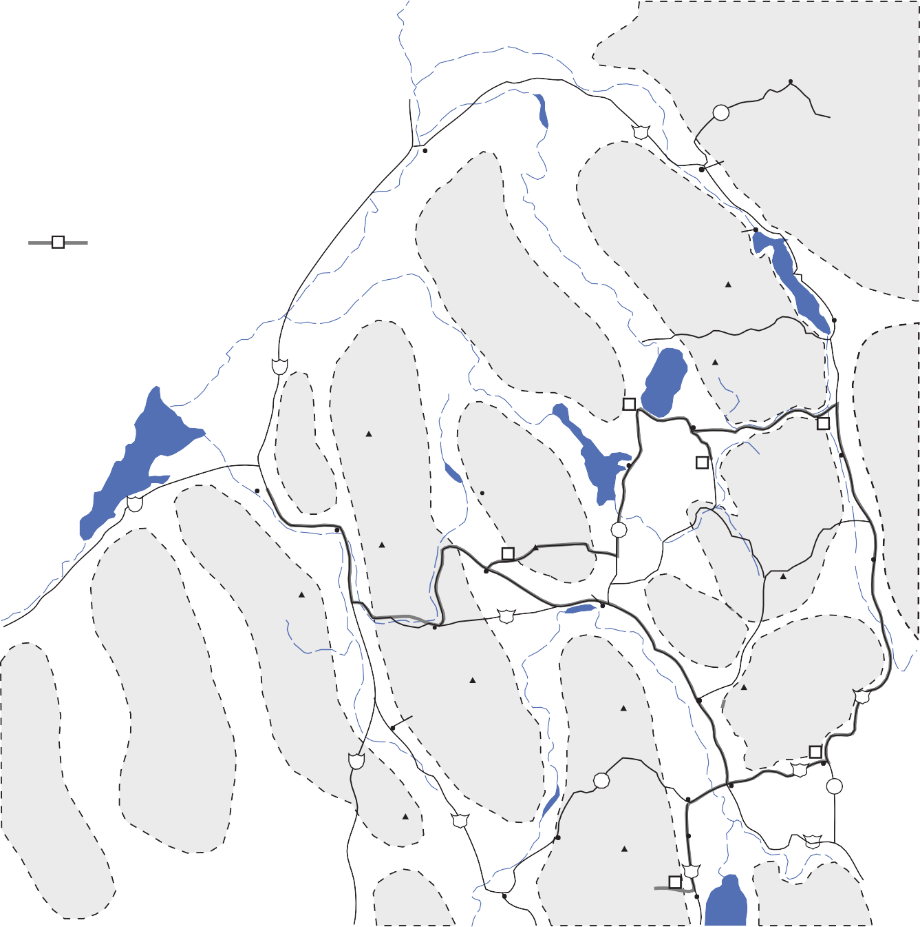Figure 1. Location map showing routes described in this article, location of field trip stops, and geography of southeastern Id aho.

The scoured scabland surface of the basalt of Portneuf Valley can be seen south of the highway. Boulder trains, stained white by calcic dust from the Ash Grove cement factory, are aligned with the westward flow of the Bonneville flood waters (O'Connor, 1993; Link and Phoenix, 1996; Link et al., this volume).

nko to a a ot Springs
The highway turns south into Marsh Valley east of Inkom, and cuts through the basalt of Portneuf Valley (Fig. 5, 6), which contains two tube-fed lava flows fed by sources near Bancroft in northern Gem Valley. Its age is about 680,000 years (Scott et al., 1982). On the north edge of the basalt cliff is a filled lava tube, an area of radial jointing in the cliffs north the freeway.

Rounding the corner and heading south in Inkom the freeway crosses the Portneuf River. Bonneville flood boulders can be seen immediately west of the road, south of the river. The limestone hill east of the road is a kipuka of fossiliferous and oolitic Cam- brian Elkhead Limestone.
The road rises to the top of the basalt of Portneuf Valley (Fig. 6). Note the flood-scoured scabland topography. Dry waterfall alcoves that contain Native American occupation sites and petroglyphs are present west of the road above Marsh Creek (Link and Phoenix, 1996).
About four miles south of Inkom the Rock Creek landslide is east of the highway. This is an area 400 yards wide and a mile long, with several homes built on it, that displays hummocky to-

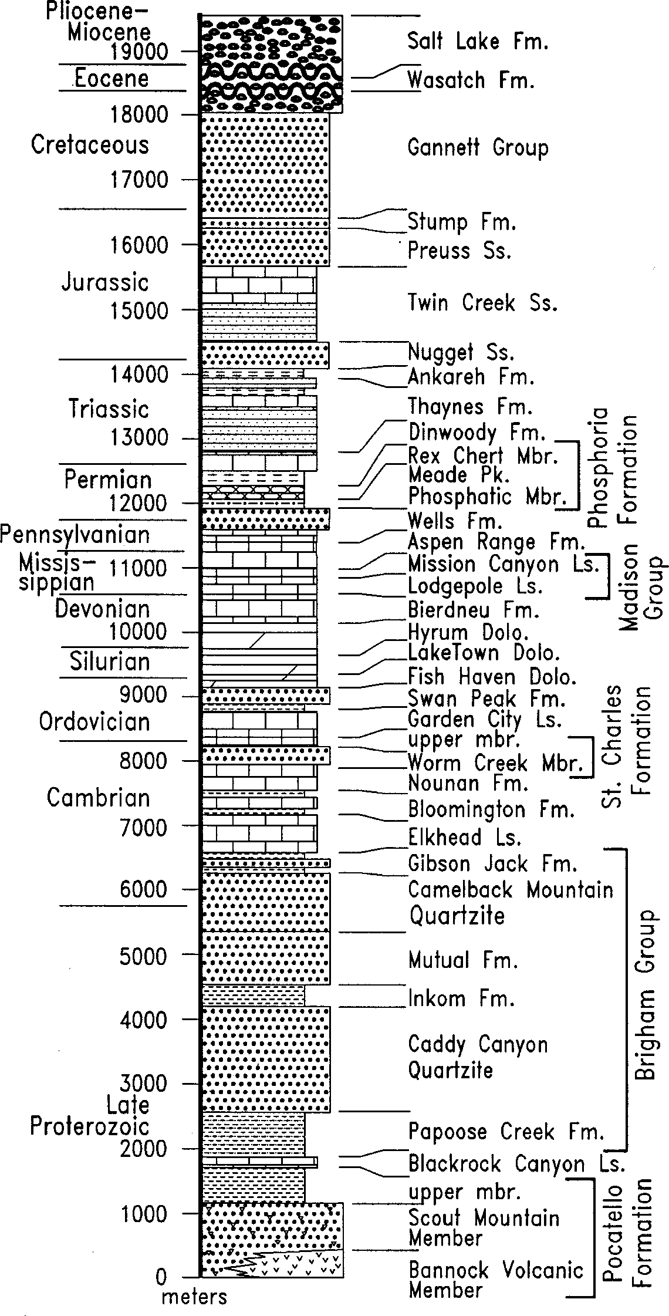
Figure 2. Generalized stratigraphic column for the southeast- ern Idaho thrust belt (from Link and Phoenix, 1996)
pography produced by Recent mass movement.
The high peaks of the Portneuf Range, Bonneville Peak and Haystack Mountain to the south, can be seen above the landslide (Fig. 7). These mountains are underlain by east-dipping Neoproterozoic, Cambrian and Ordovician strata (Armstrong and Oriel, 1965; Corbett, 1978; Christie-Blick et al., 1988; Kellogg, 1992; Riesterer et al., in prep).
West of the highway, across the valley of Marsh Creek, is the steeply north-east dipping tuff of Inkom, lowest bed of the upper part of the Starlight Formation, whose age is approximately 8 Ma (McQuarrie et al., in prep). To the southwest the high mountains are Scout Mountain and, to the south, Old Tom Mountain. The middle Pleistocene bench west of Marsh Creek was trimmed dur-
ing the Bonneville flood. Beginning south of Walker Creek, about 7 miles south of Inkom, and continuing for several miles, a num- ber of Recent landslides, in some locations provoked by leakage of irrigation water, can be seen to the east, below the Portneuf Range.
On the skyline directly south is Oxford Mountain, a north- trending ridge of Neoproterozoic rocks that has the appearance of a volcano from this angle. The apparent cone is actually two ridges of locally auriferous Brigham Group quartzite offset slightly by an east-striking normal fault (Link, 1982; 1983). The peak to the southwest, west of Malad Summit, is Elkhorn Mountain.
About ten miles south of Inkom take Highway 30 east. The view is up Harkness Canyon to Haystack Peak (Fig. 7). McCammon, once site of the Harkness House Hotel, Opera House, Power Station and Flour Mill is immediately to the south. Just north of the highway bridge over the railroad and river are the original footings of the first toll bridge over the Portneuf River, part of the Halladay stage line first operated in 1863 (Gittins, 1976; 1983). Bonneville flood gravel pits between McCammon and Highway 30 have yielded Pleistocene bison, camel, muskox, and horse fossils.
East of the Portneuf River, Highway 30 is cut into light-col- ored tuffaceous gravel of the Salt Lake Formation. A Miocene horse tooth was recovered from the roadcut just south of the en- trance to the South Bannock county landfill.
The highway curves eastward, with basalt of Portneuf Valley and the Portneuf River to the south. The mouth of Crystal Springs Canyon, leading to the spring-fed source of the McCammon wa- ter supply, is north of the road four miles east of McCammon.
About five miles east of McCammon, Paleozoic bedrock comes to the canyon floor north of the river. The light cliff is Ordovician Swan Peak Quartzite. There are numerous travertine deposits on the basalt-floored canyon. On the right is a constructed flood-control channel built after major floods in winter 1963 and 1964. The white stains on top of the basalt flow are caliche de- posits produced by evaporation of alkaline ground water.

Old Oregon Trail (sic) Sidetrip
If one takes the "Old Oregon Trail" road (not the Oregon Trail in any way, nor even the Hudspeth Cutoff, which runs south of the river close to the Highway) north just before crossing the Portneuf River on the "Steel Bridge" (see Fig. 1), distinct differ- ences in soil types can be observed. North of the road are thin alkaline soils developed on alluvial fans. South of the road, in spring-fed river bottom land, are heavy alluvial soils. The no- table differences in plant communities on this bottom-land re- flect different soil types.
An old Oregon Short Line railroad grade is evident south of the road about half a mile after leaving the Highway.
Island Butte, a stopping point on the Hudspeth Cutoff, can be seen to the south of the Gas Pipeline Substation about 3 miles beyond the Highway. About 300,000 California-bound pioneers traveled along the Hudspeth Cutoff, most during the Gold Rush of 1849 (Link and Phoenix, 1996).
Rejoin Highway 30 about 5 miles from leaving it. The former Lava Hot Springs railroad depot is used as a house and garage just west of here.

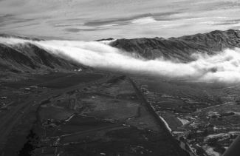

Figure 3. Fog streaming westward through the Portneuf Narrows, March, early 1990s. The ridge of the Bannock Range extends across the view, defined by the west-dipping Fort Hall Can- yon normal fault. On right side of view is the Union Pacific Mainline and the meandering Portneuf River south of it.
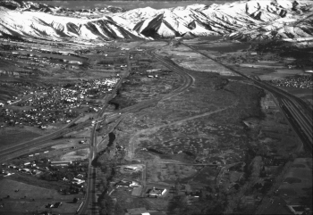
Figure 4. Midwinter aerial view southeastward to snow-covered Bannock Range, with Portneuf Narrows in the distant cen- ter. Basalt of Portneuf Valley is in the central part of view, with Ross Park and Pocatello Zoo in the foreground.

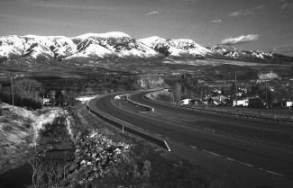
Figure 5. View southward of the west front of the Portneuf Range and the Basalt of Portneuf Valley just north of I-15 at Inkom. The Portneuf range-front fault bounds the range. Peak in cen- ter is Mt. Bonneville, with Pebble Creek ski area and Green Canyon immediately north of it. Bonneville flood waters were about 350 feet deep here.

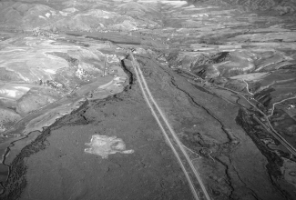
Figure 6. Aerial view northward of the Basalt of Portneuf Valley, south of Inkom. This valley and lava flow was totally inun- dated by the Lake Bonneville flood. Waterfall alcoves form the left scarp of the lava flow. This is an example of inverted to- pography, with the streams forced to the sides of a valley by a lava flow which occupies what was formerly the lowest part.
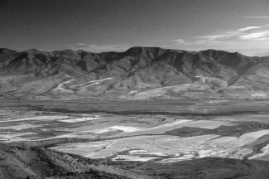
Figure 7. Haystack Mountain and the Portneuf Range, late sum- mer, view eastward from Old Tom Mountain.

Lava Hot Springs
The entrance to Lava Hot Springs is about 11 miles east of McCammon. This resort town, originally named Hall City, boasts of clean, beautifully landscaped hot pools. The geology of the area has been mapped by Schwarze (1959, 1960) and Crane et al. (in prep.).

Fish Creek Pass on U.S. 30
East of Lava Hot Springs, Highway 30 ascends Fish Creek Pass. This section of highway was not built until the late 1970s. Formerly the main route followed the Portneuf River northward (as the Union Pacific railroad mainline still does) before turning eastward through Bancroft toward Soda Springs. See Bancroft roadlog below for description of this alternate route.
The Fish Creek Pass highway crosses through the east-dip- ping succession of the Portneuf Range to the south and the Fish Creek Range to the north (Oriel, 1968; Oriel and Platt, 1980). Normal faults locally repeat the section, but in general the rocks

are Ordovician Swan Peak Quartzite (exposed on the northwest side and at the summit), dark Fish Haven Dolomite, light Laketown Dolomite, dark Devonian Hyrum Dolomite (exposed in a petroliferous outcrop on the north side of the road about half way up the east side of the pass) and light gray Mississippian lime- stones of the Chesterfield Range Group (thin-bedded Lodgepole Limestone and light gray fossiliferous Mission Canyon Limestone) at the east side of the pass.
To the south is the Portneuf Range with its high point at Sedgwick Peak. Strata on the summit are Middle and Lower Cam- brian Camelback Mountain Quartzite, Sedgwick Peak Quartzite, Lead Bell Shale, Twin Knobs Limestone, Blacksmith and Bloomington Limestones (Oriel, 1965; Oriel and Armstrong, 1971).
On the west side of Fish Creek Pass, road construction has caused oversteepening of unstable slopes. This interrupts and ponds ground water flow. The effect is small landslides and wet ground with clumps of cattails growing at the roadside.
The Hudspeth Cutoff of the Oregon Trail came west from Soda Springs through the Fish Creek area, and is about one mile south of the highway. It descended into Fish Creek and then as- cended over a ridge of the Portneuf Range, and down Henderson Canyon to what is now the Thunder Canyon golf course south- west of Lava Hot Springs (Link and Phoenix, 1996).
Coming eastward down Fish Creek Pass is an expansive view east of the Gem Valley olivine-tholeiite basalt lava-field (young- est K-Ar date of 0.1 ± 0.03 Ma; Armstrong et al. 1975), mantled by Pleistocene loess and potato farms. The Bear River Range terminates at Sheep Rock (aka Soda Point), just south of the hair- pin of Bear River, and the Chesterfield Range, with fresh fault scarps on its western side, picks up to the north of the Highway and Oregon Trail route west of Soda Springs. Tenmile Pass, through which Pleistocene lava of the Blackfoot Lava Field spilled west into Gem Valley, can be seen to the northeast. Out of sight over Tenmile Pass are several rhyolite domes, including China Hat (Fiesinger et al., 1982).
At the intersection of Highway 30 and Idaho 34 north of Grace, several basalt cinder cones can be seen north and south of the road. These cinder cones extend southward beyond the village of Grace. They are parallel to the north-south basin-and-range fault that bounds the east side of Gem Valley, and are of middle and late Pleistocene age. Link et al. (1985b) describe field trip stops and physical volcanology of these cones. The Bancroft Side Trip Log rejoins the main highway here.

Bancroft-Ten Mile Pass- ittle Flat Side Trip
Instead of remaining on Highway 30 up Fish Creek Summit, turn left (north) at the east edge of Lava Hot Springs on the old Highway, to Bancroft. The white bedrock northwest of the road is Ordovician Swan Peak Quartzite. Ordovician Fish Haven Do- lomite is east of the road.
Heading north on the Old Highway 30, the Fish Creek Range is to the east and the Portneuf Range to the west. There are sev- eral hot springs and travertine deposits along the river. Outcrops along the road are Swan Peak Quartzite and white tuff of the Salt Lake Formation.
The Caribou County line is reached about 13 miles north of
Lava Hot Springs. This area had been in Bannock County until about 1958, when residents "seceded" due to poor Sheriff pro- tection after a robbery at Whiskey Mike's Place, a well-known watering hole formerly located just east of the Pebble Creek Road about 2 miles north of the County Line.
Just north of the Pebble Basin Road, old lime kilns are present on the left, west of the river. These were used about the turn of the century making slaking lime used in calcining copper ores from mines in the region.
About four miles north of the County Line is the Kelly- Toponce road to Chesterfield. There are several good outcrops south of the road in the Ordovician Swan Peak and Fish Haven formations, repeated across small normal faults (Oriel; 1968; Oriel and Platt, 1980).
A rich part of Idaho history can be found by following the road north, and then turning east toward the historic Mormon community of Chesterfield, located on a hill east of the Portneuf River. The village was founded in 1881, and built on the grand Latter-Day Saint scheme of the "City of Zion". Chesterfield is now a historic preservation site, and the Chesterfield Foundation, with cooperation from the State of Idaho, is working to obtain and restore the several homes and stores that are a remnant of 19th century agrarian life in Idaho (The Chesterfield Foundation, 1982). The Oregon Trail crossed the north end of Gem Valley through Chesterfield, just east of Portneuf Reservoir (Link and Phoenix, 1996). This log stays on the highway heading east to Bancroft.
Bancroft is reached about 10 miles beyond the Caribou County Line. This small ranching community, located on the railroad, survived as Chesterfield dwindled in the agricultural depression after World War I. In February 1963 the town was two feet deep in water, part of the great Portneuf River flood which led to con- struction of the concrete flood-control channel through Pocatello and the aforementioned channel seen between McCammon and Lava Hot Springs.

Side Trip to Little Flat Canyon
Turn left, north across the railroad tracks, on Chesterfield Road (Chesterfield 11 miles). Heading north through northern Gem Valley there is Pleistocene basalt east of the road and alluvial bottom ground west of the road. Little Flat, an uplifted travertine terrace cut by active faults, can be seen ahead to the right. About five miles north of Bancroft turn right on Hatch Loop. Head east.
South of the road is basalt lava, with alluvial bottom-land to the north. Springs are found at the distal edges of these lava flows, and were tapped for irrigation by early farmers. Camas bloom here in wet years.
About 2 miles east of turning onto Hatch Loop the old Hatch school is just north of the road. This was one of four identical schools built in the area in the 1920s. The Chesterfield school has been preserved by the Chesterfield Foundation. Continue east toward Little Flat. The pavement ends about one-half mile east of the school, 2.5 miles east of turning onto Hatch Road.
A normal fault scarp is crossed 0.6 miles east of the end of the pavement and the road climbs abruptly up onto the Little Flat travertine terrace. The outcrops along the road contain brecci- ated basalt and travertine, demonstrating that fault movement fol-

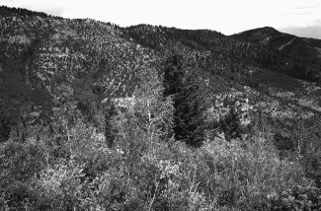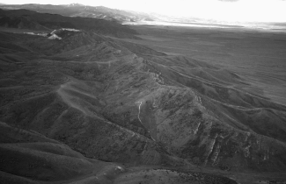

Figure 8. View southward of fossiliferous Mission Canyon Lime- stone at the Little Flat fossil location (Stop 1).

lowed eruption of the basalt, and was contemporaneous with hot spring activity and formation of travertine.

Stop 1. Little Flat Fossil Site
Proceed east through a gate and park 0.2 miles east of the gate (Fig. 8, 9). The canyon is cut from fossiliferous Mississip- pian Mission Canyon Limestone (Fig. 2) (Armstrong, 1969; Sando et al., 1981; Sandberg et al., 1983; Quinn, 1985). Horn corals, spiriferid brachiopods, and syringoporid tabulate corals can be found in the outcrops in this area, and represent a Late Mississip- pian clear-water carbonate bank.

Route to Soda Point
Turn around and proceed west to the Hatch School. Turn left, or south. Heading south, the lava flows have a water-scoured ap- pearance, suggesting this may have been the path of the Bear River just before it was diverted southward to the southern part of Gem Valley. Just less than 4 miles south of the Hatch School turn left on the paved road to Chemstar Lime. As we head east there is a good view of the lava delta of Ten Mile Pass (Fig. 9), where basalt from the Middle Pleistocene Blackfoot lava field poured into Gem Valley.
The Oregon Trail is crossed 2.8 miles after turning east onto Ten Mile Road. Two-tenths of a mile beyond the Oregon Trail, turn south on Ivins Road.

Tenmile Pass
If one continues east up to Tenmile Pass there are views across the Blackfoot Lava field to the northeast, of Caribou Mountain underlain by an Eocene intrusion, the China Hat Pleistocene rhyo- lite dome, and the Conda Mining Company limestone mine for Chemstar Lime. About 2 miles east of the mine is a graben that cuts lava flows of the Blackfoot field.

Oregon Trail and Cinder Cone
Return west to Ivins Road and proceed south. The Oregon Trail is marked by flexible strip markers west of the road. The Trail route crosses the road about 1.3 miles south of turning onto Ivins Road.
Figure 9. Aerial view southward above Little Flat Canyon along the west front of the Chesterfield Range, composed of east- dipping Mississippian limestone. Gem Valley is west of the range, mantled by Pleistocene basalt. Sheep Rock is in the sun in the far middle distance. Tenmile Pass limestone mine is in left middle distance.

A half mile past the old Ivins Cemetery on the left, turn left on an unnamed gravel road. Take a hard right across a canal and head south on the paved Ivins road. Go about a mile and turn left on Cherrett Road, passing the Ivins School and Talmage Road. Turn east (left) on a gravel road just south of Talmage Road.
The road bends to the southeast skirting a basalt lava escarp- ment uplifted on a normal fault. To the east is a cinder cone or explosive basalt eruptive center, cut by a small graben in the lava. The Oregon Trail is on the right. Travelers stored perishables in ice caves located in lava tubes in this area. The cinder cone, quar- ried by Caribou County, displays a wealth of explosive eruptive textures.
About a mile and a half past the cinder cone is a view to the west of Alexander Crater and Fish Creek Pass. Cinder cones on this east side of Gem Valley are oriented on north-south normal faults (Armstrong, 1969; Oriel and Platt, 1980). The Link et al. (1985b) road log contains descriptions of several of the cinder cones south of here, toward Grace.
The road climbs over a small limestone-cored bedrock point that affords a view of Sheep Rock (Soda Point) to the south and the location where the Hudspeth Cutoff and Oregon Trail sepa- rate (Fig. 10). Continue south and east, crossing the railroad and turn east (left) on US Highway 30 toward Soda Springs.

Sheep Rock to Soda Springs and Montpelier on U.S. 30
The mountains south of the road are the Bear River Range, with high point Sherman Peak underlain by Neoproterozoic Brigham Group. The mountains to the north are the Chesterfield Range, underlain by Ordovician and younger Paleozoic rocks (Armstrong, 1969).
We are traveling just north of the route of the Oregon Trail. An Oregon Trail park is located on the banks of Soda Point Res- ervoir about 2 miles east of Soda Point. In this area is a unique ecological mix of Rocky Mountain Juniper (the bushy ones) and Utah Juniper (the erect ones), with Limber Pine. The Oregon Trail

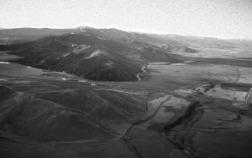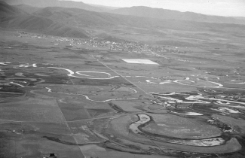

Figure 10. Aerial view southward of the north end of the Bear River Range and Sheep Rock. The Bear River makes a 180 degree bend around the north end of the range and flows away from the camera, to the south on the west side of the range. The river's path was determined by Pleistocene Gem Valley lava flows.

passed through what is now the Cedar View Country Club on the right.
Enter Soda Springs about a mile east of the Country Club. The original settlement here was Camp Connor, opened by Morrisite refugees from Ogden in May 1863, just 5 months after Colonel Edward Connor perpetrated the Bear River Massacre north of Preston (Link and Phoenix, 1996).
Proceed through Soda Springs on Highway 30. The Bear Lake County line is reached about 8 miles east. The mountains to the left are the Preuss Range, composed of upper Paleozoic strata (Oriel and Platt, 1980). Triangular facets on the mountain front are evidence of Pleistocene normal faulting. The foothills on the left are underlain by tuffaceous Salt Lake Formation.
Pass over Georgetown Summit and into the town of Georgetown. This was the railhead for a phosphate mine in Georgetown canyon that opened in the early 1900s (Armstrong and Cressman, 1963; Cressman, 1964). The railroad crossed the highway near the crest of the hill at the southeast edge of town, at a very hazardous crossing. Phosphoria Gulch, for which the
Figure 11. Aerial view looking east of scroll meander scars of Bear River flood plain in foreground and city of Montpelier in the middle distance, north of Montpelier.

Phosphoria Formation is named, is a tributary to the west side of Georgetown Canyon near the former mine site. Crook et al. (1985,
p. 303-305) describe a field trip to the mine site and the Meade thrust fault about 2 miles below it on the north wall of the canyon. Continue to Montpelier. Oregon Trail Museum is east of high- way near the center of town. Turn west on U.S. Highway 89 to
Paris.

MONTPELIER TO ST. CHARLES CANYON
The road crosses over swampy ground from Montpelier west to Ovid (Fig. 11). This area is the natural outlet of Bear Lake. Utah Power and Light has constructed a series of canals and pump- ing stations that allow water to flow both north and south in this area. Bear Lake is thus used as a reservoir for water from Bear River that would normally bypass the lake. The Bear River is crossed about two miles west of Montpelier.
The view to the west is the Bear River Range, with Neoproterozoic quartzites thrust over Mesozoic sandstone (Oriel and Platt, 1980; Crook et al., 1985) (Fig. 12, 13). To the east is the Bear Lake Plateau, bounded by a normal fault down to the west (Fig. 14). Triangular facets are obvious. This area was stud-

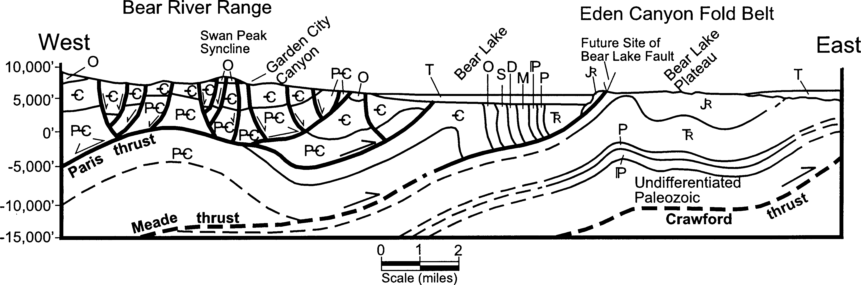

Figure 12. Geologic cross section of the Bear Lake area. This interpretation shows subsurface anticlines related to transport a nd rotation of beds over step-like features (ramps), which has important petroleum exploration implications. Location of cross section shown in Figure 1. Redrawn from Crook et al. (1985, Fig. 31), after original by J. Dover, U.S.G.S.

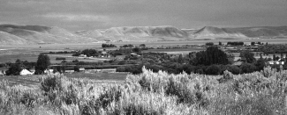

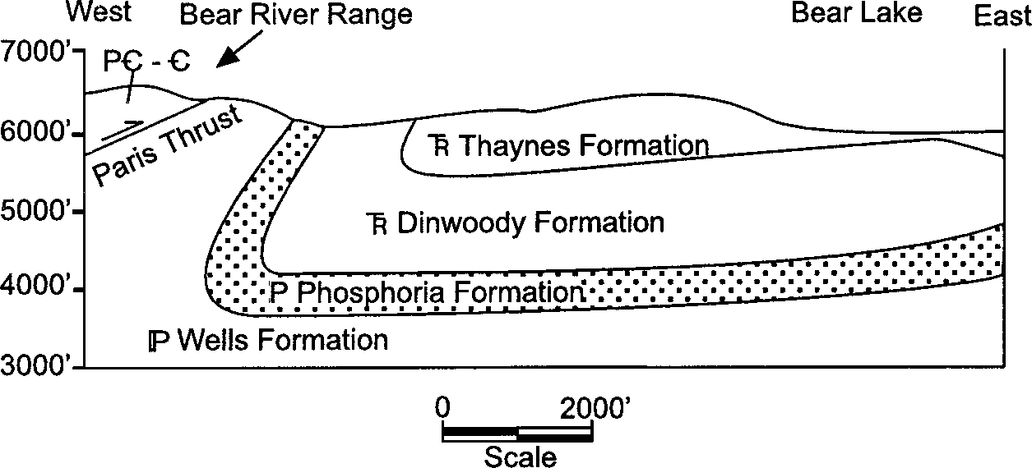
Figure 13. Cross section in the vicinity of Paris Canyon. Re- drawn from Crook et al. (1985, Fig. 34). Location of cross section shown in Figure 1.
ied by Walcott (1908), Richards and Mansfield (1912) and Mansfield (1927) and several type sections are located here and to the south.
Continue south by turning left on Highway 89 at Ovid. The historic town of Paris, founded 1863, and county seat of Bear Lake County, is about 4 miles south of Ovid. Paris Canyon road heads west in downtown, and is the location of old phosphate mines and a view of the Paris thrust (see field description in Crook et al., 1985, p. 298-302). The several oil wells drilled in this area in the 1980's were based on the interpretation that the Phosphoria Formation was mature and generating oil between 75 and 180
m.y. ago, when the thrust faults were active. Structural complica- tions and high geothermal gradient are among the reasons cited for failure of the drilled wells to encounter economic reservoirs. Continue south toward Bloomington. Old beach ridges of Bear Lake trend east-west across this nearly flat area. Bloomington Canyon is another scenic route with good exposures of Paleozoic strata. The Bear Lake fault scarp can be seen east of the lake (Fig.
14).
Continue south to St. Charles and turn right, west, on St. Charles Canyon Road. Minnetonka Cave is ten miles up the road. The Paris thrust is crossed about 2 miles west of town where the road enters the mountains (Fig. 12, 13). Outcrops along the road are west-dipping Brigham Group (Link et al., 1987), and the road proceeds up-section into lower Paleozoic rocks. The Cache Na- tional Forest is entered across a cattle guard about 3 miles up the canyon from Highway 89. Camelback Mountain Quartzite here contains Skolithos and other Cambrian trace fossils.
Blue Pond Spring is reached in another three miles. Outcrops here are Ordovician Garden City Formation.

Stop 2. Swan Peak Formation, St. Charles Canyon
Stop 0.9 miles west of Blue Pond spring. The outcrop north of the road (Fig. 15) belongs to the Ordovician Swan Peak Quartz- ite (Fig. 2) and consists of red-to-white medium-bedded sand- stone, with planar cross beds and abundant large trace fossils in- cluding Cruziana and Rhusophycos. Body fossils found here in- clude trilobites, conulareids, and phosphatic brachiopods from blue phosphatic zones.
Continue up the road to Minnetonka Cave (Fig. 16). Outcrops along the road below the cave are Mississippian Lodgepole Lime- stone. Horn corals are abundant. Return down the road to St. Charles and back to Montpelier. The view to the east of the Bear River Plateau and fault scarp is spectacular (Fig. 14).
Figure 14. View to east, from just west of village of St. Charles, of irrigated farms west of Bear Lake, the lake in the middle dis- tance, and the normal-fault bounded Bear Lake plateau to the east.
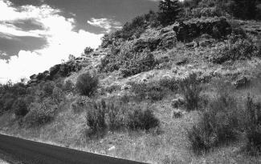
Figure 15. Outcrops of fossiliferous Ordovician Swan Peak For- mation at Stop 2, St Charles Canyon.
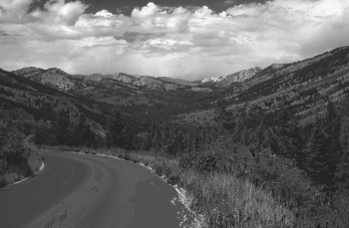
Figure 16. View northward of the north fork of St. Charles Can- yon, taken from the Minnetonka Cave parking lot. Strata form a gentle syncline, cored by Mississippian rocks.

MONTPELIER TO STAR VALLEY AND FREEDOM, WYOMING.
Reset odometer and turn north on Highway 89 at junction with U.S. Highway 30 at the Oregon Trail Museum in Montpe- lier. The route heads up Montpelier Canyon into the Preuss Range (Fig. 18). The trace of the Meade thrust is crossed 0.5 miles east

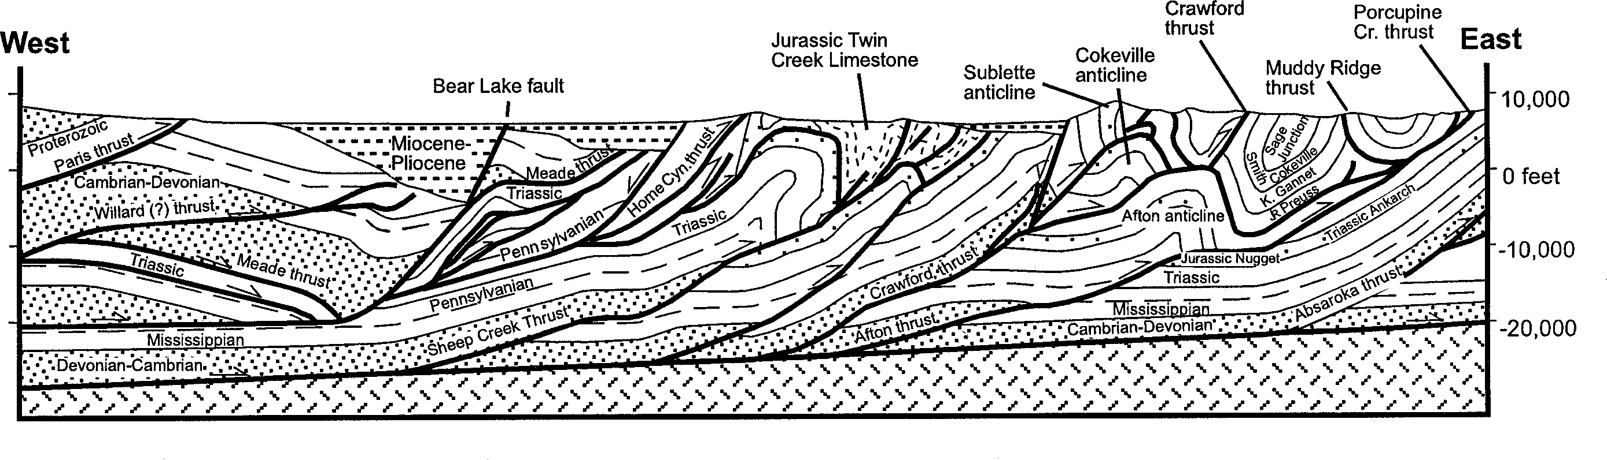
Figure 17. Geologic cross section from the frontal Crawford thrust to the Paris thrust, redrawn from original by J.C. Coogan. T he highly folded strata of the Jurassic Twin Creek Limestone are not differentiated. After Coogan and Royse (1990, Fig. 10). Location of cross section shown in Figure 1.

of town (Fig. 17). The old San Francisco Chemical Company Waterloo Phosphate Mine occupies the south side of the canyon, to the right (Service, 1967). The rocks east of (below) the Meade thrust are tightly folded Permian to Jurassic strata of the Permian Phosphoria, Triassic Dinwoody-Woodside, Triassic Thaynes, Triassic Ankareh, Jurassic Nugget, and Jurassic Twin Creek For- mations, overlain by Cretaceous Gannett Group and Bear River Formation (Fig. 2) (Link et al., 1982; Coogan and Royse, 1990). Proceeding up the road, at mile 3.5 the Forest Boundary is crossed. In general the road goes up section from the Pennsylva- nian to the Jurassic as we go east toward Geneva Summit. Home Canyon on the left contains tightly folded Triassic Ankareh redbeds, including the Portneuf Limestone Member and Timothy Sandstone Member. These strata are folded into an antiformal syncline and a synformal anticline below the Home Canyon thrust fault, which places Ankareh and Thaynes over Ankareh, Nugget and the Gypsum Spring Member of the Twin Creek Formation, all in the footwall of the Meade thrust to the west (Coogan and
Royse, 1990).
Crow Creek road is at 6.8 miles and Geneva summit at 9.5 miles. A fault-controlled valley runs north-south along the crest of the summit. Just west of the summit is an outcrop of Twin

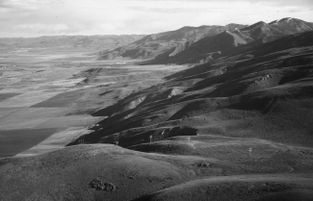
Figure 18. Aerial view looking north at the west front of the Preuss Range, just north of Montpelier Canyon. Bear Lake normal fault forms boundary between range and Bear lake Valley. Georgetown Canyon is in the middle distance at the reentrant in the range-front.

Creek Limestone with subvertical bedding and subhorizontal north striking cleavage. The cleavage is interpreted to have formed as east-west layer-parallel shortening, before the main fold event (Evans and Craddock, 1985; Mitra and Yonkee, 1985; Protzmann, 1985; Coogan and Royse, 1990). There is also a weak, east-strik- ing subvertical cleavage interpreted to have formed subparallel to axial planes of east-trending cross-folds related to a lateral ramp in the underlying Crawford thrust plane.

Stop 3. Jurassic Twin Creek Fossil Sites Along U.S. 89
Along the road are numerous outcrops of Jurassic Twin Creek Limestone (cleaved, locally gypsiferous or fossiliferous, and gen- erally fine-grained), and green shale (Fig. 19). One very good outcrop is located at 11.1 miles, and contains calcareous shale with wind ripples, mudcracks and rip-up clasts, plus abundant trace fossils, all representing a periodically exposed west-facing Jurassic carbonate margin.
The road crosses a series of outcrop-scale folds east of here, including parasitic to map-scale anticline-syncline pairs. It is clas- sic Valley and Ridge country (Fig. 20). East of Thomas Fork Val- ley is the Sublette anticline, making the resistant ridge composed of overturned east-dipping Pennsylvanian to Jurassic strata.
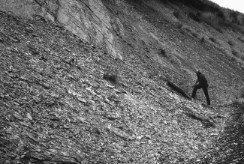
Figure 19. Talus-covered pile of Jurassic Twin Creek Limestone west of Stop 3. Rock here is a silty micrite with pencil cleav- age and sparse fossils. David Fortsch for scale.

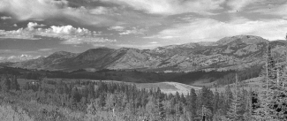

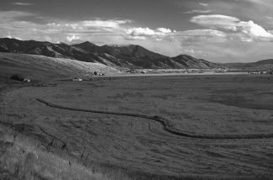
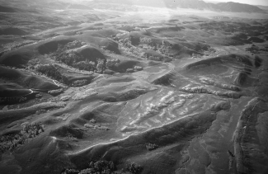
Figure 20. Aerial view looking southeast at doubly-plunging an- ticline cored by Gypsum Springs Member of the Jurassic Twin Creek Formation, northwest of Geneva.
Figure 21. View northeast to the Salt River Range from Salt River Pass. The southern end of Star Valley trends off to the left. The high peak on the right is Mount Wagner.

Raymond Canyon, south of Geneva, is a spectacular place to ob- serve this succession. Shoemaker (1985) describes the canyon with care and spirit. Link et al. (1982, p. 64-65) and Coogan and Royse (1990, p. 103-104) describe field stops there.

Gene a to Star Valley
At 13.5 miles is another fine outcrop of the contact between Jurassic Twin Creek Limestone and overlying green Preuss Sand- stone (Fig. 2). Beds are vertical, and contain wind ripples, calcar- eous nodules, and abundant calcite-filled slickenside surfaces. There is a safe parking area just past the outcrop on the west.
Enter Geneva at 14.0, and continue north and east through Twin Creek and Preuss outcrops across the Idaho-Wyoming bor- der (mile 17.8) on Highway 89. Just at the border the road enters an east-west trending canyon cut in Jurassic Nugget Formation near the axis of the Sublette anticline, which is the north-plung- ing termination of the Crawford thrust fault (Fig. 18), exposed south into Utah. The road proceeds up section through the Twin Creek Limestone, on the east limb of the Sublette anticline, passed at the Cattle Guard at mile 19.8. Further up section the road crosses through maroon Preuss Sandstone, thin green Stump Sandstone, and at mile 20.7 the road is in red Lower Cretaceous Gannett
Figure 22. View to the southeast of Star Valley and the Salt River Range. Note triangular facets on west front of range near town of Afton, Wyoming.

Group (sandstone of the Ephraim Formation) and Peterson Lime- stone in the axis of the tight Spring Creek syncline. The Ephraim was derived from erosion of the Paris thrust sheet and an older sheet to the west; the overlying Bechler Conglomerate (Aptian) had sources in the Meade and Paris sheets (DeCelles et al., 1993). At mile 24.3 Salt Creek cuts through the axis of the Spring
Creek syncline.
At mile 26.5 the road has cut down to the Preuss Sandstone and underlying Stump Sandstone.
Allred Flat Campground at mile 28.1 (highway milepost 64). There is a salt spring on the right at mile 29.5, with a source in evaporite beds in the Jurassic Preuss redbeds. The Preuss salt horizon is overthickened from 300 feet to over 5,600 feet in the core of the Afton anticline near here, and is the primary decollement for the Crawford thrust (which dies out into the Sublette anticline) (Coogan and Yonkee, 1985). The road goes up section again through Twin Creek and Preuss beds, dipping east at mile 30. From this point the road goes quickly up section in east-dipping beds, through the maroon Preuss, green Stump, to the red Ephraim and Bechler conglomerates of the Gannett Group (reached at mile 30.2)
The road heads north, oblique to strike in Cretaceous beds (Ephraim Conglomerate, Peterson Limestone, Bechler Conglom- erate, Draney Limestone and Smoot Formation of the Gannett Group, and overlying Bear River Formation (Fig. 2)). The rocks are folded into symmetrical folds with wavelengths of ~3 miles (5 km) and amplitudes of ~3,000 ft (1,000 m) along the leading edge of the Crawford thrust system (Coogan and Royse, 1990). The top of the Salt River-Thomas Fork divide is reached at mile
31.9 (Fig. 21). Outcrops to the right (south) of the road are sand- stone of the Cretaceous Bear River Formation. There are infor- mational signs about Periodic Spring and the Lander Cutoff.
The Salt River Range is to the east and the Snake River Range is to the north, down the fault-controlled trace of Star Valley (Fig. 22). The name Star Valley is shortened from "Starve (or Starva- tion) Valley", which is what the early Mormon polygamist set- tlers feared. From the summit, the road traverses west-dipping rocks of the Gannet Group, comprising the east limb of a syn- cline, and crosses obliquely down section to the Twin Creek For- mation. At mile 34.0 is Smith's Fork Road and the boundary of the National Forest. The road goes down into an alluvial, agricul- tural area and crosses the Salt River at mile 35.0. To the east are dip slopes on Jurassic rocks, with the road in a strike-valley formed in the Cretaceous Gannett Group.

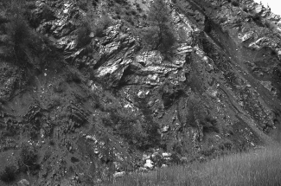
Figure 23. View looking southeast to the Salt River Range from Salt River narrows. Note triangular facets on west front of range in middle right distance.
At mile 37.8 is a Lander Cutoff Historic marker (trail built in 1858 by the U.S. Army). The Jurassic Nugget Sandstone holds up the mountain to the east. The road to Periodic Spring (Cottage Lake Road) is at mile 40.2. It proceeds east across the Afton fault scarp and into the Salt River Range.
Smoot is at mile 40.6, at the south end of the Star Valley fault. Triangular facets can be seen on the range-front to the east, and houses are built on the footwall of the active fault scarp from here north to the end of the valley (Fig. 21). The Gannett Hills and Caribou Range are to the west.
The road to Fairview is at mile 45.9, to Afton at 47.2, with Swift Canyon Road at 48.7. Our road heads north and crosses the bedrock Salt River Narrows between here and Thayne. Salt River Narrows (Fig. 23) affords a view of Ankareh, Nugget and Twin Creek rocks, folded into an anticline here, with axis located close to the Salt River bridge.
Star Valley is bounded by the Star Valley normal fault (with Holocene scarps) on the east side (Fig. 22). Just south of the Salt River Narrows, the normal fault steps westward, leaving a trans- fer zone underlying the hills east of the Narrows (McCalpin et al., 1990).
We are entering the Bedford quadrangle, one of the classic maps of W.W. Rubey (1958). The road east to Bedford is at 61 miles and the entrance to the Thayne Cheese Factory at 63.4 miles. From the parking lot there are good views east of the Salt River Range and the bounding normal fault, which is thought to flatten into the Absaroka thrust fault at depth (Dixon, 1982; Coogan and Royse, 1990)

THE TINCUP HIGHWAY, IDAHO 34: FREEDOM, WAYAN, HENRY, AND SODA SPRINGS
Reset Mileage to 0 at the junction of Wyoming Highway 239 and U.S. 89. Head west toward Freedom, where the state line runs down the north-south main street. Freedom was settled by Mormon fugitives from Fred Dubois, U.S. Marshall in Idaho Ter- ritory in the mid-1880s. Cross the Salt River at mile 1.0 and enter Freedom, Wyoming, population 100, elevation 5900.

Figure 24. Folds in Cretaceous Gannett Group mudstones and limestones along Tincup Highway just east of Stop 4.

At mile 1.4 turn right, north, to Wayan, and drive along the State Line. Turn left at mile 2.6 on Idaho Highway 34, enter Cari- bou County, Idaho and head west. This road, the Tincup High- way, crosses the Caribou Range, through tightly folded Jurassic and Lower Cretaceous rocks (Oriel and Platt, 1980). Wildcat oil wells were drilled in the mountains to the south of this canyon by Phillips Petroleum in 1981 and 1982 (Clem and Brown, 1985). The Haderlie Guest Ranch on the north side of the road has long been a source of help in getting around this difficult country.
The road proceeds up Tincup Creek, entering the Caribou National Forest at mile 5.6. Outcrops are scattered through the trees. The rocks are argillaceous, thinly bedded, tightly folded and prone to landslides (Fig. 24). At mile 8.0 are vertical red beds of the Gannett Group, with a syncline on the left or south. A prominent landslide is at mile 9.0 (milepost 107).

Stop 4. Tightly Folded Cretaceous Wayan Formation
Stop at mile 9.3 to observe tight folds and cleaved shaly lower Cretaceous Wayan Formation to the north of the road and an ac- tive landslide to the south. The outcrop across the creek contains a mesoscopic fold and a small thrust fault, cutting carbonaceous shale and limestone.
At mile 9.8 is a landslide, with headwall to the right, or north- east. South Fork Tincup trail is at mile 10.1. An exquisite anti- cline is exposed north of the road at mile 11.0. Tincup Flat road is at 11.8 and Pine Bar campground at mile 12.3. Folded sandstones and shales are present all along the road. The sagebrush vegeta- tion on dry south-facing slopes north of the road differs greatly from the dense forest to the south, on north-facing slopes. At mile
13.7 is a Gannett Group outcrop. The Lanes Creek cutoff road is at 16.7. Leave the National Forest and head downhill to Wayan at mile 17.3, near milepost 96. Caribou Mountain, an Eocene intru- sion, is to the northeast (Fig. 25).

Wayan and enry Tho as
Wayan Junction is reached at mile 21.9. Reset odometer and head south. Pass Henry Thomas' cabin at mile 1.3 (Fig. 26). Tho- mas was a sheepherder who found tons of fossils in Cretaceous beds near here. These are now donated to Idaho State University.

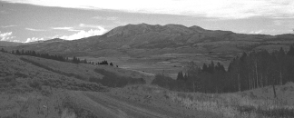

Figure 25. View north of Caribou Mountain from south of Wayan. The mountain is held up by an Eocene diorite, intruded into folded Cretaceous mudrocks.

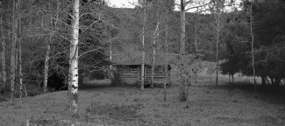
Figure 26. Home of bachelor sheepherder and fossil collector Henry Thomas, in Wayan.

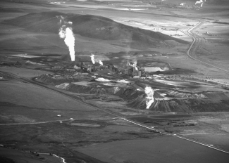
Figure 27. Monsanto elemental phosphorous plant north of Soda Springs, view from southwest.

Pass Gravel Creek Campground at mile 1.8. At mile 2.5 stay straight on the road, headed uphill on the Henry Cutoff. This north- facing canyon has beautiful mature aspen trees in an open forest.

Stops 5 and 6. Mississippian Fossils Near Wayan
Stop at mile 4.0 for an outcrop of Chesterfield Range Group containing the typical Mississippian fossil assemblage of south- east Idaho, including both tabulate and rugose corals and bra- chiopods in light gray, thin-bedded, bioclastic limestone.
Return down hill to the paved road to Wayan. Turn left and go northwest to Highway 34, and then west toward Pelican Point. Grays Lake is on the right. At milepost 90 a limestone outcrop is close to the road on the left. At Pelican Point (mile 4.5 from Wayan

Figure 28. J.R. Simplot Co. Smoky Canyon phosphate mine, west of Afton, Wyoming, view to southeast.
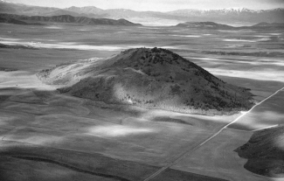
Figure 29. Aerial view of China Hat, exogenous Pleistocene rhyolite dome north of Soda Springs. View looks west to- ward Tenmile pass and Blackfoot lava field. Roadlog passes north of dome on road in right middle.
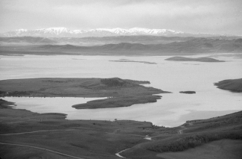
Figure 30. Aerial view of Blackfoot Reservoir, looking west to- ward snow-covered Portneuf Range.

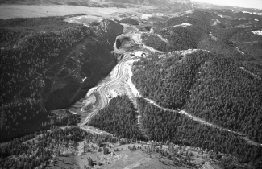
Road) is an outcrop containing horn corals, brachiopods and gas- tropods. Another similar outcrop (Stop 6) is present in a quarry reached through a gate, 0.25 miles southwest of the road (to the

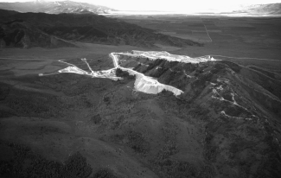

Figure 31. Tenmile Pass limestone mine, view to southwest.

right) at 8.8 miles from the Wayan Road. Here is thin-bedded petroliferous limestone with horn corals, syringoporids, and bryo- zoans.

enry and Blackfoot a a Field
Return to the paved road and head south toward Henry. Ba- salt flows of the Blackfoot lava field are west of the road, and folded Paleozoic rocks make up the mountains in the distance to the southeast. The North Henry Phosphate Mine is prominent on the skyline. Figures 27 and 28 show mines and plants in the Soda Springs phosphate industry.
Enter Henry, where the Little Blackfoot River enters from the southeast. The basalt lava on the left is cut by normal faults. South of Henry are views southward to Conda, the first underground phosphate mine in the area, which later was expanded to an open- pit operation.
China Hat (Fig. 29), a Pleistocene rhyolite dome and the south end of Blackfoot Reservoir (Fig. 30) are on the right. North of China Hat are North Cone and Middle Cone. The Dry Valley Road is reached at the China Hat Store. This road leads eastward to the FMC Dry Valley phosphate mine (see Petrun, this volume). Reset odometer. Turn west on the Dike Lake Road, about 2 miles south of the China Hat Store. Head west across a little gra- ben in the basalt east of China Hat. The road to Dike Lake is at mile 1.5. At mile 2.1 is a quarry on the left, south of the road, in airfall rhyolite and pumice from the China Hat dome (Fig. 29). West of here are several more spectacular normal faults forming grabens, cutting the lava. This road can be followed south to Soda Springs, or by turning west at Ten Mile Road (mile 7.6), one can proceed past the Chemstar Lime Plant (Fig. 31) to Bancroft, and
then turn south toward Lund and Highway 30.

ACKNOWLEDGMENTS
We are most grateful to Jim Riesterer who helped with draft- ing. Manuscript reviewed by Dave Rodgers and Gus Winterfeld.

REFERENCES CITED
Armstrong, F.C., 1969, Geologic map of the Soda Springs quadrangle, south- eastern Idaho: U.S. Geological Survey Miscellaneous Geological Investiga- tions Map I-557, scale 1:48,000.
Armstrong, F.C., and Cressman, E.R., 1963, The Bannock thrust zone in south- eastern Idaho: U.S. Geological Survey Professional Paper 374-S, 22 p.
Armstrong, F.C., and Oriel, S.S., 1965, Tectonic development of Idaho-Wyo- ming thrust belt: American Association of Petroleum Geologists Bulletin, v. 49, p. 1847-1866.
Armstrong, R.L., Leeman, W.P., and Malde, 1975, K-Ar dating, Quaternary and Neogene volcanic rocks of the Snake River Plain, Idaho: American Journal of Science, v. 275, p. 225-251.
Burgel, W.D., Rodgers, D.W., and Link, P.K., 1987, Mesozoic and Cenozoic structures of the Pocatello region, southeastern Idaho, in Miller, W.R., ed., The Thrust Belt Revisited: Wyoming Geological Association, 37th Annual Field Conference Guidebook, p. 91-100.
Chesterfield Foundation, 1982, Chesterfield: Mormon outpost in Idaho: The Chesterfield Foundation Inc., Rural Route, Bancroft Idaho, 83217.
Christie-Blick, N., Grotzinger, J.P., and von der Borch, C.C., 1988, Sequence stratigraphy in Proterozoic successions: Geology, v. 16, p. 100-104.
Clem, K., and Brown, K.W., 1985, Summary of Oil and Gas activity in north- eastern Utah and southeastern Idaho, in Kerns, G.J., and Kerns, R.L., Jr., eds., Orogenic patterns and stratigraphy of north-central Utah and south- eastern Idaho: Utah Geological Association Publication 14, p. 157-165.
Coogan, J.C., and Royse, Frank, Jr., 1990, Overview of recent developments in Thrust Belt interpretation, in Roberts, S., ed., Geologic field tours of west- ern Wyoming and parts of adjacent Idaho, Montana, and Utah: Geological Survey of Wyoming, Public Information Circular No. 29, p. 89-126
Corbett, M.D., 1978, Preliminary geologic map of the northern Portneuf Range, Bannock and Caribou counties, Idaho: U.S. Geological Survey Open-File Report 78-1018, scale 1:48,000.
Crane, T., Link, P.K., and Oriel, S.S., in preparation, Geologic map of the Lava Hot Springs quadrangle, Bannock and Caribou Counties, Idaho: Idaho Geo- logical Survey Technical Report, scale 1:24,000.
Cressman, E.R., 1964, Geology of the Georgetown Canyon-Snowdrift Moun- tain area, southeastern Idaho: U.S. Geological Survey Bulletin 1153, 105 p. Crittenden, M.D., Jr., Schaeffer, F.E., Trimble, D.E., and Woodward, L.A., 1971, Nomenclature and correlation of some upper Precambrian and basal Cam- brian sequences in western Utah and southeastern Idaho: Geological Soci-
ety of America Bulletin, v. 82, p. 581-601.
Crittenden, M.D., Jr., Christie-Blick, N., and Link, P.K., 1983, Evidence for two pulses of glaciation during the Late Proterozoic in northern Utah: Geologi- cal Society of America Bulletin, v. 94, p. 437-450.
Crook, S.R., Link, P.K., and Chidsey, T.C., Jr., 1985, Structure and stratigraphy of the Paris and Meade thrust plates and transition to the Basin and Range Province: Bear River, Preuss and Bannock Ranges, southeastern Idaho. Field Conference Road Log, Day 2, in Kerns, G.J., and Kerns, R.L., eds., Oro- genic Patterns and Stratigraphy of North-Central Utah and Southeastern Idaho: Utah Geological Association Publication 14, p. 291-314.
DeCelles, P.G., Pile, H.T., and Coogan, J.C., 1993, Kinematic history of the Meade thrust based on provenance of the Bechler Conglomerate at Red Mountain, Idaho, Sevier thrust belt: Tectonics, v. 12, no. 6, p. 1436-1450. Dixon, J.S., 1982, Regional structural synthesis, Wyoming salient of the western Overthrust Belt: American Association of Petroleum Geologists Bulletin, v.
66, p. 1560-1580.
Evans, J.P., and Craddock, J.P., 1985, Deformation history and displacement transfer between the Crawford and Meade thrusts systems, Idaho-Wyoming overthrust belt, in Kerns, G.J., and Kerns, R.L., eds., Orogenic patterns and stratigraphy of north-central Utah and southeastern Idaho: Utah Geological Association Publication 14, p. 83-96.
Fiesinger, D.W., Perkins, W.D., and Puchy, B.J., 1982, Mineralogy and petrol- ogy of Tertiary-Quaternary volcanic rocks in Caribou County, Idaho, in Bonnichsen, B., and Breckenridge, R.M., eds., Cenozoic geology of Idaho: Idaho Bureau of Mines and Geology Bulletin 16, p. 465-488.
Gittins, H. Leigh, 1976, Idaho's Gold Road: Moscow Idaho, University of Idaho Press, 165 p.
Gittins, H. Leigh, 1983, Pocatello Portrait: The Early Years, 1878-1928: Mos- cow, Idaho, University of Idaho Press, 224 p.
Kellogg, K.S., 1992, Cretaceous thrusting and Neogene block rotation in the northern Portneuf Range region, southeastern Idaho, in Link, P.K., Kuntz, M.A., and Platt, L.B., eds., Regional geology of eastern Idaho and western Wyoming: Geological Society of America Memoir 179, p. 95-114.
Kellogg, K.S., Rodgers, D.W., Hladky, F.R., Kiessling, M.A., and Riesterer, J.W., 1999, The Putnam thrust plate, Idaho Dismemberment and tilting by Ter- tiary normal faults, in Hughes, S.S. and Thackray, G.D., eds., Guidebook to

29 Guide ook to the Geology o astern Idaho

the Geology of Eastern Idaho: Pocatello, Idaho Museum of Natural History, this volume
Levy, M.E., Christie-Blick, N., and Link, P.K., 1994, Neoproterozoic incised valleys of the Eastern Great Basin, Utah and Idaho: Fluvial response to changes in depositional base level, in Dalrymple, R.B., and Zaitlin, B.A., eds., Incised-Valley Systems: Origin and Sedimentary Sequences: SEPM Special Publication no. 51, p. 369-382.
Link, P.K., 1982, Structural geology of the Oxford and Malad Summit quad- rangles, Bannock Range, southeastern Idaho, in Powers, R.B., ed., Geo- logic Studies of the Cordilleran Thrust Belt: Rocky Mountain Association of Geologists, v. 2, p. 851-858.
Link, P.K., 1983, Glacial and tectonically influenced sedimentation in the Upper Proterozoic Pocatello Formation, southeastern Idaho, in Miller, D.M., Todd, V.R., and Howard, K.A., eds., Tectonic and Stratigraphic Studies in the Eastern Great Basin: Geological Society of America Memoir 157, p. 165- 181.
Link, P.K., 1987, The Late Proterozoic Pocatello Formation A record of conti- nental rifting and glacial marine sedimentation, Portneuf Narrows, south- eastern Idaho, in Beus, S.S. ed., Centennial Field Guide Volume 2, Rocky Mountain Section of the Geological Society of America, p. 139-142.
Link, P.K., and LeFebre, G.B., 1983, Upper Proterozoic diamictites and volca- nic rocks of the Pocatello Formation and correlative units, southeastern Idaho and northern Utah: Utah Geological and Mineral Survey Special Studies 60, p. 1-32.
Link, P.K. and Phoenix, E.C., 1996, Rocks, Rails and Trails (2nd ed.): Pocatello, Idaho, Idaho Museum of Natural History, 194 p.
Link, P.K., LeFebre, G.B., Danzl, R.B., and Lindsey, K.A., 1982, Geologic Road Log from Alpine, Wyoming to Pocatello, Idaho via Preston, Idaho: North- west Geology, v. 11, p. 56-76.
Link, P.K., LeFebre, G.B., Pogue, K.R., and Burgel, W.D., 1985a, Structural geology between the Putnam thrust and the Snake River Plain, southeastern Idaho, in Kerns, G.J., and Kerns, R.L., Jr., eds., Orogenic patterns and stratig- raphy of north-central Utah and southeastern Idaho: Utah Geological Asso- ciation Publication 14, p. 97-119.
Link, P.K., Crook, S.R., and Chidsey, T.C., Jr., 1985b, Hinterland structure, Pa- leozoic stratigraphy and duplexes of the Willard thrust system: Bannock, Wellsville and Wasatch Ranges, southeastern Idaho and northern Utah. Field Conference Road Log, Day 3, in Kerns, G.J., and Kerns, R.L., eds., Oro- genic Patterns and Stratigraphy of North-Central Utah and Southeastern Idaho: Utah Geological Association Publication 14, p. 315-328.
Link, P.K., Jansen, S.T., Halimdihardja, P., Lande, A., and Zahn, P., 1987, Stratig- raphy of the Brigham Group (Late Proterozoic-Cambrian), Bannock, Portneuf, and Bear River Ranges, southeastern Idaho, in Miller, W.R., ed., The Thrust Belt Revisited: Wyoming Geological Association 37th Annual Field Conference Guidebook, p. 133-148.
Link, P.K., Miller, J.M.G., and Christie-Blick, N., 1994, Glacial-marine facies in a continental rift environment: Neoproterozoic rocks of the western United States Cordillera, in Deynoux, M., Miller, J.M.G., Domack, E.W., Eyles, N., Fairchild, I.J., and Young, G.M., eds. , International Geological Correla- tion Project 260: Earth's Glacial Record, Cambridge, U.K., Cambridge University Press, p. 29-59.
Link, P.K., Kauffman, D.S., and Thackray, G. D., 1999, Field guide to Pleis- tocene Lakes Thatcher and Bonneville and the Bonneville Flood, South- eastern Idaho, in Hughes, S.S., and Thackray, G.D., eds., Guidebook to the Geology of Eastern Idaho: Pocatello, Idaho Museum of Natural History, this volume.
Mansfield, G.R., 1927, Geography, geology, and mineral resources of part of southeastern Idaho: U.S. Geological Survey Professional Paper 152, 409 p. McCalpin, J.P., Piety, L.A., and Anders, M.H., 1990, Latest Quaternary faulting and structural evolution of Star Valley, Wyoming, in Roberts, S., ed., Geo- logic field tours of western Wyoming and parts of adjacent Idaho, Montana,
and Utah: Geological Survey of Wyoming, Public Information Circular No. 29, p. 4- 12.
McQuarrie, N., Rodgers, D.W., and Burgel, W.D., and Hersley, C., in prepara- tion, Geologic map of the Inkom quadrangle: Idaho Geological Survey Tech- nical Report, scale 1: 24,000.
Mitra, G., and Yonkee, W.A., 1985, Relationship of spaced cleavage to folds and thrusts in the Idaho-Utah-Wyoming thrust belt: Journal of Structural Geol- ogy
O'Connor, J.E., 1993, Hydrology, hydraulics, and geomorphology of the Bonneville Flood: Geological Society of America Special Paper 274, 83 p.
Oriel, S.S., 1965, Preliminary geologic map of the southwest quarter of the Bancroft quadrangle, Bannock and Caribou Counties, Idaho: U.S. Geologi- cal Survey Mineral Investigations Field Studies Map MF-299, scale 1 24,000.
Oriel, S.S., 1968, Preliminary geologic map of the Bancroft quadrangle, Cari- bou and Bannock Counties, Idaho: U.S. Geological Survey Open-file map, scale 1:48,000.
Oriel, S.S., and Armstrong, F.C., 1971, Uppermost Precambrian and lowest Cam- brian rocks in southeastern Idaho: U.S. Geological Survey Professional Pa- per 394, 52 p.
Oriel, S.S., and Platt, L.B., 1980, Geologic map of the Preston 1 o x2o quadrangle, Idaho and Wyoming: U.S. Geological Survey Miscellaneous Investigations Series Map I-1127, scale 1:250,000.
Petrun, Ray M., 1999, Field Guide to the Southeast Idaho Phosphate District, in Hughes, S.S. and Thackray, G.D., eds., Guidebook to the Geology of East- ern Idaho: Pocatello, Idaho Museum of Natural History, this volume.
Platt, L.B., 1995, Geologic map of the Clifton Creek quadrangle, Bannock and Power Counties, southeastern Idaho: U.S. Geological Survey Miscellaneous Field Studies Map MF-2278, scale 1:24,000.
Platt, L.B., 1998, Geologic Map of the Scout Mountain Quadrangle, Bannock County, Idaho: Idaho Geological Survey Technical Report, scale 1:24.000.
Protzmann, G.M., 1985, The emplacement and deformation history of the Meade thrust sheet, southeastern: M.S. Thesis, University of Rochester, 117 p.
Quinn, L.C., 1985, Petrofacies of the Late Mississippian carbonate complex, southeastern Idaho-western Wyoming (M.S. Thesis): Pocatello, Idaho State University, 186 p.
Riesterer, J., Link, P.K., and Rodgers, D.W., in preparation, Geologic map of the Bonneville Peak quadrangle, Bannock and Caribou Counties, Idaho: Idaho Geological Survey Technical Report, scale 1:24,000.
Richards, R.W., and Mansfield, G.R., 1912, The Bannock overthrust, a major fault in southeastern Idaho and northeastern Utah: Journal of Geology, v. 20, p. 681-709.
Rodgers, D.W., and Othberg, K.L, in preparation, Geologic map of the Pocatello South Quadrangle, Bannock and Power Counties, Idaho: Idaho Geological Survey Technical Report, scale 1:24,000.
Rubey, W.W., 1958, Geologic map of the Bedford Quadrangle, Wyoming: U. S. Geological Survey Geological Quadrangle Map GQ-109, scale 1:62,500.
Sandberg, C.A., Gutschick, R.C., Johnson, J.G., Poole, F.G., Sando, W.J., 1983, Middle Devonian to Late Mississippian geologic history of the Overthrust belt region, western United States, in Powers, R.B., ed., Geologic Studies of the Cordilleran Thrust Belt: Denver, Rocky Mountain Association of Ge- ologists, v. 2, p. 691-719.
Sando, W.J., Sandberg, C.A., and Gutschick, R.D., 1981, Stratigraphic and eco- nomic significance of Mississippian sequence at North Georgetown Can- yon, Idaho: American Association of Petroleum Geologists Bulletin, v. 65, p. 1433-1443.
Schwarze, D.M., 1959, Geology of the Lava Hot Springs area, Idaho: Moscow., University of Idaho, unpublished M.S. Thesis.
Schwarze, D.M., 1960, Geology of the Lava Hot Springs area, Idaho: Occa- sional Papers of the Idaho State College Museum (Idaho Museum of Natu- ral History), no. 4, 51 p.
Scott, W.E., Pierce, K.L, Bradbury, J.P., and Forester, R.M., 1982, Revised Qua- ternary stratigraphy and chronology in the American Falls area, southeast- ern Idaho, in Bonnichsen, Bill, and Breckenridge, R.M., eds., Cenozoic Geology of Idaho: Idaho Bureau of Mines and Geology Bulletin 26, p. 581- 595.
Service, A.L., 1967, Evaluation of the phosphate reserves in southeastern Idaho, in Hale, L.A., ed., Anatomy of the western phosphate field A guide to geologic occurrence, exploration methods, mining engineering and recov- ery technology: Intermountain Association of Geologists Guidebook, p. 73- 96.
Shoemaker, W.A., 1985, Structural features within a segment of the Crawford thrust sheet, Raymond Canyon, Sublette Range, Lincoln County, Wyoming: in Kerns, G.J., and Kerns, R.L., Jr., eds., Orogenic patterns and stratigraphy of north-central Utah and southeastern Idaho: Utah Geological Association Publication 14, p. 145-156.
Trimble, D.E., 1976, Geology of the Michaud and Pocatello quadrangles, Bannock and Power Counties, Idaho: U.S. Geological Survey Bulletin 1400, 88 p.
Walcott, C.D., 1908, Cambrian geology and paleontology No. 1, Nomencla- ture of some Cambrian Cordilleran formations: Smithsonian Institution Miscellaneous Collections, v. 53, p. 1-12.

