Petrun -- Field Guide to the Southeast Idaho Phosphate District 269

Field Guide to the Southeast Idaho Phosphate District

Ray M. Petron

Solutia, Inc., Box 816, Soda Springs, ID 83276

INTRODUCTION
With the exception of the SF Industries operation, owned by Simplot and Farmland, near Vernal, Utah, the phosphate indus- tries have narrowed their current mining operations to the south- eastern corner of Idaho just east and north of Soda Springs. The area, referred to as the "central phosphate region",(Williams and Holstein, 1967), has long been the focus of numerous geologic studies and active mining. Since Simplot Co. mined-out the Gay Mine, near Pocatello in 1993, all phosphate mining activity has occurred in a area bounded by Highway 34 on the west and north, the Idaho-Wyoming border on the east, and Highway 89 to the south. The companies that are currently operating in the area are: Agrium- Rasmussen Ridge mine, FMC-Dry Valley mine, Simplot- Smoky Canyon mine and Solutia-Enoch Valley mine. Agrium ships their ore via haul truck to a railhead in Wooley Valley and then by rail car to their wet acid fertilizer plant located 5 miles northeast of Soda Springs, Idaho. FMC ships their ore directly from the mine by railcar to their elemental phosphorus plant just west of Pocatello, Idaho. Simplot has a unique operation in that they beneficiate their ore at the mine site and then pump ore slurry, via pipeline, a distance of 87 miles to their wet acid fertilizer plant just west of Pocatello. Solutia ships raw ore on 210-ton payload rubber tired ore trains 19 miles via private haul road to their elemental phosphorus plant 2 miles north of Soda Springs. All four companies utilize the phosphate-rich ore found within the Meade Peak Phosphatic Shale Member of the Permian Phosphoria Formation. Refer to Figure 1 for active mine sites and current lease holdings.

STRUCTURAL SETTING
Two significant events influenced the structural aspects of this area: thrusting and folding associated with the Late Cretaceous Sevier Orogeny and late Cenozoic (<20 Ma) Basin-and-Range normal faulting. Thrusting and folding produced long northwest-

ward trending folds with tear faults generally perpendicular to the trend of the folds. Folds range from open to tight and are both upright or in many cases overturned. Later Basin-and-Range fault- ing produced the faults bounding the valleys. Folding and fault- ing in the Phosphoria Formation produced the varying dip slope configurations addressed in today's mining operations. Post- deformational weathering and erosion of the folds has exposed numerous limbs throughout the region. Many of the limbs have been mined-out, are currently being mined, are under lease, or are being explored for future leasing.

STRATIGRAPHY OF THE PERMIAN MEADE PEAK PHOSPHATIC SHALE MEMBER OF THE PHOSPHORIA FORMATION
The Phosphoria Formation is divided into four members in the Central Phosphate region of southeast Idaho. They are in as- cending order, the Meade Peak Phosphatic Shale Member, the Rex Chert Member, the cherty shale member, and the Retort Phos- phatic Shale Member. Type location for the Phosphoria Forma- tion is at Phosphoria Gulch, Bear Lake Co., Idaho. In the Central Phosphate region, the Meade Peak Member lies unconformably over the Grandeur Tongue of the Park City Formation and Pennslyvanian/Permian age Wells Formation. The Retort Phos- phatic Shale Member is unconformably overlain by Triassic age Dinwoody Formation (McKelvey and others, 1959).
The typical section for the Meade Peak Phosphatic Shale Member on Rasmussen Ridge is found in Figure 2. The Meade Peak ranges from 44-50 meters (145-165 ft.) thick at this loca- tion and consists of interbedded phosphorite, mudstones, silt- stones, limestone, and shale. A characteristic 15 centimeter (0.5 foot) of fossiliferous phosphorite marks the base of the Meade Peak Shale and is commonly referred to as the Fish Scale Marker bed. The mines each have their specific names for the various

Petrun, R.M., 1999, Field guide to the southeast Idaho Phosphate District, in Hughes, S.S., and Thackray, G.D., eds., Guidebook to the Geology of Eastern Idaho: Idaho Museum of Natural History, p. 269-279.

2 Guide oo to the Geolo o astern Idaho
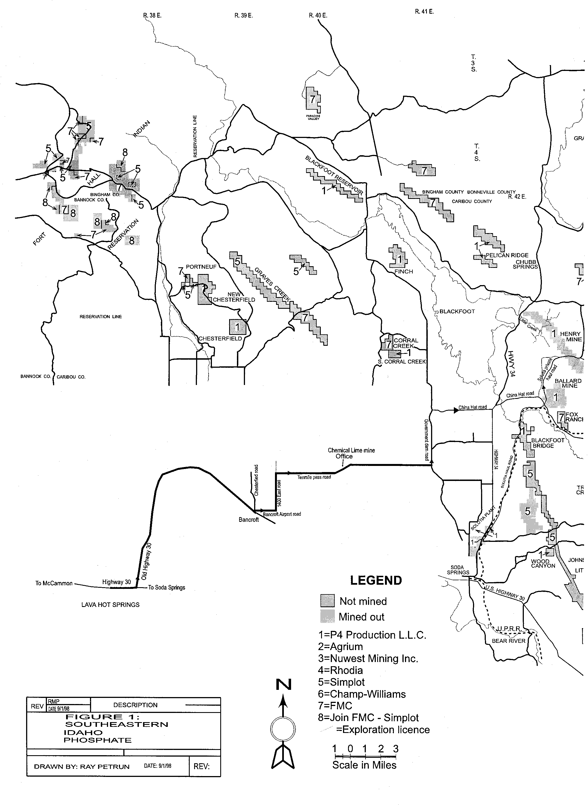

Petrun -- Field Guide to the Southeast Idaho Phosphate District
2 1

Figure 1. Southeastern Idaho Phosphate District. Lo- cation of active mines, mined-out leases, lease holdings, and road log routes in Southeast Idaho Phosphate region.
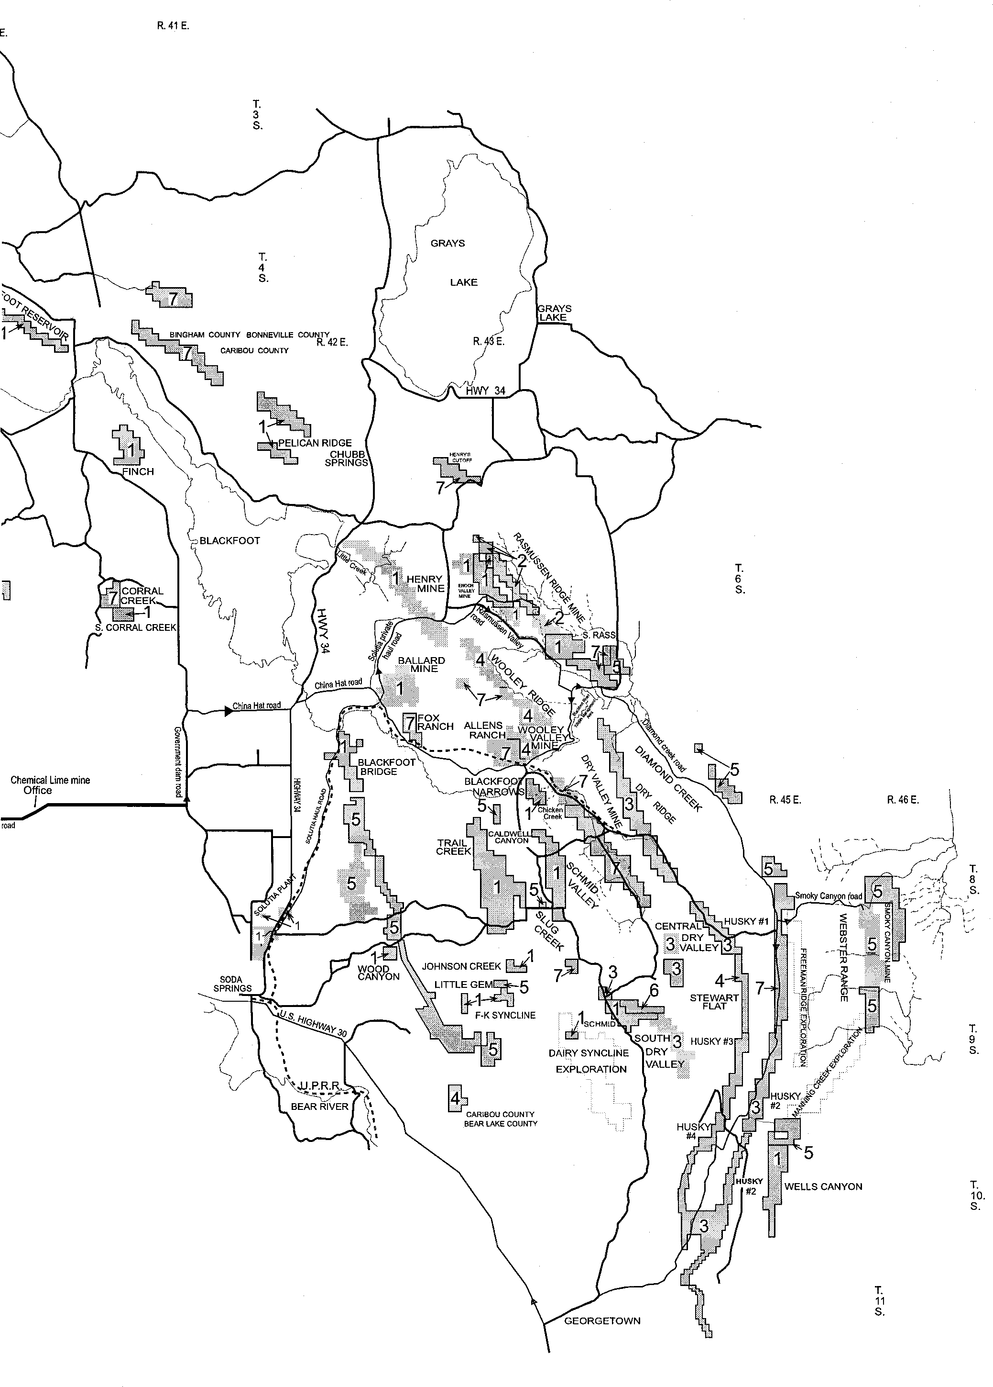

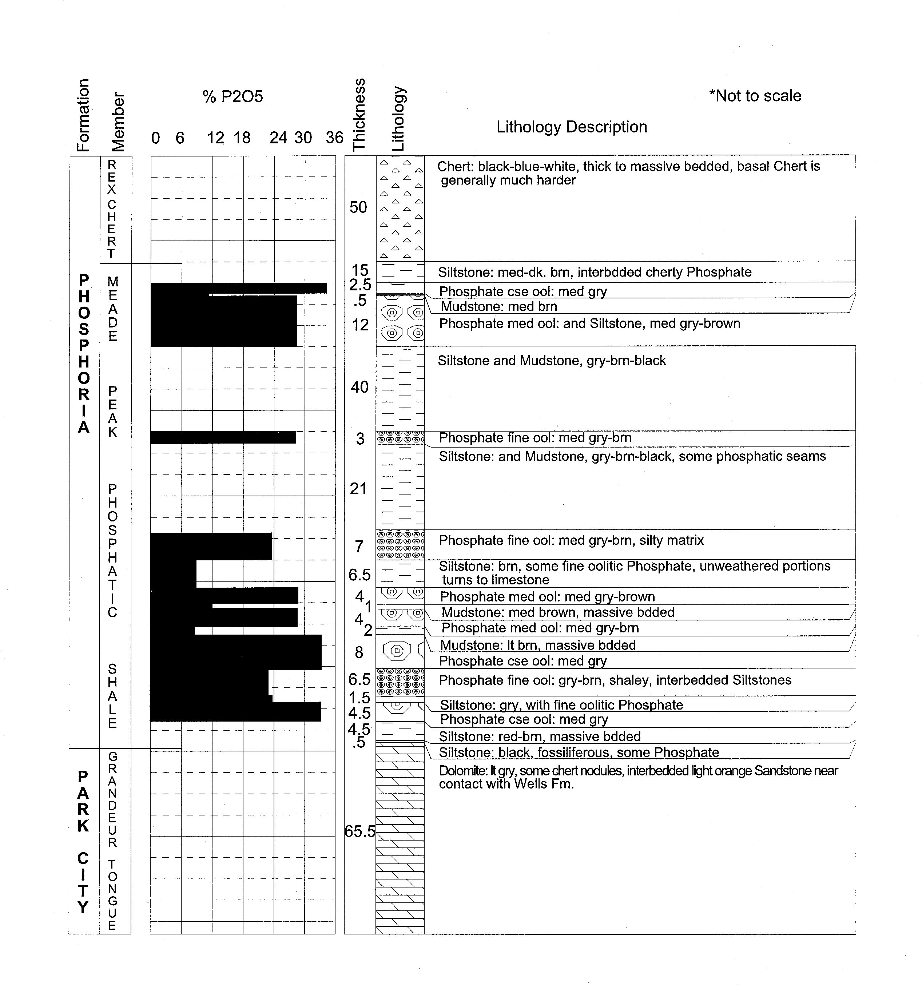

beds found within the Meade Peak Phosphatic Shale Member, but all recognize a lower ore zone 9-15 meters (30-50 ft.) thick, a center waste shale unit 20-29 meters (65-95 ft.) thick, and an up- per ore zone 3-6 meters (10-20 ft.) thick capped by 12-24 meters (40-80 ft.) of the Rex chert.

ACTIVE MINES

Enoch Valley Mine
2 2 Guide oo to the Geolo o astern Idaho

Figure 2. General Stratigraphic Column, Rasmussen Ridge, Caribou County, ID, Phosphoria and Park City Formation
- Lithology and percent P2O5.
Solutia's Enoch Valley mine is located in T. 6 S., R. 43 E., Sections 16, 17, 21, 22, and 27, Caribou County, Idaho (Fig. 3). They are mining the west limb of the northernmost extent of the Snowdrift Anticline, on the upper plate of the Meade Thrust (Blackstone, 1977). The Enoch Valley normal fault bounds the valley on the east and runs roughly parallel to the strike, along the length of the mine.

Petrun -- Field Guide to the Southeast Idaho Phosphate District
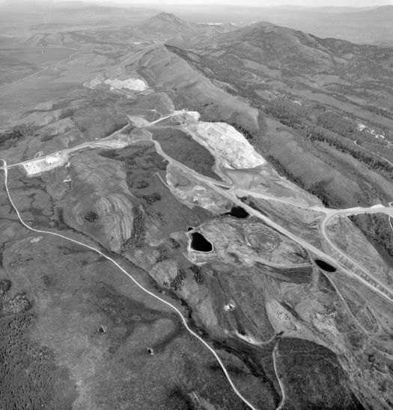
Figure 3. Aerial view of Solutia's Enoch Valley mine, Caribou County, Idaho in July of 1998.
2 3

Mine History
The earliest exploration in Enoch Valley occurred in 1912 when several pits were dug by the USGS and unknown prospec- tors. It was not until 1947 that the valley again saw activity in the form of phosphate lease applications filed by several companies, however, leases were not issued at that time. The USGS re-opened the 1912 trenches in the area of the future mine in 1949. The first drilling program was undertaken by the Ruby Co. in 1961, when they drilled 11 holes under an exploration permit. Their work led to the first lease being issued in 1963. Both Monsanto Co. and FMC joined in the flurry of activity by filing for additional leases. A lease sale was held in 1964 in which FMC was awarded Fed- eral lease I-015122. In 1968, a preference right lease (I-015033) was issued to FMC. In 1978, Monsanto applied for and was awarded State lease I-7957 and in 1981, Monsanto swapped sev- eral leases in Dry Valley for Federal Leases I-015033 and I-015022
held by FMC. Also in 1981, Monsanto acquired State of Idaho lease I-8379. The lease previously held by Ruby Co. was assigned to the Simplot Co. in 1983.
Continued interest in the deposit by Monsanto led to an agree- ment where they drilled two holes on the Simplot lease in 1988, and in 1990 swapped a lease near the Smoky Canyon mine for the Federal lease I-011683. With this acquisition, Monsanto Co. held the entire minable deposit which became known to them as the Enoch Valley Mine. Mining began on the property in October of 1989, and it is anticipated to be completed by year-end of 2001. In September of 1997, Monsanto spun off their chemical busi- ness to form a new company, named Solutia. At that time all their leases were assigned to P4 Production L.L.C. (History condensed from unpublished work by Bill Lee, U.S. Bureau of Land Man- agement)

2 Guide oo to the Geolo o astern Idaho
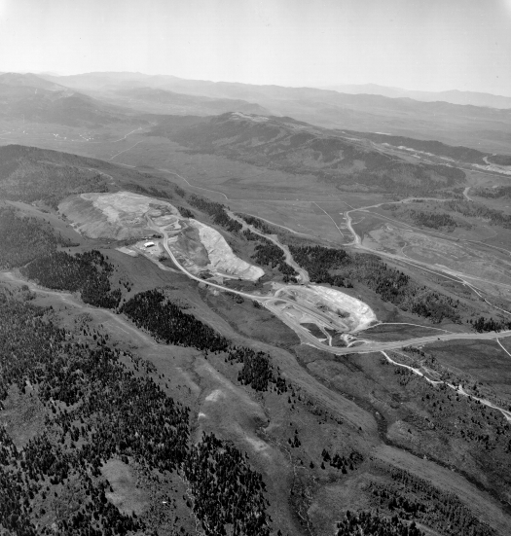
Figure 4. Aerial view of Agrium's Rasmussen Ridge mine, Caribou County, Idaho in July of 1998.

Agrium Rasmussen Ridge Mine
Agrium's mine is located in T.6S., R.42E., Sections 9,15,16,22,23,25 and 26, Caribou county, Idaho (Fig. 4). The Rasmussen Ridge mine is on the east limb of the northernmost extent of the Snowdrift anticline, in the upper plate of the Meade Thrust.

Mine History
Exploration of the Rasmussen Ridge mine began with the USGS in 1912, with the excavation of a large trench. After a 35- year lull in activity, Farmers Education & Cooperative Union of America applied for a phosphate lease. It was rejected for techni- cal reasons, appealed and again rejected in 1952. USGS again trenched on the southern end of Rasmussen Ridge in 1948. In 1953, two leases were offered, I-04375 & I-07619, both of which were acquired by J.A. Terteling & Sons. J.A. Terteling & Sons and later Terteling Land Co. did some preliminary exploration drilling and trenching. In 1967, Stauffer Chemical Co. acquired

the two leases and began their own trenching and geologic map- ping program on the property. During the 1980's the property ownership changed hands several times from Stauffer Chemical Co. to Chesebrough-Ponds Co. to Unilever N.V. to Imperial Chemical Co. and finally to Rhone-Poulenc in 1986.
As the mining operations began to wind down in Wooley Val- ley, Rhone-Poulenc turned their attention to Rasmussen Ridge with the extension of their haul road in 1990-1991. Production from the mine commenced on the south end of the lease in early 1991. Until the closing of Rhone-Poulenc's Silver Bow plant in Montana, all the ore produced at the Rasmussen Ridge was shipped there. At the plant closing, Rhone-Poulenc agreed to pro- vide ore to the Nu-West fertilizer plant at Conda for a seven year period. Rhone-Poulenc spun off their agricultural and chemical business to Rhodia and all Rhone-Poulenc leases were assigned to Rhodia. Two of the leases with remaining ore on Rasmussen Ridge were assigned in 1998 to Agrium Inc., which is currently mining the leases through their subsidiary, Nu-West Mining, Inc.

Petrun -- Field Guide to the Southeast Idaho Phosphate District
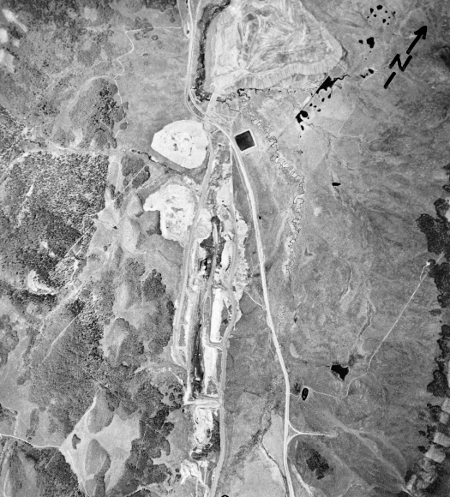

Figure 5. Aerial view or FMC's Dry Valley mine, Caribou County, Idaho.
2 5

Morrison Knudsen's Conda Mining Co. is the current mine op- erator.
The south end of the mine adjacent to P4 Production's lease I-7958 has been mined-out and backfilled, and mining has com- menced in the Central Rasmussen panel north of No-Name creek. (History condensed from unpublished work by Bill Lee, U.S. Bureau of Land Management.)

M ry Valley Mine
Location of the Dry Valley mine is Section 31, T.7S., R.44E., and sections 5, 6, 9, 16, 21 and 22 T.8S., R44E., Caribou county, Idaho (Fig. 5). FMC is mining on the upper plate of the Dry Val- ley Thrust and on the east limb of the Schmid Syncline. Bed dips range from 25°-55° to the west. The deposit is truncated on the north end by the left-lateral Blackfoot tear fault (Derkey and oth- ers, 1983).

Mine History
Exploration of the structure began with a USGS trench in 1910 on the west limb of the syncline just south and west of the current pit. No further activity was recorded until 1947, when numerous companies become interested in the phosphate business. The com- panies made application for leases but no leases were issued. The first serious applications for leasing began with the J.R. Simplot Co. in 1950 which led to a competitive lease being offered in 1951. Of the two bidders, J.R. Simplot and FMC, Simplot came in with the highest bid and was awarded the lease. The lease was later assigned to Monsanto Co. and then swapped to FMC for leases in Enoch Valley in 1981. The first drilling in the Dry Val- ley mine area was done on a prospecting permit issued to Veryl Ershel Larsen who assigned it to the FMC Corporation in 1962. Drilling was conducted in 1962, 1963 and 1965 with sufficient data collected to file for and receive Federal lease I-011866 in 1967. Concurrently, Kerr McGee Oil Industries Inc., was drilling under a prospecting permit on adjacent land. FMC took over the

2 6 Guide oo to the Geolo o astern Idaho

prospecting permit in 1965, and after more drilling applied for a preference right lease. They were granted Federal lease I-014184 in 1968.
At the request of Kerr McGee Oil Industries Inc., a lease sale was held in 1964. FMC was declared the high bidder and was awarded Federal lease I-015097. State leases are also a large part of the FMC mine. Monsanto held State lease I-3059 from 1948 until 1981 when it was assigned to FMC. Kerr McGee also held State lease I-3823 until FMC picked it up in 1967. Private leases purchased from Holmgren/Anderson, Allen, and Bollar also make up FMC Dry Valley mine holdings.
FMC's pursuit of the Dry Valley phosphate yielded approxi- mately a 6 mile strike length of ore which they began mining on the northern end in June of 1992. (History condensed from un- published work by Bill Lee, U.S. Bureau of Land Management.)

Simplot Smoky anyon Mine
Simplot's Smoky Canyon mine is located in T.8 & 9S., R.45 & 46E., Caribou County, Idaho. Simplot is mining on the upper plate of the Meade Thrust on the west limb of the Boulder Creek Anticline. Dips in the deposit range from 20°-30° W. The Meade Thrust surfaces just to the east of the Simplot's current mining on the western edge of Sage Valley (Derkey and others, 1984). On- going exploration in this area, along the east limb of the anticline, reveals complex geology, with overturned beds, thrust of Wells Formation over the Meade Peak Phosphatic Shale Member, and numerous associated faults. The mining sequence has advanced from the north toward the south, just recently (1998) crossing Sage Creek into panel "E" where overburden stripping and some initial ore mining is taking place.

Mine History
Early exploration of this area again dates back to the early 1900's when the USGS dug a trench in the area. There was no recorded activity until 1949, when the USGS again trenched in the Pole Canyon area. The first leasing action occurred in 1961 when the Wells Cargo Co. applied for a Federal phosphate lease. A competitive lease sale was held in April of 1962, with the Ruby Co. being the successful high bidder. Exploration on Federal lease I-012890 began soon after. John D. Archer entered the picture when he applied for and was issued a prospecting permit in 1965. After excavating several trenches, Mr. Archer was issued Federal phosphate lease I-015259 in 1969. Lease I-015259 was eventu- ally assigned to Alumet in 1975. Lease I-012890 was assigned to Simplot Co. in 1983 and in the same year Simplot made applica- tion for a fringe lease. Lease I-26843 was issued as a result of that application in 1989.
Additional drilling on the above leases led to another applica- tion for fringe acreage in 1990, with Federal lease I-027801 be- ing issued in 1991. Final lease issuance occurred in 1995, when Lease I-30369 was released covering fringe acreage. Simplot acquired Alumet's lease I-015259 in 1996. Simplot initiated de- velopment at the Smoky Canyon site in 1982. By early 1984, the mine was producing ore, which was beneficiated in a wash plant at the mine, and shipped via slurry line to a de-watering, calcin- ing and shipping point at Conda just north of Soda Springs. In 1991, the company extended the pipeline from Conda to Pocatello,
making the total length of the pipeline 87 miles. (History con- densed from unpublished work by Bill Lee, U.S. Bureau of Land Management.)

SELENIUM AND PHOSPHATE MINING

The Issue
Selenium is essential to most forms of life in small quantities, but can be harmful in larger doses. In January, 1997, the U.S. Forest Service notified phosphate mining companies in southeast Idaho that elevated levels of selenium had been detected on and near phosphate mine sites. The Forest Service suspected the sele- nium of causing illness in some neighboring livestock. Phosphate industry representatives responded by joining federal and state agencies in an effort to collect pertinent data, analyze the situa- tion, determine the extent of the problem, and to find a remedy.

Selenium - General

Chemistry
The element Selenium was discovered by the Swedish chem- ist Berzelius in 1817. A rare trace element, it is present in the earth's crust at only 0.09 parts per million (ppm), and ranges on average in soil from 0.2 to 0.4 ppm. Selenium is a metalloid, possessing both metallic and non-metallic properties. It can exist in an amorphous state or in any of three crystalline forms. Sele- nium behaves chemically very similar to sulfur.

Biological Effects
Adequate dietary selenium is needed to maintain health under stressful conditions such as (1) premature birth, (2) protein-en- ergy malnutrition, and (3) tissue disorders caused by aging. Re- cent studies suggest that selenium may assist in prevention of certain cancers.
The harmful effects of excess selenium in animal feed were first noted in the U.S. in 1860 among cavalry horses at Fort Randall in the Nebraska territory. Since that time, high selenium intake (Table 1) has been associated with acute (blind staggers) and chronic (alkali disease) toxicity.
Ongoing research focuses on the effect of selenium on many other species. Selenium toxicity in water for aquatic organisms is

Table 1. Suggested maximum tolerable selenium level for animals (National Research Council, 1980).

 | Maximum
 | Recommended by FDA | Toxic Level
 | (mg/head/day) | (ppm in feed)
Beef Cattle | 1.0 | 10-30
Horses | 0.5 | 5-40
Sheep | 0.23 | 3-20
Swine | <0.1 | 5-10
Chickens | <0.1 | 2
All species | 2.0 (or 2 ppm)*
*Suggested maximum tolerable level for all species

Petrun -- Field Guide to the Southeast Idaho Phosphate District
2

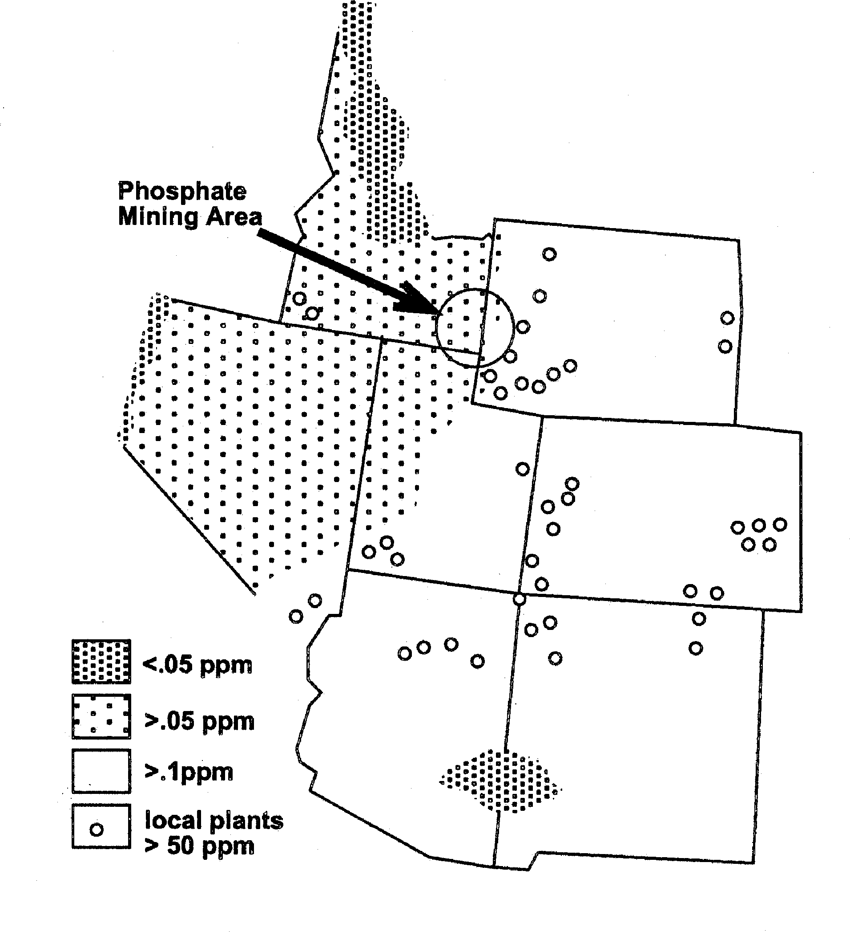
Table 2. Selenium Leachate Test Average Results, PEDCo Environmental,Inc.,1983
Leached with:
Material Acetic Acid Water

Low Grade Ore | 0.01 ppm | --
Surface Mine Waste | 0.009 ppm | <0.002 ppm
Reclaimed Waste | 0.01 ppm | 0.01 ppm
Segregated Waste | 0.03 ppm | 0.03 ppm
Tailings Pond Solids | <0.2 ppm | 0.08 ppm

Figure 6. Selenium distribution in parts per million for the Rocky Mountain States region.
believed to range from 3 parts per billion (ppb) for certain proto- zoa, to 5 ppm in some fish. For humans, the U.S. Environmental Protection Agency has established a primary standard for sele- nium in drinking water of no more than 0.05 ppm.

hosphate re and Selenium
Selenium is unevenly distributed through the earth's crust (Fig. 6). Certain mineral formations contain more selenium than oth- ers, and among those with higher concentrations is the Phosphoria Formation, from which phosphate ore is mined.
In years past, neither the phosphate industry nor its federal and state regulators believed mining would cause elevated levels of selenium. Data collected in the early 1980's for the EPA, using established regulatory testing methods, suggested phosphate mine wastes do not leach selenium (Table 2). Average leachate test results in that 1983 study showed selenium from most phosphate mining materials at levels well below the primary drinking water standard.
In light of these data, the exact cause for elevated selenium levels detected near phosphate mines, and how they can best be reduced, are questions yet to be answered. The U.S. Forest Ser- vice, the Bureau of Land Management, the Idaho Division of Environmental Quality, the Idaho Department of Lands, and the Idaho Fish and Game Department have joined with the phosphate industry in an Interagency/Phosphate Industry Selenium Work- ing Group.

The Working Group
The Interagency/Phosphate Industry Selenium Working Group has, and will continue to, select and hire qualified research pro- fessionals. Montgomery Watson was hired as the consultant to compile available reports and to conduct the field sampling of
water, soils, and vegetation. Samples are sent to the University of Idaho for analysis. The University of California at Davis serves as the quality assurance lab. Phosphate industry members have agreed to assist in underwriting research costs. The five partici- pating companies on the Working Group are: Agrium, FMC, Solutia Inc (formerly Monsanto Co), Rhodia (formerly Rhone Poulenc), and the J.R. Simplot Company. All past and present mine sites have been thoroughly sampled and will continue to be sampled for at least one full year from the initial sampling taken in fall of 1997. The U.S. Geological Survey has collected de- tailed stratigraphic sections from the Meade Peak Phosphatic Shale Member with analysis for selenium to be conducted in early 1999 (Idaho Mining Association, 1997).

SOUTHEAST IDAHO PHOSPHATE ROAD LOG

Mileage - umulative (and Interval)
- Begin at Cavanaugh's Inn, Pocatello, Idaho, go west on Pocatello Creek road.
  - (0.1) Junction with I-15, turn left onto southbound free- way ramp.
8.3 (8.2) Enter Portneuf Gap.
11.4 (3.1) State of Idaho weigh station and rest area.
13.2 (1.8) View of Ashgrove Cement plant to the west behind the town of Inkom.
Two formations are exposed in the pit: Gibson Jack Forma- tion and the Elkhead Formation of the lower Cambrian age. The Elkhead Formation makes up the feed stock for the plant and is named for the Elkhead ranch on Midnight creek in Power county, Idaho. The Elkhead Formation is underlain by the Gibson Jack Formation and is overlain by the Bloomington Formation. The Elkhead Formation is 640 meters(2,100 ft.) thick and consists of essentially all gray limestone with the exception of approximately 30 meters(100 ft.) of thin bedded, ledge-forming, platy shale about 60 meters(200 ft.) above the base of the unit. Equivalent rocks are the Langston, Ute, and Blacksmith Limestones (Trimble and Carr 1976).

16.9 (3.7) Traveling over Portneuf Valley Basalt, which origi- nated in the Gem Valley Volcanic field. Good view of Bonneville Peak (El. 2,826 meters (9,271 ft.)) to the left. Pebble Creek ski area is on the northwest flank of Bonneville Peak.

2 Guide oo to the Geolo o astern Idaho

18.6 (1.7) Good view of Haystack Mountain (El. 2,753 meters (9,033ft.)) to the left.
23.1 (4.5) Take exit 47 onto Highway 30 east.
35.5 (12.4) Lava Hot Springs overlook.
An historical marker overlooking the hot pools indicates that long before white men discovered these springs on September 9, 1812, Indians gathered here to use the free hot water. Except where they found hot springs, pre-historic Indians had a hard time get- ting hot water. They wove watertight buckets into which they put heated rocks. Here they had plenty of hot water for baths and for processing hides without going to all the work of heating baskets. This was one of their major campgrounds, especially in winter. After 1868, when they moved to the Fort Hall Indian reservation, this spot lost its importance as a winter camp.

36.0 (0.5) Turn left onto old Highway 30.
36.2 (0.2) Old manganese mines in gulch to the left. Openings are in Silurian Fish Haven Dolomite. The ore was pyrolusite veins and coatings in brecciated zones in the dolomite.
41.9 (5.7) White exposures of the Salt Lake Formation out- crop across the Portneuf River.
45.6 (3.7) Old calcium mine workings.
48.2 (2.6) Outcrop Swan Peak Quartzite.
53.2 (5.0) Bancroft, Idaho, turn left onto Chesterfield road, cross railroad tracks, go 200 yds. and turn right onto Bancroft airport road. Sign says Chemical Lime with arrow.
61.0 (7.8) Chemical Lime office. Visitors must sign in at of- fice.
62.0 (1.0) Chemical Lime's quarry access road. Conda Min- ing is the mining contractor. Chemical Lime's quarry is located at the southern end of the Chesterfield range.
At this location, the stratigraphy consists of Palezoic carbon- ates including the Silurian Laketown Dolomite, the Devonian Hyrum Dolomite, the Devonian Beirdneau Formation, and the Mississippian Lodgepole Limestone. The Chesterfield Group rests unconformably on the Lodgepole. The Chesterfield is composed of the Little Flat Formation below and the Monroe Canyon Lime- stone above. Chemical Lime is mining Upper Mississipian Mon- roe Canyon Limestone, which consists of 282 meters (925 ft.) of gray, thick bedded, bioclastic, partly sandy limestone and pale yellow calcareous siltstone with minor gray dolomite and chert in the lower part.(Bureau of Land Management, 1991).

67.6 (5.6) Turn left onto Government Dam road.
72.1 (3.5) Turn right onto China Hat road. Sign says Dike lake public access road.
74.1 (2.0) Small quarry at base of China Hat. China Hat is a Pleistocene rhyolite dome extruded through Pleis- tocene/Pliocene basalt.
76.1 (2.0) Turn left (north) onto Highway 34.
76.4 (0.3) Turn right (east) onto Blackfoot River road at China Hat store.
79.9 (3.5) Turn left at traffic light onto Solutia's private haul road. NOTE: This road should not be traveled with- out prior permission from Solutia.
80.1 (0.2) To the left is the old Monsanto Ballard mine that operated between 1951-1969.
84.5 (4.4) The haul road crosses the Henry mine that was in operation from 1969-1989.
87.5 (3.0) STOP 1 Solutia's Enoch Valley mine office.
Stop and check in as visitors; restroom facilities are avail- able. Mine tour includes the active pit and reclamation of mined- out areas. Solutia is mining the west limb of the Snowdrift anti- cline. Stratigraphy in the active mine consists of the Pennslyvanian/ Permian age (upper) Wells Formation, the Grandeur Tongue of the Park City Formation, the Phosphoria Formation, which in- cludes the Meade Peak Phosphatic Shale Member, the Rex Chert Member, the cherty shale member. A partial exposure of the Tri- assic Dinwoody Formation can be seen in places along the hang- ing wall of the mine. Geology discussions will focus on a trench cut in the active pit exposing a section of the Meade Peak Phos- phatic Shale Member of the Phosphoria. On the way to the Agrium haul road we will view and discuss the backfill, topsoil place- ment, planting, and fertilizing phases of the reclamation process. Wetland enchancement and wildlife projects will also be discussed.

88.9 (1.4) Junction with Agrium haul road.
90.6 (1.7) STOP 2 Agrium shop and office.
Check in as visitors; restroom facilities are available. Mine tour of active mine area and reclamation activities. Agrium is mining the east limb of the Snowdrift anticline and therefore, appears as a mirror image of Solutia's mine. The same stratigra- phy is exposed in both mines. We will tour the newly opened Central Rasmussen mine panel and view the reclamation in progress on the South Rasmussen panel. Lonch Break.
Backtrack 1.6 miles past junction with Solutia access road.

93.6 (3.0) Junction of Agrium haul road and Rasmussen Val- ley road, turn left (south) onto Rasmussen Valley road.
95.2 (1.6) On the ridge to the east is Solutia's South Rassmussen Lease I-7958 and ID-23658. Solutia will begin mining here in the year 2000.
95.8 (0.6) On the flank of the ridge to the east is FMC's Lease I-05975.
96.8 (1.0) After cattle guard, stay left.

LOOP 1-Georgetown Canyon (refer to Fig. 1).
97.1 (0.3) Turn left onto Forest Service (F.S.) road 095. On the right is the Blackfoot River Wildlife Manage- ment Area. The area was purchased from the Stock- ing Ranch estate by several government and pri- vate organizations and is managed by the Idaho Fish and Game.
98.3 (1.2) Turn right onto F.S. road 102. (Diamond Creek rd.)
98.7 (0.4) Crossing southern extent of Pleistocene/Pliocene basalt flow. Source area for flow is to the northeast in Grays Lake area.

Petrun -- Field Guide to the Southeast Idaho Phosphate District
2 9

103.4 (4.7) The low ridge on the east side of the valley is Simplot's lease I-014914. A trench and small pit was excavated on the property by the previous owner-Alumet.
104.6 (1.2) Entering Caribou National Forest (cattle guard).
108.8 (4.2) Johnson F.S. guard station.
110.0 (1.2) Junction with Smoky Canyon road, turn left.
110.3 (0.3) Rocks that crop out on the left are Pennslyvanian- Permian Wells Formation. South of the creek is the Freeman Ridge prospecting area. Simplot Co. ap- plied for a phosphate exploration license in 1994, and with Monsanto Co. as a participant, drilled 18 holes during the fall of 1996. Leasing of the prop- erty is still pending.
110.9 (0.6) On the left, an outcrop of the Rex Chert Member of the Phosphoria Formation can be seen. The Meade Peak Phosphatic Shale Member is present just to the east of the Rex Chert, although it cannot be seen from this point.
111.9 (1.0) Top of pass.
113.5 (1.6) Junction with Smoky Canyon mine access road. Turn right.
113.9 (0.4) Simplot's Smoky Canyon mine office and shop. Travel beyond this point is restricted and all visi- tors must check in at the office.
Backtrack 5.0 miles to Junction with Diamond Creek road.
Turn left (south) onto Diamond Creek road.
115.9 | (2.0) | Junction with Sage Meadows road; stay on F.S. road
 |  | 102.
120.2 | (4.3) | Rock outcrops are Triassic Dinwoody Formation.
120.4 | (0.2) | Rex Chert Member of the Phosphoria crops out on
 |  | the right hand side of the road.
120.5 | (0.1) | The Meade Peak Phosphatic Shale Member of the
 |  | Phosphoria Formation can be seen here in the road
 |  | cut on the right. The Deer Creek trailhead is on the
 |  | opposite side of the road.
121.5 | (1.0) | Junction with Wells Canyon F.S. road 146. Turn
 |  | right.
124 | (2.5) | Intensely folded and faulted rocks are Triassic
 |  | Thaynes Formation. Running roughly parallel to the
 |  | road is the Meade Thrust fault and the Snowdrift
 |  | overturned syncline.
124.7 | (0.7) | Here you catch a glimpse of Snowdrift Mountain
 |  | (El. 2,919 meters, 9577 ft.) to the left.
125.2 | (0.5) | Straight ahead Meade Peak (El. 3,035 meters, 9957
 |  | ft.) can be seen.
126.4 | (1.2) | Entering the old Central Farmers Fertilizer Co. min-
 |  | ing area. The actual mine pits are up on the side of
 |  | Snowdrift Mountain and not visible from the road.
126.9 | (0.5) | Old Central Farmers Fertilizer Co. plant site.
129.9 | (3.0) | Crossing the Meade Thrust, hillside on the right is
 |  | made up of Jurassic Twin Creek Formation.
131.9 | (2.0) | Junction with F.S. Road 095, stay left toward
 |  | Georgetown.
134.2 | (2.3) | Junction with Highway 30, turn right.

151.7 (17.5) Soda Springs. Junction with Highway 34 (reset odometer).

LOOP 2 Blackfoot Narrows
0 |  | Junction of Rasmussen Valley road and F.S. Road
 |  | 095, turn right.
1.0 | (1.0) | Entering Blackfoot River Narrows. Rocks through-
 |  | out the canyon are Pennsylvanian/Permian Wells
 |  | Formation.
3.8 | (2.8) | On the right hand side of the road you can see the
 |  | far south end of Stauffer's mined-out Wooley Val-
 |  | ley mine. Across the Blackfoot River to the left,
 |  | you can see the backfill in FMC's first pit in Dry
 |  | Valley.
4.0 | (0.2) | Access road to Agrium's mine on the right.
4.5 | (0.5) | Junction with Slug Creek road, turn left (south).
4.8 | (0.3) | Junction with Dry Valley road, turn left.
6.6 | (1.8) | FMC backfilled pits on both sides of the road.
8.1 | (1.5) | On the right side of the road is FMC's active pit. On
 |  | the left side of the road toward the top of the ridge
 |  | is mined-out Conda Partnership's Mabie Canyon
 |  | mine.
8.7 | (0.6) | Entrance to FMC office and shop, turn right.
8.9 | (0.2) | FMC office parking lot. All visitors must sign in at
 |  | the office.
13.3 | (4.4) | Backtrack 4.4 miles to junction of Blackfoot River
 |  | road and Slug Creek road.
14.9 | (1.6) | Junction with North Trail Canyon road. Stay right.
19.9 | (5.0) | Traffic light at Solutia's private haul road.
23.4 | (3.5) | Junction with Highway 34, turn left(south).
34.7 | (11.3) | Junction with Highway 30.

REFERENCES
Blackstone, D.L. Jr., 1977, Tectonic Map of the Overthrust Belt, Western Wyo- ming, Southeastern Idaho and Northeastern Utah: Guidebook 28 th Annual Field Conference Wyoming Geological Association.
Bureau of Land Management, 1991, Environmental Assessment, Chemstar Lime
Company, Tenmile Project.
Derkey, P.D., Palmer, P. and Wotruba, N.J., 1983, Maps Showing Selected Geol- ogy and Phosphate Resources of the Upper Valley Quadrangle, Caribou County, Idaho: Idaho Bureau of Mines and Geology, scale 1:24,000.
Derkey, P.D., Paul K., Palmer, P., Fakourbayat, M., Wotruba, N.J., and Hovland, D.R., 1984, Maps Showing Selected Geology and Phosphate Resources of the Stewart Flat Quadrangle, Caribou County, Idaho: Idaho Bureau of Mines and Geology and Bureau of Land Management, scale 1:24,000.
Idaho Mining Association, 1997, Phosphate Subcommittee Fact Sheet, "Sele- nium and Phosphate Mining.
McKelvey, V.E., Williams, J.S., Sheldon, R.P., Cressman, E.R., Cheney, T.M., and Swanson, R.W., 1959, The Phosphoria, Park City, and Shedhorn For- mations in the western phosphate field: USGS Professional Paper 313-A, p.1-28.
National Research Council, 1983, Selenium in Nutrition: Subcommittee on Se- lenium, Committee on Animal Nutrition, and Board on Agriculture.
PEDCo Environmental, Inc., 1983, Evaluation of Management Practices for Mine Solid Waste Storage, Disposal, and Treatment: Cincinnati, U.S. Environ- mental Protection Agency, p. A107-A149.
Trimble, D.E. and Carr, W.J., 1976, Geology of the Rockland and Arbon quad- rangles, Power county, Idaho: USGS bulletin 1399, p. 115.
Williams, George A. and Holstein, H. J., 1967, Geology of the Southeastern Idaho Central Phosphate Region: Anatomy of the Western Phosphate Field: Intermountain Association of Geologists 5 th Annual Conference, p. 45.

2 Guide oo to the Geolo o astern Idaho

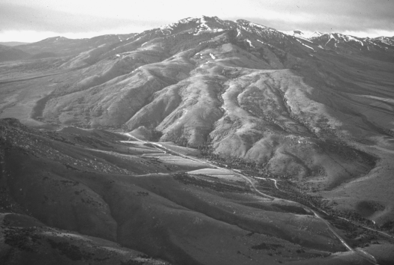

Aerial view southward of Ross Fork Narrows and North Putnam Mountain at the north end of the Portneuf Range. The Oregon Trail followed this route to Fort Hall, located ten miles west of here. Photograph by Paul Karl Link.

