Field Guide to Pleistocene Lakes Thatcher and Bonneville and the Bonneville Flood, Southeastern Idaho

Paul Karl Link

Department of Geology, Idaho State University, Pocatello, ID 83209
Darrell S. Kaufman
Department of Geology, Northern Arizona University, Flagstaff AZ 86011
Glenn D. Thackray
Department of Geology, Idaho State University, Pocatello, ID 83209

INTRODUCTION
This field guide is designed to summarize and describe field trip stops that illustrate the rise of Lakes Thatcher and Bonneville and the Bonneville Flood in southeastern Idaho (Figs. 1 and 2). The Bonneville events were sufficiently recent that their effects are well-preserved in the landscape, and easily discerned by all. Shoreline and scabland remnants are easy to see in portions of Gentile, Cache, Marsh and Portneuf valleys southeast and in the vicinity of Pocatello, Idaho. Further, the history of Lake Bonneville and its flood record interaction of climate change, basaltic volca- nic activity, and drainage capture caused by detumescence after the passage of the Yellowstone hot spot (Fig. 3). All of this infor- mation has been previously published. The primary sources are Gilbert (1890), Bright and Ore (1987), O'Connor (1993), Link
and Phoenix (1996), Bouchard et al. (1998), Anderson (1998), and Anderson and Link (1998).
An essay by H. T. Ore (written communication, 1995) relates the framework of topographic and geomorphic change in south- eastern Idaho over the last ten million years. Segments of that essay are quoted in a text box on the fourth and fifth pages of this article. Tom Ore's big-picture wisdom molded the academic tra- dition from which PKL and GDT have approached southeast Idaho geology.

GEOLOGIC BACKGROUND:
LAKES BONNEVILLE AND THATCHER
The record of Pleistocene Lake Bonneville was first recog- nized by Gilbert (1890). Lake Thatcher preceded Lake Bonneville (Bright, 1963), and occupied the southern part of Gem Valley, Idaho (Figs. 1 and 2) intermittently from ~2 Ma to 50 ka (McCoy,

1987; Bouchard et al., 1998). The Bonneville lake cycle spanned approximately 30-10 ka (radiocarbon years B.P.), during marine oxygen isotope stage 2 (Figs. 4 and 5, Table 1) (Scott et al., 1983; Currey et al., 1983; Currey and Oviatt, 1985; McCoy, 1987; Oviatt et al., 1987; 1992; Oviatt and Nash, 1989; Oviatt, 1997; Oviatt and Miller, 1997). Recent reviews of Lake Bonneville literature include Machette and Scott (1988) and Sack (1989). Currey et al. (1984) published a very useful map showing lake levels and ex- tents, and summarizing the geologic history of Lake Bonneville. The Bonneville Flood was first documented by Malde (1968), with the most recent study by O'Connor (1993), who summa- rized the geomorphology and hydraulics of the Bonneville Flood along its entire flow length, with substantial discussion of the flood path between Red Rock Pass and Pocatello.
The rise of Lakes Thatcher and Bonneville and the release of the Bonneville Flood reflect recent changes in regional drainage in southeastern Idaho. This drainage has been affected by subsid- ence in the wake of the passing Yellowstone-Snake River Plain hotspot, Pleistocene climate change, and volcanic eruptions that create dams in narrow, superposed drainages. Figure 3 outlines our present best-guess of some of these changes.

LAKE THATCHER
Thatcher Basin (~200 km2) is located at the southernmost end of Gem Valley, Idaho (Fig. 2). It hosted a series of Pleistocene lakes collectively known as Lake Thatcher (Bright, 1963). Strand- lines and river deltas that developed along the lake shore are the most pronounced geomorphic features in the basin (Fig. 6). Al- though prominent on the eastern side of the valley, the terraces fade northward near the contact with the Gem Valley Volcanics.

Link, P.K., Kaufman, D.S., and Thackray, G.D., 1999, Field Guide to Pleistocene Lakes Thatcher and Bonneville and the Bonnevill e Flood, southeastern Idaho, in
Hughes, S.S., and Thackray, G.D., eds., Guidebook to the Geology of Eastern Idaho: Idaho Museum of Natural History, p. 251-266.

252 Guide ook to the Geolo o astern daho
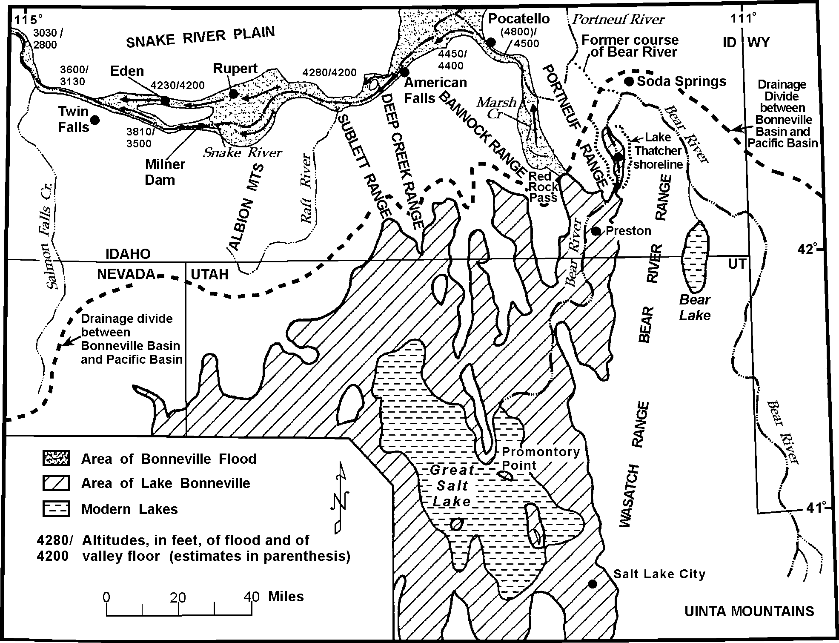
Figure 1. Map of Lake Bonneville and the path of its flood. Field trip stops are shown, as is the drainage divide between the P acific Basin and the Bonneville Basin and the former course of Bear River; after Malde (1968), and Bouchard et al. (1998).

At the southern end of the valley, a low (~1670 m [~5480 ft] above sea level), flat divide separates Thatcher Basin from Cache Valley (and the Bonneville Basin) to the south. The divide is situ- ated on an ancient pediment (McKenzie Flats of Williams, 1948)
~150 m (~490 ft) above the basin floor. This surface is nearly coincident (±10 m [30 ft]) with the highest strandlines in Thatcher Basin (Fig. 6). The highest strandlines are more than 100 m (330 ft) above the Bonneville shoreline in Cache Valley. The Plio-Pleis- tocene Main Canyon Formation (Fig. 7), deposited in Lake Thatcher over several lake cycles, spans 2 Ma to 50 ka (McCoy, 1987; Bouchard et al., 1998). The Bear River flows through the dramatic gorge of Oneida Narrows (Fig. 8), which cuts through the flats and links Thatcher Basin with the adjacent Bonneville Basin.
Northern Gem Valley contains a Pleistocene basaltic volca- nic field that occupies the former course of Bear River, a major regional drainage, to the Snake River system (Fig. 3b). The rise of Lake Thatcher, southward diversion of Bear River, and the spillover of drainage into the Bonneville basin are Pleistocene events whose timing and sequence are still unclear. As pointed out by Ore (text box facing Fig. 3), Oneida Narrows may have been cut for the first time in Late Miocene time, then backfilled with sediment, to be excavated most recently by ~50 ka. In any
event, the addition of Bear River water drastically increased flow to the Bonneville basin and was a major contributing factor to the rise of the lake to the Bonneville shoreline (Bright, 1963).
Bouchard et al. (1998) used the Sr-isotope composition of amino-acid dated shells to reconstruct the timing of the Bear River diversion into Thatcher Basin. They found that, during the early Quaternary, Thatcher basin was occupied by locally fed, shallow lakes. On the basis of an amino acid age estimate of a single shell, the oldest known inflow of Bear River water in Thatcher Basin is
~140 ka. The shell was collected from red sediment, the only non-Bonneville red sediment yet found in Thatcher Basin. This supports Bright's (1963) original suggestion that red sediment (derived from hematitic Mesozoic shales of the thrust belt to the east) may be an indicator of the Bear River flow into the basin.
Because deposits representing most of the middle Pleistocene have not yet been found, it is possible that the Bear River contrib- uted to the Thatcher Basin prior to ~140 ka. On the other hand, the 140 ka age is consistent with K-Ar dates on basaltic lava along the Portneuf Gorge near Lava Hot Springs, and derived from the Gem Valley volcanic field (Fig. 3c) (Armstrong et al., 1975). It is possible that basaltic volcanoes or lava flows temporarily blocked the course of Bear River, which caused filling of a portion, or perhaps all, of Thatcher Basin. It is unclear, however, when the

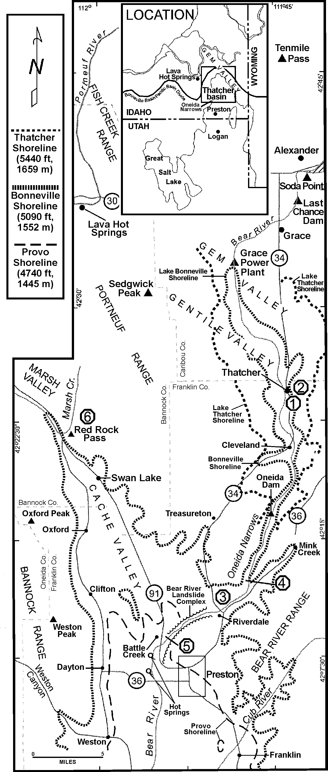

Figure 2. Map of Cache Valley and southern Gem Valley, show- ing field trips stops and shorelines (after Link and Phoenix, 1996).
basalt that forms the northern divide of Thatcher Basin (and the Great Basin, Fig. 1) had built up to allow Lake Thatcher to rise high enough to spill over the southern divide into the Bonneville Basin.
Soon after ~140 ka, the upper Main Canyon Formation re- verts to white sediment and the 87Sr/86Sr ratios shift again from a Bear River-dominated system to a locally fed lake. During this interval, Lake Thatcher rose under local-stream influence to an elevation of at least 1659 m (5440 ft) above sea level and per- sisted for at least 60,000 years. Hydrologic balance calculations (Bouchard, 1997) based upon evaporation rates measured on nearby Bear Lake suggest that, under modern conditions, the lo- cally derived discharge is more than sufficient to fill the Thatcher Basin.
It is possible that this non-Bear River phase of Lake Thatcher (~140-80 ka) achieved its stillstand elevation of 1659 m (5440 ft) above sea level by spilling to the north, down the Portneuf River. However, the coincidence of the stillstand elevation with the level of the shoreline occupied just before Lake Thatcher spilled south into the Bonneville Basin, suggests that the northern basalt di- vide was high enough to allow the lake to fill to its southern thresh- old sometime prior to or during the non-Bear River phase. Thus, water from the Thatcher Basin, but not necessarily the Bear River, probably entered Bonneville Basin and began the headward ero- sion of Oneida Narrows sometime after ~140 ka.
The Bear River was diverted back into Thatcher Basin for the final rise of Lake Thatcher around 50 ± 10 ka, based upon the calibrated amino acid ratios in shells from the uppermost Main Canyon Formation. Hydrologic balance models suggest that, un- der the influence of the Bear River, Thatcher Basin would have filled and begun spilling over the southern divide in <70 years. Thus, the incision of Oneida Narrows was fully underway by ~50 ka. The gorge was completely cut by ~20 ka, based upon the 14C age of the incursion of Lake Bonneville through Oneida Narrows and into Thatcher Basin (Oviatt et al., 1992).
In summary, Sr analyses, combined with the temporal frame- work provided by the amino acid geochronology, suggest that the diversion of Bear River into Thatcher Basin was not a single event that took place immediately prior to the last rise of Lake Bonneville (cf. Bright, 1967). Instead, the river's complicated paleohydrogeography may have included two or more diversions. The earlier one took place prior to ~140 ka. Once the river was diverted into the Thatcher Basin, it undoubtedly filled the basin, although we cannot be certain whether or not it spilled south into the Bonneville Basin. By 100 ka, however, the northern divide had built up sufficiently so that, when the Bear River once again entered Thatcher Basin ~50 ka, it did spill southward into the Bonneville Basin (Fig. 3d), adding ~33% more water and pro- viding a migration route for aquatic organisms that were previ- ously in communication with the Pacific drainage. By ~20 ka, the incision of Oneida Narrows was complete and Lake Bonneville had backed up into Thatcher Basin.

BONNEVILLE BASIN
The Bonneville Basin has been an area of internal drainage since its inception during early Basin and Range faulting 5 to 7 Ma (Miller et al., 1992) or 16 to 17 Ma (age of initiation of the

Segments from Essay on

Topographic and Geomorphic Development of Southeastern Idaho

by H. Thomas Ore, Department of Geology, Idaho State University, May 1995.

INTRODUCTION
This is an essay intended as a synthesis of thoughts con- cerning evolution of the landscape southeast of the eastern Snake River Plain. Proposing this model for Neogene evo- lution of southeast Idaho is prompted by an emerging view of the roles of evolution of basin-and-range structure and topography, and the almost concurrent passage of the North American Plate over a mantle plume (the "Snake River Plain- Yellowstone hotspot"). The essay is intended as a forum for thought, rather than as a compendium of research results of individual workers. It is, of course, based on the latter.
The overall theme is one of basin filling and emptying, and controls on those processes by base level, at a variety of scales. In fact, the whole subject of southeast Idaho topogra- phy is the story of the precursors to and the results of super- position, related to sequential basin separation and integra- tion.

Miocene Eastward Regional Drainage
In Middle Miocene time, during early basin-and-range faulting, regional drainage was eastward, still responding to effects of uplift to the west, related to earlier subduction. Eastward progression of basin-and-range faulting made new sources and sinks available in that direction. An extensive east-sloping surface, part cut, part fill, was thus prepared, with deposition starting perhaps 8 to 10 million years ago. Drainage was toward the Atlantic, and the continental di- vide was west of our area, specifically on the volcanic pla- teau in the Owyhee uplands of southwestern Idaho, just as it is now on the Yellowstone plateau.
The principal theme of the above is that sediments were transported eastward, northward and southward away from the location of the volcanic tumescence at the hot spot. East- flowing Mio-Pliocene drainage systems thus aggraded the surface eastward into western Wyoming. The great distance to permanent base level to the east afforded no opportunity for dissection in that direction.

Swan Peak Formation Lag Gravels
On pediments adjacent to the nearly buried basin-and- range mountains, resistant boulders of Ordovician Swan Peak Quartzite formed a lag concentrate on the bedrock surfaces. That white bouldery quartzite is still present as scattered boulders and patches of gravel in areas not affected by streams since they were abandoned by subsequent downcutting drain- age.

DRAINAGE DERANGEMENTS AND REVERSALS
The drainage in basins adjacent to the subsiding hot spot track reversed and became northwestward, tributary to the main axial stream of the hot spot track; i.e., the modern Snake River. The ancestral Raft River, Rock Creek (Rockland Val- ley), Bannock Creek (Arbon Valley), and Portneuf River, west to east, all had their inceptions as consequent streams responding to the new, lower base level at the collapsing hot spot track. They all started eroding headward toward the south and east, one by one capturing tributaries to old south- and east-flowing drainages that had been responsible for emplace- ment of the basin fill. These new north- and northwest-flow- ing streams also in part responded to tilting of the surface toward the Plain (at least near the Plain margin) by that same thermal collapse.

Role of the Bonneville Basin
A complicating factor was provided by downward dis- placement on the Wasatch Fault, providing a base level for streams to be captured by the Bonneville Basin. The unusual pathway of the Bear River may have originated in this man- ner. If so, it would have happened when the Gem-Gentile Basin was full of sediment, and a southward flowing drain- age into the dropping Bonneville Basin evolved. Any rivers at that position would have had great competence at least near their entrance to the Bonneville Basin. The mouth of the ancestral lower Bear River into the Bonneville Basin was superposed onto the quartzite at Oneida Narrows south of

Wasatch fault per Parry and Bruhn, 1987). Although the Bonneville basin has largely been hydrologically closed since at least the late Miocene, there may have been sporadic overflow events into the Columbia River system (as in Rockland Valley,
Idaho, Ore et al., 1996). The largest and deepest known lake ex- isted ca. 30 to 10 14C ka BP., and it is this lake that we refer to as "Lake Bonneville".

IH. Thomas Ore spent more than thirty years studying the geology and geomorphology of southeastern Idaho. He remains a geo- morphologist of a classic style, unique in his tendency to think in terms of large-scale geomorphic evolution, and his ability to integrate observations from across large areas and from multiple geologic disciplines. Prior to his retirement from Idaho State University, Tom summarized his thoughts concerning southeast Idaho drainage evolution. We present his essay here in a con- densed form, but one that conveys his ideas accurately and preserves the spirit of his thinking.

Grace, and by headward erosion captured westward-flow- ing drainage of the ancestral upper Bear River at Soda Point. Similar captures, although not quite so dramatic as erosion through the Oneida Narrows, occurred to the west.
Marsh Creek was a temporary capture by the Bonneville basin base level. The eventual result, however, was that drain- age to the ocean had an advantage over drainage to the more whimsical base level provided by a closed Bonneville basin, that was rapidly filling with sediment from all sides, and at later times filling with water as well, also raising its base level. Marsh Creek was thus captured by north-flowing drain- age to the Snake River Plain.

Superposed Gaps, Basin Integration
Some bedrock slivers, uplifted along synthetic faults with offset less than those of the major range-bounding faults, had been deeply buried by the rising level of the Miocene Salt Lake Group basin fill. Higher, more uplifted bedrock that wasn't buried deeply by basin fill, was encountered early in the regional downcutting by the northwestward-flowing drainage network. The westward draining gap between Lava Hot Springs and McCammon was occupied earlier than other narrower gaps, explaining the wide, slope- and floodplain- dominated terrain there.
As the continental divide migrated to the east, westward drainage became superposed on the basin fill and on bed- rock divides between basins, connecting those basins and allowing more upstream, eastern ones to become regraded to lower, more westerly ones. Major drainages through the Portneuf and Bannock ranges were established in this way. The cutting of the northwestward flowing main drainage of the system, through Portneuf Narrows between Inkom and Pocatello, has become a dominant westward egress to the Pacific.
A particularly elegant example of superposition and in- cipient basin capture, is the relationship between Hawkins Basin and Creek and the Garden Creek drainage. In the east- ward flow of Garden Creek, draining the basin west of Scout and Old Tom Mountain, the superposed creek had encoun- tered quartzite of the Scout Mountain Member of the Pocatello Formation, and became trapped, forming the nar- row Garden Creek Gap. As the newly north-draining Marsh Creek continued to cut downward, both Garden Creek and
Hawkins Creek followed along; the former in a steep can- yon, the latter in a broader valley. The northern headwaters of Hawkins Creek today are eating headward into a narrow ridge of volcanigenic basin fill, all that remains separating Hawkins Basin from the Garden Creek drainage. Because of the temporary base level provided by the quartzites at Gar- den Creek Gap, the divide between the headwaters of Hawkins Creek and Garden Creek will continue to migrate northward. Eventually no water will flow through Garden Creek Gap. It will become a wind gap, common in the Valley and Ridge of the Appalachians.

OVERVIEW
In terms of the broad view of southeast Idaho topographic evolution, a Neogene relative chronology emerges, suggested by basin fill stratigraphy, locations of superposed gaps be- tween basins, and migration of the hot spot and the associ- ated continental divide. The first part of the chronology is relict eastward drainage toward the continental interior left from uplift to the west from the Sevier orogenic event. The onset of eastward younging basin-and-range grabens provided sinks for preservation of siliciclastic and volcanigenic sedi- ment, the latter from silicic volcanic centers along the east- ward-migrating hot spot. Basins filled syntectonically with sediment, some more than others, depending on activity along individual fault segments.
Eventually the basin system was filled with sediment, and an equilibrium drainage system delivered whatever sediment was derived from the highlands to the west to the drainage systems leading to the Gulf of Mexico. As eastward- migrat- ing uplift occurred, as the continental divide followed the hot spot and basin-and-range extension, drainage shifted to the west.
As the Snake River Plain dropped, streams tributary to it at its margins were encouraged to eat headward into previ- ously filled basins. Low-gradient westward-draining systems on the Pacific side of the eastward-migrating continental di- vide were locally captured by headward eroding steep gradi- ent streams with local base levels provided by the Snake River. At times, the pattern was sidetracked, as by the immense Bonneville Basin locally capturing streams along its margins. Nevertheless, the general pattern was of a shift of drainage to the Pacific.

Rise of Lake Bonneville
As noted, the permanent addition of Bear River water to Lake Bonneville likely occurred 50 ± 10 ka (Bouchard et al., 1998), increasing the total discharge into the Bonneville Basin by ~33%. This addition, coupled with cool, moist conditions during late Wisconsin time, is generally thought to have been responsible for the lake reaching its all-time high during the last (Bonneville) lake cycle (Bright, 1963; McCoy, 1987; Bouchard et al., 1998). Antevs (1952) first suggested that, at the time of the glacial maxi- mum (ca. 20 ka), winter westerlies and accompanying cyclonic
storms were diverted southward into the Great Basin by high pres- sure associated with the large Canadian ice sheets, causing the rise of the Great Basin lakes. His suggestion has been corrobo- rated by climate models (e.g., Thompson et al., 1993).
At Red Rock Pass, the lowest point on the Lake Bonneville margin, alluvial fans from the adjacent Bannock and Portneuf Ranges had coalesced above tuffaceous Tertiary sediments and Cambrian limestone. As Lake Bonneville rose, overflow, coupled with leakage of water through the alluvial fan gravels and through karst in limestone bedrock, controlled the level of its maximum

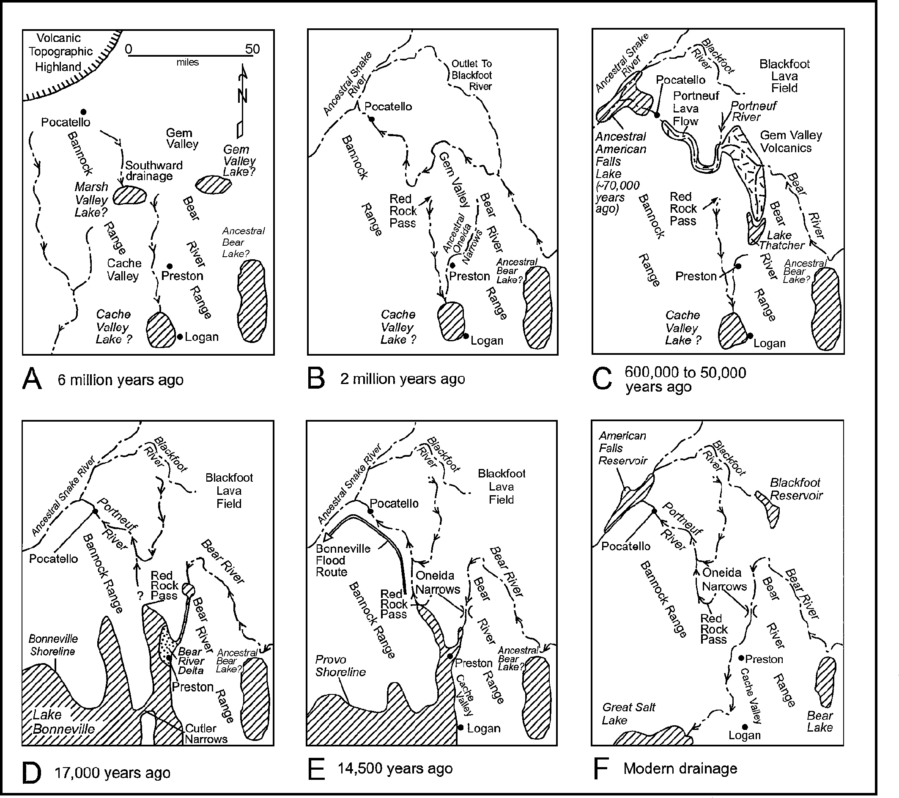

shoreline at 1552 m (5090 ft). The principal control on lake level was probably overflow. In southeastern Idaho, Lake Bonneville occupied the entire Cache Valley, the extreme southern end of Gem Valley, much of Malad Valley, and small areas south and west of Malad (Fig. 1).

Lake Cycles in Bonneville Basin
The known lake cycles in the Bonneville basin are listed in Table 1. Deposits of the Bonneville lake cycle are well-preserved in Cache Valley. Only two sites have been discovered where evi- dence for the Little Valley cycle is preserved (McCoy, 1987; Kaufman, unpublished amino acid data).

Bonneville Lake Cycle
Lake levels during the Bonneville lake cycle (Figs. and 5) rose from levels near the modern Great Salt Lake (~1280 m [4200 ft]) after 28 ka to 1340 m (4400 ft) by 26.5 ka. The lake level rose
approximately 15 m (50 ft) per ka from 26 to 21 ka, and 45 m
(148 ft) per ka from 21 to 17 ka (Scott et al., 1983; Oviatt, 1997, Fig. 5 of this paper). Between 24 and 15 ka there were several fluctuations (Stansbury, U1, U2, and U3 of Fig. 5) of 30 to 50 m (100 to 160 ft) during the overall transgressive phase of the lake. Oviatt (1997) correlates these millennial scale fluctuations with Heinrich iceberg-discharge events in the North Atlantic Ocean. Anderson and Link (1998) find evidence for these fluctuations in the Bear River delta.

Bear River Delta
Fine and coarse grained deltas formed at the mouths of streams entering Lake Bonneville from the mountains to the east (Lem- ons et al., 1996). Characteristics of the fine-grained Weber River delta (Lemons, 1997; Milligan and Lemons, 1998) are generally similar to those of the Bear River delta.
The Bear River delta sediments are exposed in cliffs (Figs. 9

Figure 3. Steps in the Development of Drainage in Southeast Idaho, expanded from Mahoney et al. (1987) and Link and Phoenix (19 96, p. 27).

A-Miocene (6 million years ago)
Topographic high of Yellowstone Hot Spot is present northeast of Pocatello. Valleys drain southward away from the tumescent volcanic plateau. The southeast Idaho mountains are largely buried in Miocene tuffaceous basin fill. Lake basins exist in southern Marsh Valley and southern Cache Valley.

B-Early Pleistocene (2 million years ago)
The Ancestral Bear River probably drained northward through Gem Valley and across the Portneuf Range through what is now the Portneuf River Canyon. Alternatively, it may have drained northward through the Blackfoot River drainage to the Snake. Base level was lo wered once longitudinal westward drainage was established (early Pleistocene?). Drainage in Marsh Valley reversed from southward (until 2-3 (?) Ma) to northward; superposed river canyons (Garden Creek Gap, Portneuf River Canyon at Lava Hot Springs) were cut first through valley fill and then in bedrock, crossing the regional structure. As Marsh Creek (and Bear River) were captured by the Snake River drainage, Portneuf Narrows was cut through the Bannock Range to connect Marsh Valley with the Snake River Plain. Prominent Pleistocene(?) alluvial fan fill- surfaces formed high-base-level terraces that are now preserved as benches in the Pocatello area and Marsh Valley.

C-Lake Thatcher and ancestral American Falls Lake, between 600,000 and ~50,000 radiocarbon years ago
Pleistocene basaltic volcanism in Gem Valley and/or the Blackfoot lava field formed a basalt dam which blocked the northward su rface drainage of Bear River. About 600,000, and possibly as late as 125,000, years ago, basalt lava flowed down the Portneuf River Canyon (Ar mstrong, 1975; Scott et al., 1982). Two flows reached the site of Pocatello. Sometime before 140,000 years ago, Lake Thatcher formed in southern Gem Valley as northward drainage was blocked. Bear River periodically drained southward into Lake Thatcher, and during dry climate cycles may have lost much of its water to northward subsurface flow through porous young basalt flows. Lake Thatcher was isolated from Bear River from 140 to 80 ka, but connected to Bear River by 50 +/- 10 ka, by which time cutting of Oneida Narrows had begun. T he cutting of Oneida Narrows may have re-excavated a superposed canyon that had formed initially in Late Miocene time. The ancestral Ameri can Falls Lake formed about 70,000 years ago, dammed by the Cedar Butte Basalt flow just northeast of Massacre Rocks, and may have drained partially or fully between ca. 30,000 and 14,500 14C yr BP.

D-Lake Bonneville (about 30,000 to 14,500 radiocarbon years ago)
The excavation of Oneida Narrows, and linkage of Bear River with the Bonneville Basin about 50,000 years ago. plus the wetter climate during the last glaciation, were instrumental in causing the rise of Lake Bonneville. The maximum lake level at 1552 m (5090 ft) may have been controlled by subsurface leakage through limestones at Red Rock Pass. The lake also spilled, but did not flood, over Red Rock Pass first around 15.2 14C ka. The diagram shows the maximum extent of Lake Bonneville northward into Gem Valley and the extent of the Bear River Delta (stippled).

E-Lake Bonneville Flood and Provo shoreline (14,500 radiocarbon years ago)
The Bonneville Flood emptied northward after failure of the alluvial dam at the Zenda Threshold, just north of Red Rock Pass. In the American Falls area, the floodwaters spread out. Some of them flushed down the modern Snake River channel, but some went north and west down Lake Channel, to return to the Snake River near what is now Massacre Rocks. A lake stood at the Provo shoreline (the bedrock li p at Red Rock Pass) for about a thousand years until it began to rapidly recede about 13,000 years ago.

F-Modern Drainage Patterns
The Bear River flows first north and then south into the Great Salt Lake. The Portneuf River flows first south and then north t hrough Portneuf Narrows to the Snake River Plain. The headwaters of the Blackfoot, Portneuf and tributaries to the Bear are all located in flat marshy ground underlain by young basalt lava north and west of Soda Springs.

and 10), prone to landsliding, east of Highway 91 north of Preston, Idaho (Anderson and Link, 1998). The Bear River delta contains facies representing four principal architectural elements:

- prodelta silt and clay, forming units 1 to 7 meters thick;
- delta front sediment-gravity flow deposits with sand to clay couplets, forming units 0.5 to 10 meters thick;
- delta top channelized and current-deposited sand, forming units 0.5 to 23 m (1.5 to 75 ft) thick;

- strath terrace gravels inset into the other facies.
The first three of these elements repeatedly occur within the Bear River delta (Fig. 10) and are associated with the rise to the Bonneville shoreline level, whereas the gravels are present unconformably above the delta at the top of the exposure. In out- crop the sandy facies form slopes and finer-grained facies form near-vertical cliffs. Some proximal and distal deltaic facies in

Table 1. Known lake cycles in the Bonneville Basin. Cycles are listed in order of ascending age and with isostatically corrected shoreline elevations. Data from Eardley and Gvosdetsky (1960), Eardley et al. (1973), Scott et al. (1983, p. 270), McCoy (1987), Machette and Scott (1988, their Figure 3; as modified in Oviatt and Miller, 1997, their Figure 2).

Lake cycle | Age | Maximum Elevation
Bonneville | 28-14.5 14C ka | 1552 m (5090 ft)
Cutler Dam | (~80-40 ka) | <1380 m (<4525 ft)
Little Valley | ~140-130 ka (oxygen isotope stage 6) | 1490 m (4887 ft)
Pokes Point | ~250-240 ka | 1428 m (4684 ft)
unnamed | predates ~630-610 ka Lava Creek ash | 1420 m (4658 ft)

Figure 9 can be traced over ~ 0.9 km (0.5 miles).
Anderson and Link (1998) interpret the exposed sediment to record small-scale autocyclicity within the episodically interrupted allocyclic transgressive phase of the Bonneville lake cycle. They interpret flooding surfaces where prodelta clay beds overlie delta- front sediment-gravity flow beds to be autocyclic. However, they interpret surfaces where clay beds overlie delta-top cross-bedded sand beds on surfaces that can be traced across the extent of the outcrop to be allocyclic regional flooding surfaces (Figs. 5 and 10). Similarly, they interpret the contacts where delta-top sand beds abruptly overlie prodelta clays and where there was evi- dence of erosion, to be allocyclic sequence boundaries.
Sediments of the Bear River delta record lake-level fluctua- tions on the scale of tens of meters and not a drop of a hundred meters, suggesting that only the Bonneville lake-cycle is repre- sented. If delta deposits of the previous Little Valley cycle were deposited, they are not exposed today. They may be present in
the subsurface.
The stratigraphic sequences generally record upward deep- ening, consistent with the known rise in lake level (Anderson and Link, 1998). Lake level oscillations (falling-lake events) caused delta-top facies to incise pro-delta facies, producing sequence boundaries. They infer three allocyclic and one autocyclic se- quence boundaries in the transgressive systems tract of the Bonneville Lake cycle (Figs. 5b and 10). It is likely that the three allocyclic sequences boundaries identified in the Bear River delta were caused by falling lake events identified by Oviatt (1997). A possible correlation is sb1 = U1-19 ka, sb2 = U2-17.5 ka, and sb4 = U3-16 ka (Fig. 5). Lemons and Chan (1999) interpret only one parasequence and no sequence boundaries within a trans- gressive systems tract for this succession.
Given the lake-level curves and their timing summarized by Oviatt (1997), the Bear River delta was deposited at the rather

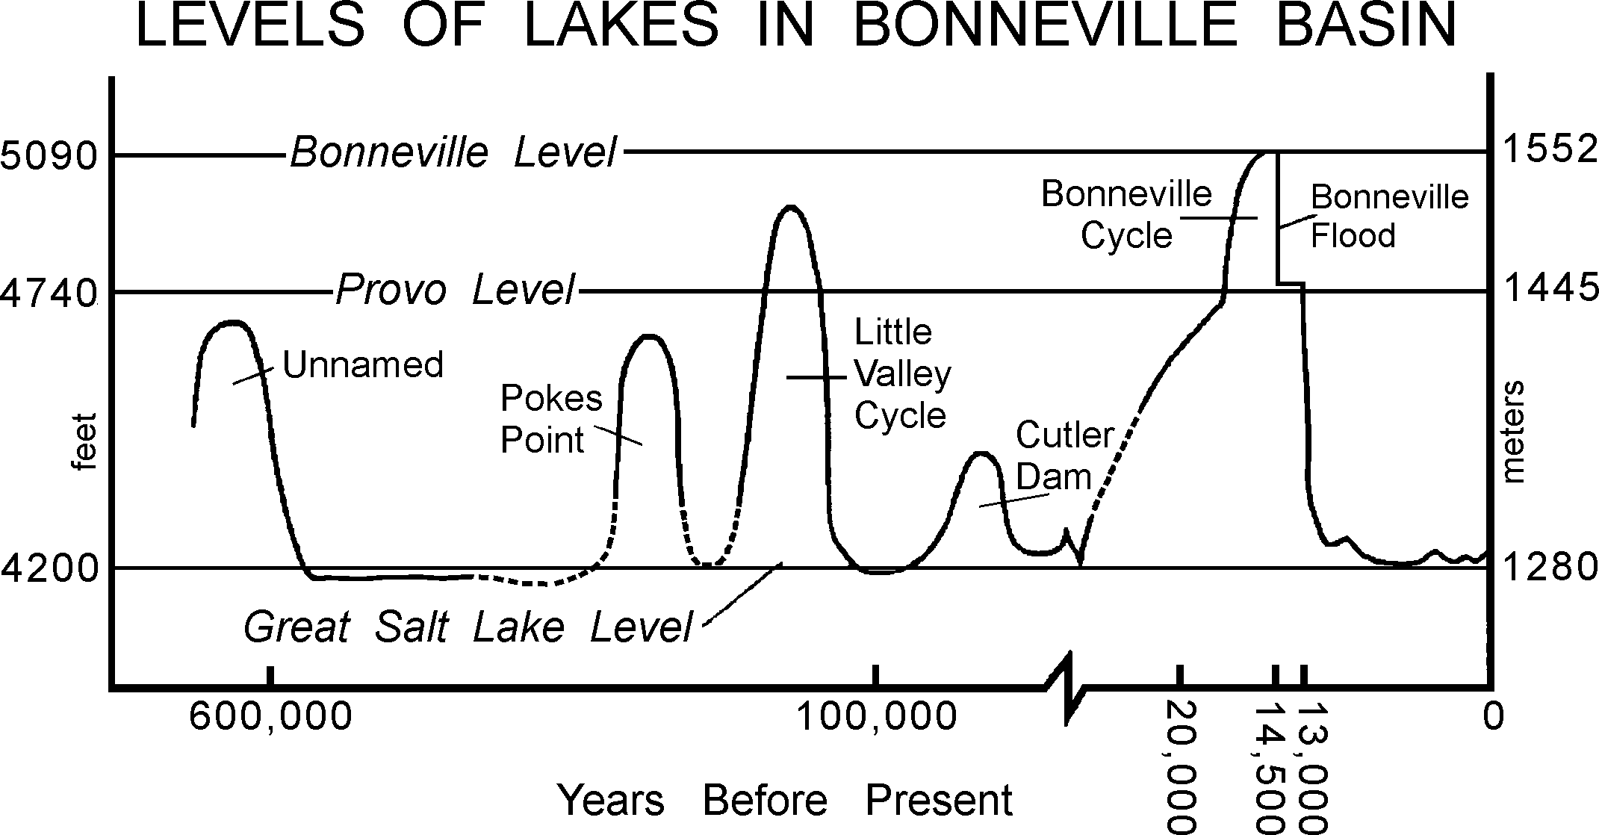

Figure 4. Levels of lakes in the Bonneville Basin. Ages and names of cycles correspond to Table 1. After Currey et al. (1984) a nd McCoy (1987), from Link and Phoenix (1996, p. 26).

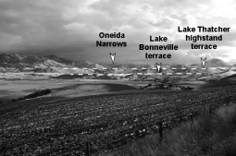

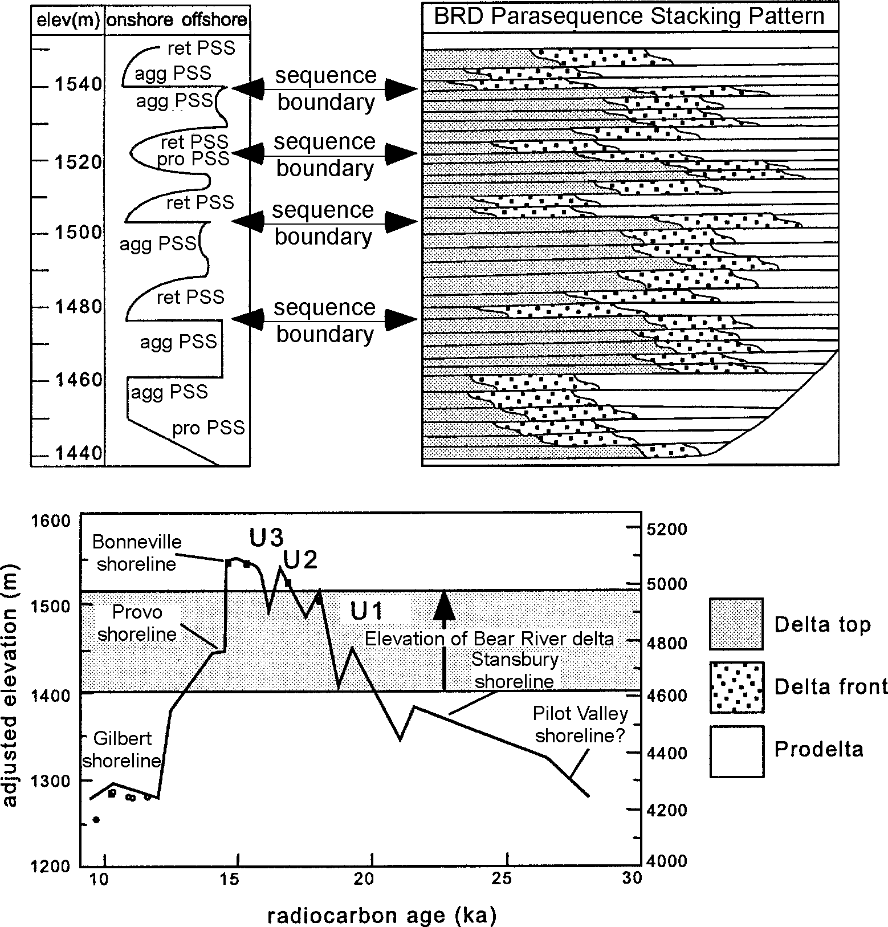
Figure 5a. Interpreted sequence stratigraphy and parasequence stack- ing pattern for the Bear River Delta. Abbreviations are as follows: proPSS=progradational parasequence set; aggPSS=aggradational parasequence set; retPSS=retrogradational parasequence set; sb=sequence boundary; rfs=regional flooding surface.
b. Lake Bonneville hydrograph of Oviatt (1997), with interpreted Bear River delta sequence stratigraphy of Anderson and Link (1998) superimposed. In the preferred interpretation U1 = sb1, U2 = sb2, U3 = sb4, and the lake-level fall during the Bonneville Flood = sb5 (from Anderson and Link, 1998, Fig. 7).

astounding rate of near 2.75 m (9 ft) per 100 years. This assumes the 110 m (360 ft) section, containing delta-top facies through- out, spans only 20 to 15.5 ka (Fig. 5). The sedimentation rate fell off to near zero once the lake rose to the Bonneville shoreline, at which time the fine-grained sediment of Bear River was dumped into southern Gem Valley, 50 km (30 mi) upstream from the Bear River delta.
In summary, sequence stratigraphic analysis of the Bear River delta independently suggests episodic falls in lake level during the transgressive portion of the Bonneville lake-cycle, which is totally compatible with the lake-level curves generated by Oviatt (1997). Anderson and Link (1998) thus identified sequences of 1-2 ka duration, each initiated by a falling-lake event, though pre- cise correlation awaits geochronologic study.

Bonneville Overflow
Lake Bonneville first overflowed when it reached 1550 m (5090 ft) at about 15.2 14C ka (Currey, 1990). This age is cited as about 16 14C ka by Scott et al. (1983) and Currey et al. (1984), and 16.4 14C ka by Currey and Oviatt (1985). The overflow was non-catastrophic and probably lasted less than 500 years (Oviatt and Miller, 1997, p. 349). This level produced the Bonneville shoreline, at which the lake remained, perhaps controlled by sub- surface leakage through karst and alluvial fan gravels at Red Rock
Figure 6. The southern end of Thatcher Basin looking south to- wards the divide between Gem and Cache Valleys. Lower dashed line marks the terraces formed by the intrusion of Lake Bonneville into the basin. Upper dashed line marks the Lake Thatcher highstand of approximately 1659 meters (5440 ft) above sea level.

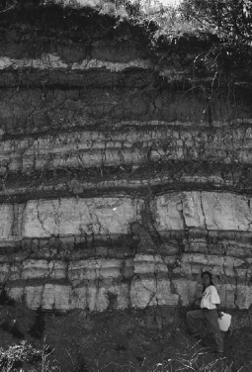

Figure 7. Lower Main Canyon Formation near Thatcher Church.

2 Guide ook to the Geolo o astern daho

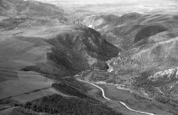

Figure 8. View looking north at Oneida Narrows and site of field trip stop 4 at bench in lower part of view, overlooking mouth of canyon. Thatcher Basin is in the distance, about 4 miles north. The bedrock ridge is composed of lower Paleo- zoic limestone, unconformably overlain by over 2000 m (6560 ft) of east-dipping Middle and Upper Miocene Salt Lake Group, including basal conglomerate, medial tuffaceous Cache Valley Formation, and upper conglomeratic Mink Creek conglomerate.

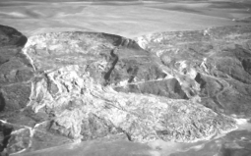

Figure 9. Aerial photograph of active slump-mudflow on the south side of the Bear River east of the Bear River Massacre site. Headwall exposes sediments of Bear River delta. Photo taken March 1983.

Pass (Link and Phoenix, 1996, p. 27), until it overflowed cata- strophically at the Zenda threshold, north of Red Rock Pass, at about 14.5 14C ka (Malde, 1968; Scott et al., 1983; Jarrett and Malde, 1987; O'Connor, 1993).
The Bonneville Flood resulted in the drop of the lake to the Provo level at 1445 m (4740 ft) (Figs. 3E, 4 and 5). In the Bear River delta a series of fill-cut terraces (gravels cut into older, highstand lake deposits) records the regressional history of the lake (Bright, 1963; Link et al., 1987), which dropped to its present Great Salt Lake level (1280 m, 4200 ft) by 11.5 ka (Oviatt et al., 1992).

BONNEVILLE FLOOD
Gilbert (1890) traced the Bonneville shoreline to the north end of Cache Valley and first recognized the evidence for cata- strophic Lake Bonneville outflow at Red Rock Pass. The cata- strophic overflow of the Bonneville Flood was apparently en- hanced by slope failure at Red Rock Pass (Bright and Ore, 1987; Shroder and Lowndes, 1989). The Zenda threshold, which main- tained the 1550 m (5090 ft) lake level represented by the Bonneville shoreline, consists of Quaternary alluvial fan gravels overlying tuffaceous Late Miocene Salt Lake Group sediments. The threshold was first breached on the east side of Red Rock Pass, but the depth of erosion was limited by limestone bedrock underlying the fan gravels in that area. When flow ultimately shifted westward into thick, unconsolidated sediments on the western side of Red Rock Pass, the channel widened rapidly via slope failure. Slope failure culminated with a 17 km2 landslide, triggered by undercutting of alluvial fans lying at the foot of the Bannock Range (Shroder and Lowndes, 1989).
From the overflow site at Red Rock Pass, the flood passed north through Marsh Valley, Portneuf Gap, and the Portneuf Val- ley before entering the Snake River Plain at Michaud Flats, north of Pocatello (Fig. 11). Evidence of the flood spans the length of the Snake River between Michaud Flats and Lewiston, beyond which evidence of the Missoula Floods dominates (Malde, 1968; O'Connor, 1993).
O'Connor (1993) determined maximum flood discharges from geomorphic evidence and hydraulic modeling. Maximum flood discharge was between 0.85 and 1.15 million m3/sec (between 30 and 41 million cfs) at Red Rock Pass, dropping to 0.57 to 0.62 million m3/sec (20 to 22 million cfs) near Lewiston. Flood-peak attenuation was likely controlled by backwater storage in flooded tributary valleys in the westernmost Snake River Plain, along the Idaho-Oregon border.
The diverse geologic and geomorphic characteristics of the flood route created variations in the nature of water flow (O'Connor, 1993). Where the flood was unconstrained and able to broaden its path, the water moved slowly, ponding at the head of constrictions. Where flow was constrained to a narrow flow path by canyon walls, the flood profile was steep and flow was intensely energetic. The flood route between Red Rock Pass and Michaud Flats reflects these variations (Fig. 11). Along this 95 km (58 mi) reach, the water surface at maximum flow dropped from 1550 m (5090 ft, Bonneville shoreline level) at Red Rock Pass to ca. 1380 m (4530 ft) at Michaud Flats. Most of the drop in the flood surface profile occurred in three narrow reaches (Fig. 12): Red Rock Pass (52 m, 171 ft drop), Portneuf Gap (70 m, 230 ft), and Red Hill (30 m, 98 ft). In contrast, the flood surface el- evation dropped only slightly in broader portions of the flood route: only 5 m (17 ft) along the entire length of Marsh Valley and ca. 3 m (10 ft) in the Portneuf Valley north of Red Hill.
The dramatic variation in the flood surface profile and the consequent variation in stream power created strong contrasts in flood geomorphology and sedimentology. For example, the Portneuf Basalt was removed from large portions of the Portneuf Gap (Portneuf Narrows) and, in some areas, the surviving rock surface was deeply scoured. In broader reaches, such as Marsh

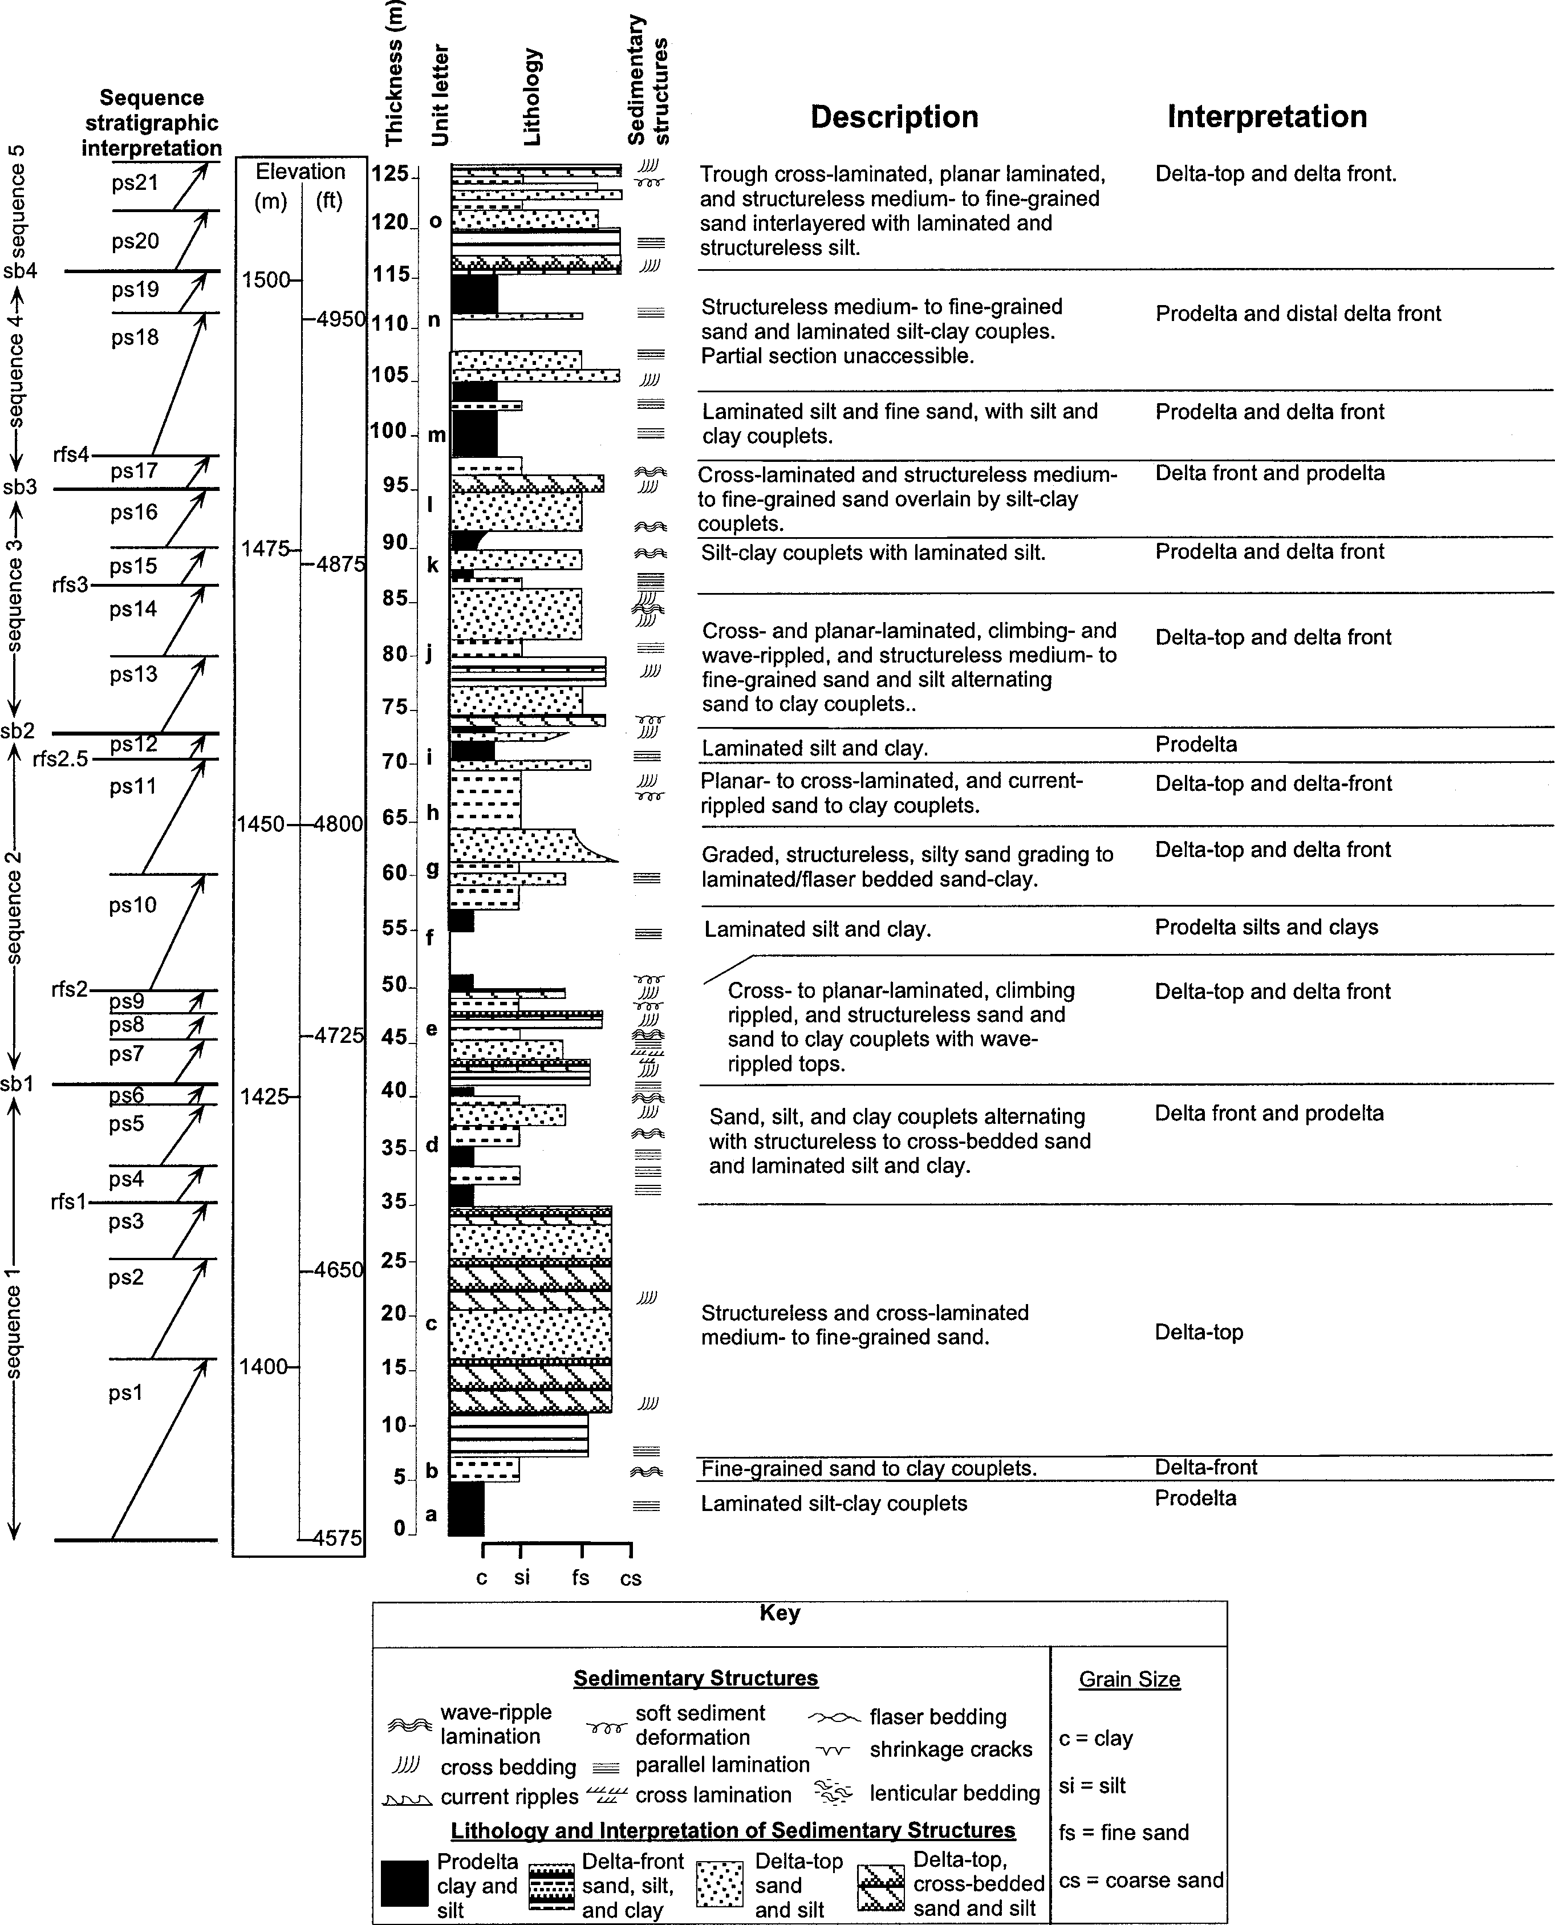

Figure 10. Simplified composite stratigraphic section of the Bear River Delta showing unit descriptions, facies and sequence st rati- graphic interpretations: rfs=regional flooding surface; ps=parasequence boundary. From Anderson and Link (1998, Fig. 5).

2 2 Guide ook to the Geolo o astern daho

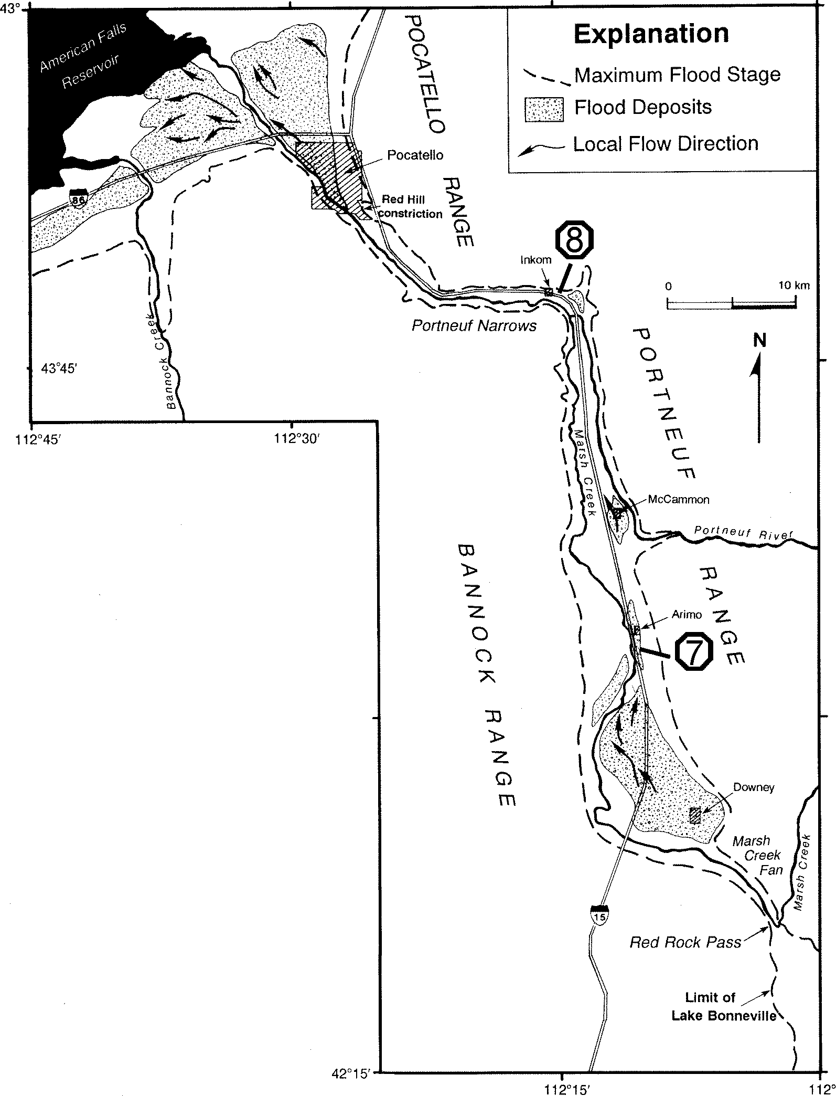
and Portneuf valleys, large volumes of gravel were deposited as bars or valley fill.

FIELD GUIDE
The Field Guide begins at the intersection of US 30 and Idaho 34, approximately 6 miles west of Soda Springs. Proceed south on Idaho 34, 16.5 miles to town of Thatcher. Stop locations are shown on Figures 2 and 11.

Stop 1. Lower portion of Main Canyon Formation at Thatcher Church.
Kauffman and coworkers subdivide the Main Canyon Forma- tion of Bright (1963) into a lower and an upper section, which are separated stratigraphically and elevationally. Here we describe two sites that illustrate the most important aspects of the two sec- tions. The head scarp of the large landslide complex ~0.5 km (0.3 mi) northwest of Thatcher Church (Fig. 7) (SE 1/4 sec. 16, T. 11
S. R. 40 E) exposes the stratigraphically and topographically low- est portion of the Main Canyon Formation. The 31-m section is dominated by light-colored silt and fine sand interstratified with dark, organic-rich beds. Organic-rich beds contain grasses and other plants including cattail, sedge, pondweed, and bur-reed that grow in shallow-water, paludal environments (Bright, 1963). Fos- sil snails, especially Valvata, are abundant, supporting the inter- pretation of a vegetated marsh or shallow lake. Izett (1981) pre- viously identified Huckleberry Ridge (~2 Ma) and Lava Creek B (~620 ka) tephras at this outcrop. Samples of these coarse-grained, light-gray tephras were collected by Hochberg (1996) and their identities were confirmed by William Nash (University of Utah). The Huckleberry Ridge ash is >2.5 m (8 ft) thick. Because the upper and lower contacts are buried, it is not known whether the ash was deposited into a lake. The Lava Creek B ash is >2 m (6.5 ft) thick. Although its lower contact is not exposed, the tephra is conformably overlain by lake sediments, suggesting that it was erupted at a time when a lake occupied the Thatcher basin. The east edge of the outcrop is truncated by red sandy sediment that extends up to 1,550 m (5084 ft) above sea level, 5 m (16 ft) be- low the Bonneville shoreline. The sediment was probably depos- ited in Lake Bonneville, following the erosion of its high shore- line.
Proceed south on Idaho 34 approximately 2 miles to Main Canyon Road. Turn left and proceed approximately 0.5 miles.

Stop 2. Upper Portion of Main Canyon Formation at Type Locality.
The Dugway along the Main Canyon Road (SE 1/4 sec. 7. T. 12 S. R. 41 E.) is the type locality of Bright's Main Canyon For- mation (Bright, 1963). In contrast to the lower part of the forma- tion, the upper section is dominated by deposits of deep lakes that filled the basin to overflowing. This site is located on the east side of the basin and exposes a delta formed into Lake Thatcher at the mouth of Kuntz Creek. It is composed of several small (<5
m) roadcut exposures separated laterally by several hundred meters and vertically by ~60 m. Deposits exposed in the upper- most exposure into the delta top was deposited at the highest Lake Thatcher terrace at 1,660 m (5445 ft) above sea level. It contains mollusk shells of four genera (Carinifex, Fluminicola, Sphaerium

Figure 11. Geologic sketch map of Bonneville flood deposits and inundated area between Red Rock Pass and the Snake River Plain north of Pocatello. Field trip stops 7 and 8 are shown. From O Connor (1993, Fig. 14, by permission).

and Lymnaea), most concentrated in a ~5-cm-thick gravelly bed. Sphaerium from the shelly gravel yielded an age of 42,500 ± 1500 yr (AA-19062), which we consider a minimum age. This age is considerably older than the one reported by Bright (1963) at the same site (27,500 yr; W-855), but overlaps with the calibrated amino acid age estimate of 50 ± 10 ka (Bouchard et al., 1998). Sr isotopes analyzed in shells from the gravel indicate that the Bear River was contributing to this highest and final rise of Lake Thatcher. The fossiliferous layer overlies a >1-m-thick oxidized, petrocalcic paleosol. This sequence is interpreted as representing a rise of Lake Thatcher to ~1659 m (5440 ft) above sea level, a subsequent drop in lake level, during which the paleosol was formed, followed by shoreline transgression to deposit the fossil- iferous gravel at 1660 m (5445 ft) above sea level.
Richly fossiliferous laminated to massive lacustrine silty sand and marl underlies the paleosol to the west. This part of the sec- tion contains a 6-cm-thick, biotite-rich, white ash at 1,598 m (5242 ft). According to Andrei Sarna-Wojcicki (U.S. Geological Sur- vey), the tephra was erupted from Mount St. Helens and corre- lates with tephra known from two other sites where it has been dated independently. On the Columbia River Plateau, Berger and Busacca (1995) used thermoluminescence to estimate an age of
~120 ka for correlated tephra. At Carp Lake, Oregon, Whitlock

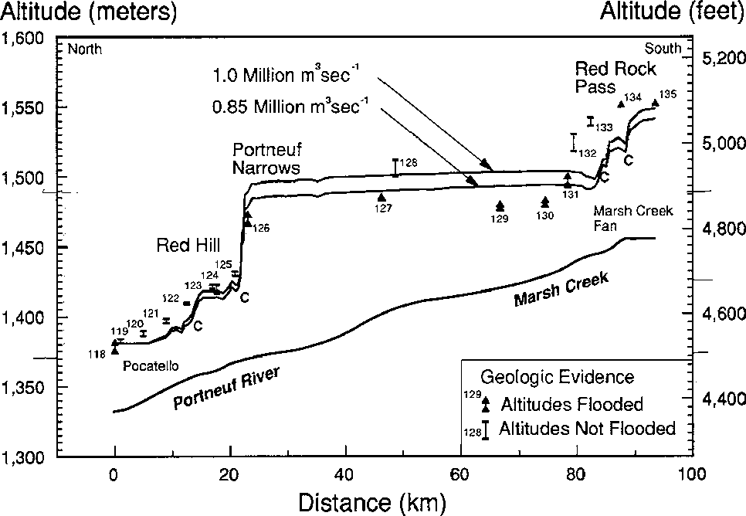

Figure 12. Geologic evidence for maximum flood stages and mod- eled water-surface profiles for the Pocatello reach. The num- bers refer to descriptions of the features in Appendix 2 of O Connor (1993). Locations that are calculated as having critical flow are labeled with the letter C. From O Connor, (1993, Fig. 15, by permission).

and Bartlein (1997) estimated an age of ~100 ka, based on the position of the tephra within their pollen sequence. Cathy Whitlock (University of Oregon) is currently studying the pollen from this site to compare with the Carp Lake results. On the basis of Sr isotopes (Bouchard et al., 1998), this part of the upper Main Can- yon Formation was deposited in a lake that formed during the early part of the late Pleistocene, but did not receive input from the Bear River. Judging from the similarity in the elevation be- tween these deposits and the overlying shelly gravel that formed when the lake did spill southward, Lake Thatcher probably over- flowed into the Bonneville basin during this lake phase.
Return to Idaho 34, turn left (south) and drive 16 miles to Stop 3, a roadcut immediately north of Twin Lakes Canal and approximately 2.5 miles south of Treasureton Reservoir.

Stop 3. Twin Lakes Canal roadcut: Climbing ripples in fine sand deposited during rise of Lake Bonneville.
This roadcut displays the sandy delta-top facies of the Bear River delta. The thin-bedded fine sands were deposited in sedi- ment-charged events likely related to spring run-off or floods. This exposure is typical of the rippled fine sand lithofacies (Fig. 10).
Continue south on Idaho 34, 1.6 miles to junction with Idaho 36, turn left (east) onto Idaho 36. Proceed 2.8 miles east on Idaho 36 and turn left (north) onto Oneida Narrows-Bear River Road. Proceed 1.2 miles to Stop 4.

Stop 4. Mouth of Oneida Narrows.
This is a panorama view stop where one can see several ele- ments of the Lake Bonneville story in Cache Valley. To the north is the rugged bedrock canyon of the Bear River, cutting through Neoproterozoic quartzite and overlying Cambrian limestone (Fig.
8) (Oriel and Platt, 1980; Lindsey, 1982; Link et al., 1993). The time of cutting of this canyon, and the series of events whereby
drainage to the Bonneville basin captured drainage in southern Gem Valley, are recorded in landforms and sediments of the Thatcher basin, as described above. To the east is the west side of the Bear River Range and the canyon of Strawberry Creek. The range is bounded on the west side by the East Cache fault. A thick succession of Miocene Salt Lake Formation conglomerate forms the foothills to the east near the hamlet of Mink Creek (Danzl, 1982). To the south is Cache Valley. The uneven slopes south of here above the incised Bear River canyon are parts of the Bear River delta of Lake Bonneville. The slopes preserve hummocky (likely original?) depositional topography on the delta slope as- sociated with the Bonneville shoreline level. The incision of the Bear River delta and the establishment of successively lower river levels from the Bonneville level, Provo level and successive lower levels are vividly expressed in the numerous terraces cut into the Bear River delta sediments.
Return to Idaho 34, turn left (south); drive 5.2 miles to junc- tion of Idaho 34 and US 91 at the north end of Preston. Continue straight (west) onto US 91 north. Drive 4 miles to bridge over Bear River and 0.5 miles beyond to Bear River Massacre historic site.

Stop 5. Bear River Massacre Site: Bear River Delta and Associ- ated Landslides.
More Native Americans (nearly 400) died in the Bear River Massacre, in January 1863, than in any other encounter between American troops and Indians. The various historical markers, in- scribed between 1932 and 1990, reflect different perceptions of this event.
We are in the center of the Bear River Landslide Complex (Mahoney et al., 1987 Link et al., 1987), which is hosted by sedi- ments of the Bear River Delta into Lake Bonneville (Anderson, 1998; Anderson and Link, 1998; Milligen and Lemons, 1998). There are a variety of slump-earth flows, rotational slides, and earth falls forming in the unconsolidated cliffs on both sides of the Bear River (Fig. 9). The complex has been active four times since 1940. Periods of activity generally last a few years, and follow several years of above-normal precipitation. Irrigation on the flat area above the landslides is surely a contributing factor, but from a geologic sense, the landslides are an inevitable mani- festation of slope retreat due to lowering of the base level of the Bear River by ca. 300 m (1000 ft) in the last 14,000 years.
The stratigraphic sequence north of the river and east of this spot was studied in detail by Anderson (1998), who divided it into twenty-one parasequences that make up five, 6th-order, strati- graphic sequences with inferred durations of one to two thousand years. These are overlain, above the major unconformity formed during the Lake Bonneville flood, by a 6th sequence containing gravel of the regressive phase of the Bonneville lake-cycle (Fig. 10). The sediments were deposited in fluvial, delta-top, delta- front, and pro-delta environments.
Proceed north on US 91, 11 miles to historical marker at Red Rock Junction (Fig. 11). South of the town of Swan Lake, note the Bonneville shoreline on the east edge of the valley. The shore- line is less prominent between Swan Lake and Red Rock Junc- tion.

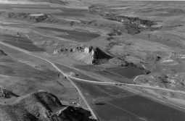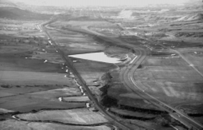

Figure 13. Aerial view looking north at Red Rock Pass. Red Rock Butte in the center of the valley is underlain by Cambrian limestone. The headwaters of Marsh Creek drain directly south, toward the camera on the east (right) side of the butte, and then turn 180' and head north in front of the butte drain- ing to Marsh Valley and the Snake River. The dam to Lake Bonneville consisted of alluvial fans that nearly covered the butte. Lake Bonneville water may have leaked through un- derground (karst) caverns in the butte and controlled the lake s highest level. (May, 1998).

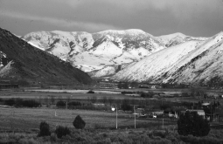

Figure 14. View looking east at Portneuf Narrows. Lake Bonneville flood was about 350 ft (108 m) deep here, reach- ing to the prominent bedrock knob on the smooth slope north of the Narrows. A standing wave must have existed here during the flood as the depth decreased drastically in the wide Pocatello Valley.

Stop 6. Red Rock Pass.
Red Rock Pass marks the lowest divide for Pleistocene Lake Bonneville and the spillover area for the Bonneville Flood (Figs. 11, 12 and 13) as recognized by Gilbert (1890). To the north can be seen remnants of two alluvial fans that formerly joined across the valley to form the threshold for Lake Bonneville (Gilbert, 1890). An early Rancholabrean vertebrate fauna from a portion of the fan on the east side of the valley, emanating from upper Marsh Creek, indicates that the fan was active between 400 ka and 150 ka (Bright and Ore, 1987). The lake filled to the thresh-
Figure 15. View of Portneuf River Valley and Pocatello, Idaho, looking northwest from Portneuf Hill, south of Portneuf Nar- rows, (April 1983). The Portneuf River meanders in a valley widened by the Lake Bonneville Flood. Some of the river s meandering has been curtailed by construction of the Union Pacific Railroad. In the upper left, just west of the railroad tracks, the Portneuf enters a flood control channel built after much of downtown Pocatello was flooded in February, 1962 and 1963. The Basalt of Portneuf Valley forms the dark es- carpment northeast of the railroad. At least two lava flows can be seen. About 600,000 years ago (and perhaps as late at 125,000 years ago), these flowed down the canyon of the Portneuf River from a source area near Bancroft in Gem Val- ley. Interstate 15 makes sweeping curves that parallel the edge of the lava flows. The Highway Pond, which fills with water in wet years only, can be seen in the middle distance.

old level between 15 and 16 14C ka (Scott et al., 1983; Currey, 1990) and spilled over into the Marsh Creek drainage. Subsur- face flow through karstic limestone of Red Rock Butte may also have accounted for part of the outflow (D.E. Fortsch, Idaho State University, oral communication, 1993). The lake remained at threshold level for several hundred years, during which time the Bonneville shoreline was formed. Around 14.5 14C ka, the thresh- old failed catastrophically, releasing the Bonneville Flood. The outlet flow cut into unconsolidated gravels in the western portion of the pass area and undercut the alluvial fan surface on the west edge of the valley, triggering landslides that rapidly widened the channel (Bright and Ore, 1987; Shroder and Lowndes, 1989). The remnants of several slide blocks can be seen northwest of the Red Rock Junction area.
Proceed 12 miles north on US 91 to Virginia.
Between Downey and Virginia, the highway traverses an enor- mous gravel bar (ca. 10 by 5 km [6 by 3 mi]) that fills the south end of Marsh Valley (Fig. 11). As the Bonneville Flood flowed from the relatively narrow valley north of Red Rock Pass into the broad Marsh Valley, the flow widened and stream power dropped (Fig. 12). The drop in stream power caused the flow to deposit large volumes of entrained sediment in this area.
At the north end of Virginia, continue straight to continue on US 91 (do not bear left to approach Interstate 15). Proceed north
2.4 miles and turn left into gravel pit approximately 2 miles south of Arimo. Access to this pit may be restricted.

Stop 7. Arimo Gravel Pit.
This gravel pit exposes a portion of an elongate mid-channel bar deposited by the Bonneville Flood (Fig. 11). The floodway was quite wide through Marsh Valley, filling the area between alluvial fan surfaces that flank the valley (O'Connor, 1993). This pit exposes gently east-dipping gravel beds deposited on the east- ern flank of the Arimo Bar. The gravels were likely derived from the edges of the alluvial fans visible to the south.
Return to road and proceed north 10 miles on US 91 through McCammon to junction with US 30. The town of McCammon sits on another mid-channel bar constructed by the Bonneville Flood.
Turn left (west) onto US 30 and proceed 2 miles to Marsh Creek Road, crossing I-15, descending the west edge of the ba- salt flow, and crossing Marsh Creek. I-15 is constructed on the ca. 600 ka Basalt of Portneuf Valley (Scott et al., 1982), which flowed down the Portneuf River valley from Gem Valley. Note flood scour features on the basalt surface. Figure 6 of Fortsch and Link (this volume) is an aerial view of this area.
Turn right (north) onto Marsh Creek Road and proceed north. Note the numerous alcoves carved into the edge of the basalt flow by the Bonneville Flood, as well as spectacular boulder bars at the alcove mouths. The latter are most visible ca. 6 to 9 miles north of the turnoff (i.e., approaching Inkom and the north end of Marsh Valley).
Proceed 10 miles on Marsh Creek Road to the Ash Grove Cement plant at Inkom. Park on the edge of the road 0.1 miles southeast of the cement plant and walk onto basalt flow surface below the north edge of the road.

Stop 8. Scoured Surface of Portneuf Basalt
The Basalt of Portneuf Valley here exhibits features indica- tive of intense flood scouring. Channels and other scour features are as much as 4 m (13 ft) deep. This site lies at the upvalley end of the Portneuf Gap. Floodwaters ponded in the Inkom area at the head of this major constriction, constructing a gravel bar on the northeast side of the prominent I-15 bend, approximately 1 mile east of this location. The maximum flood surface profile dropped 70 m (230 ft) through the Portneuf Gap (Figs. 11, 12 and 14) creating a steep profile and high stream power (O'Connor, 1993). The highly erosive flood not only scoured basalt flow surfaces, but also removed large portions of the basalt flow-particularly in the narrowest section of the Gap near its west end (Fig. 15). Much of the rock and sediment removed from the Portneuf Gap was deposited as thick valley fill in the Portneuf Valley at Pocatello, forming the prolific Lower Portneuf Aquifer.
Proceed 0.1 mile further on Marsh Creek Road to T intersec- tion. Turn left onto Portneuf Road and drive 6 miles through the Portneuf Gap to Fort Hall Mine Road. Turn right (north), across river to junction with I-15 (0.3 miles). Enter northbound I-15 and proceed 6 miles north to Pocatello.
In the vicinity of Idaho State University, note Red Hill (promi- nent hill on east end of valley with orange "I") and its counterpart across the valley. These outliers of Neoproterozoic quartzite rep- resent the last major constriction in the path of the Bonneville Flood before it entered the Snake River Plain. Maximum flood level was ca. 45 m (150 feet) below the top of Red Hill (Fig. 12)
(O'Connor, 1993). North of the Red Hill constriction, the flood- waters spread laterally and stream power dropped. As the flood- waters exited the north end of the Portneuf Valley, they were with- out lateral constraint. As stream power dropped yet further, the floodwaters deposited the thick Michaud Gravels, which extend from the north end of the valley onto the Snake River Plain at Michaud Flats (Fig. 11).

REFERENCES CITED
Anderson, S.A., 1998, Sedimentology, hydrogeology and sequence stratigraphy of Pleistocene Bear River delta, Cache Valley, Idaho [M.S. thesis]: Pocatello, Idaho State University, 61 p.
Anderson, S.A., and Link, P.K., 1998, Lake Bonneville sequence stratigraphy, Pleistocene Bear River Delta, Cache Valley, Idaho, in Pitman, J.K., and Carroll, A.R., eds., Modern and Ancient Lake Systems, Utah Geological Association Guidebook 26, p. 91-104.
Antevs, E., 1952, Cenozoic climate of the Great Basin: Geologische Rundschau, v. 40, p. 94-108.
Armstrong, R. L., Leeman, W. P., and Malde, H. E., 1975, K-Ar dating, Quater- nary and Neogene volcanic rocks of the Snake River Plain, Idaho: Ameri- can Journal of Science, v. 275, p. 225-251.
Berger, G. W., and Busacca, A. J., 1995, Thermoluminescence dating of late Pleistocene loess and tephra from eastern Washington and southern Oregon and implications for the eruptive history of Mount St. Helens: Journal of Geophysical Research, v. 100 p. 22361-22374.
Bouchard, D. P., 1997. Quaternary Bear River paleohydrogeography reconstructed from the 87Sr/86Sr composition of lacustrine fossils [M.S. Thesis]: Logan, Utah State University, 92 p.
Bouchard, D.P., Kaufman, D.S., Hochberg, A., and Quade, J., 1998, Quaternary history of the Thatcher Basin, Idaho, reconstructed from the 87Sr/86Sr and amino acid composition of lacustrine fossils-implications for the diversion of the Bear River into the Bonneville basin: Palaeogeography, Palaeoclimatology, Palaeoecology, v. 141, p. 95-114.
Bright, R.C., 1963, Pleistocene lakes Thatcher and Bonneville, southeastern Idaho [Ph.D. dissertation]: Minneapolis, MN, University of Minnesota, 292 p.
Bright, R.C., 1967, Late Pleistocene stratigraphy in Thatcher basin, southeast- ern Idaho: Tebiwa: v. 10, p. 1-7.
Bright, R.C., and Ore, H.T., 1987, Evidence for the spillover of Lake Bonneville, southeastern Idaho, in Beus, S., ed., Geological Society of America Centen- nial Field Guide 2-Rocky Mountain Section, p. 143-146.
Currey, D.R., 1990, Quaternary paleolakes in the evolution of semidesert basins, with special emphasis on Lake Bonneville and the Great Basin, U.S.A.: Palaeogeography, Palaeoclimatology, Palaeoecology, v. 76, p. 189-214.
Currey, D.R., and Oviatt, C.G., 1985, Durations, average rates, and probable causes of Lake Bonneville expansions, stillstands, and contractions during the last deep-lake cycle, 32,000 to 10,000 years ago, in Kay, P.A., and Diaz, H.F., eds., Problems of and prospects for predicting Great Salt Lake levels: Salt Lake City, University of Utah Center for Public Affairs and Adminis- tration, p. 9-24.
Currey, D.R., Oviatt, C.G., and Plyler, G.B., 1983, Lake Bonneville stratigra- phy, geomorphology, and isostatic deformation in west-central Utah, in Gurgel, K.D., ed., Geologic excursions in neotectonics and engineering ge- ology in Utah, Guidebook-Part IV: Utah Geological and Mineralogical Sur- vey Special Studies 62, p. 63-82.
Currey, D.R., Atwood, G., and Mabey, D.R., 1984, Major levels of Great Salt Lake and Lake Bonneville: Utah Geological and Mineral Survey Map 73.
Danzl, R.B., 1982, Stratigraphy and depositional environment of the Tertiary Salt Lake Group near Oneida Narrows, southeastern Idaho: Northwest Ge- ology, v. 11, p. 22-30.
Eardley, A.J., and Gvosdetsky, V., 1960, Analysis of Pleistocene core from Great Salt Lake, Utah: Geological Society of America Bulletin, v. 71, p. 1323- 1344.
Eardley, A.J., Shuey, R.T., Gvosdetsky, V., Nash, W.P., Picard, M.D., Grey, D.C., and Kukla, G.J., 1973, Lake cycles in the Bonneville Basin, Utah: Geologi- cal Society of America Bulletin, v. 84, p. 211-216.
Gilbert, G.K., 1890, Lake Bonneville: U.S. Geological Survey Monograph 1, 438 p.
Fortsch, D.E., and Link, P.K., 1999, Regional geology and fossil sites from Pocatello to Montpelier, Freedom, and Wayan, southeastern Idaho and west-

ern Wyoming, in Hughes, S.S. and Thackray, G.D., eds., Guidebook to the geology of eastern Idaho: Idaho Museum of Natural History, this volume.
Hochberg, A., 1996, Aminostratigraphy of Thatcher Basin, SE Idaho-Reas- sessment of Pleistocene lakes [M.S. Thesis]: Logan, Utah State University, 112 pp.
Izett, G. A., 1981, Stratigraphic succession, isotopic ages, partial chemical analy- ses, and sources of certain silicic volcanic ash beds (4.0-0.1 m.y.) of the western United States: U.S. Geological Survey Open File Report 81-763.
Jarrett, R.D., and Malde, H.E., 1987, Paleodischarge of the late Pleistocene Bonneville flood, Snake River, Idaho, computed from new evidence: Geo- logical Society of America Bulletin, v. 99, p. 127-134.
Lemons, D.R., 1997, Stratigraphy, paleoclimatic implications, and permeability distribution of fine-grained lacustrine deltas along the eastern margin of late Pleistocene Lake Bonneville [Ph.D. Dissertation]: Salt Lake City, Uni- versity of Utah, 314 p.
Lemons, D.R., and Chan, M.A., 1999, Facies architecture and sequence stratig- raphy of fine-grained lacustrine deltas, Bonneville basin, northern Utah and southern Idaho: American Association of Petroleum Geologists Bulletin, in press.
Lemons, D.R., Milligan, M.R., and Chan, M.A., 1996, Paleoclimatic implica- tions of late Pleistocene sediment yield rates for the Bonneville Basin, north- ern Utah: Palaeogeography, Palaeoclimatology, Palaeoecology, v. 123, p. 147-159.
Lindsey, K.A., 1982, The Upper Proterozoic and Lower Cambrian "Brigham Group", Oneida Narrows, southeastern Idaho: Northwest Geology, v. 11, p. 13-21.
Link, P.K., Christie-Blick, N., Devlin, W.J., Elston, D.P., Horodyski, R.J., Levy, M., Miller, J.M.G., Pearson, R.C., Prave, A., Stewart, J.H., Winston, D., Wright, L.A., and Wrucke C.T., 1993, Middle and Late Proterozoic strati- fied rocks of the western United States Cordillera, Colorado Plateau, and Basin and Range Province, in Reed., J., Sims, P., Houston, R.S., Rankin, D.W., Link, P.K., Van Schmus, W.R., and Bickford, M.E., eds., Precam- brian: Conterminous United States: Geological Society of America Decade of North American Geology Series, v. c-3, p. 474-690.
Link, P.K., and Phoenix, E.C., 1996, Rocks, Rails and Trails (2nd ed.): Pocatello, Idaho, Idaho Museum of Natural History, 185 p.
Link, P.K., Mahoney, J.B., McCalpin, J., and Henkelman, J.J., and Smith, B.L., 1987, Field Trip Roadlog for the Bear River Landslide Complex, Proceed- ings of the 23rd Symposium on Engineering Geology and Soils Engineer- ing: Logan, Utah, Utah State University, p. 334-353.
Machette, M.N., and Scott, W.E., 1988, Field trip introduction: A brief review of research on lake cycles and neotectonics of the eastern Basin and Range Province: Utah Geological and Mineral Survey Miscellaneous Publication 88-1, p. 7-14.
Mahoney, J.B., Link, P.K., Henkelman, J.J., McCalpin, J., and Smith, B.L., 1987, The Bear River Landslide Complex, Preston, Idaho: Geologic considerations and historical perspectives: Proceedings of the 23rd Symposium on Engi- neering Geology and Soils Engineering, Logan, Utah, Utah State Univer- sity, p. 306-353.
Malde, H.E., 1968, The catastrophic late Pleistocene Bonneville Flood in the Snake River Plain, Idaho: U.S. Geological Survey Professional Paper 596, 52 p.
McCoy, W.D., 1987, Quaternary aminostratigraphy of the Bonneville Basin, western United States: Geological Society of America Bulletin, v. 98, p. 99- 112.
Milligan, M.R., and Lemons, D.R., 1998, A sequence stratigraphic overview of sandy and gravelly lacustrine deltas deposited along the eastern margin of pate Pleistocene lake Bonneville, northern Utah and southern Idaho, in Pit- man, J.K., and Carroll, A.R., eds., Modern and Ancient Lake Systems: Utah Geological Association Guidebook 26, p. 105-129.
Miller, D.M., Nakata, J.K., Sarna-Wojcicki, A., and Meyer, C.E., 1992, Neo- gene tectonic history of northern Utah revealed by depositional, magmatic, and structural features: Geological Society of America Abstracts with Pro- grams, v. 24, no. 6, p. 53.
O'Connor, J.E., 1993, Hydrology, hydraulics, and geomorphology of the Bonneville flood: Geological Society of America Special Paper 274, 83 p.
Ore, H.T., Reid, T.V., and Link, P.K., 1996, Pre-Bonneville-level, catastrophic overflow of Plio-Pleistocene Lake Bonneville, south of Rockland, Idaho: Northwest Geology, v.26, p. 1-16.
Oriel, S.S., and Platt, L.B., 1980, Geologic map of the Preston 1° x2° quad- rangle, Idaho and Wyoming: U.S. Geological Survey Miscellaneous Investi- gations Series Map I-1127, scale 1:250,000.
Oviatt, C.G., 1997, Lake Bonneville fluctuations and global climate change: Geology, v. 25, p. 155-158.
Oviatt, C.G., and Miller, D.M., 1997, New explorations along the northern shores of Lake Bonneville: Brigham Young University Geology Studies, v. 43, no. 2, p. 345-371.
Oviatt, C.G., and Nash, W.P., 1989, Late Pleistocene basaltic ash and volcanic eruptions in the Bonneville basin, Utah: Geological Society of America Bulletin, v. 101, p. 292-303.
Oviatt, C.G., McCoy, W.D., and Reider, R.G., 1987, Evidence for a shallow early or middle Wisconsin lake in the Bonneville basin, Utah: Quaternary Research, v. 27, p. 248-262.
Oviatt, C.G., Currey, D.R., and Sack, D., 1992, Radiocarbon chronology of Lake Bonneville, eastern Great Basin, USA: Palaeogeography, Palaeoclimatology, Palaeoecology, v. 99, p. 225-241.
Parry, W.T., and Bruhn, R.L., 1986, Pore fluid and seismogenic characteristics of fault rock at depth on the Wasatch fault, Utah: Journal of Geophysical Research, v. 91, p. 225-241.
Sack, D., 1989, Reconstructing the chronology of Lake Bonneville: An histori- cal overview, in Tinkler, K.J., ed., History of geomorphology: London, Unwin Hyman, p. 223-349.
Scott, W.E., Pierce, K.L., Bradbury, J.P., and Forester, R.M., 1982, Revised Qua- ternary stratigraphy and chronology in the American Falls area, southeast- ern Idaho, in Bonnichsen, B., and Breckenridge, R.M., eds., Cenozoic geol- ogy of Idaho: Idaho Bureau of Mines and Geology Bulletin 26, p. 581-595.
Scott, W.E., McCoy, W.D., Shroba, R.R., and Rubin, M., 1983, Reinterpretation of the exposed record of the last two cycles of Lake Bonneville, western U.S.: Quaternary Research, v. 20, p. 261-285.
Shroder, J.F., and Lowndes, T., 1989, Threshold modeling, slope failure, and the Bonneville Flood: Geological Society of America Abstracts with Programs, v. 21, no. 6, p. 60.
Thompson, R.S., Whitlock, C., Bartlein, P.J., Harrison, S.P., and Spaulding, W.G., 1993, Climatic changes in the western United States since 18,000 yr B.P., in Wright, Jr., H.E., Kutzbach, J.E., Webb III, T., Ruddiman, W.F., Street- Perrott, F.A. , and Bartlein, P.J., eds., Global climates since the last glacial maximum: University of Minnesota Press, p. 468-513.
Whitlock, C., and Bartlein, P.J., 1997, Vegetation and climate change in north- west America during the past 125 kyr: Nature, v. 388, p. 57-61.
Williams, J.S., 1948, Geology of the Paleozoic rocks, Logan quadrangle, Utah: Geological Society of America Bulletin, v. 59, p. 1121-1163.

