Late Quaternary History of the Beaverhead River Canyon, Southwestern Montana

Mervin J. Bartholomew
Earth Sciences & Resources Institute, and Earth & Environmental Resources Management Program, School of the Environment, University of South Carolina, Columbia, SC 29208

Sharon E. Lewis
Earth Sciences & Resources Institute, University of South Carolina, Columbia, SC 29208

Gail S. Russell
Department of Geology, University of Southern Mississippi, Hattiesburg, MS 39406

Michael C. Stickney
Montana Bureau of Mines & Geology, Montana College of Mineral Science & Technology, Butte, MT 59701

Edith M. Wilde
Montana Bureau of Mines & Geology, Montana College of Mineral Science & Technology, Butte, MT 59701

Stephen A. Kish
Department of Geology, The Florida State University, Tallahassee, FL 32306

ABSTRACT
The Beaverhead River, part of the headwaters of the Missouri River, flows through a 190 m-deep canyon incised across the Blacktail Range of southwestern Montana. Discontinuous, un- paired terraces occur at three ranges in elevation above the mod- ern floodplain: ~11±3 m, ~34±8 m, and ~65±7 m with some ter- race remnants above ~75 m. The three terrace levels have gradi- ents similar to that of the modern floodplain. A minimum age of 90 ka (Sangamon Interglaciation) was obtained for a bench of calcareous tufa at 39 m using the U-Th disequilibrium series. Assuming an average incision rate of ~43 cm/1000 years based on the tufa age, then the approximate ages of the ~11 m and ~65 m terrace levels are ~26 ka and ~150 ka, respectively. The >75 m terraces are more than ~180 ka and the age of the canyon is greater than ~460 ka. These estimated ages for terrace levels are consis- tent with major terrace development during times of Pinedale and Bull Lake glaciation.
The Blacktail fault offsets Bull Lake outwash ~6.5 m about 29 km southeast of the Beaverhead River Canyon, and the fault scarp can be traced to within ~11 km of the canyon. The displace- ment rate across the fault is ~5.4 cm/1000 years (if the outwash is equivalent to the youngest Bull Lake glaciation at ~120 ka), which is only 13% of the average canyon-incision rate. Based on the
large difference between the incision rate and the fault-displace- ment rate as well as on the parallelism of terrace levels to the floodplain, uplift and rotation of the Blacktail Range relative to adjacent basins has not been as significant as normal fluvial pro- cesses in terrace development. Landslides may also have been an important factor in segregating terraces within different stretches of the canyon at different times.

INTRODUCTION
The Beaverhead River of southwestern Montana is part of the headwaters of the Missouri River and has incised a 190 m-deep canyon across the Blacktail Range, which is bounded on its north side by an active fault. The canyon contains scattered terraces at different elevations above river level (ARL) as well as other late Quaternary deposits. A calcareous tufa is associated with one ter- race level. We have dated the calcareous tufa and used this age to estimate a late Quaternary incision rate and from that rate have estimated the ages of other terrace levels. A trench across the Blacktail fault provides information on the timing and offset of the last displacement on this fault from which a late Quaternary displacement rate is estimated. The relative roles of incision, up- lift, glaciation, and other geomorphic processes related to the development of this canyon are discussed.

Bartholomew, M.J., Lewis, S.E., Russell, G.S., Stickney, M.C., Wilde, E.M., and Kish, S.A., 1999, Late Quaternary history of th e Beaverhead River Canyon, southwestern Montana, in Hughes, S.S., and Thackray, G.D., eds., Guidebook to the Geology of Eastern Idaho: Idaho Museum of Natural History, p. 237-250 .

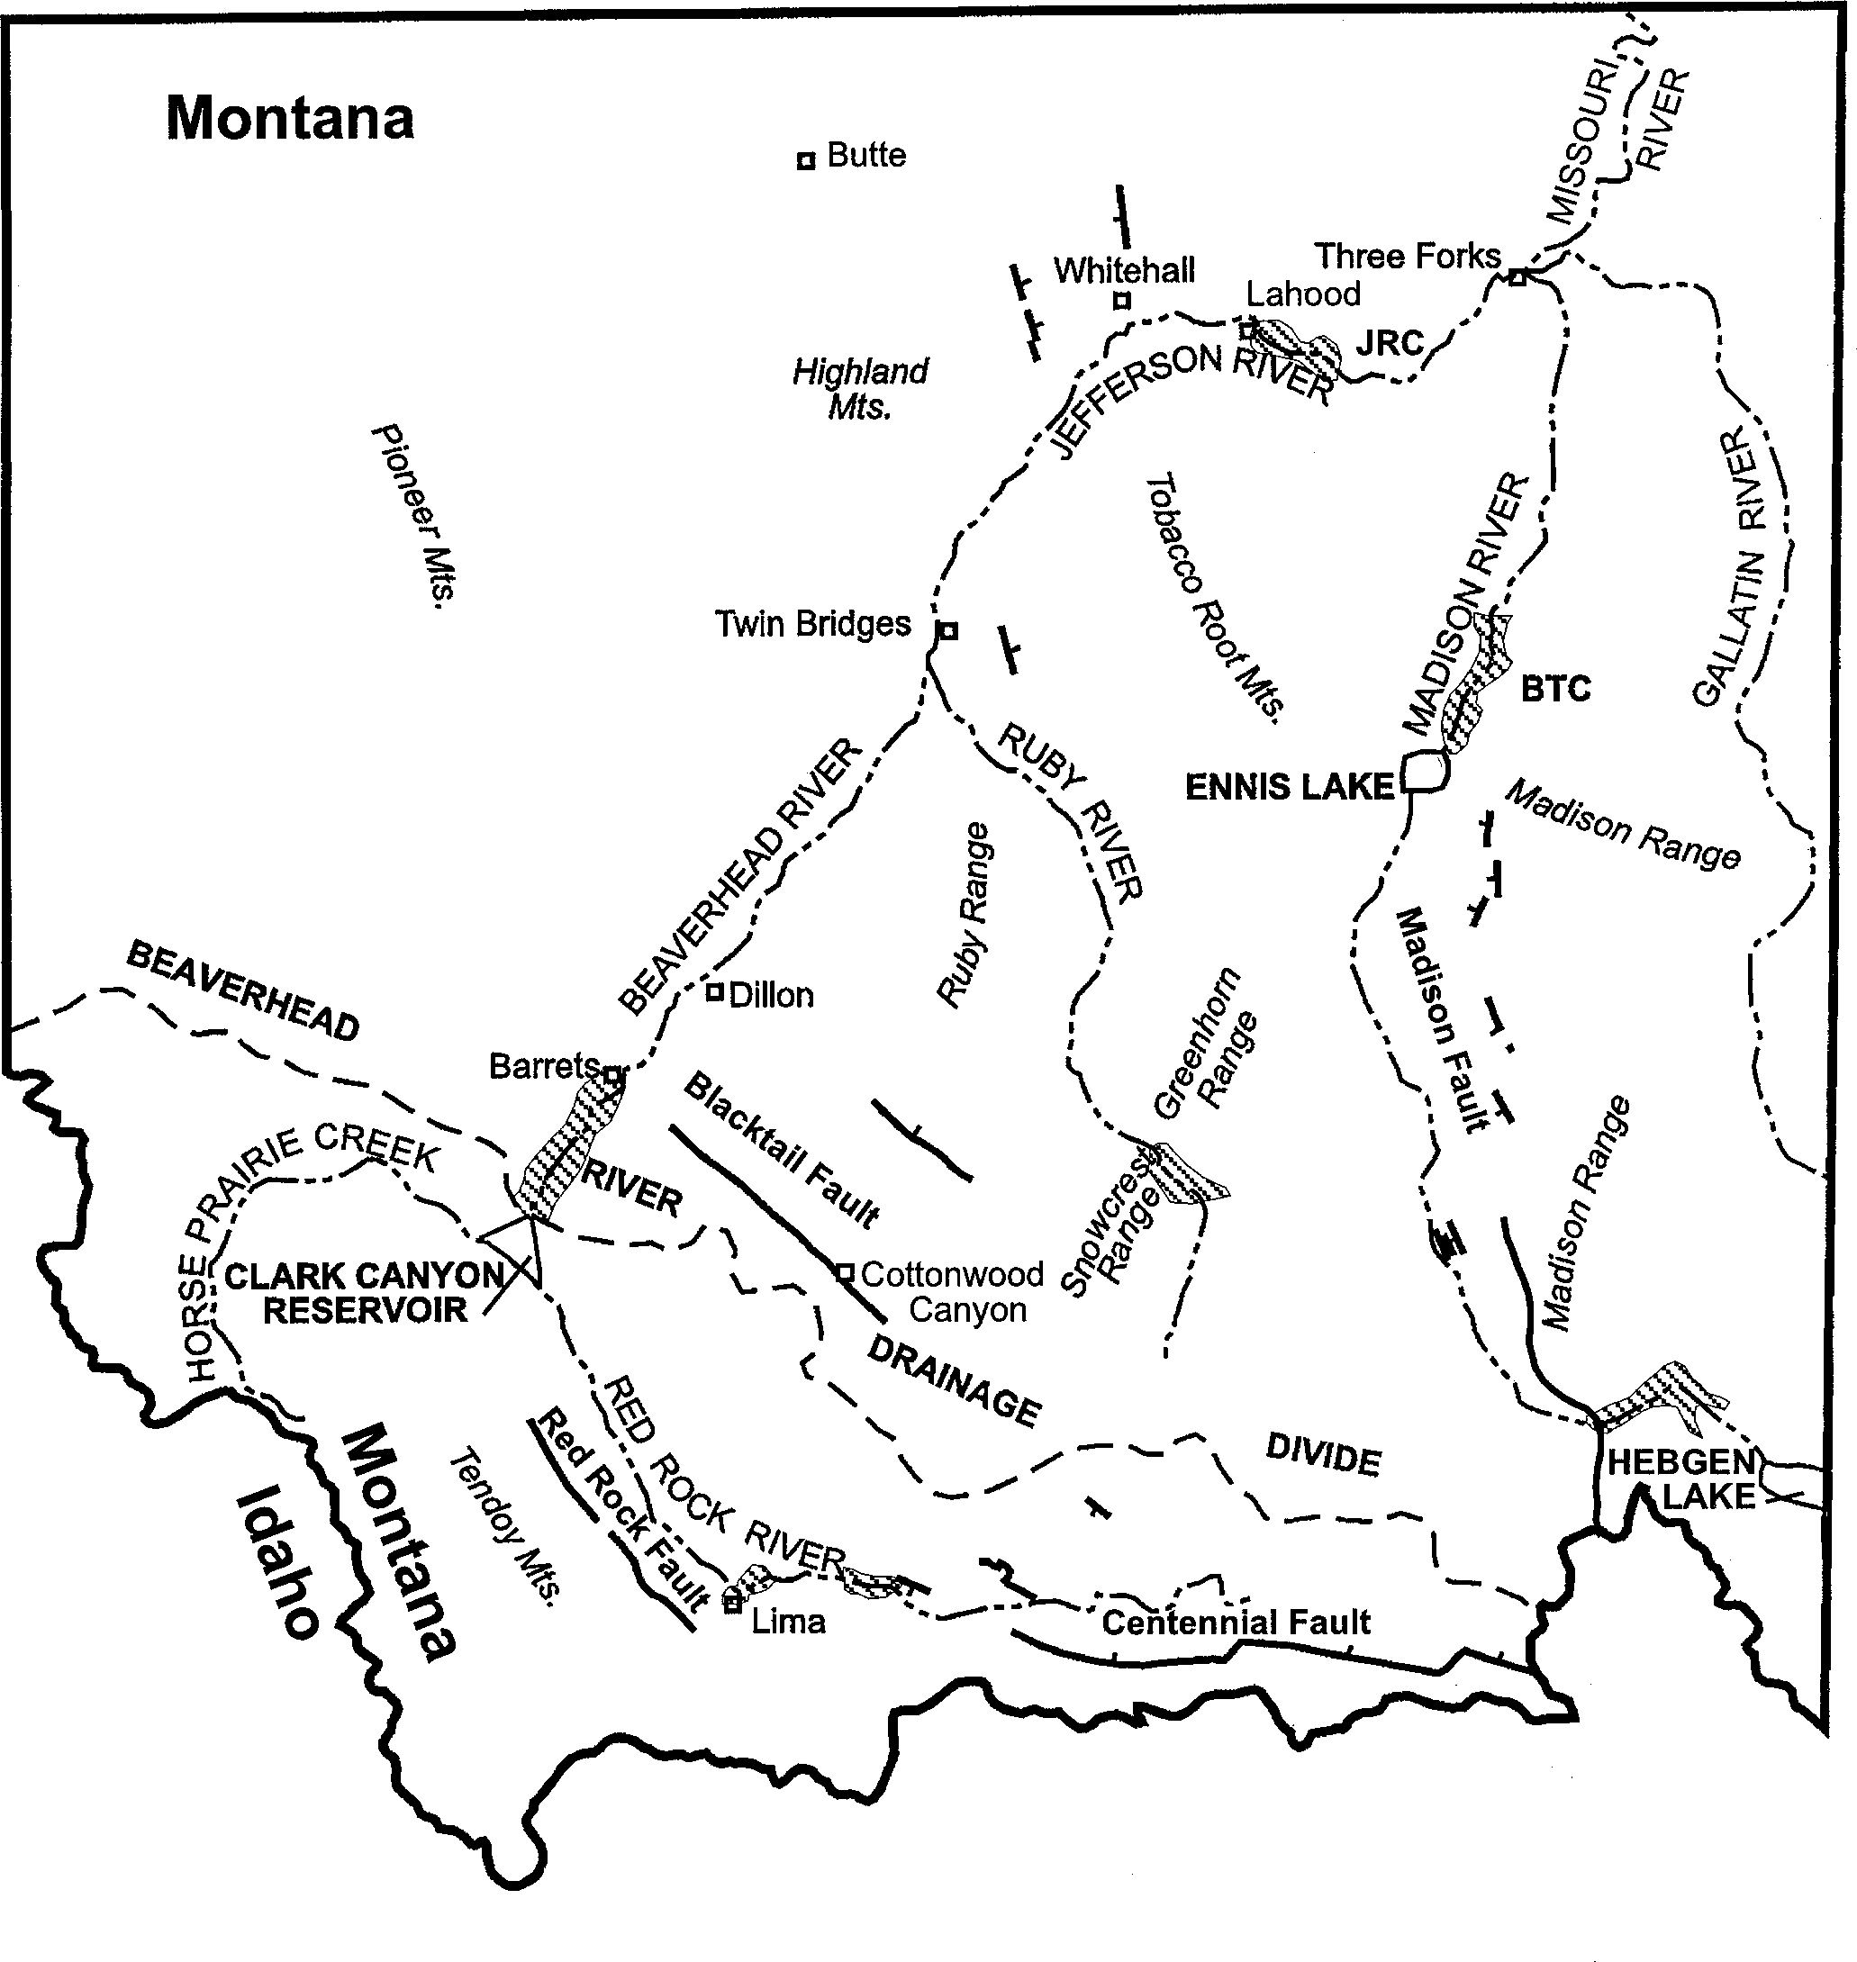
23 uide oo to the eolo y of astern daho

Figure . Map ntana bor der and
showing the headwaters region of the Missouri River relative to the continental divide (Idaho-Mo
identified active faults (Stickney and Bartholomew, 987a, b . Incised canyons are indicated by the hatchured pattern. BTC- Bear Trap Canyon. JRC- Jefferson River Canyon.

Study Area Physiography
The Beaverhead River of Montana is part of the Missouri River headwaters within the Montana-Idaho Basin and Range Province (e.g., Reynolds, 1979; Stickney and Bartholomew, 1987a,b). The Beaverhead River is formed at Clark Canyon Reservoir by the merger of the northwest-flowing Red Rock River and the east- flowing Horse Prairie Creek (Fig. 1). The river flows ~72 km northeast until it merges with the Ruby River near Twin Bridges, MT to form the Jefferson River. The Jefferson River flows ~40 km northeast then abruptly changes to an east-trend near Whitehall, MT. After flowing through the Jefferson River Canyon at La Hood, MT, it finally coalesces with the Madison and Gallatin rivers to form the Missouri River, near Three Forks, MT, ~96 km down- stream from its origin and ~168 km downstream from the Clark Canyon dam (Fig. 1).
The Beaverhead River, an open valley (e.g., Rich, 1914), flows through a very straight, N35°E-trending, ~190 m deep, narrow defile for the first 19 km of its course, between the Clark Canyon dam and Barretts (Fig. 2). It then debouches into a wide valley 13 km south of Dillon, MT (Fig. 1). Within the canyon, the Beaverhead River has an average gradient of 0.244%. Down- stream, between Barretts and Dillon, the gradient decreases slightly to an average of 0.238%. The steeper gradient within Beaverhead
River Canyon could partially reflect, among other things, Qua- ternary tectonic controls on the adjacent valleys within this tec- tonically active region (e.g., Stickney and Bartholomew, 1987b) along the perimeter of the track of the Yellowstone hotspot (e.g., Anders and others, 1989).

Study Area Bedrock Geology
Our data show that the N35°E-trending course of the Beaverhead River across the Blacktail Range was already estab-

Figure 2. Topographic map showing the Beaverhead River Can- yon and its major tributaries relative to proximal geology, alluvial fans of Blacktail Deer Creek and Rattlesnake Creek, and to the active segment of the Blacktail fault scarp and to topographic lineaments along the Blacktail Range front near the northwest, inactive segment of the Blacktail fault. B- Barretts; D- Dalys; POR- Pipe Organ Rock; CCD- Clark Canyon dam; BRT- Beaverhead River terrace; FC- fan com- plex; G- Tertiary gravel deposit; KB- Cretaceous Beaverhead Conglomerate; LS- landslide; MC- Mississippian carbonates; PED- pediment; PM- Paleozoic-Mesozoic strata; TU- tufa deposit; AMBDC- ancestral mouth of Blacktail Deer Creek; LHCF- Little Horn Creek fan; SCF- Sheep Creek fan; dotted lines are escarpments across pediments.

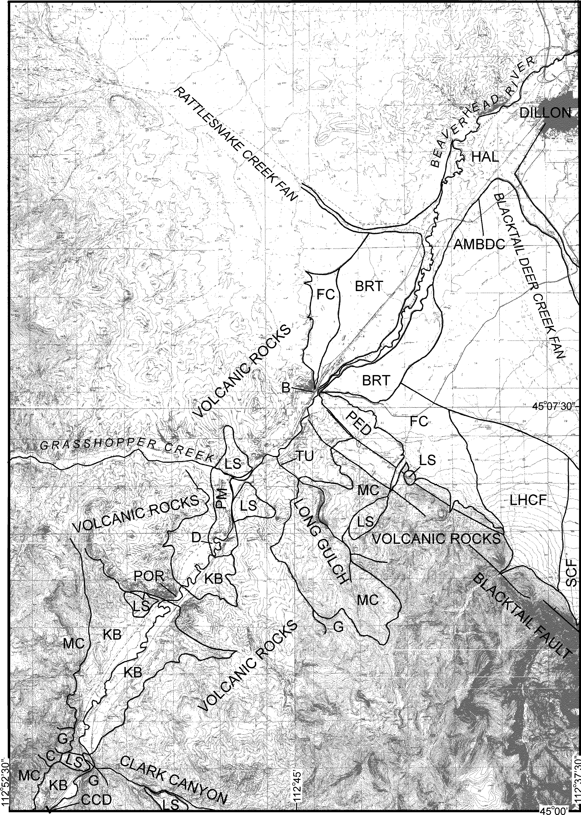

2 uide oo to the eolo y of astern daho

lished by the Late Pleistocene. Earlier, when canyon incision be- gan, Eocene volcanic rocks likely formed the bedrock along most of the river's future course. Only from Clark Canyon dam to Clark Canyon were Tertiary gravels and Paleozoic rocks likely to have been exposed. When or how this course was established is un- known. Perhaps high volumes of Middle Pleistocene glacial run- off from the continental divide to the south and southwest dic- tated the general northeast-flow direction of the ancestral river across the Blacktail Range (Fig. 1). Moreover, uplift of the Black- tail Range, relative to the valley of the Red Rock River and to the valley containing Dillon, had to be substantial in order to achieve the depth of incision across the Range without similar incision across the later Quaternary deposits (e.g., Bartholomew, 1988; 1989) in these valleys. Hanneman and Wideman (1991) showed that episodic uplift of ranges during the Tertiary produced five sequences in the basins of Jefferson River in southwestern Mon- tana. The youngest (Quaternary) of these sequences is bounded at its base by a major unconformity (upper Pliocene-lower Pleis-
tocene) which they attribute to extensional tectonism.
Late Quaternary deposition along the Beaverhead River oc- curred as the river cut through bedrock (Fig. 2). The bedrock includes late Paleozoic rocks thrust over Late Cretaceous Beaverhead Conglomerate near the Clark Canyon dam (Hildreth, 1980) (Fig. 3A), extensive Tertiary volcanic rocks north of Grass- hopper Creek (Fig. 3B), and Mesozoic and Paleozoic strata (Fig. 3C) exposed beneath the volcanic rocks locally near the river. Extrusive volcanic rocks nonconformably overlie steeply west- dipping Paleozoic/Mesozoic strata between Grasshopper Creek (Fig. 3C) and the intrusive Eocene (Chadwick, 1978,1980) vol- canic rocks at Pipe Organ Rock (Fig. 3D). From Pipe Organ Rock to Clark Canyon dam, steeply dipping Beaverhead Conglomer- ate rapidly flattens near Henneberry Gulch (Fig. 3E) and is much of the bedrock near river level. At the mouth of Clark Canyon, intrusive volcanic rocks also occur at river level, and coarse gravels nonconformably overlie volcanic rocks along the southeast-side of the river (Fig. 3F).

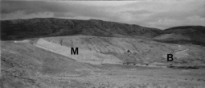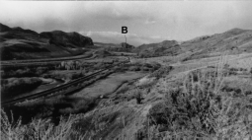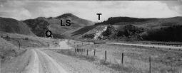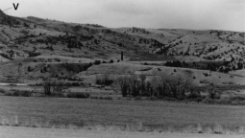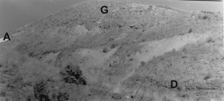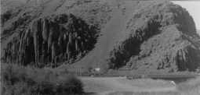
A
B
C
D
E
F

Figure 3. A- Photograph looking west at the spillway of Clark Canyon dam, showing Mississippian carbonates (M thrust over Cret aceous Beaverhead Conglomerate (B . B- Photograph looking northwest from Long Gulch toward Barretts (B where river is incised into volcanic rocks. C- Photograph looking north at the narrow canyon near Dalys, Montana. The bluff on the west-side (left of the river is held up by west-dipping Pennsylvanian Quadrant Sandstone (Q and a large landslide (LS makes up the slope of the hill (which is capped by volcanic rocks in the background through the canyon. Higher terrace (T . D- Photograph looking E at Tertiary dacite (D and volcanic ash (A capped by gravels near the mouth of Clark Canyon. E- Photograph looking east at subhorizontal Beaverhead Conglomerate ( B beneath higher terraces at Henneberry Gulch S of Pipe Organ Rock. F- Photograph looking northwest at Pipe Organ Rock.

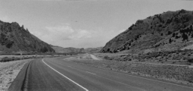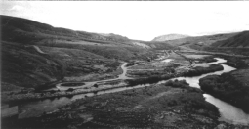At Barretts, the river enters the broad basin near Dillon nearly perpendicular to the projected trace of the Blacktail fault. The Beaverhead River Canyon was incised across underlying Meso- zoic-Cenozoic structural features after incision through Eocene volcanic rocks. Stratigraphic, structural and topographic changes at Barretts (Fig. 2) partially reflect Neogene movement on the west-northwest-trending Blacktail fault that flanks the Blacktail uplift and in front of which the valley is filled with large late Quaternary, coalescing fan complexes (Fig. 2). They could also be influenced by Late Quaternary movement along this active fault.
A
B

Previous Work
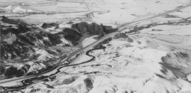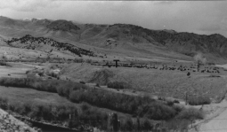Ages of Missouri-headwater rivers are poorly constrained. Studies upstream from Bear Trap Canyon (Fig. 1) along the Madi- son River, which has its headwaters in the Quaternary volcanic rocks of Yellowstone National Park, show a complex series of terraces and tributary-fluvial and glacial deposits (e.g., Locke and Schneider, 1990; Bearzi, 1990; Hall and others, 1990; Lundstrom, 1990). These features post-date both the voluminous Huckleberry Ridge Tuff (~2 Ma) and most of the subsequent tilting along the Madison fault (e.g., Locke and Schneider, 1990; Schneider, 1990b). The oldest surface there (Cameron Bench) developed partially during Bull Lake glaciation (~130 ka) although it likely is metachronous (e.g., Schneider, 1990a). Along the Jefferson River, the Ballard gravels (well exposed a few km east of La Hood on Interstate 90) lie about 485 m ARL suggesting they may be earlier Pleistocene or late Pliocene (Aram, 1979). Incision of the Jefferson River Canyon was initiated after deposition of these Plio-Pleistocene gravels (Aram, 1979). Shaping of the Tobacco Root Range southwest of this canyon was primarily Bull Lake and younger, although evidence for pre-Bull Lake glaciation does exist in the range (e.g., Hall, 1990a,b). Early Pleistocene depos- its are, however, generally lacking in the basins of the Jefferson River drainage (Hanneman and Wideman, 1991). Broad glacial outwash fans, within the Jefferson River Valley west of the To- bacco Root Mountains, are also primarily Middle Pleistocene or younger (e.g., Bartholomew and others, 1990). West of the conti- nental divide at nearby Butte and 50 km downstream at Deer Lodge, the headwater-region of the Clark Fork also has extensive Late and Middle Pleistocene terraces and glacial deposits along its main valley and tributaries (e.g., Derkey and Bartholomew, 1988; Derkey and others, 1993).
C
D

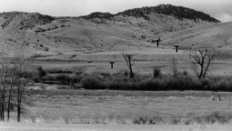Figure 4. A- Photograph looking N at breached Eocene intrusive volcanic complex (Chadwick, 978, 980 at river level at Pipe Organ Rock. B- photograph looking northeast from Clark Canyon dam showing wide floodplain and extensive terraces on the west-side of the river. C- Photograph looking north- west at the constricted Beaverhead Canyon Gateway at Barretts. D- Photograph looking northwest at extensive Pleis- tocene terrace (T with cattle on it at 3 m ARL just south of gorge at the mouth of Clark Canyon. E- Photograph looking west at multiple terrace levels preserved where unnamed tribu- tary joins the Beaverhead River ~ .5 km S of Pipe Organ Rock.
E

2 2 uide oo to the eolo y of astern daho
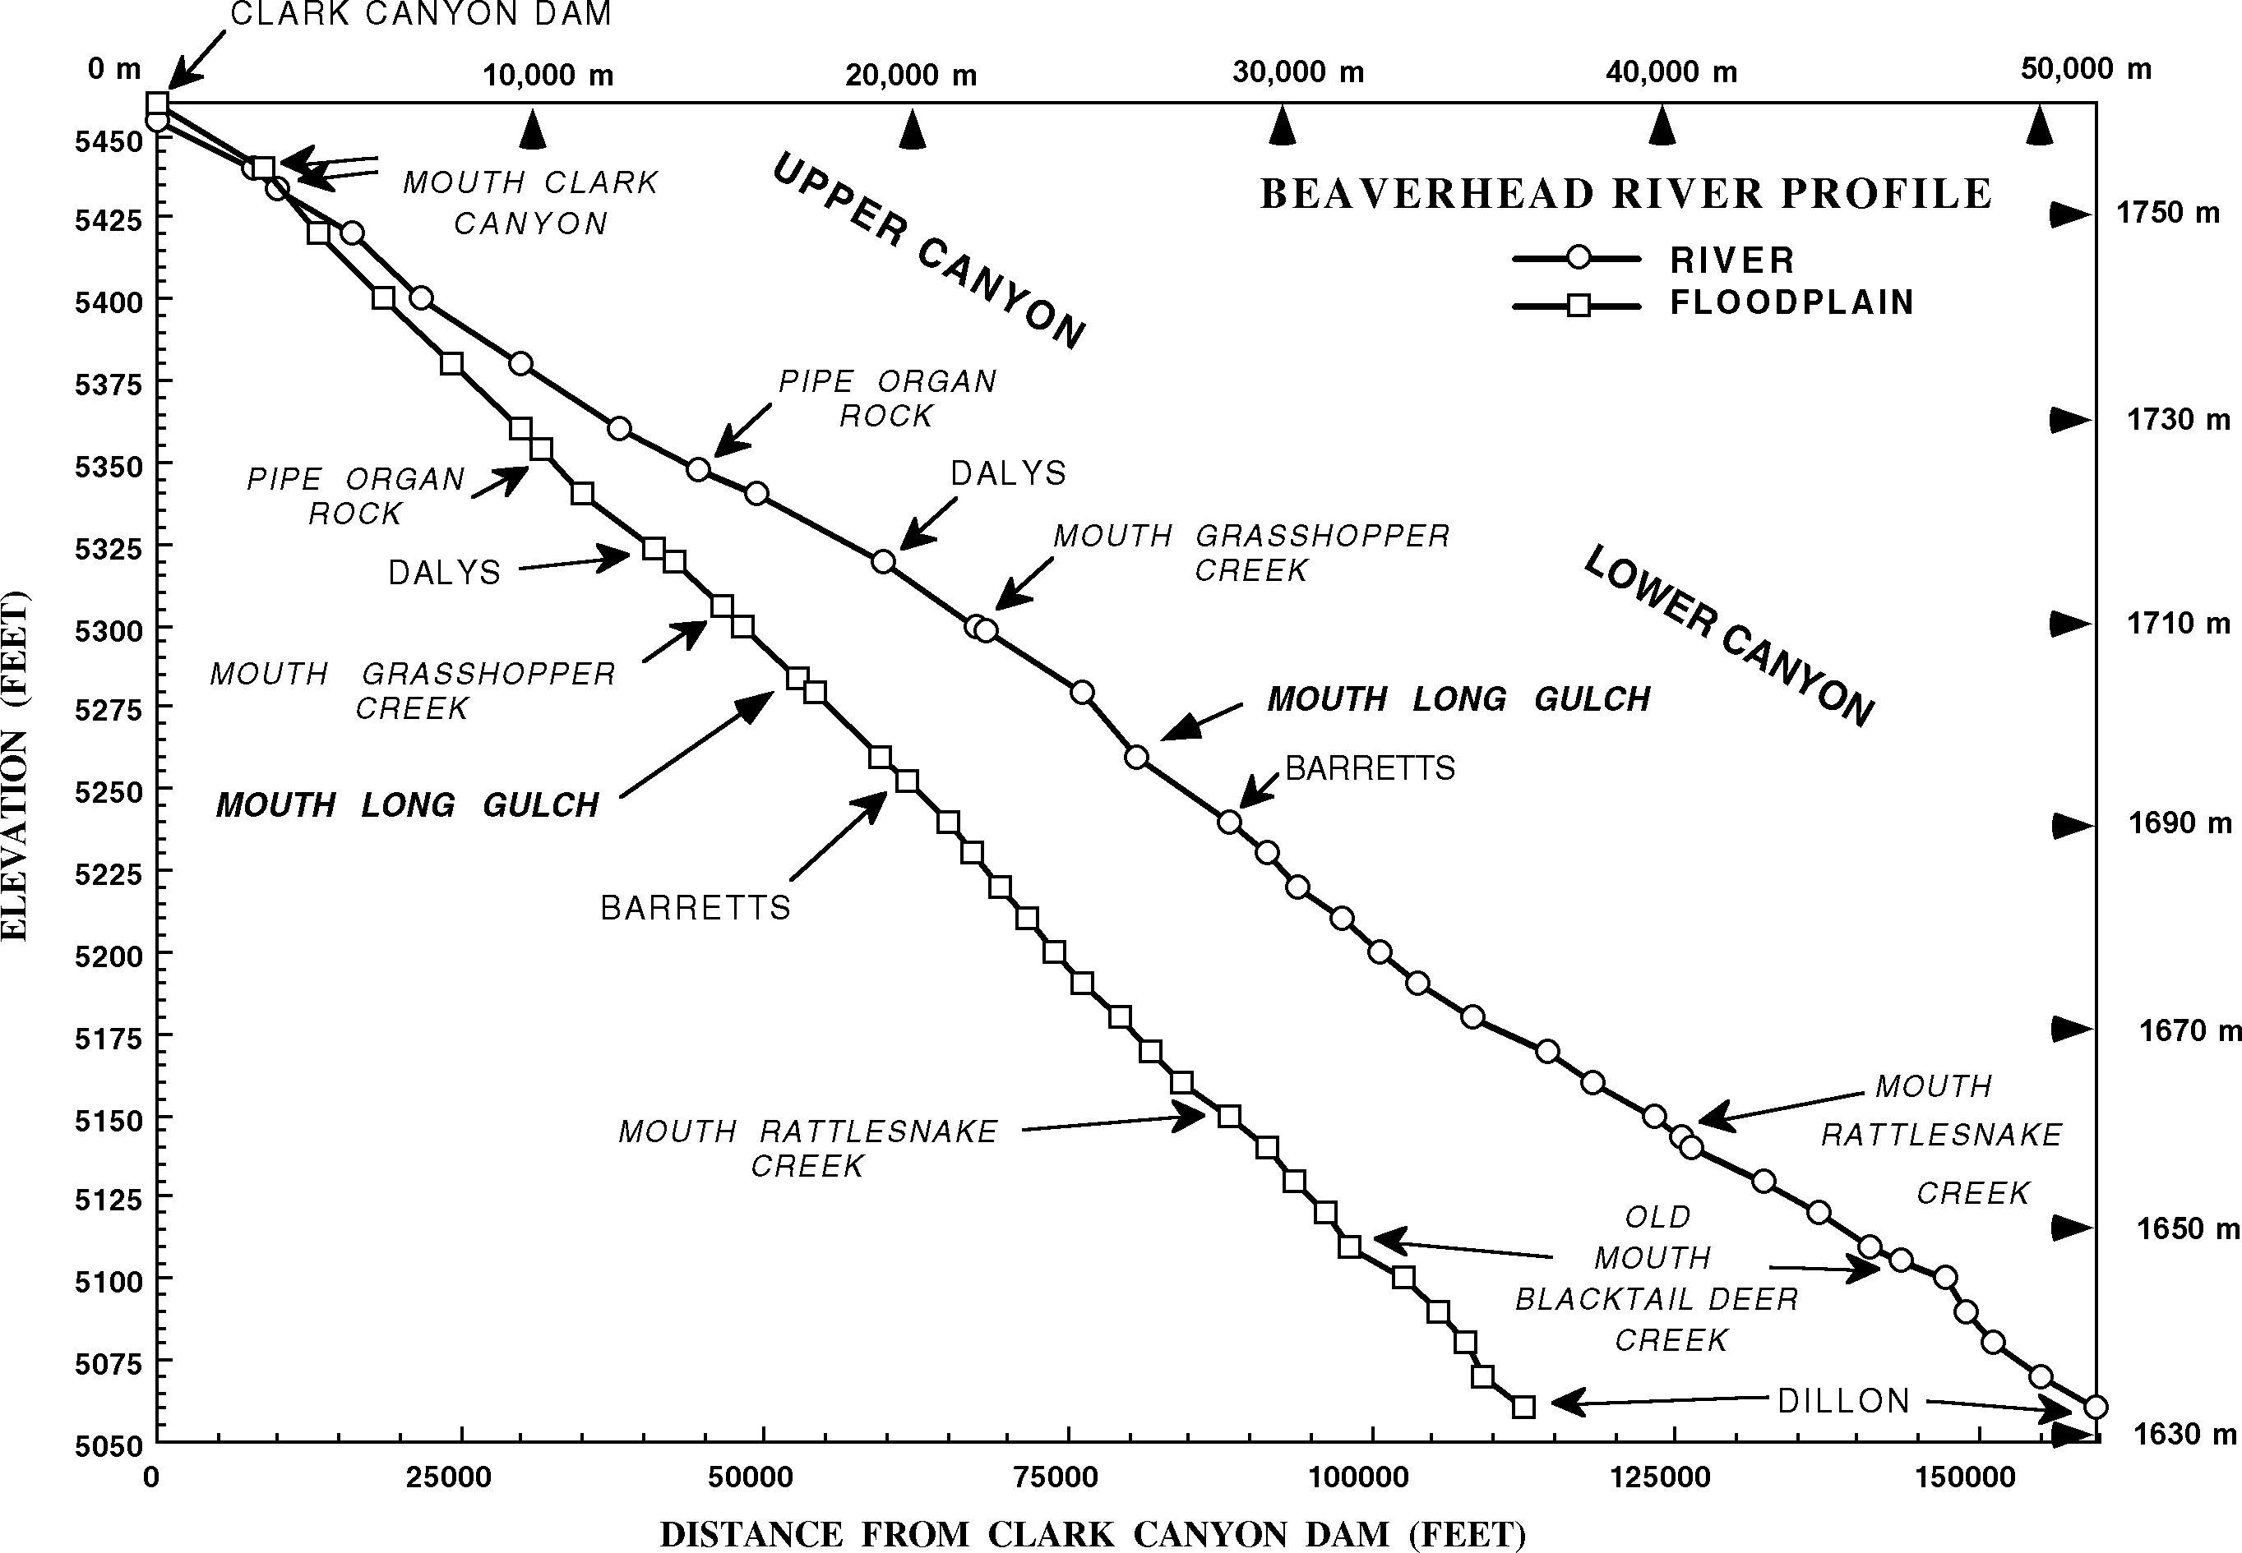
Figure 5. Beaverhead River profile and floodplain profile from the Clark Canyon Dam to Dillon.

QUATERNARY LANDFORMS

Floodplain and Gradient
The high (355 m ARL) ridge of volcanic rocks at Pipe Organ Rock (Figs. 2, 3D, & 4A) approximately bisects the Beaverhead River Canyon into an upper part (Fig. 4A, B, & D) and a lower part (Figs. 3B & 4C) that have different characteristics, but have similar gradients (Fig. 5) of 0.25% and 0.24%, respectively. In the upper canyon at the mouth of Clark Canyon, the Beaverhead River flows through a narrow, 0.8 km-long gorge, with a gradient of 0.35%, cut across a narrow intrusive volcanic complex. Ex- cept in this Clark Canyon gorge, the upper Beaverhead River Canyon has a wide (150 m-650 m) floodplain (Figs. 3C, 4B & E) which is flanked by a long stretch with wide terraces at different elevations ARL (Figs. 3E, 4D & E). The river's channel consists of meander loops, with wavelengths typically shorter than ampli- tudes, alternating with nearly straight to slightly sinuous stretches. The broad floodplain contains numerous cutoff meander loops suggestive of a compressed meander pattern upstream of resis- tant bedrock (e.g., Schumm and others, 1987).
A wide (~650 m) floodplain with meanders persists for ~2.5 km north of Pipe Organ Rock to the head of a narrow gorge (Figs. 2 & 3C) at Dalys. However, this section of the lower canyon lacks the extensive terrace deposits that characterize the upper canyon. The 0.8 km-long bedrock gorge at Dalys has a gradient (0.26%)
(Fig. 5) that is only slightly steeper than those in the upper and lower portions of the canyon. Once the river emerges from the Dalys gorge and is joined by Grasshopper Creek, it resembles a confined straight or braided channel during uplift (e.g., Ouchi, 1983) and maintains a sinuous course, with wavelengths gener- ally equal to or greater than amplitudes, through the rest of the lower canyon (Figs. 3B & 4C). The floodplain is usually <300 m wide and has a few scattered Holocene terraces flanking it. Ex- cept for those terraces at the Dalys gorge and those just below Clark Canyon dam, remnants of older terraces are virtually con- fined to the interval between the mouth of Grasshopper Creek and Long Gulch (Fig. 2). The Beaverhead River has an anoma- lous steep gradient (0.46%) for ~0.8 km south of Long Gulch (Fig. 5); this gradient is steeper than gradients through the gorges at Clark Canyon (0.35%) and Dalys (0.26%).
The profile of the Beaverhead River and the profile of its flood- plain (Fig. 5) display similar large-scale variations in gradient. The median floodplain gradient is shorter, straighter and, hence, steeper and variations in it are not as pronounced as variations along the longer meandering river. Steeper gradients occur near Clark Canyon, Dalys, Barretts, the mouth of Rattlesnake Creek, and between the old mouth of Blacktail Deer Creek and Dillon. As expected (e.g., Schumm and others, 1987), changes to gentler gradients occur upstream from the gorges at Clark Canyon and Dalys, and just upstream from Barretts. They also occur halfway between Barretts and the mouth of Rattlesnake Creek, and near

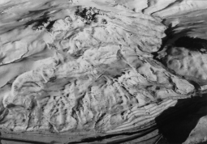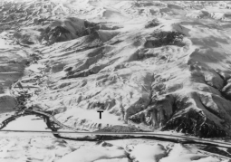
A
B
Figure 6. A- Photograph looking southeast at recurrently active landslide, which has deflected and constricted the Beaverhead River
~ .5 km north of Dalys. Bluff of west-dipping Quadrant Sandstone on west-side (right of river causes large shadow. B- Photogra ph looking northwest at large landslide at the mouth of Grasshopper Creek which impinges on remnant of Pleistocene terrace (T .

the old mouth of Blacktail Deer Creek.
North of Barretts, both the course and gradient of the Beaverhead River appear to be influenced by Pleistocene tribu- taries. Large volumes of sediment provided by ancestral Rattle- snake Creek and ancestral Blacktail Deer Creek were dropped at their mouths and subsequently impeded the Holocene Beaverhead River in a manner similar to reaches of resistant bedrock. Lower gradients and compressed meanders occur along the Beaverhead River along the upstream portion of the river's arcuate course around the toes of the very large Pleistocene alluvial fans of these two braided tributaries (Fig. 2). Steeper gradients in straighter, more confined sections occur along the flanks of these huge fans downstream of the tributaries' mouths. Similarly, gradient changes in the river near Grasshopper Creek reflect a gentler gradient upstream from two active landslides and a steeper gradient where the river is constricted across breached toes of these landslides.
Gradient changes near Clark Canyon and Dalys are typical of other rivers, with steeper gradients within and just downstream from the gorges and gentler gradients and compressed meanders upstream from such bedrock constrictions (e.g., Schumm and oth- ers, 1987). The steeper gradient starting just upstream from the bedrock constriction at Barretts may also be attributable partially to the same factors, but another factor may be Late Quaternary displacement along the range-front Blacktail fault. The projected trace of the Blacktail Range front crosses the Beaverhead River
~650 m north of Barretts (Fig. 2).

Holocene Alluvium and Fan/Tributary Deposits
Along the present-day course of the Beaverhead River, the youngest alluvial deposits form a floodplain that ranges from <130 m wide to ~650 m wide. The youngest alluvial fans are small and overlap the edges of the present day floodplain or rest on top of older surfaces. These small fans debouch onto the major flood- plain from small declivities along the river or from small tribu- tary mouths. These fans are younger than all deposits except the youngest Holocene alluvium. Just below Clark Canyon dam, Mount Mazama ash (~6.8 ka; Lemke and others, 1975) is pre- served in one of these small fans. Caliche is generally absent from
these Holocene deposits.
These youngest, small fans are also built out over an older, areally extensive, remnant fan-system. Tributaries, associated with the older fan deposits, cut an alluvial deposit at a slightly higher level (<2 m ARL) than the floodplain alluvium. This level of al- luvial deposits is fairly extensively preserved parallel to the course of the river, and some tributaries, and is cut by tributaries to both sets of fans described above. This deposit is most extensive where the floodplain is broadest, and probably reflects a similar flood- plain configuration during its deposition.

Landslides and Their Effects on the River
Late Quaternary landslides are abundant along the flanks of the lower canyon, and larger landslides at Grasshopper Creek impinge upon the floodplain (Fig. 6) and deflect the river's course somewhat in their vicinity. These two currently active landslides severely restrict the flow of the Beaverhead River. The slide on the east forces the river to impinge upon a bedrock buttress of Quadrant sandstone west of the river. The diverted river thus joins Grasshopper Creek in a more westerly location than the river had during formation of the earlier Pleistocene terraces near Long Gulch. For ~8 km upstream from Dalys to the mouth of Clark Canyon, a broad floodplain has been formed. Following eventual removal of the landslide blockage, the river will more rapidly incise and remnants of this floodplain may be preserved as matched terraces. An older landslide within early Tertiary gravel deposits lies on the western promontory at a narrow, sharp, east- wardly convex deflection from the river's overall N35°E course at the mouth of Clark Canyon. Moreover, correlative older ter- races are just upstream from this constricted stretch of the Beaverhead River, suggesting that this older landslide may have played an early role, similar to the landslides at Grasshopper Creek, in establishing the river's deflected course prior to inci- sion of the gorge at Clark Canyon and subsequent development of lower terraces. Thus, within Beaverhead Canyon, landslides have periodically blocked, constricted or diverted the river, per- haps related to major earthquakes (e.g., the Quake Lake slide associated with the August 17, 1959 Hebgen Lake earthquake,

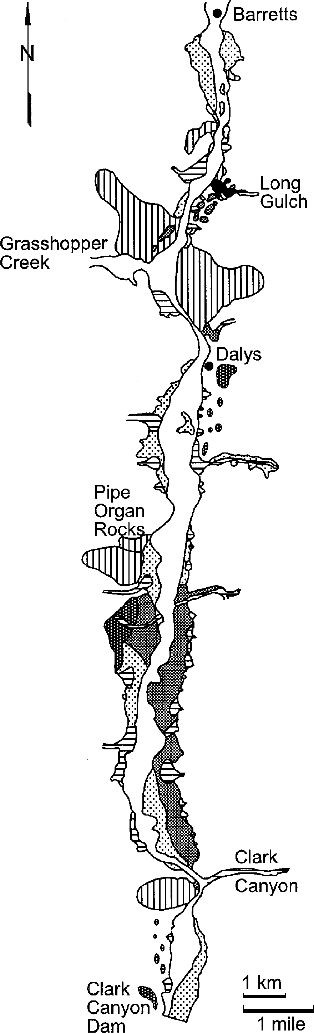
Witkind, 1964).
Numerous smaller landslides occur between Barretts and Long Gulch. The abundance of landslides in the lower canyon is re- lated to bedrock consisting mostly of mixed volcanic rocks (Fig. 2). Perhaps large landslides near Barretts impounded the Beaverhead River, thus assisting development of the series of Pleistocene terraces near Long Gulch.

Terrace Levels
Irregularly distributed, late Quaternary terrace gravels occur on relatively flat benches at variable elevations up to ~65 m ARL along the flanks of the Beaverhead River in this narrow gorge (Fig. 7). Only scattered terrace-gravel deposits occur above ~75 m AFL. Late Pleistocene alluvium, with stage II caliche, caps an extensive terrace (Figs. 7 & 4D), at 13 m ARL, south of Pipe Organ Rock and remnants of older Pleistocene terraces (Fig. 7), with stage III caliche, occur near both Long Gulch and Pipe Or- gan Rock. These older terraces within the canyon can be locally correlated by height ARL at several terrace levels for 1.5 km south of Long Gulch or for 1.5 km north of Clark Canyon dam. These local terrace levels, the extensive terrace north of Clark Canyon, and the extensive terrace between Barretts and Rattlesnake Creek all have similar gradients to the floodplain (Fig. 8). Similar gra- dients at different levels ARL indicate that the height ARL (or more specifically, height above the floodplain level-AFL) is a valid method for defining terrace levels here even if individual unpaired terraces may not be correlative within a given terrace level. Comparison of all terrace-elevation data with the flood- plain level (Fig. 8) suggests three peak levels of major terrace development during the later Pleistocene are at heights of ~10-12 m, ~25-45 m, ~55-70 m. These deposits cap remnants of prob- able Pleistocene alluvial surfaces.
Recognition of older Beaverhead River deposits, that lack recognizable geomorphic characteristics, is greatly hampered by extensive late Cretaceous/early Tertiary gravel in the upper can- yon and around the Clark Canyon Dam. Relative ages of the mapped deposits (Fig. 7) are based on relative heights of depos- its ARL and on soil development within deposits.

Tufa Deposit
An areally extensive composite tufa deposit (Fig. 7) is associ- ated with a large flowing warm spring (Fig. 9A & B) in Long Gulch, a tributary in the lower canyon that drains an area under- lain by Mississippian carbonates east of the canyon (Figs. 2 & 7). Broad, flat benches of tufa (Fig. 9A & B) have elevations ARL similar to Beaverhead River terraces (Fig. 9C & D) suggesting that they formed on the terraces, and hence, are younger than the terraces. But tufa occurs for several hundred meters downstream from the waterfall (Fig. 9A) to where this tributary enters the

Figure 7. Geologic map of Late Quaternary deposits within the Beaverhead River Canyon; white-Beaverhead River flood- plain alluvium; horizontal stripes -tributary alluvium and alluvial fans; dots -Holocene terrace deposits; medium stipple
-Pinedale terrace deposits; dark stipple -Bull Lake terrace deposits; black -90-ka tufa deposit at Long Gulch; vertical stripes -Late Quaternary landslides.

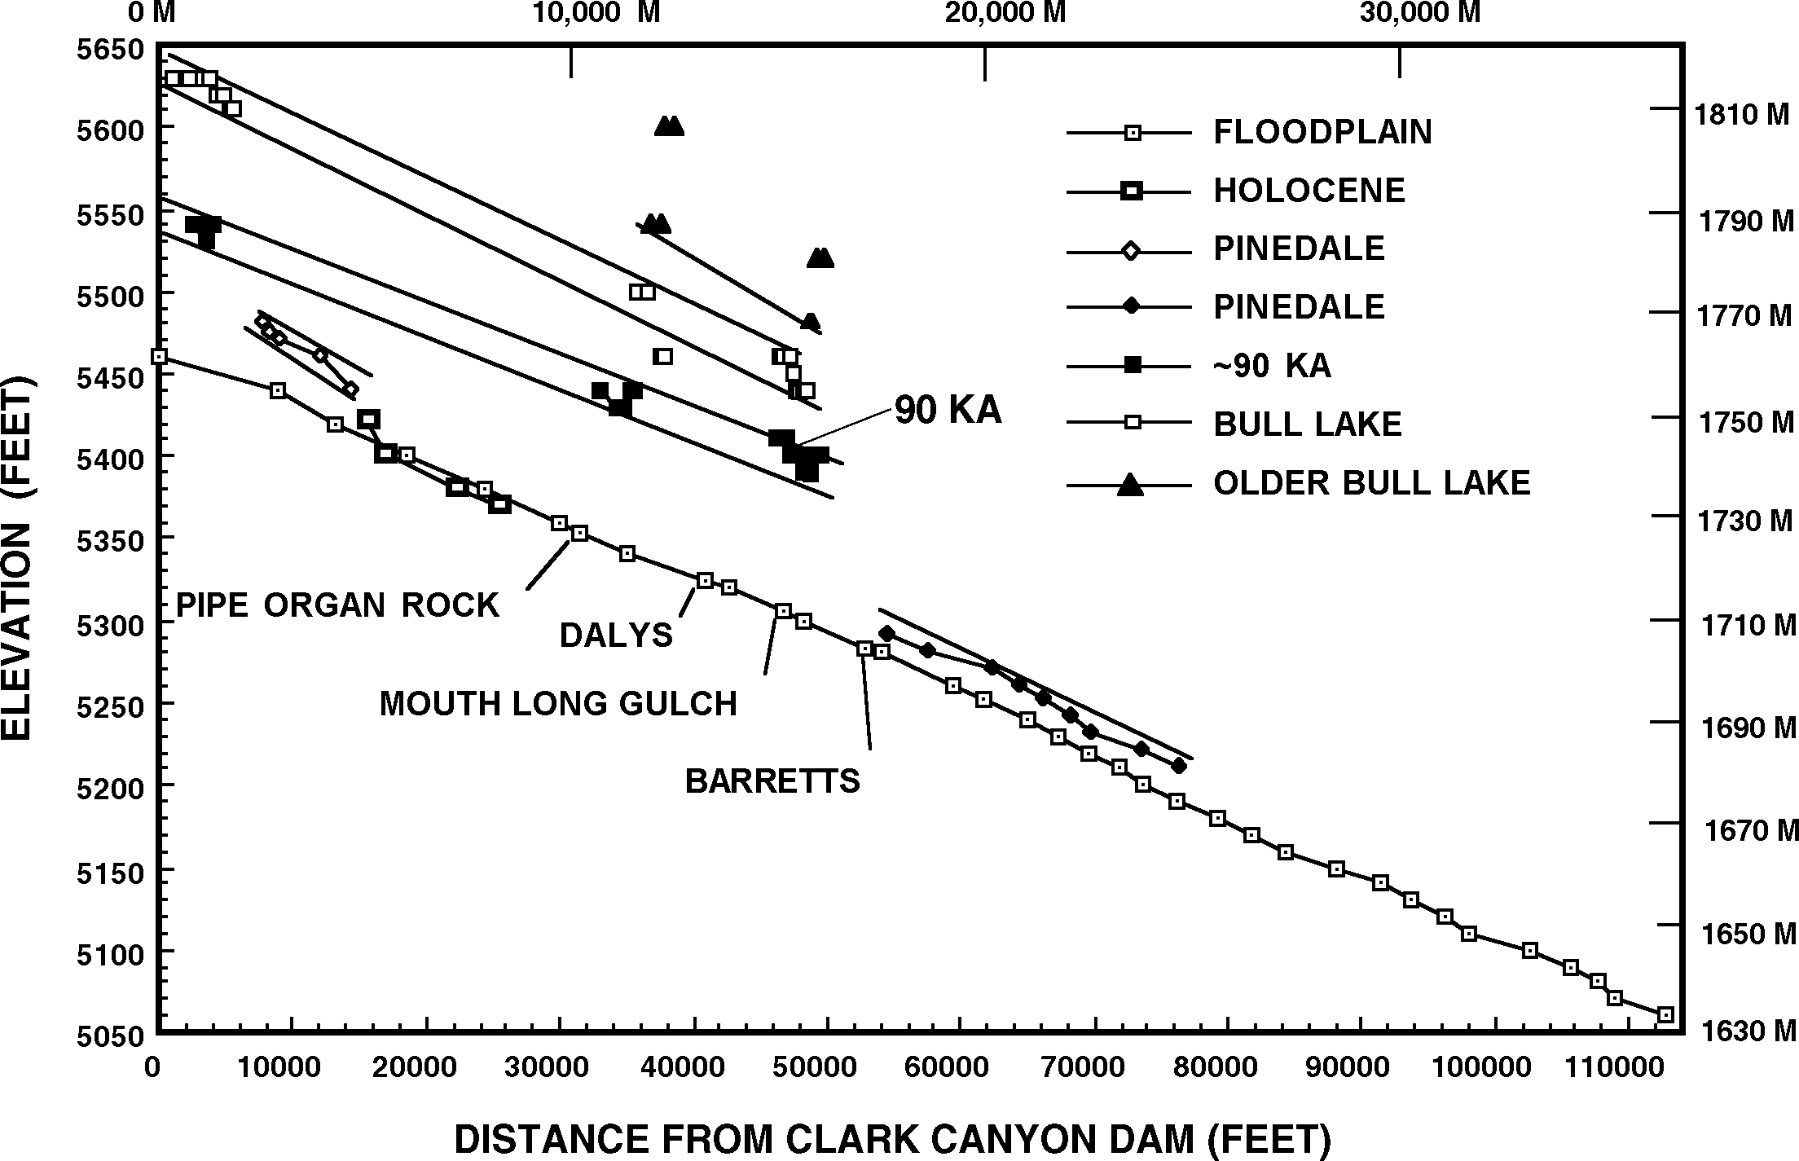

Figure 8. Elevation profiles of terraces within the Beaverhead River Canyon between Clark Canyon Dam and Barretts compared to floodplain profile. The 90 ka date shows the tufa site discussed in the text.
~1 m below the present-day surface.

Beaverhead River. Inasmuch as Holocene tufa is present where it crosses the Beaverhead River floodplain, the tufa benches could be approximately equivalent to terraces of similar elevations ARL. Tufa-deposition is thus confined to the warmer, carbonate-rich waters associated with the spring and ceases once the tributary merges with the much greater volume of faster flowing water car- ried by the river. The steep escarpment that produces the water- fall (Fig. 9A) approximates the scarp height of higher well formed Beaverhead River terraces (Fig. 9C & D) at ~39 m ARL. Above the waterfall is a broad, relatively flat portion of the tufa (Fig. 9B) which also lies at ~39 m ARL. Numerical ages, determined by U-series-disequilibrium techniques, were obtained only from this level of the tufa. Upstream, the tufa deposit steps across sev- eral broad flat benches separated by ~1.5-2 m high scarps (Fig. 9B).

RADIOMETRIC AGES

Sample Locations
Samples were collected at well-exposed tufa outcrops in an attempt to determine ages from various portions of the tufa-spring. The present-day exposure of tufa covers an area of ~300 x 300
m. Sample splits MTS 062 and MTS 063 (from Sample 47 on Table 1) were collected from within a meter of the presently ac- tive area of the stream near the waterfall (Fig. 9A), by excavating
~0.3 m below the present-day surface. Sample splits MTS 069 and MTS 070 (from Sample 50 on Table 1) were collected from an inactive and dissected portion of the tufa (Figs. 9A & 10A) at

Method
Using the 238U decay series, two sets of radiometric ages were obtained for each of the 2 sets of tufa samples (Fig. 10B & C). Because these samples are not from a sealed environment, such as a cavern, detrital thorium is more of a concern and two samples from each site were needed to ascertain reproducibility of results. For each sample, two small pieces were removed from widely separated areas. Approximately 20 grams of sample were dis- solved and spiked with 232U and 228Th of known activities. Both uranium and thorium were then separated and electroplated onto stainless steel planchets. Activities of the uranium and thorium isotopes were determined by radiation counting using a Canberra 8100 multi-channel alpha spectrometer (Table 1). Counting was maintained for 5 to 10 days.

Analytical Results
Location 47 - Both samples (MTS 062 and MTS 063) were obtained from the larger sample (~15 cm diameter) collected at this location. The uranium yields (Table 1) from both samples were similar and were adequate for the technique. Although the 230Th/232Th ratio suggests a significant degree of detrital thorium contamination in sample MTS 062, the higher ratio in MTS 063 suggests only a slight degree of contamination (Table 1). The uncorrected ages for these two samples were calculated assum- ing all 230Th was derived from in situ decay of 234U. As expected, taking detrital thorium contamination into consideration, a greater

Table 1. U-Th Data for Long Gulch Tufa.

Sample | 47 | 47 | 50 | 50
Split | MTS 062 | MTS 063 | MTS 069 | MTS 070
U concentration | 1.3 ppm | 1.6 ppm | 0.2 ppm | 0.2 ppm
U yield | 8% | 9% | 3% | 14%
Th yield | 13% | 3% | 6% | 3%
Isotope Ratios
234U/238U
1.46 | 1.47 | 2.19 | 2.37
0.151 | 0.147 | 0.672 | 0.726
7 | 18 | 5 | 3

230Th/234U
230Th/232Th

Ages (1000 years)
Uncorrected | 17.6±1.3 | 17.1±2.5 | 106±13 | 119±14
Corrected* | 14.7±1.6 | 16.1±3.5 | 91±15 | 87±18
Initial 234U/238U | 1.48 | 1.49 | 2.54 | 2.75

*230Th/232Th value of 1.25 used for detrital Th correction. Analytical uncertainties are ± one standard deviation.

disparity exists between the corrected verses uncorrected ages for the sample (MTS 062) which has the greater contamination. The corrected and uncorrected ages for MTS 063 fall within the respective ranges of analytical uncertainty, and thus this is likely the most reliable age of the two.
Location 50 - Uranium concentrations were similar in both samples MTS 069 and MTS 070, but significantly lower than in either of the samples from location 47. These low concentrations plus the somewhat low yields for U and Th suggest that counting errors may be a problem for these samples. To partially counter- act this, counting was done for 10 days. Both of these samples also show more detrital thorium contamination than either MTS 062 or MTS 063. Thus, the corrected ages versus uncorrected ages for location 50 samples show greater divergence. The cor- rected age for sample MTS 069 is still within the upper limit of the range of analytical uncertainly for the uncorrected age, and probably is the more reliable age.

DISCUSSION

Ages of Tufa and Terraces
Radiometric ages determined by U-series dating methods are in agreement with field relations that indicate the large tufa de- posit has had a complex history during the late Pleistocene. Ra- diometric dates (Table 1) suggest that areas nearest the stream likely contain younger portion of the deposit (~15 ka), whereas outlying areas of tufa are distinctly older (~90 ka). This ~90 ka age is compatible with development of the extensive tufa benches primarily during the Sangamon Interglaciation, but, because of the limited number of samples, the maximum age of this tufa de- posit is unknown. The tufa benches are partially underlain by older fluvial deposits (Fig. 9A) that are approximately correlative with remnant terraces at similar heights ARL along the river. Thus, nearby river terraces at the same height (~35-40 m ARL) as the tufa benches are inferred to have a minimum age of 90 ka, but could very well be older (e.g., youngest Bull Lake at ~120 ka),

particularly if older portions of the tufa exist.
The tufa minimum-date of 90 ka is from ~39 m AFL. This yields an average incision rate of ~43 cm/1000 years. Assuming this average rate approximates the overall rate of incision during the later Pleistocene, then the other terrace levels would have ages of: ~ 26 ka for the ~11 m level; ~150 ka for the ~65 m level; and >180 ka for terraces >75 m AFL. A comparison with ages for the Wind River Range (Chadwick and others, 1997; revised by
R. D. Hall, personal communication, 1998) shows good agree- ment, with the ~11 m level representing the major Pinedale ad- vance at ~23 ka, the 90 ka tufa level approximating the Sangamon Interglaciation, the 65 m level representing the next to oldest Bull Lake at 150 ka, and the >75m representing the oldest Bull Lake at ~200 ka in the Wind River Range.

Ages of Faulting
Stein and Barrientos (1985) used a geodetic survey to show that the 1983 Borah Peak earthquake resulted in the crest of the Lost River Range rising ~18 cm and the Tertiary basin dropping
~1 m. Because the fault surface along which the relative displace- ment occurred is inclined and is one of many parallel basin-bound- ing fault surfaces, such relative displacement across the faults necessarily involves rotation or tilting of the blocks. Following the right-hand convention (RHC: defining the strike direction as the direction you are looking with the fault surface dipping to your right) then the blocks on either side of the Lost River fault were slightly rotated counterclockwise when viewed in cross sec- tion. The Red Rock, Blacktail, and Sweet Water faults along with the Lost River, Lemhi, and Beaverhead faults of Idaho are all part of the northern Basin and Range (e.g., Stickney and Bartholomew, 1987a,b). Thus, blocks on either side of these faults may all be expected to undergo similar counterclockwise rota- tion (RHC) during strain release.
The Blacktail Range front fault is concealed beneath the broad, Late Pleistocene floodplain that emerges from the Beaverhead

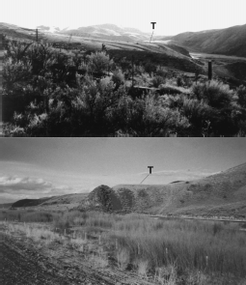
C
D

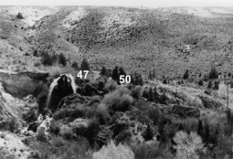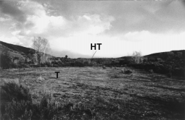River Canyon at Barretts (Fig. 2). No visible scarps were ob- served cutting this Late Pleistocene floodplain in spite of Ruppel's (1993) assertion that the Blacktail fault is active at Barretts. Stickney and Bartholomew (1987a, b) did map a prominent Late Quaternary fault scarp along the most of the Blacktail Range. This scarp can be traced for 24 km northeast from just northwest of the mouth of Sheep Creek (Fig. 2). A trench (Fig. 11) across this scarp at Cottonwood Creek (Fig. 1) showed no evidence of Holocene displacement (Stickney and others, 1987), although a small, 2 m high, 1-km-long Holocene or Late Pleistocene scarp was mapped across Bull Lake outwash ~1 km E of the trench within the basin. A reexamination of the 11-km-long portion of the inactive fault segment between Sheep Creek and Barretts by several of the authors in 1994 confirmed the absence of demon- strable Late Quaternary fault scarps here. Several narrow, dis- sected, bedrock pediments separated by escarpments are present between Barretts and Little Horn Canyon (Fig. 2), but we found no evidence of Late Quaternary scarps along either them or the range front. The escarpments bounding the pediments do project into the area where the steeper river gradient begins just upstream from Barretts.
A
B
The last surface rupture(s) of the main Blacktail fault of fset the contact between inferred Bull Lake outwash (characterized by dark reddish brown, clayey matrix) and the overlying mud- flow by ~6.5 m (Fig. 11) at Cottonwood Canyon which is ~29 km southeast of Barretts (Fig. 1). A thick colluvial wedge at the fault scarp is overlain by thick colluvium with a well-developed K horizon on the upthrown side of the fault. This Late Pleistocene
Figure 9. A- Photograph looking east at escarpment in Long Gulch tufa deposit at the mouth of Long Gulch. 47 & 50 are locations from which samples 47 & 50 were collected. B- Photograph looking east from near waterfall (Fig. 9A at tufa terrace (T from which sample 50 was collected; tufa terrace (HT in background is ~ .5 m higher. C- Photo- graph looking S from tufa sample-location 50 at an older well-preserved terrace with gravels. D- Photograph look- ing northeast from river level at the same terrace (T as Figure 9C. Eocene volcanic rock exposed beneath terrace.

colluvium is in turn overlain by a thick Holocene colluvium and soils on the downthrown side of the fault. The combined thick- ness of both colluvial deposits and the colluvial wedge suggests that the last significant displacement on the fault was near the Bull Lake to Pinedale transition (i.e., Sangamonian). Surface rup- ture at Barretts is inferred to have been even earlier inasmuch as the scarp does not extend that far northwest. Thus, the rate of movement on the main Blacktail fault is ~6.5 m/~120,000 years, or ~5.4 cm/1000 years, if the outwash represents the youngest Bull Lake estimated at ~120 ka (R. D. Hall, personal communi- cation, 1998). The rate would be less if the outwash were equiva- lent to one of the older Bull Lake glaciations.
A fault-displacement rate can also be estimated from the nearby Red Rock fault (Fig. 1) that had its last surface displace- ment ~3000 years ago. Its previous one occurred between depo- sition of the younger two Pinedale outwash fans (Bartholomew, 1989, his Figure 1A). Assuming that the older Pinedale outwash formed ~23 ka (age of major Pinedale advance per R. D. Hall, personal communication, 1998), then this fault has a rate of move- ment of ~2.6 m/~23,000 years or ~11.3 cm/1000 years. The rate would be less if the lower outwash were older. Based on these two estimates of fault-displacement rates, subsurface tilting along

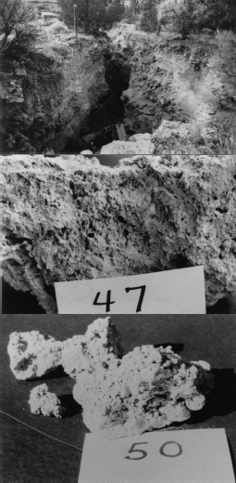
Figure 0. A- Photograph looking west at site where sample 50 was collected. B- Close-up of sample 47; length of card is
3 cm. C- Close-up of sample 50; length of card is 3 cm.

the Blacktail fault during the Late Quaternary could contribute to the steeper gradient at Barretts, but its contribution would be less than ~5-11 cm/1000 years.

Relative Rates of Change
Interaction of tectonic and denudation processes can be viewed from several hypothetical end-member processes which reflect the relative rates of block rotation and river incision for a block between normal faults such as the Blacktail and Red Rock faults. If the rate of tectonism (i.e. block rotation) was very high
relative to the river-incision rate, then the range front at Barretts should be rising and the Red Rock basin dropping rapidly. Along the uplifted part of the block (i.e., nearer Barretts) the river should be confined, terraces should be fewer and less extensive, unpaired, and at higher elevations (ARL) than equivalent-age terraces along the downdropped side of the block (nearer to Clark Canyon dam) where either deposition (rather than incision) or development of more extensive terraces associated with a wider valley could oc- cur. Thus, with sufficient time, the oldest terraces will become progressively more rotated and have lower slopes or even reverse slopes compared to the modern floodplain.
If the river-incision rate was very high relative to the rate of tectonism, then erosion would effectively wipe out minor tectonic adjustments (e.g., Schumm and others, 1987) given the ephem- eral nature of scarps (Pierce and Coleman, 1986; Pierce, 1988). The river valley should widen, and terraces should be extensive, perhaps paired, and more easily correlated by elevation ARL. Thus, with sufficient time, all correlative terrace levels ARL should have similar slopes to the modern floodplain and be more uni- formly distributed between Clark Canyon dam and Barretts based on the interaction of other factors such as reaches of resistant bedrock, sediment budgets (e.g., Howard, 1992), tributary-main river relationships (e.g., Seidel and Dietrich, 1992), and knickpoint propagation (Seidel and others, 1997).
If the rate of tectonism was highly variable, with periodic very high and low rates, then progressively older (and hence, rotated) terrace levels, representing alternating rates, should have vari- able gradients reflecting the two processes described above.
If the rate of river incision was highly variable (i.e. periods of higher discharge of late glacial runoff versus lower discharge during interstades) then rapid pulses of incisions related to early glacial intervals should be marked by abundant terraces versus fewer terraces during slower incision periods during interstades (e.g., Schumm and others, 1987).
As suggested above, very rapid rates of tectonism (block ro- tation) could produce lower or even reverse slopes on older ter- race levels. If lower gradients occur on older terrace levels within the Beaverhead River Canyon, then rotation might contribute sig- nificantly to the steeper gradient at Barretts. Conversely, if river- incision was much more rapid than rotation, then tectonism is less likely to contribute significantly to the steep gradient at Barretts. The rate of river-incision (~43 cm/1000 years) appears to be 4 to 8 times greater than the rate of tectonism (~5-11 cm/ 1000 years) based on the age of the tufa deposit and our estimates of the age and amount of the last surface rupture(s) along the main Blacktail fault. Moreover, the gradients of the different ter- race-levels do not vary systematically or differ significantly from the floodplain gradient. Thus, waning tectonism on the buried end of the Blacktail fault at Barretts is inferred to not be the ma- jor contribution to the steep gradient at Barretts.

CONCLUSIONS
Geographically scattered terraces within the Beaverhead River Canyon define three elevation-levels above the modern flood- plain where generally unpaired terraces are concentrated at ~11±3 m, ~34±8 m, and ~65±6 m with gradients sub-parallel to the flood-

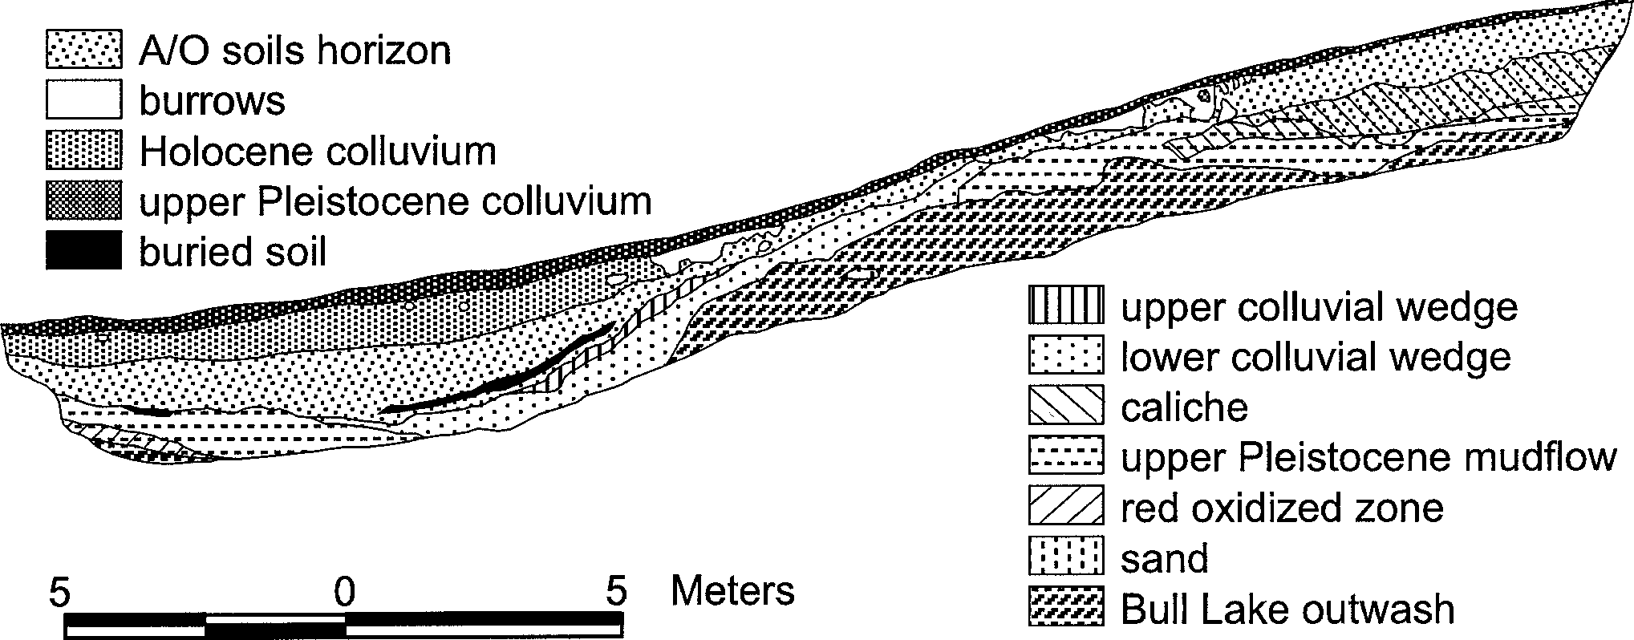

Figure . Trench log across the Blacktail fault at Cottonwood Creek, 29 km southeast of Barretts.

plain.
A calcareous tufa deposit at 39 m has a minimum age of 90 ka using the U-Th disequilibrium series.
Assuming an average incision rate of ~43 cm/1000 years based on this tufa minimum-age, then the ~11 m and ~65 m terrace levels are ~26 ka and ~150 ka, respectively.
The three terrace levels approximately correspond to a major Pinedale glaciation (~11 m), the Sangamon Interglaciation (~34
m) and the next to oldest Bull Lake glaciation (~65 m) of the Wind River Range. This is consistent with rapid incision and ter- race development during Pinedale and Bull Lake glaciation and less rapid incision during interglacial periods.
Fewer terraces occur above ~75 m. An incision-rate ~43 cm/ 1000 years yields an estimate of more than ~180 ka for high ter- races. The age of initiation of canyon incision is estimated at more than ~460 ka.
The Blacktail fault offsets Bull Lake outwash ~6.5 m at Cot- tonwood Canyon ~29 km southeast of Barretts. This 6.5 m offset probably occurred during the Sangamon. The fault has been qui- escent since then; although the very thin upper colluvial wedge may be related to minor movement when the nearby Holocene or Late Pleistocene scarp formed in the basin near Cottonwood Can- yon.
The displacement rate across the main Blacktail fault is ~5.4 cm/1000 years, only 13% of the average canyon-incision rate.
Based on the large difference between the incision rate and the fault-displacement rate as well as on the parallelism of terrace levels to the floodplain, uplift and rotation of the Blacktail Range relative to adjacent basins has not been as significant as fluvial processes in terrace development.
Landslides may also have been an important factor in localiz- ing terrace development within different stretches of the canyon at different times.

ACKNOWLEDGMENTS
We thank R.D. Hall, L.A. James, W.W. Locke and R. Torres for their thoughtful reviews. Their comments, particularly regard-
ing relationships of terrace development and incision relative to glaciation greatly improved this manuscript. R.D. Hall also kindly provided us with his latest estimates of ages of four Bull Lake glaciations from papers that are in press. Adel Dabous performed much of the analytical work done at Florida State University. Renee Greenwell and Jim Riesterer assisted with illustrations. This study was partially supported by a Montana Tech Research Center grant to S.E. Lewis and one to M.J. Bartholomew and M.C. Stickney.

REFERENCES CITED
Anders, M.H., Geissman, J.W., Piety, L.A., and Sullivan, J.T., 1989, Parabolic distribution of circumeastern Snake River Plain seismicity and latest Qua- ternary faulting: Migratory pattern and association with the Yellowstone hotspot: Journal of Geophysical Research, v. 94, p. 1589-1621.
Aram, R.B., 1979, Cenozoic geomorphic history relating to Lewis and Clark caverns, Montana [M.S. Thesis]: Bozeman, Montana State University, 149 p.
Bartholomew, M.J., 1988, Quaternary geology of basins associated with late Quaternary faults, southwestern Montana: Geological Society of America, Abstracts with Programs, v. 20, No. 7, p. 12-13.
Bartholomew, M.J., 1989, The Red Rock fault and complexly deformed struc- tures in the Tendoy and Four Eyes Canyon thrust sheets - examples of late Cenozoic and late Mesozoic deformation in southwestern Montana, in J.W. Sears, ed., Structure, Stratigraphy and Economic Geology of the Dillon Area: Tobacco Root Geological Society 14th Annual Field Conference - July 20-22, 1989: Northwest Geology, v. 18, p. 21-35.
Bartholomew, M.J., Stickney, M.C., and Wilde, E.M., 1990, Late Quaternary faults and seismicity in the Jefferson Basin, in R.D. Hall, ed., Quaternary Geology of the Western Madison Range, Madison Valley, Tobacco Root Range, and Jefferson Valley-Rocky Mountain Friends of the Pleistocene, August 15-19, 1990, Fieldtrip Guidebook: Department of Geology, Indiana University at Indianapolis, p. 238-244.
Bearzi, J.P., 1990, Late Cenozoic landscape evolution, lower Jack Creek, south- western Montana, in R.D. Hall, ed., Quaternary Geology of the Western Madison Range, Madison Valley, Tobacco Root Range, and Jefferson Val- ley-Rocky Mountain Friends of the Pleistocene, August 15-19, 1990, Fieldtrip Guidebook: Department of Geology, Indiana University at India- napolis, p.157-166.
Chadwick, O.A., Hall, R.D., and Phillips, F.M., 1997, Chronology of Pleistocene glacial advances in the central Rocky Mountains: Geological Society of America, Bulletin, v. 109, p. 1443-1452.
Chadwick, R.A., 1978, Geochronology of post-Eocene rhyolitic and basaltic volcanism in southwestern Montana: Isochron/West, No.22, p.25-28.

25 uide oo to the eolo y of astern daho

Chadwick, R.A., 1980, Radiometric ages of some Eocene volcanic rocks, south- western Montana: Isochron/West, No.27, p.11.
Derkey, P.D., and Bartholomew, M.J., 1988, Geologic map of the Ramsay quad- rangle, Silver Bow County, Montana: Montana Bureau of Mines and Geol- ogy, Geologic Map Series, No. 47 1:24,000-scale map with text .
Derkey, R.E., Watson, M., Bartholomew, M.J., Stickney, M.C., and Downey, P., 1993, Geologic map of the Deer Lodge area, Deer Lodge and Powell coun- ties, Montana: Montana Bureau of Mines and Geology, Open-File Report 271, 1:50,000-scale map with pamphlet text.
Hall, R.D., 1990, Quaternary geology of the Tobacco Root Range, in R.D. Hall, ed., Quaternary Geology of the Western Madison Range, Madison Valley, Tobacco Root Range, and Jefferson Valley-Rocky Mountain Friends of the Pleistocene, August 15-19, 1990, Fieldtrip Guidebook: Department of Geology, Indiana University at Indianapolis, p.183-193.
Hall, R.D., Garner, E.A., and Horn, L.L., 1990, A preliminary study of the gla- cial geology and soils of the South Meadow Creek and North Meadow Creek basins, Tobacco Root Range, in R.D. Hall, ed., Quaternary Geology of the Western Madison Range, Madison Valley, Tobacco Root Range, and Jefferson Valley-Rocky Mountain Friends of the Pleistocene, August 15-19, 1990, Fieldtrip Guidebook: Department of Geology, Indiana University at India- napolis, p.194-237.
Hanneman, D.L., and Wideman, C.J., 1991, Sequence stratigraphy of Cenozoic continental rocks, southwestern Montana: Geological Society of America, Bulletin, v. 103, p. 1335-1345.
Hildreth, G.D., 1980, The bedrock geology and stratigraphy of the Mississip- pian and Early Pennsylvanian rocks of the southeast flank, Armstead anti- cline, Beaverhead County, Montana [M.S. Thesis]: Corvallis, Oregon State University, 144p.
Howard, A.D., 1992, Modeling channel migration and floodplain sedimentation in meandering streams, in Carling, P.A., and Petts, G.E., eds., Lowland Flood- plain Rivers: Geomorphological Perspectives: John Wiley & Sons Ltd., New York, NY, p. 1-41.
Lemke, R.W., Mudge, M.R., Wilcox, R.E., and Powers, H.A., 1975, Geologic setting of the Glacier Peak and Mazama ash-bed markers in west-central Montana: U.S. Geological Survey, Bulletin 1395-H, p. H1-H31.
Locke, W.W., and Schneider, N.P., 1990, General geology and geomorphology of the Madison Range and Valley, southwest Montana, in R.D. Hall, ed., Quaternary Geology of the Western Madison Range, Madison Valley, To- bacco Root Range, and Jefferson Valley-Rocky Mountain Friends of the Pleistocene, August 15-19, 1990, Fieldtrip Guidebook: Department of Ge- ology, Indiana University at Indianapolis, p.1-23.
Lundstrom, S., 1990, Beaver Creek moraine and Late Pleistocene geomorphol- ogy and stratigraphy of the southern Madison Valley, in R.D. Hall, ed., Qua- ternary Geology of the Western Madison Range, Madison Valley, Tobacco Root Range, and Jefferson Valley--Rocky Mountain Friends of the Pleis- tocene, August 15-19, 1990, Fieldtrip Guidebook: Department of Geology, Indiana University at Indianapolis, p.112-125.
Pierce, K.L., 1988, History of Quaternary faulting and scarp degradation stud- ies, southern Lost River Valley, in P.K. Link, P.K., and W.R. Hackett, eds., Guidebook to Geology of Central and Southern Idaho, Part E.: Idaho Geo- logical Survey, Bulletin 27, p.233-240.
Pierce, K.L., and Coleman, S.M., 1986, Effect of height and orientations mi- croclimate on geomorphic degradation rates and processes, late-glacial ter- race scarps in central Idaho: Geological Society of America Bulletin, v.97, p.869-885.
Ouchi, S., 1983, Response of alluvial rivers to slow active tectonics [Ph.D. Dis- sertation]: Fort Collins, Colorado State University, 205 p.
Reynolds, M.W., 1979, Character and extent of basin-range faulting, western Montana and east-central Idaho: 1979 Basin and Range Symposium, Rocky Mountain Association of Geology and Utah Geological Association, p.185- 193.
Rich, J.L., 1914, Certain types of stream valleys and their meaning: Journal of Geology, v. 22, p. 469-497.
Ruppel, E.T., 1993, Cenozoic tectonic evolution of southwest Montana and east- central Idaho: Montana Bureau of Mines & Geology, Memoir 65, 62p.
Russell, G.S., and Lewis, S.E., 1989, Distribution of Late Quaternary Deposits along a Portion of the Beaverhead River, Southwestern Montana: Geologi- cal Society America, Abstracts with Programs, v. 21, no. 5, p. 106.
Schneider, N.P., 1990a, Terrace morphology of the central Madison Valley, in
R.D. Hall, ed., Quaternary Geology of the Western Madison Range, Madi- son Valley, Tobacco Root Range, and Jefferson Valley-Rocky Mountain
Friends of the Pleistocene, August 15-19, 1990, Fieldtrip Guidebook: De- partment of Geology, Indiana University at Indianapolis, p.24-57.
Schneider, N.P., 1990b, Four-dimensional segmentation of the Madison Range and Valley, southwest Montana, in R.D. Hall, ed., Quaternary Geology of the Western Madison Range, Madison Valley, Tobacco Root Range, and Jefferson Valley-Rocky Mountain Friends of the Pleistocene, August 15-19, 1990, Fieldtrip Guidebook: Department of Geology, Indiana University at Indianapolis, p.58-88.
Schumm, S.A., Mosley, M.P., and Weaver, W.E., 1987, Experimental Fluvial Geomorphology: John Wiley & Sons, New York, NY, 413 p.
Seidel, M.A., and Dietrich, W.E., 1992, The problem of channel erosion into bedrock, in K.H. Schmidt and J. de Ploey, eds., Functional Geomorphology; Landform Analysis and Models: Catena Supplement 23, p. 101-124.
Seidel, M.A., Finkel, R.C., Caffee, M.W., Hudson, G.B., and Dietrich, W.E., 1997, Cosmogenic isotope analyses applied to river longitudinal profile evo- lution: Problems and interpretations: Earth Surface Processes and Land- forms, v. 22, p.195-209.
Stein, R.S., and Barrientos, S.E., 1985, Planar high-angle faulting in the Basin and Range: Geodetic analysis of the 1983 Borah Peak, Idaho, earthquake: Journal of Geophysical Research, v. 90, no.3, p.1 1355-11366.
Stickney, M.C., and Bartholomew, M.J., 1987a, Preliminary map of late Quater- nary faults in western Montana: Montana Bureau of Mines and Geology, Open-file Report 186, 1:500,000-scale map.
Stickney, M.C., and Bartholomew, M.J., 1987b, Seismicity and Quaternary fault- ing of the northern basin and range province, Montana and Idaho: Bulletin of the Seismological Society of America, v. 77, No. 5, p. 1602-1625.
Stickney, M.C., Bartholomew, M.J., and Wilde, E.M., 1987, Trench logs across the Red Rock, Blacktail, Lima Reservoir, Georgia Gulch Vendome and Di- vide faults: Geological Society of America, Abstracts with Programs, v. 19, No. 5, p. 336-337.
Witkind, I.J., 1964, Reactivated faults north of Hebgen Lake, in The Hebgen Lake, Montana earthquake of August 17, 1959: U.S. Geological Survey, Professional Paper 435, p. 37-50.

