Fluvial Terraces along the Middle Fork Salmon River, Idaho, and their Relation to Glaciation, Landslide Dams, and Incision Rates: A Preliminary Analysis and River-mile Guide

Grant A. Meyer
Geology Department, Middlebury College, Middlebury, VT 05753

Matt E. Leidecker
Geology Department, Middlebury College, Middlebury, VT 05753

ABSTRACT
The Middle Fork of the Salmon River drains a mountainous basin in central Idaho that has no major tectonic escarpments. Despite little overt evidence of late Cenozoic uplift, relief is high in this region, with glaciated highlands rising up to 7000 ft above narrow river valleys. The Middle Fork has cut a deep canyon into resistant granitic rocks and gneiss, where a well-preserved ter- race sequence records its middle Pleistocene to Holocene fluvial dynamics and incision history. We have measured the height of most of the higher terrace treads (> 70 ft above the river) and a number of the lower ones. The more numerous lower treads are associated with last-glacial fill terraces and erosional terraces cut during subsequent rapid incision. Major fills form most of the higher terraces and are probably produced largely by episodic glacial and periglacial sediment influxes. The highest terrace treads consistently lie near 370 ft, indicating approximately uniform long- term incision along the river. Using preliminary weathering rind thickness data from basaltic clasts and correlated glacial ages for fill terraces, we limit the long-term incision rate to between 0.3 and 1.0 ft/1000 yr (0.09-0.29 m/kyr); thus, the highest terraces are between 0.4 and 1.1 million years old. The most reasonable correlations suggest that the average incision rate is between 0.39 and 0.54 ft/1000 yr (0.12-0.16 m/kyr).
The lower river was dammed by rock avalanches ~14,500 and 1800 calendar years ago, forming temporary lakes that accu- mulated fine sediments. We suspect that remnants of the 1800 yr old dam form one of the most difficult rapids on the river at Mile
13.2. Landslide dams are probably common events in the Quater- nary evolution of the Middle Fork canyon, where the narrow val- ley floor is readily blocked by erosion-resistant bouldery debris.
Key Words: Salmon River, fluvial terrace, Quaternary, incision rate, glaciation, landslide-dammed lake, weathering rind.

INTRODUCTION
From its inception at the confluence of Marsh and Bear Val- ley Creeks to the Main Salmon River, the Middle Fork of the Salmon River flows ~105 miles northeastward through the un- broken Salmon River Mountains of central Idaho (Figs. 1, 2). The river occupies a narrow, V-shaped valley in moderately to highly resistant plutonic and metamorphic rocks. Relief on river canyon slopes is over 3000 ft along upper reaches, and is com- monly 5000 ft or more in the "Impassable Canyon" below Big Creek. The river flows predominantly over thin alluvium or bed- rock, with a few short alluvial reaches where the canyon is broad- est. Despite its dominantly bedrock-confined valley, the Middle Fork has a well-preserved sequence of terraces marking former river levels along much of its length (Fig. 3).
In general, summit elevations in the Middle Fork basin lie between 8500 and 10,000 ft and rise toward the east (Fig. 1). Pleistocene glaciation thresholds also ascend eastward from about 7800 to 9200 ft, probably because airmasses moving inland from the Pacific progressively lose moisture across the broad central Idaho highlands (Porter et al., 1983). Geomorphic evidence shows that glaciers extended down many tributaries, but ice apparently reached the Middle Fork mainstem only in the valleys of Sulphur Creek and smaller tributaries upstream. Numerous moraine loops are preserved at the unusually broad mouth of the Sulphur Creek valley. We give deposits comprising these moraines the informal name of Sulphur Creek till. An older probable glacial deposit, herein named Dagger Falls till, lies outside of these moraines just

Meyer, G.A., and Leidecker, M.E., 1999, Pluvial terraces along the Middle Pork Salmon River, Idaho, and their relation to glaciation, landslide dams, and incis ion rates: A preliminary analysis and river-mile guide, in Hughes, S.S., and Thackray, G.D., eds., Guidebook to the Geology of Eastern Idaho: Pocatello, Idaho Museum of Natural History, p. 219-235.

22 uide ook to the eology o astern daho

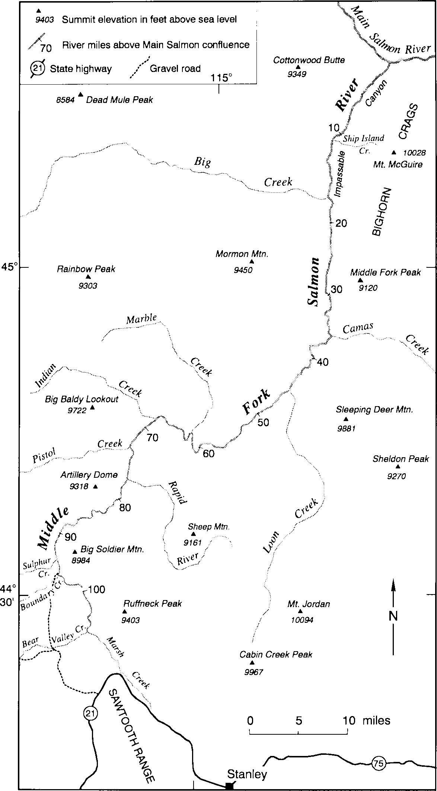
south of Boundary Creek. The Middle Fork terraces thus pro- vide an opportunity to investigate fluvial adjustments to gla- cial-interglacial hydrologic and sediment load changes in a bedrock-confined fluvial system.
Although active Basin-and-Range style faulting broadly surrounds the Middle Fork basin, major Quaternary fault es- carpments are lacking within the basin (Fig. 2). Therefore, potential tectonic influences on fluvial behavior are limited to broad-scale elevation changes and more distant tectonism affecting base level. The deep, narrow river canyon suggests rapid incision, which may be driven by regional uplift, base level changes, high-order stream captures, major late Ceno- zoic climate change, or a combination of these factors.
The Middle Fork terraces are primarily aggradational in origin (i.e., fill terraces; Bull, 1991). Day et al. (1972) and Moye (1995) infer that fill gravels underlying high terraces on the Salmon River system are 250 ft (76 m) or more thick. In contrast, we find that wherever underlying bedrock strath surfaces are exposed, fill deposits are < 30 ft (9 m) thick. On many terraces, fluvial gravel eroding from the overlying ter- race deposit mantles the bedrock scarp, giving the deceptive appearance of a thicker fill. Strath surfaces with little or no gravel cover form terraces locally. Our efforts to define the height, correlation, and age of Middle Fork terraces in this paper are early steps toward understanding the geomorphic evolution of the Salmon River fluvial system in light of cli- matic and tectonic influences.
The Middle Fork is a central corridor within the Frank Church-River of No Return Wilderness, and is accessible by road only at the Boundary Creek launch site and at the Main Salmon River confluence. Little prior research has been con- ducted on the Quaternary geology and fluvial history of this remote region. Williams (1961), Day et al. (1972), and Harrold and Dort (1987) have described terraces along the more accessible Main Salmon River. By correlation only, Harrold and Dort (1987) assigned an early Pleistocene age to terrace treads at 90-144 m (295-472 ft) above the river between Stanley and Challis (Fig. 1). They correlated 14-42 m (46-138 ft) terraces to Bull Lake and Pinedale glacial de- posits mapped by Williams (1961) in Stanley Basin, and in- ferred that terrace treads 2-12 m (7-40 ft) above the river are fill-cut surfaces post-dating ~6700 yr B.P. Mazama ash.

METHODS
Because topographic maps and river guidebooks for the Middle Fork use the English system of units, we maintain this usage for convenient navigation by river-borne geologists (ex- cept for mm-scale measurements). For age abbreviations, we use "yr B.P." to designate 14C-year ages and "ka" for approximate ages in thousands of years (Colman et al. 1987); "cal ka" indi- cates approximate ages in thousands of calendar years before 1950, derived from 14C ages using the calibration curve of Stuiver and Reimer (1993).
We measured the height of terrace treads above river high- water (bankfull) level, as approximated by debris lines, fluvial deposits, vegetation changes, and the base of cutbanks. For effi- ciency in this paper, terrace height refers to the vertical distance

Figure I. Map of the Middle Fork Salmon River area including major tributaries and selected localities mentioned in the text. See Fig- ure 2 for general location.

of the tread above bankfull level unless otherwise stated. Terrace height was measured by closed traverses with a surveying altim- eter and corrected for temperature and pressure changes. Hand- level measurements were also made of many lower terrace heights. Uncertainty in height results from assuming that pressure changes are linear over altimeter traverse periods, random error in hand- level measurements, and variations in bankfull level indicators, including local hydraulic factors causing differing stage-discharge relationships along the river. We estimate that most height mea- surements are accurate to better than ±15 ft, with greater accu-

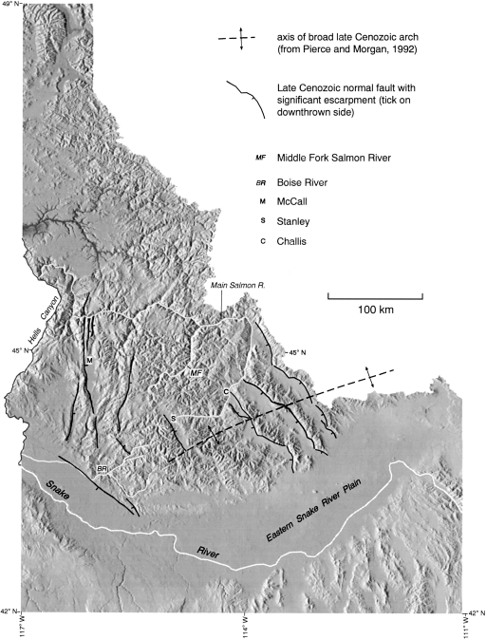

Figure 2. Digital shaded relief map of Idaho (from Chalk Butte Inc., I994) showing the location of the Middle Fork of the Salmon River (MF), selected late Cenozoic tectonic elements, and other features mentioned in the text.

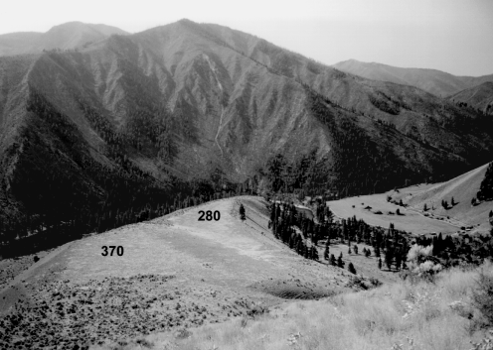
Figure 3. View to the south of high terraces at ~370 and 280 ft inside the large bend near Thomas Creek (Mile 60.6; Fig. 4), which enters from the right. The river flows from right to left. Across the river and just upstream of Thomas Creek are last-glacial and postglacial terraces at < 70 ft; (open flats at center right). A narrow failure scar and de- bris-flow track runs down Scarface Mountain at center.

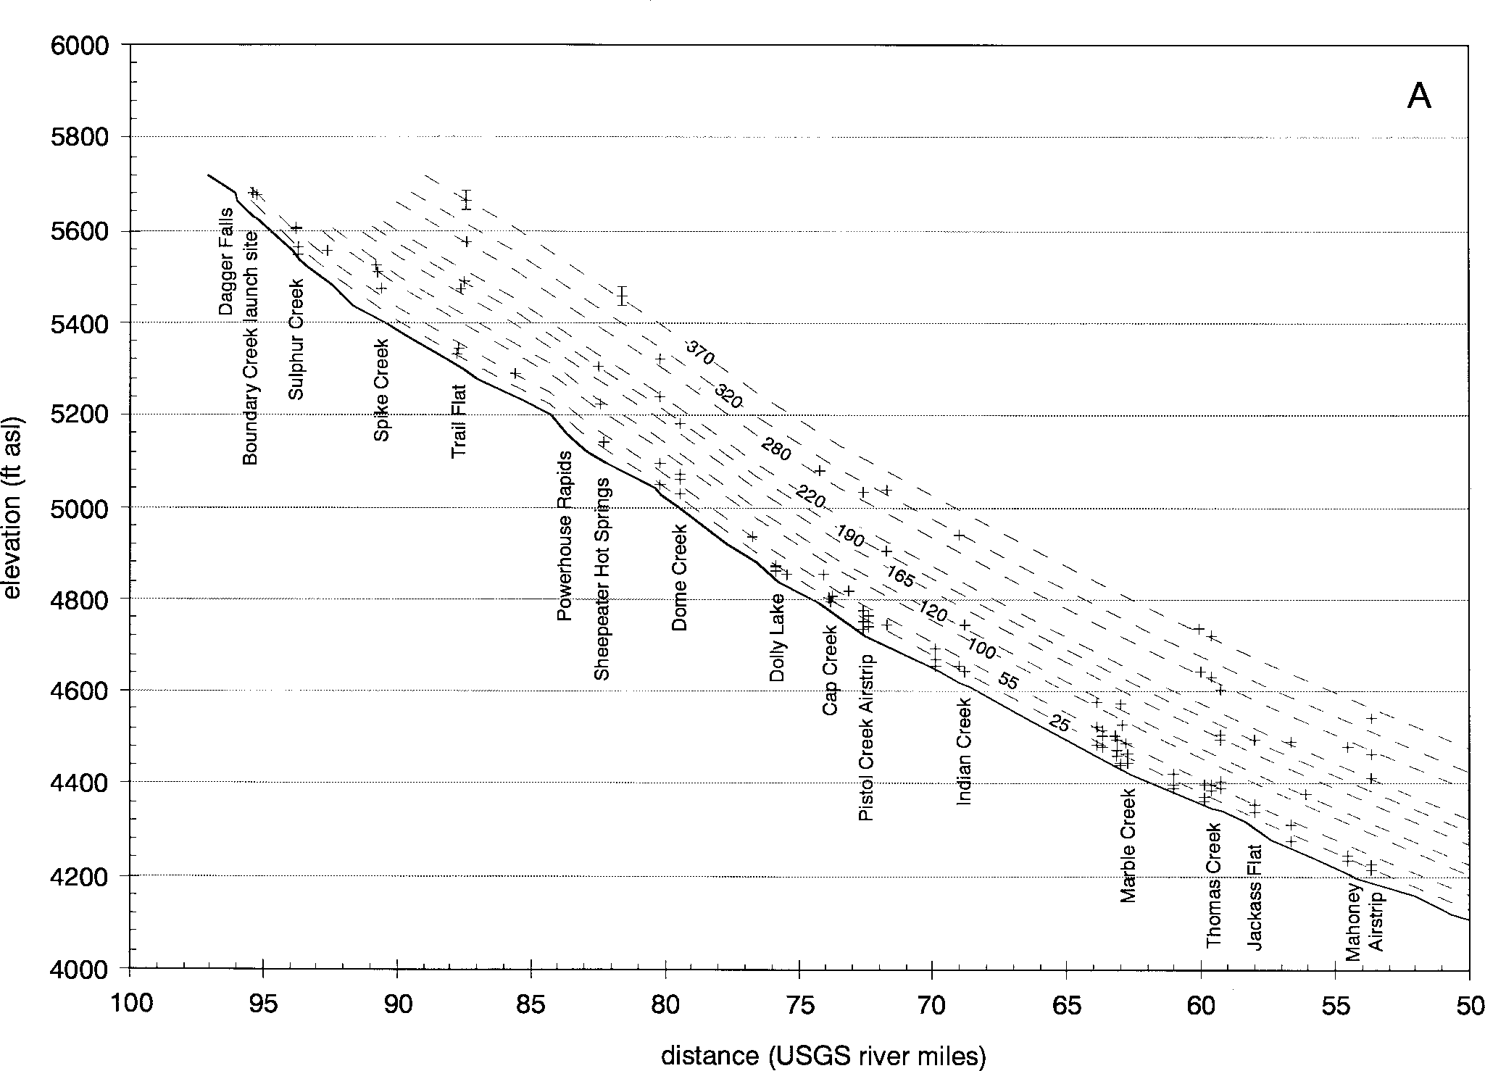
Figure 4. Longitudinal profile of the Middle Fork Salmon River and surveyed terrace elevations (+ symbol) plotted against distance upstream from the Main Salmon River confluence; A, Mile I00-50; B, Mile 50-0. Vertical lines in + symbols show the approximate average u ncer- tainty in terrace elevations of ±I0 ft. Symbols with capped error bars represent elevations and range of uncertainty estimated from topo- graphic maps for inferred terraces. Dashed lines represent average elevations for major terrace groups as presently correlated, with past river profiles roughly parallel to present, and labeled with approximate height above the present river.

racy for lower terraces. Terrace elevations in feet above sea level were obtained by adding terrace tread heights to river surface elevations interpolated from topographic maps.
In order to view terrace long profiles, we plotted terrace el- evations as a function of distance upstream from the Main Salmon River confluence (Fig.4). Distance was determined in river miles (channel length) as shown on U.S.G.S. 7.5' topographic maps. Terrace locations were projected perpendicular to the Middle Fork channel to determine river-mile distance. Past river courses clearly differed from present, allowing preservation of terraces, but the narrow Middle Fork canyon limits lateral channel changes, so resulting distortions in profiles are relatively small.
We made preliminary age estimates for Middle Fork terraces and glacial moraines near Sulphur Creek using weathering rinds on basaltic cobbles, as were used by Colman and Pierce (1986) to derive age estimates for glacial moraines near McCall, Idaho (Fig. 2). Most basaltic clasts in the terrace gravels derive from diabase or lamprophyre dikes of Challis Volcanic affinity (Fisher et al., 1992; Moye, 1995) and are typically coarser grained and less glassy than the Columbia River basalts at McCall. Texture of measured Middle Fork clasts ranged from very fine-grained phaneritic to entirely aphanitic, some with a minor percentage of small phenocrysts; coarser clasts were rejected.
Colman and Pierce (1981, 1986) indicate that weathering rinds are thickest in upper soil B horizons, and that stones from this depth yield the most consistent and representative weathering rinds. Because of the relative scarcity of basaltic cobbles and wilderness regulations, sampling from excavations was not fea-
sible. Instead, we sampled where B horizons were exposed in upper terrace scarps and from the terrace tread. Rind measure- ments were made with a 7x hand-held comparator to the nearest
0.1 mm. In sampling from scarps, clasts with little or no rind de- velopment were encountered that likely derived from unoxidized C horizons, even on higher, older terraces. Therefore, only rind thicknesses of 0.1 mm and greater were measured. Uneven rinds suggestive of erosion and those with irregular, reddish gray inner rinds were not measured (Colman and Pierce, 1981). Rinds were measured at 30 sites representing the range of terrace heights.
On moraines in the Sulphur-Boundary Creek area, we (1) sampled basaltic clasts for weathering rinds, and (2) measured maximum distal slope angles (averaged over distances of 2-3 m) and associated slope heights by clinometer and hand level. Distal slope data were found to be among the most useful for differenti- ating moraine ages at McCall (Colman and Pierce, 1986).

RESULTS AND INTERPRETATIONS

Terrace Profiles and Correlations
The maximum height of terrace treads along the Middle Fork is quite consistent at about 370 ft above bankfull level (Figs. 3, 4). Several prominent, well-preserved fill terrace treads at this level were mapped between Miles 60 and 18, and we observed no field evidence of major relative age differences between these terraces. Two probable 370 ft terraces exist between Miles 80 and 90. We identified very few possible older terrace remnants, all much higher than 370 ft and deeply eroded (e.g., Mile 33.5, River-Mile Guide). For these reasons, we tentatively assume that

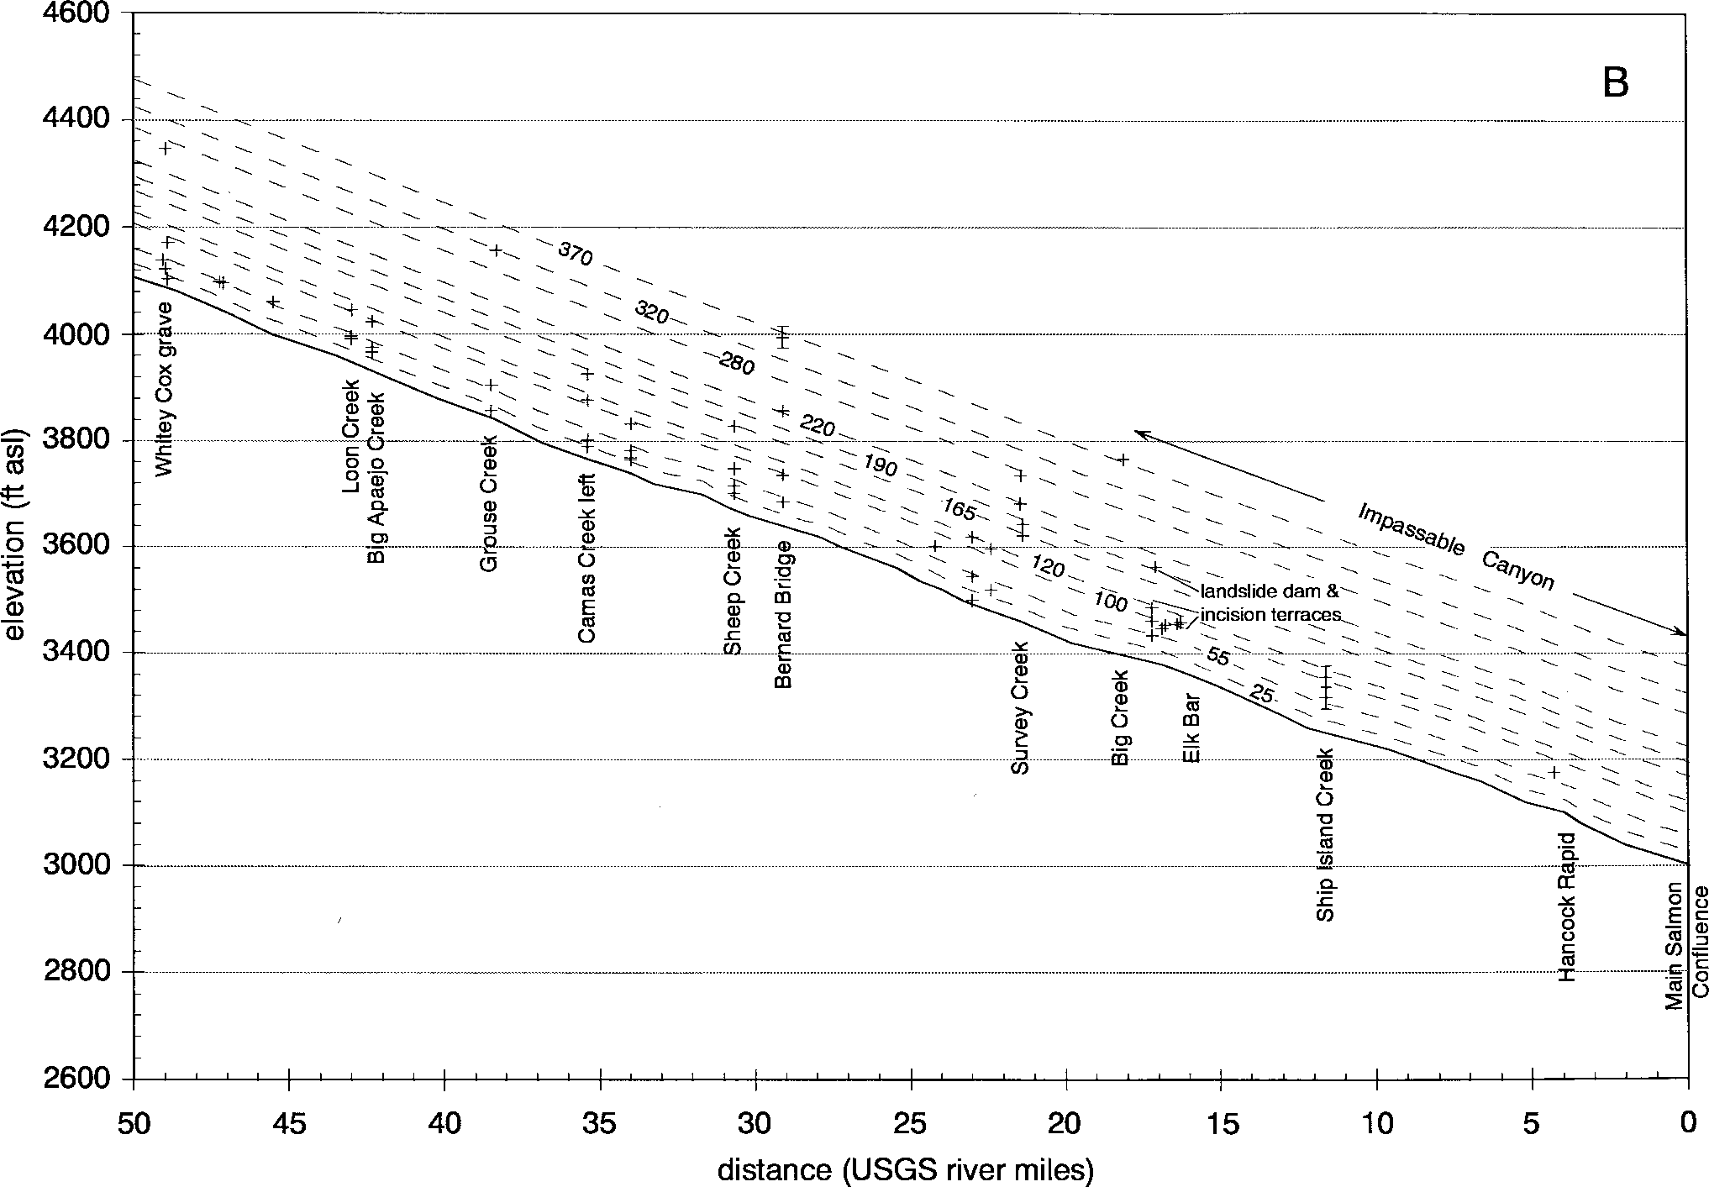

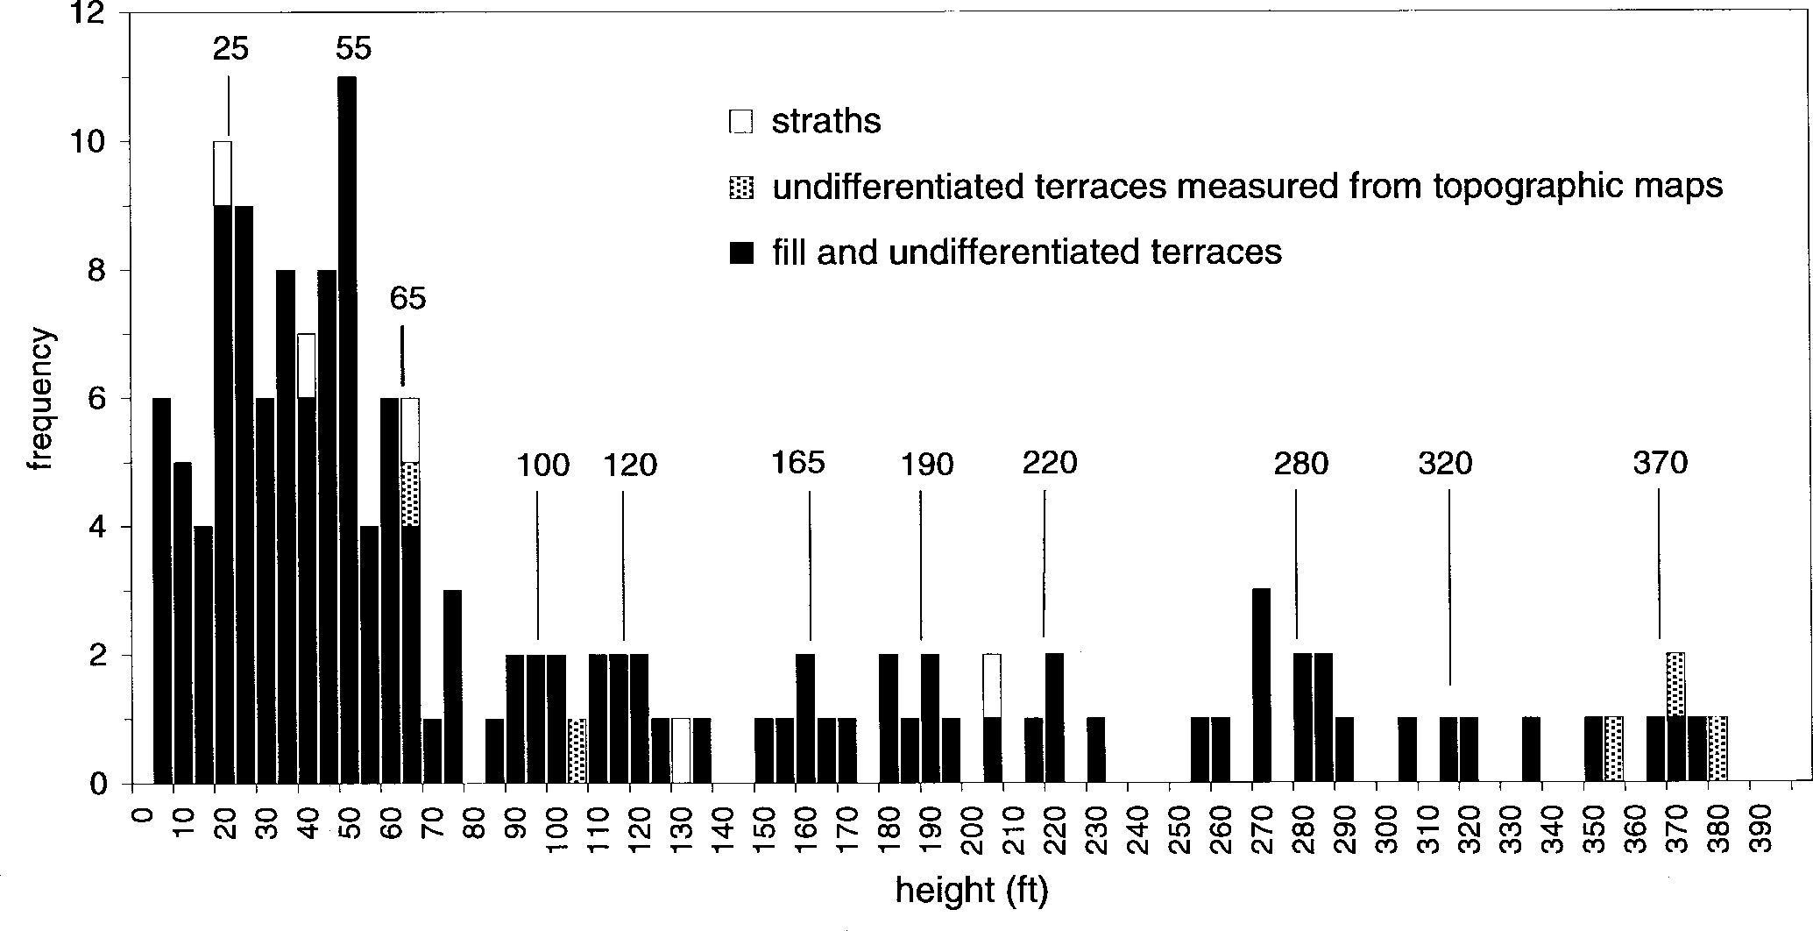
Figure 5. Histogram of measured terrace tread and strath heights on the Middle Fork Salmon River, grouped by 5 ft intervals.
Preliminary terrace height groups are indicated by values in feet above bars.

the ~370 ft terraces are correlative in age. Approximately paral- lel profiles for the highest terraces and the modern river imply that long-term incision rates were similar along the length of the river. They also imply that, as a irst approximation, other ter- races can be correlated by height. We therefore plotted a histo- gram of terrace tread heights, which shows numerous terraces between 20 and 70 ft in height. Higher terraces group approxi- mately at 100, 120, 165, 190, 220, 280, 320, and 370 ft (Fig. 5).
Fill terraces at 50-70 ft grade directly to moraines and outwash channels of probable last-glacial age near the mouth of Sulphur Creek (see discussion of moraines below). The much higher fre- quency of treads at < 70 ft reflects greater preservation of ter- races formed by this last major period of aggradation, and fill-cut and strath terraces formed during subsequent late-glacial and postglacial reincision.
As a working hypothesis, we infer that major fill terraces also generally correlate to glacial episodes in the Middle Fork basin. In addition to proximal glacial sediment sources in many tribu- taries, reduced forest cover and periglacial processes probably increased sediment flux from steep valley sides (Pierce and Scott, 1982). In Rocky Mountain intermontane basins, most rivers formed fill terraces during glacial episodes, typically with greater aggradation on upper reaches closer to glacial sediment sources (e.g., Ritter, 1967; Moss, 1974; Palmquist, 1983; Reheis et al., 1991; Chadwick et al., 1994). In contrast, both glacial and periglacial sediment sources are present along the entire length of the Middle Fork. Although perhaps greater along upper reaches, this ubiquitous sediment supply likely produced more uniform aggradation along the river.
Hydrologic changes are more difficult to reconstruct but may be important in terrace genesis. Through analysis of paleoequilibrium line altitudes, Locke (1990) inferred that pre- cipitation decreased substantially during glacial episodes over most of the central Rocky Mountains. Drier climates may pro-
mote aggradation by reduced average runoff. Rapid melting or glacial outburst floods, however, may enhance peak discharges. In contrast to glacial conditions, the present Middle Fork chan-
nel is floored by bedrock in many areas. Broad planar strath sur- faces are visible through the clear water, often cut by slot-like inner channels. These observations indicate that sufficient power is available to transport nearly all bedload supplied, and the cur- rent river is probably actively downcutting through bedrock. Greater in-channel sediment storage occurs in broader channel reaches and at many tributary mouths where coarse sediment in- put occurs by debris flows and flash floods (e.g., Sulphur Slide Rapid at Mile 92.6).

Lake Sediments and Landslide Dams
Unusually thick and well-stratified fine-grained sediments underlie some terrace treads in the general area of the Big Creek confluence (Fig. 1). Exposures of these sediments have been cre- ated through digging and gnawing by bighorn sheep ( Ovis canadensis). At these "sheep licks", the animals are targeting and consuming 1 to 20 mm thick layers of fine calcium carbonate- rich sediment that we interpret as biogenic marls. The marls are apparently a good source of calcium in this carbonate rock-poor region.
One "sheep lick" exposure is on the west bank at Mile 22.4,
~0.7 miles downstream of Wilson Creek. The lower section is a typical fluvial sequence consisting of sorted and rounded gravel (with unexposed base), capped by a thin well-sorted sand with top about 35 ft above bankfull level. Sharply overlying the river deposits are 46 ft of laminated to thin-bedded silty to fine sandy sediments that coarsen upward overall and contain thin marls (Fig. 6). Many graded beds 0.03-0.3 ft (1 to 10 cm) thick are present, often grouped in 0.3-1 ft (10-30 cm) thick upward-fining se- quences. Some sequences are capped by brown clay-rich lami-

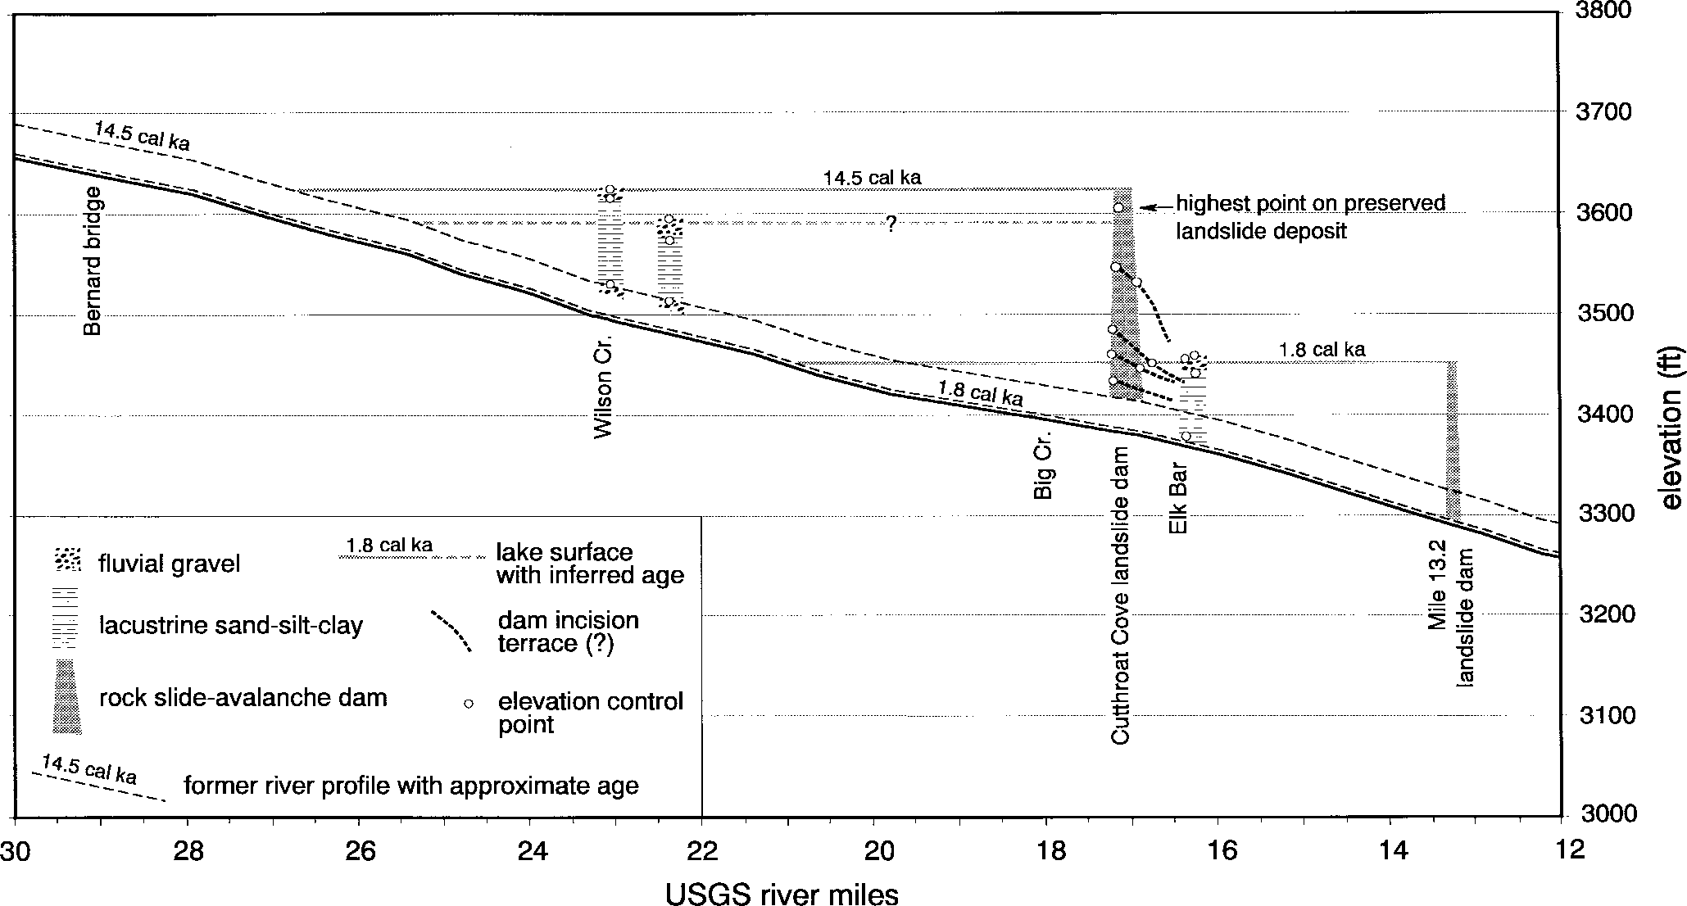

Figure 6. Plot of lake sediments and landslide dams in the Big Creek area. Current river profile and former river profiles prior to damming events at about I4,500 and I800 yr ago are shown.
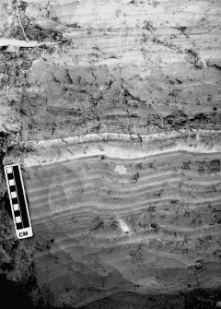
nae, and some sandy lower beds show climbing ripple structures (Fig. 7). Marls make up a small fraction of the sediment volume, and typically lie near the top of these upward-fining sequences (Fig. 7). The fine sediments are overlain by 49 ft of relatively well-sorted sediment that also generally coarsens upward from medium sand to coarse cobble gravel. The gravel cap forms a terrace tread about 130 ft above bankfull level. A similar section was described on the west bank at Mile 23.1, just below the Wil- son Creek confluence. Again, a sharp contact between fluvial deposits and overlying well-stratified fine sediments lies about 35 ft above bankfull level (Fig. 6). Poorly preserved terraces in the Grassy Flat area between these two exposures are probably also underlain by erodible silty sediments.
We infer that the fine sediments in these stratigraphic sections accumulated in a stable and sometimes seasonally productive lake
- which requires a damming event (Fig. 6). Fluvial gravels be- neath the fine lacustrine sediments represent the river channel just prior to damming, which was ~35 ft above its current level. The upward-coarsening upper sections probably represent del- taic foreset and topset beds prograding into the narrow lake from the river above. Current structures in the fine-grained bottomset facies may reflect density currents produced by sediment-laden streamflows entering the lake, or by failures of the delta slope. Similar stratigraphic sequences are interpreted for lava-dammed lakes in the Grand Canyon (Hamblin, 1994) and landslide-dammed lakes on the Rio Grande (Reneau and Dethier, 1996).
At Mile 22.4, a 20 mm-thick marl within the upper silty se- quence that showed no evidence of solution and reprecipitation

was sampled for AMS 14C dating. Only a few thin marble units exist within the Middle Fork basin, therefore serious contamina- tion by old carbon is unlikely. The marl yielded an age of 12,385±85 yr B.P. (AA-21969)(14.5 cal ka), which also gives a
Figure 7. Fine-grained sediments of the I4.5 cal ka landslide-
dammed lake at Mile 23.I. A light-colored marly lamina is present near top of scale. Note ripple structures in bottom half of photo.

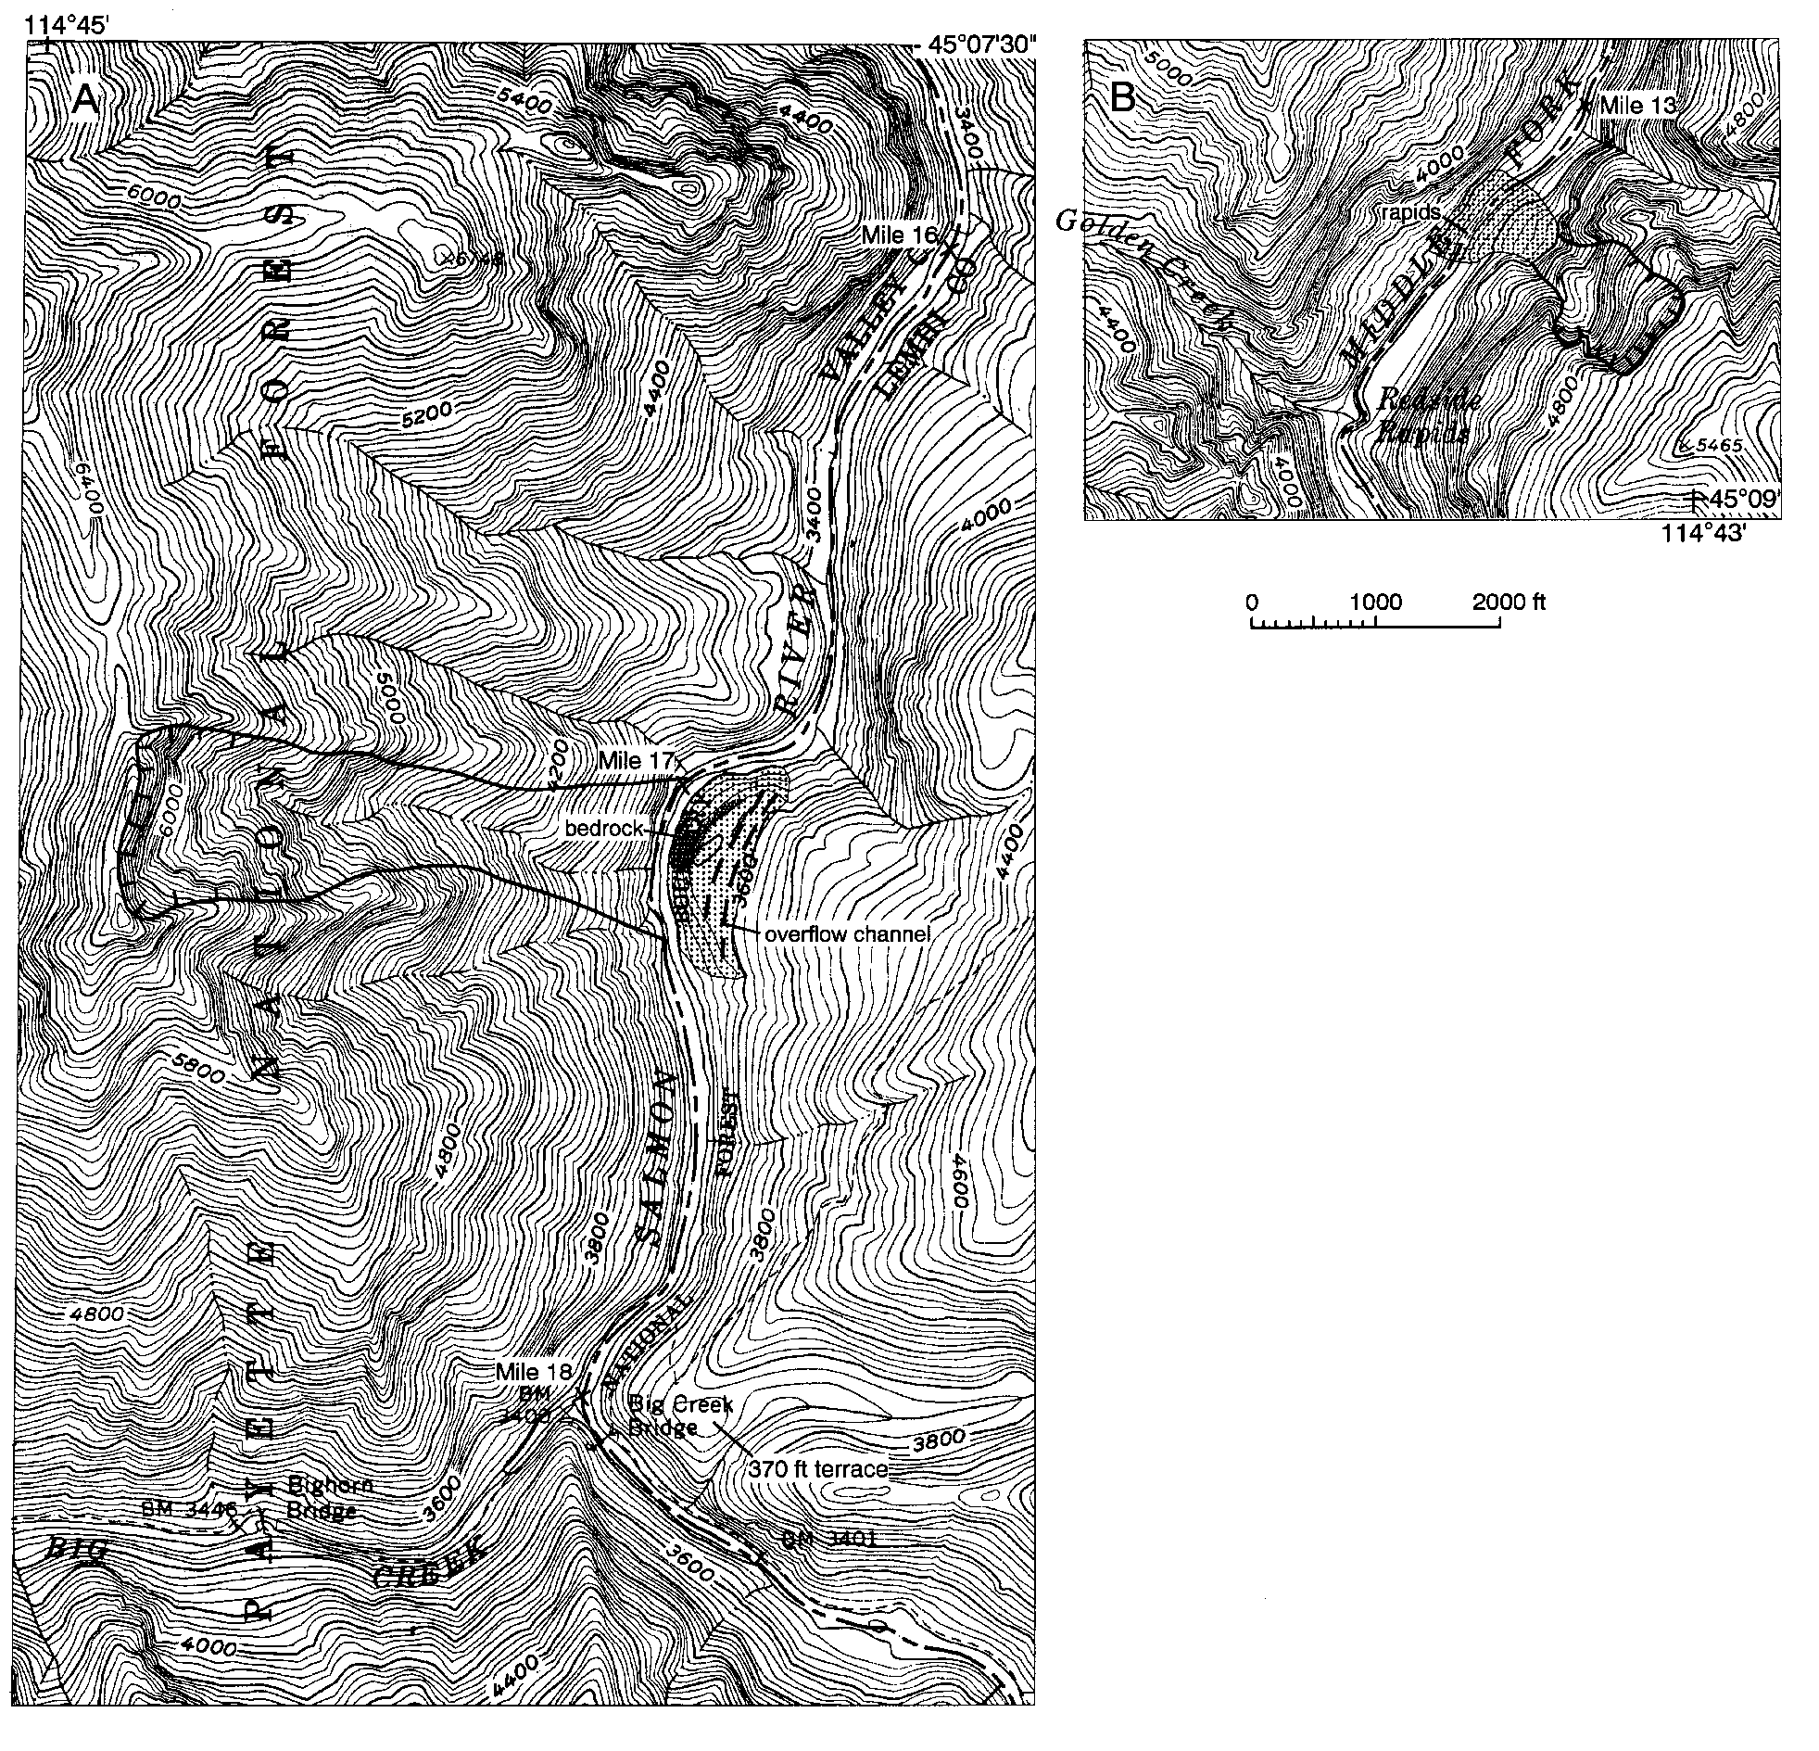
Figure 8. Maps of inferred rock slide-rock avalanche areas and associated landslide dams at A, Mile I7 (Cutthroat Cove), and B, Mile I3.2. Hachures show headscarp area, the slide path is outlined, and the deposit area is stippled.

close minimum age for the underlying ~33 ft river level.
Although late Quaternary glaciers extended down Ship Island Creek and other drainages from the Bighorn Crags (Fig. 1), V- shaped lower valleys below probable moraines indicate that ice did not reach the low elevation of the river to cause damming. A much more likely source for a natural dam is a major rock slide or rock avalanche from the steep canyon wall. A probable land- slide dam for the 14.5 cal ka lake is located near Cutthroat Cove (Mile 17.0), where a prominent 600 ft headscarp in granodiorite and slide path with over 3000 ft of relief is apparent on the west canyon wall (Figure 8A). Alarge, irregular boulder deposit mantles bedrock on the east side of the river. It has fluvial channels on its upper surface, and the highest point on the deposit is at nearly the same elevation as the gravelly top of the lake-sediment section at Mile 23.1 (Fig. 6). The present river profile shows a slight hump centered at Mile 17 that may be a remnant of the landslide dam (Figs. 4A, 6).
Fine-grained lake sediments are also exposed in sheep licks across from Elk Bar at Mile 16.3 (Fig. 6). Unlike upstream sec-
above bankfull sand gives evi- 0s of years, if ft thick rep- ments are over- above bankfull
.8 cal ka), con- ming event that
tions, the base of these sediments is only about 10 ft level. About 65 ft of laminated to bedded silt and dence of a lake persisting for perhaps 10s to 10 upward-fining clay-capped sequences typically < 1-2 resent annual accumulations (Fig. 6). These sedi lain by about 15 ft of coarse gravel. A marl at 44 ft level was dated at 1865±45 yr B.P. (AA-21970) (1 sistent with a second, late Holocene landslide-dam occurred when river level was only slightly above
A tentative location for a 1.8 cal ka landslide conical boulder deposit on the east side of the riv (Fig. 8B). Above the deposit is a ~1500 ft high sl very steep headwall scarp in granodiorite. Directl cult "rock garden" rapid with numerous boulders > eter is likely a remnant of the rock slide deposit (see Guide). The lower part of the deposit is steepene sion, and the break in slope at the top of this steep 3450 ft elevation, indicating an approximate outl
present.
dam is a large er at Mile 13.2 ide path and a y below, a diffi- 10 ft in diam-
River-Mile d by river ero- face is at about et level. Grav-
elly terraces upstream near Elk Bar lie at a similar elevation and probably represent delta surfaces that prograded over the fine deep-water lake sediments (Fig. 6). If the dam and outlet level are correctly located, incision of the dam over the last 1800 yr averaged about 90 ft/1000 yr (27.4 m/kyr); in actuality, the dam was likely downcut over a significantly shorter period.

Moraines in the Sulphur-Boundary Creek Area
Because of the association of moraines and fluvial outwash terraces, we made a reconnaissance study of glacial deposits in the area of lower Sulphur and Boundary Creeks (Fig. 1). Mo- raines at the mouth of Sulphur Creek are well preserved, with relatively sharp crests and high surface boulder frequency, and are clearly associated with ice flowing down the Sulphur Creek valley (Fig. 9). The outermost moraines show that during the maximum advance, a small tongue of ice flowed over the low south ridge into the Boundary Creek valley. Also, outer moraines tentatively identified on the east side of the Middle Fork imply that ice with surface elevation of 5600-5900 ft dammed the river at least intermittently. If so, the length of the lake was likely < 6

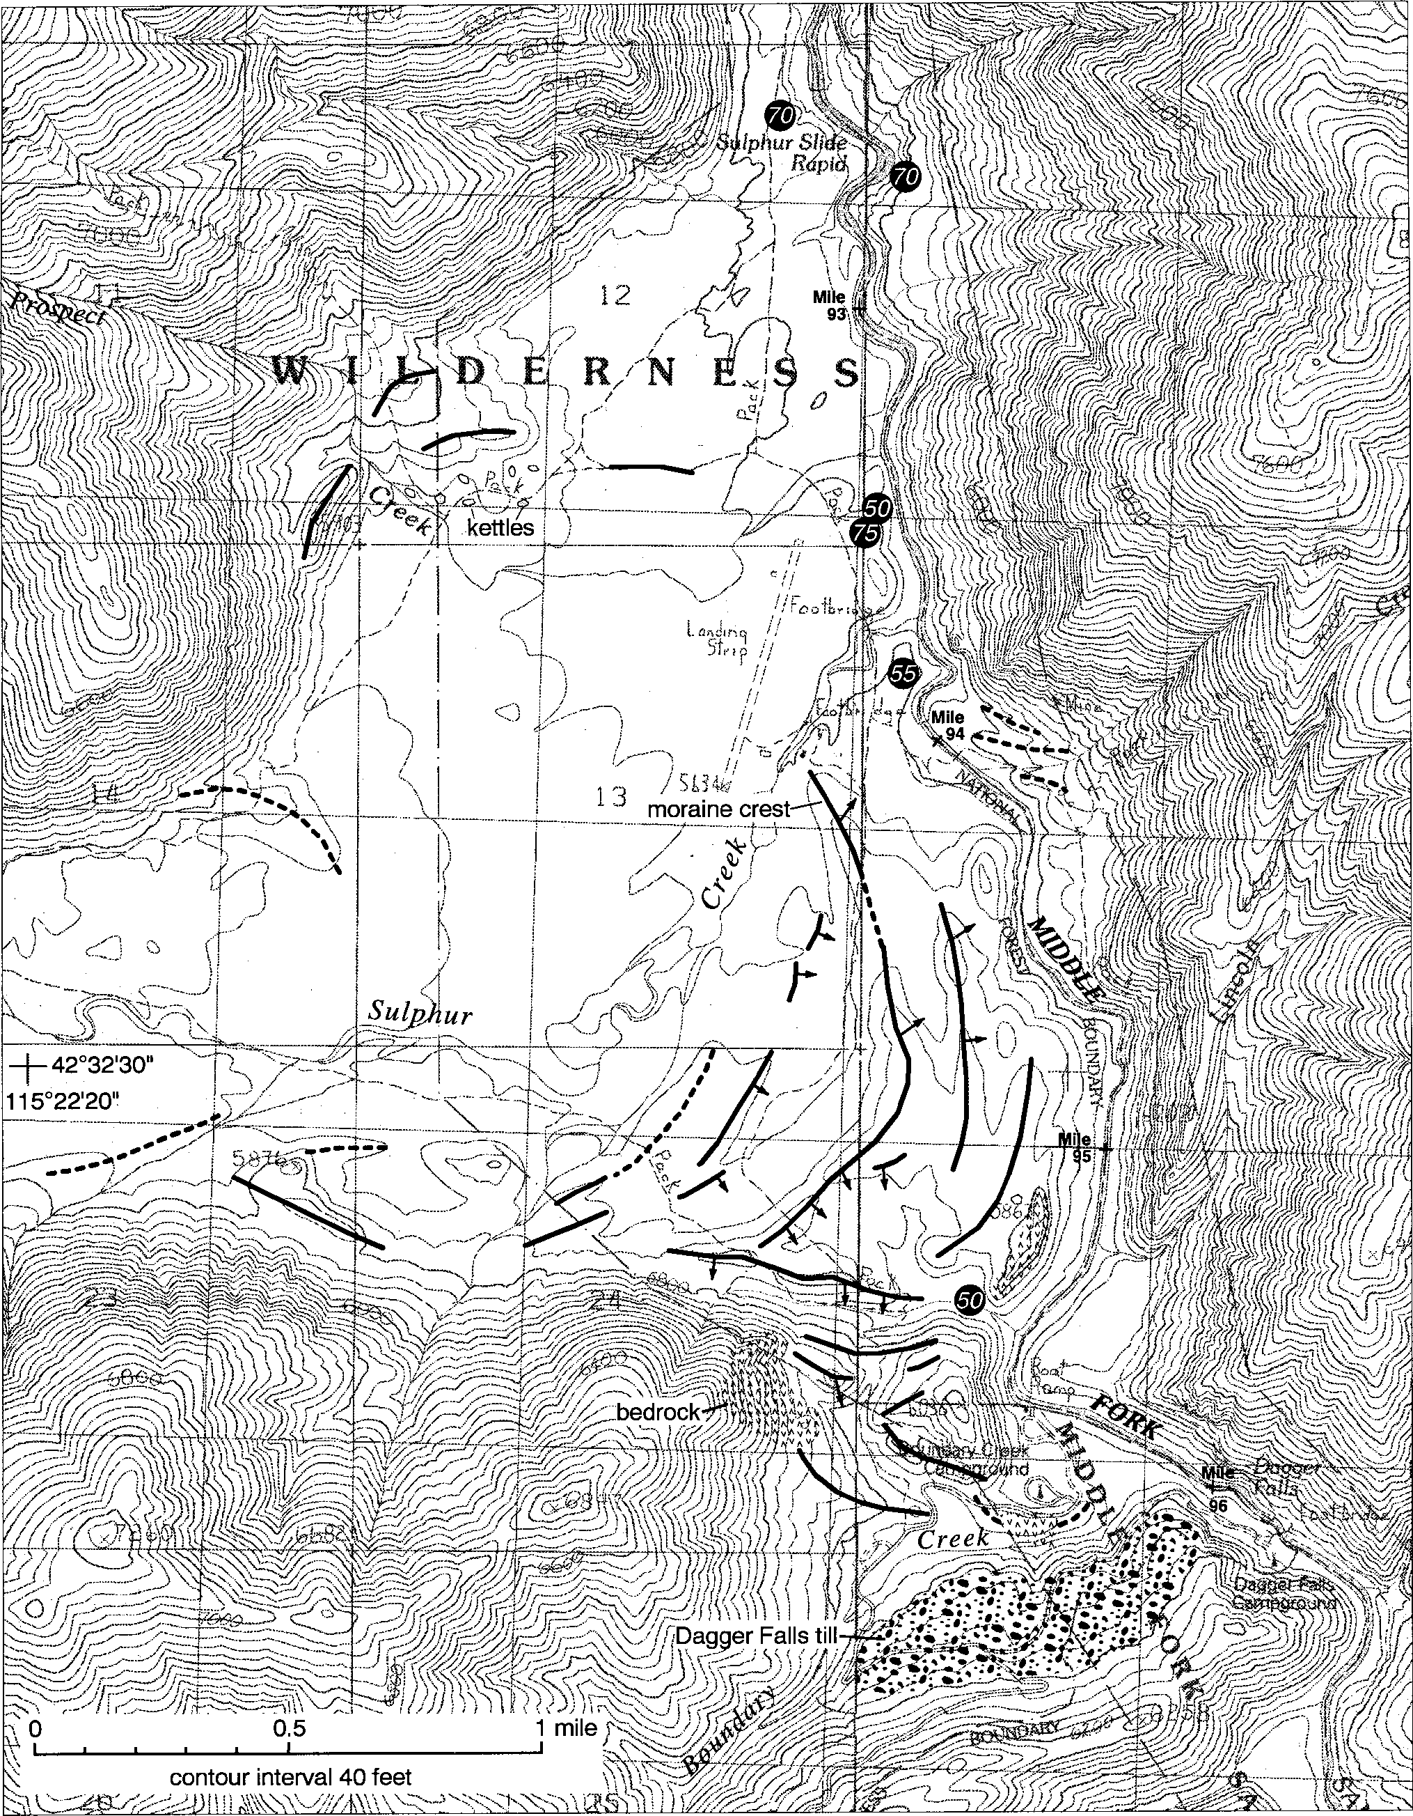

Figure 9. Preliminary map of glacial geologic features in the Sulphur-Boundary Creek area. Moraine crests (bold lines) are incom- pletely mapped and are dashed where inferred. Short arrows show moraine distal slope measurement locations. Numbers in italics indicate heights of outwash terrace treads above river bankfull level.

Table 1. Weathering rind data for Middle Fork terraces and Sulphur-Boundary Creek glacial deposits, with estimated ages and age ranges, and comparison to age ranges in incision rate scenarios (Fig. 12).

terrace tread height | mean rind thickness | std. dev.  s | n | age1 | ±1s age range1 | incision rate age range
(ft) | (mm) | (mm) |  | (ka) | (ka) | (ka)
10-30 | 0.44 | 0.32 | 20 | 20 | 10-50 | -
35-70 | 0.54 | 0.37 | 59 | 30 | 10-60 | 15-150
110-130 | 1.64 | 0.54 | 18 | 160 | 80-330 | 90-360
160 | 1.96 | 0.42 | 7 | 250 | 140-420 | 150-450
280-290 | 2.25 | 0.44 | 15 | 360 | 210-610 | 260-880
380 | 2.95 | 0.41 | 8 | 850 | 520-1400 | 340-1170
till unit  Sulphur Creek | 0.40 | 0.16 | 5 | 20 | 20-30 | -
Dagger Falls | 1.39 | 0.63 | 31 | 120 | 50-270 | -
1 Ages calculated using solid rind thickness calibration curve in Figure 10.
Minimum and maximum ages using curves A and D in Figure 12.
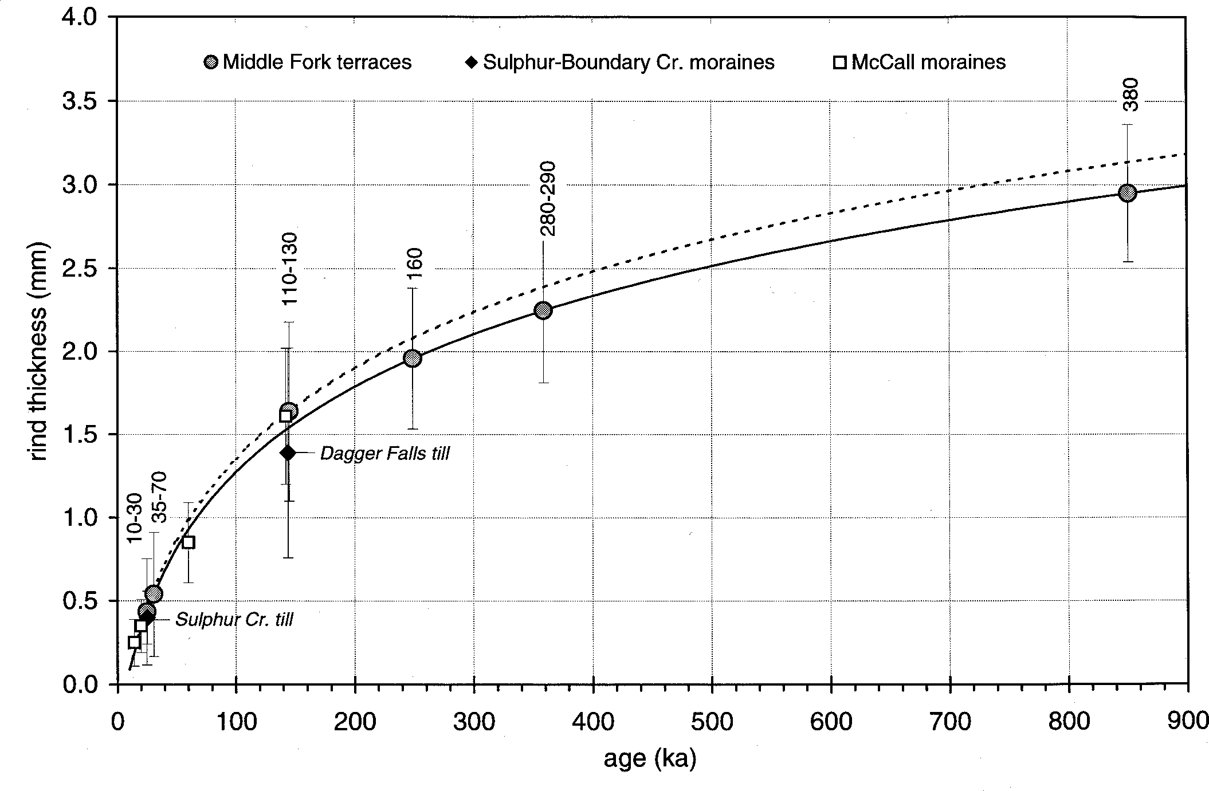
miles because of the 45 ft/mile river gradient, and its volume would have been limited by the nar- row canyon.
A small sample of weathering rinds from Sul- phur Creek till was obtained from the valley-mouth moraines (Fig. 9, Table 1). Most basaltic clasts examined, however, had very thin (< 0.1 mm) rinds that did not obscure the texture of the rock and were not included in the sample. Because we were limited to surface samples and shallow exposures along trails, our rind-thickness data are not directly comparable to those of Colman and Pierce (1986) for McCall area moraines. Nonetheless, rind thick- nesses are generally consistent with a last-glacial (Pinedale or late Wisconsin) age for Sulphur Creek till in the main valley moraines, and are compa- rable to thicknesses for the associated 50-70 ft Middle Fork terraces (see following section and Figure 10).

By comparison to McCall area moraines (Colman and Pierce, 1986), distal slope angles also indicate a last-glacial age for Sulphur Creek mo- raines (Fig. 11). Again, the McCall data are not directly comparable with our study area because of environmental differences, but Sulphur Creek moraines inside the main valley mouth are unlikely to be of early Wisconsin age or older. Moraines of significantly different age within this group could likely be differentiated by detailed study, and the outermost moraines (e.g., those spilling into Boundary Creek) may predate the late Wisconsin.
Figure I0. Mean weathering rind thicknesses as a function of age for Middle Fork terrace groups and glacial deposits in the Sulphur-Boundary Creek area (this study), and McCall, Idaho glacial deposits (Colman and Pierce, I986). Error bars show I standard deviation, and tread heights for Middle Fork terrace samples are shown above. Ages for Middle Fork terraces and Sulphur-Boundary Creek deposits are calculated using the method of Colman and Pierce (I98I, I986) to derive the solid calibration curve (see text for details). Dashed curve is calibrated for McCall de- posits, from Colman and Pierce (I986). Note that with a logarithmic calibration function, uncertainty will be larger for older ages even if the variance in measured rind thicknesses is the same.

The Dagger Falls till or diamicton forms a bench immedi- ately south of lower Boundary Creek (Fig. 9). It is banked against a ~100 ft high bedrock ridge, but the deposit volume appears much too large to have been shed from this ridge. The deposit surface is gently undulating, and its original form has likely been substantially modified by the incision of Boundary Creek. Few
boulders are exposed at the surface, but a 7 m long boulder is among them, and exposures along the Dagger Falls road reveal a till-like texture with abundant subrounded boulders of widely varying lithology. Cobbles sampled from this deposit have a gen- erally similar rind thickness (mean = 1.39 mm) to ~140-150 ka Timber Ridge till at McCall (mean = 1.61 mm; Colman and Pierce,

Figure II. Maximum distal slope angle as a function of slope height for Sulphur Creek moraines (points and solid regres- sion line; r2 = 0.74). Measurement locations are shown in Figure 9. For comparison, dashed lines show least squares regressions for McCall moraine data with corresponding cali- brated age, from Colman and Pierce (I986).

1986), therefore we tentatively assign the same 818O stage 6 age to Dagger Falls till (Table 1; Fig. 10).

Weathering Rind Data
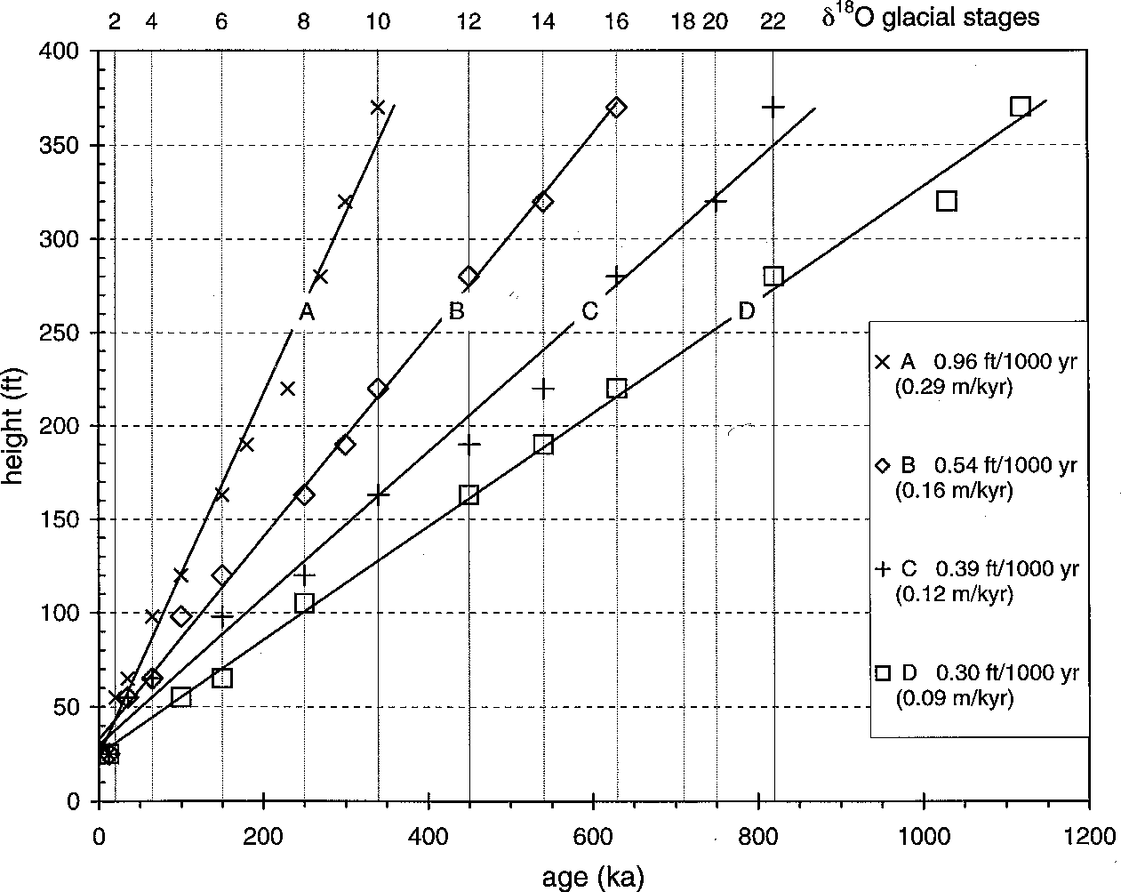
Because of the limited number of samples, weathering rind age estimates are preliminary, but demonstrate the potential to yield useful calibrated ages (Table 1). First, anomalously thick and thin rinds were rejected where greater or less than 2 standard deviations from the mean thickness. Pre- sumably, anomalously thick rinds represent re- worked clasts or atypical rock types, and thin or absent rinds represent clasts from beneath the weathering zone. Next, sampled terraces were grouped by elevation in categories consistent with the height histogram (Fig. 5), and the mean and standard deviation of rind thicknesses were cal- culated for each group, as well as for the Sulphur Creek and Dagger Falls tills (Table 1).
Following Colman and Pierce (1981, 1986), we then constructed a preliminary curve of rind thickness as a function of time, using the follow- ing data and assumptions: (1) The 110-130 ft ter- races are the next higher group of major fill ter- races above the 50-70 ft terraces, which correlate physically to last-glacial moraines. The 110-130 ft terraces also have a similar mean rind thickness
to Dagger Falls till, and are therefore the most likely group to represent 818O stage 6 glaciation. Accordingly, we assigned the 110-130 ft terraces an age of 140 ka. (2) We assumed that a curve describing mean rind thickness as a function of age for Middle Fork samples will have the same logarithmic form as the relatively well-calibrated West Yellowstone curve (Colman and Pierce, 1981). We obtained a Middle Fork curve by multiplying the West Yellowstone function by a constant (Fig. 10). First, we averaged the rind thickness mean for Middle Fork 110-130 ft terraces with the mean for Dagger Falls till to obtain a 818O stage 6 rind thickness value of 1.51 mm. We then divided this value by the West Yellowstone stage 6 mean rind thickness (0.78 mm) to yield a proportionality constant of 1.94. That is, Middle Fork weathering rinds grow
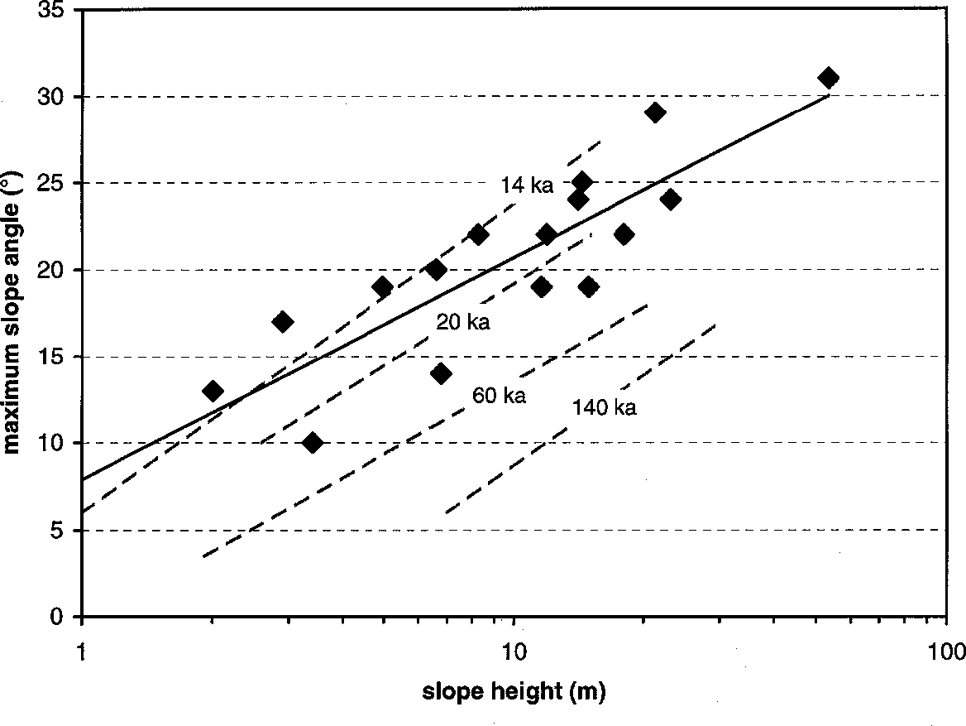
1.94 times faster than West Yellowstone rinds, and approxi- mately at the same rate as McCall rinds. (3) Lastly, we de- rived estimated ages for terraces and glacial deposits using the Middle Fork curve (Fig. 10, Table 1). Limits for estimated
age ranges were calculated using rind thickness values ±1 stan- dard deviation from means. We strongly emphasize that these weathering rind ages are preliminary, and that the estimated age ranges much etter represent the current level o dating preci- sion than do single age values.
Colman and Pierce (1981) infer that precipitation is the most important climatic factor controlling rind thickness, where wetter climates foster more rapid rind growth. Precipitation in the Middle Fork sample area is difficult to estimate accurately. Despite the strong eastward decrease in precipitation across the Middle Fork

Figure I2. Plot of four incision rate scenarios for the Middle Fork Salmon River. Heights of major terrace groups are plotted against a range of correlated ages that are mostly within the range of ages estimated by weathering rind data (Table I; see text for discussion). Vertical lines indicate maxima of 5180 glacial stages, labeled at top (from Imbrie et al., I984 for stages 2-22, and Shackleton et al., I984 for older stages). Incision rate lines A-D are least squares regressions.

region, simple and multiple regressions of precipitation with el- evation and longitude at six stations closest to the river lack sig- nificance, indicating the importance of additional local factors (Leidecker, 1997). Mean annual precipitation (MAP) is about 40 cm/yr at Middle Fork Lodge (elevation 4400 ft), the only station on the river, and we estimate that MAP is between 50 and 65 cm/ yr at Boundary Creek (elevation 5800 ft). Sampled terraces lie at elevations between 3800 and 5800 feet, thus precipitation in the sample area is generally less than at McCall (65 cm MAP) and is more similar to West Yellowstone (50 cm MAP). Lower precipi- tation on the Middle Fork would cause lower rates of rind growth than at McCall; however, this effect is probably offset by the dia- base we sampled, which is coarser grained than McCall or West Yellowstone basalts. Colman and Pierce (1981) note that for clasts of similar composition, rinds grow more rapidly on coarser- grained rocks than on finer-grained varieties. As a result, the pre- liminary Middle Fork curve is similar to the McCall curve (Fig. 10).

ncision Rates
For initial analysis of long-term incision rates, we used a broad range of possible ages for each major group of terraces, generally limited by weathering rind age ranges (Table 1). We then con- structed four possible incision rate scenarios for the Middle Fork (Fig. 12), with two major assumptions:
  - For each scenario, we assume that the long-term incision rate has not changed significantly over the period of Middle Fork terrace formation. Along the Clarks Fork of the Yellowstone River in Montana, the 630 ka Lava Creek ash and 2000 ka Huckleberry Ridge ash provide ages for high terraces (Reheis, 1987). There, correlation of lower terraces to the Pinedale (20±10 ka) and late Bull Lake (120±30 ka) glaciations is consistent with nearly linear incision at 0.41 ft/1000 yr (0.126 m/kyr) since 630 ka. The aver- age incision rate was only slightly lower between 2000 ka and 630 ka: 0.38 ft/1000 yr (0.117 m/kyr). Nonetheless, we cannot exclude the possibility of changing long-term incision rates along the Middle Fork, therefore we evaluate a range of linear incision- rate scenarios.
On shorter timescales, intervals of active downcutting must occur at rates much higher than the long-term average, which in- cludes a number of aggradational episodes. In fact, incision be- low the ~35 ft level along the lower Middle Fork averages 2.4 ft/ 1000 yr (0.74 m/1000 yr) from 14.5 cal ka to present, a rate 2.5 times greater than our most rapid long-term scenario - despite arrested downcutting because of landslide dams. The Clarks Fork and other Rocky Mountain rivers underwent similarly rapid late- to postglacial incision from 20 ka to present (Reheis, 1987; Reheis et al., 1991). Accordingly, we excluded the present river eleva- tion from our long-term incision rate scenarios, so that most re- maining data relate to major fill terraces.
  - We assume that major terrace groups higher than 50 ft represent glacial-period aggradation, and correlate to marine 818O glacial stages of Imbrie et al. (1984) and Shackleton et al. (1984). In southern and central Rocky Mountain basins, Reheis et al. (1991) found significant correlation of fluvial terraces to 818O glacial stages, but no sequence faithfully recorded all of the stages after ~600 ka. The 818O glacial stages relate to maxima in conti-
nental ice sheet volume, but maximum advances of mountain gla- ciers may predate continental ice maxima by some tens of thou- sands of years (e.g. Gillespie and Molnar, 1995). For any set of correlations, ages for Middle Fork terraces predating the last gla- cial maximum may be in error by 100 ka or more. Given such uncertainty, errors from asynchroneity are insignificant as long as mountain glacier advances generally occur during the ~100 kyr global cooling cycles that produce continental ice growth. Lesser glacial episodes may not produce significant aggradation, thus some 818O glacial stages are eliminated from the lowest rate scenario.
Of the four incision rate scenarios in Figure 12, the outside curves A and D represent bounds for reasonable rates. The rate of curve A is probably too high because it requires that each 818O glacial stage forms 2-3 major terrace groups. At nearly 1 ft/1000 yr (0.29 m/kyr), this rate nearly equals the highest incision rates calculated for rivers in the Rocky Mountain region (compiled by Pierce and Morgan, 1992, and Schumm and Ethridge, 1994), and those rivers are cutting through relatively soft sedimentary rocks. The curve D rate, 0.3 ft/1000 yr (0.09 m/kyr), is likely too low because it requires that 55 ft terraces are ~100 ka and 65 ft ter- races are ~150 ka. This contradicts correlations between prob- able last-glacial moraines and 50-70 ft terraces in the Sulphur Creek area. The lowest rate also requires that several higher ter- race groups are somewhat older than the age range estimated by weathering rinds (Table 1). Therefore, the actual average inci- sion rate probably lies between these curves.
Curve B, the 0.54 ft/1000 yr (0.16 m/kyr) scenario, assigns some terrace groups to minor peaks in global ice volume within 818O glacial stages, i.e., ~100 ft terraces are 100 ka and ~190 ft terraces are 300 ka. At this rate, the highest terraces at ~370 ft have an age of ~630 ka. Curve C, the 0.39 ft/1000 yr (0.12 m/kyr) scenario, assigns ~100 ft terraces to stage 6 (150 ka) and each higher terrace group to a 818O glacial stage on the ~100 kyr cycle. Using curve C, the highest terraces are ~860 ka. Terrace groups below 100 ft are assigned stage 4 (65 ka) and younger ages, al- though "Eowisconsin" glacial ages between 120 and 80 ka (Rich- mond, 1986) for ~65 ft terraces are still possible with this rate.
We currently have few means to evaluate which scenario is most accurate. Most documented long-term incision rates for high- energy Rocky Mountain rivers since 2.0-0.6 Ma are between 0.3 and 0.7 ft/1000 yr (0.10-0.21 m/kyr), including those cutting through resistant plutonic and metamorphic rocks (Pierce and Morgan, 1992). Somewhat like the Middle Fork, the Boise River drains a mountainous landscape on Idaho Batholith rocks, but with lower relief (Fig. 2). It has incised at an average rate of 0.16-
0.33 ft/1000 yr (0.05-0.10 m/kyr) since 2 Ma, despite several episodes of canyon filling by basalt flows and reincision (Howard et al., 1982). These comparisons support our inference that curves B and C best represent the range of possible incision rates for the Middle Fork.

DISCUSSION
The rugged relief of the Middle Fork Salmon River canyon sparks interest in potential controls on fluvial incision, including uplift, base-level change, and climatic variations. One possible source of uplift involves far-field effects of the Yellowstone hot

spot. A zone of uplift migrating away from the hot-spot track is suggested by a crescent of high terrain, with the Yellowstone Pla- teau at its apex and arms that broadly enclose the Snake River Plain (Suppe et al., 1975; Smith et al., 1985; Anders et al., 1989; Pierce and Morgan, 1992). The northern arm is an arch with late Cenozoic uplift suggested by generally high topography and ma- jor drainage divides crossing northwest-trending Basin and Range structure (Ruppel, 1967) (Fig. 2). The Middle Fork flows ob- liquely away from this arch through an outer zone of anomalously high elevations north of the main structure (Pierce and Morgan, 1992). No uplift centered south of the Middle Fork is apparent at this stage of analysis, as the approximately parallel profiles of the highest (370 ft) terrace and the modern river imply an absence of regional tilting. Harrold and Dort (1987) inferred that terrace treads 90-144 m (295-472 ft) above the Main Salmon River be- tween Salmon and Challis have steeper longitudinal profiles than lower terraces because of uplift of the arch. This reach of river flows roughly parallel to the axis of uplift (Fig. 2), however, indi- cating that tilting after terrace formation is likely to be minor. Also, their correlation of scattered high terrace remnants relies on relative age criteria, thus associated gradients remain uncer- tain.
A potential source of regional uplift that would not necessar- ily result in tilting is isostasy. The Middle Fork flows through the center of a broad negative isostatic residual gravity anomaly as- sociated with the Idaho Batholith. Although this low-density crust is probably rebounding in response to regional erosion, additional uplift due to long-term isostatic disequilibrium cannot be assumed from the negative anomaly (Jachens et al., 1989). Perhaps the greatest significance of the Idaho Batholith lies in its high-strength crust that has resisted late Cenozoic extension and aided buoy- ancy in maintaining high topography.
Molnar and England (1990) suggest that in tectonically qui- escent mountains, late Cenozoic climatic cooling accelerated denudation, increased relief, and raised summit elevations through isostatic uplift, even though the mean elevations of mountains were reduced. Modeling indicates that the potential to increase summit elevations by this mechanism is relatively small (e.g., Gilchrist et al., 1994; Montgomery, 1994; Small and Anderson, 1998). It is probably ineffective in where summits lie at the inter- section of steep valley sideslopes and thus tend to erode in pace with valley incision, as in much of the Middle Fork basin (Fig. 2). Nonetheless, lower-relief uplands exist in this region, especially along the lower Main Salmon River. If downcutting rates were significantly accelerated by increased runoff in the Quaternary, greater relief may have developed where elevated terrain was al- ready in existence, especially where valleys underwent rapid in- cision in partial isolation from uplands.
Interestingly, much of the Impassable Canyon (Fig. 1) con- tains a very steep inner gorge, where a sharp break in slope lies between 1000-1200 ft-high inner cliffs and more moderate upper mountain slopes. The break in slope is most clearly demarcated between Miles 10 and 5 and has no apparent relation to any subhorizontal geologic structure. We speculate that this feature may mark accelerated downcutting promoted by the onset of ice- age climates and related events. At the best estimated incision rates of 0.39-0.54 ft/1000 yr (0.12-0.16 m/kyr) (Fig. 12), the
Middle Fork would have formed the 1000 ft inner gorge since 2.63-1.85 Ma. These ages broadly bracket the marked cooling of climate and growth of Northern Hemisphere continental glaciers at ~2.5 Ma (e.g., Shackleton et al., 1984).
Significant base level changes may also have impacted the Salmon River system in Plio-Pleistocene time. The upper Snake River was captured when its outlet from Pliocene Lake Idaho in the western Snake River Plain spilled over into the present course of Hells Canyon (Fig. 2). Malde (1991) and Othberg (1994) place this event ~2 Ma, whereas Repenning et al. (1994) and Wood and Clemens (in review) favor an age of 3-4 Ma. Capture drastically increased the drainage area for the lower Snake River; however, evaporation from Lake Idaho probably limited outflow until some- time between 3 and 2 Ma, when sediment infilling of Lake Idaho and the transition to glacial climate allowed discharges to increase (Wood, 1994). This increase may have greatly accelerated downcutting along the lower Snake River, thus lowering base level for the Salmon River system. The magnitude of base level de- cline and the rate at which downcutting propagated upstream re- main to be investigated.

CONCLUSIONS
The Middle Fork Salmon River terrace sequence includes abundant treads at < 70 ft above bankfull level. Aggradation dur- ing the last glaciation formed the ~50-70 ft terraces, and was fol- lowed by mainly erosional terrace development during late-gla- cial and postglacial degradation. Most of the preserved higher treads lie on major fill terraces; we hypothesize that these were formed during glacial episodes, primarily from increased bedload supply. Although few in number, the highest terrace treads con- sistently lie near 370 ft and are found along most of the river, providing evidence for uniform incision. If average incision rates lie within the best estimated range of 0.39-0.54 ft/1000 yr, these terrace treads are between 0.6 and 1 million years old.
Rock avalanches dammed the lower Middle Fork about 14,500 and 1800 cal yr ago, forming temporary barriers to fish migration and lakes that persisted for at least tens of years. The steep walls of Impassable Canyon are prone to large-volume rock slides and rock avalanches, and large granitic or gneissic boulders can form erosion-resistant dams in the narrow inner gorge. Intermittent land- slide damming is probably characteristic of the Middle Fork flu- vial system.

RIVER-MILE GUIDE: QUATERNARY GEOLOGY AND GEOMORPHOLOGY
Mileage is given in river miles from the Main Salmon River confluence as shown on U.S.G.S. 7.5' topographic maps. Corre- sponding river miles on the U.S.F.S. (1985) and Moye (1995) river maps are given in parentheses, where distance is measured downstream from the Boundary Creek boat ramp (FS 0.0). These river guides with waterproof maps give much more complete in- formation on rapids, camps, required permits, and general logis- tics. Moye's (1995) geology guide focuses on bedrock geology and is written for the interested layperson. The Carrey and Conley (1992) guidebook provides interesting historical anecdotes, in- cluding many on early mining activities. By convention, left and

232 uide ook to the eology o astern daho

right banks are defined facing downstream. Only selected terrace localities are noted below, but Figure 4 shows the location of all measured terraces.

USGS River Mile
95.6 (FS 0.0) Boundary Creek boat ramp and launch area (Figs. 1, 9). River elevation 5640 ft.
92.6 (FS 2.4) Large pool just above Sulphur Slide Rapid; Gardells Hole Camp on right. A Sulphur Creek outwash terrace lies at 70 ft on the left (west), with a corresponding terrace remnant on right (Fig. 9). Sulphur Slide Rapid was formed in 1936 by a major debris flow that produced a notable damming effect upriver (Carrey and Conley, 1992). Drowned trees are still present at the margins of the pool. The debris flow emanated from the steep tributary on the east at the head of the rapid. Associated debris slide scars on the steep south face of this drainage are visible from points upriver. Debris flows from steep tributaries are re- sponsible for many whitewater rapids in the western U.S. (e.g., Webb et al., 1989).
88.1 (FS 6.9) Trail Flat Camp and hot springs on left, with a superb sequence of terraces at 28, 42, 170, 190, and 280 ft, and a possible remnant at ~370 ft to the north. As is typical for high terraces on the Middle Fork, these are pre- served on the inside of a large bend.
84.0 (FS 11.2) Powerhouse Rapids begin here and extend 0.3 miles downstream through a reach with the steepest gradi- ent on the river below Boundary Creek (66 ft/mile or 0.0125; Fig. 4A). The long rapids probably relate to the very steep 2000-3000 ft high canyon wall on the outside of the right bend here, which can supply coarse debris- flow sediment to the river channel through 2-3 major chan- nels. Long-term undercutting of this slope maintains insta- bility. The 1930s waterwheel on the right bank was built to power a stamp mill for processing gold ore, but apparently was never operated (Carrey and Conley, 1992).
80.5 (FS 14.9) Lake Creek enters on left, with camp of the same name on right. Another sequence of well-preserved ter- races at 18, 63, 207, and 290 ft is found here and extends downstream ~0.4 miles to the John's Camp area.
75.8 (FS 19.0) Big Snag (left) and Dolly Lake (right) Camps. The large deep pool here is habitat for bull trout, the salmo- nid formerly known as Dolly Varden. Postglacial and late- glacial terraces lie at 16, 27, and 33 ft on the point occu- pied by Big Snag Camp.
75.5 (FS 19.3) Big Snag (Cannon Creek) Rapid. Although a bedrock ledge protrudes on the right, the rapid is enhanced by boulders and channel constriction caused by a large debris flow that issued from Cannon Creek on the left. The deposit is well exposed in the left cutbank. It is up to 13 ft (4 m) thick and has prominent marginal levees that partly bury living trees. Tree-ring counts on near-basal cores from the even-age stand of lodgepole and ponderosa pine grow- ing on the debris-flow surface place its probable date in the early 1930s. This age assumes 7-10 years in addition to the ring count that represent (1) time for trees to be- come established, and (2) additional rings below core level,
since cores are unlikely to contain the first year of growth, even when the center pith is present (Simpson and Meyer, 1995; Meyer et al., 1995). Accordingly, the rapid was more severe in the 1940s (Carrey and Conley, 1992). Drowned trees are present upstream because of the weir-like effect of the deposit.
74.5 (FS 20.1) Cap Creek on left; river elevation 4800 ft. North of Cap Creek, a prominent high terrace at ~290 ft extends downstream to the left bend across from Lake Creek, a scouting stop for Pistol Creek Rapid. Post-glacial and last- glacial terrace treads at 22, 26, 36 (with cabin), and 69 ft lie inside the bend. Pistol Creek Rapid is a tight S-bend created by a narrow granodiorite bedrock constriction.
72.4 (FS 22.4) Pistol Creek Ranch airstrip on left. Like virtu- ally all of the airstrips in the Middle Fork canyon, this one is built on a fluvial terrace tread, here about 47 ft above bankfull level.
69.9 (FS 24.8) Indian Creek boat ramp and airstrip (upstream end) on left. The airstrip lies on a 45 ft terrace tread, a level that is commonly preserved along this reach.
69.0 (FS 25.6) Downstream end of Indian Creek airstrip. A prominent 320 ft terrace tread is easily visible as a mesa- like surface on the left; Indian Creek flows on the opposite (north) side of the mesa and enters the river just before the right bend below.
61.0 (FS 33.3) Middle Fork Lodge and gaging station on right. Prominent high terraces at 280 and 370 ft lie on the left inside the long bend for ~1.5 miles (Fig. 3). Although the scarp below the 280 ft terrace tread appears to expose only fluvial gravels, suggesting a very thick fill deposit, small granite outcrops are present < 30 ft below the tread. Also, a large outcrop is readily visible from river level on the scarp face near the south point of this terrace. These ob- servations indicate that relatively thin fill deposits overlie a bedrock strath. Terraces between 7 and 50 ft fringe the higher terraces around much of the bend. A long debris- flow track is visible on the north slope of Scarface Moun- tain looking directly downstream on this section of river (Fig. 3). Apparently this debris flow relates to a forest fire predating the 1979 Mortar Creek burn (Moye, 1995).
59.2 (FS 35.4) High geomorphic surfaces on the right are largely fan surfaces from Little Creek grading to the Middle Fork. On the left, the Thomas Creek airstrip lies on a ~50 ft ter- race.
53.8 (FS 40.8) Lower end Mahoney Creek airstrip on left. The airstrip occupies a 350+ ft terrace, and a small remnant of a ~270 ft terrace lies at the downstream end. Terraces are less well preserved in this area, presumably because of weathered 45 Ma Casto Pluton granite. This bedrock is prone to granular disintegration, and thus is both erodible and less likely to form coarse, resistant gravel.
53.2 (FS 41.8) Left bank 0.2 miles below Mahoney Creek and camp. A well-preserved sequence of terraces rises to roughly 200 ft but are yet to be measured.
48.9 (FS 46.0) Whitey Cox Camp lies on the right at the down- stream end of the lower terraces here. Terrace treads lie at
~17, 34, 49, 86, and 260 ft.

45.5 (FS 49.3) Mouth of Loon Creek on right; river elevation 4000 ft. The Simplot airstrip occupies a terrace at about 60 ft on the east side of the creek.
43.0 (FS 51.8) Cave Camp lies on the right just around the sharp right bend. On the point above are terraces at ~49 and 97 ft. Hospital Bar hot springs and camp on left. Moye (1995) reports that a tephra was discovered in the excavation for the outhouse here. The ash was sampled by Peter Larson of Washington State University (written comm., 1998) from a layer several centimeters thick at ~3.3 ft (1 m) depth, in sediments of a small fan that has built over a low terrace from the scarp above. The terrace tread height has not yet been measured but probably lies at < 15 ft. The tephra correlates to the ~1500 yr B.P. Newberry Pumice from Newberry Volcano in Oregon (Sherrod et al., 1997; Kuehn, 1997; written comm., 1998) and provides a minimum age for the terrace.
38.5 (FS 56.6) Mouth of Grouse Creek and Tappan Ranch on right. A high terrace tread at ~320 ft represents a distal Grouse Creek fan surface grading to the Middle Fork. Broad, shallow bedrock shelves forming the channel floor just downstream are strath surfaces in the making.
37.4 (FS 57.9) Tappan Falls is primarily a bedrock rapid, a ledge drop at the contact between Casto Pluto granite and more resistant gneiss (Moye, 1995). It is likely enhanced through constriction by bouldery debris flow deposits produced by the very steep drainage on the left, which drops 3000 ft in
0.85 mile (average gradient ~34°).
35.4 (FS 59.9) Camas Creek confluence on right at the apex of a tight left bend. A well-formed series of terraces at about 24, 37, 110, and 160 ft are obvious on the left, inside of the bend.
33.5 (FS 61.6) Big Bear Creek confluence and Funston Camp on left. A candidate for a very old fluvial terrace remnant exists at about 950 ft on the south side of Big Bear Creek. The possible tread is deeply eroded and has a deep silty soil and grussy sediment cover. No associated rounded gravel or exotic clasts were identified, but if terrace de- posits are present they may be strongly weathered.
30.6 (FS 65.3) Sheep Creek enters on left, with terrace treads at about 30, 46, 77, and 157 ft that represent gently sloping fan surfaces grading to former Middle Fork levels. A "sheep lick" at 180-205 ft is in well-stratified silt-fine sand with clay laminae and CaCO3-rich pods and lenses. They are similar to fine sediments near Miles 22-23 and 16.4 (see below), and were probably deposited in a landslide- dammed lake. Given their geomorphic and stratigraphic position, however, the Sheep Creek sediments are prob- ably much older than the latest Pleistocene and Holocene lacustrine deposits downriver, and marl beds here have clearly been partially dissolved and reprecipitated in un- derlying sediments.
29.1 (FS 66.8) Flying B Ranch on left, and Bernard Bridge; river elevation 3640 ft. Terraces on the right exist as high as 360 ft but are poorly preserved on deeply weathered, grussy Idaho Batholith granite.
27.9 (FS 68.1) Haystack Rapid, a "rock garden" with numer- ous large boulders. These were likely carried by large de- bris flows down Pole Creek, which enters on the right through a narrow entrenched alluvial fan channel. High debris-flow levees flank this channel at the head of the Pole Creek fan. A debris flow caused by an intense thun- derstorm on August 11, 1997 significantly modified this rapid (see photo on page 236).
23.1 (FS 72.9) Wilson Creek confluence and camp on right. Silty and sandy sediments of the 12,400 yr B.P. (14.5 cal ka) landslide-dammed lake are exposed a short distance downstream in a "sheep lick" on the left bank (see main text and Figure 7 for description).
22.4 (FS 73.6) On the left bank, fine-grained sediments of the 12,400 yr B.P. (14.5 cal ka) landslide-dammed lake are readily visible from river level about 50 ft above bankfull level in "sheep lick" exposures. The overlying ~115 ft ter- race tread probably represents a delta surface. A short dis- tance downstream, a soil slip caused by undercutting dur- ing the 1997 high discharge exposed fluvial gravel of a
~35 ft river level under the lacustrine sediments (Fig. 6).
22.2 (FS 73.9) Right bank above Sammy Gulch, which enters on left. Silty and marly sediments exposed in the footslope are only several feet above bankfull level, but are at the toe of a slump block that has carried them downward. They are probably part of the 14.5 cal ka lake sediments.
21.4 (FS 74.8) Survey Creek Camp; the creek enters just down river on the left. Above the camp, terraces step up to 160, 180, 220, and 275 ft.
18.0 (FS 77.9) Big Creek confluence on left below the pack bridge. On the right, a large isolated terrace exists at 370 ft (Fig. 8A), the highest terrace level clearly preserved along the river. Impassable Canyon begins here; no trail runs along the river below. Terraces are poorly preserved in this deep gorge, which is cut in resistant Eocene grano- diorite to Mile 11.6 (Moye, 1995).
17.0 (FS 78.9) Cutthroat Cove Camp on left; Pine Bluff Camp is about 0.2 miles upstream. These camps lie at the base of the inferred track of the large rock avalanche that formed a landslide dam ca. 14.5 cal ka (Fig. 8A). There are two broad, steep gullies converging on this area, but the longer northern path appears a more likely candidate. A 70° headscarp as much as 600 ft high lies ~3000 ft above, and the average gradient of this track is 38°. The rock ava- lanche deposit lies on the right (east) bank across from the camps and continues around the right bend below to the vicinity of Big Pine Camp. A bedrock knob protrudes through the center of the deposit. Bouldery terraces are cut on the deposit; some probably represent overflow chan- nels formed during high discharges or outburst floods (e.g., Turner and Locke, 1990; Reneau and Dethier, 1996).
16.4 (FS 79.6) Elk Bar Camp on left. Just below on the right is a "sheep lick" exposing fine-grained sediments of an 1800 yr old landslide-dammed lake (see main text and Fig. 6).
13.6 (FS 82.7) Boulder-choked rapid at the mouth of Golden Creek, called Porcupine in the authoritative Carrey and Conley (1992) historical guide, but named Redside on the

U.S.F.S. (1985) and U.S.G.S. Aggipah Mtn. 7.5' maps (Fig. 8B). Some long-time Idaho river guides refer to this rapid as Sevy's Rock, and Oregon guides call it Eagle Rock (Carrey and Conley, 1992)! Regardless of the name, the constriction and hard right bend here are clearly associ- ated with the debris-flow fan deposited by Golden Creek, however, some of the large boulders in this rapid may have fallen from the cliff on the right, as suggested by Moye (1995).
13.2 (FS 83.0) The "real" Redside Rapid (Carrey and Conley, 1992), which is not associated with a stream drainage (Fig. 8B). It is named Weber Rapid on the U.S.F.S. (1985) map, and has been called Little Porcupine, Loin of Pork, and Corkscrew as well (Carrey and Conley, 1992; Nash, 1989). On the right is the steep boulder deposit that may be part of a landslide dam formed about 1800 years ago. Dated lacustrine sediments at Elk Bar (Mile 16.4) are inferred to have accumulated behind this dam. The difficult "rock garden" rapid and boulder pile on the left bank are rem- nants of the breached rock slide or avalanche deposit.
11.8 (FS 84.5) Ship Island Creek confluence on right; camp on left. Impassable Canyon below this point is cut in resistant Precambrian gneiss, and relatively few terraces are pre- served. Just downstream from the confluence, bouldery terraces exist at roughly 65 ft and possibly up to about 120 ft, one of very few places in Impassable Canyon where terraces predating the last glaciation may exist.
9.9 (FS 86.2) Parrott Placer Camp on right. Earl Parrott, the "Hermit of Impassable Canyon", worked fluvial deposits in this area for gold from 1917 to 1942 (Carrey and Conley, 1992). This area was burned in the 1979 Ship Island Fire and again in 1989, and debris flows have reached the river here several times in recent years. An August 1998 debris flow buried several tent sites in the camp. At this point the river takes an abrupt left bend into a relatively straight N20E-trending reach. From here to Otter Bar at Mile 5.5 (FS 90.4), the left (west) side of the canyon is a steep line of cliffs that rise a consistent 1000-1200 ft above the river. A well-defined break in slope marks the transition from this inner gorge to more moderate mountain slopes above, and has no apparent relation to bedrock erosional resis- tance. West of Otter Bar, on the north side of Stoddard Creek, a broad, prominent step in the ridge also lies 1000- 1200 ft above the river. The possible terrace remnant at Big Bear Creek (Mile 33.6) lies just below 1000 ft, but any correlation of these features is highly speculative.
4.0 (FS 92.2) Hancock Rapid, below the debris fan of Nolan Creek (on left). Debris from Roaring Creek on the right forms the upper drop. A narrow 70 ft terrace lies on the right bank about 0.3 miles above the rapid. Fluctuations of water level with discharge are large in this confined reach of river.
0.0 (FS 96.3) Main Salmon River confluence. River elevation about 3000 ft.

ACKNOWLEDGMENTS
Hearty thanks are due to Ray Cullinane and Sherry Hughes of the U.S. Forest Service for cooperation; Tim Jull, L.J. Toolin, and A.L. Hatheway of NSF-Arizona Accelerator Facility for 14C dating; and Joel and Jodi Leidecker and Paula Watt for logistics, field assistance, and inspiration. Middlebury College provided funding for 14C dates. The manuscript was greatly improved through reviews by Frank Pazzaglia, Ken Pierce, and Glenn Thackray.

REFERENCES CITED
Anders, M.S., Geissman, J.W., Piety, L.A., and Sullivan, J.T., 1989, Parabolic distribution of circum-eastern Snake River Plain seismicity and latest Qua- ternary faulting: Migratory pattern and association with the Yellowstone hot spot: Journal of Geophysical Research, v. 94, p. 1589-1621.
Bull, W.B., 1991, Geomorphic responses to climatic change: New York, Oxford University Press, 326 p.
Carrey, J., and Conley, C., 1992, The Middle Pork: A guide: Cambridge, Idaho, Backeddy Books, 382 p.
Chadwick, O.A., Hall, R., Kelly, E., Amundson, R., Gosse, J., Phillips, P., and Jaworowski, C., 1994, Quaternary geology of the Wind River Basin, Wyo- ming: Priends of the Pleistocene, Rocky Mountain Cell Guidebook, 141 p. Colman, S.M, and Pierce, K.L., 1981, Weathering rinds on andesitic and basal- tic stones as a Quaternary age indicator, western United States: U.S. Geo-
logical Survey Professional Paper 1210, 56 p.
Colman, S.M. and Pierce, K.L., 1986, Glacial sequence near McCall, Idaho: Weathering rinds, soil development, morphology, and other relative-age cri- teria: Quaternary Research, v. 25, p. 25-42.
Colman, S.M., Pierce, K.L., and Birkeland, P.W., 1987, Suggested terminology for Quaternary dating methods: Quaternary Research, v. 28, p. 314-319.
Day, N.P., Pitzgerald, J.P., Kauffman, J.D., Price, S.A., and Price, W.H., 1972, Pleistocene gravel terraces of the middle Salmon River, Idaho: Geological Society of America Abstracts with Programs, v. 4, n. 3, p. 145.
Pisher, P.S., McIntyre, D.H., and Johnson, K.M., 1992, Geologic map of the Challis 1° x 2° quadrangle, Idaho: U.S. Geological Survey Miscellaneous Investigations Map I-1819, scale 1:250,000.
Gillespie, A. and Molnar, P., 1995, Asynchronous maximum advances of moun- tain and continental glaciers: Reviews of Geophysics, v. 33, p. 311-364.
Gilchrist, A.R., Summerfield, M.A., and Cockburn, H.A.P., 1994, Landscape dissection, isostatic uplift, and the morphologic development of orogens: Geology, v. 22, p. 963-966.
Hamblin, W.K., 1994, Late Cenozoic lava dams in the western Grand Canyon: Geological Society of America Memoir 183, 139 p.
Harrold, P.E., and Dort, W., Jr., 1987, Climatic and tectonic significance of mul- tiple terraces, upper Salmon River, central Idaho: Geological Society of America Abstracts with Programs, v. 19, n. 5, p. 282.
Howard, K.A., Shervais, J.W., and McKee, E.H., 1982, Canyon-filling lavas and lava dams on the Boise River, Idaho, and their significance for evaluating downcutting during the last two million years, in Bonnichsen, B., and Breckenridge, R.M., eds., Cenozoic geology of Idaho: Idaho Bureau of Mines and Geology Bulletin 26, p. 629-641.
Imbrie, J.D. and eight others, 1984, The orbital theory of Pleistocene climate: Support from a revised chronology of the marine 818O record, in Berger, A.L., and others, eds., Milankovitch and climate, Part 1: Boston, D. Reidel Publishing Co. p. 269-305.
Jachens, R.C., Simpson, R.W., Blakely, R.J., and Saltus, R.W., 1989, Isostatic residual gravity and crustal geology of the United States, in Pakiser, L.C. and Mooney, W.D., eds., Geophysical framework of the continental United States: Geological Society of America Memoir 172, p. 405-424.
Kuehn, S.C., 1997, Geochemistry and stratigraphy: the tephras of Newberry Volcano, central Oregon: Geological Society of America Abstracts with Pro- grams, v. 29, n. 6, p. A-419.
Leidecker, M.E., 1997, Reconnaissance study of fluvial terraces on the Middle Pork of the Salmon River: Implications for glacial and Quaternary history in central Idaho [B.A. thesis]: Vermont, Middlebury College, 58 p.
Locke, W.W., 1990, Late Pleistocene glaciers and the climate of western Mon- tana, U.S.A.: Arctic and Alpine Research, v. 22, p. 1-13.

Malde, H.E., 1991, Quaternary geology and structural history of the Snake River Plain, Idaho and Oregon, in Morrison, R.B. ed., Quaternary nonglacial ge- ology: Conterminous U.S.: Geological Society of America, The Geology of North America, v. K2, p. 252-282.
Meyer, G.A., Bingham, M.K., and Simpson, E.D., 1995, Changes in flood mag- nitudes and processes in northeastern Yellowstone, in Meyer, G.A., ed., Late Pleistocene-Holocene evolution of the northeastern Yellowstone landscape: Middlebury College, Priends of the Pleistocene, Rocky Mountain Cell Guide- book, p. 29-35.
Molnar, P. and England, P., 1990, Late Cenozoic uplift of mountain ranges and global climate change: Chicken or egg?: Nature, v. 346, p. 29-34.
Montgomery, D.R., 1994, Valley incision and the uplift of mountain peaks: Journal of Geophysical Research, v. 99, p. 13913-13921.
Moss, J.H., 1974, The relation of terrace formation to glaciation in the Shoshone River basin, western Wyoming, in Coates, D.R., ed., Glacial geomorphol- ogy: Binghamton, New York, Publications in Geomorphology, p. 293-314. Moye, P. J., 1995, Geology of the Middle Pork of the Salmon: A wild and scenic river: map and guide: U.S. Department of Agriculture-Porest Service, Inter-
mountain Region, map scale 1:62,500, 32 p.
Nash, R.P., 1989, The big drops: Ten legendary rapids of the American West: Boulder, Colorado, Johnson Publishing, 216 p.
Othberg, K.L., 1994, Geology and geomorphology of the Boise valley and ad- joining areas, western Snake River Plain, Idaho: Idaho Geological Survey Bulletin 29, 54 p.
Palmquist, R.C., 1983, Terrace chronologies in the Bighorn Basin, Wyoming: Wyoming Geological Association, 34th Annual Pield Conference Guide- book, p. 217-231.
Pierce, K.L., and Morgan, L.A., 1992, The track of the Yellowstone hotspot: Volcanism, faulting, and uplift, in Link, P.K., Kuntz, M.A., and Platt, L.B., eds., Regional geology of eastern Idaho and western Wyoming: Geological Society of America Memoir 179, p. 1-53.
Pierce, K.L., and Scott, W.E., 1982, Pleistocene episodes of alluvial-gravel depo- sition, southeastern Idaho, in Bonnichsen, B., and Breckenridge, R.M., eds., Cenozoic geology of Idaho: Idaho Bureau of Mines and Geology Bulletin 26, p. 685-702.
Porter, S.C., Pierce, K.L., and Hamilton, T.D., 1983, Late Wisconsin mountain glaciation in the western United States, in Porter, S.C., ed., Late-Quaternary environments of the United States, v. 1, The Late Pleistocene: Minneapolis, University of Minnesota Press, p. 71-111.
Reheis, M.C., 1987, Soils in granitic alluvium in humid and semiarid climates along Rock Creek, Carbon County, Montana: U.S. Geological Survey Bul- letin 1590-D, 71 p.
Reheis, M.C., and seven others, 1991, Quaternary history of some southern and central Rocky Mountain basins, in Morrison, R.B., ed., Quaternary nonglacial geology: Conterminous U.S.: Geological Society of America, The Geology of North America, v. K-2, p. 407-440.
Reneau, S.L. and Dethier, D.P., 1996, Late Pleistocene landslide-dammed lakes along the Rio Grande, New Mexico: Geological Society of America Bulle- tin, v. 108, p. 1492-1507.
Repenning, C.A., Weasma, T.R., and Scott, G.R., 1994, The early Pleistocene (latest Blancan-earliest Irvingtonian) Proman Perry fauna and history of the Glenns Perry Pormation, southwestern Idaho: U.S. Geological Survey Bul- letin 2105, 86 p.
Richmond, G.M., 1986, Stratigraphy and chronology of glaciations in Yellowstone National Park, in Sibrava, V., Bowen, D.Q., and Richmond, G.M., Quater- nary glaciations in the Northern Hemisphere: Quaternary Science Reviews, v. 5, p. 83-98.
Ritter, D.P., 1967, Terrace development along the front of the Beartooth Moun- tains, Montana: Geological Society of America Bulletin, v. 78, p. 467-484. Ruppel, E.T., 1967, Late Cenozoic drainage reversal, east-central Idaho, and its relation to possible undiscovered placer deposits: Economic Geology, v. 62,
p. 648-663.
Schumm, S.A., and Ethridge, P.G., 1994, Origin, evolution, and morphology of fluvial valleys, in Dalrymple, R.W., Boyd, R., and Zaitlin, B.A., eds., In- cised valley systems: Origin and sedimentary sequences: Tulsa, SEPM-So- ciety for Sedimentary Geology, SEPM Special Publication No. 51, p. 11-27. Shackleton N.J., and 16 others, 1984, Oxygen isotope calibration on the onset of ice rafting and history of glaciation in the North Atlantic region: Nature, v.
307, p. 620-623.
Sherrod, D.R., Mastin, L.G., Scott, W.E., and Schilling, S.P., 1997, Volcano hazards at Newberry Volcano, Oregon: U.S. Geological Survey Open-file Report 97-513.
Simpson, E.D., and Meyer, G.A., 1995, Changes in flood magnitudes and pro- cesses in northeastern Yellowstone Park: Geological Society of America Abstracts with Programs, v. 27, n. 4, p. 55.
Small, E.E., and Anderson, R.S., 1998, Pleistocene relief production in Laramide mountain ranges, western United States: Geology, v. 26, p. 123-126.
Smith, R.B., Richins, W.D., and Doser, D.I., 1985, The 1983 Borah Peak, Idaho, earthquake: Regional seismicity, kinematics of faulting, and tectonic mecha- nism, in Stein, R.S. and Bucknam, R.C., eds., Proceedings of Workshop XXVIII on the Borah Peak, Idaho Earthquake: U.S. Geological Survey Open- file Report 85-290, p. 236-263.
Stuiver, M. and Reimer, P.J., 1993, Extended 14C data base and revised CALIB
3.0 14C age calibration program: Radiocarbon, v. 35, p. 215-230.
Suppe, J., Powell, C., and Berry, R., 1975, Regional topography, seismicity, Quaternary volcanism, and the present day tectonics of the western United States: American Journal of Science, v. 275-A, p. 397-436.
Turner, T.R., and Locke, W.W., 1990, Spatial and temporal geomorphic response of the Madison River to point sediment loading the Madison Slide, south- west Montana, in Hall, R.D., ed., Quaternary geology of the western Madi- son Range, Madison Valley, Tobacco Root Range, and Jefferson Valley: Priends of the Pleistocene Rocky Mountain Cell Guidebook, p. 126-136.
U.S.P.S., 1985, The Middle Pork of the Salmon: a wild and scenic river: map and guide: U.S. Department of Agriculture-Porest Service Intermountain Region, map scale 1:62,500, 27 p.
Williams, P.L., 1961, Glacial geology of the Stanley Basin: Idaho Bureau of Mines and Geology Pamphlet 123, 29 p.
Webb, R.H., Pringle, P.T., and Rink, G.R., 1989, Debris flows from tributaries of the Colorado River, Grand Canyon National Park, Arizona: U.S. Geo- logical Survey Professional Paper 1492, 39 p.
Wood, S.H., 1994, Seismic expression and geological significance of a lacus- trine delta in Neogene deposits of the western Snake River Plain, Idaho: American Association of Petroleum Geologists Bulletin, v. 78, p. 102-121. Wood, S.H., and Clemens, D.M., in review, Geologic and tectonic history of the western Snake River Plain, Idaho and Oregon, in Bonnichsen, B., McCurry,
M., and White, C., eds., Tectonic and magmatic evolution of the Snake River Plain volcanic province: Idaho Geological Survey Bulletin.

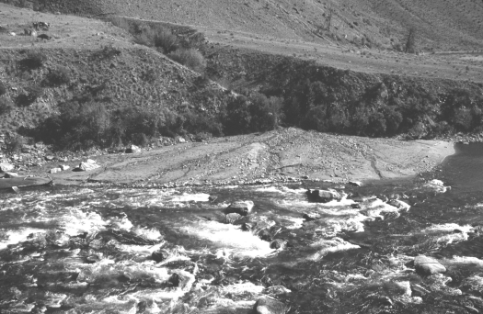

Haystack Rapid on the lower Middle Fork Salmon River at low water in 0ctober I997. The eroded toe of the Pole Creek fan of prob able last-glacial age forms the far bank. A fresh debris fan deposited in August I997 extends from the incised Pole Creek channel. The rapid is choked with granitic boulders deposited in previous larger debris-flow events. Photo by Matt E. Leidecker.

