Glacial Geology of the Southeastern Sawtooth Mountains

Jennifer A. Borgert

Department of Geology, Idaho State University, Pocatello, Idaho 83209
Kari A. Lundeen
Department of Geology, Idaho State University, Pocatello, Idaho 83209
Glenn D. Thackray
Department of Geology, Idaho State University, Pocatello, Idaho 83209

ABSTRACT
Major valleys of the southeastern Sawtooth Mountains con- tain evidence of glacier fluctuations during the last (Wisconsinan) glacial cycle. The lower portions of the Alturas, Pettit, Yellow Belly, and Hell Roaring valleys each contain seven to nine dis- tinct moraines. Pedologic and morphologic evidence indicates that these moraine sequences record at least two and probably three distinct stadial events. Pedologic data indicate three mo- raine groups in the Alturas Valley. Depths to B horizon show a clear relationship with the downvalley moraine sequence, rang- ing from 3 to 15 cm. Thickness of B horizons show a similar rela- tionship, ranging from 13 to 33 cm. With each set of data, the oldest moraine group is more distinct from the younger two groups than are the younger two groups from each other. We infer that this relationship indicates that the oldest group is more widely separated in age from the younger two. Morphologic indices from the Alturas Valley moraines suggest only two age groups. How- ever, moraine profiles from the four valleys show three distinct groups: a downvalley group of broad, voluminous, gently slop- ing moraines, a group of smaller moraines with rounded crests, and an upvalley group of small, sharp-crested moraines. We infer that the moraine sequence records two to three distinct stadial events during the last glacial cycle, including one event that oc- curred much earlier in the glacial cycle than the other two events.

INTRODUCTION
The Sawtooth Mountains were extensively glaciated during successive Pleistocene glaciations. The extensive Sawtooth high

country represents a strong orographic barrier to winter storms originating in the northeast Pacific Ocean and, during the Pleis- tocene glaciations, represented a large accumulation area for gla- cial ice. Glaciers filled major river valleys in the Sawtooth Moun- tains and, in many cases, extended beyond the eastern range front to construct piedmont moraine belts and alluvial fill sur- faces in the adjacent basins. The spectacular topography and extensive geomorphic record of glaciation on the eastern flank of the range have attracted repeated investigation into the glacial history of the Sawtooths, with each effort resulting in more de- tailed understanding of that history. Previous investigators mapped and defined major morphologic units within the pied- mont moraine complex in the Sawtooth Valley and Stanley Basin, distinguishing features produced by glaciers of Bull Lake and Pinedale age in both the Sawtooth and White Cloud Mountains. Prompted by interest in glacial chronologies that can constrain details of regional and global climatic processes, we have built on the efforts of previous workers and report here the initial results of our recent work on the southeastern flank of the Sawtooth Mountains. We have extended previous mapping from the pied- mont moraine complex into the middle portions of four major val- leys (Figure 1), collected morphometric and pedologic data on numerous moraines in those valleys, and begun to construct a numerical chronology of glacial events. Our work demonstrates that the moraine sequence records at least two, and probably three, distinct glacial episodes during the last glaciation, and re- veals a much more complex glacial history than has been previ- ously envisaged.

Borgert, I.A., Lundeen, K.A., and Thackray, G.D., 1999, Glacial Geology of the Southeastern Sawtooth Mountains, in Hughes, S.S., and Thackray, G.D., eds., Guidebook to the Geology of Eastern Idaho: Pocatello, Idaho Museum of Natural History, p. 205-217.

Previous Investigations
Previous investigators defined major Quaternary map units on the eastern flank of the Sawtooth Mountains. Williams (1961) used observations of soil development and erosional modifica- tion to distinguish moraines of two glaciations along the ca. 50 km of mountain front between Stanley Lake and the southern end of the Sawtooth Valley near Galena Pass. He correlated the Sawtooth glaciations to those in the Rocky Mountain glacial model (i.e. Bull Lake and Pinedale; Blackwelder, 1915). Breckenridge et al. (1988) refined Williams' (1961) map and ex- tended it to glacial features on the east side of the Sawtooth Valley, constructed by glaciers originating in the White Cloud Mountains. In the Fourth of July Creek area, they used weather- ing rind and other relative weathering criteria to distinguish land- forms and deposits of three distinct glaciations, implying that the two younger events postdated the last glaciation. While both of these investigations produced invaluable information concern- ing Pleistocene glaciation in the Sawtooth Mountains, their fo- cus was limited to moraines extending beyond the range front. In keeping with the focus of our project on events during the last glacial cycle, we use the mapping of Williams (1961) and Breckenridge et al. (1988) as a starting point for our mapping, and as a means of distinguishing moraines constructed during the last glaciation from those of previous glaciation(s).
Stanford (1982) mapped glacial features in the upper South Fork Payette River Valley, and extensive mapping was also com- pleted in adjacent ranges (the Boulder, White Cloud, and Pioneer Mountains) by Lehigh University graduate students in the 1970's and 1980's. This mapping resulted in the construction of the Idaho glacial model of Evenson et al. (1982). The Idaho glacial model formalizes nomenclature and correlations for Middle and Late Pleis- tocene glacial units. The glacial units of interest to the proposed project are the Potholes and Copper Basin drifts, corresponding to the Pinedale and Bull Lake drifts, respectively, in the Rocky Mountain glacial model (Blackwelder, 1915). The large body of work summarized by Evenson et al. (1982) provides an extensive base of relative weathering data and correlations, and establishes a regional framework within which to view the Sawtooth Moun- tains sequence.
Colman and Pierce (1986) conducted a detailed study of the glacial record in Long Valley near McCall, Idaho. They used weath- ering rind, soil, and moraine morphometry data to distinguish moraines of Pinedale, Bull Lake, and pre-Bull Lake ages. Very few numerical age data exist for glacial sequences in central Idaho. Cotter et al. (1986) described a sediment core from a kettle in glacial deposits at the foot of the White Cloud Range, the range immediately east of the Sawtooth Mountains. That core yielded Mazama and Glacier Peak B tephras, establishing a minimum age of ca. 11,250 yr BP for the last glaciation. Bloomfield (1983) com- pleted a detailed study of tephra units exposed in the area, de- scribing Mt. St. Helens S (ca. 13,600-13,300 yr BP) and Ye (ca. 4,350 yr BP) ash deposits in addition to Mazama (ca. 6,600 yr BP) and Glacier Peak B (ca. 11,250 yr BP) deposits.

Nomenclature
To avoid potential errors in long-range correlation of glacial units, we establish and utilize a local stratigraphic terminology for
most of our discussion. That terminology is based on informal allostratigraphic (landform) units established in the Alturas Val- ley (below), and we subsequently propose correlations to other regional terminologies. All radiocarbon dates are reported in uncalibrated radiocarbon years.
We discuss possible moraine ages in the context of the marine oxygen isotope record of global ice volume as described by Imbrie et al. (1984) and Martinson et al. (1987). We use the term "last glacial cycle" to refer to the entire period between the last interglaciation (moraine oxygen isotope substage 5e) and the Holocene (isotope stage 1). The last glacial cycle thus includes possible advances during isotope stages 5d, 5b, 4, 3, and 2. Dur- ing this period, spanning ca. 105,000 to 10,000 yr BP, global ice volume was consistently greater than at present (e.g. Porter, 1989, Fig. 1), and multiple episodes of alpine glacial expansion occurred (see review by Gillespie and Molnar, 1995).

ALTURAS VALLEY GLACIAL SEQUENCE
The Alturas Valley glacial sequence serves as a type sequence for the eastern Sawtooth Mountains. Previous mapping of the area (Williams, 1961; Breckenridge, 1988) focused primarily on the large, outermost moraines of each drainage that project eastward into the Sawtooth Valley. Mapping for this project builds on those previous investigations and includes original mapping of glacial features and deposits in the upper portions of the Alturas Valley (including and upvalley of Perkins Lake, Fig. 1). Williams (1961) and Breckenridge (1988) both mapped the large, outer moraines of the valley as Pinedale age deposits.
The glacial sequence consists of eight distinct moraines (Figs. 1 and 2). These moraines, mapped on aerial photographs at a scale of 1:42,000, are distinguished on the basis of morphologic properties. The oldest are the Busterback Ranch I, II, and III mo- raines. Located upvalley from these moraines, in the vicinity of Alturas and Perkins Lakes, are the Cabin Creek, Perkins Lake, and Alturas Lake moraines. The Eureka Gulch and Alpine Creek mo- raines are the smallest and furthest upvalley, lying approximately 2 km and 3½ km, respectively, upvalley of Alturas Lake (Fig. 1).

Busterback Ranch Moraines
There are three Busterback Ranch moraines, designated Busterback Ranch I, II, and III. These moraines are the oldest in the Alturas Valley glacial sequence, and they form the large, well- defined end moraine belt at the northeast end of the Alturas Val- ley where it merges with the broad Sawtooth Valley (Fig. 2). These moraines display typical moraine morphology-broad, hummocky crests with gently sloping proximal and distal sides. They are the largest of the Alturas Valley moraines, with vertical relief of 8 m, 15 m, and 25 m respectively, and overall widths of 50 m, 155 m, and 308 m respectively.
Busterback Ranch moraines are also associated with broad outwash terraces that fill breaches in the moraines in several loca- tions. The largest of these terraces is associated with the Busterback Ranch I advance. This broad terrace stretches north from the end moraines and merges with the broad outwash sur- face that fills most of the Sawtooth Valley.

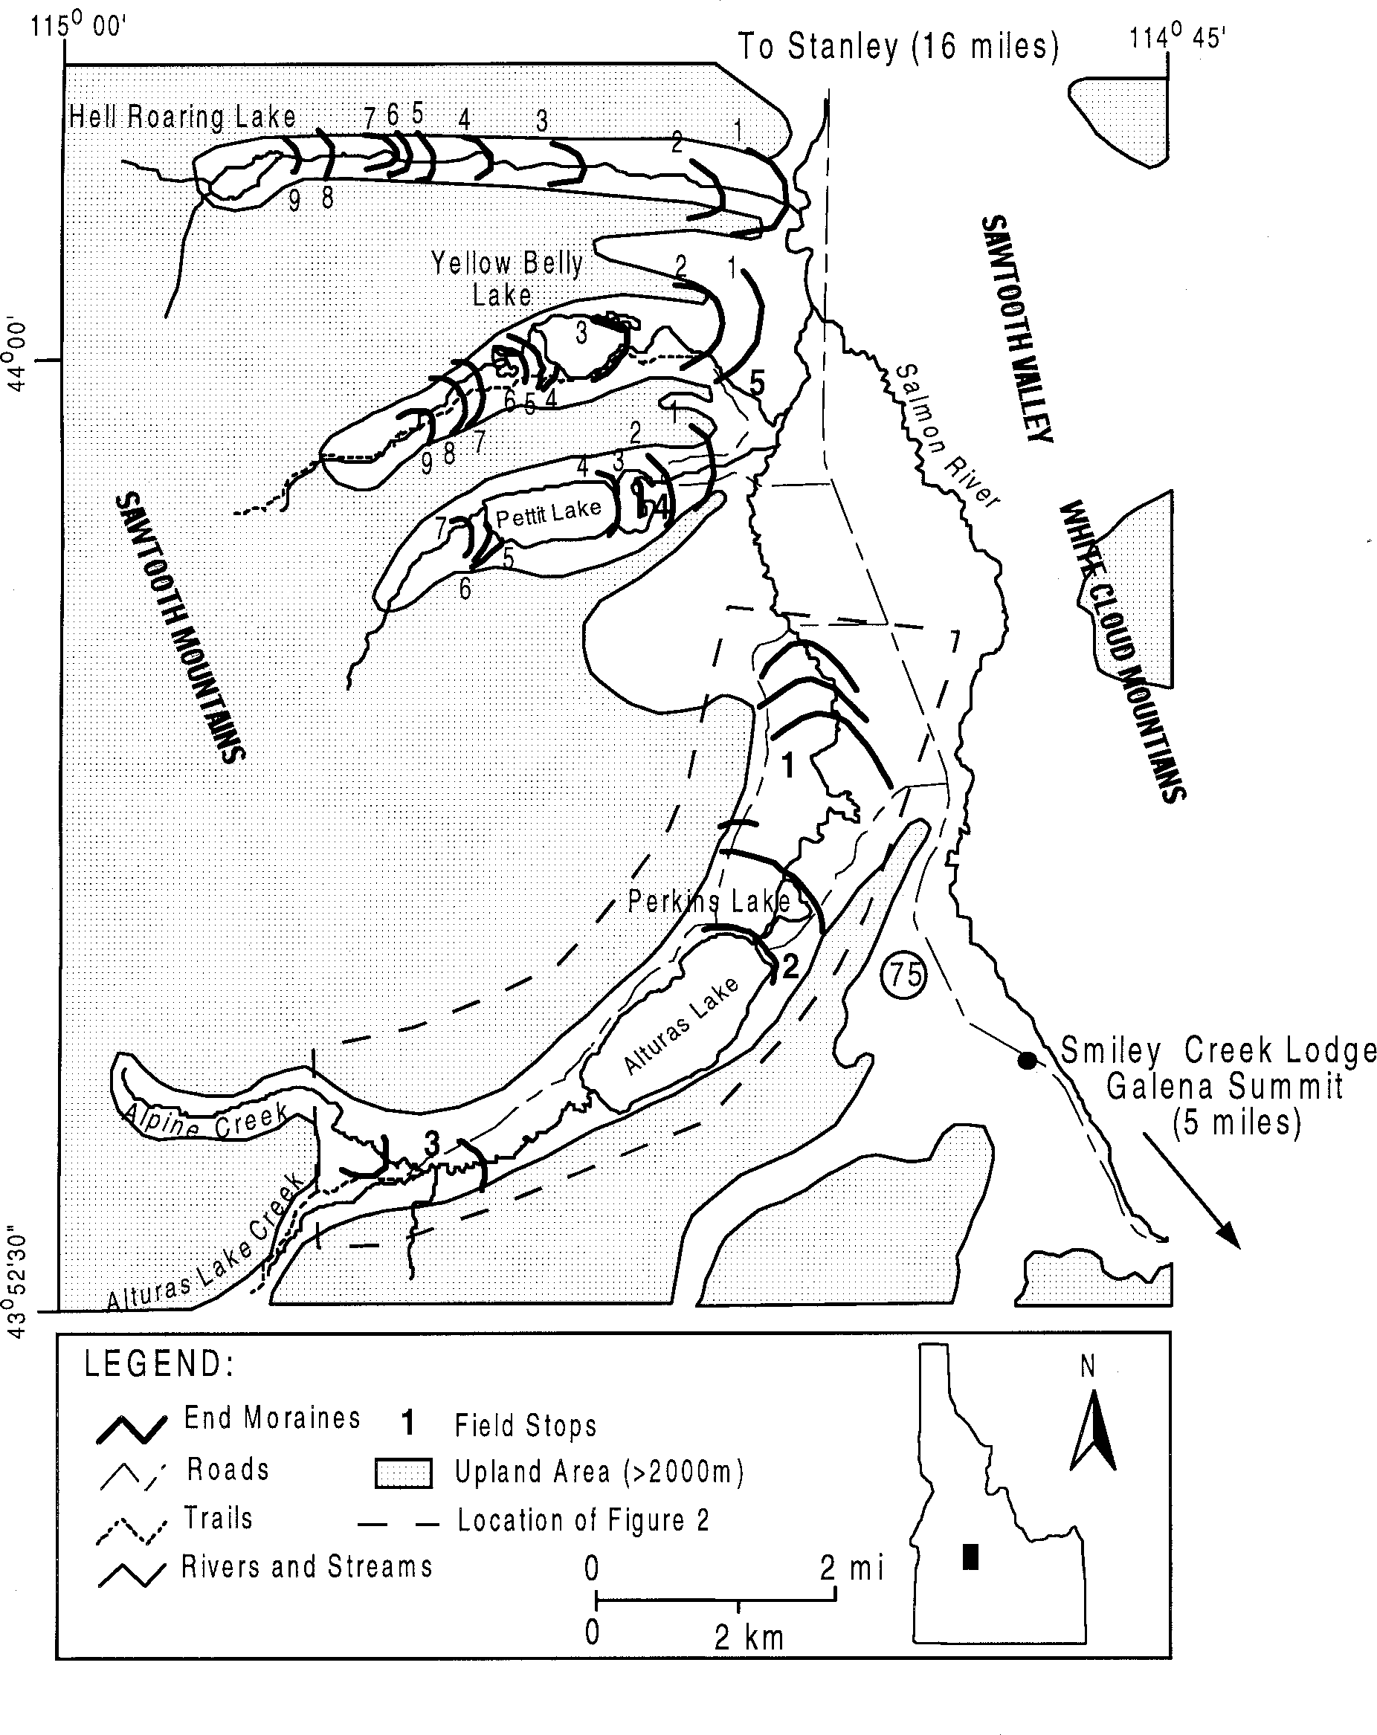
Figure 1. Location map showing major valleys, moraines, and road log stops. Numbers on end moraines refer to moraine sequence correlations for Pettit, Yellow Belly, and Hell Roaring valleys.

Cabin Creek Moraine
The Cabin Creek moraine is the least well preserved moraine of the Alturas Valley glacial sequence. The only remaining surficial evidence is a small lateral moraine remnant on the west side of the valley, just upvalley and adjacent to the Busterback Ranch III moraine. It lacks both a prominent end moraine and associated outwash terrace.

Perkins Lake Moraine
The Perkins Lake moraine is located about 1.8 km upvalley from the Busterback Ranch III moraine, forming the downvalley margin of Perkins Lake (Fig. 2). Two small portions of this end moraine remain. The larger of the two extends from the southeast side to the northwest side of Perkins Lake. It is approximately 0.5 km long, 6.5 m high, and has an overall width of only 10 m-the

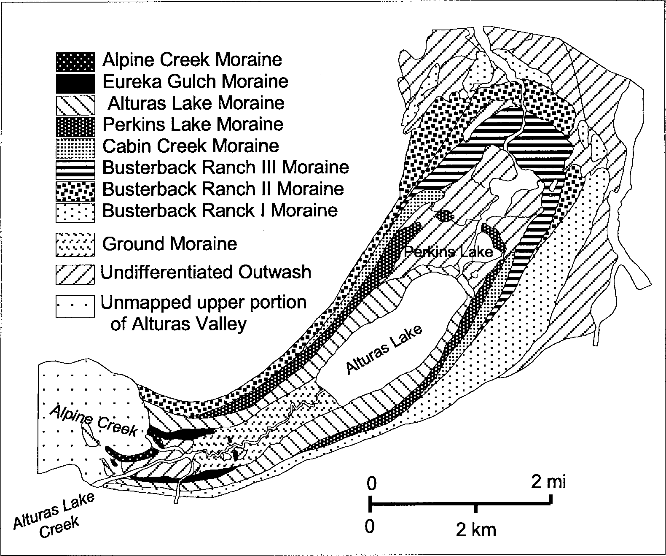

Figure 2. Alturas Valley glacial sequence. See Figure 1 for location.

narrowest of all moraines in the valley. However, human activity and construction on the southwest side of the moraine may be the cause of this unusually narrow crest. The other remnant of this moraine is a small (about 0.25 km long) ridge located approxi- mately 0.5 km west of the larger ridge.

Alturas Lake Moraine
The Alturas Lake moraine consists of lateral moraines and an end moraine wrapping almost completely around the northeast end of Alturas Lake (Fig. 2). Set about 0.8 km upvalley from the Perkins Lake moraine, this is also a low-relief moraine. It has ver- tical relief of only 7.5 m and an overall width of about 24 m, but it is relatively complete and well-defined around the entire north- east end of the lake.

Eureka Gulch Moraine
The Eureka Gulch moraine lies about 5 km upvalley from the Alturas Lake moraine. There are only two small ridges remaining from this end moraine; the more prominent of the two ridges lies on the south side of the valley. It has a vertical relief of 7.5 m, and an overall width of about 45 m. A small outwash terrace can be traced for about 0.15 km beyond the moraine. The Eureka Gulch moraine also continues on the north side of Alturas Lake Creek as a much more subdued ridge with no obvious, mappable outwash plain.

Alpine Creek Moraine
The Alpine Creek moraine is the youngest in the Alturas Val- ley glacial sequence. This moraine is actually a series of small, closely spaced moraine ridges. The largest of these ridges lies about 1.3 km upvalley of the Eureka Gulch moraine at the confluence of the Alpine Creek and Alturas Lake Creek valleys. It has a vertical relief of 5 m, and an overall width of ca. 34 m.
Approximately 0.3 km upvalley from this group of small mo- raine ridges are lateral moraine ridges correlated with the larger, downvalley moraines. These ridges reflect glaciers flowing out of the Alpine Creek valley, spreading out at the confluence, and blocking Alturas Lake Creek valley (Fig. 1). This sequence shows that, at maximum glacial conditions, ice from the Alpine Creek valley filled the area at the confluence and flowed a short dis- tance up Alturas Lake Creek valley. This suggests that there was no ice contributing to the Alturas Valley glaciers from the Alturas Lake Creek valley. Aerial photographs show a high, flat platform with many cirques and other erosional landforms at the head of the Alpine Creek valley, while the Alturas Lake Creek valley shows no obvious ice accumulation areas.

Summary
The Alturas Valley preserves a sequence of eight end mo- raines of varying size, shape, complexity, and preservation. The characteristics of these moraines are broadly similar to those in

Table 1. Summary of moraine morphometry relative dating results for Alturas Valley, Pettit Valley, Yellow Belly Valley, and Hell Roaring Valley moraines.

Crest Proximal Distal Crest Moraine Angularity Slope Slope Width
( ) ( ) ( ) (m)

Alturas Valley
Busterback Ranch I | 1.5 | 11.3 | 7.3 | 36.8
Busterback Ranch II | 5.5 | 11.8 | 12.0 | 24.8
Busterback Ranch III | 6.0 | 6.5 | 13.6 | 21.7
Perkins Lake | 4.7 | 16.2 | 16.3 | 17.7
Alturas Lake | 1.5 | 16.5 | 13.1 | 29.8
Eureka Gulch | 3.5 | 16.1 | 8.5 | 55.9
Alpine Creek  Pettit Valley | 4.3 | 20.9 | 16.7 | 21.8
Pettit 1 | 3.7 | 14.5 | 6.2 | 29.8
Pettit 2 | 2.3 | 7.8 | 4.0 | 51.0
Pettit 3 | 2.3 | 6.8 | 12.6 | 29.8
Pettit 4 | 3.7 | 12.1 | 4.3 | 27.7
Pettit 5 | 7.0 | 9.6 | 14.5 | 15.6
Pettit 6 | 8.0 | 16.2 | 12.0 | 11.7
Pettit 7 | 12.0 | 14.4 | 14.7 | 11.6
Yellow Belly Valley
Yellow Belly 1 | 1.6 | 18.6 | 13.8 | 19.7
Yellow Belly 2 | 1.0 | 19.4 | 9.6 | 29.7
Yellow Belly 3 | 3.0 | 12.7 | 12.9 | 23.5
Yellow Belly 4 | 4.3 | 9.3 | 9.7 | 29.8
Yellow Belly 5 | 4.6 | 8.0 | 13.2 | 19.7
Yellow Belly 6 | 5.6 | 5.9 | 13.0 | 29.6
Yellow Belly 7 | 10.0 | 13.6 | 8 | 19.6
Yellow Belly 8 | 7.0 | 12.5 | 15.8 | 17.5
Yellow Belly 9  Hell Roaring Valley | 3.0 | 18.9 | 4 | 69.4
Hell Roaring 1* | n/a | n/a | n/a | n/a
Hell Roaring 2 | 2.0 | 8.9 | 14.3 | 31.8
Hell Roaring 3 | 1.6 | 18.8 | 18.9 | 25.7
Hell Roaring 4 | 2.0 | 9.8 | 15.6 | 31.8
Hell Roaring 5 | 3.0 | 13.6 | 10.5 | 21.6
Hell Roaring 6 | 3.7 | 14.8 | 5.7 | 29.6
Hell Roaring 7 | 7.3 | 7.4 | 15.4 | 23.6
Hell Roaring 8* | 5.0 | n/a | 20.6 | n/a
*Morphometric data are not availa le for Hell Roaring 1, Hell Roaring , and Ca in Cree moraines.

other valleys. It is likely that some, but not all, of these moraines represent recessional stillstands or slight readvances and, thus, that they are closely related in age with downvalley moraines. In order to understand the stratigraphic and paleoclimatic signifi- cance of these moraine sequences, it is important to understand age relationships between moraines.

RELATIVE DATING
We have used relative weathering criteria to investigate age
Table 2. Summary of soil development relative dating results for Alturas Valley. Averages are listed in bold letters.

Depth to Thickness of
Moraine B horizon (cm) B horizon (cm)

Busterback Ranch I | 15.0 | 22.0
 | 16.0 | 30.0
 | 15.5 | 26.
Busterback Ranch II | 18.0 | 28.0
 | 12.0 | 20.5
 | 15. | 2 .
Busterback Ranch III | 9.0 | 27.0
 | 10.0 | 38.0
 | 9.5 | 2.5
Cabin Creek* | 4.5 | 26.0
Perkins Lake | 9.0 | 18.0
Alturas Lake | 5.0 | 19.5
 | 6.5 | 18.0
 | 5.75 | 18.75
Eureka Gulch | 4.5 | 14.0
 | 4.5 | 16.0
 | .5 | 15.
Alpine Creek | 3.5 | 13.0
 | 3.0 | 14.0
 | .25 | 1 .5
*Ca in Cree horizons were not measured in the same setting as the other moraines. They were measured on a slight slope rather than flat ground, and in an area of grassy, rather than coniferous, vegetation.

relationships within the Alturas Valley, Pettit Valley, Yellow Belly Valley, and Hell Roaring Valley moraine sequences (Fig. 1). In their landmark study of relative weathering parameters on Sierra Nevada moraines, Burke and Birkeland (1979) emphasized the use of a multiparameter approach. In keeping with that perspective, we have used two groups of relative weathering parameters- moraine morphometry and soil development. Although ambigu- ous in some cases, these data do provide a means to separate eight moraines into groups of similar relative ages.

Moraine Morphometry
The basis for moraine morphometry measurements is the as- sumption that when moraines are originally constructed, they have a relatively sharp, narrow crest and steep slopes (Kaufman and Calkin, 1988). As weathering and erosion take place, the crest becomes wider and increasingly flat, and slope angles decrease. Measuring morainal slope angles and constructing profiles al- lows us to determine the width and relative sharpness of moraine

Table . Summary of some of the previous work conducted on the glacial geology of the Sawtooth Mountains and surrounding areas. Both Idaho glacial model (established in central Idaho) and Rocky Mountian glacial model (established in the Wind River Range of Wyoming) nomenclature are provided for reference.
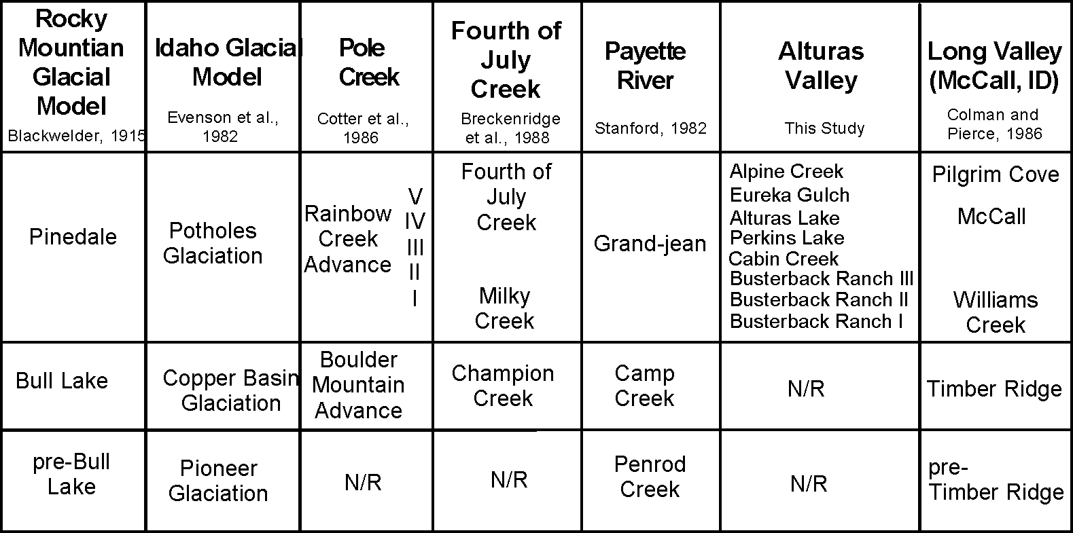

crests, as well as average slope angles, and use this information to estimate relative ages of the moraines and group them accord- ingly.

Methods
Morphometric profiles were measured in the field using a Brunton pocket transit and one- and two-meter lengths of PVC pipe. Transects were measured across relatively unobstructed locations near the center of the end moraine. Slope readings were taken at 1-meter intervals for steep portions of the moraine and at 2-meter intervals for more gently sloping sections (i.e. across the moraine crest). Slope angle readings were then used to create a topographic profile for the transect location. Several indices based on these slope angle readings and topographic profiles were cal- culated and compared:

- Crest Angularity: The average slope angle across six lin- ear meters of the moraine crest.
- Proximal Slope: The slope of the midsection (about 10 meters long) of the proximal side of the moraine (Colman and Pierce, 1986).
- Distal Slope: The slope of the midsection (about 10 meters long) of the distal side of the moraine (Colman and Pierce, 1986).
- Crest Width: The horizontal distance between two points
1.5 meters below the crest on either side of the crest (Colman and Pierce, 1986; Kaufman and Calkin, 1988).

Results and Discussion
Results from the crest angularity and proximal slope indices show largely systematic progressions with stratigraphic age (Table 1); however, only one parameter per valley proves to be useful for separating relative age groups.
In the Alturas Valley, the proximal slope index shows a general decrease in slope with increased relative age. In addition, this
general trend shows three distinct relative age groupings (Fig. 3a). One group consists of the two oldest moraines-Busterback Ranch I and II. Busterback Ranch III is clearly an outlier of the general trend, and could possibly be grouped with these mo- raines. The second group of moraines consists of the Perkins Lake, Alturas Lake, and Eureka Gulch moraines, while the Alpine Creek moraine appears to represent a third group. The crest angu- larity measurements do not show a pattern in Alturas Valley.
In Pettit Valley, Yellow Belly Valley, and Hell Roaring Valley, the crest angularity data show a general increase in crest sharp- ness with decreased age (Table 1, Figure 3b, 3c, 3d). Proximal slope measurements from these three valleys do not show any clear trend.
The moraine angularity index is reflected visually in the mo- raine profiles (Fig. 5). Pettit Valley moraines 1 and 2 are broad with rounded crests (Table 1, Fig. 5). Moraines 3, 4, and 5 are smaller but also have rounded crests. Moraines 6 and 7 have much sharper crests. Similar patterns are discernable in Yellow Belly and Hell Roaring Valleys. Moraines 1 and 2 in Yellow Belly are broad with rounded crests; moraines 3, 4, 5, and 6 are small with rounded crests; and moraines 7 and 8 have sharp crests. Moraine 9 is a larger moraine with an anomalously broad crest. However, the morphology of this moraine appears to have bedrock influence. The broad outer moraine of Hell Roaring Valley was not mea- sured. However, moraines 2 through 8 show similar roundness and angularity trends. Moraines 2, 3, 4, 5, and 6 are small moraines with rounded crests. Moraines 7 and 8 have sharp crests, al- though the angularity measurement for moraine 8 was based on a distal slope measurement only. Based on these angularity mea- surements, we suggest three age groupings for the Pettit, Yellow Belly, and Hell Roaring valleys based on morphometry. The broad outer moraines represent the oldest age group, possibly repre- senting the earliest Wisconsin advance. The smaller, rounded moraines up valley may represent a second age grouping, and the small sharp crested moraines farthest up valley may represent a third, youngest age group.

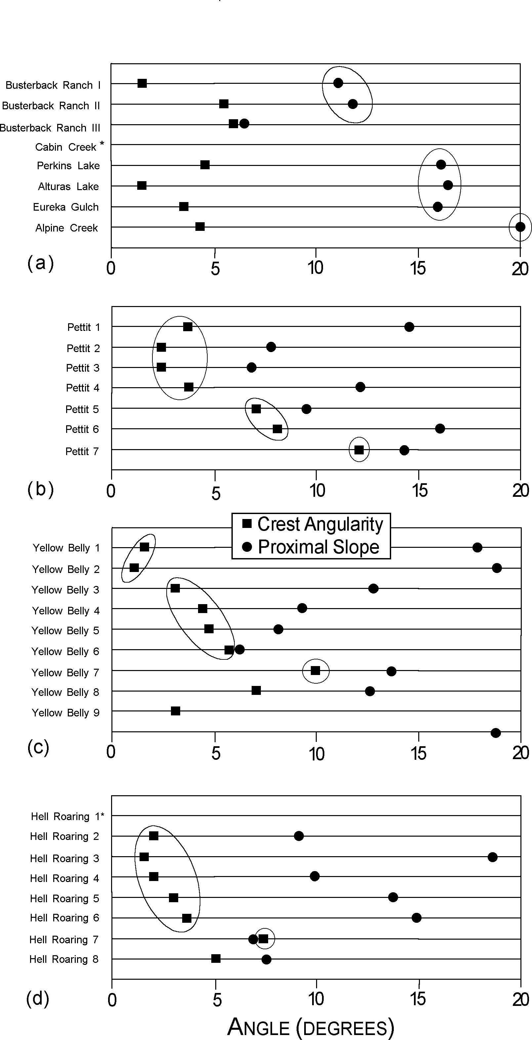
Borgert and others -- Glacial Geology of the Southeastern Sawtooth Mountains
211

Soil Development

Methods
One or two soil pits were dug on each moraine in the Alturas Valley. Pits ranged in depth from 0.6 to 1.2 meters, and were dug on horizontal, stable surfaces under similar vegetation conditions (coniferous forest). The soil pit dug on the Cabin Creek moraine was not dug in the same setting as the other pits. Since only a small portion of this moraine remains, our sampling locations were limited. As a result, this pit was dug on a gentle (about 10o) slope rather than a flat surface, and was dug in an area of grassy veg- etation rather than coniferous forest. Therefore, these results may not be comparable with other soil pits. Soils were described in the field according to methods defined by Birkeland (1984). Soil hori- zons were distinguished based on color and texture. Typically, A horizons are silty clay loams, and dark gray to black in color. B horizons are generally sandy clay loams or sandy loams, and richer in iron oxide with a distinctive red-brown color. C horizons are mostly sand and gravel and medium gray in color.
Two soil development indices were used to distinguish rela- tive ages-depth to B horizon and thickness of B horizon. Re- sults of the soil development analysis are listed in Table 1 and plotted in Figure 4. For moraines on which two soil pits were dug, both measurements are listed along with the average of those measurements in bold type.

Results and Discussion
Both the depth to B horizon and the thickness of horizon B indices show a general decrease with decrease in age (Table 2). Data from both of these measurements also show a tendency toward three relative age groups; however, the exact members of each group varies with the soil development index used (Fig. 4). Data from the depth to B horizon index show that the oldest group includes the Busterback Ranch I and II moraines. The Busterback Ranch III, Cabin Creek, and Perkins Lake moraines fall into another group, while the Alturas Lake, Eureka Gulch, and
Alpine Creek moraines comprise the third group.
Thickness of B horizon data show a slightly different configu-

Figure 3. Results of morphometric analysis of moraines for Alturas Valley (a), Pettit Valley (b), Yellow Belly Valley (c), and Hell Roaring Valley (d). "Crest angularity" is defined as the average slope of the moraine crest over the top six meters. "Proximal slope" is the slope of the midsection (about 10 meters long) of the proximal side of the moraine. Alturas Valley moraines can be divided into three groups based on proximal slope characteristics, while Pettit Valley, Yellow Belly Valley, and Hell Roaring Valley moraines are subdi- vided based on the crest angularity index. (*Morphometric data are not available for Cabin Creek and Hell Roaring 1 moraines.)

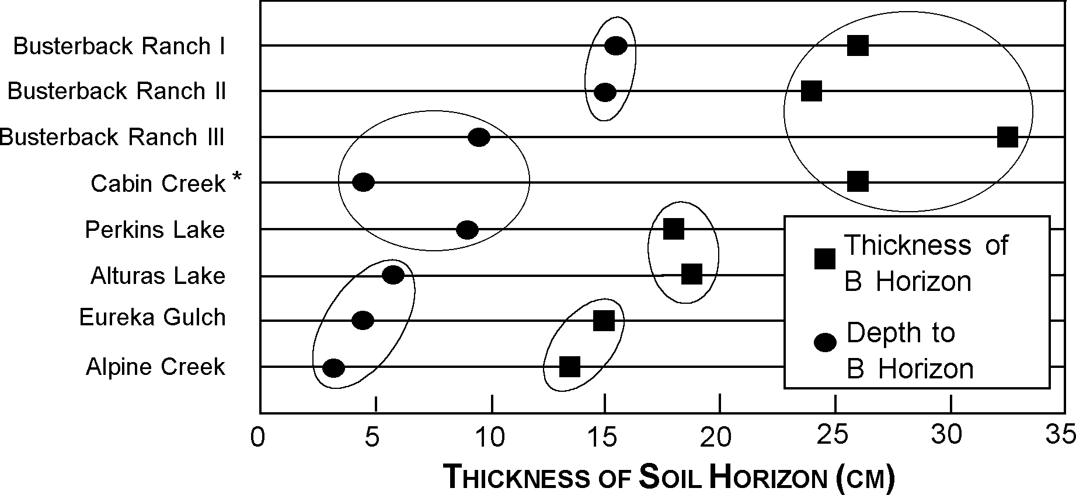
Figure 4. Results from Alturas Valley soil development analysis. Three relative age groups are distinguishable for each index. Obvious outliers are grouped with surrounding moraines. (*Cabin Creek horizons were not measured in the same set- ting as the other moraines. It was measured on a slight slope rather than flat ground, and in area of grassy vegetation rather than coniferous.)

ration of groups. The Busterback Ranch moraines and the Cabin Creek moraine make up the oldest group, while the Perkins Lake and Alturas Lake moraines make up another, and the Eureka Gulch and Alpine Creek moraines form the third.
In addition to measuring the morphometric and soil develop- ment characteristics of these moraines, we also attempted to quan- tify the boulder weathering and frequency characteristics of each moraine. However, it became apparent early on that these param- eters were not going to help define divisions of relative age. Mea- surements of boulder frequency showed no relation to strati- graphic age, nor did boulder weathering show age trends. Boul- ders on all Alturas Valley moraines are relatively fresh, rounded, and rarely display fractures.

Discussion
Relative age groupings from relative morphometric and ped- ologic data overlap. No two indices show exactly the same group- ings of moraines. There are two potential explanations. First, each relative dating index measures a different process (e.g. slope denu- dation, soil horizonation, soil iron illuviation). Each process has had the same amount of time to operate; however, the rates at which these processes operate varies from one to another, as does the potential for measurable distinction. Secondly, the lim- ited data set does not permit statistical analysis and distinction of moraine groups. Time did not allow for more than two soil pits per moraine or more than one morphometric profile per moraine.

Although the relative age groupings themselves may over- lap, the data consistently suggest that multiple age groups do exist in the Alturas Valley. This pattern suggests that these mo- raines do not simply record a single glacial advance with reces- sional still stands. If that were the case, the moraines would be of nearly the same age, and the pedologic and morphologic indices should not vary as observed. If multiple advances are indeed responsible for these moraines, the timing of those advances will be an important detail. In order to get two or possibly three sepa- rate advances in this valley-distinguishable through relative weathering criteria-a longer time frame than the last 20,000 years is almost certainly needed. This conclusion suggests an advance (or advances) prior to the Last Glacial Maximum (defined as the peak of marine oxygen isotope stage 2, ca. 18,000 14C yr BP), possibly middle or even early Wisconsinan in age. Radiocarbon dates on organic material taken from sediment cores in this valley will help to test these preliminary conclusions.

Summary of Relative Age Data
The apparent moraine age relationships revealed in relative weathering data suggest multiple glacial advances spanning the last glacial cycle. With all relative weathering criteria (Tables 1 and 2; Figs. 3, 4, and 5), the oldest moraines studied appear to be substantially older than the younger moraines: the older moraines are wide and have gentle slopes and well developed soils. Younger moraines may be very closely spaced in age (as suggested by slope angle data in the Alturas Valley) or of distinct ages (as suggested by soil data and the sharpness of moraine profiles). Thus, the relative weathering data indicate at least two, and prob- ably three distinct advances during the last glaciation. It must be
noted that moraines predating and postdating the last interglaciation are readily distinguished on the basis of soil de- velopment and moraine degradation (Williams, 1961; Breckenridge et al., 1988). Moraines mapped as Bull Lake by those workers in other drainages (e.g. Redfish) exhibit very subdued morphology, in strong contrast to the rugged, complex, and well preserved morphology of moraines mapped as Pinedale. The contrasts in morphologic character between the moraines we have studied are much more subtle than are the contrasts between these moraines and those mapped by others as Bull Lake. Thus, we are confident that the moraine data presented above pertain solely to events of the last glacial cycle.

I™PLICATIONS FOR REGIONAL STRATI- GRAPHIC CORRELATION AND PALEOCLI™ATIC INTERPRETATION
The interpretations presented above for moraine sequences in the southeastern Sawtooth Mountains bear upon regional strati- graphic correlation and regional paleoclimatic interpretation. Spe- cifically, the distinction of at least two, and probably three, mo- raine age groups, when correlated with other glacial records in the area (Table 3), prompts consideration of the paleoclimatic con- trols on glaciation in this portion of the Rocky Mountains.
Previous workers have similarly identified multiple-moraine sequences for the last glacial cycle, and one previous glaciation, in surrounding ranges. Evenson et al. (1982) used relative weath- ering criteria to subdivide moraine sequences in the Pioneer Moun- tains and construct a stratigraphic model for glaciation in Idaho. They distinguished landforms and sediments of two major glacia- tions-Copper Basin and Potholes-corresponding to Bull Lake and Pinedale features, respectively, in the Rocky Mountain gla- cial model originally described by Blackwelder (1915) and modi- fied by Mears (1974). In multiple Pioneer Mountain drainages, Evenson et al. (1982) delineated evidence of three distinct ad- vances during the Potholes glaciation, each geomorphically dis- tinct and associated with a distinct outwash terrace sequence.
Multiple Potholes-age advances were also delineated in drain- ages of the White Cloud Mountains, which lie immediately east of the Sawtooth Mountains across the Sawtooth Valley. Breckenridge et al. (1988) identified a three-moraine sequence in the Fourth of July Creek drainage. Soils on those moraines sug- gest that the oldest moraines represent Copper Basin/Bull Lake glaciation, and that the other two record distinct phases of the Potholes/Pinedale glaciation. Bloomfield (1983) mapped five Pot- holes/Pinedale-age moraines constructed by glaciers descend- ing Pole Creek. Pole Creek enters the Sawtooth Valley southeast of Alturas Lake, and maximum Potholes moraines in the two drain- ages lie only ca. 5 km apart. Based on the low, topographically- subdued character of the four upvalley moraines, Bloomfield (1983) concluded that the moraine sequence represents a single advance, with the four upvalley moraines representing recessional stillstands rather than distinct readvances. Relative weathering data were not collected for this sequence, however, and it is con- ceivable that the moraines and associated outwash terraces rep- resent multiple, distinct advances. Colman and Pierce (1986) de- lineated three moraine groups for the last glacial cycle. From rind thickness data, they estimated ages of 60 ka, 20 ka, and 14 ka for

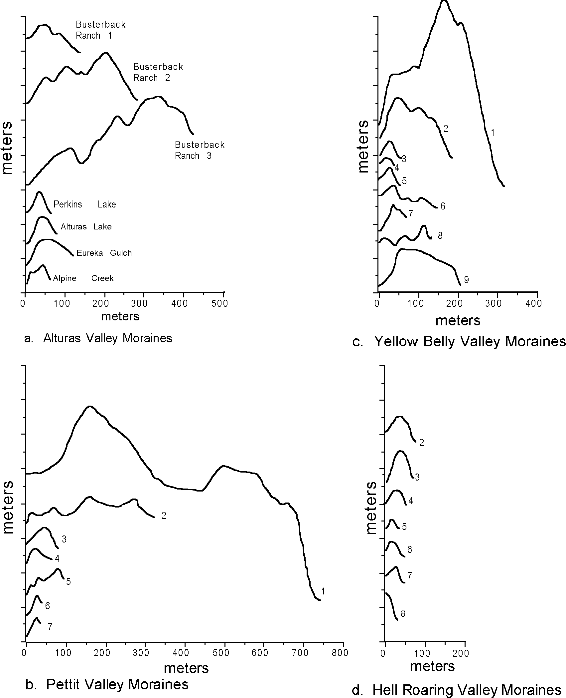

Figure 5. Moraine profiles from Alturas, Pettit, Yellow Belly, and Hell Roaring Valleys. Note consistent pattern in each valley (older to younger) of voluminous, high, outer moraines, and small sharp crested moraines. Moraines are numbered sequentially in each valley (1=oldest). Numbers are not meant to imply correlation between valleys. 10x vertical exaggera- tion. Vertical scale marked in 10 m intervals.

the Williams Creek, McCall, and Pilgrim Cove moraines, respec- tively.
Without chronologic data to place the Sawtooth moraine se- quence in a clear time framework, the moraine data suggest sev- eral possible age relationships. First, given the distinct morpho- logic and pedologic character of the voluminous downvalley moraines, we infer that they record an early Wisconsin glaciation (oxygen isotope stages 5d, 5b, or 4). It is also possible that those moraines represent middle Wisconsin advances (isotope stage 3), but we consider it unlikely that they are of late Wisconsin age
(isotope stage 2). The smaller moraines upvalley can be split into two groups based on morphometric data (and pedologic data in the Alturas Valley). However, these two groups are less distinct from one another than are they from the voluminous downvalley moraines. Thus, we infer that they represent two separate epi- sodes of glacial activity, but that those two episodes were not widely separated in time. It is likely that the two groups represent advances during middle and late Wisconsin time (isotopic stages 3 and 2), or that they solely represent distinct phases of late- Wisconsin glacier fluctuations.

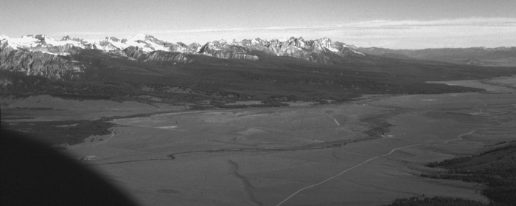

Figure 6. Aerial view of Sawtooth Valley from near Galena Summit. View to the north- west.
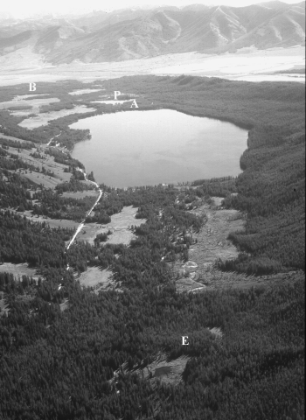
In summary, we consider it likely that the Sawtooth Mountain glacial-geomorphic sequence, and at least some glacial-geomor- phic sequences in surrounding ranges, indicate multiple advances during the last glacial cycle. This pattern is of potential impor- tance for understanding of regional climatic patterns during Late Pleistocene time. Clearly, radiometric dating of glacial deposits in the Sawtooth Mountains and surrounding areas is necessary to test these ideas. A current lake coring project should provide the necessary chronology, as well as palynologic data that will fur- ther constrain precipitation and temperature patterns during late Pleistocene time.

ROAD LOG

Accumulated/Incremental Mileage
0.0 (0) Galena Summit, elevation 8701 feet. Piedmont mo- raines of the Alturas, Pettit, and Yellow Belly val- leys can be seen in the distance (Figure 6). Drive west to Sawtooth Valley.
3.0 (3.0) Road cut exposure of Pole Creek moraines. Descrip- tion of the glacial and postglacial history of Pole Creek Canyon is presented in Breckenridge et al. (1988) with accompanying field guide.
5.0 (2.0) Smiley Creek Lodge. Gas, refreshments, and fishing licenses. Continue driving north along highway 75.
9.4 (4.4) Turnoff to Busterback Ranch. Turn west onto gravel road and drive across outwash terrace for 0.9 miles to first junction. Turn left (south) and follow road for 0.3 miles to a fork in the road. Follow the south- ern (left) fork and continue around the Busterback Ranch I moraine.
11.2 (1.8) Crest of Busterback Ranch II moraine.

11.7 (0.5) Crest of Busterback Ranch III moraine. Park at side of road and walk out onto the ridge crest.
Figure 7. Oblique aerial photograph of Alturas Lake valley look- ing east. Note tree-covered Busterback Ranch moraines near upper left. (B= Busterback Ranch moraine; P= Perkins Lake moraine; A= Alturas Lake moraine; E= Eureka Gulch mo- raine)

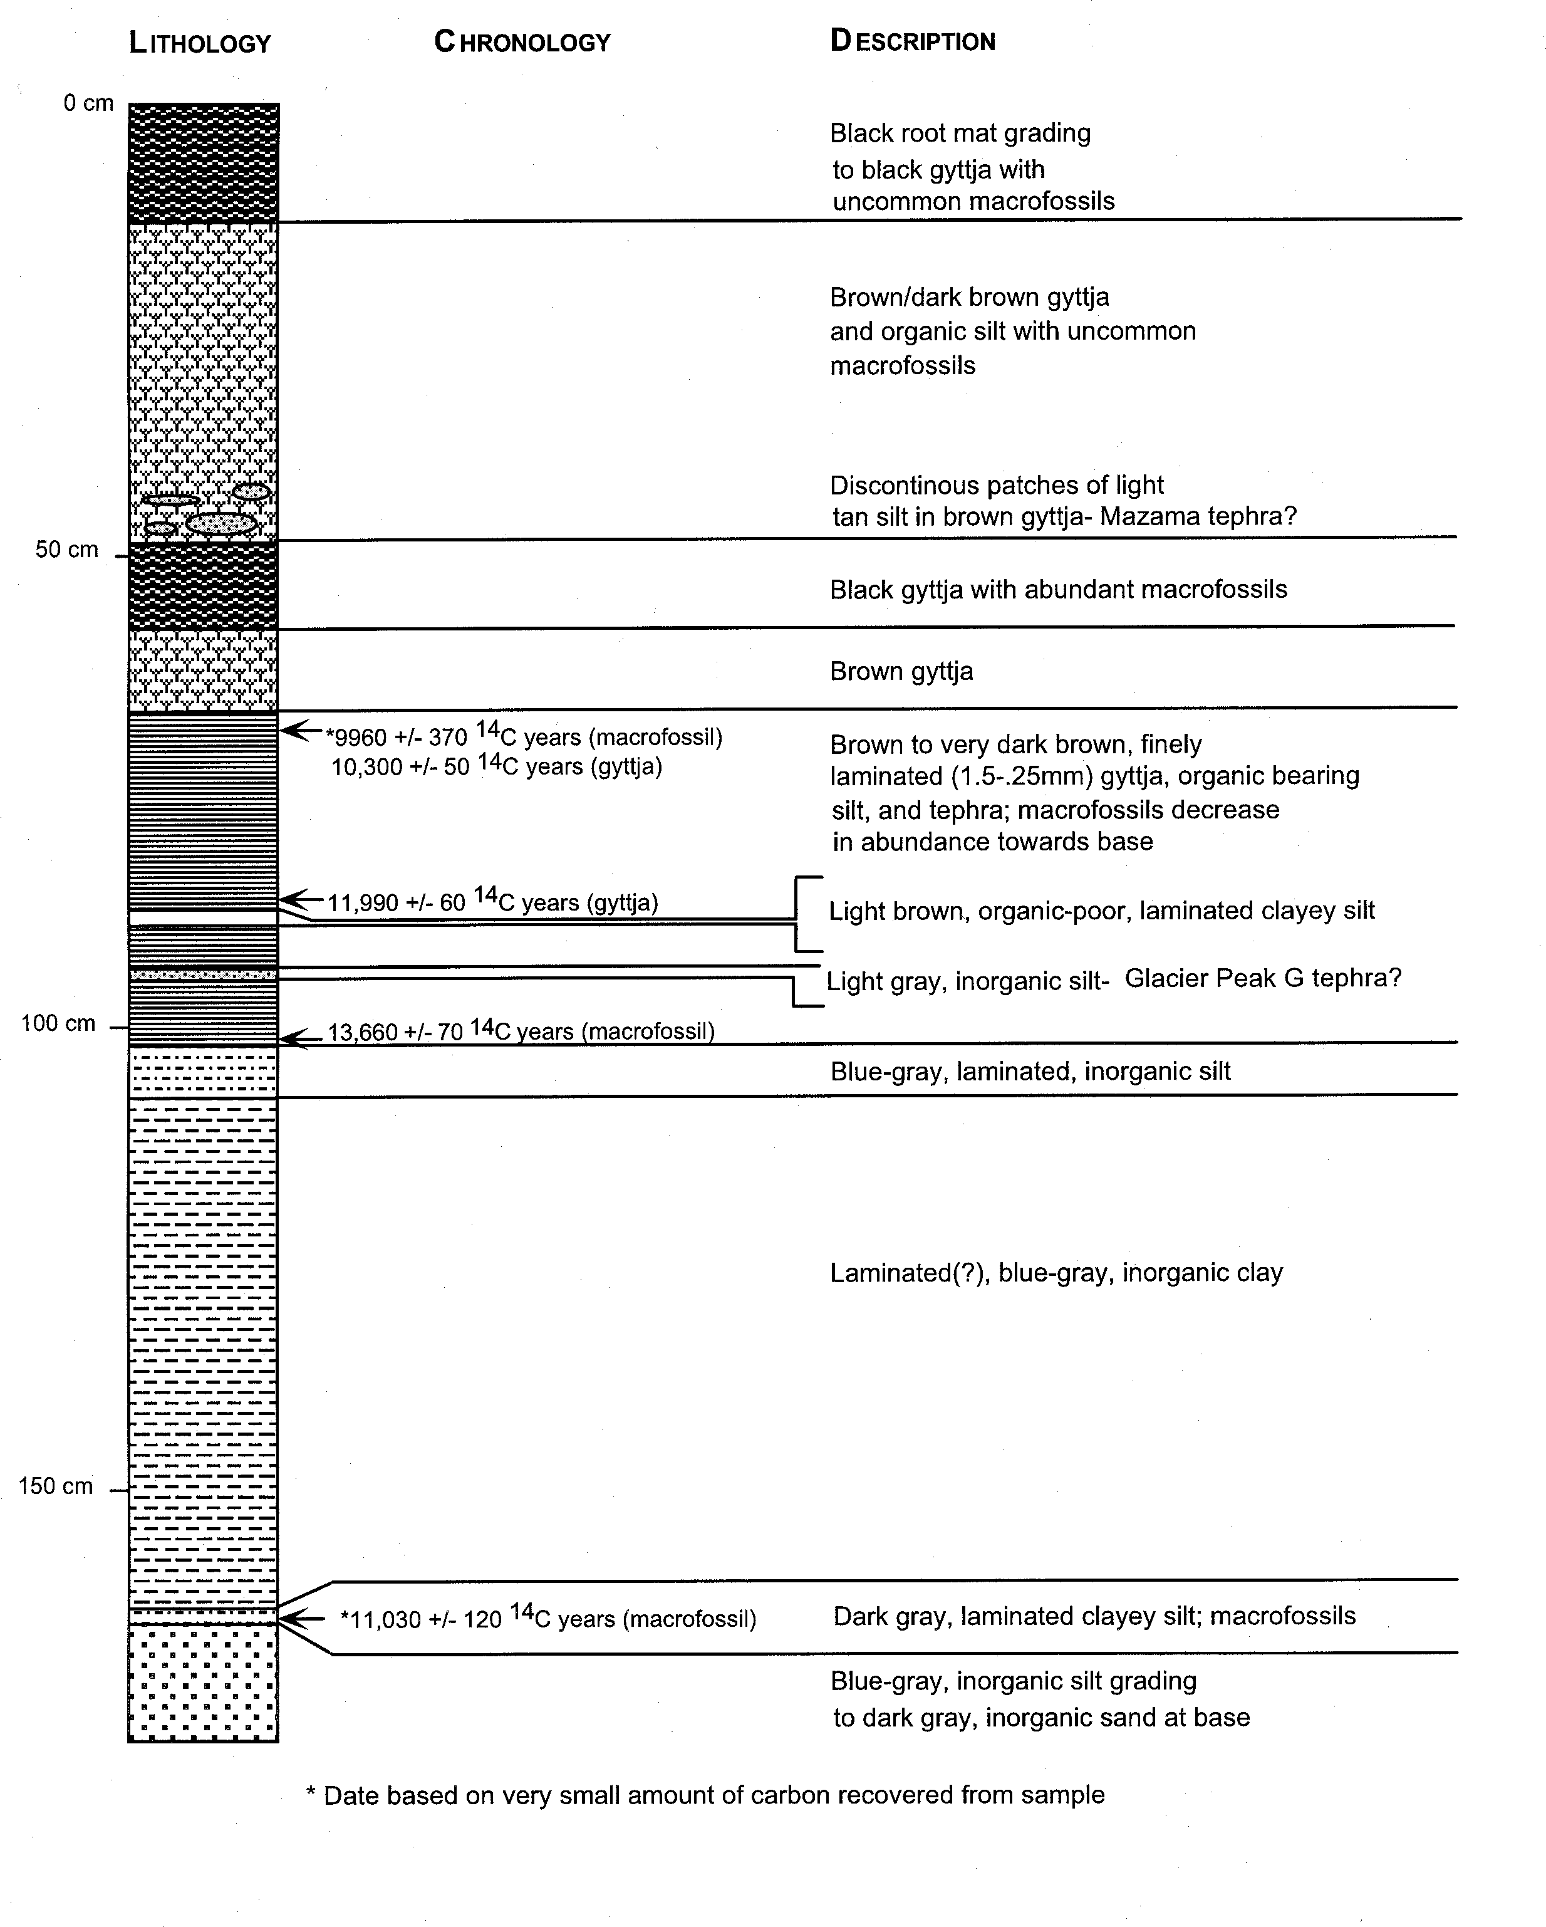STOP 2. Lost Boots Marsh is typical of the many marshes and bogs located throughout the Alturas Valley. Marshes such as this provide an ideal setting for obtain- ing sediment cores. These cores can be analyzed and sampled for radiocarbon dating, which can then help to constrain the ages of moraines and the timing of glacial advances in the valley.
Figure 8. Lost Boots Marsh core log. Core site shown in Figure 1 (stop 2).
A core was taken from this marsh in the summer of 1997 (Fig. 8). Time constraints for the upper portion of the core are relatively well established with radiocarbon dates and identified tephra horizons; however, a good basal date was not obtained for this core.
Turn vehicle around and proceed west on the Alturas road.

16.7 (2.9)Paved road ends and gravel begins.
18 (1.3)Trail head parking. Park here for stop 3. Do not take the Alpine Creek trail; instead, cross the river and walk west along the old road. After about 0.5 miles, the road climbs up onto a small moraine. This is stop 3.

STOP 1. From this location you can see a large portion of the Alturas Valley (Fig. 7). This is the largest moraine in the valley with vertical relief of 25 m, and a total crest width of approximately 308 m. Although it is the largest, it is not the oldest. The older Busterback Ranch I and II moraines can be seen to the north.
The Busterback Ranch moraines display typical morphology for the broad, voluminous, older moraines in each valley. They are very hummocky with broad, rolling crests and occasional kettles. Their proximal sides slope gently toward associated outwash terraces. The hummocky morphology of these moraines indicates burial of substantial volumes of dead ice. The stranding of this ice may have been caused by overextension of the Alturas valley glacier far into its low-gradient lower valley where a small rise in equilibrium-line altitude would have caused rapid retreat of the terminus.
These outwash terraces are also visible to the north. Separat- ing each Busterback Ranch moraine is a small outwash terrace (Figs. 2 and 7). A broad outwash terrace can be seen in the dis- tance, stretching north from the end moraines towards the Sawtooth Valley.

13.2 (1.5) Junction with paved road. Turn left (east).
13.8 (0.6) Gravel road turnoff on right side of road. Park along this gravel road and walk across paved road for stop 2.
STOP . Alpine Creek moraine is the youngest mo- raine in the Alturas valley glacial sequence. It is much smaller than the oldest moraines with vertical relief of only 5 m, and a crest width of 34 m, and also has much steeper proximal and distal sides (Table 1 and Fig. 5).
Just upvalley from this moraine are a spectacular se- ries of lateral moraine ridges correlated with the larger, downvalley moraines. These bouldery ridges reflect gla- ciers flowing out of the Alpine Creek valley and blocking the Alturas Lake Creek valley (Figs. 1 and 2). This sug- gests that there was no ice contributing to the Alturas
valley glaciers from the Alturas Lake Creek valley. The lateral moraine ridges are visible from the trail, approximately 0.2 miles upvalley from the Alpine Creek moraine, and can be followed several hundred meters uphill.
Return to vehicle and head back downvalley on Alturas Road.

22.8 (4.8) Perkins Lake moraine on west side of road.
25.2 (2.4) Junction with Highway 75. Turn left (north).
28 (2.8) Pettit Lake turnoff. Turn left (west) and drive across outwash fill surface. Pettit Lake moraines lie directly ahead.
28.9 (0.9) Beginning of outermost Pettit Lake moraines.
29.7 (0.8) Four-way intersection. Go straight into the day use area.
29.9 (0.2) Pettit Lake day use area. Park here for stop 4.

STOP . Pettit Lake Moraines. The day use parking area is located on moraine 3 of the Pettit Valley sequence (Figs. 1 and 9). From the day use area walk east, staying to the right (south) of the road. A small outwash fill surface separates moraines 2 and 3. Moraine 2 is approximately 0.1 miles (0.16 km) to the east. Mo- raine 2 is bigger than moraine 3, and is part of the outer moraine sequence. Another small outwash fill surface (~0.2 miles [0.32 km] wide) separates moraines 1 and 2. Moraine 1 is the largest mo-

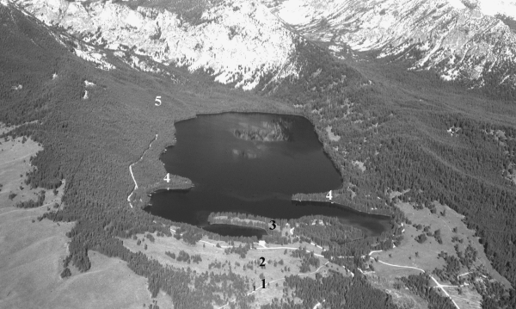

Figure 9. Oblique aerial photograph of Pettit valley looking west. Moraines are numbered as in figures 1 and 4. Note Yellow Belly valley and moraines at right.

raine in the sequence with an extremely steep distal side (maxi- mum angle 42o, average 27o). Walk back to the day use area. From the beach, look west. Moraine 4 forms the peninsula visible just up valley. Moraines 5, 6, and 7 are upvalley (west) of Pettit Lake. The Pettit and Yellow Belly sequences are very similar, with broad, steep-sided outer moraines downvalley of smaller, more rounded moraines. Each sequence has small, sharp crested moraines up valley of the lake.

30.1 (0.2) Exit day use area. Turn left (north) at four-way inter- section and veer right at the first fork in the road.
30.8 (0.7) Crest of outermost Pettit Lake moraine. Continue across Pettit Lake outwash terrace.
31.6 (0.8) Yellow Belly trailhead. Park here for stop 5.

STOP 5. Yellow Belly Creek boulder field and optional mo- raine walk-through. Walk approximately 30 meters to the creek bed. This approximately 700-meter-long portion of Yellow Belly Creek runs within a stream bed of 0.5- to 2-meter boulders (Fig. 10). This stream bed feature lies within an alluvial or debris flow fan, and represents a lag concentrate from erosion. This bouldery bed is anomalous for this creek, and may bear upon moraine deg- radation processes. We speculate that the general concentration of boulders in this area may have formed from three possible mechanisms:
- Landslide and/or debris flow from the proximal slope of the outer moraine complex, or from within the outer moraine complex;
- Fluvial erosion of outer moraines;
- Outburst floods from moraine or ice-dammed lakes.
The feature may have originated from one or from any combi- nation of these factors.

Optional moraine sequence walk
The Yellow Belly trail provides an instructive transect through the moraine sequence. The hike from trailhead to moraine 9 is ca.
3.5 miles (5.6 km).
The Yellow Belly trail begins at the terminus of moraine 1 (Fig. 1). This is the largest and steepest moraine in the sequence. The trail continues along the lateral moraine. Approximately 0.4 miles (.64 km) up the trail, moraine 2 is visible to the right. These two moraines represent the outermost moraines in the sequence and have the broadest profiles. Moraine 3 curves around the eastern
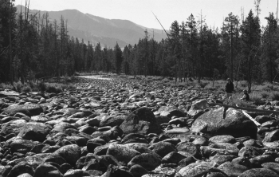
Figure 10. Yellow Belly Creek boulder field, downvalley of Yellow Belly lake. Location shown on figure 1 (stop 5).

shore of Yellow Belly Lake. Continue to the western shore of the lake. The trail crosses moraine 4 immediately west of Yellow Belly Lake. Moraines 3 and 4 are much smaller than 1 and 2 and have rounded profiles. The next sequence of moraines is small with sharp crests. The trail crosses moraines 5 and 6 approximately 0.1 miles (.16 km) west of moraine 4. Moraine 7 is 0.3 miles (.48 km) west of the McDonald Lake trail junction. Moraines 8 and 9 are another 0.1 miles (.16 km) up valley.

ACKNOWLEDG™ENTS
We thank Will Glasgow, Doug Clark, David Bates, Doug Whitmire, Chad Pietig, Charles Lundeen, Paul Link, Donald Mansfield, and Emma Thackray for assistance in the field. We also extend special thanks to Kim Hofeldt of the Sawtooth Na- tional Recreation Area for her continual support of the project. Finally, we thank personnel of Smiley Creek Lodge for reprieve from camp cuisine and for use of their shop for emergency field equipment repairs. This project has been funded by an Idaho Board of Education Specific Research Grant to G.D.T., by a Geo- logical Society of America Research Grant to J.A.B., a Sigma Xi Grant-in-Aid of Research to K.A.L., by the Idaho State University Graduate Student Research and Scholarship Committee, and by the ISU Department of Geology. Insightful reviews by Darrell S. Kaufman and Roy M. Breckenridge provided substantial improve- ment in the manuscript.

REFERENCES
Birkeland, P.W., 1984, Soils and Geomorphology: Oxford University Press, New York, 372 p.
Blackwelder, E., 1915, Post-Cretaceous history of the mountains of central western Wyoming, Part 3: Iournal of Geology, v. 23, p. 307-340.
Bloomfield, I.M., 1983, Volcanic ash in the White Cloud Peaks-Boulder Mountain region, south-central Idaho [M.S. thesis]: Bethlehem, Penn- sylvania, Lehigh University, 136 p.
Breckenridge, R.M., Stanford, L.R., Cotter, I.F.P., Bloomfield, I.M., and Evenson, E.B., 1988, Field guides to the Quaternary geology of central Idaho: Part B, Glacial geology of the Stanley Basin, in Link, P.K., and Hackett, W.R., eds., Guidebook to the Geology of Central and Southern Idaho: Idaho Geological Survey Bulletin 27, p. 209-221.
Burke, R.M., and Birkeland, P.W., 1979, Reevaluation of multiparameter relative dating techniques and their application to the glacial sequence along the eastern escarpment of the Sierra Nevada, California: Quater- nary Research, v. 11, p. 21-51.
Colman, S.M., and Pierce, K.L., 1984, Glacial sequence near McCall, Idaho: Weathering rinds, soil development, morphology, and other relative age criteria: Quaternary Research, v. 25, p. 25-42.
Cotter, I.F.P., Bloomfield, I.M., and Evenson, E.B., 1986, Glacial and post- glacial history of the White Cloud Peaks-Boulder Mountains, Idaho, U.S.A.: Geographie Physique et Quaternaire, v. XL, n. 3, p. 229-238.
Evenson, E.B., Cotter, I.F.P., and Clinch, I.M., 1982, Glaciation of the Pioneer Mountains, a proposed model for Idaho, in Bonnichsen B., and Breckenridge, R.M., eds., Cenozoic Geology of Southern Idaho: Idaho Bureau of Mines and Geology Bulletin, v. 26, p. 653-665.
Gillespie, A.R., and Molnar, P., 1995, Asynchronous maximum advances of mountain and continental glaciers: Reviews of Geophysics, v. 33, p. 311-364.
Imbrie, I., and 8 others, 1984, The orbital theory of Pleistocene climate: Support from a revised chonology of the marine 18O record, in Berger, A.L., et al., eds., Milankovitch and Climate, Part 1: Dordrecht, Reidel Publishing Company, p. 269-305.
Kaufman, D.S., and Calkin, P.E., 1988, Morphometric analysis of Pleis- tocene glacial deposits in the Kigluaik Mountains, Northwestern Alaska, U.S.A: Arctic and Alpine Research, v. 20, n. 3, p. 273-284.
Martinson, D.G., Pisias, N.G., Hays, I.D., Imbrie, I., Morre, Ir. T.C., Shackleton, N.I., 1987, Age dating and the orbital theory of the ice ages: Development of a high resolution 0-300,000-year chronostratigraphy: Quaternary Research, v. 27, p. 1-30.
Mears, B., Ir., 1974, The evolution of the Rocky Mountain Glacial Model, in Coates, D.R., ed., Glacial Geomorphology: New York State Univer- sity Press, New York, p. 11-40.
Porter, S.C., 1989, Some geological implications of average Quaternary glacial conditions: Quaternary Research, v. 32, p. 245-261.
Stanford, L.R., 1982, Glacial geology of the upper South Fork Payette River, south central Idaho [M.S. thesis]: Moscow, University of Idaho, 83 p.
Williams, P.L., 1961, Glacial geology of the Stanley Basin: Idaho Bureau of Mines and Geology Pamphlet, no. 123, 29 p.

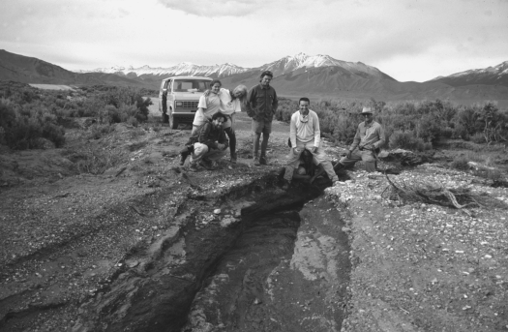

Washout from intense early summer runoff forces ISU Field Campers to negotiate an alternate route back to camp. This photograph was taken in late June, 1995 near Chilly Buttes on the west side of the Big Lost River valley. Photograph by Scott Hughes.

