Secondary Deformation Within the Huckleberry Ridge Tuff and Subjacent Pliocene Units Near the Teton Dam:
Road Log to the Regional Geology of the Eastern Margin of the Snake River Plain, Idaho

Glenn F. Embree

Department of Geology, Ricks College, Rexburg, ID, 83460-0510
Roger D. Hoggan
Department of Geology, Ricks College, Rexburg, ID, 83460-0510

ABSTRACT
Detailed geologic mapping has revealed that a 20 km by 20 km area between the south flank of Big Bend Ridge and the Teton River, has been involved in gravity sliding and secondary flow. A sheet consisting of 130 m of 2 Ma Huckleberry Ridge Tuff and at least 30 m of underlying alluvial gravel, basalts, and tuffaceous lacustrine sediments has moved a minimum of 1 km horizontally. Large scale structures in the detached sheet include overturned antiforms > 100 m in amplitude, strike slip faults with up to 1 km displacement, and an arcuate 1 km by 12 km tectonically denuded valley. Detachment apparently occurred within the underlying sediments as a result of overloading by the rapid deposition of Huckleberry Ridge Tuff. Movement occurred after considerable compaction and welding but before devitrification. During that time most of the tuff unit was still hot enough to deform plasti- cally. Secondary flow occurred after the upper part of the tuff had cooled and jointed, causing joint walls to pull apart and form open fissures >1 m wide. Lower in the unit numerous subhorizontal shear zones reflect a transition from brittle to viscous behavior. Piping of water through these fissures and shear zones contrib- uted to the failure of the Teton Dam in 1976.
The included road log emphasizes this secondary deforma- tion and its impact on the Teton Dam. Also covered is the re- gional geology of the eastern margin of the Snake River Plain, Island Park, and the Teton and Big Hole Ranges.

Key Words: Huckleberry Ridge Tuff, Secondary Deforma- tion in Ash-flow Tuffs, Eastern Snake River Plain, Teton Range, Teton Dam, Pleistocene.

INTRODUCTION
The area covered by this field guide lies at the intersection of three physiographic/geologic provinces. It is bordered on the north by the Yellowstone Plateau Volcanic Field, on the east and south by basin-range structures and the Rocky Mountain Thrust Belt (Teton and Big Hole Ranges), and on the southwest by the east- ern Snake River Plain. The geologic history of the Yellowstone/ Island Park area to the north has been done by Christiansen (1982) with field guides by Christiansen and Embree (1987) and Christiansen and Hutchinson (1987). The general geology of the Teton Range and the Big Hole Range is described by Love et al. (1992) and Staatz and Albee (1966). Geologic mapping of the volcanic rocks of this extreme northeast end of the Snake River Plain (Fig. 1) was done as part of the U.S. Geological Survey's eastern Snake River Plain Project in the 1970s by Prostka and Hackman (1974), Albee and others (1975), and Prostka and Embree (1978). A compilation of much of this work is included in the road log by Albee and others (1975).
The failure of the Teton Dam on June 5, 1976 spurred consid- erable detailed geologic study in the area of the Teton Canyon (Chadwick et al., 1976; Elkenberry et al., 1977; Prostka, 1977; and Embree, 1988). Evidence of secondary movement within the Huckleberry Ridge Tuff in the vicinity of the Teton Dam was described by Christiansen (1982), Prostka, 1977; Prostka and Embree, 1978, and Embree, 1988. Much of this paper focuses on the problem of this secondary movement because of its unusual nature and large scale, as well as its apparent impact on the fail- ure of the dam.

Embree, G.F., and Hoggan, R.D., 1999, Secondary deformation within the Huckleberry Ridge Tuff and subjacent Pliocene units near the Teton Dam: Road log to the regional geology of the eastern margin of the Snake River Plain, Idaho, in Hughes, S.S., and Thackray, G.D., eds., Guidebook to the Geology of Eastern Idaho: Pocatello, Idaho Museum of Natural History, p. 181-203.

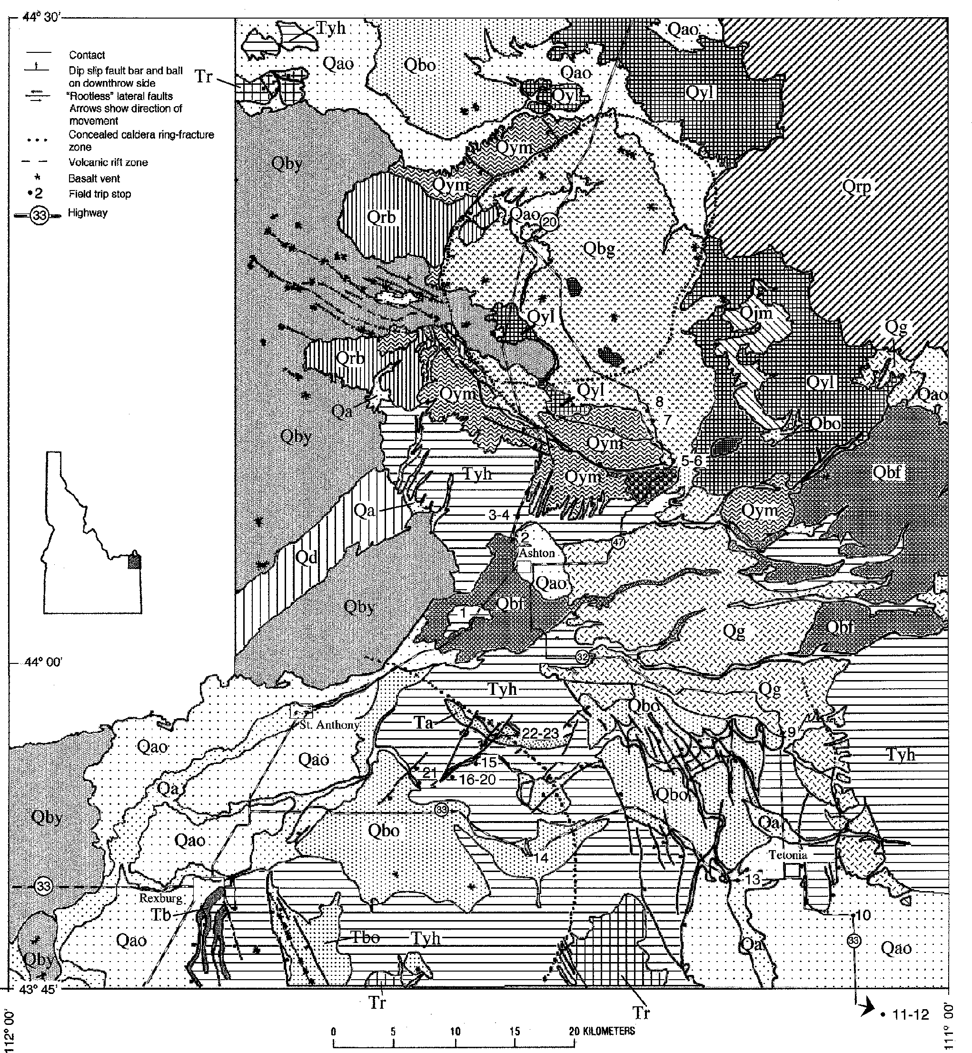

SECONDARY MOVEMENT IN THE HUCKLEBERRY RIDGE TUFF

a
The Big Bend Ridge caldera segment of the Yellowstone Pla- teau volcanic field was formed during the first cycle of caldera- forming activity that produced the eruption of the 2.0-Ma Huck- leberry Ridge Tuff (Tyh) (Christiansen, 1982; and Christiansen and Embree, 1987). During that eruption pyroclastic flows swept down the flank of Big Bend Ridge and across the countryside to the south, leaving out-flow facies deposits of member B of the Huckleberry Ridge Tuff as far south as the foothills east of Idaho Falls. In the vicinity of the Teton Dam site, within the low basin

between Big Bend Ridge and the Big Hole Mountains, the tuff ponded to a depth of at least 130 m. On the lower flanks of the ridge near the town of Ashton, and throughout the basin as far south as Teton Canyon, the tuff was intensely deformed, locally producing steep dips, moderate-to large-scale antiforms, detach- ments, and other structures (Prostka, 1977; Prostka and Embree, 1978; Christiansen, 1982; and Embree, 1988).

ra raphy
In the walls of Teton Canyon >125 m of Huckleberry Ridge Tuff is exposed. In most of the canyon the base of this unit is not visible, but where it is exposed normal zonation within the unit

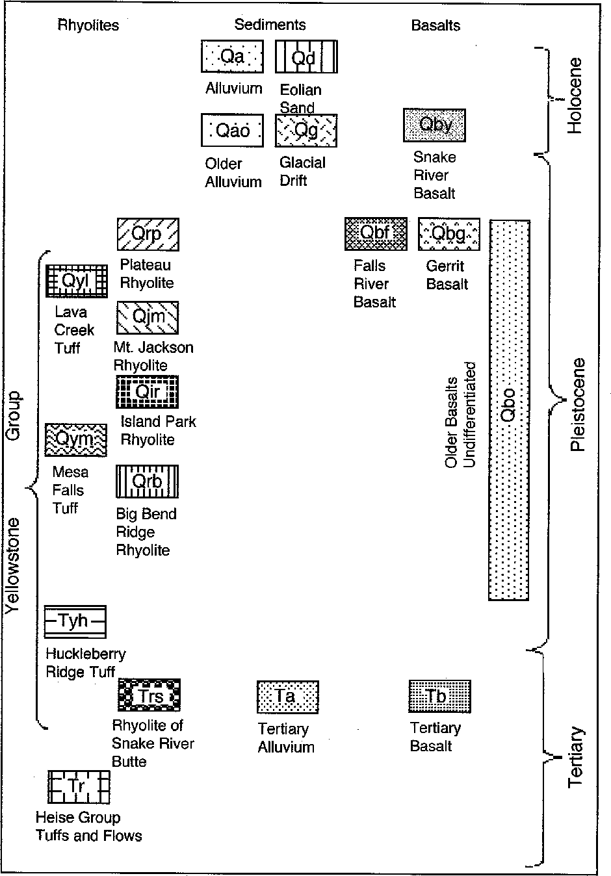Figure 1. Generalized geologic map of the northeastern end of the Snake River Plain and Island Park area. Major r oads and field trip stops are labeled. Geology from Christiansen (1982), Prostka and Hackman (1974), Prostka and Embree (1978), Scott (1992) and Mitchell and Bennett (1979).
can be seen. Above a thin (<0.3 m) nonwelded to partly welded base is a black vitrophyre up to 10 m thick. Overlying the vitrophyre, the majority of the unit consists of densely welded devitrified tuff, grading into ~7 m of pink, moderately to slightly welded, devitrified tuff at or near the top. In exceptional expo- sures a thin (~1-2 m) moderately to slightly welded vitric zone is present at the very top of the unit, and in a few localities, lami- nated air- fall ash can be found overlying the welded tuff. Through- out most of the unit a moderately well developed eutaxitic fabric has produced a foliation which is especially evident where welded or vapor-phase altered pumices are weathered out. Conspicuous columnar jointing can be seen along most of the canyon wall where excavation during dam construction exposed both vertical and horizontal joint sets. (Fig. 2) (Chadwick et al., 1976).
Well data from the area around Teton Canyon shows that the Huckleberry Ridge Tuff is underlain by unconsolidated to poorly indurated, tuffaceous gravel, sand, and clay beds, with local interbedded basalt flow(s) (Fig. 3). In a few areas, such as the cores of large scale antiforms and in Hog Hollow to the north of the Dam, pre-Tyh rock units can be observed. These units in- clude tuffaceous lacustrine clays and diatomites, fluvial gravels and sands, and basalts.

ruc ur

Fold-like Structures
Throughout the area between Big Bend Ridge and the Teton Canyon are numerous scattered exposures of Huckleberry Ridge Tuff with steeply dipping foliation (Figs. 1 and 4). In many cases these outcrops expose what appears to be the basal vitrophyre. Some of the exposures show distinct fold-like features with pre- Tyh units in the fold cores concordant to and underlying steeply

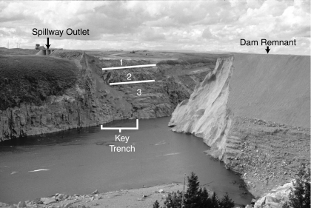
Figure 2. Teton Dam site showing the remnant of northwest end of the dam and joint patterns in Huckleberry Ridge Tuff in the key trench area as defined by Prostka (1978). Zone 1 contains numerous low-angle platy joints and vertical cooling joints; zone 2 is blocky with widely spaced moderately to steeply dipping (30° to 60°) joints and some low-angle joints; and zone 3 is blocky and massive wit h near-vertical and low-angle joints.

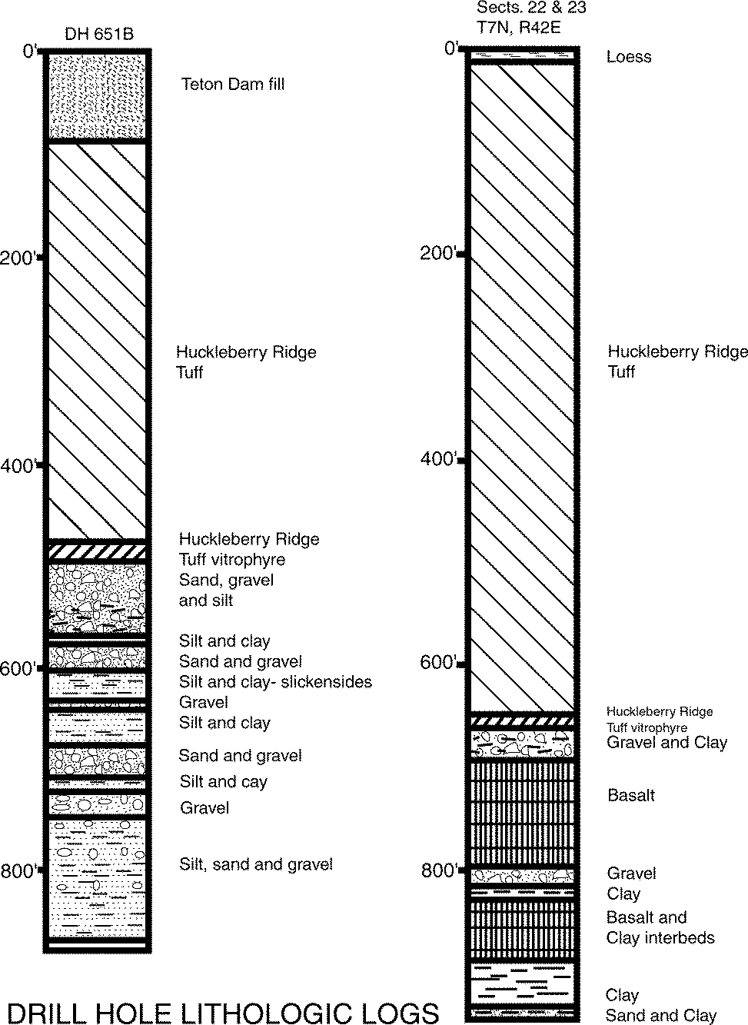

Figure 3. Stratigraphic sections taken from drill holes in the vi- cinity of the Teton Dam. DH651B is located 60m north of the spillway. The data for the other section comes from two wells drilled 5 km east of the dam near the south rim of the canyon.

dipping Tyh vitrophyre. Analysis of 180 poles to foliation from the area (Fig. 4) shows that the prevalent strike is approximately east-west and that the structures are asymmetrical with south dips slightly dominant.
The best exposures of these fold-like features are seen in Teton Canyon where large-scale, open antiforms were dissected by the river (Fig. 5). Several of these antiforms have amplitudes of ~100 m and widths of ~200m. The style of deformation ranges from broad open symmetrical antiforms to asymmetrical or even over- turned structures (Figs. 6). Although antiforms are abundant in the area, there is a conspicuous absence of synforms. Generally the foliation within the Tyh grades laterally from essentially hori- zontal into arch or dome-shaped structures. Another unusual char- acteristic of these antiforms is that the tuff thins over the crests, in many cases leaving only a vitrophyric zone <10 m thick. The result is that the top of the tuff along the canyon rim is essentially flat, with the base of the unit rising and falling to produce the structures (Fig. 5).
Although the Huckleberry Ridge Tuff is the main unit in which this deformation is seen, several of the large-amplitude antiforms have exposed pre-Tyh units in their cores. These units, including sediments and basalts, are nearly vertical in some of the Teton Canyon antiforms (Fig. 7).

H H w
An anomalous 0.5-1.8 km wide by 12 km long arcuate de- pression, called Hog Hollow, lies ~1-5 km north of Teton Canyon (Fig. 8). This depression has gravel exposed in its floor. The north rim consists of a long monoclinal feature and some smaller antiforms in the Huckleberry Ridge Tuff (Fig. 9). Erosionally re- sistant vitrophyre is common along both edges of the basin and especially the south side, where it forms vertical wall-like out- crops. Landslides are also common along both sides of the Hog Hollow depression due to the incompetence of the underlying sediments.
Several northeast-trending lineaments interpreted as "rootless lateral faults" can be seen on the air photos that transect Hog Hollow and extend south to Teton Canyon and possibly beyond (Fig. 8). These faults are "rootless" in the sense that they involve only the Huckleberry Ridge Tuff and a few underlying units, but probably do not extend down more than a few hundred meters. Along these lineaments, both rims of Hog Hollow have been off- set from 0.3-1 km in numerous places. Between Hog Hollow and Teton Canyon, these lineaments are commonly marked by straight gullies forming major tributaries of the Teton River. Within one of these gullies horizontal slickensides can be seen in the Huckle- berry Ridge Tuff. A pair of large amplitude antiforms, exposed on opposite rims of Teton Canyon, are offset by about ~0.7 km in a left lateral sense by one of these faults.

ruc ura a d L h c Z a w h h Huck-
b rry d Tuff
Unusual structural and lithologic zonation in the Huckleberry Ridge Tuff is evident along the walls of Teton Canyon in the vi- cinity of the Teton Dam. This zonation is especially well exhib- ited in the man-made exposures of the key trench cut for the north abutment of the dam and the boat ramp just upstream from the south abutment. Other exposures can be seen where the flood from the dam failure scoured the downstream walls of the can- yon, and in the cores of the large-amplitude antiforms upstream from the dam. This zonation is of two principal types: one con- sists of variation in joint patterns and secondary deformation styles vertically through the unit and the other consists of unusual lat- eral variations in the distribution of vitric and devitrified zones within the tuff.
The basal vitrophyre is generally exposed only in the cores of the large amplitude antiforms. Where it is exposed, a strong eutaxitic foliation is exhibited. In at least one location, along the north rim ~2 km upstream from the dam, this foliation exhibits small-scale (~1 m) isoclinal flow folds preserved in the vitrophyre. The axial planes of these small flowage folds are steeply dipping but parallel to the base of the tuff where it is arched into an antiform. This indicates that viscous flow occurred after compac- tion produced the eutaxitic fabric, but while this part of the unit was still hot and ductile. The flow probably resulted from inter- nal deformation during the formation of the large scale antiforms, suggesting that the antiforms themselves were produced shortly after the deposition and partial compaction of the tuff, but before it had completely welded.
Above the vitrophyre, in the central devitrified part of the unit, the welded tuff contains a large number of subhorizontal

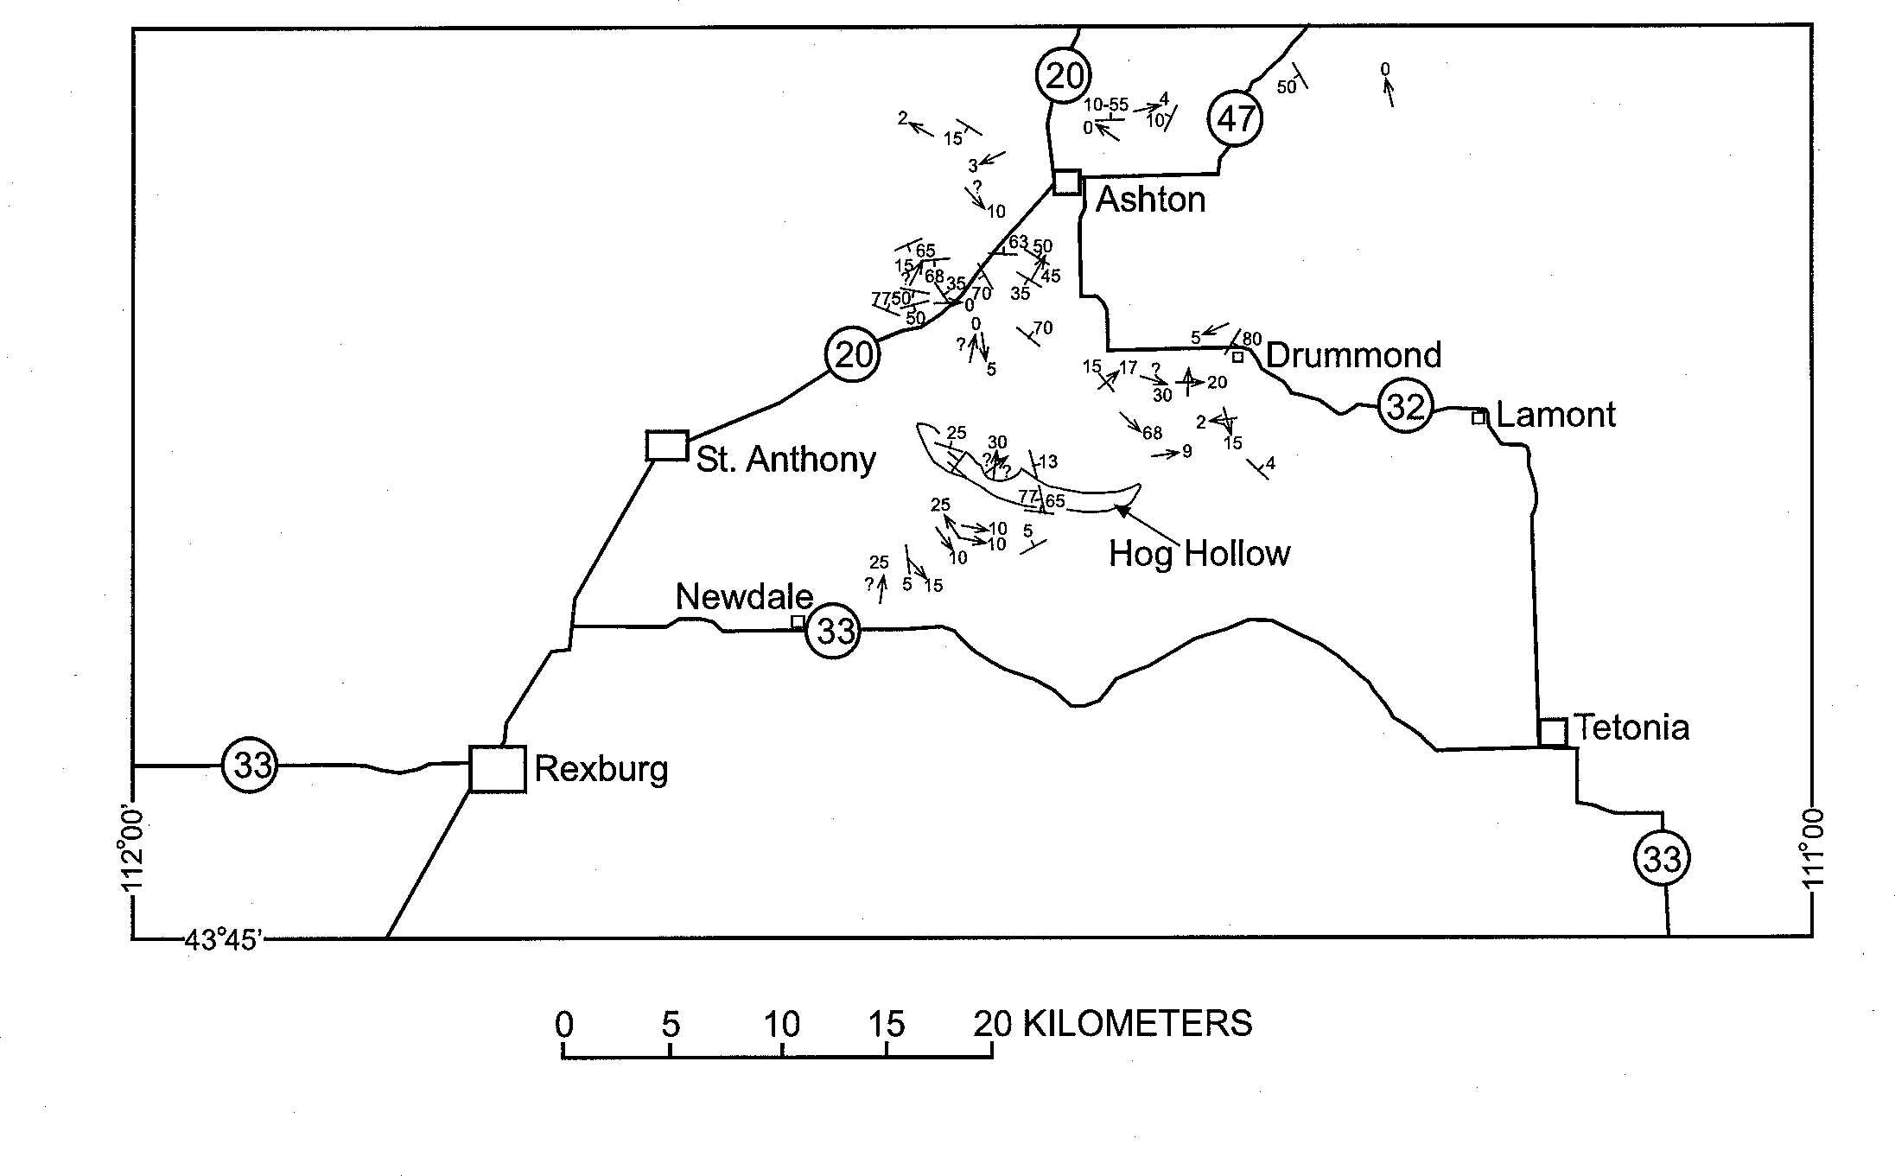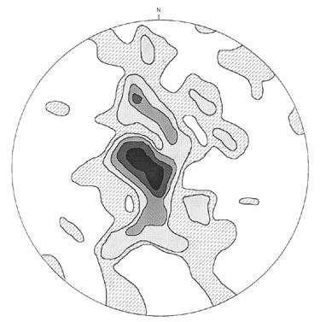A

N Figure 4. a) Map showing distribution of secondary structures in the Huckleberry Ridge Tuff. b) Equal area plot for 180 poles to foliation in the Huckleberry Ridge Tuff within the area. Contours are 10%, 8%, 6%, 4% and 2%.
B

joint sets, which are also locally arched over the antiforms (Prostka, 1977). The tuff in this central zone also exhibits a large number of closely spaced en echelon tension fractures filled with vapor-phase crystals (Fig. 10). Many of the horizontal joints are produced by dense concentrations of these tension fractures and form open channels within the tuff which contributed to the dam failure (Fig. 11) (Chadwick et al., 1976; and Elkenberry et al., 1977 ).
The pattern in the uppermost part of the tuff changes to typi- cal vertical cooling joints separated by zones of subhorizontal platy joints. Many of the vertical cooling joints are open, forming fissures with a few centimeters to more than a meter separation between the joint walls. Some of these fissures remain open to-

day and also contributed to piping responsible for the failure of the dam (Chadwick et al., 1976; and Elkenberry et al., 1977). During construction of the dam a light bulb was lowered into a drill hole ~8 m from the exposed face of the key trench and was visible through one of these open fissures from the trench face (Chadwick et al., 1976). In many instances these open fissures have been filled with nonwelded, sometimes stratified ash from above. In some cases, the vertical fissures are not only offset by horizontal fractures, but the width of the fissures varies across the horizontal breaks (Fig. 12). This suggests that many of the horizontal fractures are small-scale shear surfaces that accom- modated horizontal slippage (Prostka, 1977).
In addition to the normal vertical zonation in welding and devitrification seen in typical welded tuffs, the Huckleberry Ridge Tuff in the canyon walls exhibits lateral zonation adjacent to the open joints just described. The tuff on either side of the joints is commonly vitrophyric and grades outward into the devitrified tuff more typically found at this level within the ignimbrite sheet (Fig. 13). The width of the vitric joint selvages is generally only a few cm but in some cases they may be a meter or more wide. The width is roughly proportional to the width of the fissures, sug- gesting a relationship between fissure width and rate of heat loss. A larger-scale version of this lateral zonation is seen at the margins of the Hog Hollow depression. On either side of the de- pression, the walls exhibit vitrophyres several meters in width,
grading laterally into devitrified Huckleberry Ridge Tuff.

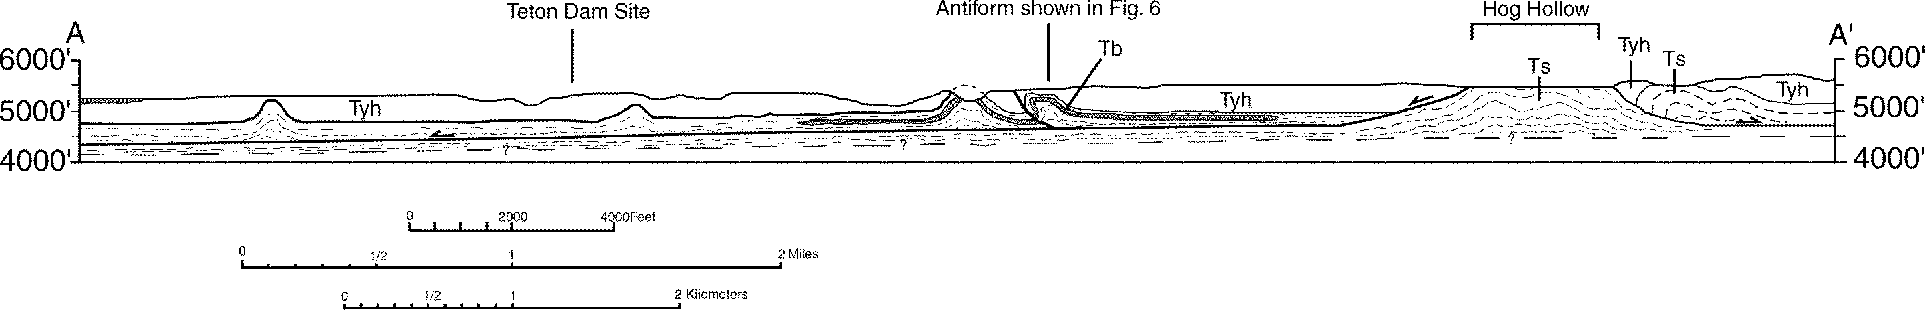

Figure 5. Structure section A-A' from Fig. 8, showing antiforms in the Huckleberry Ridge Tuff (Tyh), pre-Tyh sediments (Ts), and basalts (Tb) in the Teton Canyon area. The large-scale Hog Hollow load-and-pull-apart structure is also shown. A hypothetical detachment surface within the pre-Tyh sediments is the approximate stratigraphic level to which the "rootless faults" penetrate and the plane upon which movement occurred away from Hog Hollow.

D scuss A d I rpr a

Secondary Flow Within The Huckleberry Ridge Tuff
The variety of deformation styles within the ignimbrite sheet gives some clues as to the timing of various types of movement within different levels in the unit. After initial deposition and com- paction but prior to complete welding and devitrification, the base of the ignimbrite was apparently involved in viscous flow as evi- denced by folding of the eutaxitic foliation within the vitrophyre and some of the devitrified tuff above. During this deformation, the central part of the unit was apparently somewhat cooler and deformed by a combination of flow and semi-brittle shear form- ing the en echelon pull aparts and detachment planes. The upper part of the unit was cool enough to behave in a brittle fashion,

having already formed cooling joints which were separated to form open fissures and offset along horizontal detachment zones as the tuff in the lower part flowed. The style of deformation within the tuff is analogous to gravity-driven ductile flow in a glacier, with faster movement in the lower part of the unit carrying the upper more brittle material along for the ride. The formation of open fissures in the top of the tuff unit is similar to the formation of crevasses in the brittle upper portion of a flowing glacier (Fig. 14). The zonation in deformational styles described above is also an excellent small-scale analog to deformation within the conti- nental crust with ductile flow at depth, shear and detachment fault- ing at intermediate levels, and brittle behavior dominating at shal- low depths.

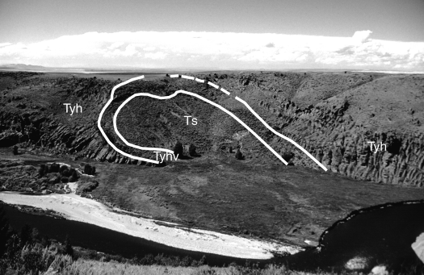

Figure 6. Large overturned antiform within the Huckleberry Ridge Tuff (Tyh) and underlying units, exposed on the north side of Teton Canyon 2.5 km upstream from the dam. Note overturned vitrophyre (Tyhv) at the base of the south (left) limb, and thinning of the tuff at the crest of the antiform. Pliocene sediments (Ts) and basalts are exposed in the core of the fold.

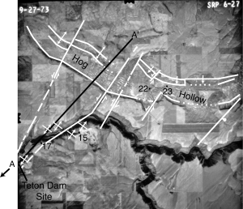

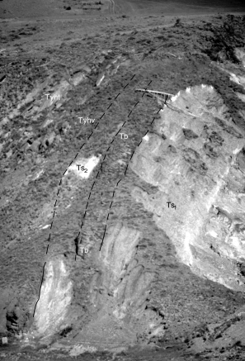
Figure 7. Pliocene gravels (Ts1), basalt (Tb), and tuffaceous sedi- ments (Ts2) exposed in the core of an antiform beneath the Huckleberry Ridge Tuff vitrophyre (Tyhv) and devitrified zone (Tyht). This antiform is located 2 km upstream from the dam on the north side of the canyon. Note fallen fir trees at top of Tb for scale.
The timing of deformation within the tuff is well constrained. Lateral zonation in devitrification adjacent to the fissures shows that fracturing and opening of the fissures in the upper part of the unit occurred after compaction and welding but before devitrifi- cation. Extensive vapor-phase filling of en echelon pull-aparts and detachment planes also indicates that extensional flow in the center of the unit occurred prior to completion of degassing and cooling of that part of the sheet. These processes were contempo- raneous with plastic deformation and on-going welding deeper in the sheet.
Evidence related to the cause of secondary movement within the tuff can be interpreted in more than one way. Prostka (1977) interpreted the flow and shear structures in the Teton Dam area to be the result of flow due to differential compaction over irregular topography, and suggested that subsequent widening of cooling joints was due to tectonic extension aided by creep and frost wedg- ing. He cites the fact that most of the open joints strike northwest, which is consistent with regional tectonic extension. However, the facts that open fissures appear to be less abundant and pro- nounced lower in the tuff unit, and are also not evident in basalts
Figure 8. Aerial photo of the Hog Hollow and Teton Canyon area. Boundary faults, "rootless lateral faults", and major monoclinal and antiformal structures associated with Hog Hollow are delineated. Numbered dots indicate locations of field trip stops.
in the area refute this hypothesis. More important, the timing of deformation in relation to vapor-phase crystallization and devit- rification prove that most of the deformation occurred during a relatively short period while the ignimbrite sheet was cooling. It was not a long-term tectonic or weathering process.
During the construction and post-failure studies of the Teton Dam-site, it was assumed that the variation in thickness of the Huckleberry Ridge Tuff encountered in drill holes and canyon exposures in the area of the dam was due to deposition on an irregular erosion surface with 135 m of relief and slopes locally
>30° (Elkenberry et al., 1977). Since then, regional mapping has
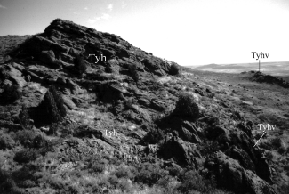
Figure 9. Monoclinal flexure on the north rim of Hog Hollow, as defined by a change in the attitudes of foliation in the Huck- leberry Ridge Tuff (Tyh). Foliation at the hilltop dips 20° to the south (right). Dips in the lower right corner of the photo are 80° south. The rocks at the extreme right edge of the exposure are vitrophyric (Tyhv). Junipers are 3-4 m high for scale.

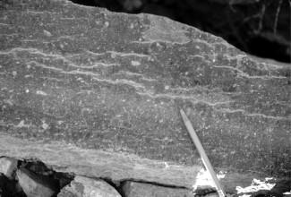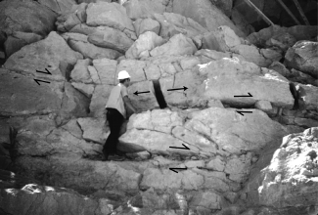

Figure 10. En echelon tension fractures in devitrified Huckle- berry Ridge Tuff in Zone 2, near the bottom of the concrete boat-ramp just east of the Teton Dam. These fractures were filled with vapor phase crystals during subsequent cooling of the tuff. Most of these fractures dip gently to the northeast (left) in this area, indicating that the lower part of the unit moved to the southwest.
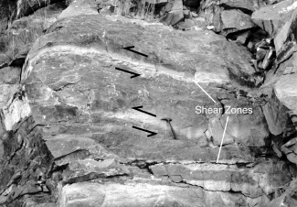
Figure 11. Vapor-phase filled en echelon extensional fractures in massive gray tuff, separated by white vapor phase filled and open shear zones. From the same location as Figure 10. Ar- rows indicate relative motion, see Fig 14.

demonstrated the existence of the large- scale fold-like structures involving the Huckleberry Ridge Tuff and underlying units. The folding process is a more plausible explanation for the irregular basal contact and the driving force for secondary deformation within the tuff than simple differential compaction. The evidence suggests that as antiforms developed, the hot mobile tuff flowed off the crests and steepening limbs. This flowage explains the thinning of the tuff above the antiforms as well as secondary flow structures within the unit.

Large-Amplitude Fold-like Structures
The large-amplitude structures appear to have been gener- ated by a combination of two processes. The principal process was probably a large-scale version of load casting. This resulted from extremely rapid loading of water saturated, unconsolidated
Figure 12. Open vertical to steeply-dipping cooling fractures offset by horizontal shear zones in the north key trench Zone
2. Both sets of open joints allowed piping of water from the reservoir, which eroded the core of the dam and caused its failure. Arrows indicate relative motion along shear zones, see Figure 14.
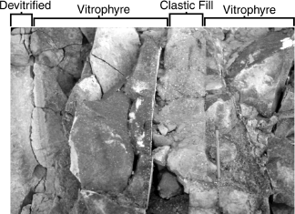
Figure 13. Section view of lateral zonation in devitrification ad- jacent to an open joint filled with reworked ash from above. This and several other similar joints are located near the top of the boat ramp.

sediments in an environment dominated by a shallow water table, lakes, and river channels. The overpressure created by the weight of >100 m of tuff on these saturated sediments caused diapiric upwelling of the sediments and arching of the Huckleberry Ridge Tuff above (Fig. 5). This apparently happened very shortly after deposition of the tuff since it was still hot and plastic enough to flow off the top of the arches and spread laterally into the spaces between.
Something similar to the above-described process has been observed in the Mississippi delta area (Fig. 15) (Morgan et al., 1968) and in the Panama Gulf Coast area (Breen et al., 1988). In these areas, large mud diapirs or parallel folds form as a result of rapid deposition of delta sediment on the unconsolidated offshore muds. In the case of the Mississippi delta, the mud diapirs arch the overlying deltaic beds into anticlines as much as 350 m wide

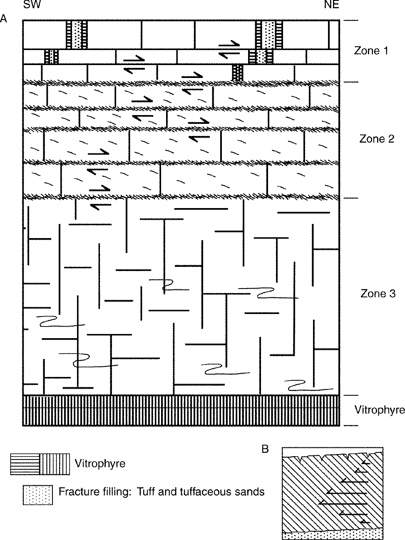
Figure 14. Schematic cross section of the Huckleberry Ridge Tuff in the Teton Canyon area. Secondary flow within the sheet is ex- pressed by different behavior at different levels within the unit. The lower part of the unit, Zone 3, deformed by viscous flow and contains small-scale recumbent isoclinal folds. Zone 2 was domi- nated by shear and contains numerous brecciated, subhorizontal shear zones (Figs.11 and 14) with relative movement indicated by the arrows. This zone also contains numerous tension frac- tures which dip northeast at low angles (Fig. 10). Zone 1 was cool and brittle; columnar joints in this zone were pulled apart and filled with ash and sediments from above (Figs.12 and 13). Secondary flowage was probably to the southwest since the lower, hotter part of the unit was more mobile and flowed southwest while the upper layers lagged behind. Figure 14B is a schematic section with vectors showing hypothetical relative rates of flow within the unit.
and 150 m in amplitude, similar in scale to the antiforms seen in Teton Canyon.
The second process involved in the formation of the fold-like structures is lateral spreading. This is indicated by the existence of ramps and fold-like structures on the lower slopes of Big Bend Ridge, near Ashton, showing that the tuff deformed by gravita- tional flow down the outer flanks of its source caldera (Christiansen, 1982, p. 353). This process contrasts with the diapirism that produced antiforms where the tuff was laid onto the thick unstable deposits of lacustrine and fluvial sediments of the plain below. The fact that at least some of the large-amplitude antiforms in the vicinity of Teton Canyon are overturned also sup- ports the existence of some secondary lateral spreading, not just vertical loading in that area. This is also supported by the exist- ence of the small-scale recumbent folds, shear structures, and open joints within the Huckleberry Ridge Tuff itself. It is possible how- ever, that these structures are related only to flow off the crests of the larger load structures and not down a regional slope.

Hog Hollow
The most enigmatic feature in this area is Hog Hollow. This conspicuous, relatively large, arcuate depression with its vitrophyric walls, monoclinal flexure, and gravel floor has been interpreted differently at different stages of our investigation. The valley form, gravel floor, and trend roughly parallel to the current course of Teton River suggest that it might have been an ancestral channel for that river. However, the absence of an inlet or outlet to the basin and the fact that the gravels contain no clasts of Huck- leberry Ridge Tuff discredit this interpretation and suggest that the gravels probably predate the tuff (Prostka and Embree, 1978). Scott (1982) and Richmond, G.M. (unpublished data, 1977) also describe this gravel as underlying the Huckleberry Ridge Tuff.

Figure 15. Cross section of large-scale load structure in Missis- sippi delta sediments (from Morgan, et al, 1965). Prodelta clay and shelf deposits intrude into and flow southward from beneath prograding delta "sands". Diapiric structures with 150m amplitudes formed in <100 years. The folds produced here are geometrically and genetically similar to those seen in Teton Canyon and the surrounding areas.

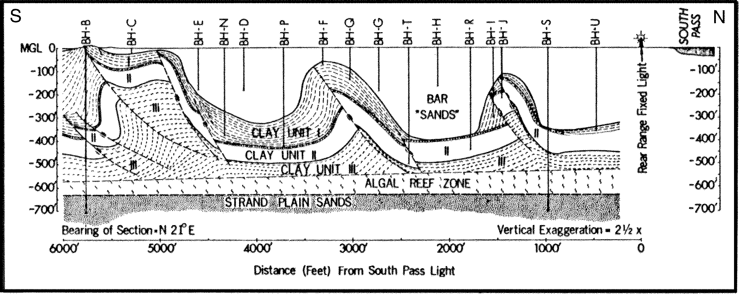

The arcuate shape of the basin along with its associated monocli- nal flexure and the dike-like ridges of erosionally resistant vitrophyre along its edges, have been interpreted as evidence that Hog Hollow might be part of a small caldera moat zone (Prostka and Embree, 1978).
Like the proverbial blind men's examination of the elephant, the interpretation of Hog Hollow is best accomplished by back- ing off and looking at the whole picture from a regional perspec- tive. Many of the clues needed to understand this feature come from the exposures in Teton Canyon a few kilometers to the south as well as examination of well data. The comparison with struc- tures seen in Teton Canyon suggests that Hog Hollow may be related to the load structure, secondary flow, and extensional phe- nomena seen in that area.
It seems likely that the Hog Hollow depression is the result of the formation of a large scale pull apart structure analogous to graben-like features formed in Anchorage, Alaska during the 1965 earthquake. These grabens formed as the result of the breakup and extensional separation of blocks of a relatively competent surface unit due to lateral spreading of liquified clays beneath. Though smaller by an order of magnitude, the 1 km long by 40 m wide graben associated with the Anchorage L Street slide looks remarkably similar to the Hog Hollow structure (Fig. 16) (Wil- son, 1967). A palinspastic reconstruction in which the two sides of Hog Hollow are brought back into alignment with one another shows that the geometric relationships are consistent with this hypothesis (Fig. 17). This reconstruction suggests that the rims broke apart and moved away from one another, with offsets being produced along the "rootless lateral faults" shown in Figure 8.
The ~0.7 km displacement of a pair of antiforms by one of these "faults" in Teton Canyon is consistent with the scale and sense of movement required to open the Hog Hollow depression and off- set its north rim ~0.9 km along the same fault.
The vitrophyre exposures at the margins of Hog Hollow are consistent with the pull-apart hypothesis. These vitrophyres may be large-scale analogies of the vitrophyric zones found on joint surfaces that were pulled apart in the upper portion of the Huck- leberry Ridge Tuff. If Hog Hollow is the result of large-scale ex- tension, contemporaneous with cooling and secondary movement as seen elsewhere in the ignimbrite sheet, the exposed tuff at the edges of the open basin would have lost heat more quickly than the adjacent tuff away from the edges and would not have been devitrified. The extension of a semi-plastic partly cooled ignim- brite would also explain the foliation attitudes observed in the apparent monoclinal flexure along the north rim of Hog Hollow. As extension occurred the tuff was pinched off, thinning the unit at the edges, and producing dips toward the center of the basin (Figs. 9 & 18).
It is possible that Hog Hollow is a large-scale version of a load structure like the antiforms exposed in Teton Canyon. In this case the sediments in the bottom of the basin are pre-Tyh depos- its which have bulged up, forcing the sides of the structure apart. This may be the mechanism responsible for the extension de- scribed above. It is conceivable that a large load structure such as this may be responsible for producing a local slope upon which the Huckleberry Ridge Tuff and underlying units moved on a detachment plane ~200 m below the surface. Thus, as is the case for the small and moderate sized structures in Teton Canyon, Hog

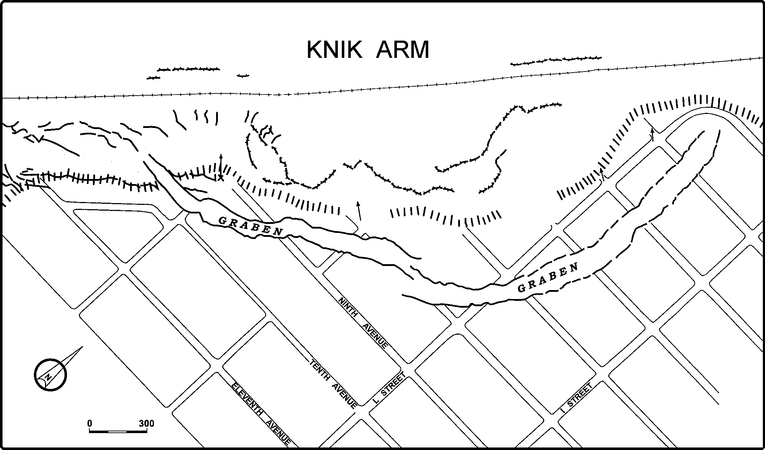

Figure 16. Map showing the graben in the L Street Slide, Anchorage, Alaska. This slide was produced by extension in the surface layers as liquified clays beneath flowed toward the Knik Arm during the 1965 Prince William Sound Earthquake (from Wood, 1967, p. 279).

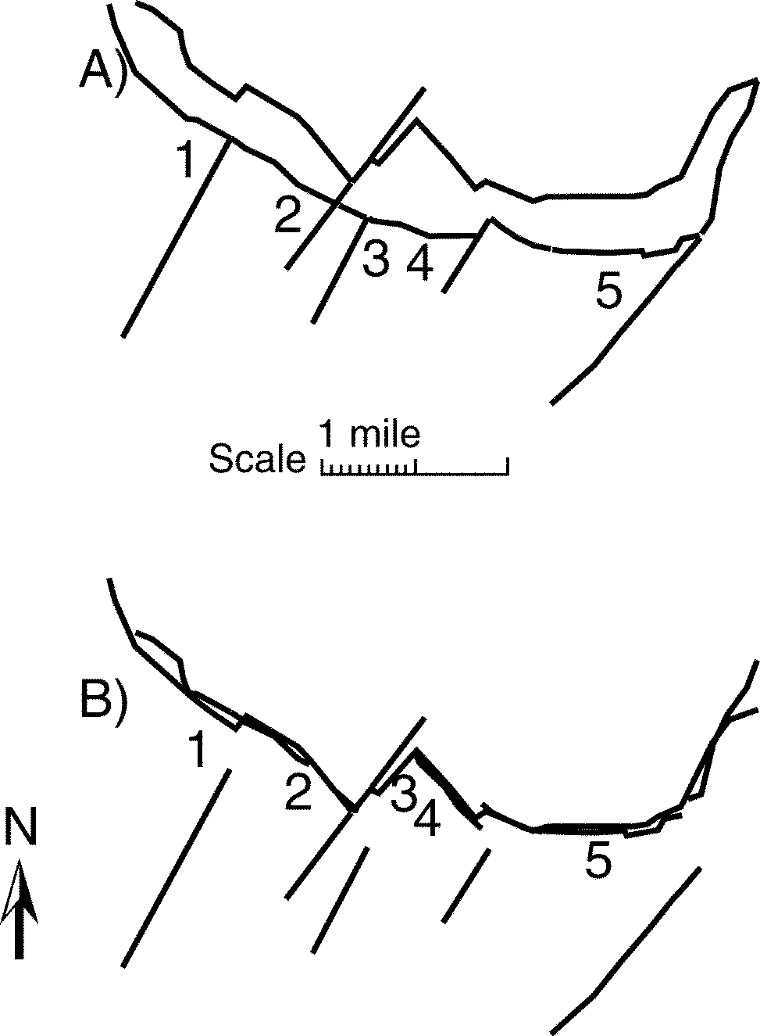
Figure 17. Palinspastic map of the Hog Hollow structure shows
A) north and south rims as they appear today and B) a re- construction with segments of the south rim moved north to approximate the best possible fit. Northeast trending lines represent "rootless faults" within the Huckleberry Ridge Tuff.

Hollow may have resulted from the formation of a diapiric load structure and lateral spreading off the high (Figs. 5 & 18).

CONCLUSION
Small to large-scale deformation within the Huckleberry Ridge Tuff and subjacent sediments and basalts cover an area of ~500 km2. It appears that most of this deformation occurred within ~200 m or so of the surface. This deformation resulted from the rapid deposition of ~100 m of pyroclastic flow deposits onto poorly compacted water saturated sediments. The resultant overpressure caused formation of large amplitude load structures, such as the antiforms visible in Teton Canyon and the even more impressive bulge in the Hog Hollow area. As the result of uplift over these load structures, lateral gravitational spreading occurred, produc- ing the Hog Hollow pull apart, "rootless lateral faults", overturn- ing of the antiforms, and secondary flow within the tuff itself.
The secondary deformation within the Huckleberry Ridge Tuff was responsible for a variety of structures including: recumbent isoclinal folding near the base of the unit, extensional shear struc- tures and detachments near the center, and open cooling joints near the top. Lateral as well as vertical zonation within the tuff shows that this deformation occurred while the unit was still cool- ing, after most compaction and welding had occurred, and prior to devitrification and vapor-phase crystallization.
The formation of open horizontal detachments and open ver-
tical cooling joint sets helped set the stage for the 1976 failure of the Teton Dam. During initial filling of the reservoir, piping of water through these open joint systems in the north abutment eroded the core of the earth-filled dam causing its collapse.

ROAD LOG
This road log begins at the intersection of State Highway 33 (Main Street, Rexburg) and U.S. Highway 20 at the west edge of Rexburg, Idaho. The log may cover more stops than can be vis- ited in one day. The reader can select those of most interest to the individuals involved. Mileage totals are broken at major highway intersections to allow flexibility in the creation of customized routes.
Drive northeast on Highway 20.

M a
0.2 To the right, on the eastern skyline is the Teton Range. In front of the Tetons, the dark ridge in the middle foreground is the Big Hole Range. The western base of the Big Hole Range marks the east edge of the Rexburg or Kilgore Caldera (Embree et al., 1982, and Morgan, 1992). This caldera is 55-70 km in diameter and is the source of the
4.3 Ma tuff of Kilgore of the Heise Volcanic Group (Mor- gan, 1992). The dark hills, to the left (northwest) of the highway are the Juniper Buttes, which are a series of fault blocks of basalt and some rhyolites, including the Tuff of Kilgore (Kuntz, 1979; and Morgan, 1992). This area may be part of a resurgent dome within the Rexburg Caldera.
11.5 The Henrys Fork of the Snake River is visible to the left.
19.7 The highway crosses Falls River which exposes basalt flows of the Snake River Group on either side of the highway. As you leave the Snake River flood plain and travel north,
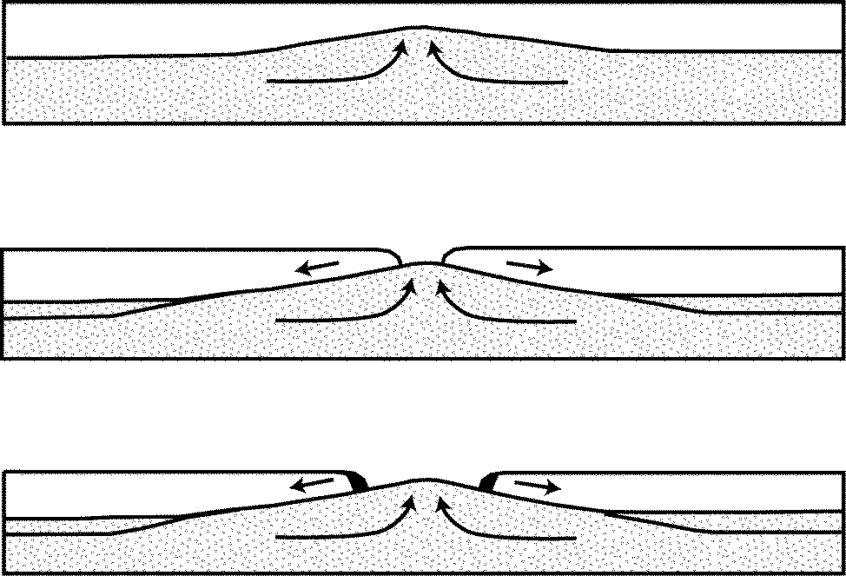

Figure 18. Stylized sketch showing the development of the Hog Hollow depression by diapiric uplift within the Tertiary sedi- ments (stippled) and lateral spreading of the Huckleberry Ridge Tuff (white) and sediment slab above. Note the thin- ning and sagging of the trailing edge of the tuff due to the fact that the unit's interior was still hot and mobile. This produced the monoclinal feature on the north rim. Also, note the near vertical vitrophyre zones (dark shaded) at the trail- ing edge. This vitrophyre resulted from heat loss before de- vitrification.

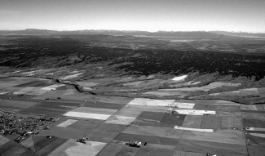
Figure 19. Oblique aerial photograph on the Big Bend Ridge caldera rim and Island Park basin beyond. Photo was taken from southeast of Ashton looking northwest.

more exposures of these basalts and occasional exposures of Huckleberry Ridge Tuff are visible in roadcuts and in the adjacent fields.
21.5 On the left side of the road is a hill which is an antiform in the Huckleberry Ridge Tuff that has been partly buried by subsequent basalt of the Snake River Group.

Stop 1. Antiform in the Huckleberry Ridge Tuff
22.8 Park in the pulloff area on the left (west) side of the road. This roadcut and the hill to the west provide an example of a large load structure or dome in the Huckleberry Ridge Tuff. At the south end of the roadcut the Huckleberry Ridge Tuff is exposed and is steeply dipping to the south. At the far north end of the hill (~275 m north of the southern outcrops) the poorly exposed tuff is dipping north. Between these outcrops, near the north end of the pull out, the slope is composed of pre-Tyh tuffaceous sediments and gravel in the core of the structure. These sediments are capped by
~1m of loess. The tuff in this road cut is unusual lithologi- cally. Above the basal vitrophyre is partly devitrified, frothy zone which may suggest that here the tuff was deposited into a body of water (Christiansen, 1982). The tuff in this area also exhibits typical strong foliation and lineation.
25.2 Ahead, and to the left is Big Bend Ridge, the southwestern edge of Island Park and the rim of the Big Bend Ridge Caldera segment. The flank of the caldera is a dip slope on the Huckleberry Ridge and Mesa Falls Tuffs to be described at Stop 2.

Stop 2. Big Bend Ridge
28.5 Pull off to the right at the "Three Tetons" historical marker which affords an opportunity to look at the Tetons and Big Bend Ridge. The Teton Range is visible on the skyline to the east. This range will be described in detail at Stops 10
- 12.
Big Bend Ridge is the southern margin of what Hamilton (1965) called the Island Park Caldera. Christiansen (1982) deter- mined that there are actually three calderas in the Yellowstone Plateau Volcanic Field, two of which lie wholly or partly within the Island Park basin (Fig. 1). Big Bend Ridge represents the rim
of the oldest or first-cycle caldera (Fig. 19), which collapsed dur- ing the eruption of the 2.0-Ma Huckleberry Ridge Tuff. The Huck- leberry Ridge Tuff covers an area of >15,000 km2 (5,800 mi2), and has a volume of >2,450 km3 (588 mi3) (Christiansen, 1982), which is ~2500 times larger than the volume of the ash produced by the 1980 Mount St. Helens eruption.
The second volcanic cycle produced a smaller caldera nestled against the northwestern edge of the first-cycle caldera. The cli- mactic eruption accompanied by the collapse of the second cycle, Henrys Fork caldera, produced the 1.3-Ma Mesa Falls Tuff. This ignimbrite sheet covered >2,700 km2 (1,050 mi2) and had a mini- mum initial volume of 280 km3 (67 mi3) (Christiansen, 1982). The third volcanic cycle produced the 0.6-Ma Lava Creek Tuff from the Yellowstone Caldera to the east in Yellowstone National Park. This unit has a volume of 1,000 km3 (Christiansen, 1982) and covered an area of 7,300 km2 (2,800 km2)(Christiansen, un- published data, 1998).
Snake River Butte, visible on the skyline at the east end of Big Bend Ridge, is a precollapse rhyolite lava flow that may have vented along the incipient ring fracture zone in the intrusively uplifted roof of the first cycle magma chamber. This flow ap- pears to be a single lava flow, with a K-Ar date of 2.0-Ma, ana- lytically indistinguishable from the age of the overlying Huckle- berry Ridge Tuff (Christiansen, 1982).

29.3 Cross the Henrys Fork of the Snake River and drive up the flank of the caldera. Dark gray, resistant exposures of the Huckleberry Ridge Tuff can be seen in the ravines on both sides of the road.

Stop 3. Huckleberry Ridge and Mesa Falls Tuffs
29.9 There is a pull-off on the right side of the road where the section shown in Figure 3 of Hamilton (1965) can be ex- amined.
The roadcut on the left (west) side of the highway exposes rhyolite tuffs deposited during the first two volcanic cycles. The dark gray cliff at the base is the upper portion of the Huckleberry Ridge Tuff. Overlying this tuff is a thin (<1 m) layer of loess (now mostly covered by colluvium) deposited during the 700,000 year interval between the culminations of the first and second eruptive cycles. The loess is overlain by ~5 m of white bedded pumiceous ash, laid down by fallout from a high eruption column during early stages of the Mesa Falls eruption. This basal deposit is generally very well sorted, has good planar bedding, and con- tains abundant crystals of sanidine, quartz, and plagioclase. Over- lying the fall deposits, at the top of the road cut, is ~15 m of ash- flow tuff of the Mesa Falls Tuff. It is a pink, partly welded, crys- tal-rich ash-flow extruded during the main stage of the second cycle. This tuff contains numerous brown pumice lapilli. Pum- ice-rich layers within this unit contain large pumice blocks up to 30 cm or more across (Christiansen and Blank, 1972; Christiansen and Embree, 1987).
Turn around at this point and head back down the highway to the south.

Stop 4. Mesa Falls Tuff
30.3 Turn right into the Ashton Hill Estates, take the right fork and proceed up the hill for ~0.1 mile and take the left fork to a road cut where the upper portion of the Mesa Falls Tuff is exposed. The tuff here is partly welded and devitri- fied. It contains numerous brown pumice lapilli and abun- dant euhedral and shattered phenocrysts of quartz, sanidine, and plagioclase. Note the sand being formed at the base of the road cut where the phenocrysts have been concentrated by washing and winnowing. At the north end of the cut, the underlying pumice-fall beds are exposed.
Return to the highway, turn right and head south to Ashton. For optional Stops, there are accessible exposures of both the Huckleberry Ridge and Mesa Falls Tuffs along the river frontage road east and west of the highway.
34.1 Enter Ashton and turn left or east on Hwy 47. Reset odom- eter and follow Highway 47 toward Mesa Falls.
8.6 Cross Robinson Creek where it flows into Warm River, which in turn joins the Henrys Fork of the Snake River about 0.6 km downstream along the flank of the caldera. The highway crosses Warm River at 8.8 miles.
8.9 Till is exposed in the road cut on the left.
~11.1 The Lava Creek Tuff is exposed in road cuts in this area.
11.3 Cuts along this section of the road expose the Huckleberry Ridge Tuff (Christiansen, 1982).

Stop 5. (Optional) Warm River Canyon and Gerrit Basalt
11.7 There is a small turn-off on the right. To the right is a sce- nic view up Warm River canyon. Up the canyon is the old Union Pacific Railroad grade and tunnel which is cut through the Huckleberry Ridge Tuff. This railroad was built in ~1915 to bring tourists to the west entrance of Yellowstone National Park (Waite, 1997). Across the road is an exposure of the Gerrit Basalt (Christiansen, 1982).

Stop 6. Gerrit Basalt Flow Features
12.2 To the left is a parking lot for Bear Gulch, an old ski area. Park at the north end of the lot. Ahead and to the left of that parking lot is an excellent exposure of the Gerrit Ba- salt.
There is a sequence of at least four flows exposed in this cliff face. By walking ~0.3 mile up the road grade ahead, excellent exposures of flow breaks within these basalts can be examined in the roadcuts. (Alternatively, you may drive to the lookout at the top of the grade and walk back down). The breaks between indi- vidual flows are marked by their pahoehoe bases as well as ex- cellent examples of vesicle trains and pipe vesicles, which extend up from the flow bases and curve off to the right indicating the direction of flow. These vesicle trains and pipe vesicles formed where steam was generated as the flows moved across wet ground (Macdonald, 1972). Return to the parking lot. Exit and continue north, up the hill on Highway 47.

Stop 7. Lower Mesa Falls and History of the Henrys Fork Gorge
14.6 Turn left into the parking lot for the lower Mesa Falls over- look. Take the right turn at the"T"to the parking area and proceed from there along the footpath to the left. Walk
approximately 100 meters down the trail along the edge of the canyon to a well-established overlook with a stone wall.
This Stop shows where the Henrys Fork has cut a gorge through the rim of the Big Bend Ridge Caldera. This overlook rests on Gerrit Basalt, which forms the upper rim on this side of the can- yon as well as the relatively flat floor of the Henrys Fork Caldera upstream. Several source vents for this basalt lie within the caldera (Fig. 1). In the Mesa Falls area, the Gerrit Basalt overlies the Lava Creek Tuff and is therefore <600 k.y. old. The basalt ap- pears to underlie the 150-ka Buffalo Lake Flow of the Plateau Rhyolite in the northern part of the Island Park basin, and Obradovich has determined a K-Ar age of 200 ka for one of the youngest Gerrit Basalt flows (Christiansen, 1982).
Below is Lower Mesa Falls, where the Henrys Fork spills over the escarpment formed by the densely welded zone near the base of the Mesa Falls Tuff. Along the bottom of the far side of the canyon this densely welded unit, with its well developed colum- nar jointing, is well exposed. On the left side of the falls is an abandoned channel and falls, where the river still occasionally flows during high runoff.
To the right of the falls is another exposure of Gerrit Basalt containing at least five flows. Upstream from the falls, along the east side of the river is a relatively level, terrace like surface on the Gerrit Basalt. That basalt is apparently younger than the ba- salt at the rim where you are standing and has partly filled a paleocanyon cut through the canyon rim basalt and into the Mesa Falls Tuff beneath (Fig. 20). After the paleocanyon was partly filled with basalt, the river flowed across the top of the flows, then moved to the west and cut along the edge of the flows, incis- ing itself again into the softer Mesa Falls Tuff. It appears that the difference in erosional resistance between the basalts and the tuff has controlled the course of the river in this area more than once. The fact that the older Gerrit Basalt appears here, on the east rim, but is not present on the west rim, suggests that this contact may have controlled the course of the river at an earlier time. At that time a canyon was cut into the Mesa Falls Tuff along the edge of the older canyon-rim Gerrit Basalt to approximately the current level of the river. That canyon was then partly filled with younger
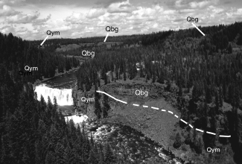
Figure 20. Upper Mesa Falls viewed from downstream on the west canyon rim. Note the paleocanyon fill of Gerrit Basalt (Qbg) cut into the Mesa Falls Tuff (Qym) and the terrace on that basalt, extending upstream on the east side of the canyon.

Gerrit Basalt; and the river then cut along the west edge of these younger flows re-incising itself down to the present level.
On the skyline to the left is the Snake River Butte lava flow described at Stop 2.
Walk back to the parking area, proceed out of the parking lot, and drive back to the road. Turn left at the Stop sign and head north toward Upper Mesa Falls.

15.4 Down the hill just past the gate at 15.5 miles, is another exposure of the Gerrit Basalt, which forms the canyon rim. Further down the road are poor exposures of the Lava Creek Tuff from the 600-ka Yellowstone caldera eruption, un- derlain by the upper vapor-phase zone of the Mesa Falls Tuff (Christiansen and Embree, 1987).

Stop 8. Upper Mesa Falls
16.3 Stop in the Upper Mesa Falls parking lot and proceed down the scenic loop trail at the west end of the parking lot. Past the lodge, take the right fork in the trail by the restroom. Take the next right fork in the boardwalk down the hill to the falls. Down this hill is an exposure of the canyon-fill- ing Gerrit Basalt that was seen from Stop 7.
At the bottom of the hill, look upriver to see more of these basalt flows on the right-hand side of the river. This flow main- tains the river level farther upstream. Proceed along the board- walk at the edges of the falls to enjoy the beautiful scenery and note that like the Lower Falls, the Upper Falls is being held up by the same relatively resistant zone within the lower part of the Mesa Falls Tuff. The cliff face on the opposite side of the river is a nearly complete (~140 m thick) exposure of the Mesa Falls Tuff. The base of the unit is not exposed here but is probably not far below the river level. The densely welded devitrified zone downstream, forms the west wall of the inner gorge while the slopes above are composed of the vapor-phase zone (Christiansan and Blank, 1972). The columns that are along the near side of the river beneath the overlooks are erosional remnants produced from the columnar joining within the densely welded zone.
At the last overlook before starting back up the hill, there is an excellent exposure of Gerrit Basalt. This exposure has, what appears to be, at least five major flows, some of which contain several flow units. Pahoehoe bases and pipe vesicles in many of these flows are visible with binoculars, and indicate some of the flow breaks. Columnar jointing in these flows is well developed with the vertical colonnades at the base and top and a crude enta- blature where the two join at the middle of the flows. The joint patterns along with pipe vesicles suggest at least a brief interval between the major units. Christiansen (unpublished data, 1998) considers all of these units to be parts of one flow complex. Again, it is important to note that the Gerrit Basalt here is filling the paleocanyon cut into the Mesa Falls Tuff. This can be best ob- served by looking upstream toward our present location from the opposite side of the canyon (Fig. 20). As was the case at the Lower Falls, the river has moved off to the west edge of the basalt flows, and cut down into the softer Mesa Falls tuff. From the platform upon which you now stand, look downstream ~200m to an expo- sure of Mesa Falls Tuff beneath the Gerrit Basalt, just below the point on the east canyon rim. This exposure of tuff corresponds
to the tuff below you and probably represents the west side of the paleocanyon through which the basalt flowed.
Follow the walkway back to the parking lot. This is a good spot for a rest stop.
Leave the parking lot and proceed back to Highway 47. Turn right at the top of the hill and backtrack following the highway down to Warm River and back to Ashton.

31.5 Just before reaching Ashton, turn left and take Hwy 32 south, toward Driggs. Reset odometer.
3.7 Enter the canyon of Falls River. Huckleberry Ridge Tuff is exposed along the canyon rims on either side of the river. Just upstream from the bridge, a flow of the Falls River Basalt overlies the tuff. This basalt comes from the north- east near the southwest corner of Yellowstone National Park (Christiansen, 1982)
The rolling landscape between Ashton and the Big Hole Moun- tains to the south is typical of the agriculturally productive region at the northeast end of the eastern Snake River Plain. Wheat, bar- ley, and potatoes are produced from the rich loess soils in this area. These Pleistocene loess deposits were derived from wind- blown silt carried here by the prevailing winds from the flood plain of the Snake River to the southwest. The thickness of these loess deposits is commonly 7-15 m, with a maximum of 60 m (Scott, 1982). The deposits are similar to the productive soils characteristic of the Palouse Prairie of eastern part of the Wash- ington State. The loess in this area mantles deposits of till and glacial outwash, as well as the Huckleberry Ridge Tuff and local post-Tyh basalts.

9.6 For the next ~10 miles past the town of Drummond sev- eral road cuts expose pre-Pinedale till. This till was de- posited near the southwest terminus of an ice sheet that flowed off of the Yellowstone Plateau. Most of these de- posits were probably laid down during Bull Lake Glacia- tion ~140,000 years ago (Scott, 1982).
19.4 The road turns from east to south towards the Teton Basin. There is a good view of the Teton Range ahead. The slop- ing foothills in the foreground to the east and southeast are capped by the Huckleberry Ridge Tuff, which laps onto and overlies the Tertiary Conant Creek Tuff of the Heise Volcanic Group (Christiansen and Love, 1978; and Mor- gan, 1992).

Stop 9. Yellowstone Group Tuffs
20.4 Exposures of the outflow tuffs from the Yellowstone Pla- teau volcanic field can be examined by parking in the pull- out on the north side of Bitch Creek and walking north along the roadcut on the east side of the highway. At the south end of the cut, partly welded, devitrified Huckle- berry Ridge Tuff is exposed.
Farther to the north the Huckleberry Ridge Tuff appears to be juxtaposed against a deposit of nonwelded tuff. The juxtaposi- tion may be the result of faulting and/or channel erosion and fill- ing. The nonwelded tuff overlies the two-pumice, vapor-phase zone of Member B of the Huckleberry Ridge Tuff at the north end of the exposure (Christiansen, unpublished data, 1998), and

appears to be composed primarily of reworked material from that unit. The reworked tuff is capped by ~1 m of vitrophyre, which may be either a late Huckleberry Ridge Tuff flow unit or possibly a thin deposit of Lava Creek Tuff.
The tuffs are unconformably overlain by moderately sorted, angular to well rounded, pebble to boulder fluvial and possible mudflow gravels. These gravels are in turn overlain by a layer of loess, at the top of the cut.
Return to the vehicle and drive to the pullout just south of the Bitch Creek Bridge (mile 21). The gravels just seen on the north rim of the canyon are thicker (~7 m) and better exposed here on the south side of the canyon. In this roadcut the gravel overlies a 2-3 m thick basalt flow, which in turn overlies densely welded vitrophyric top of the Huckleberry Ridge Tuff.

26.8 Just past Badger Creek is an excellent view ahead of what is called Teton Basin or Pierre's Hole, a graben or half graben on the west side of the Tetons. It is bounded by the Teton Range on the east and the Big Hole Range on the west.
The Big Hole Range is composed primarily of folded and thrust-faulted Paleozoic and Mesozoic rocks with Tertiary volca- nic deposits lapping onto the west and north flanks. By contrast, the Tetons have a core of Precambrian crystalline rocks overlain by westward-dipping Paleozoic strata. At the eastern base of the Big Hole Mountains, to the right, is a pronounced fault scarp that offsets the Huckleberry Ridge Tuff. Well data indicates that the basin itself is filled with ~520m (~1700 ft) of Quaternary and Tertiary sediments and tuffs, and ~1280 m (~4200ft) of Meso- zoic and Paleozoic rocks above the Precambrian basement com- plex.
The small hills in the foreground to the left are known as the Tetonia Horst, a small, uplifted block in the center of the valley. The Tetonia Horst named for the little town of Tetonia ahead, consists of Tertiary air-fall ash and tuffaceous sediments overlain by the Huckleberry Ridge Tuff (Christiansen, R.L., unpublished data, 1974 and Prostka, H.J., unpublished data, 1977).

28.9 Intersection of Highway 32 and Highway 33. Reset odom- eter and turn left on Highway 33 toward Driggs.
2.5 To the left is an exposure of air fall ash beneath the Huck- leberry Ridge Tuff at the south end of the Tetonia Horst.

Stop 10. Panoramic View of the Teton and Big Hole Ranges
4.9 Pull off in the parking lot of the Drawknife Furniture Co. From this vantage point the glacially sculptured peaks of the Tetons are visible to the east. There are still several small active glaciers in the range.
The Teton Range is a tilted fault block with a major fault on the east side of the range and smaller fault on the west. The active Teton Fault on the east side marks the boundary between the Teton Range and the Jackson Hole graben. The total displacement on the Teton Fault is ~6,000-10,000m (Smith et al., 1993). Most of that displacement has occurred during the last 9 million years, making this one of the youngest and most active ranges in the region. Mount Moran is the prominent flat-topped peak due east of this locality. It contains Archean granites and gneisses over-
lain by a 20-m remnant of ~500 m.y. old Cambrian Flathead Sand- stone in a noncomformable relationship. Grand, Middle, and South Teton peaks top the skyline with Housetop Mountain and Buck Mountain farther to the south. The peaks are glacial horns sepa- rated by cols. The high peaks are gneisses intruded by ~2,450 Ma granites (Love et al., 1992). Housetop and Buck Mountains are mostly upper Paleozoic sedimentary rocks. Paleozoic units dip
~10° westward toward the valley on this side of the range.
To the west is the Big Hole Range. It is bordered by normal faults on the east and south sides of the range, and the Rexburg Caldera on the west. It contains Paleozoic carbonates and Meso- zoic clastic units that have been displaced by major thrust faults of the late Cretaceous Sevier Orogeny and normal extensional faults of the Cretaceous-Tertiary Laramide Orogeny. Only sig- nificant economic coal deposit in the state of Idaho occur in the Lower Cretaceous Bear River Formation west of Driggs in the Horseshoe Creek district. Sporadic production totalling roughly 100,000 tons occurred between 1882 and the early 1950s (Staatz and Albee, 1966). The north end of the range is a dip slope where the Huckleberry Ridge Tuff overlaps older units.
A recommended side trip from Victor to Swan Valley on High- way 31 shows exposures of Mesozoic units on the northeast side to Paleozoic carbonates on the southwest side of the range. Sev- eral major thrusts are crossed in the traverse (Staatz and Albee, 1966).

10.0 Turn left on Little Avenue and head toward Alta, Grand Targhee Recreation Area, and Teton Canyon, a U-shaped valley with faceted spurs and peaks resulting from Pleis- tocene glaciation.
11.0 Take the left fork.
14.6 Alta Wyoming
14.8 Note the till deposits containing large boulders in the fields and road cuts to the left. For the next mile or two, the road crosses the end moraines of Teton Canyon.

Stop 11. Lateral and End Moraines of Teton Canyon
17.7 Park on the shoulder ~0.4 mile past the switchback. The long ridge upon which you are standing is a lateral mo- raine from the valley glacier which filled Teton Canyon during the Pleistocene. On the south side of the road be- low is a smaller moraine. Equivalent lateral moraines can be seen on the opposite side of the canyon. At the mouth of the canyon most of the terminal moraine has been eroded away, although some remnants can be seen around Alta.
Drive up the road and turn around at a small pullout at the next switchback (17.9 miles). Backtrack to the bottom of the moraine.

19.4 Turn left and proceed up Teton Canyon on the gravel road. About 0.1 mile after leaving the pavement in the road cut on the left, the Huckleberry Ridge Tuff is overlain by till. Note the U shaped profile of the valley and watch for gla- cial boulders scattered along the valley floor as you pro- ceed upstream.
22.2 To the right above Treasure Mountain Scout Camp is an excellent example of a hanging valley.

Stop 12. Precambrian and Paleozoic Exposures Modified by Pleis- tocene Glaciation
23.8 Park in the lot just past the Teton Canyon Campground. Take the switchback trail up Huckleberry Canyon east of the parking lot.
At the foot of the trail is a large outcrop of the Archean base- ment complex. By climbing up this outcrop you may observe three major rock units that are typical of this complex (Love et al., 1992). The layered gneiss and migmatite is the oldest unit and has experienced at least 3 major deformation events (Embree, 1976). This gneiss was intruded by the 2,450-Ma Mount Owens Quartz Monzonite (Love et al., 1992) which in turn was cut by pegmatite dikes. Climb to the top of the outcrop and pick up the trail again. Continue up the trail to the top of the switchbacks where the trail flattens out. There you will notice a sign indicat- ing the boundary of the Jedediah Smith Wilderness Area. Just beyond this sign and uphill to the left is a large exposure of Pre- cambrian rocks. Walk up the hill and climb to the top of the out- crop.
From this viewpoint you can see west down Teton Canyon toward Driggs as well up the hanging valley of Huckleberry Can- yon in which you are standing.
The rocks you are standing on are Archean gneisses and gran- ites similar to the ones at the trailhead. On top of the easternmost of the two outcrops is evidence of Pleistocene glacial abrasion in
the form of smooth polished and striated surfaces on the granite. The view on the opposite side of Teton Canyon shows rounded exposures of Precambrian rocks at the base of the section (Fig. 21). The major Precambrian-Cambrian unconformity occurs just above those outcrops. It is covered by vegetation. A hiatus of approximately 2 billion years is represented by that unconformity. The lower Paleozoic units that overlie the Precambrian rocks rep- resent a transgressional sequence of sandstone, shale and lime- stone deposited as the Sauk Sea inundated the land approximately 500 million years ago. The middle Cambrian Flathead Sandstone (60 m), Gros Ventre Formation (300 m), and Gallatin Limestone (70 m) were laid down at that time. A regressive unit, the Ordovi- cian Big Horn Dolomite forms the lower major cliff about half way up the canyon wall. This was deposited as the sea shallowed. No Silurian units are present in this region, indicating a discon- formity between the Big Horn Dolomite and the overlying Devo- nian Darby Formation (150 m). The Darby Formation consists of thin marine dolomite and limestone units and forms the slope above the Big Horn Dolomite. The next major cliff-former is the Mississippian Lodgepole Limestone (135 m) which was depos- ited as the sea covered the land again. It contains abundant shal- low water brachiopods, bryozoans, crinoids, and corals in lime- stone beds. Occasional trilobite remains have been found. The alternating limestone and siltstone beds at the top of most of the peaks comprise the Mission Canyon Limestone (300 m). It is usu-

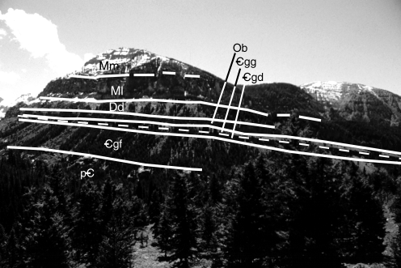
Figure 21. View of the west side of Teton Canyon, Wyoming showing stratigraphic units. At the base are Precambrian granitic and metamorphic rocks (pC) overlain by Cambrian Flathead Sandstone and Wolsey Shale members of the Gros Ventre Formation (Cgf), Death Canyon Limestone member of the Gros Ventre Formation (C gd), Gallatin Limestone (Cgg), Ordovician Big Horn Dolomite (Ob), Devonian Darby Formation (Dd), Mississippian Lodgepole Limestone (Ml) and Mission Canyon Limestone (Mm).

ally not as fossiliferous as the Lodgepole and represents cyclic influx of fine clastics from the craton to the east. Endothyrid fora- minifera remains occur in the upper Mission Canyon.
Return to the parking lot. This is another good place for a rest stop. Drive back to Driggs, turn right on Highway 33, and retrace your route back to the Highway 32 intersection and then on to- ward Rexburg.

44.6 Reset odometer at the intersection of Highway 32 and Highway 33. Continue west on Highway 33. Straight ahead is the very evident fault scarp that runs along the eastern edge of the Big Hole Range.

Stop 13. Teton River and Teton Canyon, Idaho
2.5 Pull off by the corrals on the right just before crossing the Teton River. The Teton River is a slow, meandering stream south of the highway, where it flows from south to north along the west edge of the valley. (This can be seen best by making another stop at the scenic overlook on the left past the bridge ahead.)
To the north, the river enters Teton Canyon, Idaho (not to be confused with Teton Canyon, Wyoming just visited in the Teton Range). This canyon has been cut into a broad, fault-bounded arch, which is the northern extension of the Big Hole Range. To the northwest, the river becomes an antecedent stream, similar to the Colorado River in the Grand Canyon. Here erosion by the Teton River apparently managed to keep pace with the relative uplift of the Big Hole tectonic block, and cut a 150 m deep can- yon. This canyon is the site of the Teton Dam, which is described at Stop 16.

4.2 Ahead and to the left is an excellent view of the main fault scarp that runs along the base of the Big Hole Range. To the right, at ~5.1 miles, along this main escarpment, the Huckleberry Ridge Tuff is exposed.
6.3 To the left is another of the northwest trending normal faults bounding the east side of the Big Hole Range. Continuing to the west, numerous outcrops of Huckleberry Ridge Tuff will be seen.
9.8 The highway crosses two more of the small, normal faults. Like the others, these faults are downdropped to the east. In the area ahead, the broad, gently sloping topography running from the base of the pine-covered mountains down to the north, is a loess-covered dip-slope of Huckleberry Ridge Tuff. At about the upper end of the cultivated fields, the Huckleberry Ridge Tuff laps onto the older Tertiary volcanic rocks of the Heise Group, and the Mesozoic rocks of the Big Hole Range. The loess on these dip slopes tends to thin from an average of ~10-20 m on the lower slopes to as little as a few cm at the upper edges of the fields where plows and cultivators commonly tear up pieces of the tuff.
11.5 Canyon Creek Butte, a broad post-Tyh basalt shield cone is visible straight ahead on the horizon. This is one of sev- eral small shield volcanoes on the Rexburg Bench. Most of the exposed basalts on the Bench overlie Huckleberry Ridge Tuff; however, well data and some fault-scarp and
canyon exposures suggest that there are many pre-Tyh basalts present as well (Prostka and Embree, 1978).
14.9 Turnoff to Green Canyon Hot Springs. These hot springs are located ~4 miles up the road on the left and are on a large travertine deposit located on a fault associated with on the ring-fracture zone of the Rexburg Caldera (Prostka and Embree, 1978). Water emerges from these springs at 115° F (46° C) (Ross, 1971).

Stop 14. (Optional) Canyon Creek Basalt Flows
15.3 Pull off to the right before crossing the bridge. Below, Canyon Creek has cut into basalt flows which overlie the Huckleberry Ridge Tuff just downstream from here, and has filled a paleocanyon in the tuff as far as 4 km upstream (Prostka and Embree, 1978). Canyon Creek parallels the approximate trace of the Rexburg Caldera ring fracture zone in this area (Fig. 1).
18.8 Cresting the broad upwarp in the northern extension of the Big Hole Range reveals a panorama to the west. The dark- colored hills in the distance are the Juniper Buttes. Be- yond them, from west to east, the Lemhi, Beaverhead, and Centennial Ranges can be seen. These are typical basin and range block fault mountains, which form the northern boundary of the eastern Snake River Plain. With the ex- ception of the Centennial Range, which trends east-west (paralleling the northern margin of the plain in that area), these ranges trend northwest (perpendicular to the plain), reflecting late Tertiary southwest-northeast regional exten- sion.
19.9 Just as the highway turns directly west there is a dirt road that turns back to the right. Turn on that road and follow it toward the rim of the Teton Canyon. This gravel farm road proceeds directly east to 20.6 miles where it turns due north. At 22.2 the road turns east again, and then north at 22.6 miles. At 23.0 miles the road turns back to the east. At this corner there is a small farm road that goes straight ahead (north) along the edge of the fields. Take this small road to the edge of the canyon and park.

Stop 15. Large-Amplitude Antiforms in Teton Canyon
23.5 Walk ~425 m (~1/4 mile) west along the canyon rim to a point where there is a good view both upstream and down- stream. From this point, look directly across the canyon to see one of the large antiforms in the Huckleberry Ridge Tuff (Figs. 5, 6, & 8).
The basal vitrophyre is overturned at the base of the west limb of this structure. As a result of the exposure of the nonresistant pre-Tyh units in the core of this antiform, a small alcove or reen- trant has been eroded into the canyon rim. To the west, another reentrant ~0.5 km farther down the canyon marks another antiform (Fig. 7). Note the way that the foliation within the Huckleberry Ridge Tuff delineates changes in attitude associated with the antiformal flexure. Orientation of the columnar jointing in the Huckleberry Ridge Tuff also changes with respect to the defor- mation. The core of this antiform contains pre-Tyh stream grav- els and other unconsolidated fluvial and lacustrine sediments. Some of these antiforms also contain basalt flows, which attain

198
uidebook to the eology of Ea tern daho

near-vertical dips. Note the way that the tuff thins over the crest of the antiform, and the foliation becomes essentially horizontal away from the limbs on either side. This suggests that at the time the sediments pushed upward to form the antiforms, the tuff was still plastic enough to flow off the hinge into the space between.
Over the top and slightly to the left of the westernmost antiform on the far canyon rim, is a small knoll. The top of the knoll is almost completely surrounded by farmland. The hilltop is not cultivated because of a circular exposure of Huckleberry Ridge vitrophyre at the edge of the field. Within this vitrophyre ring on the top of the knoll is a circular exposure of gravel with basalt in the center. This is interpreted to be a dome-shaped piercement of pre-Tyh units through to the surface.
Immediately upstream, to the right and on this (the south) side of the canyon, is another reentrant where arching in the foliation within the Huckleberry Ridge Tuff is plainly visible from here. This is the core of that westernmost antiform you see across the canyon. Farther east on the south side of the canyon, a very steeply dipping vitrophyre in the next reentrant is barely visible, just around the corner. That vitrophyre represents the far flank of the antiform located immediately across from your position. The antiforms on this side of the canyon have been off-set by a left lateral "rootless fault" within the Huckleberry Ridge Tuff, which strikes up the canyon and follows the tributary canyon to the north- west. This gives a good impression of the amount of offset along this fault structure (Fig. 8).
Return to the vehicle and go directly back to Hwy 33; then turn right and proceed west.

Stop 16. Teton Dam
27.8 Turn right at a sign that says "Teton Dam Site", by a power substation on your right, and proceed about 1.5 mile north to the dam (29.3 miles). At the edge of the canyon the road forks; take the left fork into the parking lot for the over- look of the Teton Dam.
On June 5, 1976 the Teton Dam failed, thus sending 80 bil- lion gallons of water down this canyon and out onto the Snake River Plain below. The peak flow during this failure was roughly equivalent to that of the Mississipi river in flood stage (Elkenberry et al., 1977). Eleven people lost their lives, 25,000 were left home- less, 300 mi2 of land was inundated, and $1 billion in damage was done to the communities downstream. The dam was an earth-fill structure and was nearing completion when it failed. At the time of the failure the reservoir level was within a meter of the spill- way sill. Original plans called for filling the reservoir over a pe- riod of two years, but due to an extraordinarily heavy snow pack in 1976 it filled in one season. Reservoir levels could not be low- ered due to delays in the completion of the outlet works tunnel.
The failure has been attributed to both geologic and engineer- ing factors. The geologic factors responsible for the dam failure were: 1) Abundant open fractures in the wall rocks which allowed rapid access of water to the core of the dam during reservoir fill- ing. 2) The material used for the impervious core was loess de- rived clayey silt, which was more brittle and erodible than pure clay which is usually used for such purposes. Clay is not locally available but loess is. The water flowing through the fractures eroded away the core materials in the key trench area, and even-

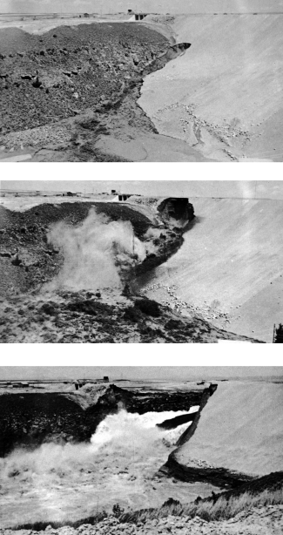

Figure 22. Sequence of photos taken during the failure of the 90 m high Teton Dam. These three photos were taken at 11:20 a.m., 11:50 a.m., and the early afternoon of June 5, 1976 (from Chadwick, 1976). Over a period of hours, piping through joints in the key trench area eroded the core material from within, undermining the north side of the dam.

tually undermined the dam (Fig. 22). Hydraulic fracturing of the core materials may have aided the erosion process. Although a concerted effort was made to develop a grout curtain during con- struction, the open nature of the fractures and their abundance precluded the formation of an effective seal.
From this vantage point the remains of the Teton Dam can be seen to the right, in the center of the canyon. On the far side of the canyon the spillway is still in place at the top of the key trench excavation. The intensely jointed Huckleberry Ridge Tuff in this area was divided into 3 zones by those involved in the post-fail-

ure studies (Fig. 2) (Prostka, 1977). The boundary between zones 2 and 3 appears to be a significant detachment consisting of an open breccia zone which separates dipping foliation above from horizontal foliation below. The south side of the dam was exca- vated during post-failure studies to gain additional insight into the causes. The excavated wall exposes the internal structure of the dam.
On the far side of the canyon about 2 km upstream from the dam is a straight tributary which marks the trace of one of the "rootless faults" in the Huckleberry Ridge Tuff. Along strike, the fault apparently passes directly beneath the south side of the dam and the view point on which you stand (Fig. 8).
On the canyon floor below you and downstream, debris from the dam and blocks of tuff from the key trench area form an im- mense gravel bar up to 20 m thick. During the failure of the dam, nearly as much wall rock as dam fill was removed, attesting to the structurally weak nature of the jointed tuff. The river downstream from the dam has reestablished its former grade by cutting a chan- nel into the gravel bar on the far side of the canyon. Downstream, a point on the south rim was removed by flood waters, and enor- mous blocks were strewn along the canyon floor.
Farther downstream where the canyon turns, a series of basalt flows can be seen to overlie the Huckleberry Ridge Tuff on the south canyon wall. Each of these flows has a pillow zone at its base. These flows will be examined at Stop 21.
Return to the vehicle, and proceed out of the parking lot. Turn
left, just past the east end of the parking lot, go through a chain- link fence, and follow the dirt access road east along the canyon rim. About 100 m after passing the fence, take the right fork. The left fork goes down to the dam itself if you wish to examine it more closely on your own. Follow the more-traveled road, ignor- ing the small right fork at about 29.6 miles.

Stop 17. Boat-Ramp Exposures of Structures in the Huckleberry Ridge Tuff
30.7 Take the sharp left fork to reach the top of the boat ramp for the Teton Reservoir. This ramp was never used. Walk down the concrete boat ramp to closely examine this ex- cellent exposure of the Huckleberry Ridge Tuff in the cut on the left.
The upper end of the cut exposes the zone where the tuff con- tains both open and sediment filled cooling joints (Fig. 13). Note the lateral gradation in welding and devitrification along the mar- gins of these joints. Near the bottom of the concrete ramp the tuff contains numerous subhorizontal shear zones and en echelon ex- tension fractures which have been filled with vapor phase depos- its (Figs. 10 & 11). See the section on "Structural and Lithologic Zonation Within the Huckleberry Ridge Tuff" at the beginning of this paper.
After reaching the bottom of the concrete portion of the boat ramp, return to the vehicles and drive down the ramp to the bot- tom of the canyon.

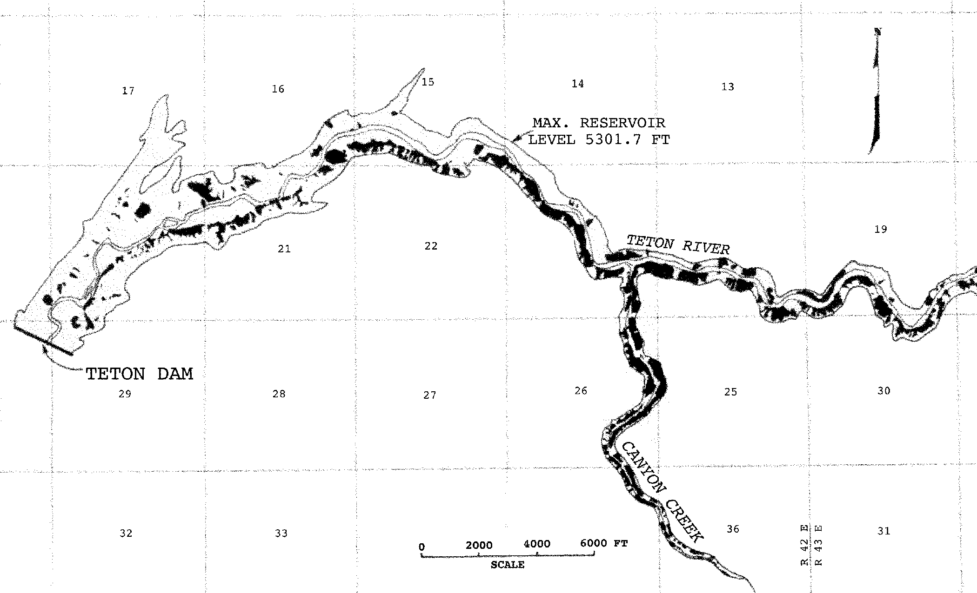

Figure 23. West end of Teton Reservoir showing landslides (in black) produced after draining of the reservoir (from Schuster and Embree, 1980).

Stop 18. Landslides Caused by Teton Dam Failure
  - At the bottom of the canyon on the left, or south side, are several small landslides involving the Huckleberry Ridge tuff and its loess cover. These are typical of the hundreds of landslides along the canyon rim that resulted from the rapid drawdown of the Teton reservoir when the dam failed (Fig. 23). During reservoir filling, the rocks and soil on the canyon rims became saturated; and when the water drained away, they collapsed due to lack of support and excess weight. Many of these slides involve bedrock; but most, particularly on the south rim of the canyon, prima- rily involved the loess cover. Because of the prevailing southwesterly winds, the loess is thicker on the south side of the canyon than on the north side. It built up much like a snow cornice on the downwind side of a ridge. Due to the thicker loess cover, ~55% of the south rim along the entire length of the reservoir failed. By contrast only ~13% of the north rim was involved in landsliding (Schuster and Embree, 1980).

Stop 19. Closeup View of a Large-Amplitude Antiform
  - Just upstream from the water intake tower, on the south side of the canyon, is another reentrant in the side of the canyon. This marks the position of another antiform. Look- ing toward the east, you can see the foliation in the Huck- leberry Ridge Tuff steepen in a downstream direction, form- ing the east limb of the structure. Slightly upstream of your position, an almost vertical wall of basal vitrophyre marks the east limb. This vitrophyre descends near the intake tower to form the west limb. Looking north, across the canyon, another more subdued, arch-shaped structure is visible in the tuff. The basal vitrophyre is not exposed on that side of the canyon.
Follow the road to river's edge for a downstream view of the breach in the dam. From this position you can also get a better perspective of the antiform located near the water intake tower. Turn around, drive up the boat ramp, and back toward Highway 33.

Stop 20. Panoramic View to the West
33.6 Just past the chain link fence where the pavement begins, there are some concrete slabs on the right. These slabs mark the foundations of the buildings used during the construc- tion of the Teton Dam. This is an excellent place to pull off for a second to look at the geologic panorama to the west. In the middle distance are the Menan Buttes, a pair of basalt tuff cones, produced by phreatomagmatic erup- tions caused by the interaction between rising magma and groundwater in near-surface Snake River flood-plain de- posits (Hackett and Morgan, 1988). Just to the left of the South Menan Butte, ~100 km in the distance, Big South- ern Butte, a ~300 ka rhyolite lava dome (Kuntz et al., 1994), is visible on clear days. Directly to the west is the classic profile of a shield volcano on the Snake River Plain, and beyond it the Lemhi and Beaverhead Ranges are visible.
Return to Highway 33.
34.9 Turn west on Highway 33. About 9 miles to the southwest are two small hills that are remnants of cinder cones. These cones are aligned with 8 others along a northwest-trending rift zone that crosses the Rexburg Bench and is the exten- sion of the Grand Valley Fault. The Grand Valley Fault forms the east side of the Swan Valley graben ~20 km to the south. Here, at the northwest end of this rift, the cones are sitting in a small graben that is filled with basalt (Fig. 1). These are post-Tyh flows that filled the graben and overflowed its margins in a few areas. The graben lies near the summit of a pre-Tyh shield volcano. Rexburg and Ricks College sit on the northwest flank of this shield. In con- trast with its thickness in the Teton Canyon areas, the Huck- leberry Ridge Tuff is only about 10 m thick where it mantles this shield cone.
36.0 From here, there is an excellent view of a shield volcano directly ahead and the Menan Buttes to the southwest. North of the shield are the Juniper Buttes. The St. An- thony sand dunes can be seen where they have built up on the south side of Juniper Buttes. Most of the dunes in that area have gone around the buttes, but a few dunes have managed to climb over them. These dunes are composed of sand, apparently derived from a Pleistocene pluvial lake in the area of what is now Market Lake, just north of Idaho Falls. The fields are made up predominantly of transverse dunes, with parabolic dunes along the margins where veg- etation is more plentiful. There is a series of individual dune fields strung out from this area, northeastward to- ward the southern flank of Big Bend Ridge. The individual fields are separated by vegetated areas, and may represent accumulations of sand released to move northeast from the lake bed during interglacial periods. These fields are aligned with the prevailing southwesterly winds of this re- gion. Measurements taken by E.J. Williams (unpublished data) indicate a current migration rate ranging from 1 to 6 m/year, with an average of ~2.5 m/year over the past 30 years. The St. Anthony sand-dune fields can be accessed by taking the North Rexburg exit on Highway 20, turning right, and driving ~10 miles to the north.
38.3 Turn right on Main Street in Newdale and proceed north through town. The road makes a short jog to the left at the north end of town and then turns right to follow the rail- road. Continue north along this road. The town of Newdale was the object of a geothermal exploration program in the 1970s because the city well and private wells in the area produced water at temperatures of up to 97° F (36° C) (Ross, 1971). The residents commonly needed to refriger- ate their drinking water to make it palatable. This water also has a high fluoride content and many of the local resi- dents who used that drinking source for years had fluoridosis, which gave great cavity protection but tended to stain their teeth black or brown.
41.8 Cross the Teton River at the mouth of Teton Canyon.
42.3 At the "T", turn right and drive 2 miles east. Turn right on 3000 E (44.3 miles) where the pavement ends. Drive 1 mile and turn left or east again at 45.3 miles. Turn right at the quonset huts at 45.8 miles, and drive 1.4 miles to the

Embree and Hoggan -- Secondary Deformation Within the Huckleberry Ridge Tuff 1
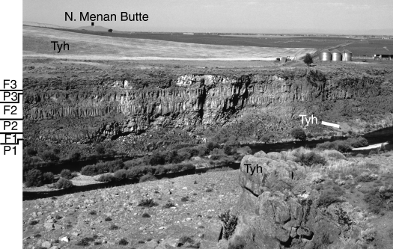
Figure 24. Three basalt flows (F1-F3) on the south side of Teton Canyon near its mouth, 2 km downstream from the Teton Dam site. Each flow has a pillow zone at its base (P1-P3). The flows came from the south, flowed around the light-colored hill of Huckleberry Ridge Tuff (Thy) in the middle distance and into a paleocanyon cut into the Huckleberry Ridge Tuff. North Menan Butte in the distance is a phreatomagmatic tuff cone.

north canyon rim. Park and walk ~1/4 mile west along the canyon rim to a vantage point where you can see the south wall of the canyon.

Stop 21. View of Pillow Basalt Flows
There are 3 basalt flows in the cliffs across the canyon. Each has a pillow zone at the base (Fig. 24). The probable source of the flows is one of the shield volcanoes on the Rexburg Bench south of Newdale. They apparently flowed around the west end of the hill just south of the canyon and into a paleocanyon cut into the Huckleberry Ridge Tuff, outcrops of which can be seen at the base of the basalt cliffs. As the lava flowed into the canyon, pil- lows were produced as it entered the river and/or the water that ponded upstream from the low lava dam it formed.
Return to the vehicle and drive 2.9 miles back to the pave- ment.

50.1 Reset odometer and turn right (east) at the corner of 3000 E and 400 N. Follow the dirt road 0.5 mile east then 1 mile north. Turn right at the paved road.
3.7 Hog Hollow is visible to the left.
4.8 The road crosses the south scarp of Hog Hollow.
  - Take the right fork.
Stop 22. Pre-Tyh Deposits
  - A small quarry on the left exposes pre-Tyh deposits. At the south end of the quarry, the overlying erosionally re- sistant Huckleberry Ridge Tuff vitrophyre dips ~75° west. Palagonite tuff, clays, and gravel are exposed in the north wall. Beneath the palagonite tuff is a chaotic mixture con- taining gravel, silt, rhyolite glass shardes, pumice, and glassy scoria. This mixture was probably produced by dis- ruption of pre-Tyh units as they flowed inward and up- ward to form the Hog Hollow bulge (Fig. 18).
Turn around, return to the fork, and turn east at 6.8 miles.

6.9 To the left is a ridge of vertically dipping Huckleberry Ridge Tuff vitrophyre.

Stop 23 Monocline in the Huckleberry Ridge Tuff
7.5 The north rim of Hog Hollow is marked by a monoclinal structure in the Huckleberry Ridge Tuff. The face of the cliff is vertically dipping vitrophyre and at the top of the hill, devitrified tuff dips ~20° south (Figs. 8 and 9). This exposure shows how the tuff grades laterally from vitrophyre where it was chilled at the open face of the Hog Hollow scarp to devitrified tuff in the interior of the unit, away from the cooling surface (Fig. 18).
Turn around and follow this road west to St. Anthony.

12.8 Turn right at the "T" and drive 0.2 mile north and 0.1 mile west to intersect Highway 20.
End of log.

ACKNOWLEDGMENTS
Over the past 30 years Ricks College faculty and students have conducted numerous research projects and annual field trips to various parts of the area covered in this field guide. This guide is a compilation of information from those trips and research. We are indebted to Ricks College and the U. S. Geological survey for funding to support the research as well as many individuals for their pioneering work and willingness to share their data and ideas. Special recognition should be given to H.J. Prostka and D.J. Doherty for their efforts in working out the structural and strati- graphic framework for the Tertiary volcanics on this portion of the eastern Snake River Plain; and to R.L. Christiansen for shar- ing his work on the Yellowstone Plateau Volcanic Field, includ- ing Big Bend Ridge, Mesa Falls, and Teton Canyon areas. As was the case with so many other projects in this region, Steve Oriel provided direction and encouragement. M. Lovell and G. Oberhansley worked as field assistants on projects involving the secondary movement structures in the Huckleberry Ridge Tuff in the Teton Dam area. J. Chase, J. Reisterer, V. Taube and A. Hayes helped with illustration preparation. We are also indebted to E.J. Williams and S.C. Hansen of the Ricks College geology depart- ment for introducing us to the geology of much of this area. Re- views and helpful comments by R.L. Christiansen, H.J. Prostka and the editors of this volume are greatly appreciated.

REFERENCES
Albee, H.F., Prostka, H.J., Jobin, D.A., Love, J.D., 1975, Field trip guide to the Idaho-Wyoming thrust fault zone: Geol. Soc. America, Rocky Mtn. Sec. Mtg., Boise, Idaho, Field trip no. 4, 22 p.
Breen, N.A., Tagudin, J.E., Reed, D.L., and Silver, E.A., 1988, Mud-cored par- allel folds and possible melange development in the North Panama Thrust Belt: Geology, v.16, p. 207-210.
Chadwick, W.L., et al., 1976, Report to U.S. Department of the Interior and State of Idaho on failure of Teton Dam: Washington D.C., U.S. Government Printing Office.
Christiansen, R.L. and Blank, H.R., Jr., 1972, Volcanic stratigraphy of the Qua- ternary Rhyolite Plateau in Yellowstone National Park: U.S. Geological Survey Professional Paper 729-B, 18 p.
Christiansen, R.L 1982, Late Cenozoic volcanism of the Island Park area, east- ern Idaho, in Bonnichsen, B., and Breckenridge, R.M., eds., Cenozoic Ge- ology of Idaho: Idaho Bureau of Mines and Geology Bulletin 26, p. 345- 368.
Christiansen, R.L., and Embree, G.F., 1987, Island Park, Idaho; Transition from rhyolites of the Yellowstone Plateau to basalts of the Snake River Plain, in Geological Society of America Centennial Field Guide-Rocky Mountain Section, p. 103-108.
Elkenberry, W.F., et al., 1977, Failure of Teton Dam: a report of findings by U.S. Department of the Interior Teton Dam Failure Review Group: Washington D.C., U.S. Government Printing Office.
Embree, G. F., 1976, Structural analysis of the Precambrian rocks, Green Lake Basin, Teton Range, Wyoming: University of Idaho, Unpublished, 104 p.
Embree, G.F., 1988, Secondary flow and gravity sliding within the Huckleberry Ridge Tuff, [abs.]: Geological Society of American Abstracts with programs, v.20, no.6, p. 453.
Embree, G.F., McBroome, L.A., and Doherty, D.J., 1982, Preliminary strati- graphic framework of the Pliocene and Miocene rhyolites, eastern Snake River Plain, Idaho in Bonnichsen, B., Breckenridge, R.M., editors, Ceno- zoic Geology of Idaho: Idaho Bureau of Mines and Geology Bulletin 26, p. 333-368.
Hamilton, W. 1965, Geology and petrogenesis of the Island Park caldera of rhyolite and basalt, eastern Idaho: U.S. Geological Survey Professional Paper 504- C, 37 p.
Hackett, W.R. and Morgan, L.A., 1988, Explosive basaltic and rhyolitic volcan- ism of the eastern Snake River Plain, Idaho, in Link, P.K. and Hackett, W.R., eds., Guidebook to the Geology of Central and Southern Idaho: Idaho Geological Survey, Bulletin 27, p. 283-301.
Kunz, M.A., 1979, Geologic map of the Juniper Buttes area, eastern Snake River Plain, Idaho: U.S. Geological Survey Map I-1115, scale 1:48,000.
Kuntz, M.A., et al., 1994, Geologic map of the Idaho National Engineering Labo- ratory and adjoining areas, eastern Idaho: U.S. Geological Survey Map I- 2330, scale 1:100,000.
Love, J.D., Reed, J.C., Jr., and Christiansen, A.C., 1992, Geologic map of Grand Teton National Park, Teton County, Wyoming: U.S. Geological Survey Mis- cellaneous Geologic Investigations Map I-2031, scale 1:62,500.
Macdonald, G.A., 1972, Volcanoes: New Jersey, Prentice-Hall, Inc., p. 90. Mitchell, V.E., and Bennett, E.H., 1979, Geologic map of the Driggs Quad-
rangle, Idaho: Idaho Bureau of Mines and Geology, scale 1:250,000.
Morgan, J.P., Coleman J.M., and Gagliano, S.M., 1968, Mudlumps: Diapiric structures in Mississippi Delta sediments: American Association of Petro- leum Geology, Memoir 8, p. 145-161.
Morgan, L.A., 1992, Stratigraphic relations and paleomagnetic and geochemi- cal correlations of ignimbrites of the Heise Volcanic Field, eastern Snake River Plain, in Link, P.K., Kuntz, M.A., and Platt, L.B., eds., Regional geol- ogy of eastern Idaho and western Wyoming: Geological Society of America Memoir 179, p. 215-226.
Prostka, H.J., 1977, Joints, fissures, and voids in rhyolite welded ash-flow tuff at Teton Dam site, Idaho: U.S. Geological Survey Open-File Report 77-211, 13 p.
Prostka, H.J., and Hackman, R.J., 1974, Preliminary geologic map of the NW 1/ 4 Driggs 1° by 2° quadrangle, southeastern Idaho: U.S. Geological Survey Open-File Report, p. 74-105, scale 1:125,000.
Prostka, H.J., and Embree, G.F., 1978, Geology and geothermal resources of the Rexburg area, eastern Idaho: U.S. Geological Survey Open-File Report 78- 1009, 15 p.
Ross, S.H., 1971, Geothermal potential of Idaho: Idaho Bureau of Mines and Geology, Pamphlet 150, 72 p.
Schuster, R.L. and Embree, G.F., 1980, Landslides caused by rapid draining of Teton Reservoir, Idaho in Proceedings of 17 Annual Symposium of Engi- neering Geology and Soils Engineering, Boise, Idaho, p. 1-14.
Scott, W.E., 1982, Surficial geologic map of the eastern Snake River Plain and adjacent areas, 111° to 115° W., Idaho and Wyoming: U.S. Geological Sur- vey Map I-1372, scale 1:125,000.
Smith, R.B., Pierce, K.L., and Wold, R.J., 1993, Seismic surveys and Quater- nary history of Jackson Lake, Wyoming, in Snoke, A.W., Steidtmann, J.R., and Roberts, S.M., eds., Geology of Wyoming: Geological Survey of Wyo- ming, p. 668-693.
Staatz, M.H., and Albee, H.F., 1966, Geology of the Garns Mountain quadrangle, Bonneville, Madison, and Teton Counties, Idaho: U.S. Geological Survey Bulletin 1205, 122 p.
Waite, Thornton, 1997, Yellowstone Branch of the Union Pacific: Route of the Yellowstone Special: Missouri, Brueggen, Johann/Reese and Thornton Waite. Wilson, S.D., 1967, Landslides in the City of Anchorage, in Wood, F.J. et al., eds., The Prince William Sound, Alaska, Earthquake of 1964 and After- shocks, v.2, part A: U.S. Dept. of Commerce, Coast and Geodetic Survey,
Publication 10-3, 279 p.

