Seismic Hazard Susceptibility in Southwestern Montana: Comparison at Dillon and Bozeman

Arleen A. Hilll

Earth & Environmental Resources Management Program, School of the Environment, The University of South Caro- lina, Columbia, SC 29208
Mervin J. Bartholomew
Earth Sciences & Resources Institute and Earth & Environmental Resources Management Program, School of the Environment, The University of South Carolina, Columbia, SC 29208

ABSTRACT
A GIS was employed to integrate spatial distribution of ac- tive faults, earthquakes, and other geologic parameters in devel- oping a more rigorous method for delineating expected Modified Mercalli Intensity (MMI) values for two communities in south- western Montana. Characteristic earthquakes were selected for the three overlapping stress fields affecting southwestern Mon- tana (mid-continent, Basin and Range and Yellowstone stress fields). Fault-plane solutions for the characteristic events (1925 Clarkston Valley, 1959 Hebgen Lake, and 1983 Borah Peak, re- spectively) and attitude data for known active faults in the region were compared to determine if active faults were favorably, unfa- vorably, or severely misoriented for reactivation within each stress field. Published isoseismal maps for each characteristic event were used to determine potential MMI=VI, VII and VIII areas around each fault. Results show that Dillon and Bozeman lie within MMI=VIII and VII areas, respectively. Limitations created by reliance on felt reports and characteristic events yield a system- atic underestimate of anticipated maximum MMI. It is important to note that the absence of intensity IX and X values is not in- tended to suggest that southwestern Montana is not susceptible to these intensities. Local geology, groundwater hydrology and ma- terial property contrasts have not been incorporated here and are all factors that influence local response to seismic energy.

!Present Address: Hazards Research Lab, Department of Geography, The Uni- versity of South Carolina, Columbia, SC 29208. aahill@sc.edu

INTRODUCTION
Late Quaternary faulting and high levels of seismicity charac- terize southwestern Montana and adjacent Idaho. Strain accumu- lation in this tectonically complex region results from the mid- continent, Basin and Range, and Yellowstone-hotspot stress re- gimes (e.g., Stickney and Bartholomew, 1987; Doser, 1989). His- torically, earthquakes in the Rocky Mountains have occurred in sparsely populated regions (Hebgen Lake, MT, Borah Peak, ID, Fairview Peak, NV, Dixie Valley, NV). Even so, Montana has the same per capita death rate (4/100,000) as California (Bartholomew et al., 1988). Given current and expected increases in the popula- tion, the nature and extent of risk from seismic hazards in south- western Montana should be reevaluated. In Montana the oppor- tunity exists to assess and mitigate seismic hazards before further population explosion occurs.
Location and classification of potentially seismogenic features in southwestern Montana and adjacent Idaho (Fig. 1) form the basis of this earthquake hazard evaluation. Youngs and others (1988) demonstrated that integration of detailed geologic data increases the resolution of hazard assessment, permitting study of local variations of susceptibility. We utilize active fault data for southwestern Montana to investigate the effect of fault prox- imity on hazard susceptibility as measured by expected Modified Mercalli Intensity (MMI) at two communities.
Three stress fields exist in this region (Fig. 1). The mid-con- tinent stress field is characterized by horizontal compression. The stress field extends from the Rocky Mountain front to within 230

Hill, A.A., and Bartholomew, M.J., 1999, Seismic Hazard Susceptibility in Southwestern Montana: Comparison at Dillon and Bozema n, in Hughes, S.S., and Thackray, G.D., eds., Guidebook to the Geology of Eastern Idaho: Pocatello, Idaho Museum of Natural History, p. x-xx.

Table 1. Characteristic Event Summary.

Characteristic Event | Magnitude | Favorable Orientations | Unfavorable Orientations
1925 Clarkston Valley, MT Mid-continent compression | 6.75 | 018° - 345°  054° - 078°  164° - 188°  232° - 258° | 030° - 333°  042° - 087°  152° - 200°  220° - 270°
1959 Hebgen Lake, MT Yellowstone extensional | 7.5 | 108° - 162°  288° - 342° | 084° - 186°  264° - 006°
1983 Borah Peak, ID Basin & Range extension | 7.3 | 072° - 116°  252° - 296° | 048° - 140°  228° - 320°

kms of the mid-Atlantic ridge. Both the Basin and Range and Yellowstone stress regimes overprint the mid-continent field in southwestern Montana. While both of the later stress fields are extensional they can be differentiated based on T-axis orienta- tions. A characteristic earthquake is assigned to each stress field used in this study: 1925 Clarkston Valley, MT for the mid-conti- nent stress field, 1959 Hebgen Lake, MT is assigned to the Yellowstone stress regime, and the 1983 Borah Peak, ID event is the reference earthquake for the Basin and Range stress field (Table 1).

Dillon and Bozeman were selected as case-study localities for the following reasons:
- The southwestern portion of Montana has the state's high- est degree of tectonism. The earthquake hazard map
(Bartholomew, et al., 1988) designates the greatest hazard rating in the state to this region (Fig. 2).
- The population density in southwestern Montana is high. This portion of the state is also a popular tourist destina- tion. Recent, large-scale development in southwestern Montana communities increases the number of people and property at risk. In 1997, 2,889,513 people visited Yellowstone National Park (Yellowstone Information Ser- vices, 1998, personal communication). Thus a large tran- sient population is also at risk.
- Both Dillon and Bozeman are built on Quaternary depos- its. Therefore, the primary variation in local seismic haz- ard may be ascribed to the proximity of a fault to a com- munity.

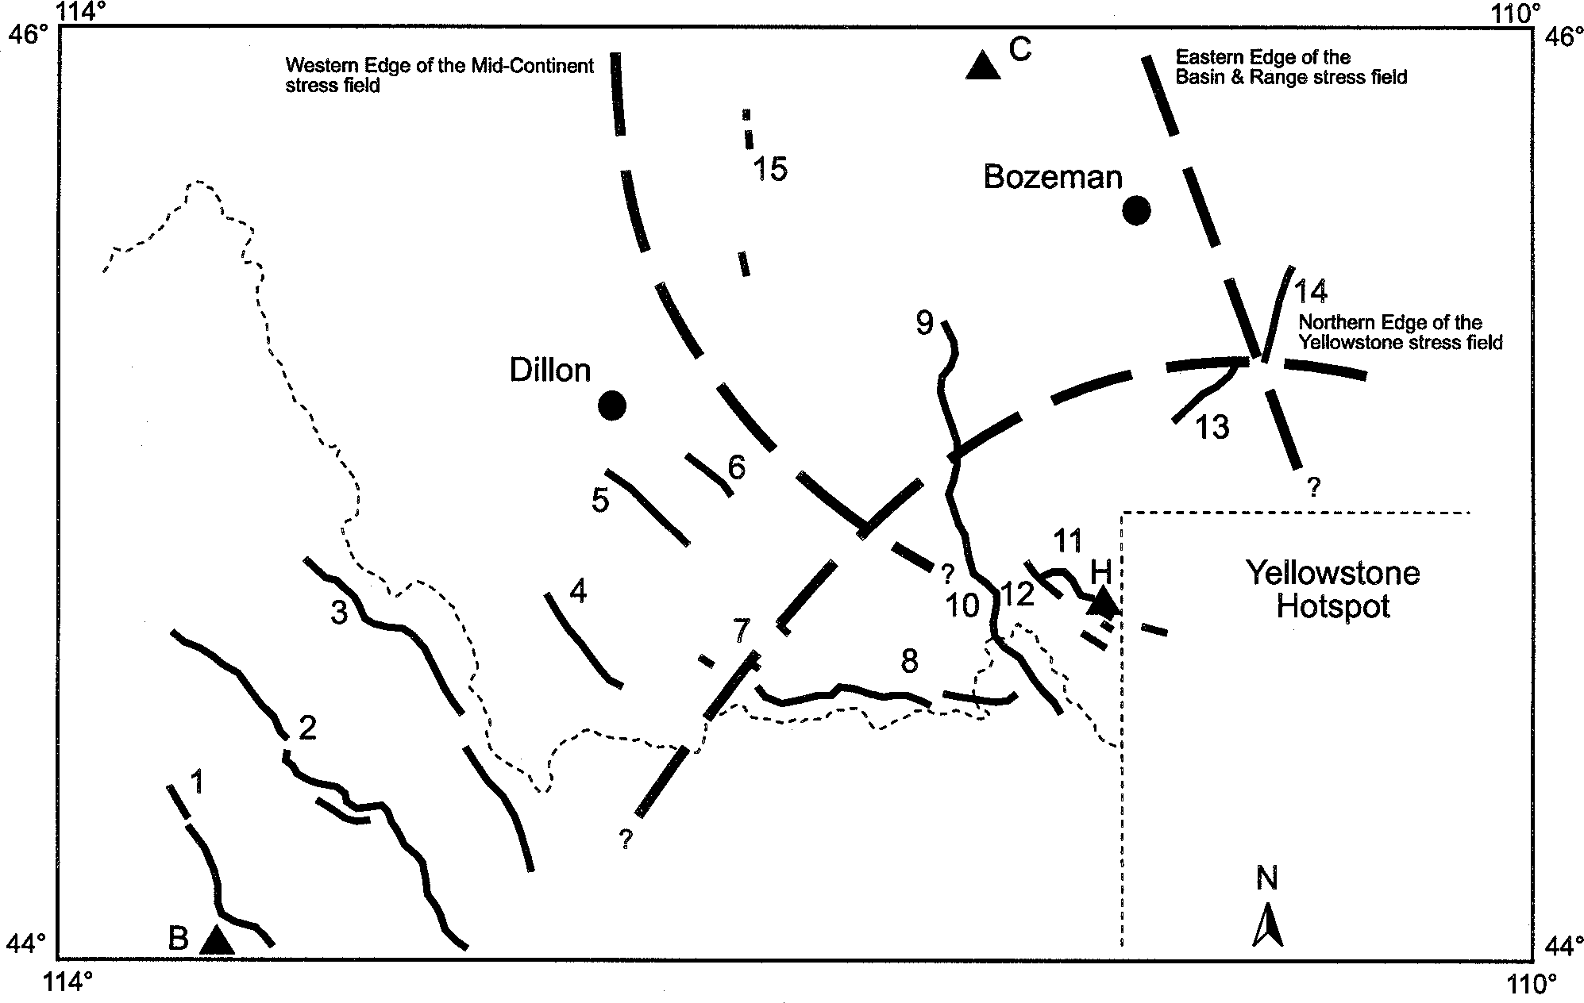
Figure 1. Map of active-faults, stress fields, and characteristic events relative to Dillon and Bozeman. Epicenters for charact eristic events are designated with triangles, C = Clarkston Valley, H = Hebgen Lake, and B = Borah Peak. Fault numbers correspond to those in Tabl e 2.

REGIONAL TECTONIC SETTING AND HISTORIC SEISMICITY
Southwestern Montana is situated in the Montana-Idaho ba- sin and range segment of the Basin and Range physiographic prov- ince. North of the Snake River Plain (SRP), the Montana-Idaho basin and range is characterized by mountain ranges bounded by steeply dipping normal faults and Cenozoic sediment-filled ba- sins (e.g., Reynolds, 1979). The region has undergone one of the longest intervals of active extension documented in the North American Cordillera (e.g., Janecke, 1992). In addition to Basin and Range structural features, volcanic features associated with the track and current position of the Yellowstone hotspot are im- portant to an overall hazard assessment. The Yellowstone Pla- teau-Hebgen Lake-Teton region is one of the most seismically active and youthful volcanic regions in the world (e.g., Anders, et al., 1989).
The 1987 Yellowstone-Hebgen Lake Crustal Deformation Project team documented extensional strain accumulation and large-scale uplift continuing since the 1959 Hebgen Lake earth- quake sequence. Both rapid horizontal and vertical deformation, and the largest strain rates in the continental United States, out- side southern California, were revealed by trilateration surveys in 1973 and 1984 (Smith, et al., 1989). Elevation changes dem- onstrate the dynamic nature of the caldera area. Specifically, in the northern caldera 20 mm of subsidence occurred from 1987 to 1989 (Meertens and Smith, 1991). Earlier, at the northwestern caldera edge, an earthquake swarm was associated with 66 mm of uplift (Meertens and Smith, 1991). This 1985-1986 swarm, centered at 44°40' N, 111° W, had an extension direction similar to the 1959 Hebgen Lake event (Savage, et al., 1993). The 1977- 1984 rate of uplift had a maximum of 20 mm/yr (Dzurisin, et al., 1990). The subsequent 1987-1989 period of subsidence was 25- 35 mm/yr, but this rate decreased to 10 mm/yr through 1990 (Dzurisin, 1990).
The Intermountain Seismic Belt (ISB) is a zone of pronounced seismicity roughly corresponding to the eastern margin of the

based ns des-
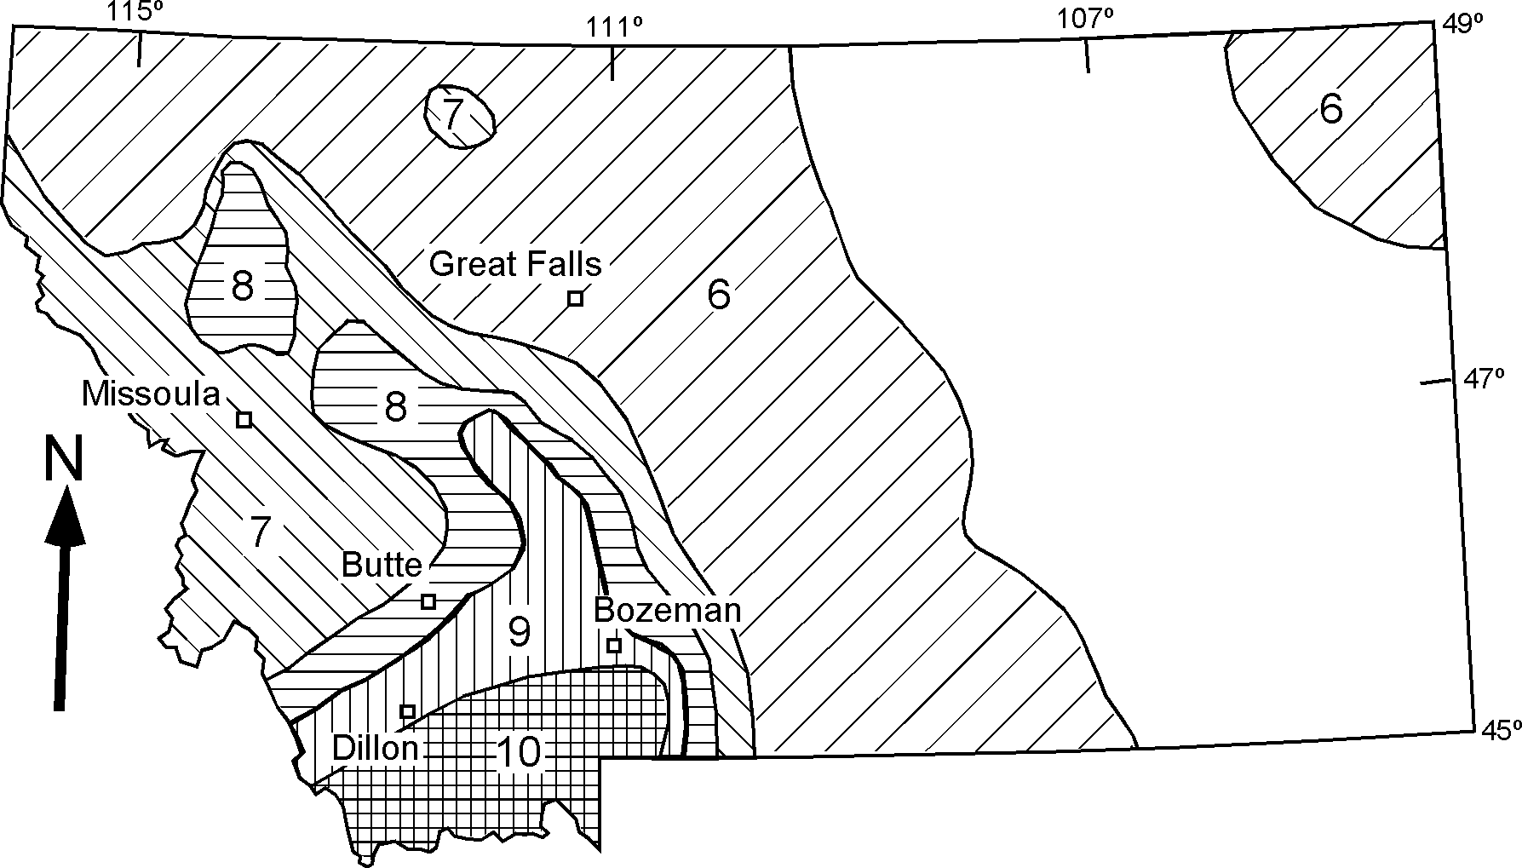
ignate expected Modified Mercalli Index for bedrock (Ara- bic numerals were used for clarity) adapted from Bartholomew, et al. (1988).
Figure 2. Earthquake hazard map for the state of Montana on seismicity and distribution of active faults. Patter

Basin and Range Province (Smith and Sbar, 1974). Waveform modeling and focal mechanism studies document that large events in Montana and Idaho occur along high angle faults dipping 45°- 80° with an 8-15 km depth range (Doser, 1989). Stretching from east-central Idaho to Yellowstone National Park, the Centennial Tectonic Belt (CTB) is defined by seismicity and active faulting (Stickney and Bartholomew, 1987). Along the northern flank of the SRP, the CTB is the most tectonically active portion of Mon- tana and Idaho exhibiting a high level of seismicity and Holocene displacement on numerous faults (Stickney and Bartholomew, 1987). The Yellowstone Park-Hebgen Lake portion is the most seismically active zone of the CTB (Stickney and Bartholomew, 1987; Doser, 1989). Events at Borah Peak, ID and Hebgen Lake, MT both occurred in the CTB. While the events have similar surface wave magnitudes, moment magnitudes show that Hebgen Lake was a much larger event (7.4 versus 6.8 at Borah Peak). In contrast to the seismic and tectonic activity of the Yellowstone- Hebgen Lake portion of the hotspot system, seismicity in the SRP is infrequent and of small magnitude with shallow hypocenters (Jackson, et al., 1993). From 1884 to present, historic records report no events with mL > 2.5 (Jackson, et al., 1993).
North of the SRP, Stickney and Bartholomew (1987) docu-
mented a spatial correlation between high seismicity levels and late Quaternary faulting. All earthquakes of magnitude greater than 5.5, and most identified late Quaternary faults found in Mon- tana, exist south of the Lewis and Clark Zone (Stickney and Bartholomew, 1987; Doser, 1989). Consistent with the work of Stickney and Bartholomew, Doser grouped focal mechanisms into distinct stress regimes (e.g., Stickney and Bartholomew, 1987, Doser, 1989). T-axes for the 1959 and 1964 Hebgen Lake events lie close to the Yellowstone stress regime, indicating the transi- tion from Yellowstone to Basin and Range stress regime falls just north of Hebgen Lake (Doser, 1989).

Table 2. Characteristic Event Assignments
Fault Strike Favorable Unfavorable Misoriented

1. | Lost River | 315° | Borah Peak | Hebgen Lake | Clarkston Valley
2. | Lemhi | 315° | Borah Peak | Hebgen Lake | Clarkston Valley
3. | Beaverhead | 315° | Borah Peak | Hebgen Lake | Clarkston Valley
4. | Red Rock | 308° | Borah Peak | Hebgen Lake | Clarkston Valley
5. | Blacktail | 300° | Borah Peak | Hebgen Lake | Clarkston Valley
6. | Sweetwater | 300° | Borah Peak | Hebgen Lake | Clarkston Valley
7. | Lima Reservoir | 265° | Hebgen Lake | Borah Peak | Clarkston Valley
 | Trail Creek | 290°
8. | Centennial | 270° | Hebgen Lake | Borah Peak | Clarkston Valley
9. | North Madison | 170° | Clarkston Valley | Borah Peak | Hebgen Lake
10. | South Madison | 140° | Borah Peak | Hebgen Lake | Clarkston Valley
11. | Red Canyon | 120° | Borah Peak | Hebgen Lake | Clarkston Valley
12. | Hebgen | 120° | Borah Peak | Hebgen Lake | Clarkston Valley
13. | Southwest Emigrant | 48° | Clarkston Valley | Hebgen Lake | Borah Peak
14. | Northeast Emigrant | 57° | Clarkston Valley | Hebgen Lake | Borah Peak
15. | Vendome | 350° | Clarkston Valley | Borah Peak | Hebgen Lake
15. | Whitetail Deer | 170° | Clarkston Valley | Hebgen Lake | Borah Peak
 | Georgia Gulch

Fault numbers correspond to those on Figure 1.
Characteristic Events in bold represent the event parameters applied to the fault for this study.

METHOD
The Method for this seismic hazard susceptibility study has two parts. The first part is the integration of active-fault data; the second part compares results to published hazard maps for the state of Montana. Fault attitudes (orientation and dip) and fault locations are utilized in evaluating seismogenic features. The ac- tual slip directions on most of these active fault surfaces are un- known, however, hence slip direction was not incorporated into this study. In this study only active faults, those exhibiting Late Pleistocene and/or Holocene displacement, are considered po- tentially seismogenic. Active faults are defined to be those mov- ing once in 10,000 years or multiple movements in 500,000 years (e.g., Slemmons and McKinney, 1977; Stickney and Bartholomew, 1987). However, fault scarps, which are the primary evidence of movement, are ephemeral features (Pierce and Colman, 1986; Pierce, 1988). Therefore aside from evidence of movement ob- served in trenches, the oldest scarps typically recognized in the field are Bull Lake aged (120,000 - 200,000 years; personal com- munication, R.D. Hall, 1998).

Active Fault Data
Part one of this study is composed of four steps:
  - Determination of fault-reactivation potential in prevailing stress fields.
  - Grouping of faults based on favorable or unfavorable re- activation potential.
  - Assignment of Characteristic-event parameters to grouped faults.
  - Generation of maps for Dillon and Bozeman delineating expected MMI values.

Because three different stress fields affect parts of southwest- ern Montana, the potential of each active fault to be reactivated within each stress field was evaluated. Sibson (1990, p. 1580) showed that:

"For typical values of rock friction, active faults may be defined as avorably oriented for fric- tional reactivation, un avorably oriented, or severely misoriented, depending on their atti- tude in the prevailing stress field."

The ranges for fault-attitude for both favorable and unfavorable orientation were considered for each fault-characteristic event pair to determine which characteristic event to attribute to a given fault (Tables 1 and 2).
Faults with orientations within 12° of the fault-plane solution for a characteristic event were classified as favorably oriented for reactivation in the stress field represented by that characteris- tic event. Unfavorably oriented faults lie 12° to 24° from the plane of a focal mechanism. Those faults positioned greater than 24° from the characteristic event fault plane are considered severely misoriented. Reactivation of severely misoriented faults were not considered for two reasons:
    - All of the active faults in southwestern Montana are favor- ably oriented for one of the stress regimes and unfavorably ori- ented for a second stress regime. It is likely that one of these two stress regimes would be responsible for major earthquakes on a given active fault, therefore it is not necessary to consider the case of severely misoriented reactivation (Sibson, 1990).

    - While reactivation of a severely misoriented fault might occur, it is more likely to be a consequence of a major event on a nearby active fault. For example, displacement on the Madison fault occurred as a consequence of the 1959 Hebgen Lake earth- quake (Barrientos et al., 1987). That segment of the Madison fault is severely misoriented for reactivation in the Yellowstone stress regime and hence only minor displacement occurred along it. Strain accumulation on severely misoriented faults is more likely released in small increments, as in this case, rather than in a single large rupture event.
Reactivation classification formed the criteria for placing faults within the study area into one of three groups. Where a fault is oriented such that reactivation is probable in multiple stress re- gimes it is placed in the group with maximum parameters. Fol- lowing this grouping, felt-area MMI values reported for charac- teristic events were applied to fault groups. Faults then are buff- ered within a GIS according to published isoseismal data (sum- marized in the following section). This final step yields a map of expected seismic hazard susceptibility for southwestern Montana. In general MMI values greater than those reported would be expected for Ms > 7 earthquakes. However, in the case of the Hebgen Lake and Borah Peak earthquakes, published isoseismal maps report maximum MMI values of VII. MMI > VIII were associated with the Clarkston Valley and Helena Valley (1935) events, but these earthquakes had Ms < 7. These earthquakes oc- curred in different geologic settings compared to the Hebgen Lake and Borah Peak. The effect of valley fill on energy transmission was not quantified here. An effort was made to apply MMI > VII values to represent hazard susceptibility at Dillon and Bozeman. In mapping expected or potential MMI we assumed that any point on a fault surface might serve as the point of rupture nucle- ation. The role of fault segmentation on rupture nucleation and propagation is not tightly constrained for this region, hence, the complexity of segments and their boundaries was not incorpo-
rated in this study, but could be incorporated in the method in the future.

Comparison With Existing Hazard Maps
The second part of this study compares the results of the first part with two existing hazard maps. One map (Fig. 3) is based solely on historical seismicity; the other (Fig. 2) includes consid- eration of active faults and is a modification of the first. Pub- lished hazard maps delineate boundaries in expected MMI val- ues; the extent to which integration of more specific fault data constrain these boundaries provides the motivation for the com- parison. The comparison is a qualitative one made visually rela- tive to Dillon and Bozeman; it is not a statistical comparison.

Characteristic Events

Mid-continent Stress Field:
Clarkston Valley, MT
The June 27, 1925, magnitude 6.75 event in Clarkston Valley was the first instrumentally recorded event in Montana (e.g., Doser, 1989). Felt over a 1554 km2 area centered near Lombard, MT (Fig. 4). Damage to five schoolhouses in Gallatin County was estimated at $62,000 (Pardee, 1926). A total of 42 rock falls oc- curred. No deaths were reported (Pardee, 1926). Inversion re- search (Doser, 1989) suggests that rupture occurred on a high angle normal fault, thought to strike parallel to older thrusts at the southeastern end of the valley. Estimates of the focal depth are
9.3 ± 1.5 km. Doser's focal mechanism and waveform modeling of Clarkston Valley events generated T-axis values that strongly support Stickney and Bartholomew's suggestion that the Clarkston event is associated with the mid-continent stress field.

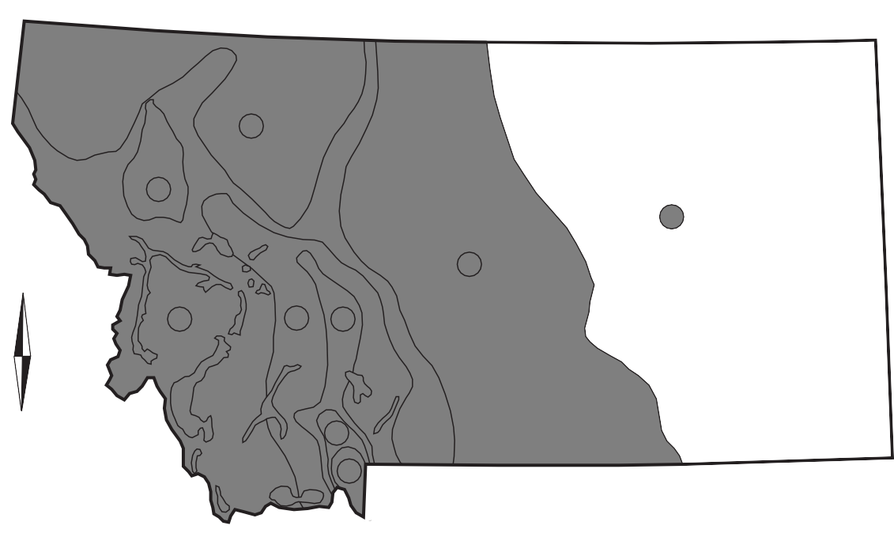
6
8
5
N
6
7
8 9
10
11
Figure 3. Earthquake hazard map for the state of Montana. Patterns designate expected Modified Mercalli Index, adapted from Esp et al. (1987).

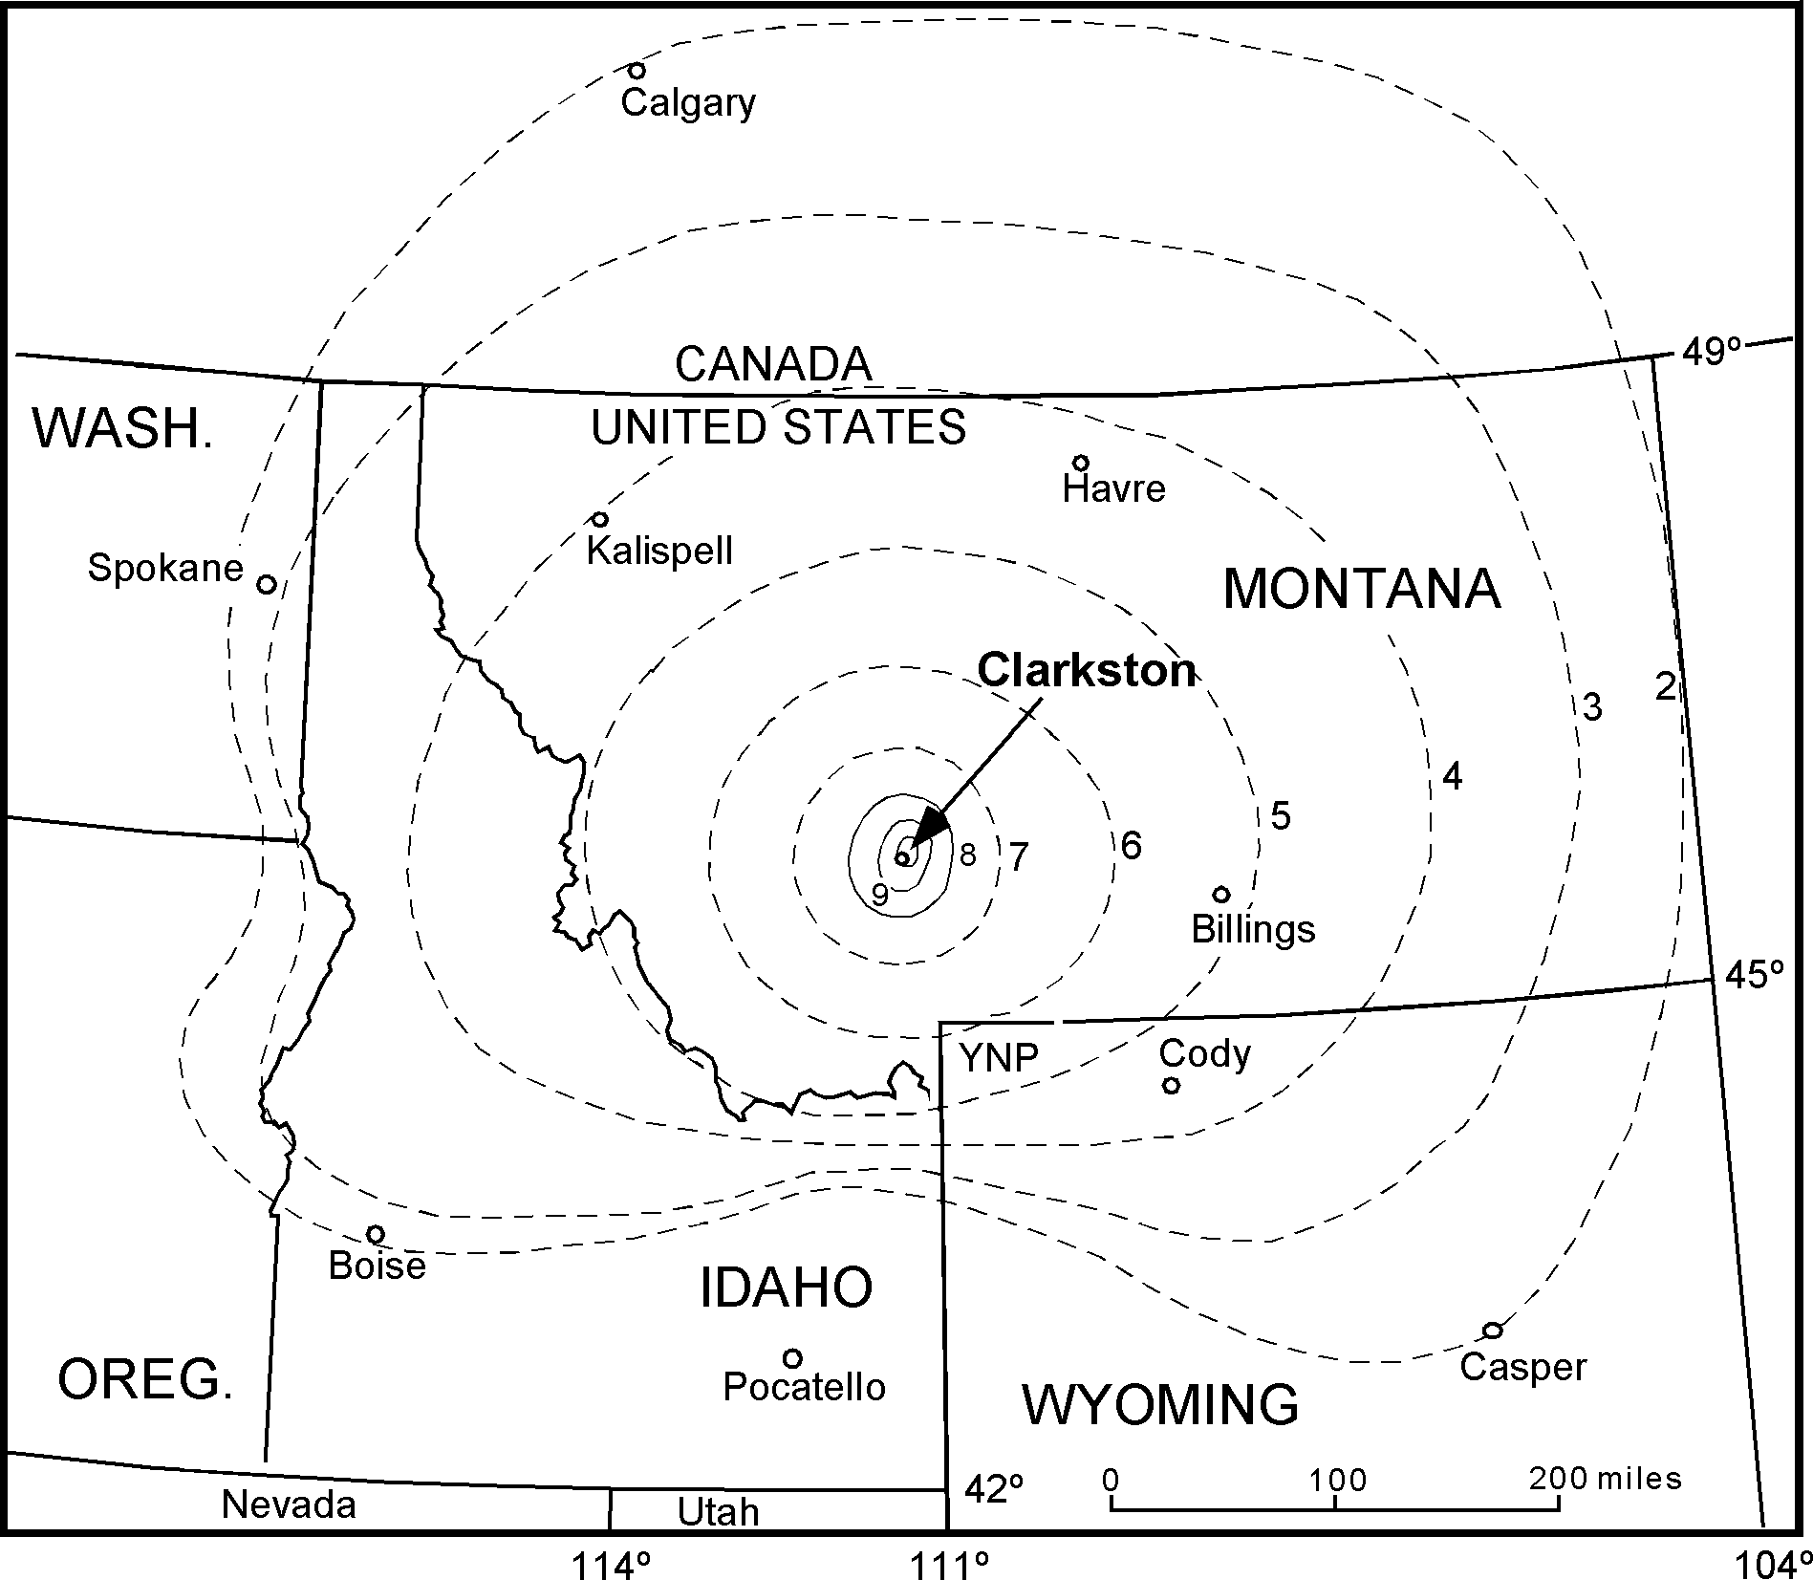
Figure 4. Isoseismal Map for Clarkston Valley, 1925 earthquake. (after Pardee, 1926).

Basin and Range Stress Regime:
Borah Peak, ID
On October 28, 1983, an earthquake with Ms=7.3 occurred on the northwest-trending, southwest-dipping, Lost River fault near Borah Peak, Idaho (e.g., Smith et al, 1985). Movement was dominantly normal-slip with a lesser component of sinistral-slip. The mainshock rupture (focal depth of 16 km) propagated north- westward with 36 km of surface rupture and a maximum scarp height of 2.7 m (Crone, 1985). While the event occurred in a historically low seismicity region, abundant Holocene and late Pleistocene scarps are recognized along the Lost River fault (e.g., Crone and Machette,1984; Scott, et al., 1985). Damage was esti- mated at $12.5 million, two lives were lost in Challis (Meek, 1988; Crone and Machette, 1984). Fig. 5 is an isoseismal map for the Borah Peak earthquake.

Yellowstone Superimposed Stress Field:
Hebgen Lake, MT
The largest earthquake to occur in the ISB or the CTB was the August 17, 1959 Hebgen Lake event (e.g., Stickney and Bartholomew, 1987). The quake occurred on the en-echelon Hebgen and Red Canyon normal faults, 30 km west of the rim of
the Yellowstone caldera. Additionally, a 5 km-long segment of the Madison fault also ruptured during the event (Barrientos, et al., 1987). Focal depths were estimated at 15-25 km. Losses to- taled $11 million and 28 lives (Freidline, et al., 1976). The event was felt in nine states and three Canadian provinces, over 1,555,260 km2 (Tocher, 1962)(Fig. 6). Widespread subsidence occurred within the Hebgen Lake basin with a maximum of 6.7 m (Whitkind et al., 1962). Tourists at two different locations lost their lives, 2 killed by a large falling boulder and 26 buried at Rock Creek public campground by the Madison Canyon land- slide (Whitkind et al., 1962). This 30.4 million-m3 landslide, dammed the Madison River impounding Earthquake Lake (e.g., Qamar and Stickney, 1983).

RESULTS AND DISCUSSION
Early earthquake hazard maps of Montana relied on historic seismicity (Fig. 3). In this map the authors illustrate anticipated intensity values, Bozeman and Dillon are located within the in- tensity IX areas. Bartholomew et al. (1988) incorporated active fault data from Stickney and Bartholomew (1987) to modify the previous hazard map (Fig. 2). On their hazard map, both Dillon and Bozeman were also located within the intensity IX region.

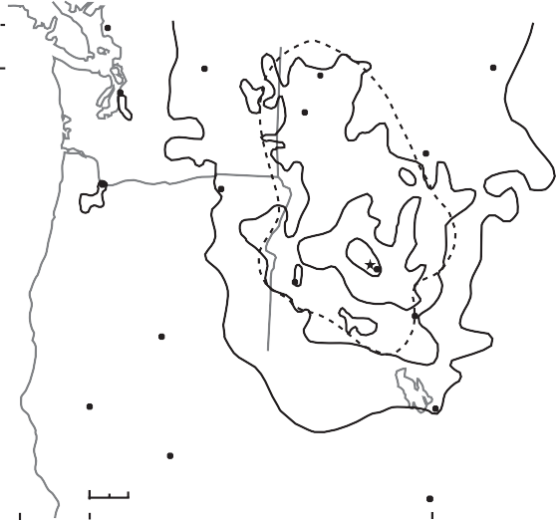Va c0uver

Seatt e

Omak

Ke 0gg

L bby

II-IV

avre

48⁰

Id h

VIII
VII
VI

WAS INGTON

0rt a e et0

OREGON

I A O

V VI VII
MONTANA
e e a

M es C ty

46⁰

44⁰

Lakev ew
B0 se

II-IV
Mackay

0cate 0

Casper

42⁰

Re g

0 100 km

Re 0

NEVA A

Sa t Lake C ty

TA

R c e

COLORA O
Aspe

40⁰

124⁰

122⁰

120⁰

118⁰

116⁰
114⁰

112⁰
110⁰
108⁰

106⁰

Figure 5. Isoseismal Map for Borah Peak, 1983 earthquake. (From
tover, 1984).
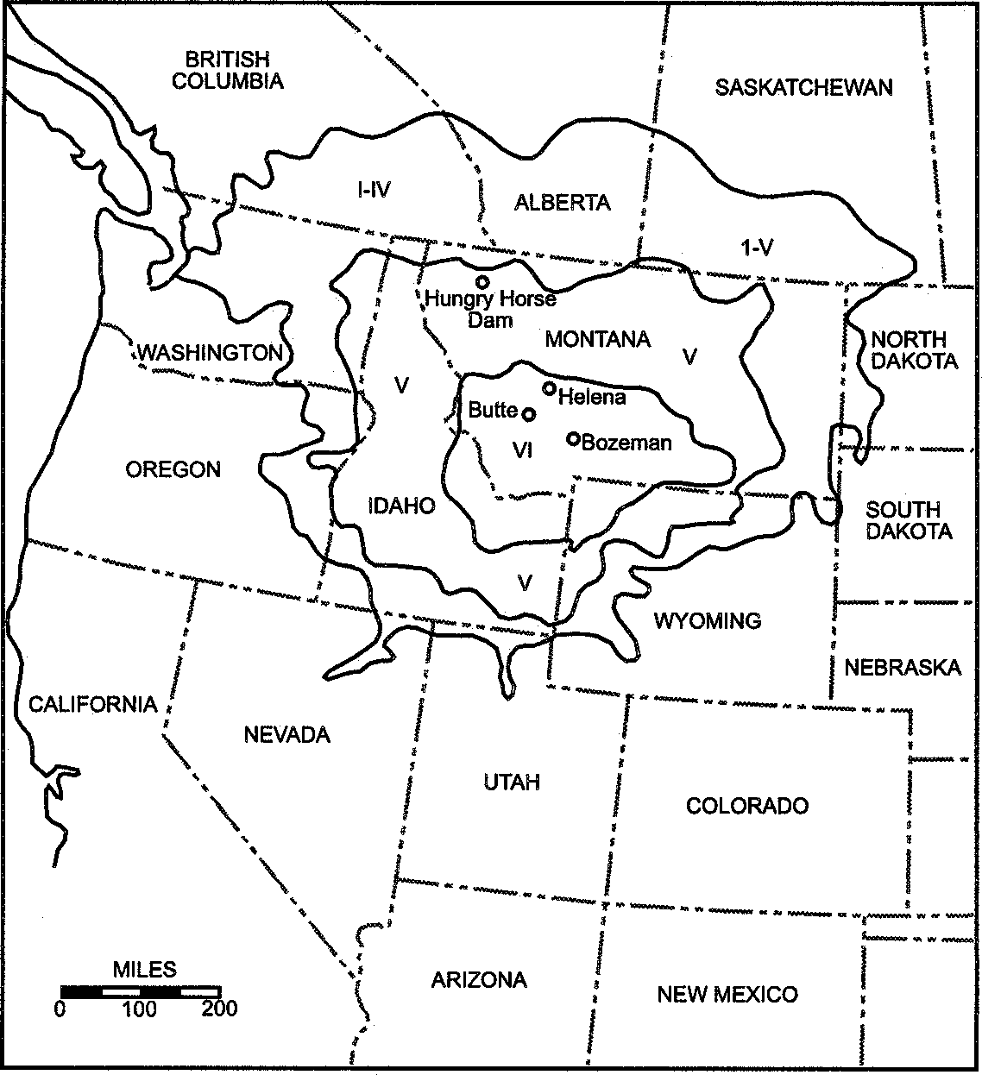
Figure 6. Isoseismal Map for Hebgen Lake, 1959 earthquake. (From teinbrugge and Cloud, 1962).
In this study, areas with anticipated MMI values of VI and MMI VII were delineated based on reported felt areas of maxi- mum characteristic event and location of active faults within the study area (Fig. 7). Comparison of this map to previous maps suggests that the proximity of active faults to a community does influence risk. This method aids in the determination of which features are of concern to a community.
These results constrain expected MMIs of VI and VII, but MMI > VIII were not as easily determined. Ideally, detailed re- gional attenuation curves and fault-segmentation dimensions could be used to calculate expected ground acceleration and, in turn,
Figure 7. Earthquake Hazard susceptibility map for southwest- ern Montana. Anticipated MMI = VI, VII, and VIII are mapped relative to Dillon and Bozeman.
intensity of shaking at Dillon and Bozeman. However, instrument calibrations and local attenuation parameters are not currently available for southwestern Montana. Isoseismal lines could be reliably utilized if a regional correlation between magnitude and MMI was observed. However, comparison of the three charac- teristic events and the 1935 Helena earthquakes does not support such a relationship for southwestern Montana. The larger, 1959 Hebgen Lake (Ms 7.5) and 1983 Borah Peak (Ms 7.3) earthquakes both are associated with a maximum intensity of VII, while maxi- mum intensity values of X and VIII were associated with the smaller, 1925 Clarkston Valley (Ms 6.75) and 1935 Helena (Ms 6.3) earthquakes.
Clearly, regional or local geologic factors contribute to ob- served intensity values. MMI values associated with the Clarkston Valley earthquake are likely related to local features including the Missouri River flood plain.
Alternatively, the relative lack of population or structures may also explain the discrepancy in observed maximum MMI men- tioned above. Certainly even today the population and building density in Helena is greater than in the immediate vicinity of the Hebgen Lake or Borah Peak epicenters.
The Hebgen Lake (Ms 7.5) and Borah Peak (Ms 7.3) events demonstrate that neither large areas of bedrock nor of Tertiary valley-fill are susceptible to intensity VIII or greater in response
to Ms > 7 earthquakes. Therefore, MMI of VIII would only be expected in lower relief valleys, or portions thereof, character- ized by rivers and alluvial sediments.
For the 1925 Clarkston Valley event, the ellipsoidal axial ra- tios of VIII-area/VII-area are 58% and 49% for the long and short axes, respectively. This ratio was utilized in delineating potential areas near Bozeman and Dillon that may be susceptible to MMI
VIII. To anticipate a susceptibility to MMIs of IX or X, local geology, slope, groundwater hydrology, and material property contrasts all contribute to seismic energy response and hence need to be evaluated. Due to the unconstrained nature of these factors, intensity IX and X regions are not delineated on this seismic haz- ard-susceptibility map. The absence of this designation is not in-

tended to suggest that southwestern Montana is exempt from risks associated with MMI values of IX and X; it represents limita- tions of currently available data to define the specific areas which might be associated with MMI values of IX or X.

CONCLUSIONS
Through application of felt areas, associated with regionally characteristic events, to faults with potential for reactivation, a hazard-susceptibility map was generated. Limitations created by reliance on felt reports and characteristic events yield a system- atic underestimate of anticipated maximum MMI. Additional geologic information and isoseismal relationships for Helena Valley were incorporated in an attempt to correct this underesti- mate.
Our study shows that Dillon is susceptible to MMI values of VIII based on proximity to the Blacktail fault. Due to the dimen- sion of the Sweetwater fault, generation of a magnitude > 7 earth- quake is not probable. Therefore, although the fault is located immediately adjacent to Dillon, other faults capable of greater accumulation of strain and larger earthquakes pose a larger risk to residents and residences at Dillon. The Beaverhead River and extensive irrigation of nearby ranchland may serve to increase liquefaction potential and intensity felt near Dillon, therefore MMI
> VIII are possible locally. This study confirms that the Blacktail fault posses the largest threat of loss to Dillon.
Proximity of both the Clarkston Valley epicenter and the north- ern portion of the Emigrant fault both influence susceptibility at Bozeman. Intensity values equal to VIII associated with Clarkston Valley and the Emigrant are very near to the bedrock mountains adjacent to Bozeman. Local geologic settings could make por- tions of Bozeman susceptible to greater intensity. Delineation of the concealed faults associated with the 1925 Clarkston Valley event could better resolve hazard near Bozeman. Until the extent of this concealed fault system is studied, the delineation of inten- sity VIII values is less certain. Development in Bozeman is spread- ing into the bedrock mountains adjacent to the community; this is an area that could expect VIII intensities. It is the identification of seismogenic source that this study contributes to the under- standing of hazard susceptibility at Bozeman.
This study documents the effectiveness of a method employ- ing specific fault and earthquake data to assess spatial variation in seismic hazard susceptibility at the local level. The distribu- tion of historical seismicity would not highlight the Blacktail or Emigrant faults as sources of vulnerability at the study localities. Nevertheless, the faults each exhibit evidence of Late Quaternary displacement which does suggest their seismogenic potential. Expected MMI values delineated around each identified active fault within the study area illustrate that fault proximity does in- fluence vulnerability of communities.
It is important to note that this method can evolve and inte- grate additional geologic, hydrologic, and material-properties data as they become available. Furthermore segmentation, rupture nucleation and propagation studies could also be incorporated. These data sources as well as attenuation parameters will better constrain and resolve local seismic hazard evaluations.
Recommendations for future research and consideration in- clude but are not limited to:
- Attenuation studies, regional or local. This data would permit consideration of fault/segment dimensions and en- ergy transmission to determine a maximum credible event for each fault, eliminating reliance on characteristic events.
- Understanding of the role of segmentation and segment boundaries in rupture nucleation and propagation could aid in developing a criteria for selecting epicenters, again moving away from reliance on characteristic events.
- Liquefaction-potential mapping, at the local or regional scale. Slope-failure-potential mapping, at a local or regional scale.
- Application of this method, with modification, to other areas where detailed geologic data, specifically active fault data exists.
- In Montana the opportunity exists to assess and prepare for seismic hazards before a significant population explo- sion takes place. Dillon and Bozeman specifically have the chance to incorporate hazard assessments in zoning, building codes, and plans for growth.

ACKNOWLEDGMENTS
We thank Diane Doser, Joe Kruger, and Michael Stickney for their reviews of this paper. Mike also provided seismicity and active fault data and answered many questions. Rick Cannon and Elzbieta Covington provided hardware and software support.

REFERENCES
Anders, M.H., Geissman, J.W., Piety, L.A., and Sullivan, J.T., 1989, Parabolic distribution of circumeastern Snake River Plain seismicity and latest Qua- ternary faulting: migratory pattern and association with the Yellowstone hotspot: Journal of Geophysical Research, v. 94, no. B2, p. 1589-1621.
Barrientos, S.E., Stein, R.S., and Ward, S.N., 1987, Comparison of the 1959 Hebgen Lake, Montana and 1983 Borah Peak, Idaho earthquake from geo- detic observations: Bulletin of Seismological Society of America, v. 77, no. 3, p. 783-808.
Bartholomew, M.J., Stickney, M.C., Henry, J., 1988,Perspective 28 years after the August 18, 1959 Hebgen Lake earthquake, in A review of earthquake research applications in the National Earthquake Hazard Reduction Pro- gram: 1977-1987, Proceedings of Conference XLI: US Geological Survey Open File Report 88-13-A, p. 155-167.
Crone, A.J., Machette, M.N., Bonilla, M.G., Lienkaemper, J.J., Pierce, K.L., Scott, W.E., and Bucknam, R.C., 1985, Characteristics of surface faulting accompanying the Borah Peak earthquake, central Idaho, in Workshop XXVIII on the Borah Peak, Idaho earthquake: US Geological Survey Open File Report 85-290, p. 236-263.
Crone, A.J. and Machette, M.N., 1984, Surface faulting accompanying the Borah Peak earthquake, Idaho: Geology, v. 12, p. 664-667.
Doser, D.I., 1989, Source Parameters of Montana earthquakes (1925-1964) and tectonic deformation in the northern Intermountain Belt: Bulletin of the Seismological Society of America, v. 79, no. 1, p. 31-50.
Dzurisin, D., Savage, J.C., and Rournier, R.O., 1990, Recent crustal subsidence at Yellowstone Caldera, Wyoming: Bulletin of Volcanology, v. 52, p. 247- 270.
Esp, D. L., Metesh, J., and Clement, W., 1987, Montana hazard/vulnerability analysis - Earthquake annex: Montana Disaster and Emer gency Services Division, Department of Military Affairs, 21 p.
Freidline, R.A., Smith, R.B., and Blackwell, D.D., 1976, Seismicity and con- temporary tectonics of the Helena, Montana area: Bulletin of the Seismo- logical Society of America, v. 66, no. 1, p. 81-95.
Iyer, H.M., 1984, A review of crust and upper mantle structure studies of the Snake River Plain-Yellowstone volcanic system: a major lithospheric anomaly in the western USA: Tectonophysics, v. 105, p. 291-308.

Jackson, S.M., Wong, I.G., Carpenter, G.S., Anderson, D.M., and Martin, S.M., 1993, Contemporary seismicity in the eastern Snake River Plain, Idaho based on microearthquake monitoring: Bulletin of the Seismological Society of America, v. 83, no. 3, p. 680-695.
Janecke, S.U., 1992, Kinematics and timing of three superimposed extensional systems, east central Idaho: Evidence for an Eocene tectonic transition: Tec- tonics, v. 11, no. 6, p. 1121-1138.
King, J.J., Doyle, T.E., and Jackson, S.M., 1987, Seismicity of the eastern Snake River Plain region, Idaho, prior to the Borah Peak, Idaho, earthquake: Octo- ber 1972-October 1983: Bulletin of the Seismological Society of America, v. 77, p. 809-818.
Meek, C.D., 1988, Four years after Borah Peak, Idaho earthquake, what mitiga- tion for future events has occurred, in Hays, Walter, ed., A review of earth- quake research applications in the National Earthquake Hazard Reduction Program: 1977-1987, Proceedings of Conference XLI: USGS Open File Report 88-13-A, Reston, VA, p. 194-199.
Meertens, C.M., and Smith, R.B., 1991, Crustal deformation of the Yellowstone Caldera from first GPS measurements: 1987-1989: Geophysical Research Letters, v. 18, no. 9, p. 1763-1766.
Pardee, J.T., 1926, The Montana earthquake of June 27, 1925: US Geological Survey Professional Paper 141-B, p. 43-58.
Pierce, K.L., and Colman, S.M., 1986, Effect of height and orientations (micro- climate) on geomorphic degradation rates and processes, late-glacial terrace scarps in central Idaho: Geological Society of America Bulletin, v. 97, p. 869-885.
Pierce, K.L., 1988, Field guides to Quaternary geology of central Idaho: Part E., History of Quaternary faulting and scarp degradation studies, southern Lost River Valley, in Link, P.K., and Hackett, W.R., eds., Guidebook to the Geol- ogy of Central and Southern Idaho: Idaho Geological Survey Bulletin 27, p. 233-240.
Qamar, A.I. and Stickney, M.C., 1983, Montana Earthquakes, 1869-1979: His- torical seismicity and earthquake hazard: Memoir 51, Montana Bureau of Mines and Geology, p. 79.
Reynolds, M.W., 1979, Character and extent of basin and range faulting, west- ern Montana and east-central Idaho: Rocky Mountain Association of Geol- ogy and Utah Geological Association, 1979 Basin and Range Symposium, p. 185-193.
Savage, J.C., Lisowski, M., Prescott, W.H., and Pitt, A.M., 1993, Deformation from 1973 to 1987 in the epicentral area of the 1959 Hebgen Lake, Mon-
tana, earthquake (Ms=7.5): Journal of Geophysical Research, v. 98, no. B2, p. 2145-2153.
Sbar, M.L., Barazangi, M., Dorman, J., Scholz, C.H., and Smith, R.B., 1972, Tectonics of the Intermountain Seismic Belt, western United States: mi- croearthquake seismicity and composite fault plane solutions: Bulletin of the Seismological Society of America, v. 83, p. 13-28.
Scott, W.E., Pierce, K.L., and Hait, M.H., 1985, Quaternary tectonic setting of the 1983 Borah Peak earthquake, central Idaho: Bulletin of the Seismologi- cal Society of America, v. 75, p. 1053-1066.
Sibson, R.H., 1990, Rupture nucleation on unfavorably oriented faults: Bulletin of the Seismological Society of America, v. 80, no. 6, p. 1580-1604.
Slemmons, D.B. and McKinney, R., 1977, Definition of " active fault : US Army Engineer Waterways Experiment Station, Soils and Pavements Laboratory, Misc. Paper S-77-8, 22p.
Smith, R.B. and Sbar, M.L., 1974, Contemporary tectonics and seismicity of the western United States with emphasis on the Intermountain Seismic Belt: Geological Society of America Bulletin, v. 85, no. 2, p. 1205-1218.
Smith,R.B., Richins, W.D., and Doser, D.I., 1985, The 1983 Borah Peak, Idaho earthquake; regional seismicity, kinematics of faulting, and tectonic mecha- nism, in Workshop XXVIII on the Borah Peak, Idaho earthquake: US Geo- logical Survey Open File Report 85-290, p. 236-263.
Smith, R.B., Reilinger, R.E., Meertens, C.M., Hollis, J.R., Holdahl, S.R., Dzurisin, D., Gross, W.K., and Klingele, E.E., 1989, What s moving at Yellowstone? The 1987 crustal deformation survey from GPS, leveling, precision gravity, and trilateration: EOS, transactions, American Geophysical Union, v. 70, no. 8, p. 113-128.
Stickney, M.C., and Bartholomew, M.J., 1987, Seismicity and late Quaternary faulting of the northern Basin and Range Province, Montana and Idaho: Bulletin of the Seismological Society of America, v. 77, no. 5, p. 1602- 1625.
Steinbrugge, K.V., and Cloud, W.K., 1962, Epicentral intensities and damage in the Hebgen Lake, Montana earthquake of August, 17, 1959: Bulletin of the Seismological Society of America, v. 52, no. 2, p. 181-234.
Stover, C.W., 1984, The Borah Peak, Idaho earthquake of October 28, 1983 Isoseismal map and intensity distribution: Earthquake Spectra, v. 2, p. 11- 16.
Tocher, D., 1962, The Hebgen Lake, Montana, earthquake of August 17, 1959, MST: Bulletin of the Seismological Society of America, v. 52, no. 2, p. 153- 162.
Whitkind, I.J., Myers, W.B., Hadley, J.B., Hamilton, W., and Fraser, G.D., 1962, Geological features of the earthquake at Hebgen Lake, Montana, August 17, 1959: Bulletin of the Seismological Society of America, v. 52, no. 2, p. 163-180.
Youngs, R.R., Swan, F.H., and Power, M.S., 1988, Use of detailed geologic data in regional probabilistic seismic hazard analyses: and example from the Wasatch Front, Utah, in von Thun, J.L., ed., Earthquake Engineering and Soil Dynamics II: Recent advances in ground motion evaluations: Geotechnical Special Publication #20, p. 156-172.

1 uideboo to the eolo y o astern daho

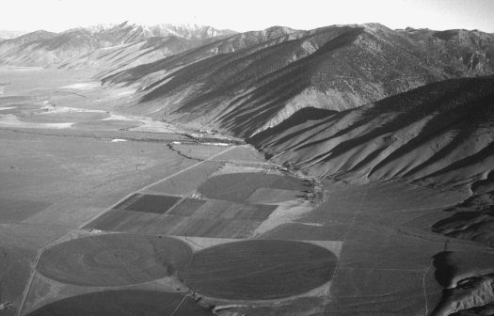

Aerial view to the northwest of the Lemhi Range bounded by the Lemhi fault which cuts Quaternary alluvial fan deposits at the mouth of Patterson Creek (center of photograph). Photograph by Paul Karl Link.

