The Putnam Thrust Plate, Idaho-Dismemberment and Tilting by Tertiary Normal Faults

Karl S. Kellogg
U S Geological Survey, Box 25046, MS 913, Denver, CO 80225

David W. Rodgers
Department of Geology, Idaho State University, Pocatello, ID 83209

Frank R. Hladky
Oregon Department of Geology and Mineral Industries, Grants Pass Field Office, 5375 Monument Drive, Grants Pass, OR 97526

Mark A. Kiessling
Department of Geology, Idaho State University, Pocatello, ID 83209

James W. Riesterer
Department of Geology, Idaho State University, Pocatello, ID 83209

INTRODUCTION
The Putnam thrust is one of the major structures of the Idaho- Wyoming fold-and-thrust belt. It is exposed in the northern Portneuf Range, about 25 km northeast of Pocatello (Figs. 1 and 3), a region underlain by a thick sequence of Upper Proterozoic to Mesozoic rocks (Fig. 2). Detailed descriptions of these units are given by Link (1983), Link and others (1987), Kellogg and others (1989), Kellogg (1990), and Hladky and Kellogg (1990). At most localities, the Putnam thrust places Ordovician rocks above Permian and Pennsylvanian rocks of the Meade thrust plate, although near its southeastern extent, the thrust ramps laterally downsection and places Cambrian rocks above Mississippian (Hladky and others, 1992; Kellogg, 1992). The total stratigraphic offset across the thrust is as great as about 3,700 m. Hanging wall rocks include the oldest and most deeply buried sedimentary and volcanic rocks known in the entire Idaho-Wyoming-Utah thrust belt, brought up in the core of a major thrust culmination cen- tered in the Bannock and Pocatello ranges near Pocatello (Fig. 1) (Trimble, 1976; Burgel and others, 1987; Rodgers and Janecke, 1992). These relationships require that the Putnam thrust ramp steeply downsection in the footwall somewhere to the west and south of Pocatello.
The Putnam thrust has been well known for years (Mansfield, 1920, 1927; Trimble, 1982), but the details of the complex up- per-plate structures remained elusive until recent detailed map-
ping and structural analysis was completed at scales of 1:24,000 or more. (Hladky, 1986; Kellogg and others, 1989; Kellogg, 1990; Hladky and Kellogg, 1990; Hladky and others, 1992; Kellogg, 1992; Rodgers and Othberg, in press; McQuarrie and others, in press; Riesterer and Link, in press).
The age of movement on the Putnam thrust can only be in- ferred. The north end of the Paris thrust system, which is not shown on Figure 3, is about 40 km southeast of the eastern exposed trace of the Putnam thrust and is probably connected to the Putnam thrust by a thrust-transfer system (Kellogg, 1992; Rodgers and Janecke, 1992). This suggests that the age of movement on the Putnam thrust is probably coeval with that on the Paris thrust system. The Paris thrust is no younger than Early Cretaceous (Aptian) (DeCelles and others, 1993), and may be as old as Late Jurassic (Armstrong and Cressman, 1963). These ages most likely also constrain the age of the Putnam thrust and, by a somewhat more tenuous projection, contractional structures in its hanging wall.

Hanging Wall Structure of the Putnam thrust
Three subplates comprise the hanging wall of the Putnum thrust in the Pocatello Range and northern Portneuf Range (Figs. 3 and 5), although Neogene extension has profoundly modified the thrust geometry by block faulting and tilting. (The term subplate is used

Kellogg, K.S., Rodgers, D.W., Hladky, F.R., Kiessling, M.A., and Riesterer, J.W., 1999, The Putnam Thrust Plate, Idaho-Dismemberment and tilting by Tertiary normal faults, in Hughes, S.S., and Thackray, G.D., eds., Guidebook to the Geology of Eastern Idaho: Pocatello, Idaho Museum of Natural History, p. 97-114.

98 Gu debook to the Geology of Eastern Idaho
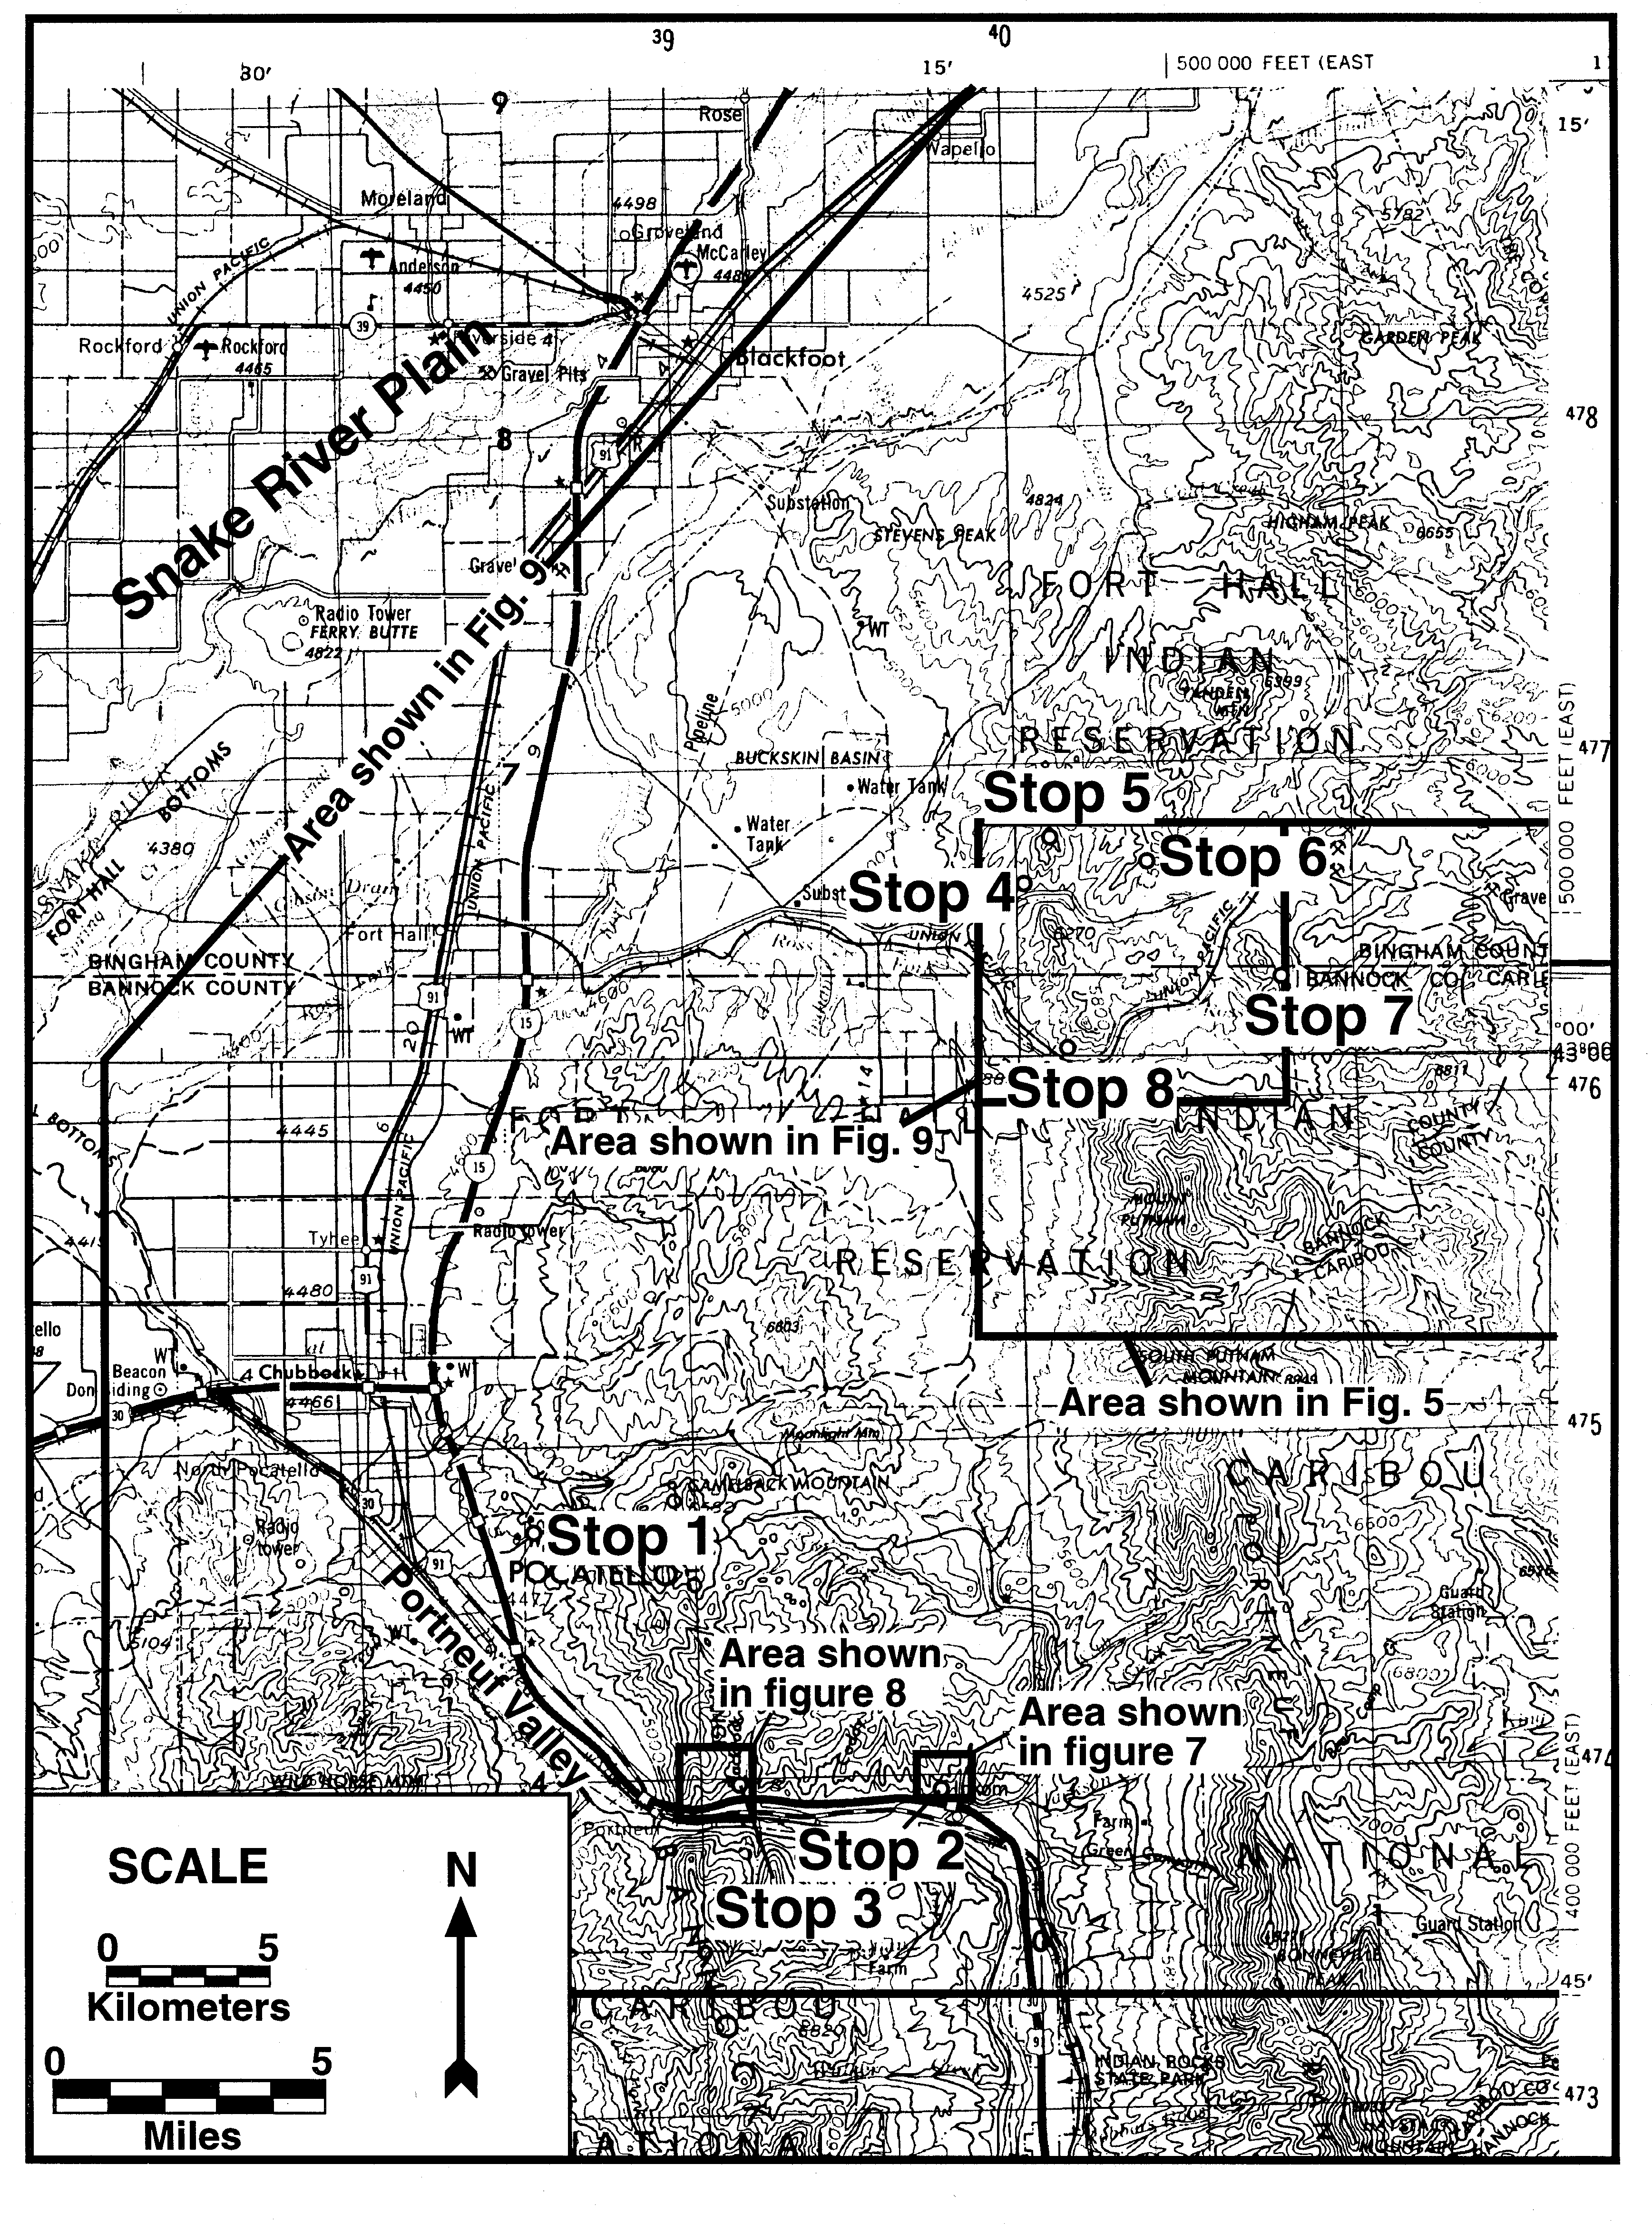

Figure 1. Location map of Pocatello region, showing areas of Figures 3, 5, 7, 8, and 9, and fieldtrip Stops 1-8.

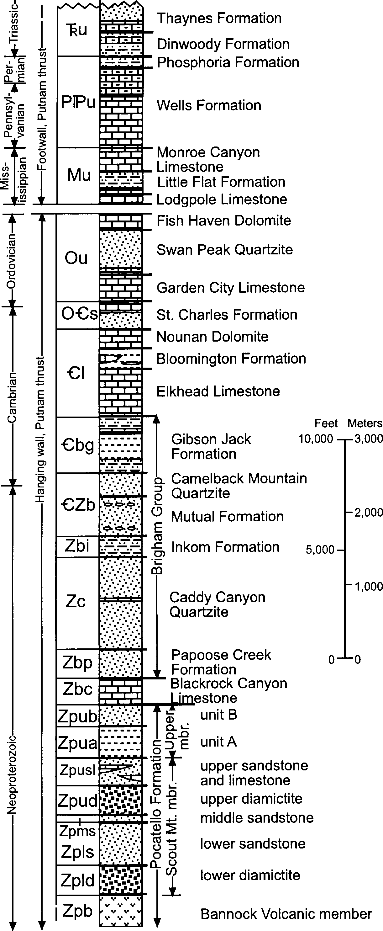

Figure 2. Stratigraphic column of rocks exposed in the northern Portneuf, Pocatello, and Bannock Ranges. Adapted from Kellogg (1992) and McQuarrie and others (in press).

to distinguish large thrust slices within the Putnam thrust plate.) The three subplates are, from structurally lowest to highest (and generally north to south), the Lone Pine subplate, the Narrows subplate, and the Bear Canyon-Toponce subplate (Fig. 5).
The Lone Pine subplate, composed of Ordovician and Cam- brian rocks, and the Narrows subplate, composed mostly of Up- per Proterozoic Brigham and Pocatello Groups (but locally con- taining rocks as young as Silurian), are juxtaposed across the
steeply south-dipping Ross Fork Narrows fault, which is viewed as a steep lateral ramp (Kellogg, 1992; Trimble [1982] called it a "tear fault") although this interpretation may be a topic of lively discussions on the trip. Overlying the Narrows subplate and un- derlying the Bear Canyon-Toponce subplate is the Bear Canyon thrust, which dips eastward along the west side of the Portneuf Range and places mostly lower Brigham Group quartzite (Caddy Canyon Quartzite) above Cambrian limestone and upper Brigham Group rocks. The strongly folded Toponce thrust, on the east side of the Portneuf Range (Fig. 3), is believed to be an eastward ex- tension of the Bear Canyon thrust (Kellogg, 1992). This thrust geometry is further complicated by (1) steep thrust ramps, both frontal and lateral, (2) numerous east-striking tear faults (com- partmental faults of Brown, 1984), which accommodated differ- ent styles of shortening on either side of the fault (see Kellogg, 1990 for good examples), and (3) locally developed, tight S- and Z-shaped folds, each containing one gently-dipping overturned limb and a near-horizontal axial plane, which are particularly well developed in the Narrows subplate.
The Bear Canyon thrust is somewhat unusual in the Cordille- ran thrust belt because it dips eastward. At least three explana- tions may account for this: (1) the thrust is a back thrust above the Putnam thrust and was west-directed, (2) the thrust, prior to Neo- gene extension, dipped west and was east-directed, but was sub- sequently tilted by down-to-the-east block tilting along large down- to-the-west normal faults, or 3) the thrust forms the roof of a large foreland-dipping duplex and was arched during duplex forma- tion, so that its foreland side dips eastward.
We will present evidence that the latter two explanations both contributed to the eastward dip of Bear Canyon thrust and that the thrust is, indeed, an east-directed structure. The evidence is based mainly on the observation that the thrust ramps up-section to the east, both in the hanging wall and (particularly) in the foot- wall.
Eastward tilting of parts of the Portneuf, Pocatello, and Bannock Ranges by as much as 45° during Neogene extension certainly accounts for a large component of eastward dip of struc- tures, but leaves room for an additional component of eastward dip induced by formation of the foreland-dipping duplex (Fig. 6; see Kellogg [1992] for a detailed discussion of this structure). The Narrows subplate is viewed as a large horse in the duplex, in which the Bear Canyon-Toponce thrusts define the roof thrust and the Putnam thrust defines the floor thrust. At the eastern end of the duplex, the roof thrust is nose down on the Putnam thrust and dips east. Beds are tectonically thickened and thinned within the Narrows subplate, reflecting a combination of bedding-plane slip, small-scale duplex stacking and thrust imbrication, and duc- tile flow. Outcrop- to map-scale, steeply overturned S- and Z- shaped folds, and a fanning of axial-plane cleavages by rotation during thrusting are common features in the Narrows subplate. In marked contrast to the foreland-dipping-duplex structure of the Narrows subplate, the Lone Pine and Bear Canyon-Toponce subplates contain mostly a moderately east-dipping sequence of relatively unsheared rocks.
Cambrian and Upper Proterozoic Brigham Group rocks and older rocks of the aerially extensive Narrows subplate were bur- ied as deeply as about 15 km during Mesozoic contraction. The

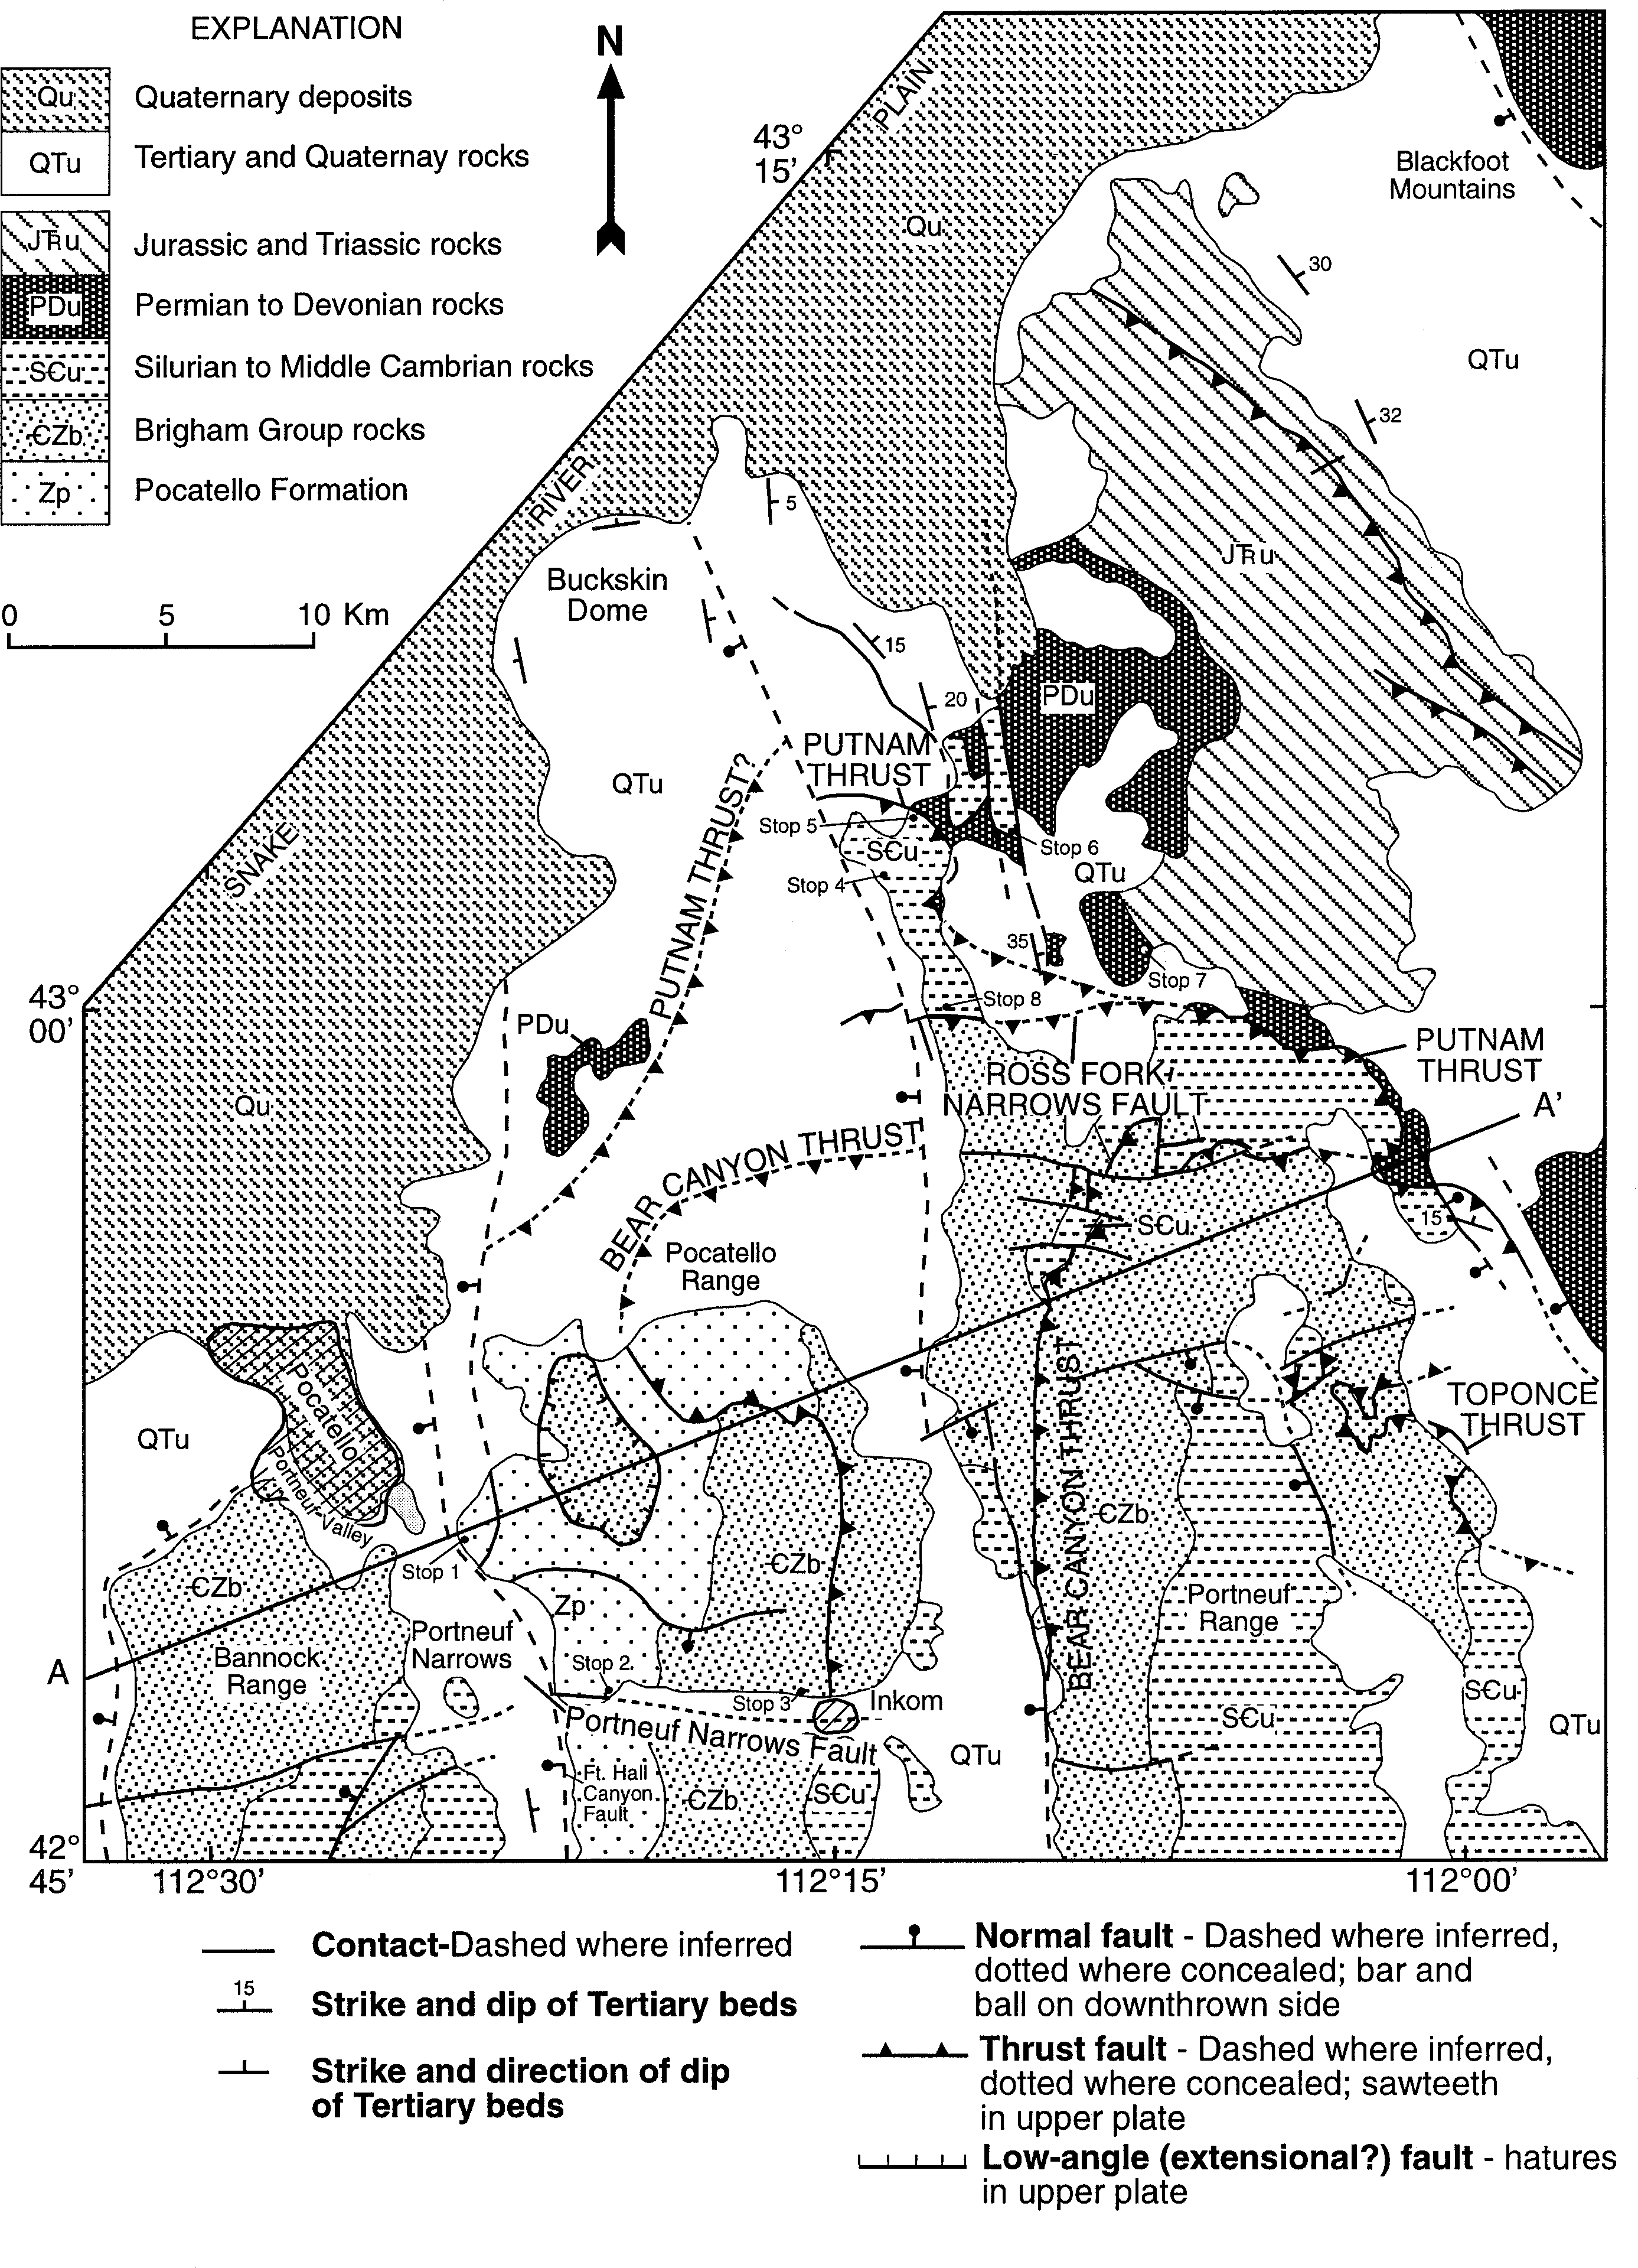

Kellogg and others -- The Putnam Thrust Plate, Idaho
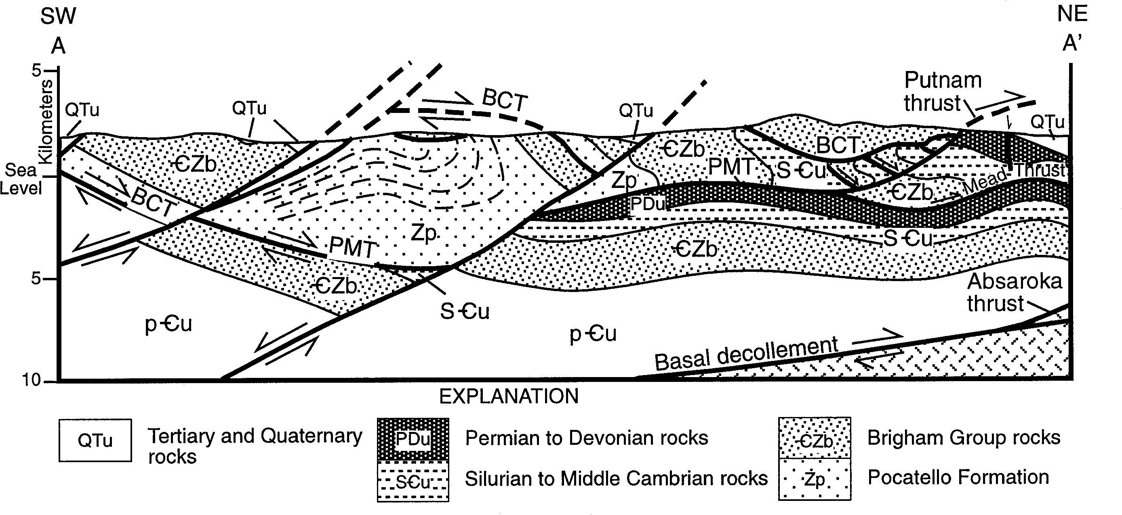
Figure 4. Cross section along line A-A' of Figure 3, modified from Kellogg (1992). All but largest range-front Tertiary faults have been removed. The cross section is largely schematic, due to lack of seismic and deep-well data for area, but depths to Meade thrust, Absaroka thrust, and magnetic basement are approximately known from Royse and others (1975). BCT is Bear Canyon thrust, PMT is westward extension of Putnam and Meade thrusts, and pCu is Precambrian undivided. Arrows show relative movement across major faults.

rocks were metamorphosed as high as upper greenschist facies. The deep burial (with associated quasi-ductile deformation), and formation of the duplex created many structures distinct from many other regions of the thrust belt. Large nappe-like folds are wide- spread (we will traverse one of these structures on the fieldtrip- the Blackrock Canyon fold at Stop 3).

eogene tension
Neogene extension has affected, to varying degrees, all of southeastern Idaho, producing numerous north-trending valleys and ranges characteristic of the Basin-and-Range Province. This extension is at least as old as about 16 Ma, the maximum-known age of valley-fill deposits in the region (Starlight Formation of Carr and Trimble [1963]), although a major pulse of normal fault- ing and basin filling culminated 6-8 Ma (Kellogg and Marvin, 1988; Rodgers and others, 1990). In addition, downwarping and extension adjacent to the Snake River Plain during late Miocene- Pleistocene time (post-7-10 Ma) has tilted rocks down to the north- west about northeast axes, producing a visible warping into the plain and numerous northeast-striking normal faults (Kirkham, 1931; Trimble, 1976, Zentner, 1989, Kellogg and others, 1994; Rodgers and Othberg, in press). Before some idea of the older thrust geometry can be appreciated, the effects of regional exten-

Figure 3. Generalized tectonic map of northern Portneuf Range, Pocatello Range, and northern Bannock Range. Map is modified from Kellogg (1992; refer to this reference for complete sources of geologic information), with additions based on recent unpublished mapping by Rodgers and Riesterer. Blackrock Canyon Limestone of Trimble (1976) is included with Pocatello Formation. Strikes and dips shown for Tertiary units only. Fold symbols and numerous nor- mal faults are omitted from figure.
sion and tilting must be removed by restoring the Neogene nor- mal faults back to their pre-extension position (we will examine one attempt to restore Neogene extension at Stops 5 and 6).

Field Trip - Overview
The fieldtrip will focus on major contractional structures in the hanging wall of the Putnam thrust and examine how these structures were modified by Neogene extension. At several lo- calities, we will see how widespread overturning in the Narrows subplate, producing S- and Z-shaped folds with near-horizontal axial planes, characterizes the style of "ductile-thrust" deforma- tion in these once deeply-buried rocks. We will discuss how the formation of a foreland-dipping duplex (Boyer and Elliott, 1982) may be associated with this style of deformation.
Three structurally distinct areas will be visited during the field trip (Fig. 1 and 3):
- The Narrows subplate near the Portneuf Narrows, where we will traverse a spectacular fold nappe involving the Pocatello Formation (Stop 3). We will revisit the Narrows subplate at our last stop (Stop 8) at the Ross Fork Narrows fault (not to be con- fused with the Portneuf Narrows fault).
- The Bear Canyon-Toponce subplate and the southern extent of the Bear Canyon thrust near Inkom, where Upper Proterozoic Caddy Canyon Quartzite overlies quartzite of Upper Proterozoic Mutual Formation (Stop 2). A new, more detailed understanding of the Brigham Group stratigraphy greatly facilitated the deter- mination of some of these subtle thrust relationships (e.g., Link and others, 1987).
- The Lone Pine subplate, where an east-ramping section of Cambrian and Ordovician rocks directly overlies rocks as old as the Pennsylvanian Wells Formation and as young as the Triassic Dinwoody Formation (Stops 4-8). The Lone Pine subplate was

extensively faulted and locally brecciated, during both Basin- Range and Snake River Plain extension, and contains exposed rocks as old as the Middle and Upper Cambrian Nounan Forma- tion and as young as the Upper Ordovician part of the Fish Haven Dolomite (Hladky and Kellogg, 1990).

DAY l

Total/lncremental Mileage
0.0 |  | Leave parking lot of the Cavanaugh Motel and take
 |  | southbound onramp (at exit 71) of Interstate 15.
2.0 | 2.0 | Exit at first opportunity (Exit 69). Turn left through
 |  | underpass and proceed east on Clark St.
2.1 | 0.1 | On the left, Miocene gravels tilt east about 20°, re-
 |  | flecting the eastward tilt of the Portneuf Valley, a
 |  | half graben typical of the Basin and Range. About
 |  | 100 m farther east, a west-dipping normal fault, with
 |  | slip of several 100 m, cuts the gravels.
2.3 | 0.2 | Turn right on Hospital Way.
2.7 | 0.4 | At the crest of the hill is the first good view south
 |  | along the Portneuf Valley. The east side of the val-
 |  | ley is bounded by a gently-dipping (about 30°) nor-
 |  | mal fault with an estimated 8 km of stratigraphic
 |  | offset (Fig. 4). Both basin fill and bedrock have been
 |  | tilted east.
3.1 | 0.4 | Turn left on Buckskin Road. Along Buckskin Road,
 |  | note the numerous cuts into the Miocene gravels,
 |  | which have been locally oxidized and reddened.
4.3 | 1.2 | At the top of the grade, park on the left (northwest)
 |  | side. Walk to the crest of the hill.

STOP 1-Tilted Miocene beds and overview of regional geology.
Miocene basin fill underlies most of the eastern half of the Portneuf Valley. Basin fill consists of conglomerate and reworked rhyolite ash which now dip about 25° east, reflecting regional tilting associated with formation of the Portneuf Valley half gra-
ben. Immediately below us on the west side of the hill is a section of reworked ash beds, one of four distinct ash layers interbedded with conglomerate. This ash is the youngest one in the valley and yielded an 40Ar/39Ar age of 7.39±0.05 Ma (Rodgers and Othberg, in press). The oldest ash, located at the base of the basin fill, has an approximate age of 8.1 ± 0.5 Ma based on its chemical corre- lation to the informally named Inkom ash (Rodgers and Othberg, in press), thus bracketing half-graben basin filling to a short pe- riod in the late Miocene.
The Fort Hall Canyon Fault, a large range-bounding normal fault along which the valley tilted, is located about 500m to the east of us. The fault dips about 25° west beneath the valley and accommodated 6-8 km of dip slip, one of the largest offsets in the northeastern Basin and Range.
Upper Proterozoic rocks of the Pocatello Formation occupy the hills east of the Fort Hall Canyon Fault. These rocks record glaciation and initial rifting of the Cordillera (Link, 1983). The rocks are everywhere overturned in this region, forming the in- verted limb of the Blackrock Canyon fold, a map-scale recum- bent anticline which we will visit at Stop 3.
Tilted Proterozoic to Cambrian rocks crop out in the Bannock Range west of the Portneuf Valley. The approximate 45° east dip of the rocks reflects Basin-Range tectonics, although some tilting may be partially due to Sevier folding. Tilting is a major theme of the field trip: due to domino-style tilting of rocks and west-dip- ping normal faults, older west-dipping structural features may now be flat or east dipping, as we hope to show at Stop 2.
The Snake River Plain is visible to the north and northwest. In this region it consists of a ~1 km thick veneer of Pliocene- Pleistocene basalt lava and intercalated sediment, underlain by several kilometers of Miocene rhyolite. Rhyolite magmatism gen- erally progressed from west to east across the Plain (Armstrong and others, 1975; Pierce and Morgan, 1992), with eruptions near Pocatello from about 10.2 to 7.9 Ma (Kellogg and others, 1994). One anomaly is the formation of several rhyolite buttes, which rise many hundreds of feet above the basaltic plain - these buttes are Late Pleistocene plugs or laccoliths which have ascended through Plio-Pleistocene basalt.
MEADE
N
FAULT
PL ATE
b r a nch
line

tip lines
BEAR CANYON-TOPONCE SUBPLATE

NARROWS SUBPLATE
MEADE PLATE

0 5 10 KM

Figure 5. Diagramatic block diagram of northern Portneuf Range area showing the major structural elements, adapted from Kellogg (1992). The Narrows subplate extends west to and includes the northern Bannock Range. Its extent southward is unknown. Branch line and tip line are defined by Boyer and Elliott (1982).

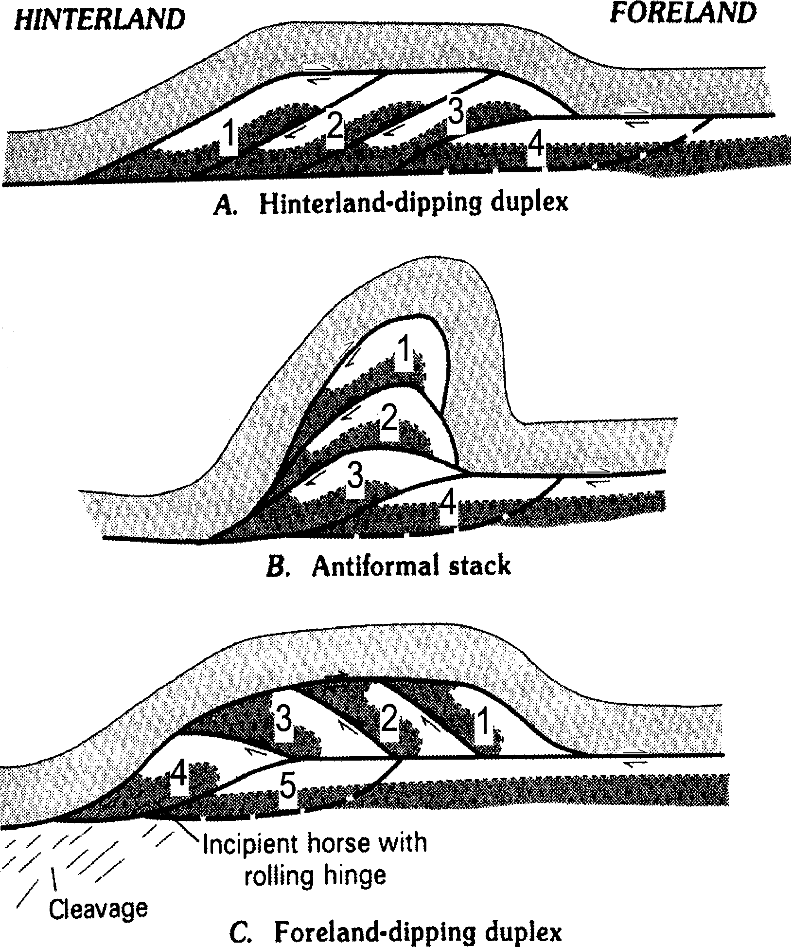

Figure 6. Schematic diagram showing the development of (A) hin- terland-dipping duplex, (B) antiformal stack (a situation in- termediate to a hinterland- and foreland-dipping duplex), and
(C) foreland-dipping duplex. Relative order of formation of horses is indicated by numbers, 1 being first formed; note that relative order in hinterland-dipping and foreland-dipping du- plexes is reversed. From Kellogg (1992), who adapted dia- gram from Boyer and Elliott (1982). Refer to Kellogg (1992) for more detailed explanation.

From this vantage the Snake River downwarp is well illus- trated by the northward plunge of the Bannock Range. The tim- ing and amount of subsidence along the margins of the downwarp encompass our most exciting areas of current research. We be- lieve the Basin-Range and Cretaceous thrust belt once existed well north of its current border with the Plain, only to be buried by subsidence and accumulation of young basalts. Crustal sub- sidence along the north edge of the Plain amounts to 5-8 km (McQuarrie and Rodgers, 1998), but the amount near Pocatello is unknown at this time. Subsidence occurred at some time (shortly?) after 7 Ma, based upon the northward tilts of Miocene basin fill, and continues today as shown by tilted Plio-Pliestocene rocks (Houser, 1992).
Finally, the latest Pleistocene Bonneville Flood flowed through the Portneuf Valley after breaching a dam at Red Rock Pass near Preston, Idaho. With a peak discharge of about one million cubic meters per second that lasted for perhaps 8 weeks (Jarrett and Malde, 1987; O'Conner, 1993), it was of the largest floods ever recorded in geologic history. In the Portneuf Valley the flood pro- duced scabland topography, a channel throughout downtown Pocatello filled with boulders as long as 3 m, and a delta deposit in northern Portneuf Valley where it widens and joins the Snake River Plain.
The trip will now return along Buckskin Road.

5.1 | 0.8 | Turn left from Buckskin Road on Alvin Ricken
 |  | Drive; proceed through an industrial park.
6.2 | 1.1 | Turn right on Barton Road.
6.5 | 0.3 | Camelback Mountain Quartzite and underlying
 |  | Mutual Formation are strongly brecciated in the road
 |  | cut and along the crest of Red Hill to the right. There
 |  | is some controversy as to the origin of these rocks.
 |  | They may either be part of a large pre-Pleistocene
 |  | landslide that originated east of the Fort Hall Can-
 |  | yon fault that bounds the Pocatello Range (Trimble,
 |  | 1976; Link and others, 1985), or (as Dave Rodgers
 |  | believes), they are part of a separate normal-fault-
 |  | bounded block that downdropped to the west into
 |  | the Portneuf Valley.
6.7 | 0.2 | At the stop sign on 5th Avenue, proceed straight
 |  | ahead to 4th Avenue. Turn left on 4th Avenue.
7.0 | 0.3 | Basalt of Portneuf Valley forms the small bluffs on
 |  | the right (a local playground for the area's rock
 |  | climbers). The basalt has been dated at 583 ± 104
 |  | ka (Scott and others, 1982).
7.4 | 0.4 | Take southbound onramp to Interstate 15 (Exit 67).
 |  | Drive on Basalt of Portneuf Valley.
11.4 | 4.0 | The interstate bends left (east) and enters the
 |  | Portneuf Narrows. The Pocatello Range is to the
 |  | north, the Bannock Range is to the south, and the
 |  | Portneuf Range is visible in the distance to the east.
 |  | On the left, across the interstate, are Upper Prot-
 |  | erozoic volcanic rocks (Bannock Volcanic Mem-
 |  | ber of the Pocatello Formation) and diamictites
 |  | (within the Scout Mountain Member of the Pocatello
 |  | Formation). The diamictites have been interpreted
 |  | as a mixed till and submarine flow deposit (Link,
 |  | 1983). These rocks are cut by a south-dipping fault
 |  | (Portneuf Narrows fault), out of view from here,
 |  | which we will visit at Stop 3.
On the right is a steeply east-dipping homocline of diamictite, sandstone, conglomerate, and siltstone of the Scout Mountain Member of the Pocatello Formation, cut by a few normal faults with small offset.

16.4 5.0 At Inkom, take exit 58. Turn left under interstate and immediately turn right on Sorrelle Road.
16.8 0.4 Cross cattle guard and immediately turn left and park by gate.

STOP 2-The Bear Canyon thrust.
The Bear Canyon thrust, first identified by Pogue (1984) in the northern Portneuf Range, was soon recognized as a major structural feature of the region (Kellogg, 1990, 1992). The thrust was mapped southward along the west side of the Portneuf Range (Kellogg, 1990), and was predicted to crop out again in the Pocatello Range as a consequence of downdropping along the range-front normal fault bordering the west side of the Portneuf Range. Subsequent mapping in the Bonneville Peak (Riesterer and Link, in press) and Inkom areas (McQuarrie and others, in

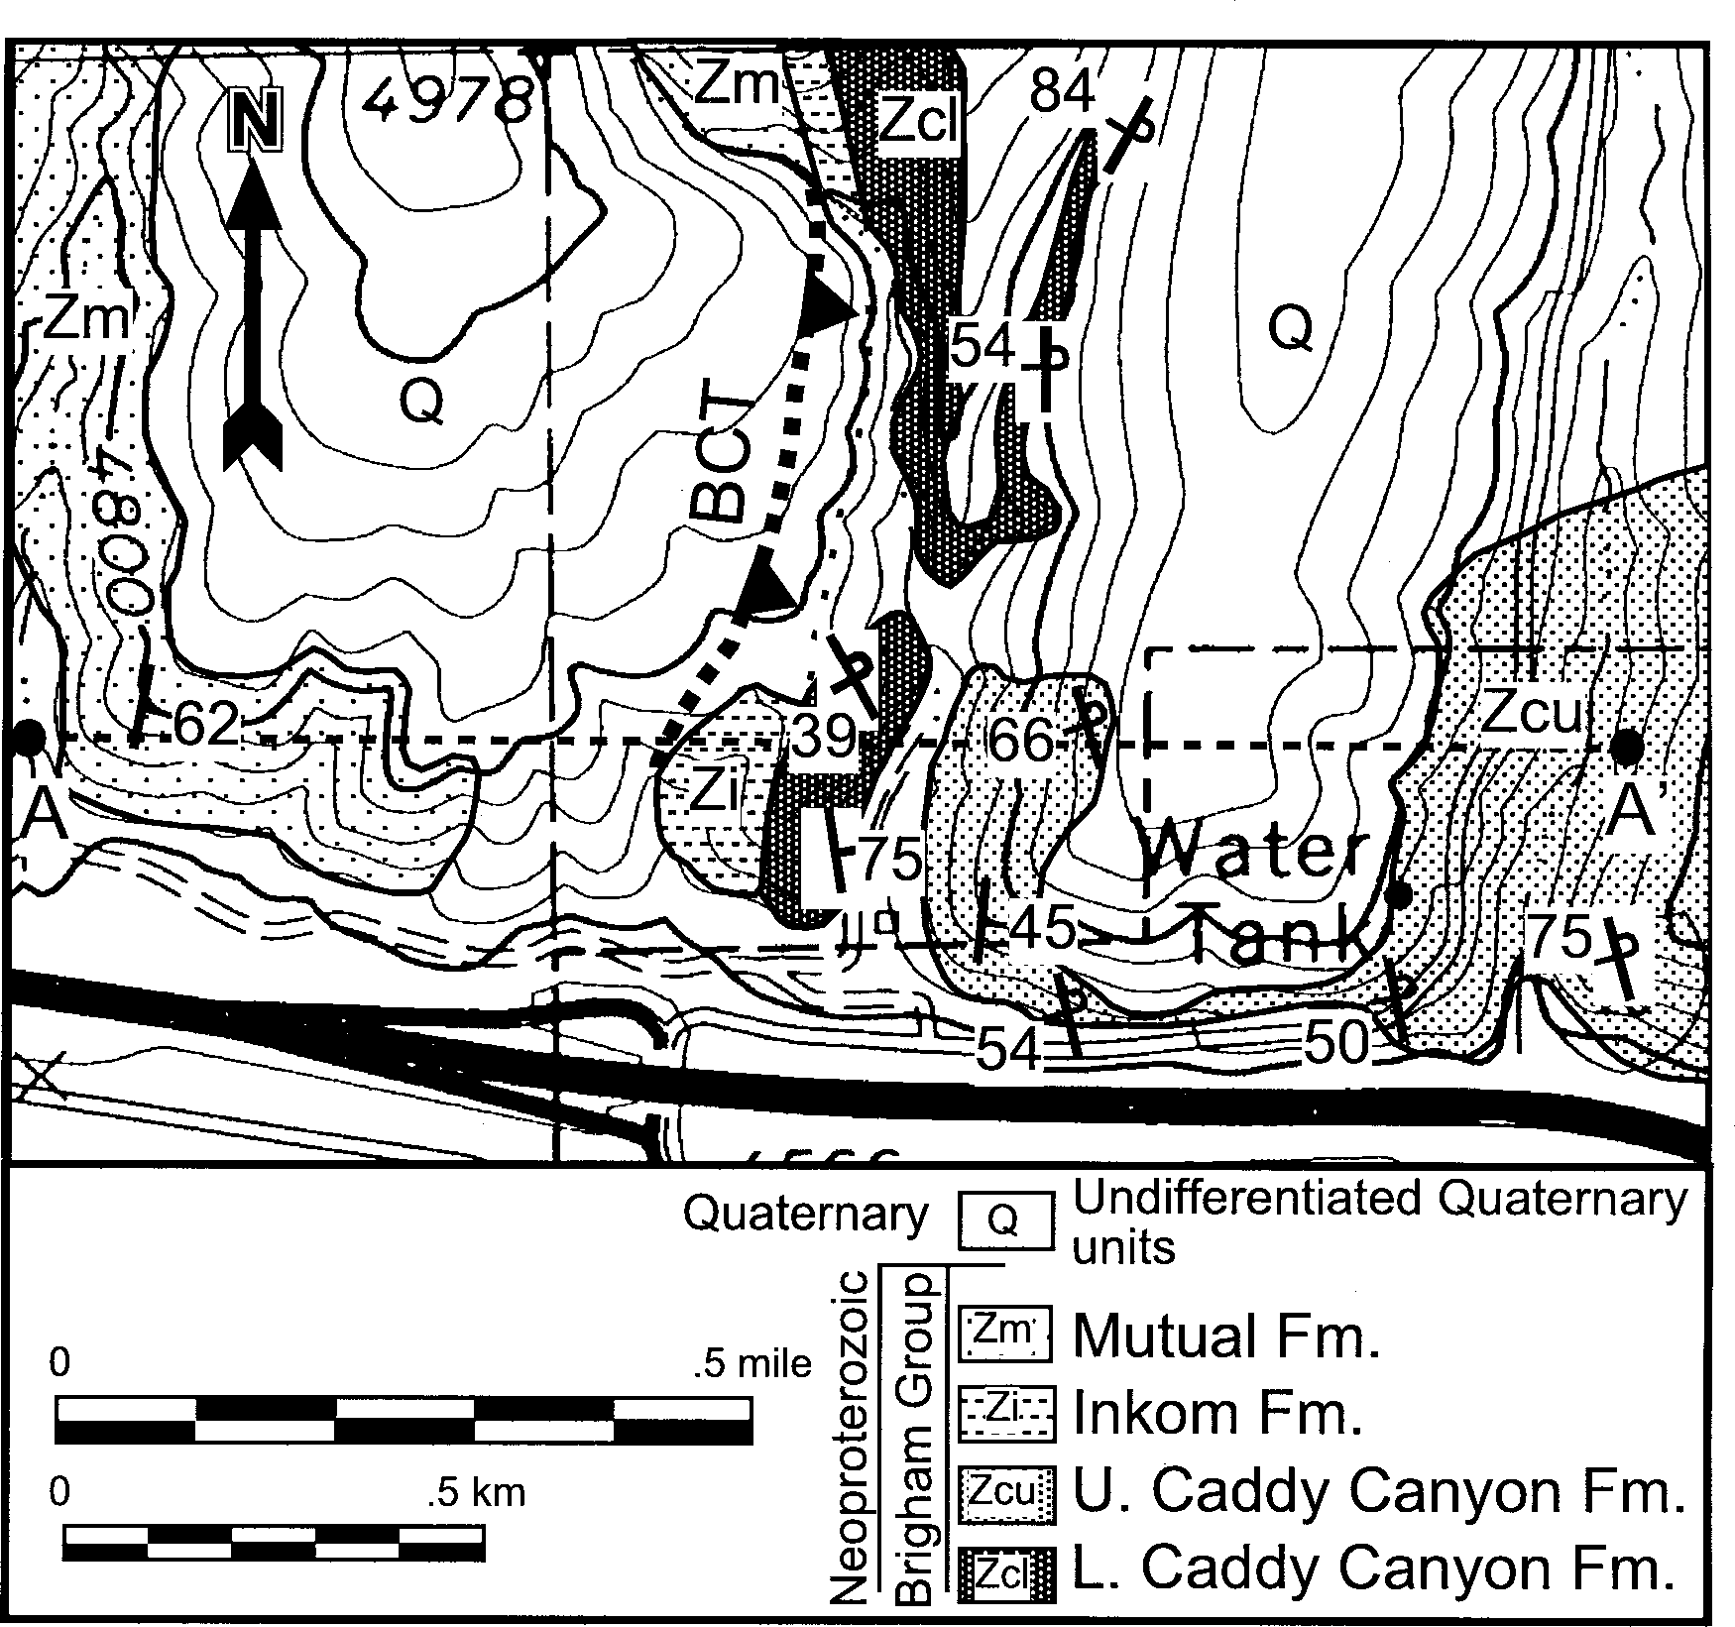
A

B
A
A
Q
Zcl
Q
Zm
Zi
Zcu

Figure 7. A, Geologic map of Stop 2, and B, cross section along A-A'. Bear Canyon thrust (BCT) separates a hanging wall of lower Caddy Canyon Quartzite (Zcl) and upper Caddy Canyon Quartzite (Zcu) from a footwall of Mutual Formation (Zm). Inkom Formation (Zi) is present in the fault zone and Quaternary units (Q) overlie all rocks and structures. Modified from Burgel (1986) and McQuarrie and others (in press).

press) has confirmed this prediction. This stop will examine the east-dipping Bear Canyon thrust.
A geologic map and cross-section of this stop are shown in Figure 7. Maroon quartzite (Mutual Formation) and brown to red quartzite (Caddy Canyon Quartzite) are juxtaposed, with slivers of green shale (Inkom Formation) locally in between. The Mu- tual Formation dips east whereas the Caddy Canyon Quartzite is subvertical to west-dipping (overturned) in most places. Burgel (1986) and Burgel and others (1987) interpreted the contact be- tween quartzites as a west-dipping normal fault, but regional re- lations described above require the contact to be the Bear Can- yon thrust fault, with Caddy Canyon Quartzite thrust over Mutual Formation. The map pattern indicates the unexposed thrust is moderately to steeply dipping, so we interpret it to be parallel to bedding in Mutual Formation (dipping 50°E). Immediately east of this stop the overturned Caddy Canyon Quartzite beds pro- gressively unfold to become moderately east-dipping. Thus, the Bear Canyon thrust is interpreted to separate a hanging wall anti- cline from a footwall flat.
We will now drive west, back toward Pocatello. Turn right on Sorrell Road, then turn left and drive through interstate under- pass.

17.0 0.2 Immediately past interstate offramp, turn right (west) onto Old Highway 91. Proceed west, parallel to In- terstate 15.
21.1 4.1 Turn right (north) on Blackrock Canyon Road. To the north, all the prominently stratified rocks at the top of the ridge to the left are overturned Pocatello Formation rocks on the north side of the Portneuf Narrows fault. These overturned rocks form part of the inverted limb of a large east-vergent recumbent fold, the Blackrock Canyon fold (McQuarrie and others, in press).
Continue under I-15. Upright diamictite of the Scout Moun- tain Member of the Pocatello Formation crops out prominently in the hill directly ahead.

21.9 0.8 Pass phyllitic rocks of the upper member, Pocatello Formation.
22.2 0.3 Pavement ends as road enters Blackrock Canyon. The stratified rocks on the right are east-dipping (upright) Blackrock Canyon Limestone (Upper Pro- terozoic).
22.4 0.2 Park by west-trending gully on left.

STOP 3 - The Blackrock Canyon fold and the Portneuf arrows fault.
Stop 3 provides an opportunity to traverse two regionally ex- tensive structures that strongly influence the map pattern of rocks throughout the Pocatello Range. We will walk west and south through the hills, returning to Blackrock Canyon Road where it crosses beneath Interstate 15 (mile 21.9, above). The walk is about 1 mile long, involves 700' elevation gain, should take about 2 hours, and is shown on the accompanying geologic map and cross- section (Fig. 8).
Overturned rocks that comprise the Blackrock Canyon fold
were recognized along the crest of the Pocatello Range (LeFebre, 1984; Link and others,1980), and interpreted in terms of an over- turned limb of an east-vergent anticline-syncline pair. Burgel (1986) mapped local regions of overturned rocks east of Blackrock Canyon and proposed the existence of an east-vergent recumbent anticline, the Rapid Creek fold, which includes the crest of the Pocatello Range and projects to the east above the modern land- scape (Burgel and others, 1987). More recent mapping by other graduate students at Idaho State University yielded a better map of rocks along the crest of the range, and a new interpretation that the east-vergent recumbent anticline projects east from the crest of the Pocatello Range below the modern landscape (McQuarrie and others, in press). To distinguish this new fold geometry and to associate the fold with its area of exposure, the latter authors proposed the name "Blackrock Canyon fold".
The Blackrock Canyon fold is a subhorizontal, north-trend- ing map-scale fold whose axial plane is subhorizontal to gently east-dipping. The inverted limb, which crops out throughout the crest of the Pocatello Range, involves the Pocatello Formation, including the Bannock Volcanic Member, five informal units of the Scout Mountain Member, and the informal upper member. These overturned rocks typically dip 15-30° west, indicating 330°+ of tilting via folding (and superimposed Neogene tilting, see below). Outcrop-scale folds are not common except in the upper member of the Pocatello Formation, but small-scale defor- mation is illustrated by a pervasive axial planar cleavage, flatten- ing of diamictite clasts, and marked thinning of some stratigraphic units in comparison to their upright equivalents.
The hinge region of the Blackrock Canyon fold is evident only at the mouth of Blackrock Canyon (along this traverse) where the upper member of the Pocatello Formation changes orienta- tion from east-dipping to west-dipping. Elsewhere, the fold and its hinge are cut by faults; to the west, the inverted limb is cut by the Fort Hall Canyon normal fault (with 6-8 km of slip), to the east the fold is cut by the Blackrock Canyon normal fault (with 1- 2 km of slip), and to the south the fold is cut by the Portneuf Narrows fault (Lefebre, 1984; McQuarrie and others, in press). Thus, the inverted limb is exposed in a horst flanked by downdropped, upright rocks that presumably formed the upright limb of the fold before faulting. Furthermore, the Blackrock Can- yon fold was affected by regional tilting that accompanied nor- mal faulting - removing a superimposed 45° eastward tilt would restore the fold to a north-trending, east-vergent anticline with a gently (30°) west-dipping axial plane.
The traverse at Stop 3 encounters several geometric elements of the Blackrock Canyon fold, as well as the Portneuf Narrows fault that abruptly transects the fold. Key outcrops are described below, and located on Figure 8.

3A Phyllite of upper member of the Pocatello Formation dips moderately east and contains a gently east-dipping axial planar cleavage. Although bedding dips more steeply than cleavage, these rocks are not overturned; after removing superimposed eastward tilting, cleavage would dip more steeply west than bedding.

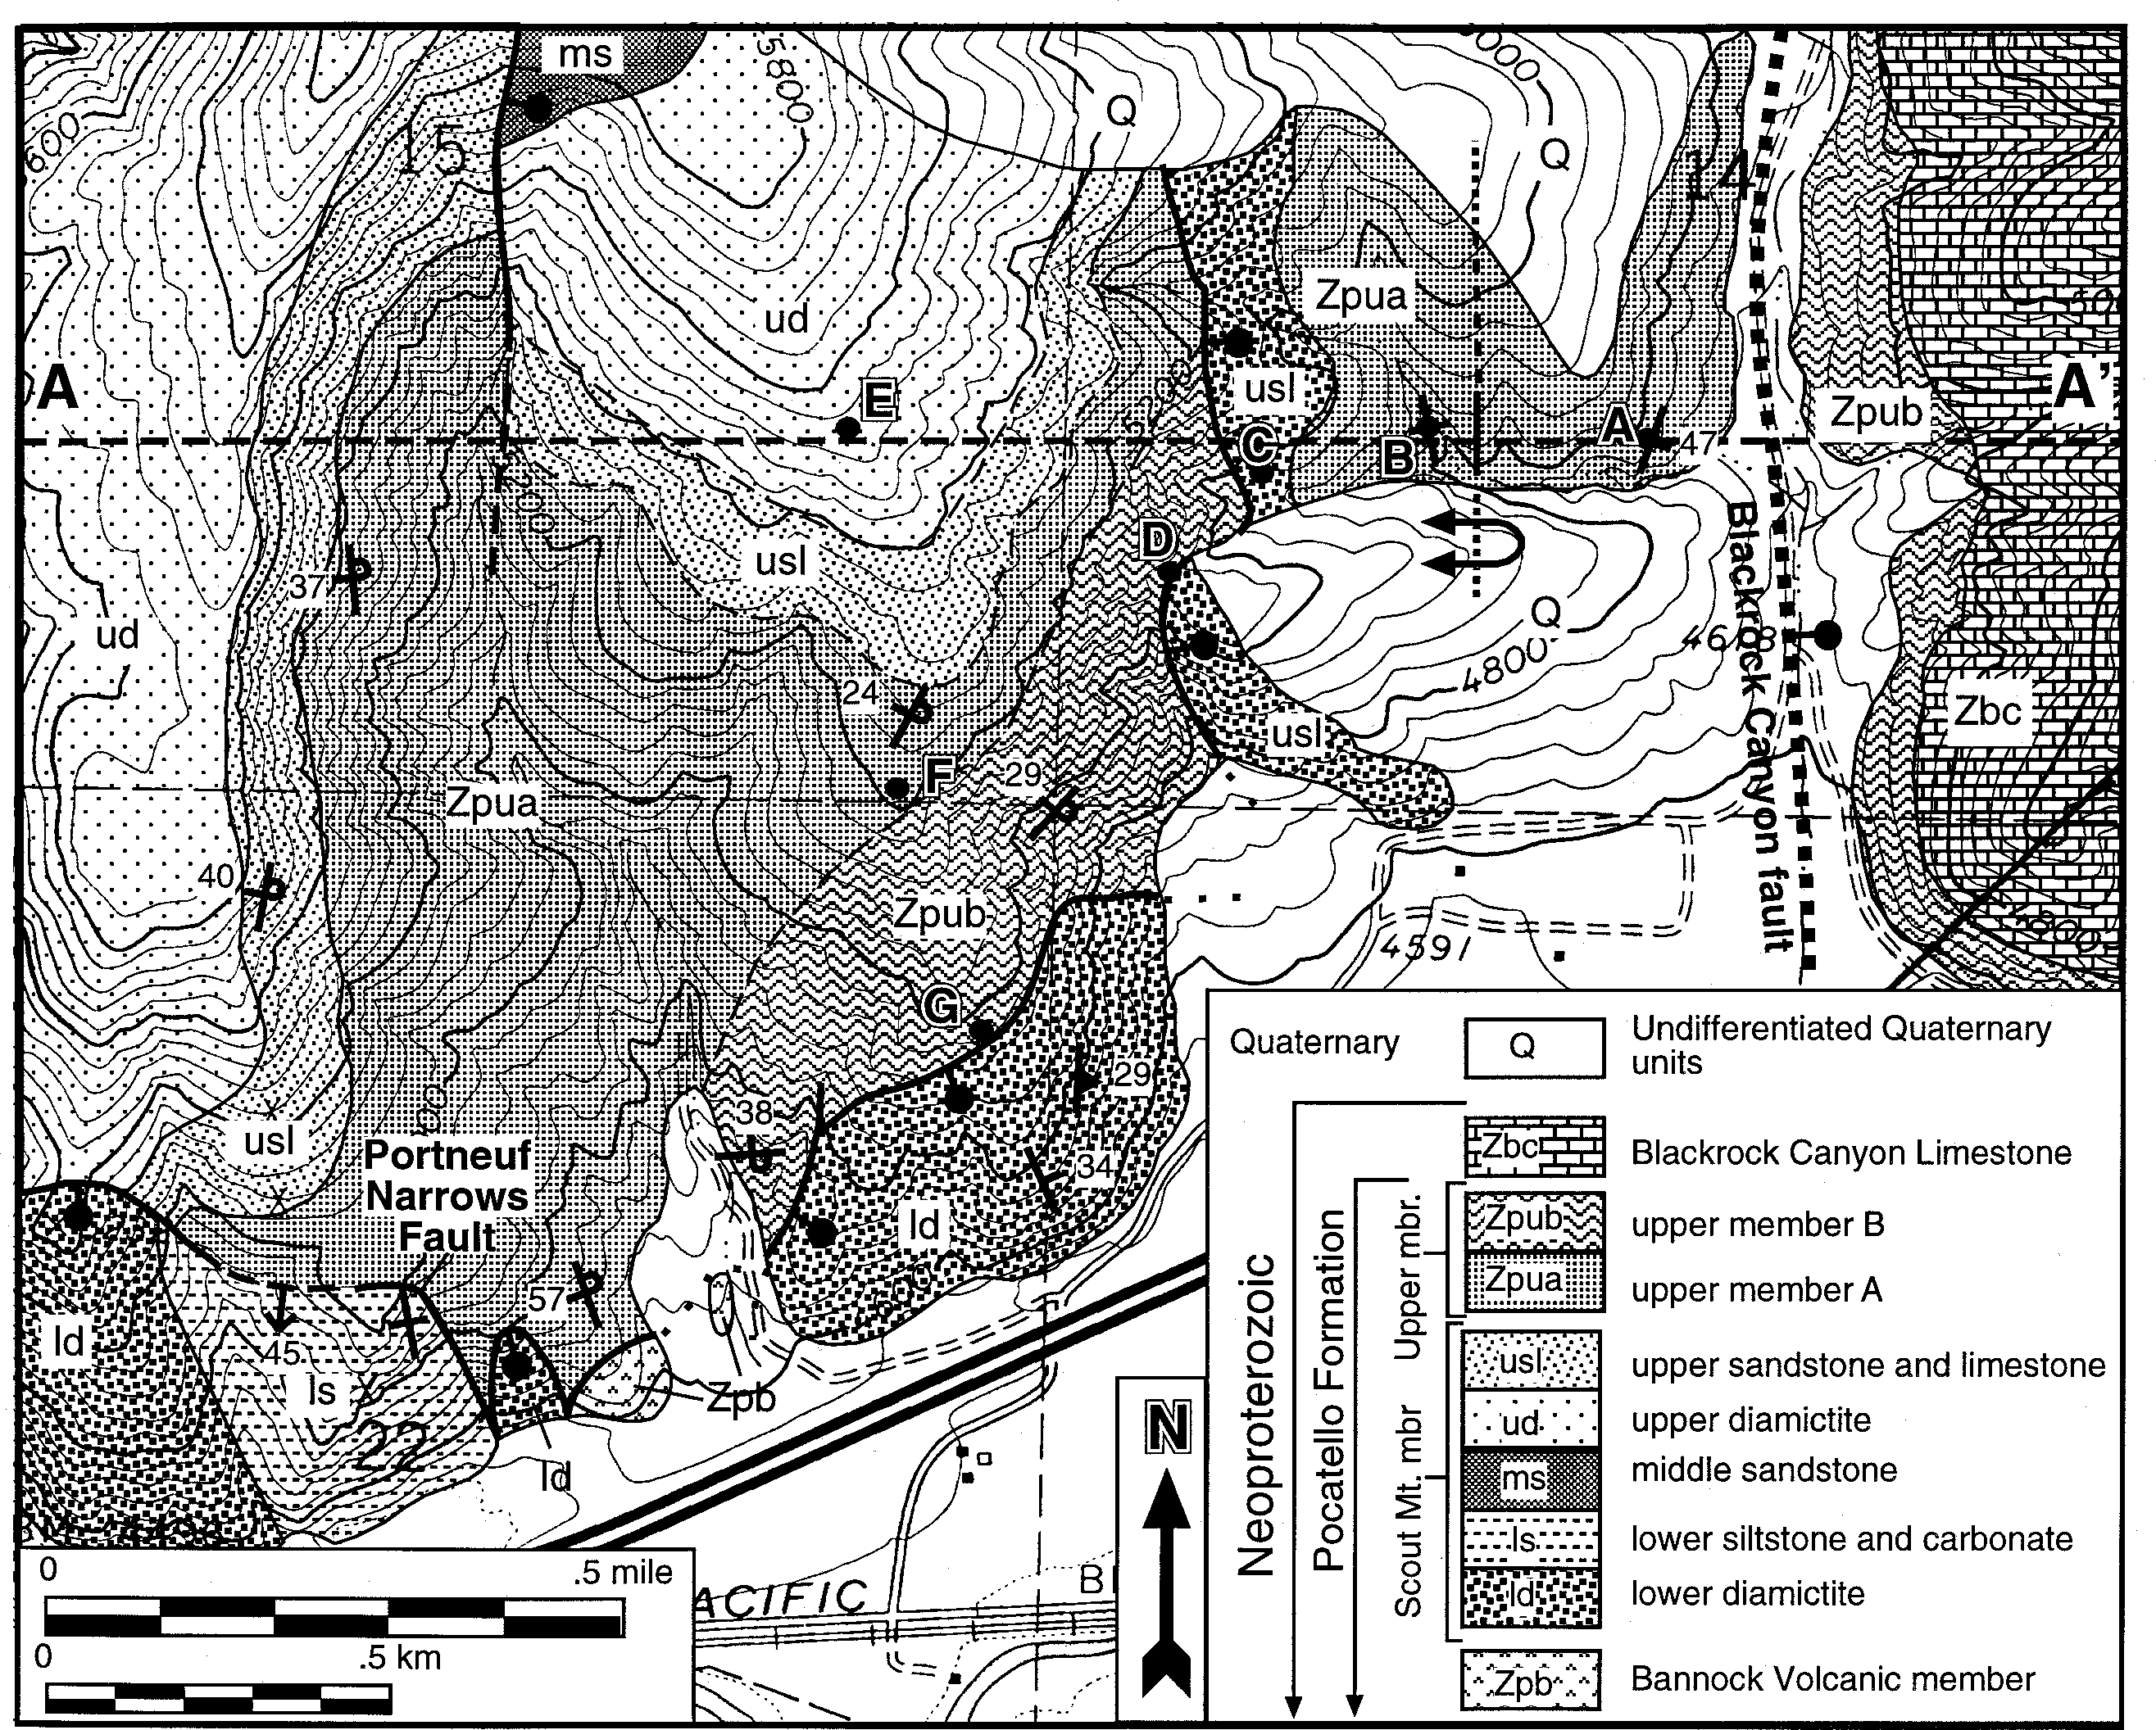
A

B

A A’
ud
ud
usl
usl
usl
Blackrock Canyon
Blackrock Canyon Fold
Q
Zpu
Zbc
Zpu
Zpu
Zpu
6000’

West East
4000’
5000’
Figure 8. A, Geologic map of Stop 3, and B, cross section along A-A'. Blackrock Canyon fold involves members of the Pocatello Formation, including upper member (Zpu) and Scout Mountain Member (usl, ud, ms). The fold is bounded on the south by the Portneuf Narrows fault, and on the east by the Blackrock Canyon fault. See Figure 2 for explanation of other map symbols. Modified from McQuarrie and others (in press), Link (1987), and LeFebre (1984).

3B Phyllite is subvertical and cleavage dips gently east. This is the hinge zone of the Blackrock Canyon fold.

3C Limestone float is from subcrops of upper sandstone and limestone unit and diamictite float from uphill outcrops of upper diamictite unit, both of the Scout Mountain Mem- ber, Pocatello Formation.

3D East-dipping normal fault juxtaposes upper sandstone and limestone unit in the hanging wall, and upper member Pocatello Formation in the footwall. Note overturned bed- ding in upper member, indicative of inverted limb of Blackrock Canyon fold.

3E Outcrops of upper diamicitite unit, Scout Mountain Mem- ber. Bedding is absent but cleavage and flattened cobbles are evident. Across ravine on hillside to the west is an ex- cellent section of gently dipping, inverted Pocatello For- mation, described by Link (1987). Traverse turns south along 4WD road, leading down through progressively younger (overturned) rocks.

3F Outcrops of upper member Pocatello Formation along 4WD road indicate gentle west dips.

3G Portneuf Narrows fault. Based upon its trace over rugged topography, the fault strikes northeast and dips southeast, but a short distance to the west the fault strikes N80W and dips 45° south. The fault surface is not exposed along this transect, but brown fine-grained inverted sandstone (up- per part of upper member, Pocatello Formation) is adja- cent to phyllite, tan medium-grained quartzite, or pebble- to cobble-sized metadiamictite (lower diamictite unit, Scout Mountain Member). The lower diamicitite unit lacks bed- ding but is interpreted to be upright based on its internal stratigraphy (phyllite over diamictite) and on its contact with Bannock Volcanic Member to the west. Across the Portneuf Narrows to the south, an upright east-dipping homocline of Scout Mountain Member and upper member Pocatello Formation are evident.

The Portneuf Narrows fault clearly separates an extensive block of inverted rocks from an even more extensive block of upright rocks, but opinions differ about its kinematics and tim- ing. It may be (as Kellogg proposes) a large Mesozoic tear fault (compartmental fault of Brown, 1984) that separates differing tectonic styles across the fault; movement would then be coeval with Early Cretaceous and Late Jurassic thrusting. Alternatively, the Portneuf Narrows fault may be (as Rodgers prefers) a Neo- gene down-to-the-south normal fault related to north-south ex- tension associated with formation of the Snake River Plain. We will discuss the merits and problems of both possibilities.
From the end of the traverse (near mile 21.9, above), we will return to Pocatello. Retrace route southwards on Blackrock Can- yon Road, turn right (west) on Old Highway 91, drive 1.4 miles to northbound interstate onramp, and drive north on interstate 15 to exit 71 and Cavanaugh Motel.
DAY 2
This portion of the fieldtrip is on the eastern Fort Hall Indian Reservation. A trespass permit from the Fort Hall Tribal Council, representing the Bannock and Shoshone tribes, is required before entering tribal lands.

Total/lncremental Mileage
0.0 0.0 Leave parking lot of the Cavanaugh Motel and take
 |  | northbound onramp of Interstate 15. Proceed north
 |  | on I-15 to Fort Hall.
8.0 | 8.0 | Low, mostly loess-covered hills on the right mark
 |  | the northern end of the Pocatello Range and are
 |  | underlain by the strongly flow-banded, 9.1-Ma rhyo-
 |  | lite of Two and a Half Mile Creek (Kellogg and
 |  | Marvin, 1988). The rhyolite flow overlies coarse
 |  | Tertiary diamictites (probably debris flows) com-
 |  | posed mostly of angular blocks of Ordovician Swan
 |  | Peak Quartzite, Jurassic Nugget Sandstone, and the
 |  | 10.2-Ma tuff of Arbon Valley (the tuff is described
 |  | in Kellogg and others, 1994). These Tertiary units,
 |  | in turn, overlie Paleozoic rocks as young as Upper
 |  | Mississippian Monroe Canyon Limestone (exposed
 |  | about 3-5 km east of here), which are interpreted as
 |  | part of the lower (Meade) plate below the Putnam
 |  | thrust (Kellogg, 1992; Fig. 3).
9.3 | 1.3 | Exit at Ft. Hall (Exit 80). Turn right on Simplot
 |  | Road. To the northeast is a long, flat-topped ridge,
 |  | which defines the southwest margin of the almost
 |  | circular, 7-km-wide "Buckskin dome" (Kellogg and
 |  | Embree, 1986).
This enigmatic feature is a basaltic uplift, cut by numerous north-northwest-striking normal faults that dip both east and west and are related to east-west Basin-and-Range extension. Three whole-rock K-Ar dates on basalts of the dome range from 2.2±0.2 Ma to 3.7±0.7 Ma (Kellogg and Marvin, 1988). Because doming and faulting postdate the basalts, Basin-and-Range extension in this area probably was ongoing into Pleistocene time.
Over the next couple of miles, a few scruffy exposures of Pliocene basalt can be seen poking through the loess as the road nears the margin of the Snake River Plain province. These basalts overlie a very thick, largely caldera-derived rhyolitic sequence that, due to subsidence of the plain, is only exposed along its downwarped margins. The rhyolite of Two and a Half Mile Creek underlies most of the hills on the right.
The extensive loess deposits that mantle large parts of the Snake River Plain, are easily the most valuable geologic resource in Idaho, as the famous Idaho potatoes, as well as other crops, grow in the loess. The surface loess is at least as old as 150,000 years (time of Bull Lake glaciation) and as young as 10,000 years and overlies an even older loess sequence (Pierce and others, 1982;
K.L. Pierce, USGS, personal commun., 1998). The loess is cur- rently being eroded and is locally highly dissected.

10.3 1.0 Cross railroad tracks, which were used to bring phos- phate ore from the Gay Mine to the Simplot Mill in Pocatello. The phosphate ore, from the Permian Phosphoria Formation, was mined from several pits

8 Gu debook to the Geology of Eastern Idaho

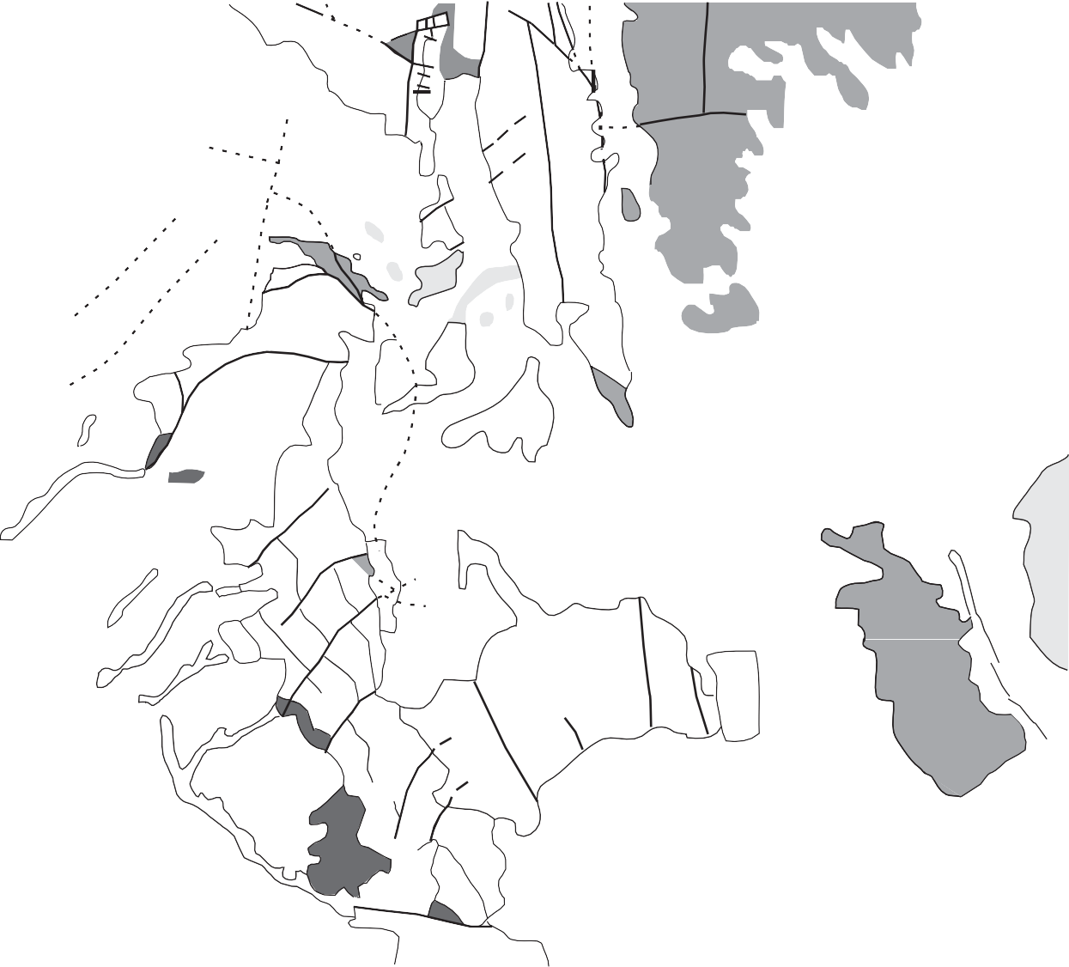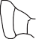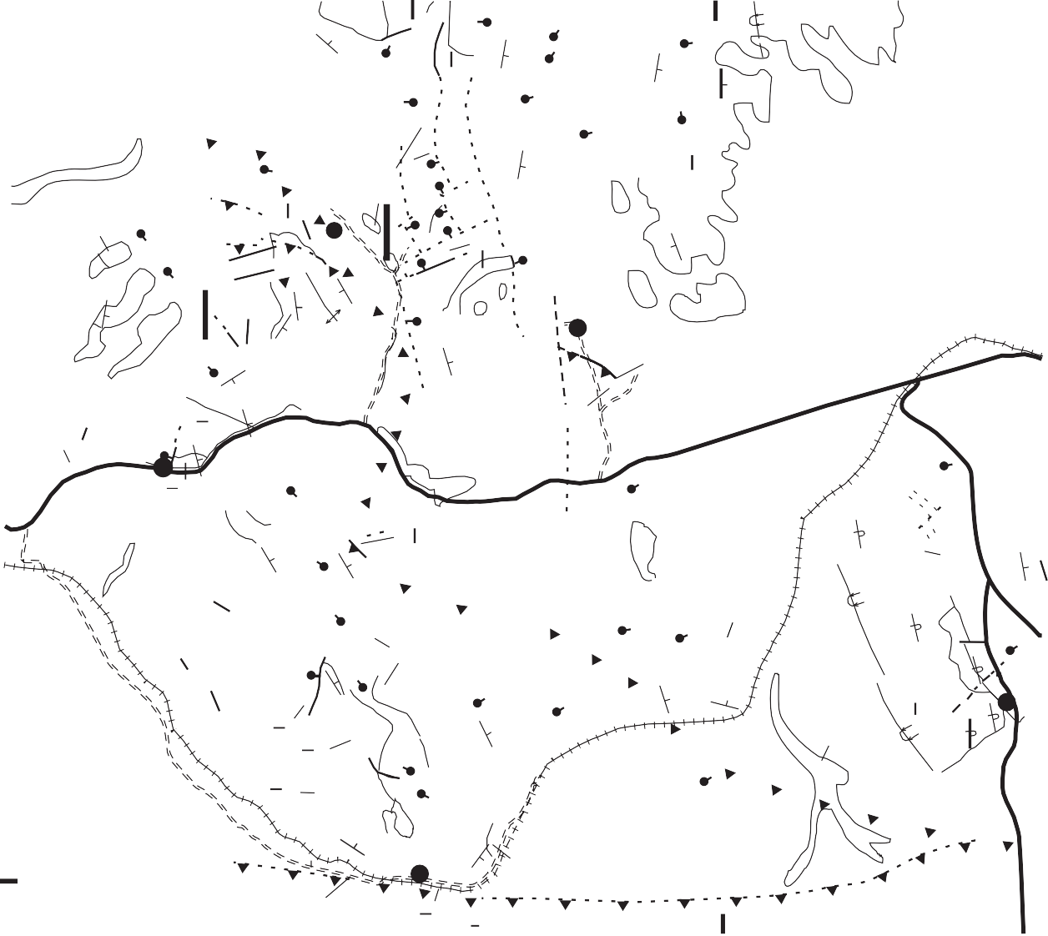112o10' A'

43º05'

Qla

25

Putnam

PPw

15
zy 45 22

thrust
PPw 5
Os
Of TRu
10
Os
PPw
Qla

•yz
20
Ql Os
30 70

47
TRu
Of
6
7

Og 40
Putnam thrust?

QTaf
A

15
OCs

32
4
Cn
45

Os PPw

42
35
PPw

TRu
10
Pp
30
B'

Ql
Og

Mmc
25

Of 4400

QTaf 40
B 35 7

Cn
OCs
Cn

39

25
QTaf

PPw 32
35

43º00'
Qla
33
8 50 Of
Qla

The Narrows
Cn Pcc

Loess and alluvium Landslide deposit
Qla
Ql
Q Taf
Tu
TR u
Pp
PPw
Mmc
Of
Os
Og
OCs
Cn
Pcc

Old alluvial fan deposit
Miocene sedimentary rocks, rhyolite tuff Triassic rocks, undivided
Contact--dotted where covered Normal fault--dotted where covered Thrust fault--dotted where covered
20 Strike and dip
Syncline--trace of axial plane

Phosphoria Formation Wells Formation
Monroe Canyon Limestone
Overturned syncline--trace of axial plane Paved or gravel road

Fish Haven Dolomite Swan Peak Quartzite Garden City Limestone St. Charles Formation Nounan Dolomite
Caddy Canyon Quartzite
Dirt road
5 Fieldtrip stop

0 1 MI

0 1 2 KM

Figure 9. Simplified geologic map of the Yandell Springs-Simplot Road area of the Fort Hall Indian Reservation, showing locatio ns of fieldtrip Stops 4-8. Modified from Hladky and others (1992), and Hladky and Kellogg (1990).

in a complex array of normal-fault-bounded blocks. The mine closed in the early 1990's, which ended an important revenue source for the Bannock and Shoshone tribes.
13.5 3.2 Good view of Mt. Putnam (2 o'clock), underlain mostly by quartzites of the Lower Cambrian and Upper Proterozoic Brigham Group. The low rocky ridge (straight ahead) is underlain mostly by Or- dovician rocks in the hanging wall of the Putnam thrust; the crest of the ridge is mostly Middle Or- dovician Swan Peak Quartzite. The Narrows (not to be confused with the Portneuf Narrows, which we visited yesterday) occupies the deep canyon just north of Mt. Putnam. We will later visit the Ross Fork Narrows fault (Fig. 9), which strikes west through The Narrows and which marks a proposed major Late Cretaceous boundary between the Lone Pine and Narrows subplates of the Putnam thrust plate, juxtaposing Ordovician and Cambrian rocks against Upper Proterozoic Caddy Canyon quartz- ite. Miocene tuffs and tuffaceous sedimentary rocks underlie the low, rounded hills to the north.
15.9 2.4 Ross Fork Creek Road on right. Continue straight ahead.
17.3 1.4 Narrows Road (dirt) on right. We will drive down this road later in the trip. Continue straight ahead.
17.7 0.4 Dissected debris fans on the left probably are as old as Tertiary and were generated by west-dipping normal faults along the western flank of the ridge.
18.3 0.6 End of pavement. Limestone of the Upper and Middle Cambrian Nounan Formation forms the outcrops on the left; Swan Peak Quartzite underlies the skyline rocks.
18.6 0.3 Good exposure of Nounan Formation limestone, dipping about 35° east. Exit vans here.

STOP 4 - Forelimb of hanging-wall anticline of Putnam thrust.
The purpose of this stop is to inspect the forelimb of the hang- ing-wall anticline of the Putnam thrust (Fig. 9). From this outcrop of Nounan carbonate, we will walk upsection along the road as high as the Swan Peak Quartzite, which immediately overlies the Putnam thrust. The thrust is not exposed here; we will visit it at the next stop. One purpose of this traverse is to note the locally extensive breccia zones associated with Tertiary extension.
The Upper and Middle Cambrian Formation is composed of a medium- to dark-gray, thin- to medium-bedded oolitic lime- stone and dolostone, about 275 m thick. Several breccia zones cut the unit in the next few 100 meters. Brecciated Upper Cam- brian Worm Creek Quartzite Member of the St. Charles Forma- tion (the two members of the St. Charles are not shown on Figure
9) crops out about 300 m from the start of the traverse. The Worm Creek is characterized by pale-tan, medium-grained, well-sorted, locally cross-bedded feldspathic quartzite containing numerous limonitic spots; the unit grades downward into light-brown coarsely crystalline sandy dolostone and is about 150 m thick. The upper member of the St. Charles is thin- to medium-bedded,
brownish-gray dolostone, containing dark-gray chert lenses. Where encountered (about 800 m from start of traverse), the unit dips 60° east. Just to the east, good exposures of the Lower Or- dovician Garden City Limestone dip about 45° east and expose gray, fine-grained, tabular limestone containing orange-tan mot- tling and intraformational conglomerate. To save time, the vans will shuttle us the next 0.5 km to the easternmost prominent out- crops of highly brecciated upper member of the Swan Peak Quartz- ite, a dense, white orthoquartzite. The lower member of the Swan Peak (abundantly cherty dolostone and quartzite) is not exposed along the road.
One question we will discuss is whether brittle deformation (brecciation) is entirely formed by widespread Tertiary crustal extension. At least one fieldtrip leader (Kellogg) believes that essentially all brecciation is Tertiary and not related to thrusting; i.e., thrusts can move only when hydrostatic pressure approaches lithostatic pressure (similar to Hubbert and Rubey's [1959] fa- mous beer can experiment), a condition that is not conducive to the formation of significant breccia.

19.6 1.0 We resume driving east from the last (easternmost) outcrop of Swan Peak Quartzite.
19.8 0.2 Turn left at gate in fence (leave gates as you find them ). We will be crossing the buried trace of the Putnam thrust.
20.3 0.5 Take left fork through gate near abandoned water- well in Triassic lower-plate rocks (gray-brown silt- stone and limestone of Dinwoody or Thaynes For- mation).
20.7 0.4 Park at base of grassy hill to the southwest. We will walk to the top of this hill.

STOP 5 - The Putnam thrust
The lowest, prominent outcrops up the hill are nearly mas- sive, gray, cherty limestone of the Middle Pennsylvanian lower member of the Wells Formation, which dips about 25° to the south- west. These rocks are just a few meters below the main Putnam thrust, above which are exposed rocks of the Lone Pine subplate of the Putnam thrust (Fig. 5). The Lone Pine subplate contains rocks as young as Lower Silurian and Upper Ordovician Fish Haven Dolomite and as old as Upper and Middle Cambrian Nounan Formation. At this locality, however, the stratigraphically lowest exposed upper-plate rocks are those of the lower member of the Middle Ordovician Swan Peak Quartzite (the members of the Swan Peak are not differentiated on Fig. 9). This member, which crops out on a flat shoulder of the ridge, contains lami- nated limestone and dolostone containing abundant, flattened black chert. Brecciated white quartzite of the upper member of the Swan Peak Quartzite is prominently exposed just above the lower member. The Swan Peak Quartzite pinches out to the east between the main Putnam thrust and a much smaller, structurally higher, hanging-wall imbricate thrust, which places Lower Or- dovician Garden City Limestone above the Swan Peak Quartzite.
A small syncline deforms the Garden City Limestone near the top of the hill. This enigmatic structure is superimposed on a larger hanging-wall anticline and may be related to Tertiary reactiva- tion (backsliding) along the Putnam thrust, or, alternatively, sim-

ply points to the fact that geologic "rules" ("only anticlines form immediately above thrusts") are not always followed.
The top of the hill provides a good vantage to discuss struc- tures in the hanging wall of the Putnam thrust. The mostly buried and pervasively normal-faulted trace of the Putnam thrust extends to the southeast, through the swale on the northeast flank of Mt. Putnam, the large prominent mountain to the south. The Narrows, the deep canyon to the north of Mt. Putnam, marks a major bound- ary between the Lone Pine subplate, on which we are standing, and the overlying Narrows subplate, which includes rocks as far west as the Bannock Range (Fig. 3). The Narrows subplate con- tains rocks as old as the Upper Proterozoic Pocatello Group and as young as the Lower Silurian and Upper Ordovician Fish Ha- ven Dolomite.
The Bear Canyon thrust, an east-dipping structure, is hidden just behind the summit of Mt. Putnam. The thrust continues south along the west flank of the Portneuf Range. The hanging-wall rocks of the thrust are part of the Bear Canyon-Toponce subplate (Fig. 5) and range in age from Lower Ordovician and Upper Cam-
brian St. Charles Formation to Upper Proterozoic Caddy Canyon Quartzite.
East of the summit of Mt. Putnam, the Bear Canyon thrust places Caddy Canyon Quartzite above rocks as young as St. Charles Formation in an east-younging footwall ramp; the Bear Canyon thrust is inferred to merge with the covered Putnam thrust about 10 km east of Mt. Putnam. The observed ramping, up-sec- tion to the east, is the main reason that we believe the Bear Can- yon thrust is an east-directed thrust, tilted to the east by Neogene half-graben faulting, and not a back thrust. A complicated set of east-striking tear-faults near the summit of Mt. Putnam formed contemporaneously with thrusting. Across each tear fault, the hanging-wall and footwall stratigraphy changes discontinuously. South of these tear faults, Caddy Canyon Quartzite overlies Middle Cambrian Elkhead Limestone, and southward along the west side of the Portneuf Range, the thrust ramps laterally downsection in the footwall. Near Inkom, for example, we observed yesterday that Caddy Canyon Quartzite overlies Mutual Formation, a jux- taposition that reflects decreasing stratigraphic offset to the south.

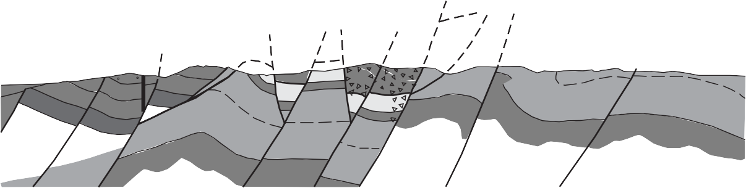A A'
METERS

2,500

2,000
A
QTaf

Putnam thrust

Os Og

Og Os SOf SOf Os

1,500

1,000

500

0

Tu

Cambrian rocks
Og OCsc Cn
OCsc
Cn
Pp TRd Pp

PPw

TR d
PPw

MISSISSIPPIAN AND OLDER ROCKS

younger surficial deposits not shown

0 1 2 3 KM

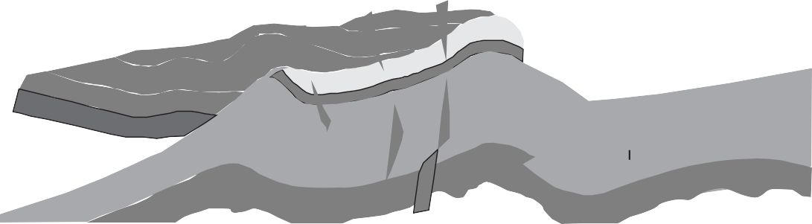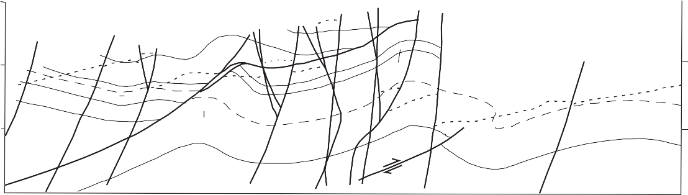METE 3,000
RS
B
SOf
Os
TRu
Os
Og
Pp
OCs
Cn
PPw
Cambrian
rocks
PPw

2,000

1,000

0

EXPLANATION
Lower-plate rocks Upper-plate rocks

Alluvial fan deposits Miocene rocks
QTaf
Tu
Triassic rocks
Phosphoria Fm. Wells Formation
TRu
Pp
PPw
Mu

Mississippian rocks
Fish Haven Dolomite Swam Peak Quartzite
Garden City Limestone St. Charles Formation
SOf
Os
Og
OCs
Cn

Nounan Formation
Overlaps and gaps Breccia zone

Figure 10. A, Cross section along A-A', Figure 9. Cross-section shows more stratigraphic and structural detail than appears on Figure 9. B, Cross section A-A' after all Tertiary faults have been restored to their prefaulting positions. Cross-hatched areas are zones of overlap, and horizontally lined areas are gaps. Adapted from Figure 5 of Kellogg (1992) and Hladky and Kellogg (1990).

Kellogg and others -- The Putnam Thrust Plate, Idaho

To the east, across several normal faults that dip both east and west, exposed rocks belong to both the upper and lower plates (Fig. 10A; adapted from Hladky and Kellogg, 1990, and Kellogg, 1992). The reason that both upper- and lower-plate rocks are closely juxtaposed is because the Putnam thrust is relatively flat here and offset across the normal faults is as large as 1,200 m. The horst-and-graben assemblage of blocks correspond roughly to the series of visible low ridges, with the larger intervening nor- mal faults approximately following the gullies. Triassic lower- plate rocks underlie the low, mostly loess-covered hills in the fore- ground. The juniper-covered ridge beyond is underlain by strongly brecciated upper-plate Fish Haven Dolomite. The low ridges be- yond the Fish Haven exposures contain Wells Formation and other units of the lower plate.
Restoration of pre-extension geometry following Mesozoic thrusting (Fig. 10B) indicates that the Putnam thrust ramps up eastward through the Cambrian and Ordovician section in the hanging wall. In the footwall, the thrust is interpreted to be a flat in the lower Wells Formation on the west, then ramps through the upper Wells and Phosphoria Formation, and finally forms a flat in the Dinwoody Formation to the east.
The top of the hill also provides a commanding view of the Snake River Plain and structures along its margin. To the west, the rhyolite of Two and a Half Mile Creek can be seen dipping generally north, reflecting Neogene downwarping of the plain's margin. The Buckskin dome is clearly visible to the northwest. To the north-northwest, the east-dipping 10.2-Ma Arbon Valley Tuff is repeated at least twice across west-dipping normal faults (a small model for the entire region ).
Return to the vans and drive back to Simplot Road. Reset odometer to 0.0.
which locally has been brecciated so extensively that the finely commuted clasts have flowed, displaying a crude flow banding. The large fault which bounds this block on the east has over 1 km of throw (Fig. 10A). Lower-plate rocks of the Wells Formation crop out east of the fault and Triassic lower-plate rocks are in fault contact with the block on the west. A reasonable restoration of Tertiary faulting (Fig. 10B) shows significant misfits (overlaps and gaps) along the sides of the blocks, resolvable only by wide- spread internal deformation, here by brecciation. The misfits are, of course, dependent on the initial geometry chosen, but nonethe- less suggests that brittle internal accommodation of a block to Neogene extensional faulting increases roughly proportional to the increase in slip on faults bounding the block.
Return to Simplot Road.

3.8 1.0 From gate, turn left onto Simplot Road.
6.1 2.3 Cross railroad tracks and immediately take right turn (toward Blackfoot Reservoir).
7.2 1.1 Grassy hills on the right are reclaimed dumps from the last period of phosphate mining by the J.R. Simplot company, which lasted from 1987 to the early 1990's.
7.7 0.5 Take right turn over cattle guard.
8.1 0.4 Park by edge of partially infilled open pit.

STOP 7 - Overturned limb of footwall syncline of the Putnam thrust.
The mine follows the trace of the overturned Lower Permian Phosphoria Formation. Phosphate ore was mined in the lower of two members of the formation, the Meade Peak Phosphatic Shale Member, which consists of dark-brown to black phosphatic shale or mudstone and pelletal phosphorite. The phosphorite beds ("fish- scale beds") contain abundant fish scales, bones, and small chert and phosphorite nodules. The phosphorite contains as much as
0.0 | 0.0 | Turn left (east) on Simplot Road.
1.1 | 1.1 | Road crosses some small exposures of Tertiary con-
 |  | glomerate, which underlie the small basin across
 |  | which we are driving. These rocks contain mostly
 |  | subrounded Paleozoic limestone clasts and, where
 |  | nearby exposures are good enough to see bedding,
 |  | reflect 25°-40° eastward tilting.
1.8 | 0.7 | Turn left through gate; follow dirt track.
2.3 | 0.5 | Take left track at intersection.
2.6 | 0.3 | The light-gray limestone outcrops on the right are
 |  | Pennsylvanian lower Wells Formation. Immediately
 |  | north of here are exposures of highly brecciated
 |  | Ordovician and Silurian Fish Haven Dolomite
 |  | (Hladky and Kellogg, 1990; Hladky and others,
 |  | 1992). The contact between the Wells and Fish
 |  | Haven is almost certainly the trace of the Putnam
 |  | thrust, which here dips generally northeast, an ori-
 |  | entation induced by eastward tilting.
2.8 | 0.2 | Stop just south of small hill in brecciated Fish Ha-
 |  | ven Dolomite.

35% P O (ore grades reviewed by Hladky and others, 1992).
2 5

STOP 6 - Putnam thrust and pervasive Tertiary brecciation of the hanging-wall Fish Haven Dolomite
The purpose of this stop is to examine the deformation in a large fault-bounded block of upper-plate Fish Haven Dolomite,
The lower 15 m of the member contain some interbeds of dense limestone. The Meade Peak is 37-55 m thick. The thicker (105- 110 m thick) upper member of the Phosphoria formation is the cherty shale member, which consists of dark-brown to black cherty and noncherty mudstone, and subordinate thin-bedded argillaceous chert.
On the west wall of the pit, an overturned sequence of light- gray, ledgy, locally cherty dolomitic sandstone and limestone is mapped as part of the upper member of the Wells Formation (Hladky and Kellogg, 1990); the uppermost 15-30 m of brown, fetid dolomitic limestone is correlated with the Lower Permian Grandeur Member of the Park City Formation (Williams and Holstein, 1967).
The entire overturned sequence dips about 40°-50° southwest. Just southwest of the hill above the mine (Dare Peak), the trace of the west-dipping Putnam thrust is entirely buried by Tertiary and Quaternary deposits and its projection is several thousand meters above this spot (Fig. 11). The rocks exposed in the mine, there- fore, represent the overturned limb of an overturned footwall syn- cline. We will take a few minutes to examine this structure. Please do not climb on the mine faces; the rocks are extremely loose Note the numerous cross faults that cut and offset the deposit.

FEET 7,000
B
B'
Dare Peak
Simplot Mine
Qu
Qu
Tu
TRu
Pp
TRu
Pp
PPw
Mmc
PPw
Mississippian and older rocks

6,000

5,000

4,000

3,000

2,000

EXPLANATION

Miocene rocks
Tu
Triassic rocks
Phosphoria Fm.
Pp
TRu
Wells Formation
Monroe Canyon Limestone
Mmc
PPw

Figure 11. Cross section along B-B', Figure 9, through Simplot phosphate mine (Stop 7), showing relationship of overturned lower-plate beds to the Putnam thrust.

From the parking area, we have a good view to the south of the general trace of the Putnam thrust. The thrust is mapped in the near hills visible to the southeast, where Upper Cambrian Worm Creek Quartzite overlies Wells Formation (Kellogg and others, 1989). The hanging-wall rocks ramp steeply up section to the east, so that for most of the visible extent, the thrust places Lower Ordovician Garden City Limestone above Wells. The thrust wraps southward along the eastern flank of the Portneuf Range, and where last exposed to the southeast (about 11 km southeast of here), it has ramped down section in both hanging wall and foot- wall, so that rocks as old as Middle and Upper Cambrian Nounan Formation overlie rocks as young as Upper and Lower Mississip- pian Little Flat Formation.
From here, we will retrace our route back toward Ft. Hall.

16.7 8.6 Turn south off Simplot Road on Narrows Road (a good dirt road, though slippery when wet).
21.5 4.8 At The Narrows, stop next to railroad cut. Across the railroad is a prominent knob of white Caddy Canyon Quartzite.

STOP 8 - The Ross Fork arrows fault
The Ross Fork Narrows fault is interpreted as a steeply south- dipping lateral ramp having a large component of strike-slip move- ment (Kellogg, 1992), although a detailed study of the fault kine- matics has not been performed. If the interpretation is correct, the Ross Fork Narrows fault merges with the Putnam thrust to the east under a thick, faulted, east-dipping sequence of mostly con- glomerate and volcanogenic sandstone (Hladky, 1986), correlated with the upper Miocene Starlight Formation. The Ross Fork Nar- rows fault thus forms a steeply dipping part of the floor thrust of the Narrows subplate (Fig. 5) Gently-dipping but overturned
Caddy Canyon Quartzite is well exposed south of the fault; strong east-directed shearing is indicated by stretched pebbles at several localities (Kellogg, 1990). This style of deformation (shear and strong overturning, forming S- and Z-shaped folds), as we have seen at other stops, is characteristic of the Narrows subplate of the Putnam thrust. Here, and on the entire northwest flank of Mt. Putnam, the Caddy Canyon Quartzite is unusually pale as com- pared to exposures south of Mt. Putnam. In the hanging-wall of the Bear Canyon fault, just south of Mt. Putnam, rocks of the Caddy Canyon are upright and more characteristically pale pink and tan (Kellogg, 1990). Speculatively, this local bleaching may be due to thermal effects of Neogene Snake River Plain volcan- ism.
North of the Ross Fork Narrows fault, limestone of the Nounan Formation is strongly brecciated. We can observe the deformed Nounan in the railroad cut adjacent to the road. The ridge above us, to the north, is underlain by east-dipping, upright Ordovician Swan Peak Quartzite; Garden City Limestone is exposed in road cuts a few hundred meters east.
The effects of the Ross Fork Narrows fault is well exposed in the quartzite, which, over a meter or so from the fault, is strongly brecciated. The Cambrian limestone adjacent to the fault is not well exposed. The brecciation is interpreted as a Neogene (prob- ably Miocene) overprint on the Cretaceous structures, imposed during regional crustal extension.
Why doesn't the brecciation along the Ross Fork Narrows fault argue for an entirely extensional origin, with south-side-down movement? Several lines of evidence argue against this possibil- ity. First, if the fault were extensional, then the style of deforma- tion and the age of the rocks on the north side of the fault would require that they be from the hanging wall (Bear Canyon-Toponce subplate) of the Bear Canyon thrust. This would require at least 4

Kellogg and others -- The Putnam Thrust Plate, Idaho
3

km of throw on the fault, which, although not impossible, seems unlikely, especially along an east-striking fault. Second, the style of Cretaceous deformation is dramatically different on either side of the fault; the rocks north of the fault are upright and not notice- ably sheared (although Neogene brecciation is pervasive), while those to the south are sheared and overturned. Third, and perhaps most importantly, the Putnam thrust to the east, although not well exposed, does not appear to be appreciably offset (Hladky and others, 1992), as it probably would along a normal fault with sev- eral km of throw.
We will walk over to the fault and examine some of the fea- tures there. See if you can find slickensides that indicate the di- rection of last movement on the fault. Also, look for any bedding features that support overturning of the Caddy Canyon.
This is our last stop; from here, we return to Pocatello.

ACKNOWLEDGMENTS
The authors gratefully acknowledge the Shoshone-Bannock Tribal Council, who granted permission for Karl Kellogg and Frank Hladky to make geologic maps in the 1980's and also granted permission for this 1999 field trip to take place. KSK is indebted to the late Steven S. Oriel for advice and insight regard- ing the Idaho thrust belt, and DWR thanks Nadine McQuarrie for numerous discussions related to the geology of the Bannock Range. Robert B. Scott provided a particularly thorough review that greatly improved the manuscript. Funding was provided by the Bureau of Land Management, and by the U.S. Geological Survey through the Educational Component of the National Co- operative Geologic Mapping Program (EDMAP).

REFERENCES CITED
Armstrong, R.L., Leeman, W.P., and Malde, H.E., 1975, K-Ar dating, Quater- nary and Neogene volcanic rocks of the Snake River Plain, Idaho: Ameri- can Journal of Science, v. 275, p. 225-251.
Armstrong, F.C., and Cressman, E.R., 1963, The Bannock thrust zone, south- eastern Idaho: U.S. Geological Survey Professional Paper 374-J, 22 p.
Boyer, S.E., and Elliott, David, 1982, Thrust systems: American Association of Petroleum Geologists Bulletin, v. 66, p. 1196-1230.
Brown, W.G., 1984, Basement involved tectonics, foreland areas: American Association of Petroleum Geologists, Continuing Education Course Notes No. 26, 92 p.
Burgel, W.D., 1986, Structural Geology of the Rapid Creek area, Pocatello Range, north of Inkom, southeast Idaho [M.S. thesis]: Pocatello, Idaho State Uni- versity, 72p.
Burgel, W.D., Rodgers, D.W., and Link, P.K., 1987, Mesozoic and Cenozoic structures of the Pocatello region, southeastern Idaho, in Miller, W.R., ed., The thrust belt revisited: Wyoming Geological Association Guidebook (38th Field Conference), p. 91-100.
Carr, W.J., and Trimble, D.E., 1963, Geology of the American Falls quadrangle, Idaho: U.S. Geological Survey Bulletin 1121-G, 44 p.
DeCelles, P.G., Pile, H.T., Coogan, J.C., 1993, Kinematic history of the Meade thrust based on provenance of the Bechler Conglomerate at Red Mountain, Idaho, Sevier thrust belt: Tectonics, v.12, p.1436-1450.
Hladky, F.R., 1986, Geology of an area north of The Narrows of Ross Fork can- yon, northernmost Portneuf Range, Fort Hall Indian Reservation, Bannock and Bingham Counties, Idaho [M.S. thesis]: Pocatello, Idaho State Univer- sity, 110 p.
Hladky, F.R., and Kellogg, K.S., 1990, Geology of the andell Springs 7-1 2- minute quadrangle, Bannock and Bingham Counties, Idaho: U.S. Geologi- cal Survey Quadrangle Map GQ-1678, scale 1:24,000.
Hladky, F.R., Kellogg, K.S., Oriel, S.S., Link, P.K., Nielson, J.W., and Amerman, R.E., 1992, Geologic map of the eastern part of the Fort Hall Indian Reser-
vation, Bannock, Bingham, and Caribou Counties, Idaho: U.S. Geological Survey Miscellaneous Investigations Map Series I-2006, scale 1:50,000.
Houser, B.B., 1992, Quaternary stratigraphy of an area northeast of American Falls Reservoir, eastern Snake River Plain, Idaho, in Link, P.K., Kuntz, M.A., and Platt, L.B., eds., Regional geology of eastern Idaho and western Wyo- ming: Geological Society of America Memoir 179, p. 269-288.
Hubbert, M.K., and Rubey, W.W., 1959, Role of fluid pressure in mechanics of overthrust faulting: Geological Society of America Bulletin, v. 80, no. 6, p. 115-166.
Jarrett, R.D., and Malde, H.E., 1987, Paleodischarge of the late Pleistocene Bonneville Flood, Snake River, Idaho, computed from new evidence: Geo- logical Society of America Bulletin, v. 99, p. 127-134.
Kellogg, K.S., 1990, Geologic map of the South Putnam Mountain quadrangle, Bannock and Caribou Counties, Idaho: U.S. Geological Survey Geologic Quadrangle Map GQ-1665, scale 1:24,000.
Kellogg, K.S., 1992, Cretaceous thrusting and Neogene block rotation in the northern Portneuf Range region, southeastern Idaho, in Link, P.K., Kuntz, M.A., and Platt, L.B., eds, Regional geology of eastern Idaho and western Wyoming: Geological Society of America Memoir 179, p. 95-113.
Kellogg, K.S., and Embree, G. F., 1986, Geologic map of the Stevens Peak and Buckskin basin areas, Bingham and Bannock Counties, Idaho: U.S. Geo- logical Survey Miscellaneous Field Studies Map MF-1854, scale 1:24,000. Kellogg, K.S., Harlan, S.S., Mehnert, H.H., Snee, L.W., Pierce, K.L., Hackett, W.R., and Rodgers, D.W., 1994, Major 10.2-Ma rhyolitic volcanism in the eastern Snake River Plain, Idaho-Isotopic age and stratigraphic setting of
the Arbon Valley Tuff Member of the Starlight Formation: U.S. Geologic Survey Bulletin 2091, 18 p.
Kellogg, K.S., and Marvin, R.F., 1988, New potassium-argon ages, geochemis- try, and tectonic setting of upper Cenozoic volcanic rocks near Blackfoot, Idaho: U.S. Geological Survey Bulletin1806, 19 p.
Kellogg, K.S., Oriel, S.S., Amerman, R.E., Link, P.K., and Hladky, F.R., 1989, Geologic map of the Jeff Cabin Creek quadrangle, Bannock and Caribou counties, Idaho: U.S. Geological Survey Geologic Quadrangle Map GQ- 1669, scale 1:24,000.
Kirkham, V.R.D., 1931, Snake River downwarp: Journal of Geology, v. 39, p.
456-487.
LeFebre, G.B., 1984, Geology of the Chinks Peak Area, Pocatello Range, Bannock County, Idaho [M.S. thesis]: Pocatello, Idaho State University, 61p.
Link, P.K., 1983, Glacially and tectonically influenced sedimentation in the up- per Proterozoic Pocatello Formation, southeastern Idaho, in Miller, D.M. Todd, V.R., and Howard, K.A., eds., Tectonic and stratigraphic studies in the eastern Great Basin: Geological Society of America Memoir 157, p. 165-182.
Link, P.K., 1987, The Late Proterozoic Pocatello Formation; a record of conti- nental rifting and glacial marine sedimentation, Portneuf Narrows, south- eastern Idaho: in Beus, S.S., ed., Rocky Mountain Section of the Geological Society of America: Geological Society of America DNAG Series, Centen- nial Field Guide, v. 2, p. 139-142.
Link, P.K., LeFebre, G.B., Pogue, K.R., and Burgel, W.D., 1985, Structural ge- ology between the Putnam thrust and the Snake River Plain, southeastern Idaho, in Kerns, G.J. and Kerns, Jr., R.L., eds., Orogenic patterns and stratig- raphy of north-central Utah and southeastern Idaho: Utah Geological Asso- ciation Publication 14, p. 97-117.
Link, P.K., Jansen, S.T., Halimdihardja, P., Lande, A., and ahn, P., 1987, Stratig- raphy of the Brigham Group (Late Proterozoic-Cambrian), Bannock, Portneuf, and Bear River Ranges, southeastern Idaho, in Miller, W.R., ed., The thrust belt revisited: Wyomimg Geological Association Guidebook (38th Field Conference), p. 133-148.
Mansfield, G.R., 1920, Geography, geology, and mineral resources of the Fort Hall Indian Reservation, Idaho: U.S. Geological Survey Bulletin 713, 152 p.
Mansfield, G.R., 1927, Geography, geology, and mineral resources of part of the Fort Hall Indian Reservation, Idaho: U.S. Geological Survey Professional Paper 152, 453 p.
McQuarrie, Nadine, and Rodgers, D.W., 1998, Subsidence of a volcanic basin by fle ure and lower crustal flow: the eastern Snake River Plain, Idaho: Tectonics, v. 17, p. 203-220.
McQuarrie, Nadine, Rodgers, D.W., Burgel, W.D., and Herseley, C.F., in press, Geologic map of the Inkom Quadrangle, Idaho: Idaho Geological Survey Technical Report.
O'Conner, J.E., 1993, Hydrology, hydraulics, and geomorphology of the Bonneville flood: Geological society of America Special Paper 274, 83p.

Pierce, K.L., Fosberg, M.A., Scott, W.E., Lewis, G.C., and Colman, S.M., 1982, Loess deposits of southeastern Idaho - age and correlation of the upper two loess units, in Bonnichsen, Bill, and Breckenridge, R.M., eds., Cenozoic Geology of Idaho: Idaho Bureau of Mines and Geology Bulletin 26, p. 717- 723.
Pierce, K.L., and Morgan, L.A., 1992, The track of the ellowstone hot spot - volcanism, faulting, and uplift, in Link, P.K., Kuntz, M.A., and Platt, L.B., eds., Regional geology of eastern Idaho and western Wyoming: Geological Society of America Memoir 179, p. 1-54.
Pogue, K.R., 1984, The geology of the Mt. Putnam area, northern Portneuf Range, Bannock and Caribou Counties, Idaho [M.S. thesis]: Pocatello, Idaho State University, 106 p.
Riesterer, J.W., and Link, P.K., in press, Geologic Map of the Bonneville Peak Quadrangle, Bannock and Caribou Counties, Idaho: Idaho Geological Sur- vey Technical Report.
Rodgers, D.W., Hackett, W.R. and Ore, H.T., 1990, E tension of the ellowstone plateau, eastern Snake River Plain, and Owyhee plateau: Geology, v. 18, p. 1138-1141.
Rodgers, D.W., and Janecke, S.U., 1992, Tertiary paleogeographic maps of the western Idaho-Wyoming-Montana thrust belt, in Link, P.K., Kuntz, M.A., and Platt, L.B. eds., Regional geology of eastern Idaho and western Wyo- ming: Geological Society of America Memoir 179, p. 83-94.
Rodgers, D.W., and Othberg, K.L., in press, Geologic Map of the Pocatello South Quadrangle, Idaho: Idaho Geological Survey Technical Report.
Royse, Frank, Jr., Warner, M.A., and Reese, D.L., 1975, Thrust belt structural geometry and related stratigraphic problems, Wyoming-Idaho-northern Utah, in Bolyard, D.W., ed., Deep drilling frontiers in central Rocky Mountains: Denver, Rocky Mountain Association of Geologists, p. 41, p. 41-54.
Scott, W.E., Pierce, K.L., Bradbury, J.P., and Forester, R.M., 1982, Revised Qua- ternary stratigraphy and chronology in the American Falls area, southeast- ern Idaho, in Bonnichsen, Bill, and Breckenridge, R.M., Cenozoic geology of Idaho: Moscow, Idaho, Idaho Bureau of Mines and Geology Bulletin 26, p. 581-596.
Trimble, D.E., 1976, Geology of the Michaud and Pocatello quadrangles, Bannock and Power Counties, Idaho: U.S. Geological Survey Bulletin 1400, 88 p.
Trimble, D.E., 1982, Geologic map of the andell Springs quadrangle, Bannock and Bingham Counties, Idaho: U.S. Geological Survey Geologic Quadrangle Map GQ-1553, scale 1:48,000.
Williams, G.A., and Holstein, H.J., 1967, Geology of southeastern Idaho central phosphate region, in Anatomy of the western phosphate field: Intermoun- tain Association of Geologists, Salt Lake City, Publishers Press, p. 45.
entner, N.C., 1989, Neogene normal faults related to the structural origin of the eastern Snake River Plain, Idaho [M.S. thesis]: Pocatello, Idaho State Uni- versity, 47p.

