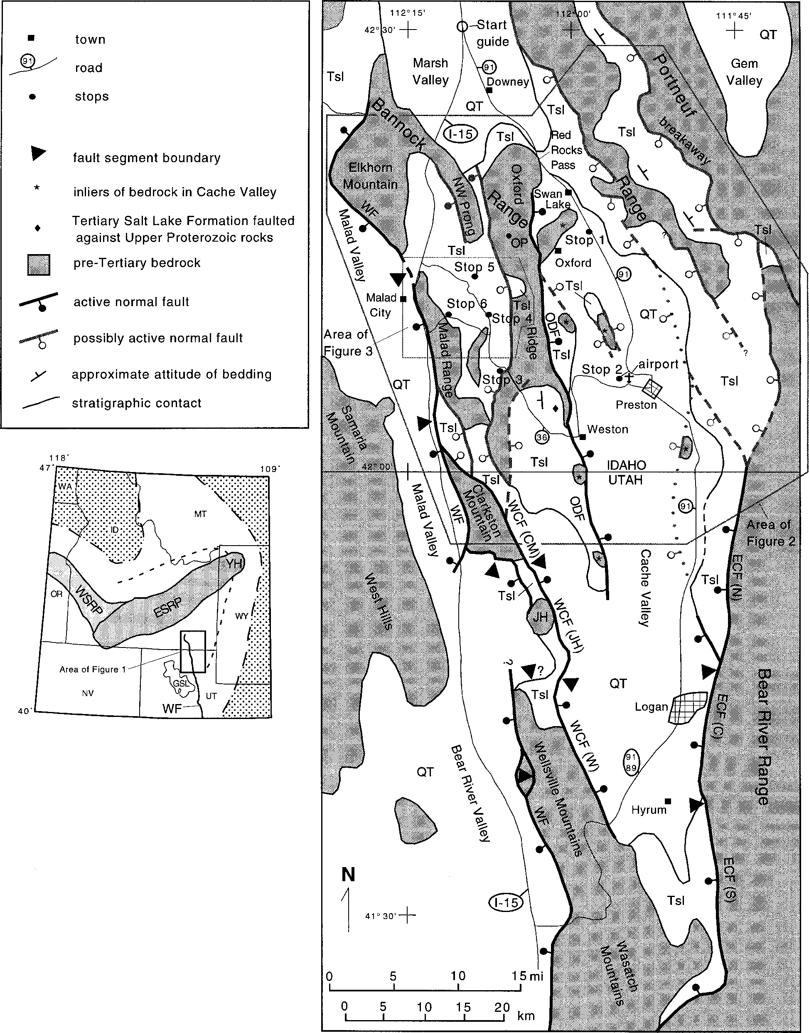

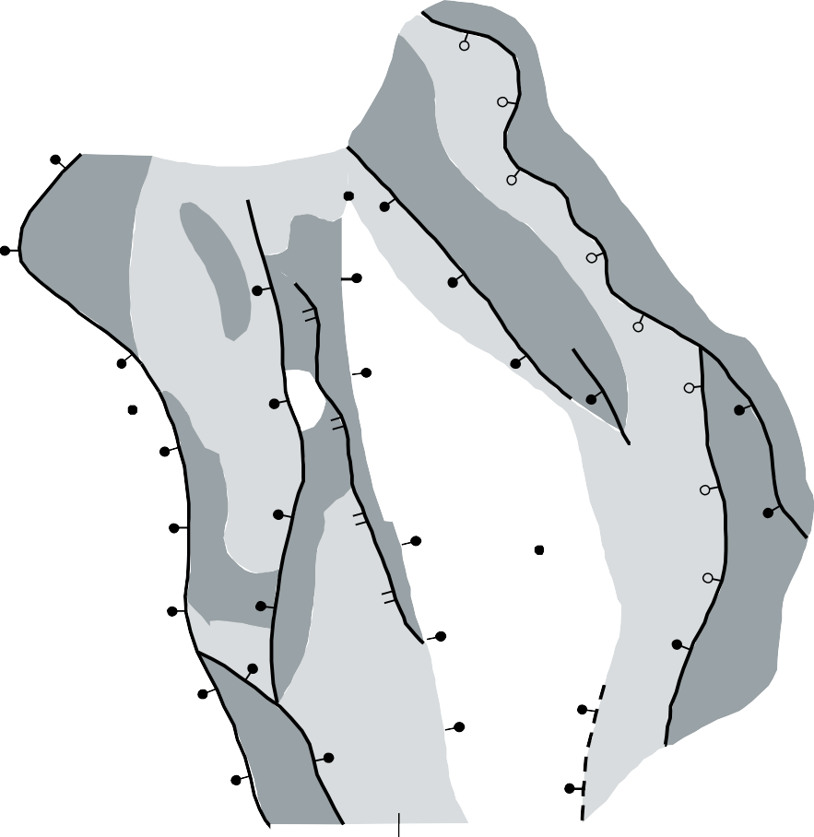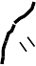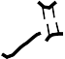112 o 00’ W
MT
Red Rock
Tsl
ID
Pass
NV
UT
A’
Tsl
Q
Tsl
Q
N
Tsl
Malad City
Area of
Figure 3
A
Tsl
Preston
IDAHO
Tsl
42o 00’ N
UTAH
Q
Tsl
0
15
km
CO
WY

A A’
Cottonwood Valley
Swan Lake block
Oxford Ridge

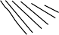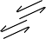2,000 m
Tsl
Tsl
Tsl
Tsl
Bannock detachment
Wasatch fault
Cache Valley
Deep Creek
half-graben
Malad Range

sea level

-2,000

SW
no vertical exaggeration

-4,000
NE
0 5
km

Normal fault showing offset direction

Undifferentiated Quaternary

Q

Normal fault

Tertiary Salt Lake Formation
Tsl

Elkhorn
Mountains
Low-angle normal fault Undifferentiated pre-Tertiary rocks

Listric breakaway for detachment faults





