Brachiopod Paleontology and Paleoecology of the Lower Mississippian Lodgepole Limestone in Southeastern Idaho

Ann M. Christensen1
Geology Department, University of Idaho, Moscow, ID 83844

ABSTRACT
Lodgepole Limestone strata (Lower Mississippian-upper Kinderhookian to lower Osagean) is located throughout south- eastern Idaho. The lower Paine Member of the Lodgepole Lime- stone represents basin deposits in the eastern part of a foreland basin, and the upper Woodhurst Member represents shallower deposition on a ramp directly west of a cratonic platform. A pale- ontological and paleoecological analysis was performed on the brachiopod samples and comparisons were made to other similar age localities. Four localities in southeastern Idaho-Buckskin Hill, Little Flat Canyon, Gardner Canyon, and St. Charles Can- yon were studied. Disarticulation, current stable positions, and size sorting of the fossils suggest quiet marine conditions with occasional storm events. The Paine Member was deposited be- low storm wave-base and the Woodhurst Member above storm and below fairweather wave-base. The fossils suggest deposition in a quiet, oxygenated environment with a soft substrate. The in- creasing number of individual specimens up section indicates the development of more stable conditions on the ramp through time. The Lodgepole Limestone contains thirteen different species of brachiopods from twelve genera. The population is composed of 37% impunctate spiriferids, 25% athyridids, 22% rhynchonellids, 14% punctate spiriferids, and 2% other (punctate orthids, strophomenids, and chonetids). Although there is no major lat- eral change between the four sections, the Buckskin Hill section may represent a paleo-high. Vertical changes in the sections show shallower water deposition and a significant increase in the num- ber of fossils up section. The Lodgepole Limestone's depositional environment and brachiopod content are very similar to the Banff Formation in Alberta, Canada. Only tentative correlations can be done with the midcontinent.

!Present Address: ATC Associates, Inc., 2777 Finley Rd., Unit 4, Downers Grove, IL 60515

INTRODUCTION
Lower Mississippian (345-330 mya) strata of the Lodgepole Limestone (Madison Group) is found throughout southeastern Idaho in north to northwest-trending linear fault block mountains. A paleogeographic view of the western United States during this time would show the Antler highlands on the west, a foreland basin, and the western cratonic platform on the east (Poole and Sandberg, 1977) (Fig. 1). The Lodgepole Limestone in south- eastern Idaho has been divided into the Paine and Woodhurst Members. The lower Paine Member accumulated in the eastern part of the foreland basin. The upper Woodhurst Member con- tains rocks consistent with deposition on a ramp directly west of the cratonic platform. The Lodgepole Limestone was deposited during a transgressive marine event during the Lower Mississip- pian (Craig and Varnes, 1979; Skipp and others, 1979).
Brachiopods are generally the most abundant macrofossil found in the Lodgepole Limestone. Although no comprehensive study of the Lodgepole Limestone brachiopods has been made, brachiopods are well documented from Lower Mississippian rocks of western Canada and the midcontinent of the United States (Carter, 1968, 1972, 1987, 1988). The abundance of brachiopods in the Lodgepole Limestone, and descriptions of Lower Missis- sippian brachiopods from other localities made them a valuable macrofossil to study.

Location of Study Sections
Lodgepole Limestone sections were measured, described, and collected at six different localities in southeastern Idaho: Buck- skin Hill (BH), Little Flat Canyon (LFC), Gardner Canyon (GC), St. Charles Canyon, (STC), North Georgetown Canyon (NGC), and Wells Canyon (WC) (Fig. 2, Table 1).
Exposures of the Lodgepole Limestone vary in profile, cov- erage, and completeness at each locality. At most localities, ex- cept Gardner Canyon, the underlying Paine Member is a slope

Christensen, A.M., 1999, Brachiopod Paleontology and Paleoecology of the Lower Mississippian Lodgepole Limestone in Southeaster n Idaho, in Hughes, S.S., and Thackray, G.D., eds., Guidebook to the Geology of Eastern Idaho: Pocatello, Idaho Museum of Natural History, p. 57-67.

5 ide oo to the eology o astern daho
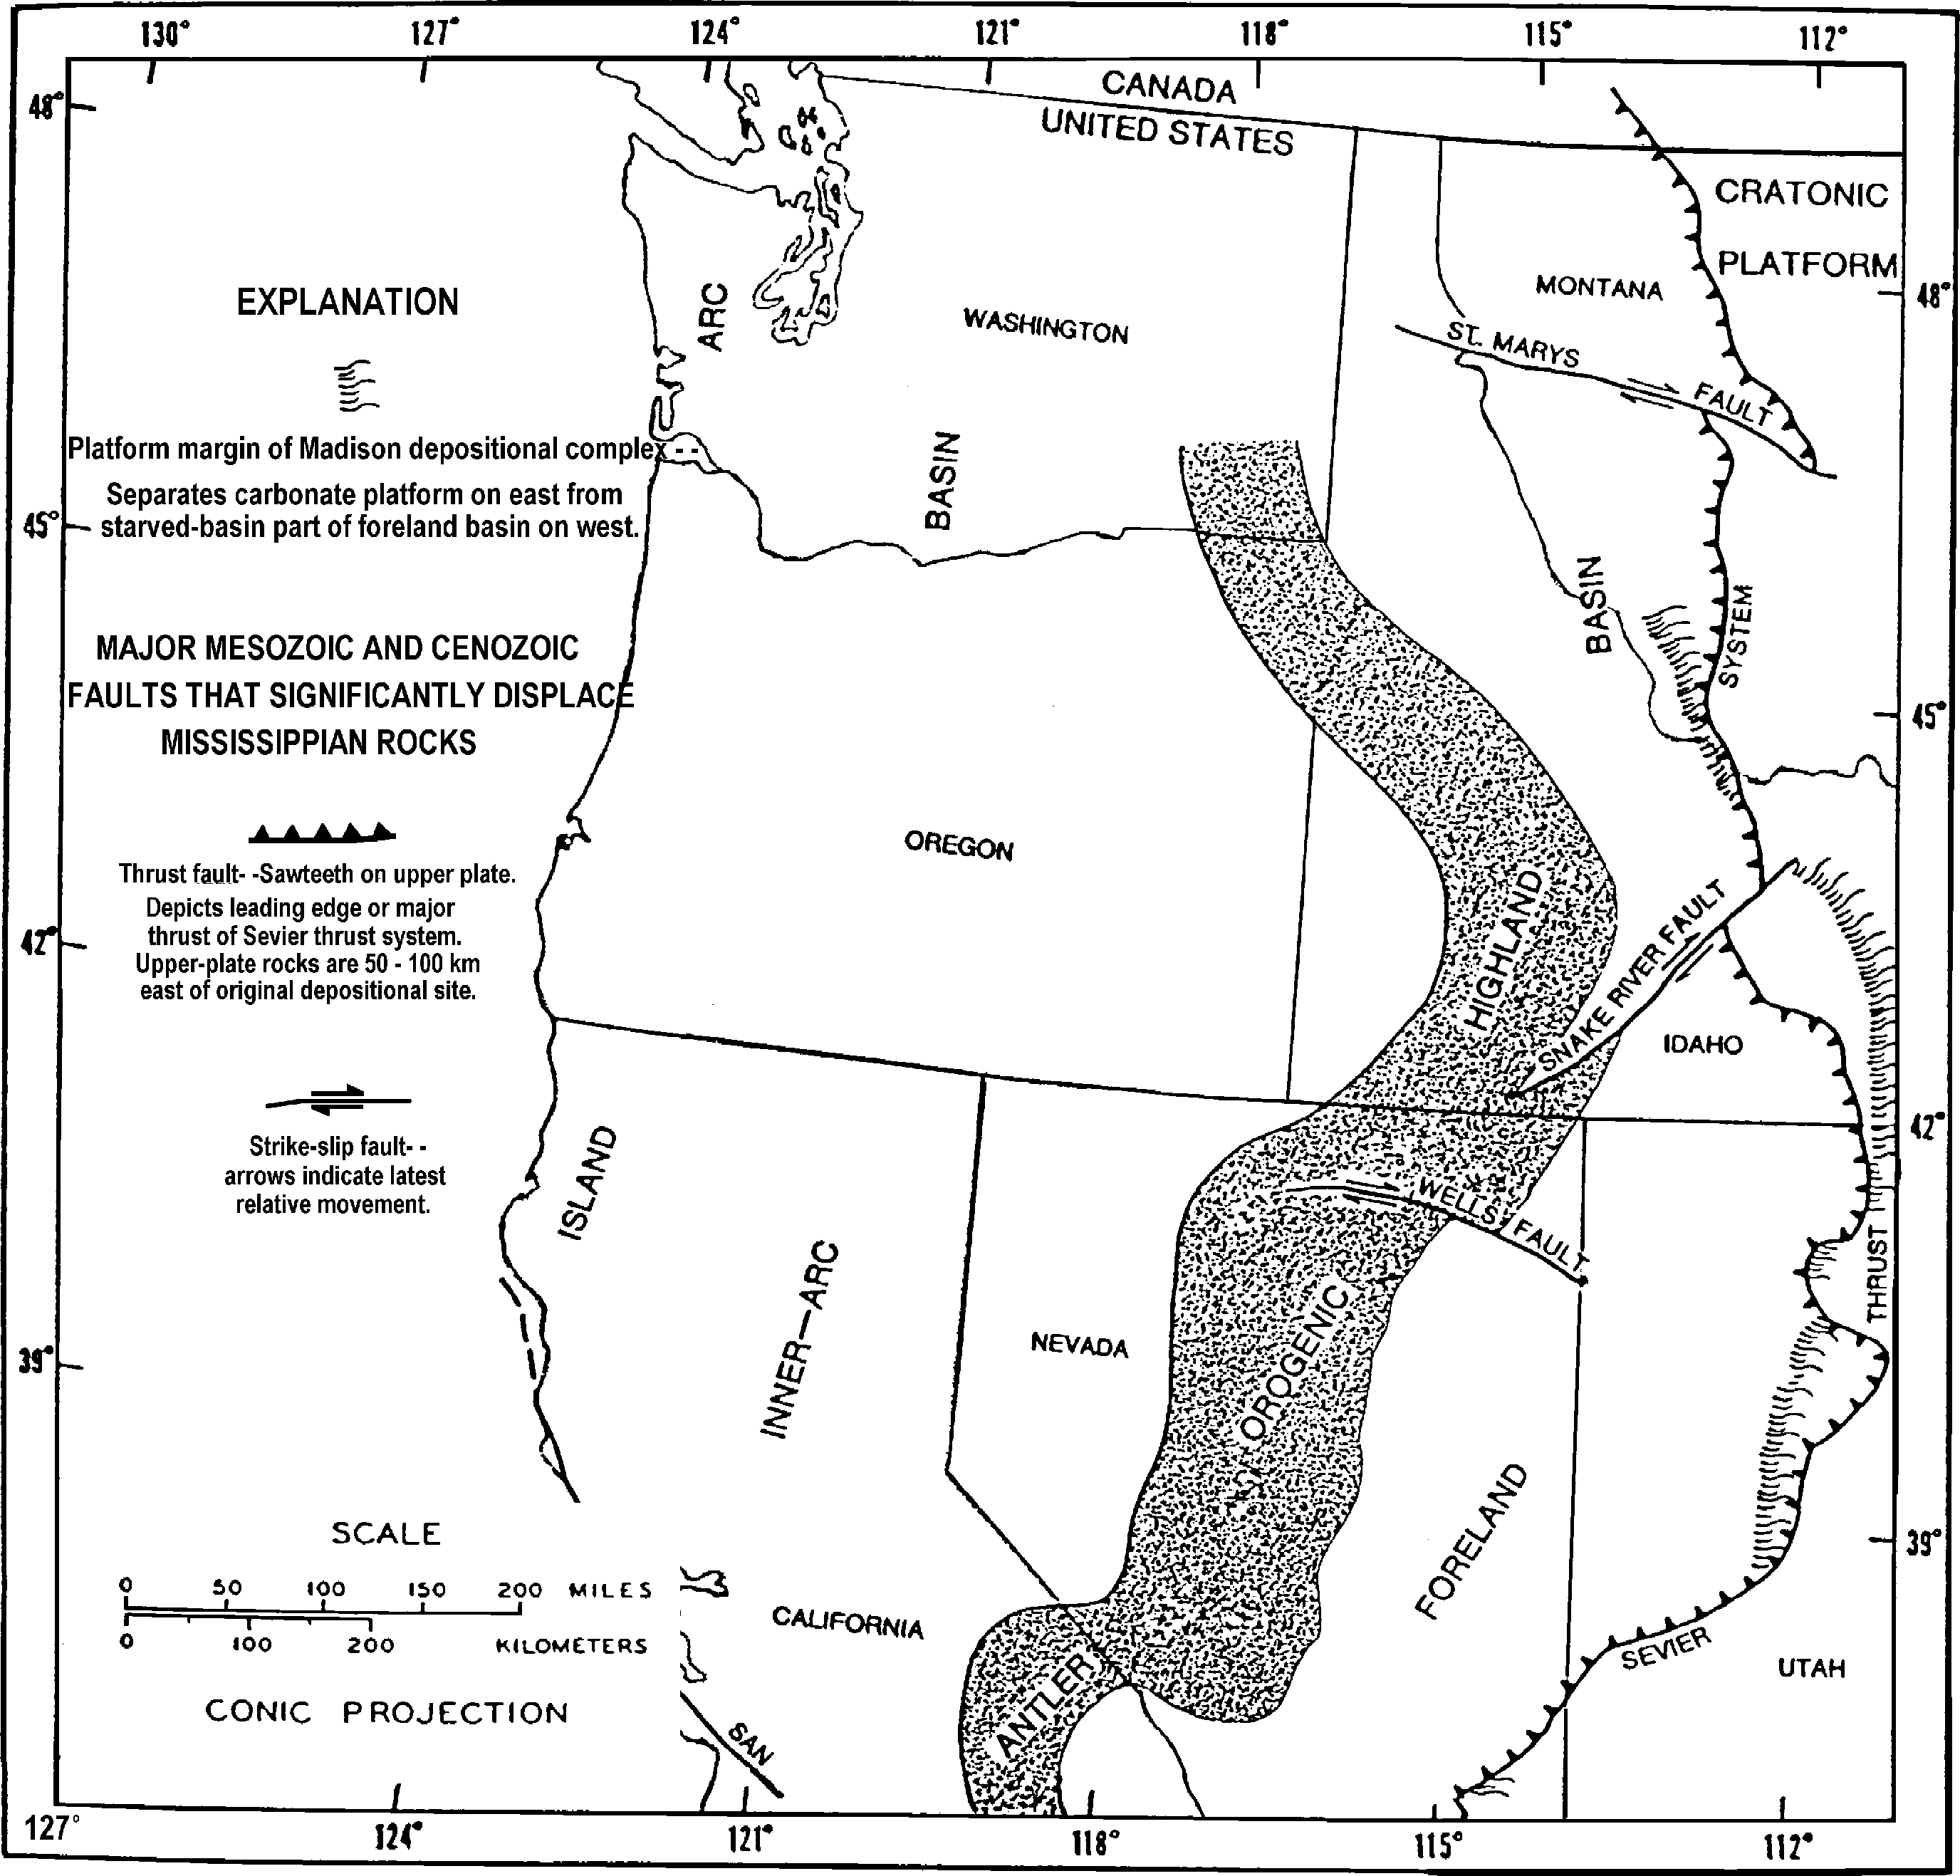
Figure 1. Paleogeographic map of the western United States the Early Mississippian (Poole and Sandberg, 1977).

former and the overlying Woodhurst Member is represented by sub-cliffs. At Gardner Canyon, the Lodgepole Limestone con- sists of a cliff former, a slope former, a sub-cliff unit, and a final sub-cliff unit (Wickwire and others, 1985; Webster and others, 1987a; 1987b).

e ious o
Regional studies of the Early Mississippian in the western United States were conducted by Poole and Sandberg (1977), Rose (1977), Skipp and others (1979), Gutschick and others (1980), Skipp and Hall (1980), and Elrick and Read (1991).
The first description, and the type section, of the Lodgepole Limestone was done in Montana by Collier and Cathcart (1922) (Sando and Dutro, 1979). Additional work was conducted on the formation in Montana by Easton (1962), Cotter (1965), Wilson (1969), Smith (1972, 1977), and Gutschick and others (1976).
Work has expanded into Idaho by Mansfield (1927), Dutro and Sando (1963), Cressman (1964), Beus (1968), Sando and others
(1976), Sando (1977), Sando and Dutro (1979, 1981), Sando and others (1981), Wickwire and others (1985), Webster and others (1987a), and Webster and others (1987b) and into Wyoming by Strickland (1956, 1960). Most previous studies focused on stratig- raphy and biostratigraphy. Work on sedimentology and deposi- tional conditions has also been conducted (Cotter, 1965; Sando, 1967; Wilson, 1969; Smith, 1972,1977; Isaacson and others,
1985).
Systematic paleontological investigations, within the Lodge- pole Limestone, have been conducted (Girty, 1927) on brachio- pods (Mactavish, 1971), foraminifera (Zeller, 1957), corals (Sando and Dutro, 1960; Sando and Bamber, 1985), and conodonts (Sandberg and Gutschick, 1979; Wickwire and others, 1985; Webster and others, 1987b). However, no work has been done on

Table 1. Study section localities in Idaho.
Study Section Mountain Range Map (1° X 2°) Township and Range

Buckskin Hill (Buckskin Mtn) Fish Creek Range Pocatello E 1/2, sec. 22, T.9S., R.29E. Little Flat Canyon Chesterfield Range Preston NW1/4, sec. 20, T.7S., R.40E Gardner Canyon Samaria Mountains Pocatello SW1/4, sec. 12, T.16S., R.35E. St. Charles Canyon Wasatch Range Preston SW1/4, sec. 23, T.15S., R.42E.
North Georgetown Canyon Preuss Range Preston S1/2 NE1/4, sec. 16, T.10S., R.44E. Wells Canyon Preuss Range Preston SW1/4 SW1/4, sec. 11
SE1/4, sec. 10, T.10S., R.45E.

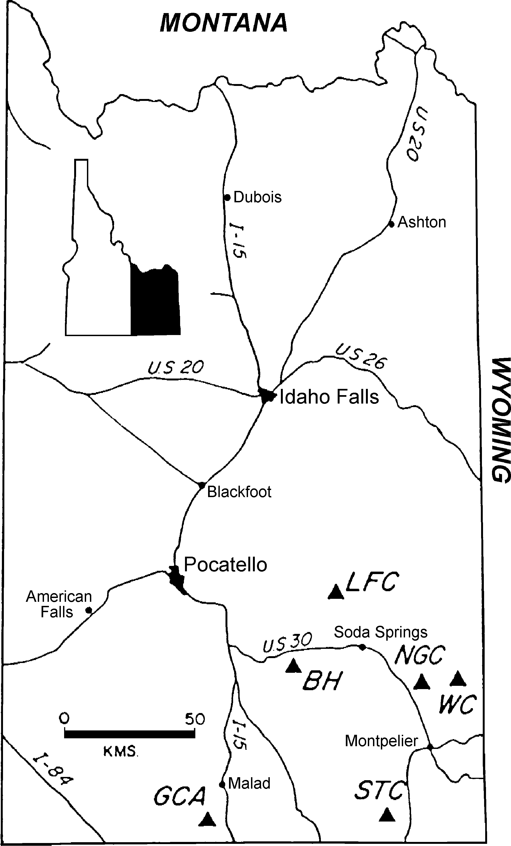

Figure 2. Map of southeastern Idaho showing study section lo- calities. EH- Euckskin Hill, LFC- Little Flat Canyon, GCA- Gardner Canyon, NGC- North Georgetown Canyon, STC- St. Charles Canyon, WC- Wells Canyon (Isaacson and oth- ers, 1985).
the community aspect of the macrofauna assemblage in the Lodge- pole Limestone.

Methods
The six study localities were described, measured, and sampled for macrofossils. Many of the Lodgepole Limestone fossils are silicified, requiring dissolution of the rock matrix in muriatic acid. This process was performed in the Fossil Preparation Lab at the University of Idaho. Lab methods used were consistent with Coo- per and Whittington (1965). Following identification, the samples were stored in the University of Idaho's invertebrate collection. Rocks from Buckskin Hill, Little Flat Canyon, Gardner Can- yon, and St. Charles Canyon localities contained well-silicified fossils. Fossils from North Georgetown Canyon and Wells Can-
yon were not well-silicified and are not to be discussed further.

GEOLOGIC SETTING AND HISTORY
The Mississippian rocks in Idaho were deposited across a former continental shelf and a cratonic platform that had been relatively stable from the Late Precambrian through the Late De- vonian. In the latest Devonian and earliest Mississippian, during the Antler orogeny, Devonian and older rocks of continental slope and ocean basin origins were obducted onto the continental mar- gin. A foreland basin developed to the east of the Antler high- lands. East of the trough, thick orogenic, thin starved-basin, and thick carbonate sediments were deposited at this time (Skipp and others, 1979; Poole and Sandberg, 1991).
The Madison Group, deposited during the Early Mississip- pian, consists of the transgressive Lodgepole Limestone overlain by the regressive Mission Canyon Limestone (Rose, 1977). In general, these deposits thicken westward to the inner cratonic plat- form (Rose, 1977; Skipp and others, 1979). West of the inner cratonic margin, in southeastern Idaho, the Lodgepole Limestone consists mainly of the Paine Member with a thin Woodhurst Mem- ber. The Paine Member is a sparsely fossiliferous, thin-bedded, fine-grained, silty limestone. It represents slope deposits laid down seaward from the shelf carbonate bank (Sando, 1967; Isaacson and others, 1985). The Woodhurst Member contains cyclically interbedded fine-grained and coarse-grained carbonate beds, dem- onstrating the alternation of high and low energy conditions (Sando, 1967; Isaacson and others, 1985). It is believed that the Woodhurst Member was deposited on the ramp in shallower wa- ter than the Paine Member (Sando, 1967; Rose, 1977; Skipp and others, 1979; Isaacson and others, 1985).

LITHOLOGIES AND FOSSIL CONDITIONS
One of the sections for this study, Gardner Canyon, does not have the lithologies, cycles, and topographic expression of the typical Paine and Woodhurst Members of the Lodgepole Lime- stone. This section does correlate with the Lodgepole Limestone as it is upper Kinderhookian to lower Osagean in age based on conodont faunas (Wickwire and others, 1985; Webster and oth- ers, 1987b). The Lodgepole Limestone equivalent has been des- ignated the Henderson Canyon Formation by Webster and others (1987b), but will be referred to as the Lodgepole Limestone in this paper.
Only general lithologies and fossil conditions are provided in this paper. For more detailed lithologies see Christensen (1998). The Lodgepole Limestone in southeastern Idaho disconformably overlies the Devonian Beirdneau Formation and is conformably overlain by the phosphatic member of the Deep Creek Forma- tion. The Paine Member, forming the lower part of the Lodge- pole Limestone is a slope former represented by dark grey, fine crystalline, massive mudstone that forms sub-cliffs. The unit con- tains chert in stringers and nodules, but no macrofossils. The over- lying Woodhurst Member is a sub-cliff former of medium grey, medium crystalline wackestone to packstone. It is bedded, typi- cally contains chert nodules and stringers, and occasionally con- tains intraclasts. The Woodhurst Member is a fossiliferous unit containing crinoid fragments, brachiopods, solitary and colonial corals, gastropods, bryozoans, and bivalves. Fossil abundance in- creases up section.

Plate 1 -- Explanation.
The depositional setting of the Lodgepole Limestone suggests accumulation in a basin, or most likely, on the lower portion of the foreslope of a cratonic shelf or a ramp for the Paine Member (Smith, 1972; Rose, 1977; Gutschick and others, 1980; Isaacson and others, 1985). The depositional setting of the Woodhurst Member is a more shallow and higher energy setting than the Paine Member, such as the lower portion of a ramp (Smith, 1972; Gutschick and others, 1980).
Elrick and Read's (1991) ramp depositional model for the Lodgepole Limestone fits well with the described strata in south- eastern Idaho. The dark limestone of the Paine Member and the lack of wave or current features indicates deposition below storm wave-base. The cherty skeletal wackestones and packstones of the Woodhurst Member indicate deposits farther up on the ramp below normal wave-base but above storm wave-base (Elrick and Read, 1991).
The condition of the macrofossils in the Woodhurst Member of the Lodgepole Limestone provides a more detailed deposi- tional setting of the rocks. Most of the brachiopods are disarticu- lated. Some are in current stable positions with the convex por- tion of a single valve towards the top. They appear to be some- what size sorted, with adults outnumbering juveniles in all locali- ties. Some are slightly abraded, but mostly intact. Degree of dis- articulation, current stable positions, size sorting, and small amounts of abrasion of the brachiopods are consistent with nor- mal marine deposits (Dodd and Stanton, 1990). The fossils may have been transported a short distance and deposited during a period of higher energy conditions. Intraclasts and layers of fos- siliferous packstone found in the measured sections may indicate

Figures 1-4. Schizophoria cf. S. poststriat la (Weller)
1. Ventral valve exterior, x1.5. 2. Ventral valve interior, x1.6. 3. Ventral valve exterior, x1.6.
- Ventral valve interior, x1.6.
Figures 5-8. Rhipidomella misso riensis (Swallow)
- Dorsal valve exterior, x1.7. 6. Dorsal valve interior, x1.7. 7. Ventral valve exterior, x1.7.
- Ventral valve interior, x1.7.
Figure 9. Leptagonia misso riensis Carter
- Ventral valve exterior, x1.5.
Figures 10-11. S glo osochonetes norq ayensis (Carter)
- Ventral valve exterior, x1.6. 11. Ventral valve interior, x1.6.
Figures 12-15. R gosochonetes c . R. loganensis (Hall & Whitfield)
12. Ventral valve exterior, x1.7. 13. Dorsal valve exterior, x1.7. 14. Ventral valve exterior, x1.7.
15. Ventral valve interior, x1.7.
Figures 16-24. Macropotamorhync s insolit s (Carter)
16. Ventral valve exterior, x1.6. | 17. Ventral valve interior, x1.6. | 18. Ventral valve exterior, x1.5.
19. Ventral valve interior, x1.8. | 20. Ventral valve exterior, x1.4. | 21. Ventral valve interior, x1.4.
22. Ventral valve interior, x1.7. | 23. Ventral valve exterior, x1.5. | 24. Ventral valve interior, x1.5.
Figures 25-33. Cleiothyridina miettens  25. Ventral valve exterior, x1.7. | is (Carter)  26. Ventral valve interior, x1.7. | 27. Dorsal valve exterior, x1.7.
28. Dorsal valve interior, x1.7. | 29. Ventral valve exterior, x1.5. | 30. Dorsal valve exterior, x1.5.
31. Ventral valve exterior, x1.7. | 32. Dorsal valve exterior, x1.7. | 33. Lateral view, x1.7.
Figures 34-43. Composita h m lis (Girty)
34. Ventral valve exterior, x1.5. | 35. Ventral valve interior, x1.5. | 36. Ventral valve exterior, x1.5.
37. Ventral valve interior, x1.5. | 38. Ventral valve exterior, x1.5. | 39. Dorsal valve exterior, x1.5.
40. Ventral valve interior, x1.5. | 41. Dorsal valve exterior, x1.5.
42. Ventral valve exterior, x1.5.
43. Dorsal valve interior, x1.5.

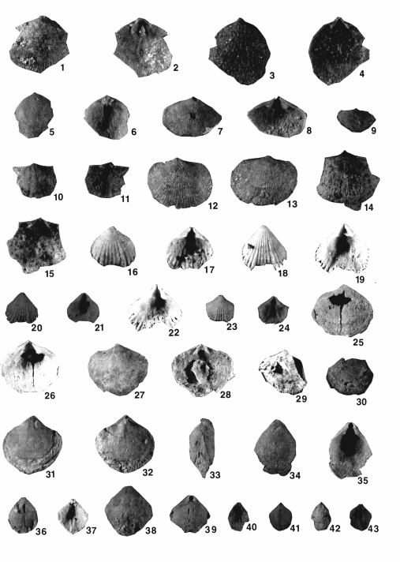

PLATE 1

deposition during occasional storm events (tempestites).
The number of individual macrofossils increases upwards in all of the measured sections. The changing lithologies, from deeper water to more shallow water deposits, with the larger number of fossils in the upper part of the section, provide evidence for a shallowing upward sequence in the Lodgepole Limestone. Shallowing upwards would most likely be occurring with growth of the carbonate platform (ramp) since the Early Mississippian is a time of marine transgression.

PALEONTOLOGY
Solitary and colonial corals, gastropods, crinoids, bryozoans, and bivalves are all found in the Lodgepole Limestone, however this study focuses on the brachiopod assemblage. Detailed sys- tematic paleontology descriptions of the brachiopods are provided in Christensen (1998).
The brachiopod assemblage in the Lodgepole Limestone in southeastern Idaho consists of thirteen species distributed in twelve genera (Plates 1 and 2). Impunctate spiriferids comprise thirty- seven percent of the total number of brachiopods sampled. These are represented by Prospira, Unispiri er, and omartiniopsis. Athyridids compose twenty-five percent of the total brachiopod sample, with only Cleiothyridina and Composita represented. Rhynchonellids, represented by Macropotamorhync s, comprise twenty-two percent of the total brachiopod assemblage. Punctate spiriferids, represented by P nctospiri er, compose fourteen per- cent of the total brachiopod sample. The remaining two percent of the brachiopods are represented by the punctate orthids Rhipidomella and Schizophoria; the strophomenid Leptagonia; and the chonetids S glo osochonetes and R gosochonetes. No inarticulates, orthotetids, productids, retziids, or terebratulids were found in the study section. Figure 3 shows the distribution of the
brachiopod species at the sample localities.
The most abundant brachiopods at all four localities are Prospira cf. P. al apinensis (34% of the total sample) and Cleiothyridina miettensis (22% of the total sample). Macropotamorhync s insolit s is the most abundant at St. Charles Canyon, where it occurs in larger numbers than at the other sec- tions.
Fossil preservation varies at each locality and between differ- ent fossil organisms. In general, St. Charles Canyon and Gardner Canyon have better silicification of the fossils than Buckskin Hill and Little Flat Canyon. Bryozoans and bivalves seen in the mea- sured sections are not well silicified. Due to the poor silicifica- tion of some specimens, they are not represented in the fossil residues following the acid bath. Most of the major details of the brachiopods are preserved. However, some of the finer ornament on the exterior of the valves is not preserved, and most of the internal details are not seen. The lack of preservation of orna- ment makes it hard to distinguish between the genera Composita and Cleiothyridina.
In general, the number of individuals and the diversity of fos- sils increases towards the top of each Lodgepole Limestone sec- tion. Some abrasion is seen in the samples, with size sorting and current stable positions most noted in the brachiopods. Crinoids are preserved mostly as disarticulated stem pieces. Colonial cor- als are only found preserved in growth position at Little Flat Can- yon and Gardner Canyon. All of the sample localities have con- centrations of fossils in layers within a fossiliferous matrix.

Depositional Setting/En i onmental Conditions
Environmental conditions of different fossil groups, from Boardman and others (1987) and Clarkson (1992), provide envi- ronmental conditions and a depositional setting for the Lower

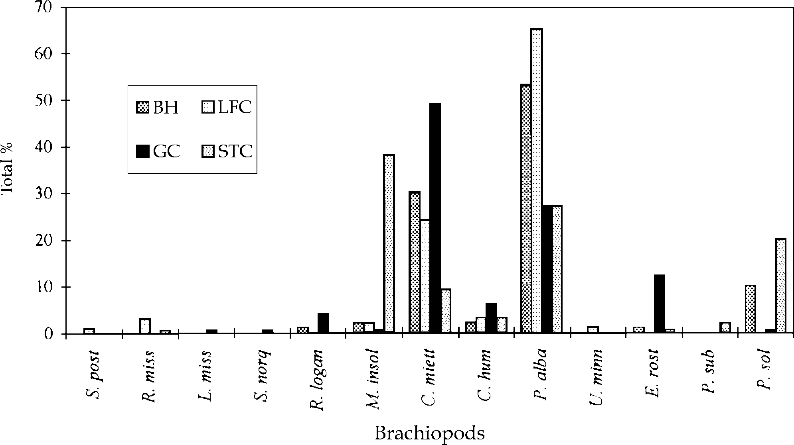

Figure 3. Percent of individual brachiopod species from each locality plotted against each other.

Mississippian Lodgepole Limestone. The fossil condition of all macrofossils found within the Lodgepole Limestone was consid- ered when determining the depositional setting during the Early Mississippian.
Corals, brachiopods, crinoids, and some gastropods found in the Lodgepole Limestone would suggest a soft sediment substrate in quiet waters during the Lower Mississippian. Evidence of bioturbation indicates oxygenated waters. A complete crinoid, including the calyx, found at Buckskin Hill suggests rapid burial with soft sediment, possibly during storm events. The disarticu- lation of the brachiopods leaving mostly pedicle valves, the large amount of disarticulated crinoids, the good preservation of the fossils, and the concentrated fossil layers suggests some of the samples were preserved during storm events with rapid burial. However, most were deposited under normal, quiet conditions with possibly a short distance of transportation. Evidence for trans- portation includes the size sorting of the brachiopods with low numbers of juveniles and the disarticulation of the crinoid stems. However, the small number of juveniles may be more a function of the community than a reflection of transportation. A soft sub- strate in a quiet environment, with occasional storm events, would correlate with the lower ramp depositional setting based on the rock and fossil condition evidence discussed earlier.
The large number of gastropods at Buckskin Hill suggests a shallower environment than the others localities, possibly a paleo- high. The area was not much higher relative to the surrounding sections since the fossil assemblages are very similar; and Little Flat Canyon, located approximately 25 km to the northeast, does not have a large number of gastropods.

PALEOECOLOGY
Paleoecology is the study of the interactions of organisms with one another and with their environment in the geologic past. Al- though the fossil record typically preserves only a small part of the original biota, the organisms can be studied over a large time interval allowing the study of long-term environmental and evo- lutionary changes (Odum, 1971; Dodd and Stanton, 1990).
added at a constant arithmetic rate but species accumulate at a decreasing logarithmic rate. The rarefaction method is dependent on the shape of the species abundance curve rather than the abso- lute number of specimens per sample (Sanders, 1968).
The rarefaction curves for the four measured localities of the Lodgepole Limestone in southeastern Idaho are shown in Figure
4. The similarity of the rate of species increment for the rarefac- tion curves for all four measured localities suggest similar envi- ronments. The settings must have been comparable to allow equal rate of species addition (Sanders, 1968).
The first community structure index measured for the bra- chiopods of the Lodgepole Limestone was richness. Richness is the number of species or taxa and their proportions and is strongly dependent on the sample size. Margalef's diversity index (D) mini- mizes sample size biases and was used for this study:

DMG = (S-1)/ln N
where S= number of taxa, and N= number of individuals. The relationship between sample size and richness is determined by two factors. First, the common species will be present in small samples and as the sample size increases, the rarer species will be recorded. It requires an ever larger increase in sample size to add new species to the list. Second, the larger sample size means that a larger volume or area of the original environment is included in the sample. Heterogeneities in environment and biota are more likely to be incorporated into the sample (Odum, 1971; Dodd and Stanton, 1990).
Richness values range from 1.09 to 1.55 for the brachiopod communities of the Lodgepole Limestone. St. Charles Canyon had the lowest value of 1.09 and Buckskin Hill had the highest value of 1.55.
Dominance is measured with entropy and is the probability that two individuals drawn randomly from a sample are the same species. The Shannon index (H) is used in this study to measure dominance:

H = -Ι: P ln P

In this discussion the term community will be defined as the 1 1
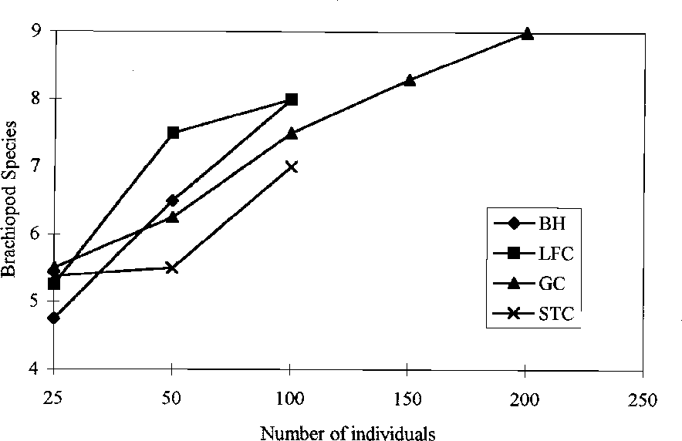
fossil assemblage, not the biocoenosis (Dodd and Stanton, 1990). A community's attributes can be divided into its taxonomic com- position and its community structure. The taxonomic composi- tion includes the presence or absence of taxa and the relative abun- dance of taxa. Diversity, dominance, and trophic relationships compose the community structure. Community structure analy- ses are useful in that they avoid the problem of decreasing taxo- nomic similarity with increasing geologic age. It is independent of taxonomic composition and age (Dodd and Stanton, 1990). The taxonomic composition of the brachiopod community was discussed earlier, so the paleoecology analysis will focus mainly on the community structure.
The size of the sample and the taxonomic level used can alter the calculated values for many of the community structure indi- ces. This study used the species level values for all the calcula-

tions, as they are believed to be the most accurate measure of the community. The rarefaction method was used to further hinder any sample size biases. The typical problem in comparing samples of different sizes is that as sample size increases, individuals are
Figure 4. Rarefaction curves for the Lodgepole Limestone localities in southeastern Idaho. EH- Euckskin Hill, LFC- Little Flat Canyon, GC- Gardner Canyon, STC- St. Charles Canyon. Rarefaction curves were based on work by Sanders (1968).

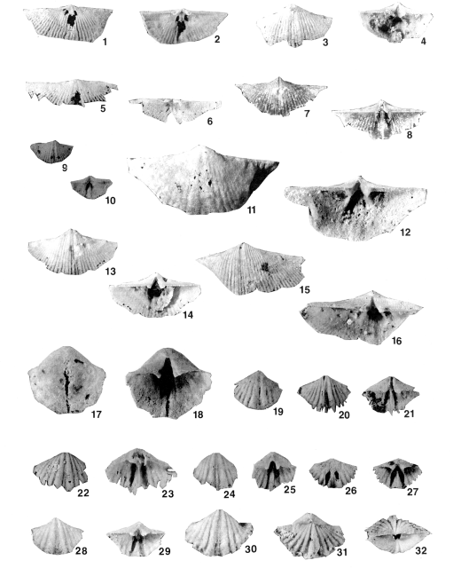

PLATE 2

Plate 2 -- Explanation
Figures 1-14. Prospira cf. P. al apinensis (Hall & Whitfield)
1. | Dorsal valve exterior, x1.8. | 2. | Dorsal valve interior, x1.8. | 3. | Ventral valve exterior, x1.7.
4. | Ventral valve interior, x1.7. | 5. | Dorsal valve exterior, x1.7. | 6. | Dorsal valve interior, x1.7.
7. | Ventral valve exterior, x1.6. | 8. | Ventral valve interior, x1.6. | 9. | Ventral valve exterior, x1.6.
10. | Ventral valve interior, x1.6. | 11. | Ventral valve exterior, x1.5. | 12. | Ventral valve interior, x1.5.
13. | Ventral valve exterior, x1.6. | 14. | Ventral valve interior, x1.6.
Figures 15-16. Unispiri er minnewan ensis (Shimer)
15. Ventral valve exterior, x1.6. 16. Ventral valve interior, x1.6.
Figures 17-18. omartiniopsis rostrata (Girty)
17. Ventral valve exterior, x1.7. 18. Ventral valve interior, x1.7.
Figures 19-21. P nctospiri er cf. P. s texta (White)
19. Ventral valve exterior, x1.4. 20. Ventral valve exterior, x1.4. 21. Ventral valve interior, x1.4.
Figures 22-32. P nctospiri er solidirostris (White)
22. Ventral valve exterior, x1.4. | 23. Ventral valve interior, x1.8. | 24. Ventral valve exterior, x1.5.
25. Ventral valve interior, x1.5. | 26. Ventral valve exterior, x1.5. | 27. Ventral valve interior, x1.5.
28. Ventral valve exterior, x1.5.  31. Dorsal valve exterior, x1.8. | 29. Ventral valve interior, x1.5.  32. Lateral, x1.8. | 30. Ventral valve exterior, x1.8.

where P is the proportion of the ith species in a sample = n /N, zero. The index of dissimilarity can be measured as 1-S (Odum,
1 1

n1= number of individuals in a species, and N= total number of individuals. If all the species are represented by equal numbers of individuals, the Shannon index will equal two. If there is only
one type of species in the community, the Shannon index will equal zero. Therefore, the closer the measured value is to zero, the more dominant a particular species is. The closer the value is to two, the more equal the numbers of individuals of the different species (Dodd and Stanton, 1990).
Dominance values for the brachiopods of the Lodgepole Lime- stone range from 1.01 to 1.47. The following localities are listed in order of the most equally dominant to the most unequally domi- nant: St. Charles Canyon, Gardner Canyon, Buckskin Hill, and Little Flat Canyon. In general, all the localities had several domi- nant species. Prospira al apinensis and Cleiothyridina miettensis are dominant species at all localities. Macropotamorhync s insolit s is the most dominant at St. Charles Canyon.
Similarity (S) is the measure of the sameness of two different samples. Although similarity is considered more of a measure of taxonomic composition, rather than community structure, it is in- cluded in this section:

S = 2C/A+B

where A= number of species in A, B= number of species in B, and C= number of species in both A and B. If the two samples are the same, in that they share all of the same species the index will be one, if they are dissimilar with no shared species the value is

Table 2. Similarity values for brachiopod species.
1971; Dodd and Stanton, 1990).
The similarity values of the brachiopod species in the Lodge- pole Limestone range from 0.88 to 0.59. Buckskin Hill seems to be the most similar to all the other localities. The similarity val- ues are shown in Table 2.
The trophic structure of the benthic community of the Lodge- pole Limestone was also studied. The results of the trophic struc- ture are based on work by Turpaeva (1957) which is summarized in Walker (1972). Following Turpaeva's (1957) work the high- level suspension feeders in the Lodgepole Limestone include: solitary and colonial corals, crinoids, and bryozoans. Brachio- pods and bivalves are the low-level suspension feeders. Some of the gastropods may have been infaunal deposit feeders and the epifaunal deposit feeders are only represented by gastropods. This distribution would suggest a stable community with little compe- tition for food resources (Turpaeva, 1957).

aleoecology Conclusions
In terms of lateral and vertical changes all four study locali- ties of the Lodgepole Limestone seem to be similar. The domi- nant species of brachiopods in the uppermost portion of the Woodhurst Member are similar throughout the study area with no distinct difference in any one locality. The only notable change is that Macropotamorhync s insolit s, the most dominant brachio- pod at St. Charles Canyon, is seen in smaller numbers at the other localities. This may be due to deeper water, or more likely a short- term community structure variation. At all localities the number

 | Buckskin Hill | Little Flat Canyon | Gardner Canyon | St. Charles Canyon
Buckskin Hill | 1 | 0.75 | 0.82 | 0.88
Little Flat Canyon | 0.75 | 1 | 0.59 | 0.75
Gardner Canyon | 0.82 | 0.59 | 1 | 0.71
St. Charles Canyon | 0.88 | 0.75 | 0.71 | 1

of individuals, both brachiopods and other macrofossils, increases up through the Woodhurst Member, with the diversity staying the same throughout the member. The community structure indices also suggest no major difference in the four localities. The pre- ceding evidence would suggest a similar depositional environ- ment for the brachiopods at the four localities.
All four Lodgepole Limestone localities exhibit the same groups of organisms in the trophic structure levels. This would suggest that each site was fairly stable in its diversity of different organisms with little to no competition amongst trophic groups (Turpaeva, 1957).
The Lodgepole Limestone in southeastern Idaho was also compared to other Early Mississippian units in the United States and Canada. The brachiopod assemblage in the southeastern Idaho Lodgepole Limestone is very similar to the assemblage seen in the Banff Formation in Alberta, Canada (Carter, 1988). The only significant difference in the brachiopod population is a lack of productids in southeastern Idaho. This may reflect different sub- strates (Carter, 1988; Christensen, 1998). Only tentative correla- tions can be done with rocks in the midcontinent (Carter, 1987).

CONCLUSIONS
The lithologies described from the Lodgepole Limestone in southeastern Idaho provide evidence for possible depositional settings. The dark color, mud dominated, fine crystalline texture, and few if any fossils in the Paine Member is consistent with accumulation on the lower portion of a ramp or a basin (Elrick and Read, 1991). The light color, medium texture, abundant fos- sils, and intraclasts of the Woodhurst Member would be depos- ited farther up on the ramp in a more shallow water setting (Elrick and Read, 1991). The disarticulation, current stable positions, and size sorting of the fossils suggests normal, quiet marine con- ditions with occasional storm events (Dodd and Stanton, 1990). The distribution of mudstone, wackestone, and packstone in the two Lodgepole Limestone Members would indicate below storm wave-base deposition for the Paine Member and above storm wave-base and below fairweather wave-base for the Woodhurst Member (Elrick and Read, 1991; Tucker and Wright, 1992).
Brachiopods and solitary corals are the most abundant mac- rofossils found in the Woodhurst Member of the Lodgepole Lime- stone. All of the fossils increase in number towards the top of the section, with the diversity remaining the same throughout. The fossils and bioturbation suggest deposition in a quiet environ- ment with a soft substrate and well oxygenated waters (Dodd and Stanton, 1990). The large number of gastropods present at Buck- skin Hill may be due to a paleo-high at this locality. The increas- ing number of individual specimens up section may represent the development of more stable conditions on the ramp through time. The Lodgepole Limestone contains twelve genera and thir- teen species of brachiopods. Impunctate spiriferids comprise 37% of the total population, athyridids compose 25%, rhynchonellids make up 22%, punctate spiriferids are 14%, and the combination of punctate orthids, strophomenids, and chonetids compose 2% of the total population. Systematic paleontology descriptions were
performed on the brachiopod assemblage (Christensen, 1998). Community structure indices indicate Prospira cf. P.
al apinensis and Cleiothyridina miettensis were the dominant
species at all localities. Macropotamorhync s insolit s was also dominant at St. Charles Canyon. The Buckskin Hill locality was the most similar to all of the other measured sections.
The paleoecology study also led to some ideas on the trophic structure of the complete macrofossil assemblage (Turpaeva, 1957). Brachiopods were most likely the dominant low-level sus- pension feeders and the crinoids and solitary corals were the domi- nant high-level suspension feeders.
Lateral and vertical changes were studied throughout the four sections. There are no major lateral changes between the four sections. All sections were similar in their lithology and paleon- tology. Vertical changes in the sections show shallower water deposition up-section, with a significant increase in the number of fossils. This probably indicates stable depositional conditions on the lower part of the ramp.

ACKNOWLEDGMENTS
I would like to thank Drs. Peter Isaacson, Gary Gianniny, and Gus Winterfeld for reviewing this manuscript, Dr. John Carter at the Carnegie Museum for his assistance with the brachiopod iden- tifications and descriptions, and the National Geographic Soci- ety for their financial support of this project.

REFERENCES
Beus, S.S., 1968, Paleozoic stratigraphy of Samaria Mountain, Idaho-Utah: American Association of Petroleum Geologists Bulletin, v. 52, p. 782-808. Boardman, R.S., Cheetham, A.H., and Rowell, A.J., 1987, Fossil invertebrates:
Blackwell Science, Cambridge, Mass., 713 p.
Carter, J.L., 1968, New genera and species of Early Mississippian brachiopods from the Burlington Limestone: Journal of Paleontology, v. 42, p. 1140- 1152.
Carter, J.L., 1972, Early Mississippian brachiopods from the Gilmore City Lime- stone of Iowa: Journal of Paleontology, v. 46, p. 473-491.
Carter, J.L., 1987, Lower Carboniferous brachiopods from the Banff Formation of Western Alberta: Geological Society of Canada- Bulletin 378, 183 p.
Carter, J.L., 1988, Early Mississippian brachiopods from the Glen Price Forma- tion of Illinois and Missouri: Bulletin of Carnegie Museum of Natural His- tory, Number 27, 82 p.
Clarkson, E.N.K., 1992, Invertebrate palaeontology and evolution: Chapman and Hall, New York, 434 p.
Christensen, A.M., 1998, Brachiopod paleontology and paleoecology of the Lower Mississippian Lodgepole Limestone in southeastern Idaho: University of Idaho, M.S. Thesis, 128p.
Collier, A.J. and Cathcart, S.H., 1922, Possibility of finding oil in laccolithic domes south of the Little Rocky Mountains, Montana: United States Geo- logical Survey Bulletin 736-F, p. 171-178.
Cooper, G.A. and Whittington, H.B., 1965, Use of acids in preparation of fos- sils, in Kummel, B. and Raup, D., editors, Handbook of Paleontological Techniques: W.H. Freeman and Company, San Francisco, p. 294-300.
Cotter, E., 1965, Waulsortian-type carbonate banks in the Mississippian Lodge- pole Formation of Central Montana: Journal of Geology, v. 73, p. 881-888. Craig, L.C. and Varnes, K.L., 1979, History of the Mississippian System- an interpretive summary: Geological Survey Professional Paper 1010-R, p. 371-
406.
Cressman, E.R., 1964, Geology of the Georgetown Canyon-Snowdrift Moun- tain area, Southeastern Idaho: Geological Survey Bulletin 1153, p. 1-105.
Dodd, J.R. and Stanton, Jr., R.J., 1990, Paleoecology: Concepts and applica- tions: John Wiley and Sons, New York, 497 p.
Dutro, Jr., J.T. and Sando, W.J., 1963, New Mississippian formations and faunal zones in Chesterfield Range, Portneuf quadrangle, southeastern Idaho: American Association of Petroleum Geologists, v. 47, p. 1963-1986.
Easton, W.H., 1962, Carboniferous formations and faunas of central Montana: United States Geological Survey Professional Paper 348, 126 p.

Elrick, M. and Read, J.F., 1991, Cyclic ramp-to-basin carbonate deposits, Lower Mississippian, Wyoming and Montana: A combined field and computer modeling study: Journal of Sedimentary Petrology, v. 61, p. 1194-1224.
Girty, G.H., 1927, Descriptions of new species of Carboniferous and Triassic fossils, in Mansfield, G.R., editor, Geography, geology, and mineral resources of part of southeastern Idaho: United States Geological Survey Professional Paper 152, p. 411-446.
Gutschick, R.C., McLane, M.J., and Rodriguez, J., 1976, Summary of Late De- vonian-Early Mississippian biostratigraphic framework in western Montana: Tobacco Root Geological Society Guidebook, 1976 Field Conference, Mon- tana Bureau of Mines and Geology Special Publication 73, p. 91-124.
Gutschick, R.C., Sandberg, C.A., and Sando, W.J., 1980, Mississippian shelf margin and carbonate platform from Montana to Nevada, in Fouch, T.D. and Magathan, E.R., editors, Paleozoic paleogeography of the West-Central U.S.: Rocky Mountain Paleogeography Symposium 1, Society of Economic Paleontology and Mineralogy, p. 111-128.
Isaacson, P.E., Measures, E.A., and Siegmann, S.A., 1985, Depositional paleoenvironments and paleogeography of the Mississippian Lodgepole and Monroe Canyon Formations (and equivalents), Southeastern Idaho, in Kerns,
G.J. and Kerns, R.L., editors, Orogenic patterns and stratigraphy of North- central Utah and Southeastern Idaho: Utah Geological Association Publica- tion 14, p. 15-27.
Mactavish, J.N., 1971, Faunal elements of part of the Lodgepole Formation, Madison Group (Mississippian), from Darby Canyon, Grand Teton Moun- tains, Wyoming: Case Western Reserve University, Ph.D. Thesis, 235 p.
Mansfield, G.R., 1927, Geography, geology, and mineral resources of part of Southeastern Idaho, U.S. Geological Survey Professional Paper 152, 453p. Odum, E.P., 1971, Fundamentals of Ecology: W.B. Saunders Company, Phila-
delphia, 574 p.
Poole, F.G. and Sandberg, C.A., 1977, Mississippian paleogeography and tec- tonics of the western United States, in Stewart, J.H., Stevens, C.H., and Fritsche, A.E., editors, Paleozoic paleogeography of the Western U.S.: Pa- cific Coast Paleogeography Symposium 1, Society of Economic Paleontol- ogy and Mineralogy, p. 67-85.
Poole, F.G. and Sandberg, C.A., 1991, Mississippian paleogeography and con- odont biostratigraphy of the western United States, in Cooper, J.D. and Stevens, C.H., editors, Paleozoic Paleogeography of the Western United States- II: Pacific Section Society of Economic Paleontology and Mineral- ogy, v. 67, p. 107-136.
Rose, P.R., 1977, Mississippian carbonate shelf margins, Western United State: Wyoming Geological Association Guidebook, Twenty-Ninth Annual Field Conference, p. 155-172.
Sandberg, C.A. and Gutschick, R.C., 1979, Devonian and Lower Mississippian conodont zonation of the Great Basin and Rocky Mountains, in Sandberg,
C.A. and Clark, D.L., editors, Conodont Biostratigraphy of the Great Basin and Rocky Mountains: Brigham Young University Geology Studies, v. 26, p. 87-106.
Sanders, H.L., 1968, Marine benthic diversity: A comparative study: The Ameri- can Naturalist, v. 102, p. 243-282.
Sando, W.J., 1967, Mississippian depositional provinces in the Northern Cordil- leran Region: United States Geological Survey Professional Paper 575-D, p. D29-D38.
Sando, W.J., 1977, Stratigraphy of the Madison Group (Mississippian) in the Northern part of the Wyoming-Idaho overthrust belt and adjacent areas: Wyoming Geological Association Guidebook Twenty-Ninth Annual Field Conference, p. 173-177.
Sando, W.J. and Bamber, E.W., 1985, Coral zonation of the Mississippian Sys- tem in the Western Interior Province of North America: U.S. Geological Survey Professional Paper 1334, p. 1-61.
Sando, W.J. and Dutro, Jr., J.T., 1960, Stratigraphy and coral zonation of the Madison Group and Brazier Dolomite in norhteastern Utah, western Wyo- ming, and southwestern Montana: Wyoming Geological Association, 15 th Annual Field Conference Guidebook, p. 117-126.
Sando, W.J. and Dutro, Jr., J.T., 1979, Type Madison section, Logan, Montana, in Dutro, Jr., J.T., editor, Carboniferous of the northern Rocky Mountains: AGI Selected Guidebook Series No. 3, p. 39-42.
Sando, W.J. and Dutro, Jr., J.T., 1981, Some stratigraphic sections of the Madi- son Group in the overthrust belt of western Wyoming and southeastern Idaho:
U.S. Geological Survey Open-File Report 81-1354, 99p.
Sando, W.J., Dutro, Jr., J.T., Sandberg, C.A., and Mamet, B.L., 1976, Revision of Mississippian stratigraphy, Eastern Idaho and Northeastern Utah: Jour- nal of Research, U.S. Geological Survey, v. 4, p. 467-479.
Sando, W.J., Sandberg, C.A., and Gutschick, R.C., 1981, Stratigraphic and eco- nomic significance of Mississippian sequence at North Georgetown Can- yon, Idaho: American Association of Petroleum Geologists Bulletin, v. 65, p. 1433-1443.
Skipp, B.A.L. and Hall, W.E., 1980, Upper Paleozoic paleotectonics and paleo- geography of Idaho, in Fouch, T.D. and Magathan, E.R., editors, Paleozoic paleogeography of the West-Central U.S.: Rocky Mountain Paleogeogra- phy Symposium 1, Society of Economic Paleontology and Mineralogy, p. 387-422.
Skipp, B., Sando, W.J., and Hall, W.E., 1979, The Mississippian and Pennsylva- nian (Carboniferous) systems in the United States- Idaho: Geological Sur- vey Professional Paper 1110-AA, AA1-AA42.
Smith, D.L., 1972, Depositional cycles of the Lodgepole Formation (Mississip- pian) in Central Montana: Montana Geological Society 21 t Annual Field Conference, p. 29-35.
Smith, D.L., 1977, Transition from deep- to shallow-water carbonates, Paine Member, Lodgepole Limestone, central Montana, in Cook, H.C. and Enos, P., editors, Deep-water carbonate environments: Society of Economic Pale- ontologists and Mineralogists Special Publication No. 25, p. 187-201.
Strickland, J.W., 1956, Mississippian stratigraphy, western Wyoming: Wyoming Geological Association, 11th Annual Field Conference Guidebook, p. 51- 57.
Strickland, J.W., 1960, Summary of Mississippian stratigraphy, western Wyo- ming and vicinity: Billings Geological Society, 11 th Annual Field Confer- ence, p. 217-224, 1 Pl.
Tucker, M.E. and Wright, V.P., 1992, Carbonate sedimentology: Blackwell Sci- entific Publications, Boston, 482 p.
Walker, K.R., 1972, Trophic analysis: A method for studying the function of ancient communities: Journal of Paleontology, v. 46, p. 82-93.
Webster, G.D., Davis, L.E., and Wickwire, D.W., 1987a, Lower Mississippian carbonate stratigraphy of Southeastern Idaho and Northeastern Utah: Ameri- can Association of Petroleum Geologists Bulletin, v. 71, p. 1017.
Webster, G.D., Davis, L.E., and Wickwire, D.W., 1987b, Lithostratigraphy and biostratigraphy of Early Mississippian strata of Southeastern Idaho and Northeastern Utah, U.S.A.: Cour. Forsch.-Inst. Senckenberg, v. 98, p. 179- 191.
Wickwire, D.W., Davis, L.E., and Webster, G.D., 1985, Conodont biostratigra- phy of a Lodgepole Limestone equivalent at Samaria Mountain, Southeast- ern Idaho, in Kerns, G.J. and Kerns, R.L., editors, Orogenic patterns and stratigraphy of North-central Utah and Southeastern Idaho: Utah Geologi- cal Association Publication 14, p. 67-74.
Wilson, J.L., 1969, Microfacies and sedimentary structures in 'deeper water' lime mudstones, in Friedman, G.M., editor, Depositional environments of carbonate rocks: Society of Economic Paleontologists and Mineralogists Special Publication 14, p. 4-19.
Zeller, E.J., 1957, Mississippian endothyroid Foraminifera from the Cordilleran geosyncline: Journal of Paleontology, v. 31, p. 679-704, 9 Pl.

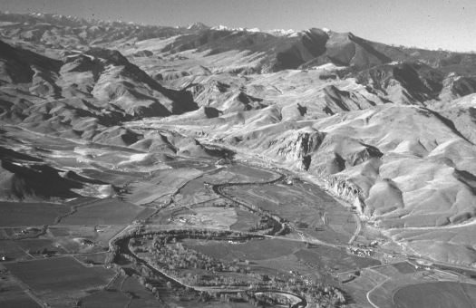

Aerial view o Salmon River Canyon so thwest o Challis, daho, view to the west. Snow-covered White Clo d Mo ntains and Castle Pea orm the s yline. Photograph y Pa l Karl Lin .

