Devonian Stratigraphy in East-Central Idaho: New Perspectives from the Lemhi Range and Bayhorse Area

George W. Grader

Department of Geology, University of Idaho, Moscow, ID 83844
Carol M. Dehler
Department of Earth and Planetary Sciences, University of New Mexico, Albuquerque, NM 87131

ABSTRACT
Shelf-to-basin stratigraphic studies of Devonian rocks in the Lemhi Range and Bayhorse area reveal new paleogeographic reso- lution of depositional environments across E-W and NNW-SSE transects. Lower and Middle Devonian mixed carbonate and siliciclastic strata (<600 m thick) include restricted shallow-ma- rine deposits of the Carey Dolomite, unnamed marginal-marine deposits, and discontinuous paleovalley deposits of the Beartooth Butte Formation. Estuarine and inner shelf lithofacies with mi- cro- and macrovertebrate faunal assemblages including thelodonts, pteraspids, acanthodians, osteostracans and placoderms allow basinward correlation with conodont-bearing deposits of the Carey Dolomite and associated unnamed strata. Fluvio-karst deposits and filled incised valleys in the Lemhi Range suggest that the exposed lower Paleozoic shelf had moderate topography and brackish(?) water fish habitat. Sea-level changes and shoreward migration of inner shelf environments beveled paleorelief and culminated in establishment of the Jefferson Formation carbon- ate ramp during Middle to Late Devonian time. Apparently the fish followed the transgression of shore environments, as they do not occur in these marine deposits.
The Jefferson Formation thins depositionally from about 900 m in the central Lemhi Range to about 100 m at Black Canyon (~75 km to the SSE non-palinspastic). Distinctly bedded accu- mulations of dolostone, limestone, and quartz arenite suggest peritidal and shallow subtidal environments. Most of the Jefferson Formation features shallowing-upward successions (1 to 20 m thick) of bioturbated and fossiliferous carbonate overlain by al- gal and laminated lithofacies with breccia caps. Three 3rd order deepening-upward sequences of the lower Jefferson (<393 m of Givetian and Frasnian strata) represent overall back-stepping of
shelf environments. Depositional style changed during end- Frasnian time following a regional subaerial unconformity. Famennian upper Jefferson carbonates (<512 m thick) are interbedded with extensive stratiform breccias and shallow-wa- ter sandstone units. Carbonate solution breccias (artifacts after evaporites) with sandy cryptalgal dolostones represent restricted shelf environments and overall regression. Sparse fossiliferous beds mark continued subsidence with sea-level incursion, but open marine benthos is absent.
Devonian stratigraphy reflects differential regional subsidence on the miogeocline, sea-level changes and pronounced environ- mental changes. Long-term shallow-water lithofacies thin across a flank of the Lemhi Arch (sensu Sloss, 1954) in the southern Lemhi Range and help to define a NE-trending Central Idaho Trough (sensu Wiler, 1992). Extrabasinal Famennian glacio- eustatic draw-down and brecciation of the Jefferson Famennian shelf is interpreted to overprint tectonic Antler foreland controls.

Key words: Beartooth Butte Formation, Carey Dolomite, Jefferson Formation, Devonian vertebrates, Paleovalleys, Glacio- eustasy

INTRODUCTION
Over the past century, spectacular exposures of Devonian rocks in alpine and high desert areas of east-central Idaho have received much less attention than equivalent rocks in Nevada and Canada. Little is known of the east-west lateral changes of Lower Devo- nian paleovalley to marine systems or Upper Devonian facies changes of the Jefferson Formation. This report combines infor- mation from recent University of Idaho and Northern Arizona University Masters thesis projects (Wiler, 1992; Dehler, 1995; DeSantis, 1996; Grader, 1998; Fig. 1) and provides new lithofacies

Grader, G.W., and Dehler, C.M, 1999, Devonian stratigraphy in east-central Idaho: New perspectives from the Lemhi Range and Bay horse area, in Hughes, S.S., and Thackray, G.D., eds., Guidebook to the Geology of Eastern Idaho: Idaho Museum of Natural History, p. 29-54.

45o

Ellis

Hayden Creek

Railroad Canyon

Leadore

Maiden Peak

MONTANA

93

Challis

Patterson
Meadow Peak
Grouse Creek Mahogany Hill

Liberty Gulch (North)

Gilmore
Liberty Gulch (South)

Warm Springs Spring Mtn. Canyon

Grandview Canyon

Bradshaw Basin

Bear Mtn.
Horseshoe Gulch

28

Rancho

75 Spar Canyon
Gooseberry Creek Sheep Creek

Donkey Hills

Basinger Canyon

Meadow Canyon

Cedar Run

Copper Mtn.

Bayhorse Area

Rock Creek

Borah Peak

Cedar Canyon
Hawley Mtn.

Hawley Mtn. Sink Hole
Badger Creek
Bunting Canyon

Uncle Ike Creek

44o N

To Ketchum

MAP VIEW

South Creek Slide Block
93

King Mtn.

Hurst Creek

Black Canyon

Middle Canyon

22

Howe

SCALE

0
0

114o W

25 km
25 m
Fish Creek Res.

Arco

93

113o

= Measured sections of the Jefferson Formation (Grader)
= Measured sections of basal Devonian rocks and Beartooth Butte Formation (Dehler)
= Measured sections of basal Devonian rocks and Beartooth Butte Formation (Grader)
= Measured sections of the Jefferson Formation (Wiler, 1992; DeSantis, 1996)
= Other areas of reconnaissance and reference.

Figure I. Map of east-central Idaho showing localities of study.

descriptions and paleoenvironmental interpretations, and corre- lated lithostratigraphic measured sections. We describe paleon- tology, local and regional biostratigraphy, lithostratigraphy, and sequence stratigraphy in the Early to Middle Devonian
miogeoclinal hinge zone (Beartooth Butte Formation, associated unnamed strata, and Carey Dolomite) and the lithostratigraphy of the Middle to Late Devonian Jefferson Formation.
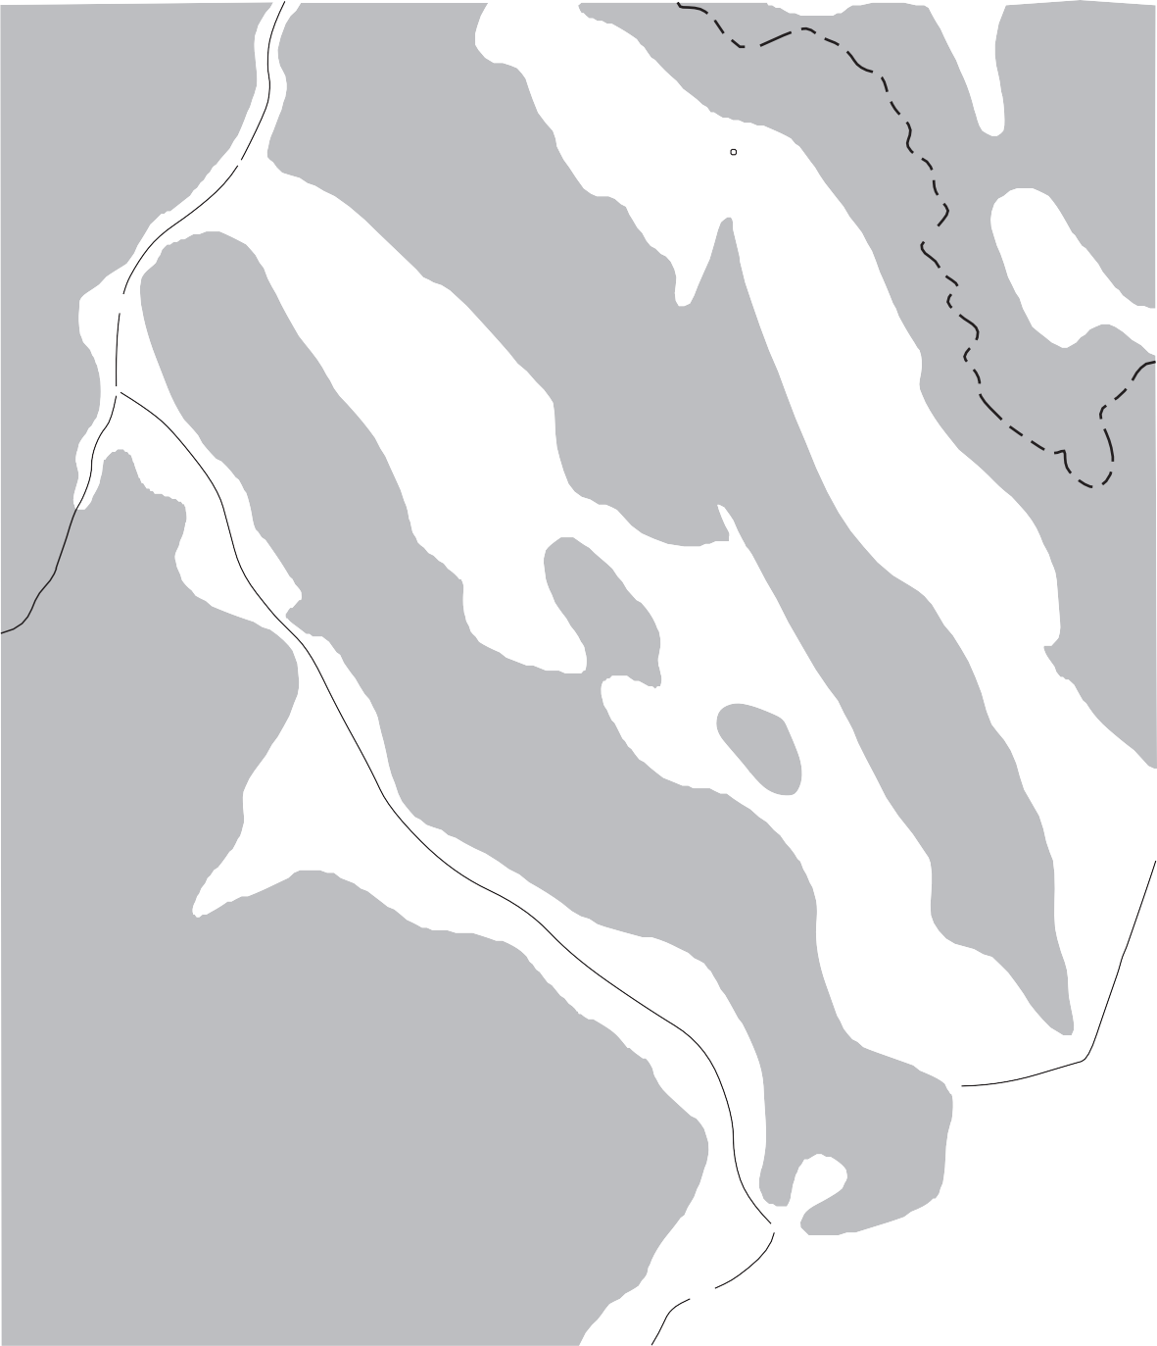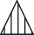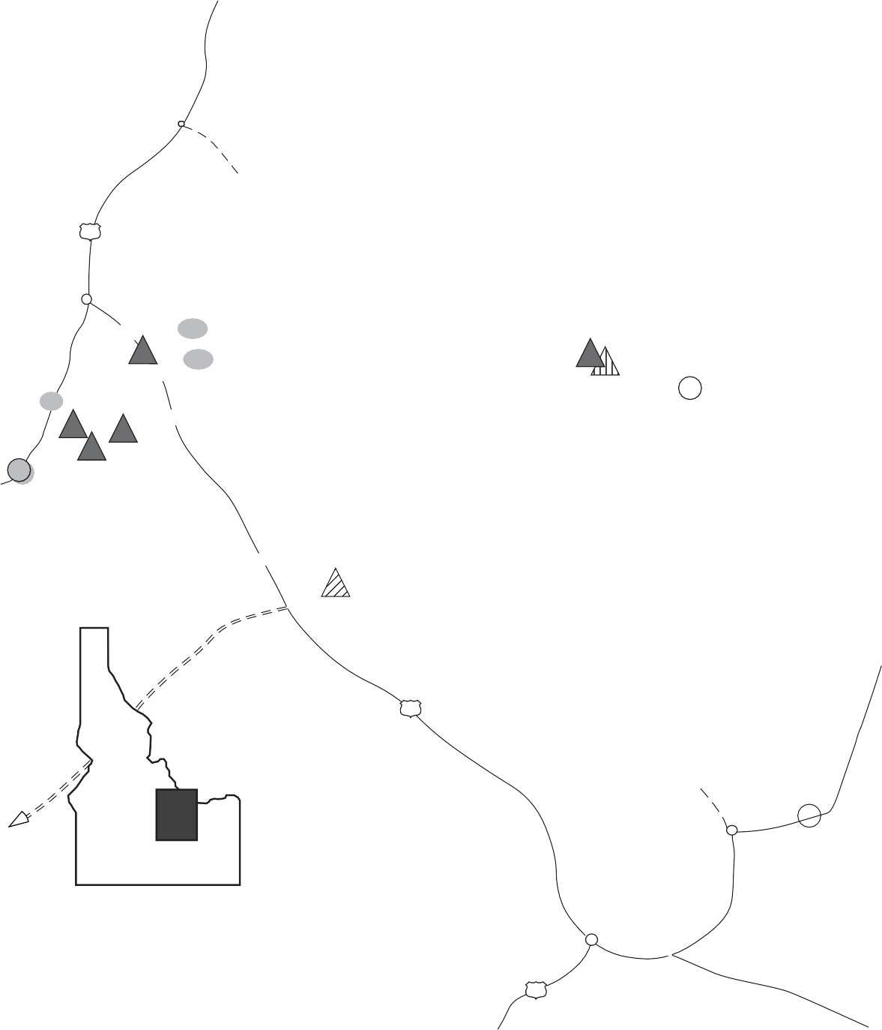In the Lemhi Range and Bayhorse area, 1600+ m (in compos- ite) of Devonian strata are preserved. These rocks were depos- ited in a wide variety of environments ranging from fluvio-karst

354
Ma MISS...
TOURNAIS...
CONODONT ZONES

duplicata sulcata
EustaticCurve
Events and T/R Cycles
Fall
Rise
1
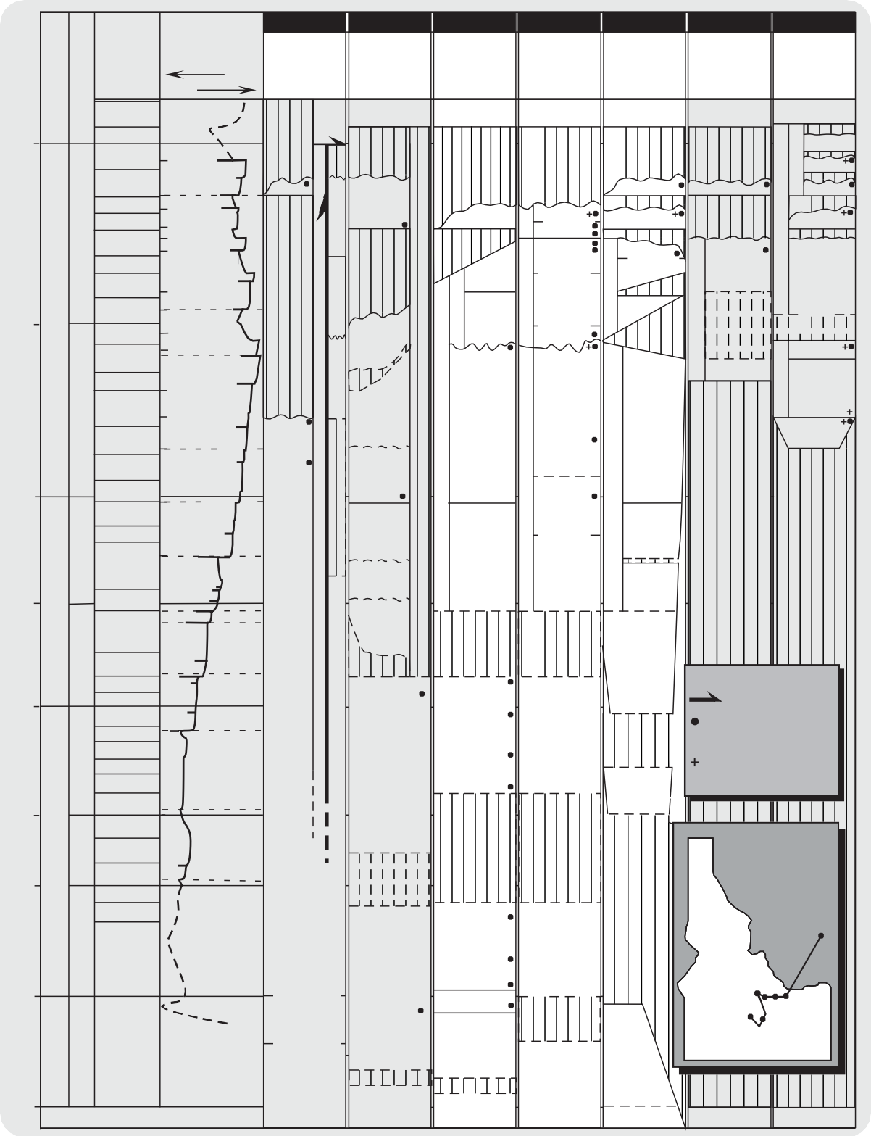
WOODRIVER AREA / PIONEER MTS:
COPPER BASIN FM.
2
WHITE KNOBMTS../ FISHCREEK. RES.
MCGOWAN CREEK FM.
3
SPAR CANYON / GRANDVIEW CANYON
MCGOWAN CREEK FM.
4
LOST RIVER RANGE
MCGOWAN CREEK FM.
Tridt.
5
LEMHI RANGE

MCGOWAN CREEK FM.
GRANDVIEW DL.
6
BEAVER- HEAD MTS.
MCGOWAN CREEK FM.
7
LOGAN CANYON MONTANA
LODGEPOLE FM.
T HREE FORKS FM.
Sappingtonmbr

Upper

praesulcata 17
DEVONIAN
FAMENNIAN
expansa
16
IIf

Unnamed
? ?
PICABO
PICABO FM.

Base. Sapp.

BasalSappington
Middle
Basal

postera trachytera

14
FM.

Trident
Unit 2-4 Unit 1

Trident

Trident mbr

364
marginifera 12
rhomboidea
crepida 11
triangularis 9
linguiformis 8
rhenana 6
UPPER
FRASNIAN
jamieae
5
hassi 4
IIe

IId

IIc

Upper

Yellow vuggy dol.
?
a t i o n
JEFF. FM.
( ? )

Banded dol.

"False Birdbear"
Yellow shallow- water dol.
J E F F E R S O N F O R M A T I O N
GRANDVIEW

Reef

Dark Dolomite
Unit VI
LOWER JEFFERSON FM. UPPER JEFF.

Unit V

Unit IV

Buildups
Unit III
D6
D5

D4
?
FORMATION

D3
"False Birdbear"

Lower mbr.
JEFFERSON FORMATION
Logan Gulch Mbr. / "Upper
Ls."

Birdbear Lower mbr.
JEFF. FM.
Maywood

374

380
punctata

transitans
falsiovalis disparilis herm.-cristatus
MIDDLE DEVONIAN
GIVETIAN
varcus

ensensis kockelianus
EIFELIAN
australis costatus partitus
patulus
EMSIAN
3
IIb

2
IIa
1
If

Id Ic
Mbr. Type Milligen Fm

Black dol.
F o r m

Blue dol.

Silty dol.

Basal channel
MILLIGEN FORMATION AND UNNAMED ROCKS
(see LInk et al., 1995)
M i l l i g e n
D O L O M I T E

?

Banded Dolomite

v

?

CAREY

Unit II

Unit I

s

?

CAREY
Bio-stromes

D2
JEFFERSON

?
D1
?
v CHANNEL
SANDSTONES
( Givetian?)
v v
Fm. v

EXPLANATION
Fault contact Conodonts

serotinus
LOWER DEVONIAN
inversus
nothoperbonus Ib

CAREY DOLOMITE
A
R
E
Y
DOLOMITE
(Unit B)
DOLOMITE
? v Vertebrates Brachiopods
v s

392

396

408
gronbergi dehiscens pirenese
kindlei Ia
LOCHKOVIAN PRAGIAN
sulcatus pesavis delta
woschmidti- post- woschmidti

ROBERTS MOUNTAINS FORMATION

Unnamed (Unit A)
C

v

"Beartooth Butte Formation"

v
Beartooth Butte Fm.?
Stringocephalus

7

3 4

TRAIL CREEK FORMATION
SILURIAN

MiddleDevonian? BeartoothButte
Formation
LAKETOWN DOLOMITE / ROBERTS
5 6
2
1
LAKE-

438

ORDOVICIAN

PHI KAPPA FORMATION
MTS. FM.

SATURDAY MTN. FM.
?

LAKETOWN DOLOMITE
TOWN DOL.

FISHHAVEN DOLOMITE

(PRECAMBRIAN) (CAMB.-ORD.)

Figure 2. Regional correlation of Devonian rocks in Idaho and Mon- tana. I: Link et al. (I995); Nilsen (I977), 2: Skipp and Sandberg (I975), 3: Dehler (I995); Hays et al. (I980); Johnson and Sandberg (I977), 4: Dehler (I995); Wiler (I992), Johnson et al. (I985), 5: (this report); Isaacson et al. (I983b); Hait (I965), 6 & 7: Sandberg et al. (I988). Stages after Gradstein and Ogg (I996). "To scale" : 3 cm = ~I0 m.y.
to outer shelf during a long-term on- and offlap of sea level (a "2nd order turn-around sequence" lasting ~40 m.y.). Lower Devo- nian deposits only are present from the Lemhi Range westward, but widespread Upper Devonian carbonates extend across the miogeocline to the Montana craton. These are generally under- stood to represent transgressive deposits during high Kaskaskia sea levels. Relatively thin deposits in Montana are associated with

long hiatuses in contrast to thick deposits in Idaho (Fig. 2).

Lower Devonian rocks
Lower Devonian strata comprise interbedded and mixed car- bonate and siliciclastic sedimentary rocks which grade from thin, discontinuous, non-marine to marginal-marine paleovalley depos- its in the east ("Beartooth Butte Formation"), to thick, laterally continuous accumulations of storm- and tide-influenced, shallow and marginal-marine deposits in the Bayhorse area (Beartooth Butte Formation, unnamed strata, and Carey Dolomite; Figs. 1,2, & 4). Disarticulated to semi-articulated early vertebrate (domi- nantly fish) assemblages are present in the marginal-marine de- posits of the Beartooth Butte Formation and unnamed strata, and are absent (except for conodonts) in the more distal marine Carey Dolomite. These strata represent three depositional sequences.
Lower Devonian miogeoclinal accumulation of carbonate- dominated deposits in the Bayhorse area shifted to the Lost River Range and central Lemhi Range during Middle to Late Devonian time, where a NW trending pericratonic basin was formed (Cen- tral Idaho Trough - Wiler, 1992). Although we do not discuss how the carbonates of the shelf relate to the western Milligen Formation, extensional controls documented in the slope setting of the Milligen Formation in the Sun Valley area (Turner and Otto, 1995; Link et al., 1995) may also have affected the Devo- nian shelf in east-central Idaho.

Middle and Upper Devonian rocks
Middle and Upper Devonian rocks in the Lemhi Range are divided into discontinuous paleovalley units (vertebrate-bearing only at Spring Mountain Canyon) and lithostratigraphic mem- bers (D1 - D6; Fig. 2) as originally used for mapping purposes by Hait (1965). Peritidal, lagoonal and offshore biostromal deposits of the Jefferson Formation (Givetian to Frasnian Banded and Dark Dolomite Members - D1 to D3 members) are equivalent to the Elk Point through Winterburn Alberta Megacycles. These rocks are overlain by mappable shallow-water deposits of Famennian members D4, D5 and D6 which include thick, stratiform, struc- turally overprinted Famennian evaporite-solution breccia units (M'Gonigle, 1982), cryptalgal dolobindstone and (recycled) quartz sandstone. Members D4 - D6 are equivalent to the Grandview Dolomite and Logan Gulch Member of the Three Forks Formation (the latter are equivalent to the Paliser-Wabanum Megacycles, Figs. 2 & 12).

Explanation of Devonian Geological Problems
A number of overlapping topics of discussion provide insight into the Devonian depositional system in Idaho. We divide our studies into 1) Beartooth Butte Formation and associated strata with a focus on the biostratigraphy of micro- and macrovertebrate- bearing facies, lithostratigraphy, and sequence stratigraphy, and
2) the lithostratigraphy of the Jefferson Formation in the Lemhi Range. Common stratigraphic themes elucidating Jefferson depo- sitional controls have been isolated to form two central, long- standing geologic questions: a) is isopach thinning towards the southern Lemhi Range the result of Devonian syntectonic and depositional (paleogeographic) processes, or is it an artifact of later deformation and erosion? And b) what role did eustasy play

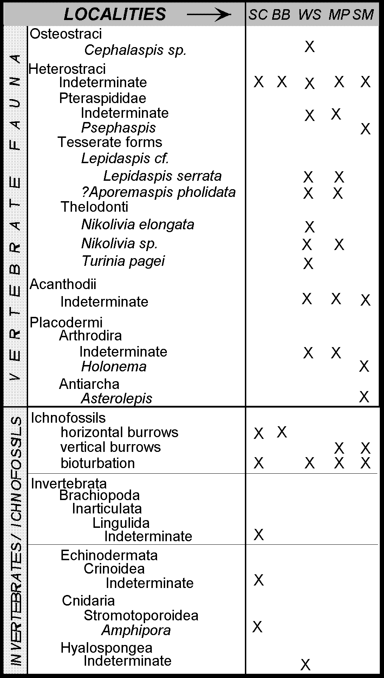
Table la. Lower Devonian (and Middle Devonian at Spring Moun- tain Canyon) vertebrate fauna, invertebrate fauna, and ichnofossil list for field area in relation to individual field locations of strati- graphic sections. SC = Spar Canyon, BB = Bradshaw Basin, WS
= Warm Springs, MP = Meadow Peak, and SM = Spring Moun- tain Canyon. See Fig. I for locations of study areas.

in controlling regional stratigraphic stacking patterns versus early subsidence due to the Antler Orogeny?

Depositional versus tectonic thinning of the Jefferson Formation in the Lemhi Range
Devonian paleovalley deposits and the Jefferson Formation measure 1174+ m in the Gilmore area of the central Lemhi Range (Ruppel and Lopez, 1988); seventy five km SSE of Gilmore (non- palinspastic), near Black and Middle Canyons, these rocks thin to ~110 m (Fig. 1). Although southeastern isopach thinning was previously attributed to structural thinning (Mapel and Sandberg, 1968), Hait (1987) re-emphasized the need to resolve the possi-

New genus and species New genus and species
Onchus sp. Onchus sp. Onchus sp. Onchus sp.
Uranolophus wyomingensis Uranolophus wyomingensis Uranolophus sp.
delta Zone delta Zone
Bryantolepis sp.
Bryantolepis brachycephala
Placodermi
Acanthodii Dipnoi Conodonta
Nikolivia elongata Nikolivia elongata Nikolivia sp. Nikolivia sp.
Thelodonti
Allocryptaspis flabelliformis Allocryptaspis utahensis
New genus & species A & B New genus & species A & B
Lepidaspis serrata Lepidaspis serrata
Errivaspis? priscillae
Cosmaspis transversa Cosmaspis sp.
Cardipeltis wallacii Cardipeltis richardsoni Cardipeltis wallacii ?Cardipeltis richardsoni
Errivaspis? priscillae
Oreaspis dunklei

Oreaspis ampla
Protaspis bucheri Protaspis mcgrewi
Heterostraci
Pteraspididae

Cardipeltidae Cyathaspididae
Tesserate forms
Cephalaspis sp.
wyomingensis

Cephalaspis sp. ?Cephalaspis
Cephalaspis sp. Cephalaspis wyomingensis
Osteostraci
Lost Burro Fm. Lippincott Member
Death Valley California
(Elliott and Ilyes, 1995)

Windmill Limestone
Simpson Park Range Nevada
(Turner and Murphy, 1988)
Water Canyon Formation Card Member
Bear River Range Utah
(Elliott and Ilyes, 1995)
Sevy Dolomite Sandy Member
Northern Egan Range Nevada
(Elliott and Ilyes, 1995)
Beartooth Butte Formation
Cottonwood Canyon Wyo- ming
(Elliott and Ilyes, 1995)
Beartooth Butte Formation
Beartooth Butte Wyoming
(Elliott and Ilyes, 1995)
Beartooth Butte Formation equivalents
East-central Idaho
(Dehler, 1995)
Vertebrate fauna
generic similarity specific similarity
Table lb. Simplified regional correlation chart of vertebrate fauna in western United States. Refer to Elliott and Ilyes (I995) and Dehl er (I995) for more details.

bility of depositional thinning. This led to the examination of Lemhi Range facies changes and resulted in the reintroduction of the concept of a long-term, passive Lemhi Arch (Grader, 1998).
The term "Lemhi Arch" was originally proposed on the basis of lower Paleozoic and Devonian isopach data by Sloss (1954). The Lemhi Arch was later modified to Tendoy Dome using iso- pach data from Montana (Scholten, 1957; Scholten and Hait, 1962). Ruppel (1986) adopted the term and extended its use to explain Proterozoic relationships. Ruppel's concept of a Protero- zoic "Lemhi Arch" was challenged and abandoned by Link et al. (1997) and Winston et al. (this volume). The term is here used sensu Sloss to explain Devonian facies changes in the Lemhi Range (Figs. 3, 10 & 11) and supports early regional analysis by Scholten and Hait (1962). With the later, but geographically as- sociated Devonian epeirogenic "Southern Beaverhead Mountains uplift" (Sandberg et al., 1975), the arch helps to explain deposi- tional thinning over the southern Lemhi Range paleohighland (before inferred, later erosional thinning).

Controls of Jefferson stratigraphic stacking patterns
With limited biostratigraphic control we recognize 3rd order stratigraphic sequences and environmental changes in the Jefferson Formation. Interpretations incorporate both autocyclic changes inherent to carbonate factories as well as allocyclic tectonic and eustatic controls. Tectonic interpretations of depositional controls for Upper Devonian strata and hiatuses have included intra-plate stresses (Sandberg et al., 1988a), incipient Antler convergence, and foreland uplift and subsequent tectonic inversion (Isaacson et al., 1983a; Dorobek et al., 1991). We acknowledge that com- plex possible foreland models and analogues have been suggested for the Late Devonian U.S. margin (Dorobek, 1995; Giles and Dickinson, 1995), but argue that tectonic depositional controls must interface with growing evidence for glacio-eustatic / cli- matic controls (specifically for Famennian strata).
Relative sea-level changes on the Jefferson shelf have been previously attributed to glacio-eustasy (Johnson et al., 1985; Dorobek et al., 1991) and we subscribe with more conviction to
this hypothesis on the basis of evidence for Famennian Gondwanan glaciation and effects on equatorial continental shelves (Buggisch, 1991; Isaacson et al., 1998, in press). Eustatic fluctuations and evaporitic draw-downs related to Famennian climate change and polar glaciation may better account for the mixed lithofacies and hiatuses in the Famennian rock record of east-central Idaho (Isaacson et al., 1997; Fig. 2).

LOCATION AND GEOLOGIC SETTING
Localities of stratigraphic sections (Fig. 1) are shown in rela- tion to Devonian isopachs and major thrust faults in Fig. 3. The study area is located in Basin and Range topography where the Rocky Mountain foreland and the Cordilleran fold and thrust belt overlap (Kulik and Schmidt, 1988; Skipp, 1988). Post-Devonian deformation in this part of Idaho has been discussed by Hait (1965), Beutner (1968), Dover (1980), Skipp (1988), Link et al. (1988) and Rodgers et al. (1995). Tertiary extension events are described by Janecke (1992; 1994). Although east-vergent, im- bricate translation of rocks is commonly found in the field, the need for long-range telescoping and juxtaposition of lithofacies (e.g., Ruppel and Lopez, 1984) seems to have diminished with re-interpretation of regional geology (e.g., Rodgers and Janecke, 1992; Winston et al., this volume). Devonian facies changes in the field area appear to be laterally continuous and support this interpretation.

PREVIOUS WORK ON DEVONIAN STRATIG- RAPHY AND PALEOGEOGRAPHY IN IDAHO
The stratigraphy and paleogeography of the Jefferson Forma- tion, Carey Dolomite, Beartooth Butte Formation and associated strata in east-central Idaho is largely based on lithologic charac- ter and general reports with some biostratigraphy (Ross, 1947; Sloss, 1954; Churkin, 1962; Scholten and Hait, 1962; Sandberg et al., 1988a; Johnson et al., 1988; Hobbs et al., 1991).
Lower and Middle Devonian rocks overlie Silurian Laketown Dolomite and are overlain by Middle to Upper Devonian Jefferson

IDAHO BATHOLITH
SE MONTANA "STABLE DEVONIAN CRATONIC SHEL
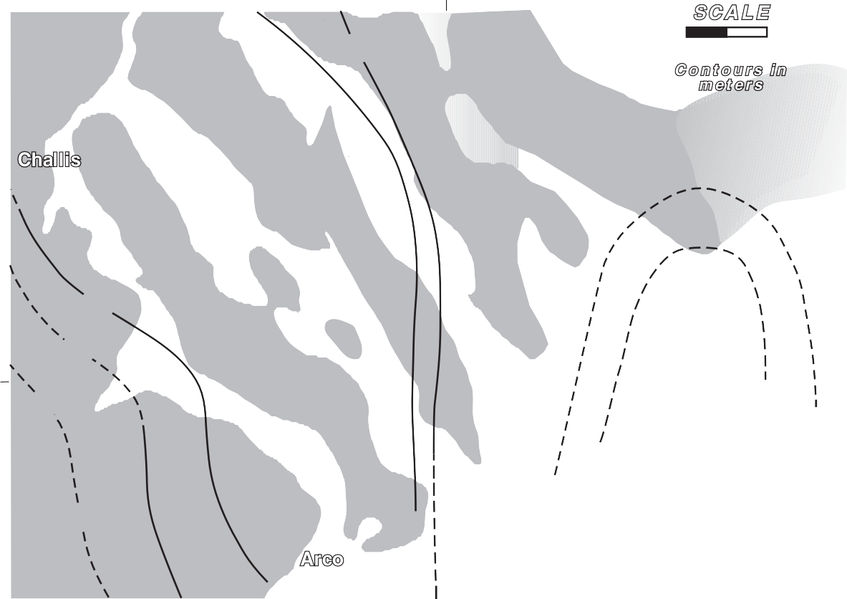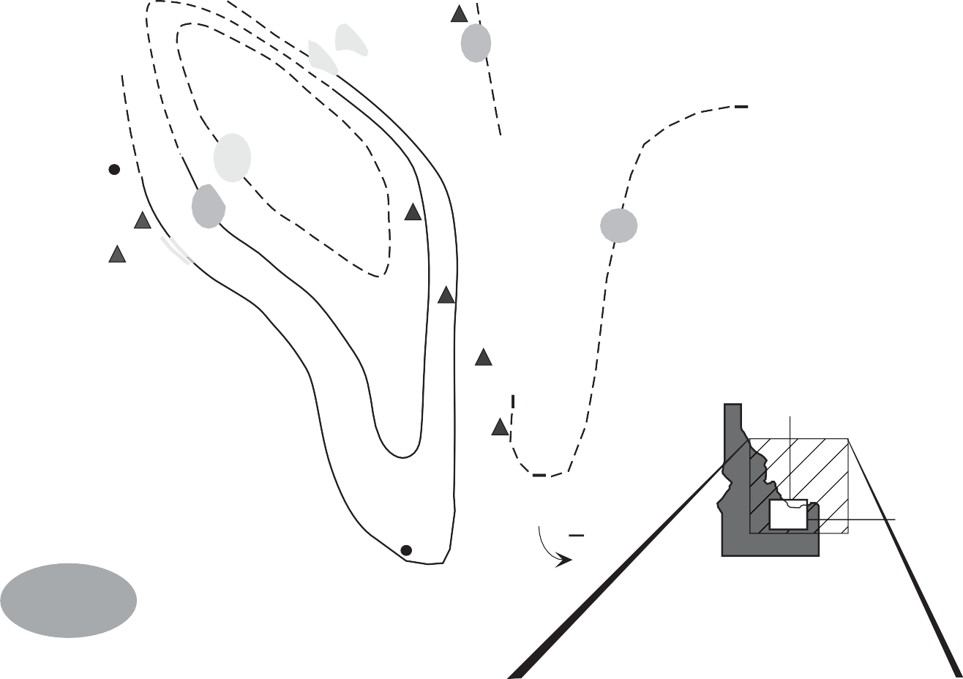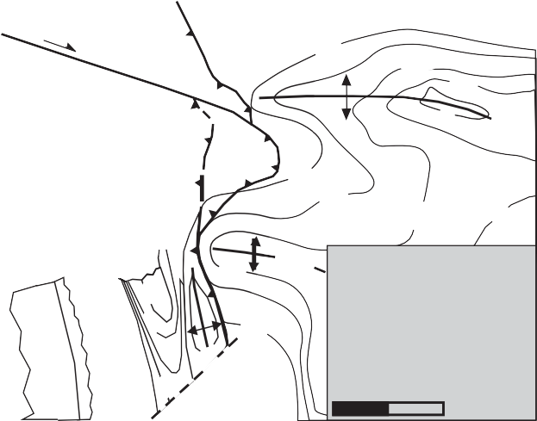113 o
F"
HC MP

TENDOY DOME
(Yellowstone Park Uplift)
25 km

LG

MH
GC HG

SC
DH
CR
HM
BP
UIC

RUBY TROUGH

44o N
BC 113º

KM

Study Area (Fig. 1)
MAP

44º

HEAVY FC
POST-DEVONIAN DEFORMATION

SNAKE RIVER
PLAIN VOLCANICS

Figure 3. Unrestored isopach map of the Jefferson Formation in east-central Idaho showing the Late Devonian NW trend- ing Central Idaho Trough (Wiler, I992). Modified after Peterson (I98I), see Fig. I for locality names. This basin was a carbonate-dominated, no-shale basin; miogeoclinal platform conditions prevailed (Sandberg et al., I982). In the modified regional isopach map (right), this part of Idaho is shown as part of an "Antler foredeep" (Dorobek, I99I).

Regional Upper Devonian Isopach Map
160 km

Formation; Lower Devonian and lower Middle Devonian strata are represented by unconformities in the eastern part of the study area (Fig. 2). These rocks, thus far, are dated by limited conodont data (Johnson et al., 1988; and references therein). The Beartooth Butte Formation is a time-transgressive, vertebrate-bearing paleovalley or marginal-marine deposit that is related to deposits in Montana and Wyoming (Dorf, 1934; Sandberg, 1961). Similar discontinuous paleovalley-fill deposits are present in the vicinity of the Lemhi Range (Mapel and Shropshire, 1973; Hoggan, 1981). Hays et al. (1980) recognized Lower Devonian Units A and B in the Bayhorse area where they overlie the Beartooth Butte Forma- tion - Units A and B are overlain by or partly correlative to the Middle Devonian Carey Dolomite originally described at Fish Creek Reservoir (Skipp and Sandberg, 1975). In this paper, Unit A is referred to as the unnamed strata and Unit B is considered Carey Dolomite (Fig. 2). Stratigraphic analyses of these units by

Dehler (1995) (summarized in this report) allowed correlation between the conodont-bearing conformable(?) Lower to lower Middle Devonian strata in the Bayhorse area to previously un- dated Devonian strata in the Lost River and Lemhi Ranges (Fig. 4).
The Middle to Upper Devonian Jefferson Formation was ex- tended to Idaho from Montana by Ross (1934) based on the dark dolostones present below the Famennian Three Forks Formation.

Lower Jefferson rocks were differentiated from the older Carey Dolomite in the western part of the study area by Johnson and Sandberg (1977) and are regionally known as the "Banded" and "Dark Dolomite Members" (Isaacson et al., 1983b; Johnson et al., 1985; see Fig. 2). The Grandview Member of the upper Jefferson Formation is partially correlative with the Logan Gulch Member of the Three Forks Formation in Montana (Sloss, 1954). The lower part of this member is known as the "False Birdbear" (Sandberg et al., 1982). The stratigraphy of Jefferson rocks in the Lemhi Range received brief attention at their thinnest and most southern exposures at Black Canyon (Ross, 1961; Mapel and Sandberg, 1968).
Ruppel and Lopez (1988) and M'Gonigle (1982) investigated Jefferson rocks and associated breccia units in the central Lemhi Range. These authors used six informal members (D1 - D6) origi- nally differentiated by Hait (1965). Hait used their color and li- thology for mapping purposes; Grader (1998) traced Lemhi Range facies changes and commented on their value as depositional se- quences. Wiler (1992) studied and synthesized stratigraphic and conodont data in the Lost River Range and at Fish Creek Reser- voir (Fig. 1). Wiler (1992) independently differentiated six lithostratigraphic units (similar to the six Lemhi Range members; Fig. 2) and related upper Jefferson clastic deposition to outer shelf forebulge uplift to the west.
Early studies of Paleozoic facies changes and thinning trends from the Tendoy Range to the Lost River Range led to the con- cept of a transitional hinge line between a Paleozoic shelf and geosyncline (Ross, 1934b; Sloss and Moritz, 1951; Scholten, 1957). Regional paleogeography and sea-level changes across the large Devonian continental shelf and miogeocline were described by Sandberg and Poole (1977), Loucks (1977), Johnson et al. (1985; 1988) and Sandberg et al. (1988a). Detailed studies of Jefferson depositional environments in Idaho have focused mainly on a few sections in the Lost River Range but local depositional sequences are not well correlated.
Simpson (1983) and Wiler (1992) associated overall shallow subtidal and intertidal facies with the formation of the Central Idaho Trough and shallow-water environments to the west. More detailed studies of Devonian rocks have concentrated primarily on end-Frasnian coral / stromatoporoid buildup(s) in deep-wa- ter(?) followed by sub-aerial exposure and shallow-water depo- sition, presumably the result of western outer shelf uplift (Isaacson et al., 1983a; Dorobek and Filby, 1988; Isaacson and Dorobek, 1989; DeSantis, 1996). Regional controls of lithostratigraphy and relative sea-level change in relation to Lemhi Range strata have remained unexplored.

LOWER DEVONIAN PALEOVALLEY FILL AND CORRELATIVE DEPOSITS: BEARTOOTH BUTTE FORMATION AND ASSOCIATED STRATA (INCLUDING CAREY DOLOMITE)
Basal Devonian vertebrate-bearing strata are present across east-central Idaho and allow preliminary correlation and applica- tion of sequence stratigraphy (Figs. 4, 7, & 8). In Spar Canyon (Figs. 1, 2 & 4), a 600 m-thick conformable(?) Silurian to Devo-
nian succession contains Lochkovian and Emsian (and Eifelian) strata on the basis of conodont zonations (Johnson and Sandberg, 1977). These marginal-marine and marine strata comprise verte- brate-bearing (fish and conodonts) sandy dolomites, sandstones, and quartzites of the "Beartooth Butte Formation" (and associ- ated overlying strata) and overlying conodont-bearing dolomites of the Carey Dolomite (Figs. 2 & 4). Distinctive fish-bearing strata at Meadow Peak and Warm Springs are equivalent to the domi- nantly carbonate deposits at Spar Canyon to the west based on lithofacies similarities and vertebrate faunal correlations (Fig. 4). The latter deposits overlie the Laketown Dolomite with confor- mity but similar deposits are found in significant paleovalleys to the east in the Lemhi Range (Fig. 4). Deposits filling paleovalleys cut into Silurian and Ordovician rocks are located at Spring Moun- tain Canyon, Hawley Mountain and Badger Creek and show strik- ing variations in sedimentology and paleoenvironments (Figs. 1, 4, & 5).

Micro- and Macrovertebrate Paleontology and Biostratigraphy
A diversity of fossils including invertebrates, trace, and ver- tebrates are present in a number of different lithofacies and are spatially summarized in Table 1a. The preservation of the fossils is generally poor; very little detail is recognizable and whole speci- mens are rare. The invertebrates are low in number and variety, and consist of crinoid columnals, stromatoporoid debris, sponge spicules and lingulid brachiopod internal molds. Bioturbation is common, and trace fossils including horizontal and vertical bur- rows are abundant. Vertebrate fossils are far more ubiquitous and consist of conodonts, tesserate elements (fish), fish scales, fish spines, fish shields and semi-articulated fish specimens (Table 1a). This section focuses on the vertebrate fauna due to their greater diversity and potential utility for biostratigraphic correlations of the paleovalley deposits with continuous restricted shelf strata to the west.
Although vertebrate faunal assemblages share transglobal similarities and as an assemblage usually indicate an Early Devo- nian age, few specific correlations can be made due to the en- demic nature of each geographically distinct assemblage. The lack of specific correlations thus far has prohibited the use of these assemblages as better-resolution (i.e.; Epoch-level) age indica- tors. Biostratigraphic applications in this report demonstrate the potential utility of microvertebrate fish as Epoch-level index fos- sils for the Early Devonian.
A long-standing debate concerns the particular habitats of the early vertebrates. Worldwide evidence shows that the earliest vertebrates (pre-Devonian) are associated with predominantly marine deposits, whereas the vertebrates in younger deposits (post- Silurian) are found in mostly non-marine and marginal-marine facies (Boucot and Janis, 1983; Halstead, 1985, Dineley, 1988). This suggests that vertebrates occupied different environments through time; a progression from the sea landward into fresh wa- ters. Data from our research indicate deposition in a variety of shallow- and marginal-marine environments (inner shelf, shoreface, tidal channels, intertidal zone). No vertebrate fauna are found in the lithofacies representing distal, lower-energy ma- rine environments (outer shelf). These interpretations support the

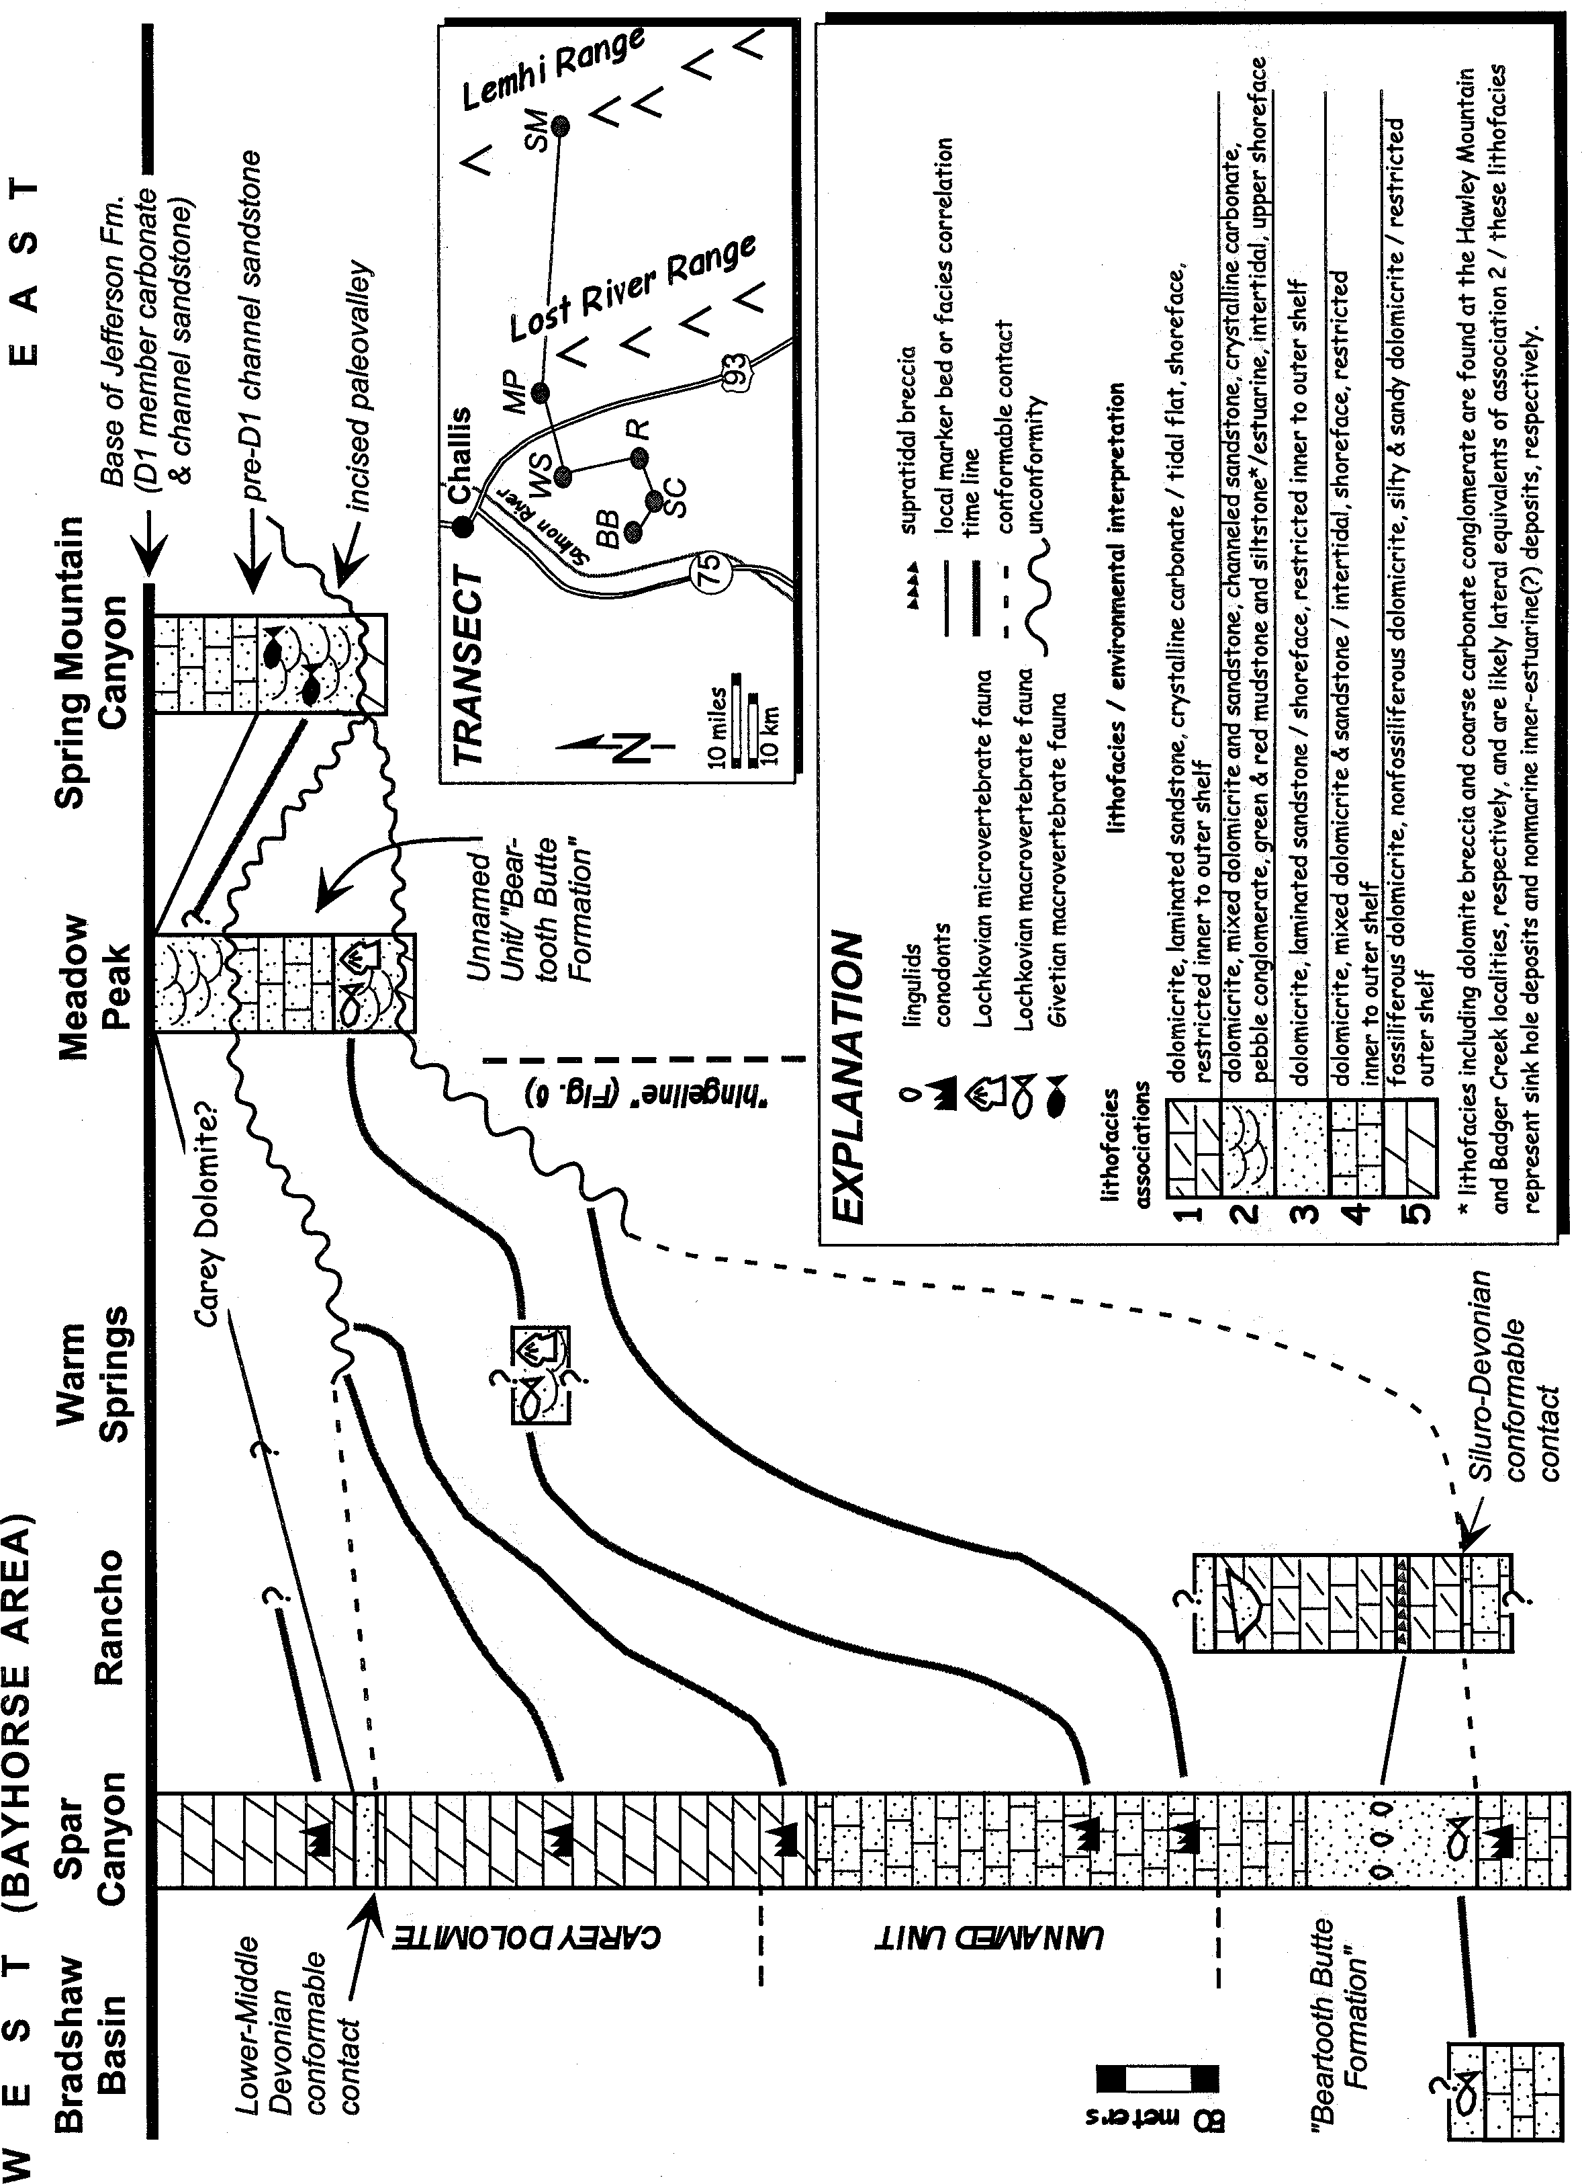

idea that the habitat(s) of early (Devonian) vertebrate fish were in the shallow- marine and marginal-marine realm.
Figure 4. Schematic diagram showing biostratigraphic, lithostratigraphic and sequence boundary correlations of Beartooth Butte Fm. and associated strata from the Bayhorse area in the west to Spring Mountain Canyon in the east. True horizontal distances between m ea- sured sections are shown on transect map inset.

Macrovertebrates
The vertebrate macrofaunas were collected from the Warm Springs, Meadow Peak, Spar Canyon, Bradshaw Basin, and Spring Mountain Canyon localities (Fig. 1 & Table 1a). The Warm
Springs locality has the greatest concentration and diversity of macrovertebrates. A similar fauna is present at Meadow Peak, although the vertebrate material is confined to only one horizon and is much less abundant. Laminated sandstone beds present at Spar Canyon and Bradshaw Basin contain lag concentrations of granule to pebble-size, unidentifiable heterostracan fragments.
The Spring Mountain Canyon "channel sandstone" contains the arthrodiran placoderm Holonema and the antiarch placoderm

Asterolepis, as well as the pteraspid Psephaspis (Table 1a; Denison, 1968). This combination of fossils seemed to be prob- lematic, for it was thought that the pteraspid line died out by the end of the Early Devonian, whereas Holonema is only known from localities that indicate a Middle or Late Devonian age (Denison, 1968). A precisely similar fauna from the Yahatinda Formation of Alberta, Canada has been dated by a spore assem- blage that indicates a late Middle Devonian to earliest Late De- vonian age (Aitken, 1966). McGregor (pers. comm. to Elliott, 1992) confirmed a late Middle Devonian (Givetian) age for the Yahatinda Formation based on further spore dating. The recent collection of additional material of the antiarch placoderm Asterolepis (this report) enforces the faunal likeness to the Yahatinda Formation fauna, confirming a Givetian age for the "channel sandstone" and supporting Denison's (1968) theory that the pteraspid lineage persisted into Middle Devonian time.
A 17-meter-thick siltstone and mudstone unit is exposed be- low the "channel sandstone" at Spring Mountain Canyon (Figs. 1 & 5) and rests on the unconformity cut into the Ordovician Fish Haven Dolomite. This thin unit contains broken fragments of heterostracans that are too small to identify. No age-diagnostic fossils have been found in this unit. The other units in the field area which contain exclusively heterostracan fragments are Early Devonian. Therefore, it is likely that this heterostracan unit is also Early Devonian. Another possibility is that it could be a finer- grained facies of the Middle Devonian sequence above. To re- solve this age problem, the mudstone was sampled for palynomorph analysis; however, no spores were recovered.

Microvertebrates
Conodonts have been reported from the Spar Canyon locality (Hays et al., 1980; Sandberg, pers. comm., 1993; Figs. 1 & 4) and are useful as age indicators for Pridolian, Lochkovian, Emsian and Eifelian stages. Acanthodian scales, tesserate heterostracans, and thelodonts have been discovered in the macrovertebrate-bear- ing units at Warm Springs and Meadow Peak (Table 1a, Figs. 1 & 4). The tesserate heterostracans are similiar to Lepidaspis serrata and ?Aporemaspis pholidata of the Delorme Formation of the Northwest Territories and the Snowblind Bay Formation of the Canadian Arctic (Dineley and Loeffler, 1976; Elliott and Loeffler, 1988; Elliott, pers. comm., 1994). Other tesserate heterostracans were found in sediment residue from the Warm Springs locality although their identities remain unclear. The thelodonts have been identified as Ni olivia elongata and Turinia pagei, (Elliott, pers. comm., 1994). A similiar microvertebrate fauna is known from the Windmill Limestone in the Simpson Park Range of Nevada that was recovered from residues that contain conodonts and grap- tolites indicating the delta Zone of the Lochkovian (Table 1b; Turner and Murphy, 1988).

Faunal Comparisons and Ages: Local Correlations
The presence of the thelodont Ni olivia sp. and the tesserate forms Lepidaspis serrata and ?Aporemaspis pholidata at both the Warm Springs and Meadow Peak localities allows for a local biostratigraphic correlation (Table 1a, Fig. 4). Ni olivia sp., Ni olivia elongata, and Lepidaspis serrata are known from the

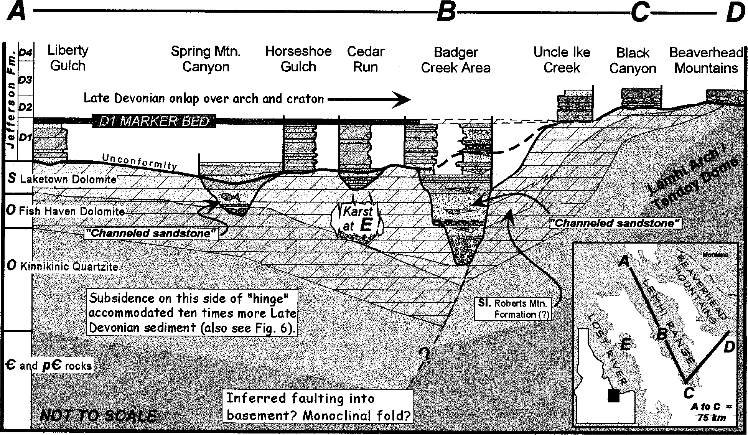

Figure 5. Schematic Middle Devonian paleovalley depositional system and relationship to Lower Jefferson Formation in the Lemhi Range. Sections are hung from Givetian DI marker beds, about I00 m above the base of the Jefferson between "A" and "B" on transect. Karst breccia at Hawley Mountain ("E") and red shale and non-marine conglomerates at Cedar Run and Badger Creek are associated with the Beartooth Butte Formation. Green shale with plant debris below channeled sandstone lithofacies with Eifelian/Givetian vertebrat es(?) at Spring Mountain Canyon are also part of the Beartooth Butte Formation(?). The Badger Cr eek area was the site of I) Early Paleozoic facies changes, 2) long-term Devonian facies changes (see Fig. I0), and 3) a hinge point for Late Paleozoic basin inversion.

delta Zone of the Windmill Limestone (Table 1b; Turner and Murphy, 1988). This age is further substantiated by the presence of Turinia pagei, at the Warm Springs locality. This fossil is an accepted age indicator for the Lochkovian (Dittonian) Stage of the Old Red Sandstone in Europe, and typically is found in asso- ciation with nikoliviid scales which are also prevalent in Lower Devonian strata (Turner et al., 1981). Also supportive of this lo- cal correlation is a macrovertebrate assemblage of pteraspids, and sandstone beds in the upper patulus Zone (Eifelian?) of the Carey Dolomite at Spar Canyon (Fig. 4). Another possible correlation is to the Banded Dolomite of the Jefferson Formation in the Spar Canyon area and the Lower Jefferson Formation in the Meadow Peak area (Fig. 2). The basal 17 m at Spring Mountain Canyon contains unidentifiable heterostracan fragments that could be cor- relative with the Lower Devonian heterostracan-bearing units to the west, or it could be related to the Middle Devonian "channel sandstone" above. The Bradshaw Basin locality contains uniden- tifiable heterostracan fragments, which are most likely Lochkovian based on stratigraphic position and the similarity of the fossil- bearing facies to those of the Spar Canyon locality (Table 1a).

Faunal Comparisons and Ages: Regional Correlations
Regional correlations have been made between the local Idaho vertebrate fauna and other early vertebrate assemblages in the western United States and are summarized in Table 1b. For de- tails on the regional and global correlations involving the Idaho fauna refer to Dehler (1995).
The Lower Devonian Idaho faunas only roughly correlate with other Lower Devonian faunas in the western Cordillera. Specifi- cally, the Idaho fauna is the most similar to the Windmill Lime- stone fauna in Nevada, and both are Lochkovian (Table 1b). The Cottonwood Canyon Formation in Wyoming contains spores of late Lochkovian-early Pragian age (Tanner, 1983), although only one vertebrate species-level correlation can be made (Table 1b). All other vertebrate assemblages, including the Beartooth Butte Formation at the type locality in Wyoming, can be demonstrated to be Emsian based on conodonts, spores, or confident species- level vertebrate correlations (Table 1b; Dehler, 1995 and refer- ences therein).
The lack of specific similarities is typical of early vertebrate faunal correlations and is attributed to the endemic nature and age of each geographically distinct assemblage. The Lower De- vonian Idaho fauna contains a unique microfauna, lacks macrovertebrate diversity, and is Lochkovian in age. This older, provincial fauna may have evolved in a semi-isolated basin that inhibited its geographic range and biodiversity. The Idaho fauna may lack diversity because it was a more primitive group of early vertebrates as compared to the more diverse descendant faunas of the late Lochkovian-Pragian and Emsian.

Lithostratigraphy of Lower Devonian Beartooth Butte Formation and Associated Strata (including Carey Dolomite)
Dolomite, sandstone and quartzite, and mixed dolomite and siliciclastic lithofacies, representing paleovalley fill and associ- ated marginal-marine to shallow-marine paleoenvironments, have been described at 8 measured sections and are summarized in
Table 2a (Fig. 1). For more detailed descriptions of lithofacies refer to Dehler (1995) and Grader (1998). Six of these measured sections lie in an east-west transect from the Spring Mountain Canyon locality, Lemhi Range to the Bradshaw Basin and Spar Canyon localities, Bayhorse area representing the transition from paleovalley to restricted-shelf strata, respectively (Figs. 1 & 4). Lithofacies were grouped into five lithofacies associations for lithostratigraphic and sequence stratigraphic correlations (Table 2a, Figs. 4 & 7, see below). Two additional stratigraphic sections were measured at Hawley Mountain and Badger Creek (Fig. 1), and are briefly discussed and summarized in their relationship to the Banded Dolomite (D1 and D2 members, Fig. 9) of the Jefferson Formation in Fig. 5. These localities are of special interest be- cause evidence of non-marine deposition has enhanced our un- derstanding of regional paleogeography (Fig. 6).

Hawley Mountain and Badger Creek Deposits (local non-marine and marginal-marine deposits)
Carbonate breccia and mudstone deposits (150 m thick) are present in a paleo-depression at Hawley Mountain. Similar rock types fill in an incised valley at Badger Creek where basal, poorly- sorted, carbonate conglomerates (87 m thick), are overlain by sandstone, mudstone and dolomudstone (113 m thick) and are overlain by the Jefferson Formation (Figs. 1 & 5, Table 2a). These strata are lithostratigraphically associated to the (Eifelian?- Givetian) channel sandstone at Spring Mountain Canyon, yet this correlation is uncertain because no fossils were found (Fig. 5).
Geographically limited mass-flow deposits, channeled sand- stone and interbedded dolostones suggest that periodically acti- vated steep watersheds funneled terrestrial and locally-derived, recycled deposits into restricted estuarine environments.
The deposits at Hawley Mountain and Badger Creek are in- terpreted as marginal-marine(?) karstic collapse and non-marine debris flows associated with fluvio-karst processes (see Grader, 1998 and references therein). These deposits mark significant sink- hole and incised valley environments and may represent deposi- tional responses to local sediment supply, climate, or tectonic fac- tors. These rocks are landward equivalents of Association 2 (in- tertidal to shallow subtidal facies, Fig. 4, Table 2a) and are simi- lar to facies present at the Beartooth Butte Formation type sec- tion (Fig. 5; Dorf, 1934). Due to the lack of fossils, no Epoch- level correlation can be made.

Association 1 (marginal-marine, supra- to shallow subtidal)
Association 1 is found at the Rancho locality and is problem- atic because it does not share lithologic similarities with other localities and does not contain fossils. The sandstone and quartz- ite is very similar to that of Association 3 (marine-shallow subtidal) and may be a shoreward facies equivalent to Association 3 at the Spar Canyon and Bradshaw Basin localities (Table 2a, Fig. 4). Association 3 at Spar Canyon records a shallowing-upward event by the change from conodont-bearing dolomicrite (outer shelf) to lingulid brachiopod-bearing sandstones and quartzites (shoreface). Association 1 at the Rancho locality also records a shallowing- upward event by the vertical change from a silty, sandy algal- laminated dolomite (intertidal) to a sedimentary breccia

Figure 6. Schematic Early to Middle Devonian paleogeography of east-central Idaho showing incisement across the miogeoclinal hinge zone and submergence of the lower Paleozoic shelf during TST (Sequence C, Figs. 7, 8 & I2). During successive onlap, paleovalleys (calanques) were drowned, filled and their interfluves were planed off. Basal Jefferson Formation sandstone lags in the Lemhi Range (channel ravinements) overlie diverse paleovalley fill deposits and disconformities (see Fig. 5).
114o
Miogeocline
Craton
45o
25 km
25 miles
"Tendoy Dome"
Montana
LG
Emsian Beartooth Butte Fm. below Carey Dolomite
Lower Devonian record most complete here (Lochkovian Beartooth Butte Fm. below Carey Dolomite)
BA
SPR MTN
MP
Emsian(?) Beartooth Butte Fm. below Eifelian- Givetian(?) incised "Spring Mtn. channeled sandstone"
Estuarine deposition
HG
Fluviokarst deposition
Shallow marine deposition
CR
BAD CR
Basinward (Milligen Fm.?)
HM
UI
BA - Bayhorse Area BAD CR - Badger Creek
44o
BC CR HG HM LG MP
- Black Canyon
- Cedar Run
- Horseshoe Gulch
- Hawley Mtn.
- Liberty Gulch
- Mahogany Hill
BC
MAP VIEW
SPR MTN - Spring Mtn Canyon
"Lemhi Arch"
UI - Uncle Ike Creek
Transect of Grader 1998 (Fig. 5)
Transect of Dehler 1995 (Fig. 4)
Subaerial exposure, sink holes and fluviokarst.
Area of non-deposition of lower Jefferson Formation (Banded Dolomite D1 and D2 members)
Ancestral "Arco Arch" (Ordovician / Silurian)
113o

(supratidal). If these two associations are related, based on their similar shallowing-upward trends, then somewhere between the Rancho and Spar Canyon localities would mark the early Lochkovian coastline (between the tidal zone of the Rancho lo- cality and the upper shoreface zone at the Spar Canyon locality). A test of this hypothesis was attempted by the collection of con- odont data at the Rancho locality, but unfortunately the samples were not productive.

Association 2 (intertidal to shallow subtidal)
Association 2 is present at the Warm Springs, Meadow Peak and Spring Mountain localities (Fig.4). This association contains a Lochkovian vertebrate fauna at both the Warm Springs and Meadow Peak localities, and a Givetian vertebrate fauna at Spring Mountain (Table 1a). These faunas are also equivalent to those at the Spar Canyon locality (Fig. 4) based on conodont biostratigra- phy. Lithologically, this association represents a shoreward fa- cies equivalent of Association 3 at all localities and a basinward

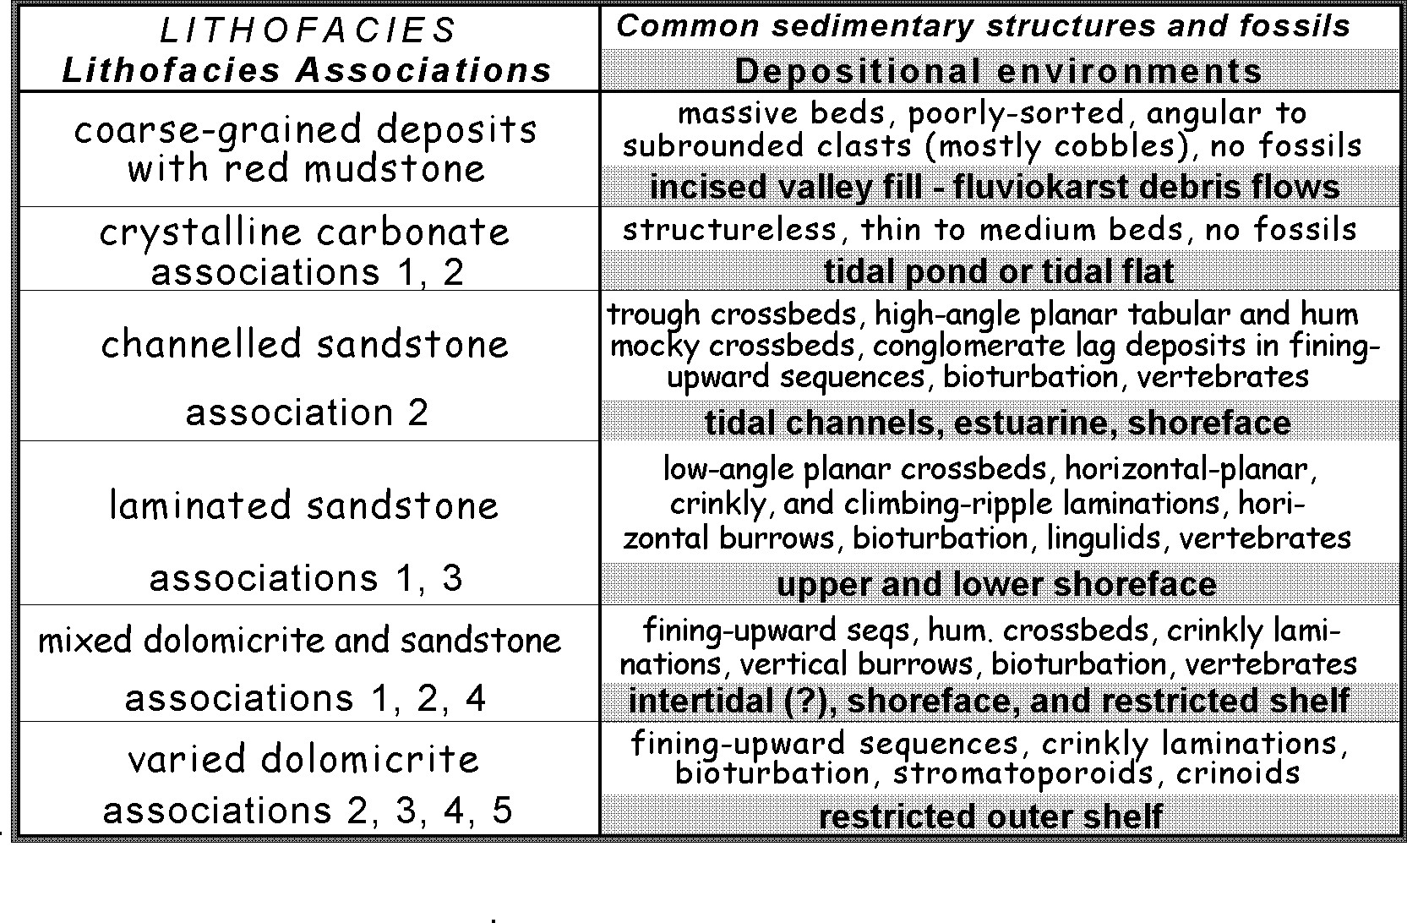
the Lower Devonian deposits in the study area. Numbers represent lithofacies associations discussed in text and shown in Fig. 4.
Table 2a. Generalized lithofacies, lithofacies associations, and interpretations of depositional environments of

equivalent of Association 1 at the Rancho locality (Fig. 4). Asso- ciation 2 is also present in the upper Meadow Peak section, yet correlation is uncertain due to the lack of fossils. This association of quartzite and cherty dolomicrite unconformably overlies As- sociation 4 (shallow subtidal) and is interpreted to be part of a younger sequence (younger than Lochkovian). These younger strata may correlate with strata near the top of the Spar Canyon section where there is a thin (2 m) bed of similar laminated sand- stone (Fig. 4).

Association 3 (subtidal)
Association 3 is present at the Spar Canyon and Bradshaw Basin localities. These two localities correlate biostratigraphically, as well as lithologically, and are basinward facies equivalents to Association 1 at the Rancho locality.

Association 4 (subtidal)
Association 4 makes up the middle part of the Spar Canyon section as well as the middle of the Meadow Peak section (Fig. 4). At the Spar Canyon locality, it is lithologically related and is time-transgressive with the Meadow Peak association (Fig. 4). Deposition in the Spar Canyon area occurred earlier, and as the sea transgressed eastward deposition in the Meadow Peak area followed, probably during late Lochkovian time. Association 4 at Spring Mountain Canyon is lithologically similar to the other localities, yet Givetian (?) in age.

Association 5 (distal shallow subtidal)
Association 5 is found only at Spar Canyon and represents distal facies that were either never deposited or have been eroded away in the east. Emsian and Eifelian conodont zonations reveal continuous(?) deposition from late Early Devonian through early Middle Devonian time. The presence of Emsian age deposits at
the type section of the Beartooth Butte Formation to the east in Wyoming suggests that deposition occurred in the Lost River Range area during the Emsian.

Sequence Stratigraphy
Third order sequences (1 - 10 my) identified across the E-W transect are summarized in Figures 7 and 8. One complete se- quence (Sequence B) and two partial sequences (Sequences A and C) are recognized. These sequences are defined by two unconformities at the Meadow Peak locality which pass west- ward (basinward) into the conformable(?) stratal package at Spar Canyon and eastward into one unconformity at the Lemhi local- ity (Figs. 4 & 7). This convergence of unconformities is due to the pinch out of Lower Devonian strata to the east, indicating that Devonian strata were either not deposited there or were eroded. A sequence boundary is recognized at Spring Mountain Can- yon where Lower Devonian(?) to Givetian strata rest on Ordovi- cian strata (Figs. 2, 4, & 5). Here, Silurian and Lower Devonian(?) strata are missing and facies change abruptly from an open ma- rine carbonate shelf to a clastic-dominated estuarine environment. Furthermore, karstic processes such as dissolution, brecciation and dolomitization that take place in exposed carbonate platforms
have modified this surface (Choquette and James, 1988).
This sequence boundary is present at the base of a channel which is 170 m deep (Ruppel and Lopez, 1988) and cuts down through the Silurian Laketown Dolomite and into the Ordovician Saturday Mountain Formation. Deepening-upward deposits in this incised valley (Hoggan, 1981) and at Badger Creek indicate a traceable transgressive systems tract (TST Sequence C, Figs. 5, 7, & 12).
At Meadow Peak, two unconformities bound a Lochkovian stratal package of peritidal facies which deepens upward to in- ner-outer shelf facies. This package rests unconformably on the

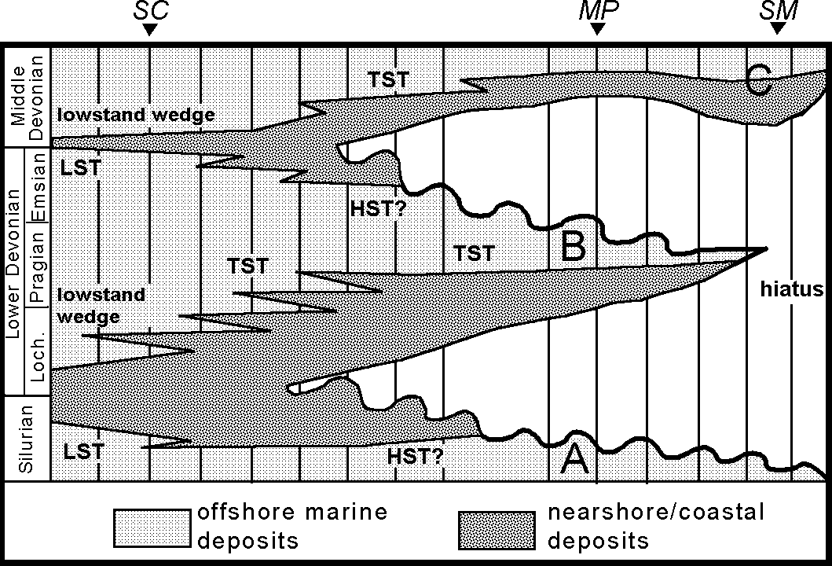

Figure 7. Chronostratigraphic chart of Lower and Middle Devo- nian strata in the Bayhorse area based on conodont, thelodont, and tesserate-form fossil data showing Sequence B and partial sequences A and C. Key to symbols: LST = lowstand-systems tract; TST = transgressive-systems tract; HST = highstand-sys- tems tract; SC = Spar Canyon; MP = Meadow Peak; and SM
= Spring Mountain Canyon.

Silurian Laketown Dolomite (partial Sequence A) and is overlain unconformably by another deepening-upward sequence (partial Sequence C) assumed to be Middle Devonian in age using lithostratigraphic correlation. Based on the overlying unconformity cut into the inner-outer shelf facies, it appears that erosion has removed younger Lower Devonian strata and that a more com- plete sequence was once present (Fig. 7). Therefore, Sequence B and C at the Meadow Peak locality are transgressive systems tracts (TST, Fig. 7; Posamentier and Vail, 1988).
A conformable(?) section of Upper Silurian through Middle Devonian strata is present at the Spar Canyon locality and in- cludes Sequences A, B, and C (Fig. 7). At the base of this section, a conformable sequence of middle-inner shelf dolomicrite shal- lows upward into laminated sandstone of the shoreface environ- ment forming a lowstand wedge (top of Sequence A, base of Se- quence B; Fig. 7). This lowstand wedge coincides with the Siluro- Devonian systemic boundary and correlates with the basal unconformity at Meadow Peak and the unconformity at the base of the Spring Mountain paleovalley. This sandstone deepens up- ward into inner-middle shelf dolomicrite.
The base of the TST (Sequence B) is recorded at Spar Can- yon in the change from nearshore sandstones (top of the lowstand wedge) and dolomitic sandstones upward into pure dolomicrite of the outer shelf. Above the TST, facies subtly shallow upward from dolomicrite and sandy dolomicrite of the inner-outer shelf to dolomitic siltstone and sandstone of the inner shelf-shoreface. These are capped by a 2 meter-thick, laminated sandstone body that represents a second lowstand (sandstone facies) wedge; mark- ing the top of Sequence B (Fig. 7). The top of this lowstand wedge would coincide with the beginning of another TST (Sequence C) which is evidenced by a deepening-upward succession into outer shelf crinoidal dolomicrite.
Incised valleys in the Lemhi Range area developed during times of low base level. These valleys may have been cut and filled multiple times. Fluvial systems probably aggraded and es-
tuaries backfilled these valleys during TST Sequence C, preserv- ing the paleovalley deposits at Badger Creek(?) and Spring Moun- tain Canyon.

Spar Canyon Relative Sea-Level Curve
The Spar Canyon succession offers a potentially continuous record of deposition during the Early Devonian based on lithostratigraphy and conodont biostratigraphy. These data allow for the construction of a local sea-level curve (Fig. 8). The maxi- mum lowstand represents the greatest progradation of the shore- line and corresponds to the laminated sandstone lithofacies (lowstand wedge) at the base of the Spar Canyon section (Fig. 7). The rises and falls of sea level are marked by relative facies changes, where each facies is assigned a number relative to the maximum lowstand. The maximum lowstand sandstone is assigned the number 0 and each successively deeper (or more distal) fa- cies is assigned a progressively higher integral value (Fig. 8).
Six cycles within the Spar Canyon section roughly correspond with the transgressive-regressive cycles of Johnson et al., 1985 (Figs. 2, 8, & 12). Although there is not a good record of the Pre- Ia cycle in the western U.S., it is generally characterized by two subcycles that coincide with cycles in the Lochkovian strata of this study (Fig. 8). The inferred Pragian strata coincide with the Ia cycle, and the Emsian strata coincide with the Ib cycle. The number and distribution of cycles within the Lower Devonian strata at the Spar Canyon locality suggest that all stages are present and that cycles were eustatically controlled. However, many of the vertical facies changes involve only subtle environmental shifts (e.g.; inner shelf to inner-proximal outer shelf) which could be produced by autocyclic processes.
The complete Pre-1a cycle (Sequence B, Fig. 8) in the Spar Canyon strata spans the entire Lower Devonian epoch and repre- sents approximately 10 my. This cycle length could be of second
0 1 2 3 4
C
partitus
Ic patulus
serotinus inversus
6

5
B 4 3
2
1
A
maximum lowstand shoreline
nothoperbonus
Ib gronbergi

Ia
dehiscens pirenese kindlei sulcatus
pesavis
pre delta

Ia
woschmidti-
postwoschmidti
eosteinhornensis
FALL
RISE
(relative change of sea-level)
LOWER DEVONIAN
EMSIAN
EI.
PRAG. LOCH. PR.
Proposed correlation of sequences and parasequences? (this report)

Figure 8. Chart of local relative sea-level changes in the Lower Devonian Spar Canyon measured section based on facies changes relative to the maximum lowstand and conodont zonation data (Hayes et al., I980; Sandberg, pers. comm., I993). 0 = shoreface; I = inner shelf; 2 = middle shelf; 3 = proximal outer shelf; and 4 = distal outer shelf. Light gray curve on right is part of the qualitative eustatic curve from Johnson et al. (I985); pre Ia - Ic = transgressive-regressive depophases.

or third order of Vail et al. (1977). Since there is no evidence for glaciations during this time (Eyles and Young, 1994), it is prob- able that Sequence B was influenced by volumetric changes in mid-ocean spreading ridge systems.
r s o n
(Three Forks Fm.)
168+ m

Depositional Model and Early Devonian Paleogeography
Our depositional model suggests that western shallow-marine deposits in the Bayhorse area interfingered with a calanque (calanques are drowned river valleys within carbonate bedrock) coastline in the Lemhi Range (Fig. 6). This clastic-influenced, restricted carbonate shelf was affected by storms and tides as the sea transgressed eastward throughout late Lochkovian to middle- late Emsian time (Figs. 4, 7, & 8). Paleoenvironments include restricted outer and inner shelf, shoreface, tidal zones, and karstic- collapse-controlled incised valleys (Table 2a). Specifically, stromatoporoid build-ups and crinoid thickets of the Carey Dolo- mite flanked the restricted basin in the westward outer shelf area. The restricted shallow shelf of the Carey Dolomite (and associ- ated unnamed strata) passed landward into a mixed siliciclastic- dolomite shoreline ("Beartooth Butte Formation" and unnamed strata), where storms occasionally affected an otherwise low en- ergy, tide-affected coast. In the Lemhi Range (and on the Lemhi Arch), a digitate calanque coastline model is suggested as evi- denced by a number of drowned carbonate bedrock valleys ("Beartooth Butte Formation" at Hawley Mountain and Badger Creek; Figs. 5 & 6).
U p p e r
G r a n d v i e w
130 m
J e f f e
M e m b e r
214 m
J e f f e r s o n
Dark Dolomite
183 m
The mixed siliciclastic-carbonate setting suggests some anal- ogy to parts of the modern Belize shelf, although the Belize shelf is not tidally-influenced. The favored ancient analogue of the Beartooth Butte Formation and associated strata is the Emsian Sevy Dolomite in Nevada (Table 1b), which was chosen for its restricted fauna, vertebrate faunal assemblage, and quartz sand sheets with dolomicrite beds (Smith, 1989). The Sevy Dolomite tidal flat complex exhibits fluvial influence and a high percent- age of fabrics of supratidal origin versus subtidal facies, yet lacks karstic features (Smith, 1989). In Idaho however, structural(?) accommodation space at Hawley Mountain and Badger Creek allowed for the preservation of estuarine and fluvio-karst depos- its that are not preserved in other Lower Devonian depositional systems (Figs. 5, & 10).
L o w e r
Banded Dolomite
108 m
101 m

THE JEFFERSON FORMATION IN THE LEMHI RANGE
Silurian

General Lithostratigraphic Description
The mixed siliciclastic and carbonate deposits of the end- Eifelian to Famennian Jefferson Formation in the Lemhi Range (Fig. 2) are divided into six members (D1 - D6, sensu Hait, 1965) using outcrop color and lithology. Nomenclature and general member description thickness, lithologies and color are presented in a representative section (Fig. 9) measured at Liberty Gulch (Fig. 1). Figure 9 shows the Jefferson Formation in the Lemhi Range at its maximum thickness (904+ m) which is comparable to Jefferson rocks in the Lost River Range. The D4 member in Figure 9 is a composite section which includes southern Lemhi Range sandstones concentrated in the Badger Creek area (Figs. 1

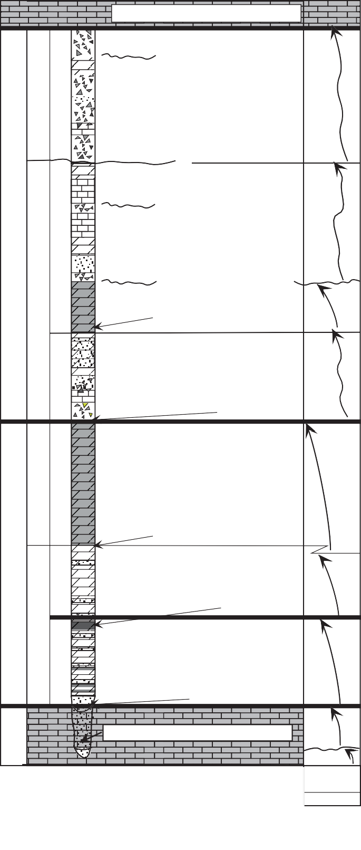& 10). Figure 10 shows lithostratigraphic correlation, suggested depositional environments and SSE stratigraphic thinning onto the Lemhi Arch (Figs. 3,5 & 10).
Three Forks Trident Mbr.
(Logan Gulch
?
D6 is mostly evaporate
Member)
solution breccia. Artifacts after evaporite deposits are implicated (M’Gonigle, 1982).
?
(False Birdbear)
?
D5 is a dark dolostone followed by a lighter colored mix of sandstone, breccia and limestone.
? ?

Flooding
D4 is characterized
(No Name)
by a basal red breccia, limestone, and thick sandstone beds.
Subaerial exposure
D3 is a dark fossiliferous
and laminated dolomudstone with minor light gray dolostone beds.

Gradational, back-stepping contact

D2 is like D1, only there is less sandstone. It is light gray in outcrop.
D1 marker beds

D1 is a light and dark alternating dolostone with sandstone. Breccias cap shallowing-upward beds.
Basal D1 incised channels

Incised paleovalley channel
Figure 9. General Jefferson Formation member descriptions. Example from Liberty Gulch in the central Lemhi Range.
S h e l f
Ubiquitous basal Jefferson Formation quartz sandstones fill small channels cut into the Silurian Laketown Dolomite or earlier Devonian incised channel deposits (Figs. 5 & 10). Reintroduc- tion of siliciclastic sediment and repetitive lithofacies with sharp

Grader and Dehler -- Devonian Stratigraphy in East-Central Idaho
5

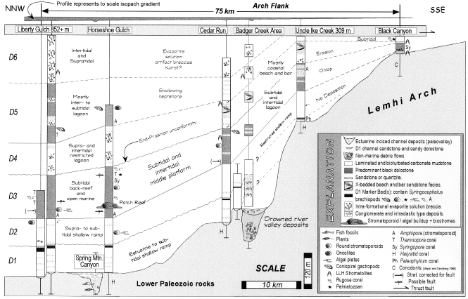

Figure I0. Lithostratigraphic correlation and general environmental interpretations of the Jefferson Formation DI to D6 members in the Lemhi Range

bedding contacts are a common characteristic of all six members resulting in a banded appearance; the "stripy" D1 and D2 mem- bers are the most striking in this respect. In general, the lower Jefferson Formation D1 - D3 members crop out well and are pre- dominately dolostone. The upper Jefferson Formation D4 - D6 members (Grandview Member) crop out poorly and are charac- terized by mixed lithologies and carbonate solution breccia (Fig. 9).

Depositional setting
West of the Lemhi Range, laterally variable units similar to the D1 - D6 members are present in the Lost River Range (Fig. 2) and consist of peritidal carbonates, western-derived siliciclastic deposits and subtidal bioturbated and biostromal units (Simpson, 1983; Wiler, 1992). In comparison, the Lemhi Range strata are lighter in color, have more cryptalgal laminations versus bioturbated zones, are interbedded with more sandstone and brec- cia units and are less fossiliferous. On the basis of SSE-thicken- ing quartz sandstone units, the provenance for recycled sand in the Lemhi Range is interpreted as "from the SE" (Fig. 10). Given the above data and barring local currents and variation in topog- raphy, Lemhi Range sediments represent proximal shelf deposits which accumulated on a gentle, ramp-like profile (Read, 1985). Lithofacies representing outer shelf environments in the west- ern part of east-central Idaho (Fig. 1) do not show any breaks in bathymetry. Deposits in the Lost River Range (600- m to 800+ m thick) and at Fish Creek (245 m) are characterized by dark lower Jefferson Formation subtidal units (Figs. 1, 2, & 9). Laminated dolostones are common to all localities and are present at Grandview Canyon (Fig. 3) with small and rare synsedimentary
folds and down-slope rip-up clasts in the Dark Dolomite Mem- ber (Fig. 2). Up-section stromatoporoid / coral bioherm facies are similar to Canadian "Nisku" outer shelf facies, but do not show evidence for a foreslope margin (McFaddan et al., 1988; Isaacson and Dorobek, 1989; DeSantis, 1996). Although there is evidence for significant base-level fluctuations at this section, environmental interpretations remain limited to "distal ramp" (Dorobek and Filby, 1988). Lithofacies of the Dark Dolomite Member (D3) contrast with peritidal stromatolitic environments lower in the Jefferson Formation section and abundant in the up- per Jefferson Formation (Skipp and Sandberg, 1975; Simpson, 1983; Wiler, 1992; this report). In summary, interpretations of depositional environments in the Lost River and Lemhi Ranges are dependent on vertical stacking patterns and lack seaward data.

Lemhi Range Lithofacies
The rest of this paper uses "inner and middle shelf" in refer- ence to proximity to the Lemhi Arch. Lithofacies and interpreta- tions of shelf depositional environments are presented in Table 2b. Interpretations draw from Shinn (1983), Wilson (1975) and contemporaneous Jefferson lithofacies in SW Montana (Dorobek, 1991) and the Lost River Range (Simpson, 1983; Wiler, 1992). We recognize fossiliferous Devonian lithofacies typical of the Williston basin (Wilson, 1975), Montana (Blount, 1986) and western Canada (Switzer et al., 1992; Wendte, 1992). These lithofacies include black, fossiliferous dolostones, common lami- nated dolo- and lime mudstones and other lighter colored car- bonates. Below, we briefly discuss the most common and least discussed Jefferson lithofacies.

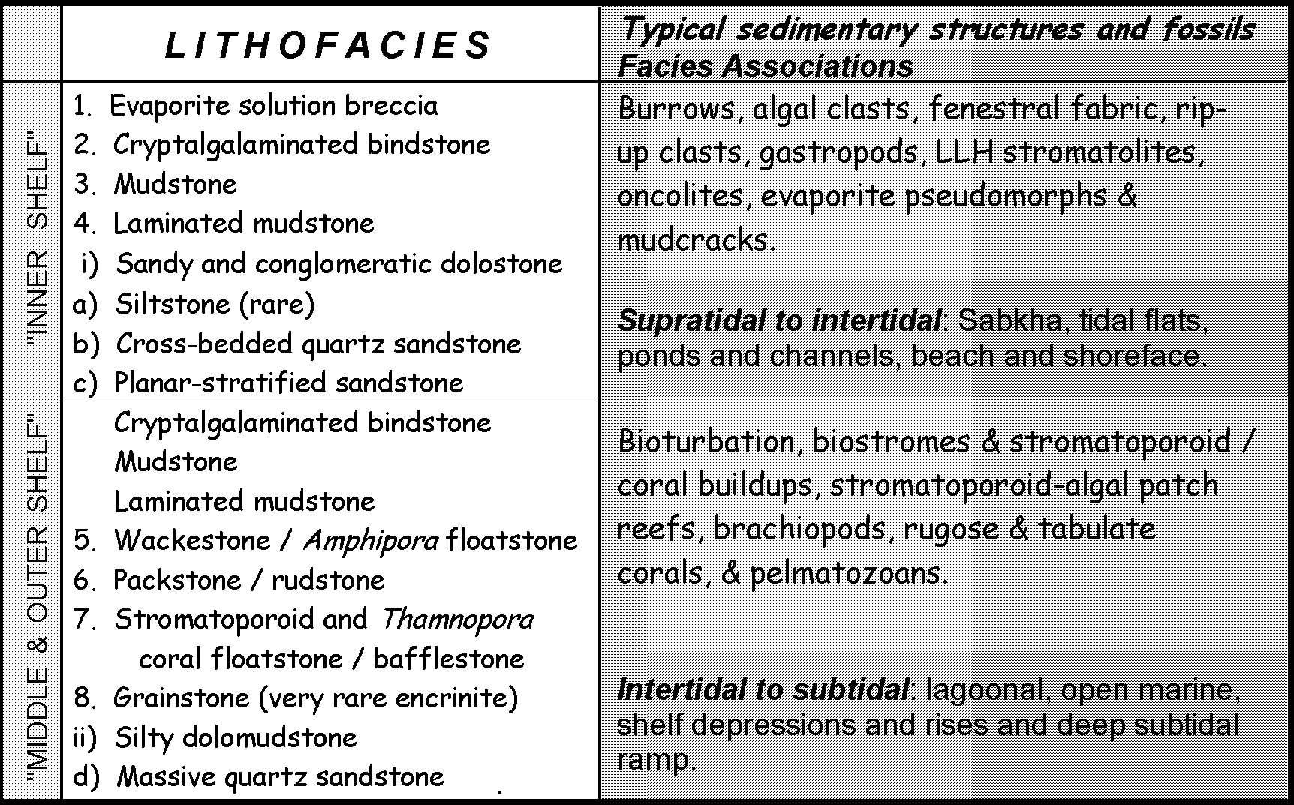

Table 2b. Generalized Jefferson lithofacies and interpretations of depositional environments (I - 8 = dolo- and limestone lithofacies, a - d = siliciclastic lithofacies and i & ii = mixed lithofacies). Predominance of lithofacies 2, 3, and 4 (and I in the upper Jefferson Fm.) suggest that the overall depositional environment was a shallow pericratonic shelf associated with poor water circulation.

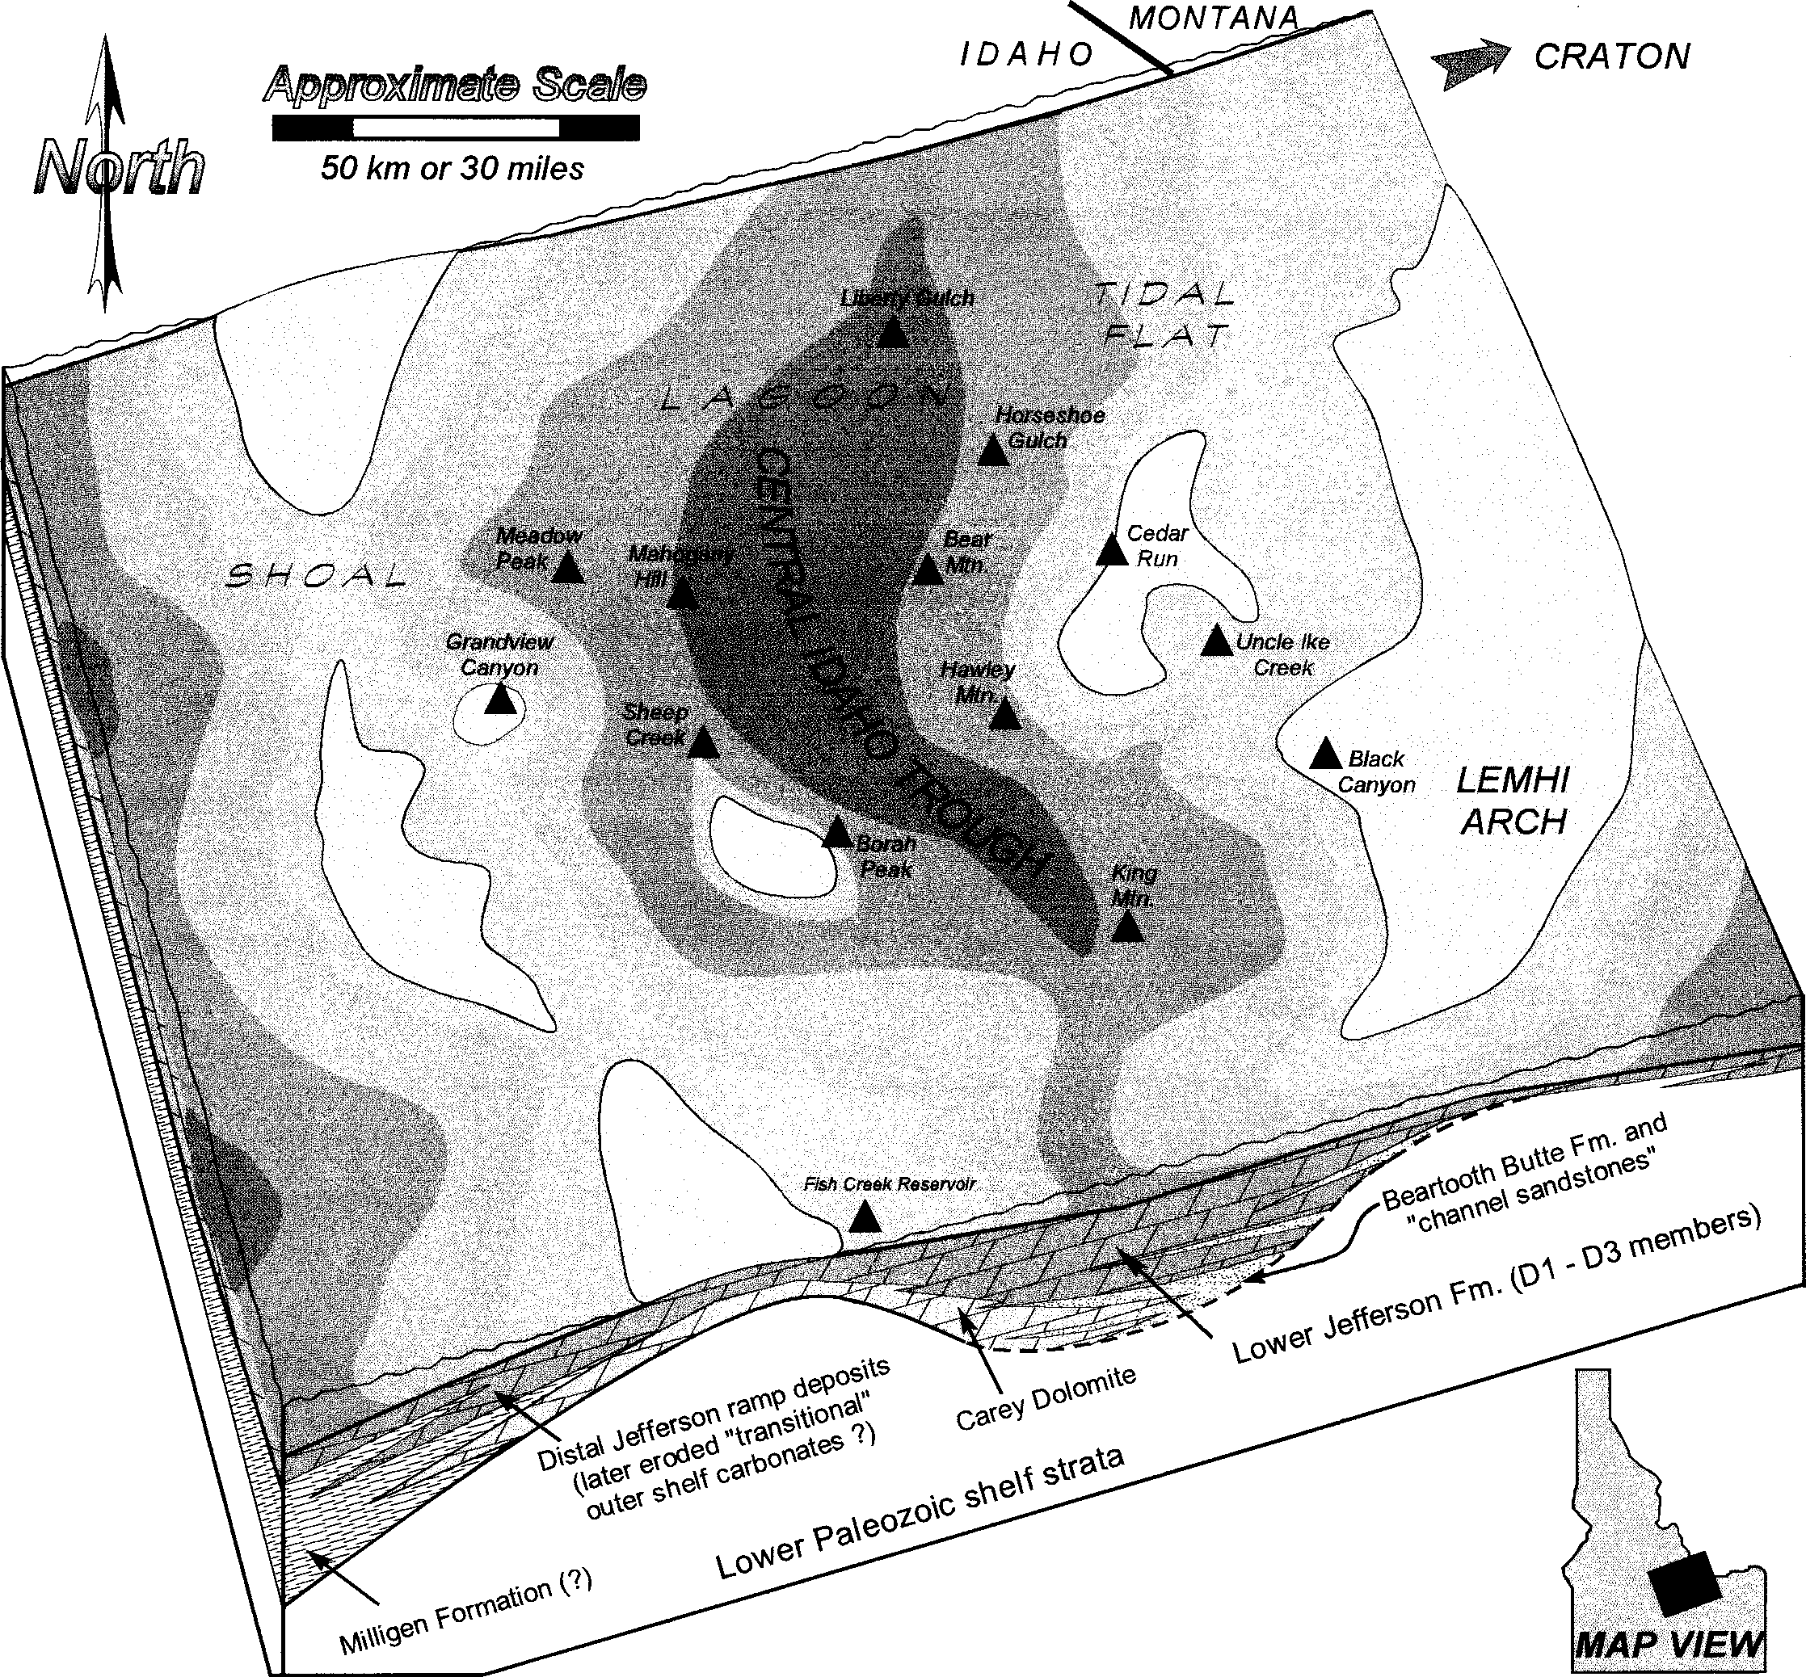

Figure II. Idealized paleogeographic map for the end-Frasnian and Early Famennian (end-D3 / D4 members) in central and east-cen tral Idaho (modified after Wiler, I992). A global(?) lowstand and subaerial exposure (see Figs. 2, 9 & I2) was followed by deposition of D4 member evaporites (forming later solution breccia) and sandstones on the margins of the Central Idaho Trough. This map represents transition from a more open marine lower Jefferson ramp (miogeocline) to a shallow, restricted, and subsiding upper Jefferson shelf (distal Antler foreland?). Grandview Member - members D4, D5 and D6) were deposited with fluctuating (glacio-eustatic?) sea levels.

Shallowing-Upward Successions
Typical shallowing-upward successions (1 - 20 m thick) in the Jefferson Formation include: 1) a bioturbated, fossiliferous or evenly- laminated dolostone (not algal in origin) interpreted as subtidal open marine or deep middle shelf lagoon, followed by 2) a light gray mottled dolostone or crossbedded siliciclastics formed in shallow subtidal to intertidal areas of an outer shelf shoal or inner shelf tidal flat, followed by 3) cryptalgalaminated or stro- matolitic dolostone (intertidal to supratidal), and ending with 4) a

subaerial evaporitic breccia cap. Given the resolution of our Jefferson Formation data, we cannot differentiate between autocyclic sediment-controlled prograding successions or allocyclic "punctuated aggradational sequences" (Pratt et al., 1992; and references therein). However, the extreme size and low- angle nature of the Devonian Euramerican shelf (Wilson, 1975) suggests that small relative base level changes resulted in sharp bedding contacts and lithofacies juxtaposition.

Laminated Dolomudstone
Light and dark planar-laminated dolostones are the most com- mon lithofacies in all members and their wide range of deposi- tional environments (outer shelf to inner shelf) depends on supra-, inter- and subtidal association to other lithofacies. In the D1, D2, D4, D5 and D6 members (Figs. 9 & 10) laminated dolomudstones are sometimes associated with crinkly-laminated rocks or LLH stromatolites. In this case they are considered "cryptalgal" because of the lack of associated open marine fos- sils. When these rocks are in association with quartz sandstone deposits with high-angle and herringbone crossbeds, light gray fenestral dolostones or evaporite-solution breccia, then they are interpreted as shallow-water "inner shelf."
Conversely, rhythmically-laminated dolomudstones are also associated with burrowed and fossiliferous beds or well bioturbated mudstones with sparse skeletal grains. These lithofacies represent shallow to deep subtidal, possibly turbiditic lithofacies of the outer shelf or intra-shelf depressions. Lamina- tions sometimes exhibit an undulatory form and low-angle trun- cation and may also represent offshore storm-influenced primary structures. Alternatively, in association with monospecific Amphipora wackestones and floatstones, laminations are inter- preted as suspension settling layers in quiet waters that were pe- riodically affected by currents and intense burrowing. We argue that conditions controlling the preservation of laminations may relate to subsidence, sediment supply rates, restricted oxygen lev- els, temperature and salinity. Without other lithofacies, they pro- vide no clear depth indication (after Kendall, 1992).

Evaporite-Solution Breccia
Breccia beds (0.1 - 40 m thick) can be laterally continuous (stratiform) or discontinuous. Clasts are white, red and dark gray dolostone and limestone with rare quartzite or chert. Breccias may be matrix- or clast-supported. Carbonate matrixes with de- trital (frosted) quartz grains are common. Angular clasts are some- times stromatolitic. Some matrixes contain disseminated red silt- stones and mud chips. Evaporite pseudomorphs and flow struc- tures are rare. Breccia beds are associated with shallow-water, quartz sandstone beds, cryptalgalaminated and LLH stromato- lites and also occur in contact with featureless dolo- and lime mudstone.
Six different types of breccias and seven different brecciating mechanisms in the Lemhi Range are discussed by M'Gonigle (1982). Generally referred to as evaporite-solution breccias or "rauhwacke," these diagenetically and structurally overprinted shallow marine evaporitic carbonates are proxies for evaporite deposition and subaerial exposure. Lithofacies associations sug- gest that the breccias are supratidal to intertidal and accumulated in sabkha and restricted platform conditions in a semi-arid to arid climate. Associated reworked (recycled?) sandstone beds and quartz grains in breccia matrixes probably originated in aeolian environments to the east.

Banded Dolomite D1 and D2 Members

D1 Description
A ubiquitous system of shallow channels filled with quartz
sandstone overlies Lower Paleozoic dolostone and previous paleovalley deposits (Fig. 5). Dark to light gray and yellowish gray, thinly laminated, partly sandy, petroliferous dolostone is interbedded with yellow, fine- to medium-grained dolomitic and quartz sandstone. Cross-bedding and algal laminations are com- mon. Very thin to thickly bedded sandstone / dolostone cycles (20 cm to 4 m thick) include thick bioturbated dark beds and lighter gray beds with planar laminations. Discontinuous dolo- mitic breccias (< 2 m) vary from a rare flat pebble type to evapor- ite-solution collapse breccia. Clast-supported pebble conglomer- ates are interbedded with "stripy" D1 member rocks at Badger Creek (Figs. 5 & 10).
Sandstones are common throughout the lower part of the D1 member. They are well sorted, fine- to medium-grained, well rounded, and generally have a sheet-like geometry. Lenticular beds are present near the top of the member below conspicuous fossil- iferous "D1 marker bed(s)," (Fig. 9). Black dolofloatstones (3- 15 m thick) are sharply interbedded with a white weathering mi- crocrystalline dolomudstone at Liberty Gulch, Horseshoe Gulch and Cedar Run (Figs. 5 & 10).

D1 Interpretation
The D1 member is organized into a 0 to 107 m thick stack of supratidal to subtidal rocks characterized by cyclic lithofacies successions and a marked decrease in the proportion of siliciclastic deposits upward through the section. A general paucity of grada- tional contacts suggests an abrupt lateral distribution or rapid migration of facies (Mount, 1984). Deposits record a gradual, upward-deepening trend with more dark bioturbated beds up-sec- tion.
Basal sandstones represent proximal to distal tidal channels with lateral tidal flats. Accumulation of coarse-grained rocks at Badger Creek (Figs. 5 & 10) suggest that this area was adjacent to steeper topography (fault?). The appearance of sandstones up- section suggests increasing energy and sea-level fall. This event is followed by deepening which is represented by open marine organisms and preserved storm deposits of the D1 marker bed. Unusual recrystallized algal plate beds found in association with large globular stromatoporoids ("spaghetti beds" which are not Amphipora) have been previously noted at other localities in Idaho and Montana (Scholten and Hait, 1962). These dark beds repre- sent a rapid transgression. The D1 marker bed lies directly below ubiquitous yellow, intra-clastic sandstones with scour marks and wave ripple crossbeds. This (sequence) boundary is interpreted as a widely correlated disconformity with the D2 member (Figs. 9 & 10).
Sharply-banded peritidal facies dominate the D1 member with siliciclastic influx probably from the east (local highs and the exposed Montana shelf, see hatched area in Fig. 6). Peritidal shallowing-upward successions represent shelf response to over- all sea level rise with aggradation and progradation over a low- angle ramp during 3rd order(?) transgression (Fig. 12).

D2 Description
In comparison with the D1 member, the D2 member (Fig. 9) has a higher percentage of light colored, generally thicker car- bonate beds including minor but thick, dark fossiliferous beds.

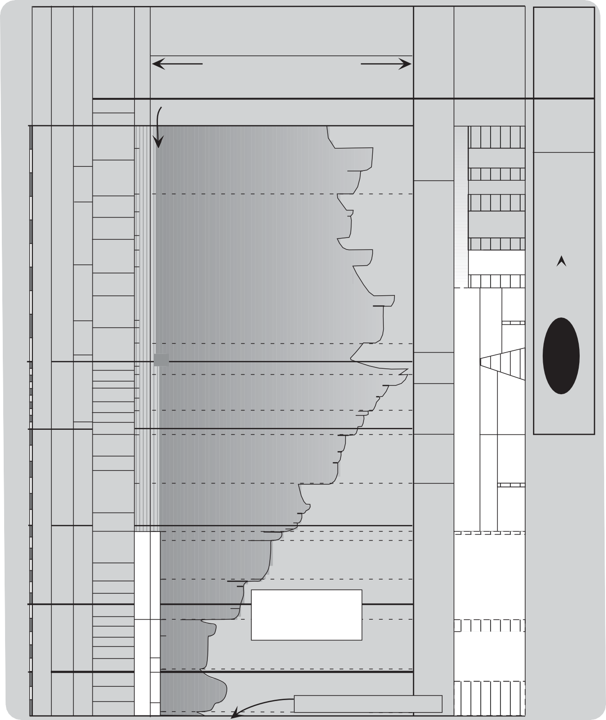
Events, sea-level curve with T/R cycles and conodont zones described in
CARBONIFEROUS
TOURNAISIAN
PALYNOZONES
CONODONT ZONES
EVENTS
Sandberg et al. (1988)

Fall Rise

Equatorial IDAHO
Stratigraphy and
ALBERTA MEGACYCLES

Antarctic BRAZIL / BOLIVIA
Deposits

354

duplicata sulcata
MARGIN EMERGENCE
T/R CYCLES
CRATON FLOODING
Hiatuses

McGowan Creek Fm.
Exshaw
- Banff
Fm.

Bolivian glacial

praesulcata
LL-LN
17

expansa
D E V O N I A N
A N
VCo
16
? postera 15
I
trachytera
N N
GF
14

IIf
Fall accompanied with extinction event

Widespread black shales "Onset of epeirogenic uplifts"

Sappington Members
Trident Mbr.
Palliser - Wabamun
Three Forks
diamictites

Bolivian(?) and Brazilian glacial diamictites

marginifera 13
E
12 IIe
rhomboidea
M
GH

crepida
U P P E R
A
? 11
F
10
V

False Birdbear Member deposition
LoganGulch Mbr. D 6

?
F o r m a t i o n
Grandview Dolomite
GLACIATION ON-SET ?
D5

D4

triangularis 9
Prevalent Euramerican margin sandstones

364
Dark Dol.

linguiformis rhenana
FRASNIAN
IV
8 IId
6
Fall preceeding F/F extinction event
Winter- burn

374

380
jamieae
hassi punctata transitans falsiovalis

disparilis herm.-cristatus
DEVONIAN
GIVETIAN
Brachiopod Stringocephalus

varcus

ensensis kockelianus
MIDDLE
EIFELIAN
australis
costatus
5 IIc
4
3
IIb
2

IIa

1
If

C
?Nevada meteor impact?
?German Kellwasser events?

Cratonic Taghanic onlap
Widespread Reefs

Wood- bend

Beaver- hill Lake

Elk
Ie Point

Id

D3

D2
J e f f e r s o n
Banded Dolmite

D1

?

"Channel Sandstones" (Givetian?)

387

392
partitus patulus serotinus
inversus nothoperbonus 6
LOWER (part)
EMSIAN
gronbergi dehiscens B 5
PRAGIAN
pirenese 4
See Figs. 4, 7 & 8 for Ic
correlation and sequences (B/C) and
parasequences? (3-6) Ib

Ia

?
Unnamed Unit
Incised Paleovalleys
(Beartooth Butte Fm?)

kindlei
sulcatus 3
Maximum Tippecanoe-Kaskaskia lowstand ?
near Pridolian (Silurian)-Lockovian boundary

Figure I2. Devonian eustatic curve for Euramerica (Johnson et al., I985) correlated to lithostratigraphic Lemhi Range Jefferson Forma- tion members and Alberta mega-cycles (not to scale). Isaacson et al. (I998, in press) suggest an alternative, more regressive F amennian sea-level curve characterized by abundant hiatuses on the equatorial Idaho shelf (Grandview Member) and on other continents. Hiatuses were caused by Gondwanan glaciation events.

Siliciclastic material is abundant at the base of the member mark- ing a sharp change from the D1 marker beds below. D2 lithofacies are similar to D1 lithofacies, although thicker fossiliferous or bioturbated beds are overlain by cryptalgalaminated beds and are capped by birdseye dolostones rather than discontinuous brec- cias as in D1. Thin-bedded crossbedded quartz sandstone units are present at Horseshoe Gulch (Fig. 10), but diminish up-sec- tion. At Liberty Gulch these rock types are present with matrix- supported conglomerate, solution breccias, tan-colored fenestral dolomudstones and very light gray planar laminated units. Up- section, brachiopod wackestone beds and black dolofloatstone are present with bulbous stromatoporoids. This member is capped by light-colored, laminated, conglomeratic sandstone and the pres- ence of oncolites at both Liberty Gulch and Horseshoe Gulch. Contact with the D3 member (Dark Dolomite Member) is grada- tional.

D2 Interpretation
Member D2 is separated from member D1 by a disconfor- mity that may be related to the Taghanic onlap event in Appala- chia (Johnson et al., 1985). Like D1, D2 represents a deepening- upward sequence with periods of autocyclic carbonate aggrada- tion during stillstands. Shallow shelf, wave-dominated siliciclastic beds of the basal D2 member continue up-section with rhythmi- cally- laminated and bioturbated dolostones and local intraclastic deposits. The upper part of D2 represents subtidal middle shelf environments.
High-energy winnowed grainstones are entirely lacking. In- stead, D2 lithofacies are similar to the lime mudstone-dominated shoaling-upward shelf cycles of the standard facies belts 6 - 9 (Wilson, 1975). A greater percentage of light gray carbonate beds give this member a light colored appearance and suggests more efficient water circulation over the shelf. Dark dolomudstone bands cut across this member at the Horseshoe Gulch cirque rep- resenting depositional excursions into deeper environments (an- oxic?). Stromatoporoid beds were briefly established here during open marine conditions prior to shallowing and restriction by carbonate aggradation. End-D2 member oncolitic lithofacies sug- gest the westward migration of intertidal environments during a highstand.

Regional Distribution of Banded Dolomite Members D1 and D2
Isopach thinning and facies changes of the D1 and D2 mem- bers over the Badger Creek area are interpreted as the flank of the (earlier questioned) Lemhi Arch (Figs. 5 & 10). Banded D1 and D2 members do not occur south of Uncle Ike Creek or in the Beaverhead Range (also noted by Scholten and Hait, 1962). The mostly conformable central Lemhi Range sections are therefore contrasted by hiatuses to the SSE (e.g., Black Canyon). At Rail- road Canyon (Fig. 1), 70 m of Jefferson strata include the upper D1 and lower D2 members (Ruppel and Lopez, 1988). At Cop- per Mountain we report thin deposits of Jefferson and Three Forks Formations in a faulted relationship. Similar relationships exist at Black Canyon (Mapel and Sandberg, 1968), where lower Jefferson rocks may not be present or represent condensed sec- tions (Fig. 10). Scholten and Hait (1962) suggested that all of
these rocks are the upper Jefferson Formation.
Similar to D1, a basal member (Unit I, Fig. 2) is 30 to 100 m thick and overlies the Carey Dolomite in the central and southern Lost River Range (Wiler, 1992). Jefferson Formation sediments in this area accumulated in shallow water and were influenced by a long-lived western positive area; anomalous facies were recorded at Fish Creek and Borah Peak (Wiler, 1992). The western equiva- lent of the D2 member in the Lost River Range (Unit II) varies from 110 m to 190 m. These rocks are dark, bioturbated or fossil- iferous dolostones and light-colored, laminated dolostones (Wiler, 1992).
The restricted inner to middle shelf setting of the (Givetian - Frasnian) D1 and D2 members in the Lemhi Range are similar to the low-energy, lime-mudstone cycles described from the Duperow Formation in the Williston basin (Wilson, 1975). The latter Frasnian rocks formed in a vast, shallow back-reef lagoon behind the Cooking Lake platform and Leduc reefs of Alberta.

Dark Dolomite D3 Member

D3 Description
The Dark Dolomite D3 member is a thick-bedded, dark gray, fossiliferous and bioturbated dolostone interbedded with medium gray, laminated dolomudstone. D3 is 182 m thick at Liberty Gulch and Horseshoe Gulch, but it thins and changes character to the SSE (Fig. 10). At Cedar Run, Badger Creek and Bunting Can- yon, black petroliferous, stromatoporoid dolorudstones are interbedded with abundant crossbedded sandstones, stratiform breccia units and large, stacked columnar stromatolites. At Uncle Ike Creek, D3 is 85 m thick and characterized by subequal amounts of yellow quartzite and sandstone, black Amphipora wackestone beds and algal-laminated dolobindstone. At Black Canyon, dark bioturbated dolostone beds with Syringopora debris and hard grounds are 23+ m thick. Rare carbonate cavity fabrics resemble those described at a Frasnian impact site in Nevada (Warme and Kuehner, 1998). These rocks have D3 lithofacies affiliation but correlation is uncertain (Fig. 10).
Abrupt along-strike changes in biofacies characterize the D3 member in the central Lemhi Range. Biofacies and isopach varia- tions also are present in equivalent rocks (Unit III - Fig. 2) in the Lost River Range (Wiler, 1992). We report a small stromatoporoid-algal buildup (15 m) at Horseshoe Gulch and di- verse fossil assemblages at Liberty Gulch (Fig. 10); Thamnopora coral debris, Amphipora floatstones and gastropod beds are as- sociated with planar-laminated dolostones and relate to facies described at the Grandview Canyon bioherm (Isaacson and Dorobek, 1989; DeSantis, 1996). Reports of Lost River Range biostromes (Wiler, 1992) led to the discovery of new buildups in the western part of the study area at Rock and Sheep Creek (DeSantis and Grader, ongoing field work; Fig. 1).

D3 Interpretation
Regional evidence for deeper water environments includes the lack of current-generated structures and thick, dark gray, bioturbated and biostromal dolostones suggesting photic, open marine deposition. Thick, organic-rich dolomudstone beds are the subtidal component of asymmetrical, shallowing-upward suc- cessions that commonly end in disrupted fossiliferous facies or

rare sedimentary breccias. The geometry and facies of D3 shallowing-upward successions are different from the peritidal successions of the D1 and D2 members (although planar-lami- nated lithofacies are common to both).
Establishment of this Dark Dolomite Member suggests a gradual eastward back-stepping of facies belts (drowning) onto the Montana craton. However, proximal to the Lemhi Arch (Figs. 10 & 11), monospecific Amphipora dolowackestones reflect shal- low quiet lagoonal environments. At Uncle Ike Creek, these lithofacies are sharply interbedded with crossbedded sandstones indicating alternation with nearshore intertidal environments (Fig. 10). At Cedar Run, algal laminations, columnar stromatolites, fenestral fabrics and solution breccias suggest that autocyclic shallowing occurred over this topographic high during generally transgressive conditions. Alternatively, allocyclic sea level drops occurred. Abrupt vertical facies changes and hardgrounds sug- gest disconformities and condensed sections in the southern Lemhi Range (Lemhi Arch, Figs. 10 & 11).
We interpret a gradual ramp (Read, 1985) with middle and outer shelf biogenic control of topography. Western, Lost River Range buildups and eastern Lemhi Range back-reef facies sug- gest topographic buildup at the shelf margin. Presence of lagoonal depressions with stromatoporoid patch reefs, intertidal environ- ments on the Lemhi Arch (Fig. 10), and lack of stenohaline pelmatozoans (common only at King Mountain, Moser, 1981 - Fig. 1) suggest variable middle shelf environments in the Lemhi Range. Limited circulation and wave fetch is suggested. Sand- stones remained trapped on the inner shelves east (and west?) of the study area. Sub-basins and overall shallow subtidal environ- ments (with shallow conodont biofacies) were also suggested for equivalent rocks in the Lost River Range (Wiler, 1992).

D3/D4 (Frasnian/Famennian) Boundary Paleogeography
Consecutive deepening and shallowing events are recorded by detailed biofacies stacking patterns in the Dark Dolomite Member (D3) at the Grandview buildup (DeSantis, 1996; Figs. 1 & 11). These events and changes in sedimentation following sub- aerial unconformity have been ascribed to base level changes - i.e., drowning, subaerial exposure, continental loading and tec- tonic uplift (Antler Orogeny), global extinction events, increased sediment supply and turbidity (Dorobek and Filby, 1988; Isaacson and Dorobek, 1989). Siliciclastic shallow-water sedimentation "from the west" due to outer shelf uplift is not well documented (e.g., paleocurrent data of Wiler, 1992), but general facies pat- terns in the Lost River Range support this depositional setting (Simpson, 1983; Isaacson et al., 1983a).
We provide a paleogeographic interpretation of the region during end-D3 subaerial exposure and D4 member deposition (Fig. 11). Global glacio-eustatic draw-down was accompanied by major shifts in benthic marine habitat and later Famennian climate fluctuations (Sandberg et al., 1988b; Isaacson et al., 1998, in press; Fig. 12).

D4 Member (Lower Grandview Member)

D4 Description
The D4 member ("unnamed member," Isaacson et al., 1983b),
consists of <122 m of light to dark limestone, with minor reddish limestone, dark gray dolomite, limestone breccia and fine- to coarse-grained sandstone beds. Laminated limestone and mas- sive quartzite beds are common. Rare mudcracks are present within thick yellow and red solution breccias at Horseshoe Gulch and Bear Mountain (Figs. 1 & 10). At Cedar Run, 97 m of section is dominated by planar and crossbedded fine- to coarse-grained quartz sandstones interbedded with crinkly-laminated algal dolobindstone, LLH stromatolites and breccia units. These lithofacies grade laterally into Amphipora wackestones.
Basal D4 breccias in the central Lemhi Range are similar to those at Grandview Canyon where undulatory paleorelief with breccia and mixed carbonate and sandstone strata overlie the Grandview bioherm (Isaacson and Dorobek, 1989). In the Lost River Range, Wiler (1992) characterized his Unit IV (Fig. 2) by the increase in light-colored beds, dominant dolomudstones, basal intraclastic zones, common quartz sandstone and algal bindstones with shallow-water features.

D4 Interpretation
Grandview Dolomite equivalent beds in the Lemhi Range (D4 through D5) are above the same unconformity as documented in the Lost River Range (Wiler, 1992; Isaacson and Filby, 1988; Figs. 2, 10 & 12). This time interval (end-Frasnian to Famennian) witnessed end-Frasnian global sea level drop, the end of Nisku reefs in Canada and the time of anoxic Kellwasser events (Wendte, 1992; Sandberg et al., 1988b). Thick quartz sandstone bodies and associated solution breccias with shallow-water indicators (e.g., herringbone crossbedding) suggest "inner shelf" environments in the Lemhi Range. These deposits may represent regressive outer shelf barrier beach sands with inner and outer shoreface environ- ments - the 'missing barrier facies' of SW Montana (Dorobek, 1991). Coeval analogues include the Beirdneau Formation, Utah (Beus, 1968), the uartz Spring Member of the Lost Burro For- mation, California (Albright, 1991) and Canadian siliciclastics of the early Wabanum / Palliser megasequence (Morrow and Geldsetzer, 1988).
In the Badger Creek area, predicted D4 facies changes are present where changes in the isopachs and facies of D3, D2, D1 and earlier deposits preceded them (Figs. 5 & 10). Mixed sand- stone and carbonate rock types and thick local sandstone depos- its suggest overall sea level regression with variable accommo- dation space (related to tectonic subsidence?). It is inferred that thin lower Jefferson deposits on the Lemhi Arch (e.g., Black Can- yon) were subject to subaerial erosion at this time (Figs. 10 & 11).
Sandstone beds are thin at D4 localities in the central Lemhi Range (Fig. 10); they are interbedded with algal carbonates, la- goonal Amphipora floatstones and several evaporite-solution breccias. Distribution of D4 sandstone lithofacies and associa- tions suggest a local sand source (and facies belt stacking) and aggradational evaporite tidal flats in the Lemhi Range. Thicker isopachs and shoaling marine conditions in the Lost River Range (Fig. 11) suggest that the Central Idaho Trough underwent differ- ential subsidence as it filled with sediment.
From conodont data, the lower half of Unit IV in the Lost River Range (D4 equivalent - Fig. 2) occurs entirely in the

Lingui ormis zone and represents rapid sand influx from the west
- apparently the result of outer shelf (forebulge?) uplift (Wiler, 1992). A slow, coeval flooding of the Lemhi Arch at this time may support this interpretation if deposits under the D5 member ("False Birdbear"- Figs. 2 & 10) at Black Canyon are really post- D3, Famennian rocks (as proposed by Scholten and Hait, 1962). To solve this problem we sampled for conodonts, but none were found.

D5 Member (Upper Grandview "False Birdbear" Member)

D5 Description
The D5 member and its equivalent Unit V in the Lost River Range are known as the False Birdbear Member (Mapel and Sandberg, 1968; Fig. 2). D5 is composed of <214 m of dark gray, petroliferous dolostone with light gray dolostone, limestone, sand- stone and stratiform carbonate breccia beds (Figs. 9 & 10). At Horseshoe Gulch a thick dark dolomite D5 unit is composed of alternating bioturbated and cryptalgalaminated beds with sparse fossils including Amphipora and algal-coated gastropods. At Cedar Run, 70 m of sandy, laminated dolostone with quartzite interbeds correlates(?) with D5 rocks in the central Lemhi Range (Fig. 10). The contacts with the D4 and D6 members are grada- tional and include multiple breccia units. At Black Canyon and Uncle Ike Creek, the D5 member is represented respectively by only 23+ m and 39 m of bioturbated, sparsely fossiliferous, cryptalgalaminated and stromatolitic dolomudstones, thin brec- cia units and quartzite beds. At these localities, the D6 member is absent and the Jefferson Formation is overlain by the Trident and basal Sappington Members of the Three Forks Formation (Fig. 2).
Compared to the D4 and D6 members, the D5 member has fewer breccia intervals, more dark bioturbated dolostone beds and abundant cryptalgalaminated beds. In the Lost River Range the False Birdbear (Unit V - Fig. 2) is thinner (~100 m thick) and crinoid grainstones are also found interbedded with common cryptalgalaminated lithofacies (Wiler, 1992).

D5 Interpretation
As breccia beds increase in thickness up-section and crop out poorly, interpretation of the stratigraphic record deteriorates. Evaporites associated with D5 solution breccia beds have not been identified in outcrop, but pseudomorphs after evaporites are present in equivalent strata in the Lost River Range (Simpson, 1983). Evaporites are also reported in the subsurface near the Tendoy Mountains (M'Gonigle, 1982). Artifacts after evaporites, few metazoans, crossbedded sandstone, bioturbated mudstone and common cryptalgal rocks suggest supra- to shallow subtidal re- stricted conditions.
Rocks of the central Lemhi Range record evaporite-carbon- ate lowstand/flood cycles, which started during the end-Frasnian and continued into the Famennian. Rapid(?) fluctuating base level changes controlled these cycles which were preserved probably due to differential tectonic subsidence. Overall this member rep- resents a transgression (Fig. 12). Inter-glacial transgression has been previously proposed for the (same) False Birdbear Member (Sandberg et al., 1988a).

D6 Member (Logan Gulch Member of the Three Forks Formation)

D6 Description
The D6 member is <168+ m thick at Liberty Gulch and thins over the Badger Creek area (Fig. 10). D6 consists of thick-bed- ded, medium to light gray limestone, limestone evaporite-solu- tion breccia and minor fine-grained sandstone interbeds. The unit is barren of skeletal remains. Thin bioturbated dark dolostone beds are interbedded with very thick breccias near the base. In the Lost River Range, Wiler (1992) reported a 10 to 30 m thick Unit VI (D6 equivalent?) that is a light and dark sandy dolomudstone. Wiler also noted diverse metazoans, bioturbation, algal laminated rocks and 26 m of quartz arenite at Borah Peak (Figs. 1 & 2).

D6 Interpretation
This member can best be described as "damned rubble" (after Laznicka, 1988) and is correlative with the "evaporative Logan Gulch Member" of the Three Forks Formation in Montana (Fig. 2; Sloss and Laird, 1947; Sandberg, 1962). These thick evaporite successions interbedded with bioturbated carbonates suggest lowstands were followed by occasional flooding. Thin red shales interbedded with laminated dolostone (as reported from lower Three Forks Fm. in Montana; Rau, 1968) are observed as red mud chips within massive breccia units in the Lemhi Range. Com- parable depositional environments suggest high salinity and scat- tered briny ponds over embayments and sub-basins (after Rau, 1968). Part of the Lemhi Range was a restricted shallow basin which experienced major drops in base level that exposed most of the Famennian shelf. This process may have been rapid with possible phreatic dissolution at separate horizons (Isaacson et al., 1997).

Jefferson Formation Paleotectonic and Depositional Setting
From a sedimentological standpoint we cautiously apply Walter's law to Devonian facies patterns to explain paleo-tec- tonic setting. Interpretations of 1) a restricted Lower Devonian shelf (Dehler, 1995; see above), 2) ramp-type Middle to Upper Devonian deposits with limited western buildups (Dorobek and Isaacson, 1989), and 3) shoaling Upper Devonian environments influenced by eastern and western paleogeographic shelf features (Sandberg et al., 1975; Moser, 1981; Simpson, 1983; Isaacson et al., 1983a; this report) suggest an overall transitional "passive margin," yet not a west-thickening wedge of sediment. That Jefferson Formation deposits in the Lost River Range were distal ramp deposits, part of an Antler (shale-filled) foredeep (Dorobek et al., 1991; Fig. 3) is problematic because isopach and shallow local facies changes suggest a two-sided (east to west) lensoid- shaped sequence of rocks (Poole et al., 1992). This is manifested in the Central Idaho Trough (Wiler, 1992; Figs. 3 & 11) which is dominated by shallow peritidal, (pericratonic?) Jefferson Forma- tion facies.
Development of the Central Idaho Trough caused basin re- striction as reflected in dolomudstone-dominated lagoonal, and evaporite-solution breccia facies of the upper Jefferson Forma- tion. We question whether the cause of this progression was by

simple "forebulge" flexure of the continental margin west of the Lost River Range (Wiler, 1992), but acknowledge evidence of Devonian extension (Garmezy, 1981; Turner and Otto, 1988; 1995) and later Mississippian pull-apart sedimentation (Wilson et al., 1994; Link et al., 1996). We additionally provide possible evidence for Middle Devonian extension in the Lemhi Range (Fig. 5). Perhaps a (smaller) modern analogue is the geologically var- ied, tectonically and eustatically influenced Belize coast (Lara, 1993).

DISCUSSION
Environmental interpretations of Lower, Middle, and Upper Devonian facies in Idaho suggest a broad shift from a wet to arid climate. This is inferred by the change from Early Devonian karst features and associated fluvio-karst incised valleys, to Middle Devonian shallow marine systems and Late Devonian evaporitic basins. This trend is compatible with northward Euramerican drift into an arid belt (Witzke and Heckel, 1988; Boucot, 1988) but is also associated with a change from greenhouse to icehouse cli- mate modes (Worsely et al., 1984).
The primary purpose of this paper is to describe the details of Devonian facies relations within a regional stratigraphic frame- work. Understanding regional paleogeography and depositional controls will lead to a better understanding of the effects of these on early vertebrate evolution and will help to differentiate tec- tonic from eustatic stratigraphic signatures. Our preliminary depo- sitional sequences, lithostratigraphic and paleogeographic inter- pretations are summarized in Figs. 4, 6, 7, 10 & 11 and are corre- lated to sea-level curves in Figs. 8 & 12. Topics and questions regarding local, regional and global Devonian depositional con- trols are addressed below.

Lower Devonian Vertebrate Fauna and Depositional Environments
Vertebrate faunal distributions across Idaho during the Early and Middle Devonian were controlled by sequence-scale trans- gressive/regressive cycles (Figs. 7 & 8) and afford a significant window into the Age of the Fishes. The discovery of thelodonts and tesserate elements (microvertebrates) in clastic deposits is significant for biostratigraphic control because it offers transi- tional- facies index fossils that link conodont-bearing distal fa- cies with macrovertebrate (fish) fauna of marginal marine to ter- restrial facies. Habitat in "calanque-type" drowned fluvio-karst valleys and related nearshore environments (Fig. 6) was essen- tial(?) for vertebrate evolution and may be responsible for Middle Devonian(?) pteraspid hold-overs at Spring Mountain Canyon.

2a. Depositional Versus Tectonic Thinning in the Lemhi Range
Facies patterns along the NNW-SSE Lemhi transect line sup- port a transitional facies zone and hinge line at Badger Creek (Fig. 10). This hinge stepped eastward and was responsible for thinning trends and controls of Lower Devonian siliciclastic rocks at Meadow Peak and conglomerate debris flows in the Badger Creek area. Up-section at Badger Creek, Frasnian and Famennian deposition of lagoonal and high-energy D4 strandline deposits
represent up-dip shallowing along the flank of the Lemhi Arch. Paleo-tectonic controls are implicated, however we argue that the D1 - D6 members thin depositionally and passively towards the southern Lemhi Range (Fig. 10). These facies changes are not an artifact of Late Paleozoic uplift or Sevier/Laramide thrust juxta- position.

2b. Control of Stratigraphic Stacking Patterns
We have assembled a 3rd order sequence stratigraphy for Lower and Middle Devonian strata (Figs. 4, 7 & 8). However, a defining sequence stratigraphic interpretation is still premature for Upper Devonian rocks. Underlying causes of base level change for Lower and Middle Devonian rocks cannot be narrowed beyond theo- retical global tectonic cycles and ocean volume changes (Prothero, 1990). There is also no evidence of glaciations driving Early Devonian sea-level changes. Conversely, glacio-eustatic controls were previously anticipated for the Upper Devonian Jefferson Formation in Montana (Dorobek, 1991), the Devonian of Euramerica (Johnson et al., 1985), and are implicated in other Late Devonian data (Schlager, 1981; Copper, 1986; Stearn, 1987; Sandberg et al., 1988b). We believe that the thick upper Jefferson strata of east-central Idaho contain a good record of relative base level shifts including glacio-eustatic sea-level changes.
Regional Jefferson Formation facies changes allow for some comparison of tectonic (foreland) versus eustatic depositional controls. Most important is the end-Frasnian (D3/D4) unconformity and widespread change in sedimentation across the entire shelf (Figs. 11 & 12). This may have been a result of brittle response to outboard loading and flexure of continental crust. Yet this interpretation must also compete with extrabasinal hia- tuses related to periglacial data from Gondwana, Frasnian/ Famennian extinction and (global?) changes in Famennian sedi- mentation (Caputo, 1985; Caputo and Crowell, 1985; Buggisch, 1991; Isaacson et al., 1997; 1998, in press; Diaz-Martinez et al., 1998, in prep.).
We are skeptical that sea-level turn-around, thick evaporite solution breccias and sandstone deposition in the Lemhi Range are solely explained by tectonic controls (and siliciclastic influx "from the west"). We argue that siliciclastic and evaporite depos- its were ubiquitous during eustatic draw-down and that the shal- low Central Idaho Trough had a long-lived eastern siliciclastic source area. On the basis of compelling evidence for Late Devo- nian climate change, we submit that glacio-eustatic sea-level changes influenced the equatorial Idaho shelf and upper Jefferson stacking patterns starting at end-Frasnian time (Figs. 2, 10 & 12). Glacio-eustatic signals were overprinted onto slower Antler tec- tonic depositional controls.

ACKNOWLEDGMENTS
David Elliott, Geological Society of America, Wyoming Geo- logical Association, and Friday Lunch Clubbe provided Carol Dehler with support. Research in the Lemhi Range by George Grader was kindly supported by Peter Isaacson. Encouragement came from Roger Hoggan and Paul Link. We thank Mike DeSantis who discovered new bioherms and tested George Grader's outra- geous ideas in the Lost River Range. We are greatly indebted to

our reviewers, Maya Elrick and (especially) Paul Link. Finally, thanks to Scott Hughes and Glenn Thackray for their hard work on this guidebook and his patience with the "Devonian authors".

REFERENCES
Aitken, J.D., 1966, Sub-Fairholme Devonian rocks of the eastern Front Ranges, southern Rocky Mountains, Alberta: Geological Survey of Canada, Paper 64-33, 88 p.
Albright, G.R., 1991, Late Devonian and Early Mississippian paleogeography of the Death Valley region, California, in Cooper, J.D., and Stevens, C.H., eds., Paleozoic paleogeography of the western United States - 2: Pacific section of Society of Economic Paleontologists and Mineralogists, v. 67, p. 271-280.
Beus, S.S., 1968, Paleozoic stratigraphy of Samaria Mountain, Idaho-Utah: American Association of Petroleum Geologists Bulletin, v. 52, no. 5, p. 782- 808.
Beutner, E.C., 1968, Structure and tectonics of the southern Lemhi Range, Idaho [Ph.D. thesis]: University Park, The Pennsylvania State University, 106 p. Blount, G.C., 1986, Stratigraphy, depositional environment and diagenesis re- lated to porosity formation and destruction in the Devonian Jefferson For- mation, Sawtooth Range, Northwestern Montana [Masters thesis]: Moscow,
University of Idaho, 100 p.
Boucot, A.J., 1988, Devonian paleogeography: an update, in McMillan, N.J., Embry, A.F., and Glass, D.J., eds., Devonian of the World: Canadian Soci- ety of Petroleum Geology Memoir 14 (3), p. 211-227.
Boucot, A.J., and Janis, C., 1983, Environments of early Paleozoic vertebrates: Paleooceanography, Paleoclimatology, Paleoecology, 41, p. 251-287.
Buggisch, W., 1991, The global Frasnian-Famennian Kellwasser Event: Geologische Rundschau, v. 80, no. 1, p. 49-72.
Caputo, M.V., 1985, Late Devonian glaciation in South America: Paleogeogra- phy, Palaeoclimatology, Palaeoecology, 51, p. 291-317, Amsterdam.
Caputo, M.V., and Crowell, J.C., 1985, Migration of glacial centers across Gondwana during the Paleozoic Era: Geological Society of America Bulle- tin, v. 96, p. 1020-1036.
Choquette, P.W., and James, N.P., 1988, Introduction, in James, N.P. and Choquette, P.W., eds., Paleokarst: Springer Verlag, New York, p. 1-21.
Churkin, M.Jr., 1962, Facies across Paleozoic miogeosynclinal mar gin of cen- tral Idaho: American Association of Petroleum Geologists Bulletin 46, no. 5, p. 569-591.
Copper, P., 1986, Frasnian/Famennian mass extinction and cold water oceans: Geology, v. 14, p. 835-839.
Dehler, C.M., 1995, Paleo-environmental and stratigraphic analysis of Lower Devonian Beartooth Butte Formation and associated strata, central-eastern Idaho [Masters thesis]: Flagstaff, Northern Arizona University, 157 p.
Denison, R.H., 1968, Devonian fishes from the Lemhi Range of Idaho, Fieldiana: Geology, Field Museum of Natural History, v. 16, no. 10, p. 269-288.
DeSantis, M., 1996, Anatomy and succession of a Devonian coral-stromatoporoid carbonate build-up, Grandview Canyon, east-central Idaho [Masters the- sis]: Moscow, University of Idaho, 64 p.
Diaz-Martinez, E., Vavrdova, M., Bek, J., and Isaacson, P.E., 1998, Late Devo- nian (Famennian) glaciation in western Gondwana: evidence from the cen- tral Andes, in preparation.
Dineley, D.L., 1988, The radiation and dispersal of Agnatha in Early Devonian time. Paleontology, Paleoecology and Biostratigraphy, in N.J. McMillan,
A.F. Embry, and D.J. Glass, eds., Devonian of the World, v. 3: Regional Synthesis: Canadian Society of Petroleum Geologists, Memoir 14, p. 569- 577.
Dineley, D.L., and Loeffler, E.J., 1976, stracoderm faunas of the Delorme and associated Siluro-Devonian formations, Northwest Territories, Canada: Jour- nal of Vertebrate Paleontology, v. 2, p. 389-406.
Dorf, E., 1934, Stratigraphy and paleontology of a new Devonian Formation at Beartooth Butte, Wyoming: Journal of Geology, v. 42, p. 720-737.
Dorobek, S.L., and Filby, R.H., 1988, rigin of dolomites in a down-slope bioherm, Jefferson Formation (Devonian), central Idaho: Evidence from REE patterns, stable isotopes, and petrography: Bulletin of Canadian Petroleum Geology, v. 36, no. 2, p. 202-215.
Dorobek, S.L., 1991, Cyclic platform carbonates of the Devonian Jefferson For- mation, southwestern Montana, in Cooper, J.D., and Stevens, C.H., eds., Paleozoic paleogeography of the western United States - 2: Pacific Section
of Society of Economic Paleontologists and Mineralogists, v. 67, p. 507- 526.
Dorobek, S.L., Reid, S.K., and Elrick, M., 1991, Antler foreland stratigraphy of Montana and Idaho: The stratigraphic record of eustatic fluctuations and episodic tectonic events, in Cooper, J.D., and Stevens, C.H., eds., Paleozoic paleogeography of the western United States - 2: Pacific section of Society of Economic Paleontologists and Mineralogists, v. 67, p. 487 - 507.
Dorobek, S.L., 1995, Synorogenic carbonate platforms and reefs in foreland basins: Controls on stratigraphic evolution and platform / reef morphology, Stratigraphic Evolution of Foreland Basins: Society of Economic Paleon- tologists and Mineralogists No. 52, p. 127-147.
Dover, J. H., 1980, Status of the Antler orogeny in central Idaho: Clarifications and constraints from the Pioneer Mountains, in Fouch, T.D., and Magathan, E.R., eds., Paleozoic paleogeography of the west-central United States: So- ciety of Economic Paleontologists and Mineralogists, Rocky Mountain Sec- tion, p. 371-386.
Elliott, D.K., and Loeffler, E.J., 1988, A new agnathan from the Lower Devo- nian of Arctic Canada, and a review of tesselated heterostracans: Paleontol- ogy, v. 32, part 4, p. 883-889.
Elliott, D.K., and Ilyes, R.R., 1995, Lower Devonian vertebrate biostratigraphy of the western United States: Modern Geology.
Eyles, N., and Young, G.M., 1994, Geodynamic controls on glaciation in Earth history, in Deynoux, et al., eds., Earth's glacial record, Cambridge Univer- sity Press, Great Britain, p. 1-28.
Garmezy, L., 1981, Geology and tectonic evolution of the southern Beaverhead Range, east-central Idaho [Masters thesis]: University Park, The Pennsylva- nia State University, 155 p.
Giles, K.A., and Dickinson, W.R., 1995, The interplay of eustacy and lithos- pheric flexure in forming stratigraphic sequences in foreland settings: An example from the Antler foreland, Nevada and Utah, Stratigraphic Evolu- tion of Foreland Basins: Society of Economic Paleontologists and Miner- alogists Special Publication No. 52, p. 187-211.
Grader, G.W., 1998, Stratigraphy of the Devonian Jefferson Formation and paleovalley deposits in the Lemhi Range, east-central Idaho [Masters the- sis]: Moscow, University of Idaho, 229 p.
Gradstein, F.M., and gg, J., 1996, A Phanerozoic time scale: Episodes, v. 19, nos. 1 and 2, p. 3-5.
Hait, M.H., Jr., 1965, Structure of the Gilmore area, Lemhi Range, Idaho [Ph.D. thesis]: University Park, The Pennsylvania State University, 134 p.
Hait, Jr., M.H., 1987, Southern Lemhi Range, east-central Idaho: Geological Society of America Centennial Field Guide - Rocky Mountain Section, p. 99-102.
Halstead, L.B., 1985, The vertebrate invasion of freshwater: Philosophical Trans- actions of the Royal Society of London, B309, p. 243-258.
Hays, W.H., Harris, A.G., Dutro, J.T., Jr., and Ross, R.J., Jr., 1980, Stratigraphic sections of Middle Paleozoic rocks in the vicinity of Spar Canyon, Custer County, Idaho: U.S. Geological Survey pen-File Report 80-1097, 82 p.
Hobbs, S.W., Hays, W.H., and McIntyre, D.H., 1991, Geologic map of the Bayhorse Area, central Custer County, Idaho: U.S. Geological Survey Mis- cellaneous Investigations Series Map I-1882, scale 1:62,500.
Hoggan, R., 1981, Devonian channels in the southern Lemhi Range, Idaho, Montana: Geological Society Field Conference Southwest Montana, p. 45- 47.
Isaacson, P.E., Simpson, K.R., and McFaddan, M.D., 1983a, Depositional set- ting and carbonate buildup succession in the Jefferson Formation (Devo- nian), central Idaho a harbinger of Antler uplift : Geological Society of America Abstracts with Programs, v. 15, no. 5, p. 306.
Isaacson, P.E., Bachtel, S.L., and McFaddan, M.D., 1983b, Stratigraphic corre- lation of the Paleozoic and Mesozoic rocks of Idaho: Idaho Bureau of Mines and Geology, Information Circular No. 37.
Isaacson, P.E., and Dorobek, S.L., 1989, Regional significance and interpreta- tion of a coral-stromatoporoid carbonate buildup succession, Jefferson For- mation (upper Devonian), east-central Idaho, in McMillan, N.J., Embry, A.F., and Glass, D.J. , eds., Devonian of the World: Canadian Society of Petroleum Geology Memoir 14, v. 1, p. 719-728.
Isaacson , P.E., Grader, G.W., and Diaz-Martinez, E., 1997, Late Devonian (Famennian) glaciation in Gondwana and forced marine regression in North America: Geological Society of America Abstracts with Programs, v. 29, no.6, p. A-117.
Isaacson, P.E., Hladil, J., Jian-Wei, S., Kalvoda, J., Grader, G.W., 1998, Late Devonian (Famennian) glaciation in South America and marine offlap on other continents: Geologische Bundesanstalt Austria, in press.

Janecke, S.U., 1992, Kinematics and timing of three superimposed extensional systems, east-central Idaho: evidence for an Eocene tectonic transition: Tec- tonics, v. 11, no. 6, p. 1121-1138.
Janecke, S.U., 1994, Sedimentation and paleogeography of an Eocene to li- gocene rift zone, Idaho and Montana: Geological Society of America Bulle- tin, v. 106, p. 1083-1095.
Johnson, J.G., and Sandberg, C.A., 1977, Lower and Middle Devonian conti- nental shelf rocks of the western United States, in Murphy, M.A. Berry, W.B.N., and Sandberg, C.A., eds., Western North American Devonian: Uni- versity of California, Riverside, Campus Museum Contributions 4, p. 121- 143.
Johnson, J.G., Klapper, G., and Sandberg, C.A., 1985, Devonian eustatic fluc- tuations in Euramerica: Geological Society of America Bulletin, v. 96, p. 567-587.
Kendall, A.C., 1992, Evaporites, in Walker, R.G., and James, N.P., Facies Mod- els: response to sea level change: Geological Association of Canada, p. 375- 409.
Kulik, D.M., and Schmidt, C.J., 1988, Region of overlap and styles of interac- tion of Cordilleran thrust belt and Rocky Mountain foreland, in Schmidt, C.J., and Perry, W.J., eds., Interaction of the Rocky Mountain foreland and the Cordilleran thrust belt: Geological Society of America Memoir 171, p. 75-98.
Lara, M.E., 1993, Divergent wrench faulting in the Belize southern lagoon, im- plications for Tertiary Caribbean plate movements and Quaternary reef dis- tribution: American Association of Petroleum Geologists Bulletin, v. 77, no. 6, p. 1041-1063.
Laznicka, P., 1988, Breccias and coarse fragmentites, Developments in economic geology: Elsevier, New York, 832 p.
Link, P.K., Skipp, B., Hait, M.H., Jr., Janecke, S., and Burton, B.R., 1988, Struc- tural and stratigraphic transect of south-central Idaho: A field guide to the Lost River, White Knob, Pioneer, Boulder and Smoky Mountains, in Link, P.K., and Hackett, W.R., eds., Guidebook to the geology of central and south- ern Idaho: Idaho Geological Survey Bulletin 27, p. 5-42.
Link, P.K., Mahoney, J.B., Bruner, D.J., Batatian, L.D., Wilson, E., and Will- iams, F.J.C., 1995, Stratigraphic setting of sediment-hosted mineral depos- its in the eastern part of the Hailey 1° x 2° quadrangle and part of the southern part of the Challis 1° x 2° quadrangle, south-central Idaho: U.S. Geological Survey Bulletin 2064, p. C1-C33.
Link, P.K., Warren, I., Preacher, J.M., and Skipp, B., 1996, Stratigraphic analy- sis and interpretation of the Mississippian Copper Basin Group, McGowan Creek Formation, and White Knob Limestone, south-central Idaho, in M.W. Longman and M.D. Sonnenfeld, eds., Paleozoic systems of the Rocky Moun- tain region: Rocky Mountain Section, Society of Economic Paleontologists and Mineralogists, p. 117-144.
Link, P.K., Winston, D., and Hathaway, N., 1997, The Yellowjacket is not the Prichard: Revised correlation of Lemhi Group, Yellowjacket Formation and Belt Supergroup, Mesoproterozoic, Montana and Idaho: Geological Society of America, Abstracts with Programs, v. 29, no. 6, p. A-408.
Loucks, G.G., 1977, Geologic history of the Devonian, northern Alberta to south- western Arizona, in Rocky Mountain thrust belt geology and resources: Wyoming Geological Association Guidebook, 29 th Annual Field Confer- ence, p. 119-134.
Mapel, W.J., and Shropshire, K.L., 1973, Preliminary geologic map and section of the Hawley Mountain Quadrangle, Custer, Butte and Lemhi Counties, Idaho: U.S. Geological Service Miscellaneous Field Studies Map MF-546, scale 1:62,500.
Mapel, W.J., and Sandberg, C.A., 1968, Devonian paleotectonics in east-central Idaho and southwestern Montana: U.S. Geological Survey Professional Pa- per 600-D, p. 115-125.
McFaddan, M.D., Measures, E.A., and Isaacson, P.E., 1988, Early Paleozoic continental margin development, central Idaho, in Link, P.K., and Hackett, W.R., eds., Guidebook to the geology of central and southern Idaho: Idaho Geological Survey Bulletin 27, p. 129-152.
M'Gonigle, J.W., 1982, Devonian carbonate-breccia units in southwestern Mon- tana and Idaho a review of brecciating mechanisms: Rocky Mountain As- sociation of Geologists, p. 677-690.
Morrow, D.W., and Geldsetzer, H.H.J., 1988, Devonian of eastern Canadian cor- dillera, in McMillan, N.J., Embry, A.F., and Glass, D.J., eds., Devonian of the World, Calgary: Canadian Society of Petroleum Geologists, Memoir 14, v. 1, p. 376-380.
Moser, J.A., 1981, Stratigraphy of the Jefferson Formation at King Mountain in the southern Lost River Range, south-central Idaho [Masters thesis]: Pull- man, Washington State University, 86 p.
Mount, J.F., 1984, Mixing of siliciclastic and carbonate sediments in shallow shelf environments: Geology, v. 12, p. 432-435.
Nilsen, T.H., 1977, Paleogeography of Mississippian Turbidites in south-central Idaho, in Stewart, J.H., Stevens, C.H., and Fritsche, A.E., eds., Paleozoic paleogeography of the western United States: Pacific Section, Society of Economic Paleontologists and Mineralogists, Pacific Coast Paleogeogra- phy Symposium 1, p. 275-299.
Peterson, J.A., 1981, General stratigraphy and regional paleostructure of the western Montana overthrust belt: Montana Geological Society, Field con- ference, Southwest Montana, p. 5-35.
Poole, F.G., Stewart, J.H., Palmer, A.R., Sandberg, C.A., Madrid, R.J., Ross,
R.J. Jr., Hintze, L.F., Miller, M.M., and Wrucke, C.T., 1992, Latest Precam- brian to latest Devonian time, Development of a continental margin, in Burchfiel, B. C., Lipmann, P.W., and Zoback, M.L., eds., The Cordilleran orogen: conterminous United States: The Geology of North America, v. G- 3, p. 9-56.
Posamentier, H.W., and Vail, P.R., 1988, Eustatic controls on clastic deposition II-Sequence and systems tract models, in Wilgus, C.K., Hastings, B.S. Ross, C.A., Posamentier, H.W., Van Wagoner, J., Kendall, C.G. St. C., eds., Sea Level Changes: An integrated approach: Society of Paleontologists and Mineralogists Special Publication no. 42, p.125-154.
Pratt, B.R., James, N.P., and Cowan, C.A., 1992, Peritidal carbonates, in Walker, R.G., and James, N.P., eds., Facies models: response to sea level change: Geological Association of Canada, p. 303-322.
Prothero, D.R., 1990, Interpreting the stratigraphic record: W.H. Freeman and Company, New York, 410 p.
Rau, J.,L., 1962, The stratigraphy of the Three Forks formation, in Hansen, A.R., and Keever, J.H., eds., The Devonian system of Montana and adjacent ar- eas: Billings Geological Society, 13th Annual Field Conference and Sympo- sium p. 51-65.
Read, F.J., 1985, Carbonate platform facies models: American Association of Petroleum Geologists Bulletin, v. 69, no. 1, p. 1-21.
Rodgers, D.W., and Janecke, S.U., 1992, Tertiary Paleogeographic maps of the western Idaho-Wyoming-Montana thrust belt, in Link, P.K, Kuntz, M.A., and Platt, L.B., eds., The regional geology of eastern Idaho and western Wyoming: Geological Society of America, Memoir 179, p. 83-94.
Rodgers, D.W., Link, P.K., and Huerta, A.D., 1995, Structural framework of mineral deposits hosted by Paleozoic rocks in the northeastern part of the Hailey 1° x 2° quadrangle, south-central Idaho: U.S. Geological Survey Bul- letin 2064, p. B1-B18.
Ross, C.P., 1934b, Correlation and interpretation of Paleozoic stratigraphy in south-central Idaho: U.S. Geological Survey Bulletin 854, 135 p.
Ross, C.P., 1947, Geology of the Borah Peak Quadrangle, Idaho: Geological Society of America Bulletin, v. 58, p. 1085-1160.
Ross, C.P., 1961, Geology of the southern part of the Lemhi Range: U.S. Geo- logical Survey Bulletin 1081-F, p. 189-260.
Ruppel, E.T., 1986, The Lemhi arch, a major late Precambrian - early Paleozoic paleotectonic feature, Montana - Idaho, in Paleotectonics and sedimenta- tion in the Rocky Mountain region, United States: American Association of Petroleum Geologists, Memoir 41, p. 119 - 130.
Ruppel, E.T and Lopez, D.A., 1984, The thrust belt in southwest Montana and east-central Idaho: Geological Survey Professional Paper 1278, 41 p.
Ruppel, E.T., and Lopez, D.A., 1988, The regional geology and mineral deposits in and near the central part of the Lemhi Range, Lemhi County, Idaho: Geo- logical Survey Professional Paper 1480, 122 p.
Sandberg, C.A., 1961, Widespread Beartooth Butte Formation of Early Devo- nian age in Montana and Wyoming and its paleogeographic significance: American Association of Petroleum Geologists Bulletin, v. 45, p. 1301-1309. Sandberg, C.A., 1962, Stratigraphic section of type Three Forks and Jefferson Formations at Logan, Montana, in Hansen, A.R., and Keever, J. H., eds.,
The Devonian system of Montana and adjacent areas: Billings Geological Society, 13th Annual Field Conference and Symposium, p. 47-50.
Sandberg, C.A., Hall, W.E., Batchelder, J.N., and Axelsen, C., 1975, Stratigra- phy, conodont dating and paleotectonic interpretation of the type Milligen Formation (Devonian), Wood River area, Idaho: U.S. Geological Survey Journal of Research, v. 3, no. 6, p. 707-720.
Sandberg, C.A., and Poole, F.G., 1977, Conodont biostratigraphy and deposi- tional complexes of Upper Devonian cratonic-platform and continental shelf rocks in western United States, in Murphy, M.A., Berry, W.B.N., and

Sandberg, C.A., eds., Western North America Devonian: California Univer- sity, Riverside, Campus Museum Contribution 4, p. 144-182.
Sandberg, C.A., Gutschick, R.C., Johnson, J.G., Poole, F.G., and Sando, W.J., 1982, Middle Devonian to Late Mississippian geologic history of the overthrust belt region, western United States: Rocky Mountain Association of Geologists, p. 691-718.
Sandberg, C.A, Poole, F.G., and Johnson, J.G., 1988a, Upper Devonian of West- ern United States, in McMillan, N.J., Embry, A.F., and Glass, D.J., eds., Devonian of the World, Calgary: Canadian Society of Petroleum Geolo- gists, Memoir 14, v. 3, p. 171-178.
Sandberg, C.A., Ziegler, W., Dreesen, R., and Butler, J.L., 1988b, Late Frasnian mass extinction: conodont event stratigraphy, global changes, and possible causes: Cour. Forsch.-Inst. Senckenberg, Frankfurt a. M., 102, p. 263-307. Schlager, W., 1981, The paradox of drowned reefs and carbonate platforms:
Geological Society of America Bulletin, Part I, v. 92, p. 197-211.
Scholten, R., 1957, Paleozoic evolution of the geosynclinal margin north of the Snake River Plain, Idaho-Montana: Geological Society of America Bulle- tin, v. 43, p. 151-170.
Scholten, R., and Hait, M.H., Jr., 1962, Devonian system from shelf edge of geosyncline, southwestern Montana-central Idaho, in Hansen, A.R., and McKeever, J.H., eds., The Devonian system of Montana and adjacent areas, 13th Annual Field Conference Guidebook: Billings Geological Society, p. 13-22.
Shinn, E., 1983, Tidal flat, in Scholle, P.A., Bebout, D.G., and Moore, C.H., Carbonate depositional systems: American Association of Petroleum Ge- ologists Memoir 33, p. 172-210.
Simpson, K.R., 1983, Petrology and depositional environment of the upper De- vonian Grandview Dolomite, Custer County, Idaho [Masters thesis]: Mos- cow, University of Idaho, 109 p.
Skipp, B., 1988, Cordilleran thrust belt and faulted foreland in the Beaverhead Mountain, Idaho and Montana, in Schmidt, C.J., and Perry, W.J., eds., In- teraction of the Rocky Mountain foreland and the Cordilleran thrust belt: Geological Society of America Memoir 171, p. 237-266.
Skipp, B., and Sandberg, C.A., 1975, Silurian and Devonian miogeoclinal and transitional rocks of the Fish Creek Reservoir Window, Central Idaho: U.S. Geological Survey Journal of Research, v. 3, no. 6, p. 691-114.
Sloss, L.L., 1954, Lemhi arch, a mid-Paleozoic positive element in south-central Idaho: Geological Society of America Bulletin, v. 65, p. 365-368.
Sloss, L.L., and Laird, W.M., 1947, Devonian system in central and northwest- ern Montana: American Association of Petroleum Geologists Bulletin, v. 31, p. 1404-1430.
Sloss, L.L., and Moritz, C.A., 1951, Paleozoic stratigraphy of southwestern Montana: American Association of Petroleum Geologists Bulletin, v. 35, p. 2135-2169.
Smith, C.D., 1989, Paleoenvironment of a new Lower Devonian vertebrate fauna, Sevy Dolomite, east-central Nevada [Masters thesis]: Flagstaff, Northern Arizona University, 176 p.
Stearn, C.W., 1987, Effect of the Frasnian-Famennian extinction on the stromatoporoid: Geology, v. 15, p. 677-679.
Switzer, S.B., Holland, W.G., Christie, D.S., Graf, G.C., Hedinger, A.S., McAuley, R.J., Wierzbicki, R.A., Packard, J.J., 1992, Devonian Woodbend-Winterburn strata of the western Canada sedimentary basin, in Mossop, G.D., and Shetsen, I., (compilers), Geological atlas of the western Canada basin, Calgary: Canadian Association of Petroleum Geologists and Alberta Re- search Council, p. 129-147.
Tanner, W., 1983, A fossil flora from the Beartooth Butte Formation of northern Wyoming [Ph.D. thesis]: Southern Illinois University, 208 p.
Turner, R.J.W., and tto, B. R., 1988, Stratigraphy and structure of the Milligen Formation, Sun Valley area, Idaho, in Link, P.K., and Hackett, W.R., eds., Guidebook to the geology of central and southern Idaho: Idaho Geological Survey Bulletin 27, p. 153-167.
Turner, R.J.W., and tto, B.R., 1995, Structural and stratigraphic setting of the Triumph stratiform Zinc-Lead-Silver deposit, Devonian Milligen Forma- tion, central Idaho: U.S. Geological Survey Bulletin 2064, p. E1-E27.
Turner, S., Jones, P.J., and Draper, J.J., 1981, Early Devonian thelodonts (Agnatha) from the Toko syncline, western Queensland and a review of other Austra- lian discoveries, Bureau of Mineral Resources: Journal of Australian Geol- ogy and Geophysics. v. 6, p. 51-69.
Turner, S., and Murphy, M., 1988, Early Devonian microfossils from the Simpson Park Range, Eureka County, Nevada: Journal of Paleontology, v. 62, no. 6, p. 959-964.
Vail, P.R., Mitchum, R.M., and Thompson, S., 1977, Seismic stratigraphy and global changes of sea level, Part 4: Global cycles of relative changes of sea level, in Payton, Charles, ed., Seismic stratigraphy-applications to hydro- carbon exploration: Society of Paleontologists and Mineralogists Memoir 26, p. 83-97.
Warme, J.E., and Kuehner, H.C., 1998, Anatomy of an anomaly: the Devonian catastrophic Alamo impact breccia of southern Nevada: International Geol- ogy Review, v. 40, p. 189-216.
Wendte, J.C., 1992, Cyclicity of Devonian Strata in the western Canada sedi- mentary basin, in Wendte, J.C., Stoakes, F.A., and Campbell, C.V., Devo- nian-Early Mississippian Carbonates of the western Canada sedimentary basin: A sequence stratigraphic framework: Society of Paleontologists and Mineralogists Short Course No. 28, Calgary, June 20-21.
Wiler, S.W., 1992, Stratigraphy, conodont biostratigraphy and paleogeography of middle and upper Devonian foreland basin in central Idaho [Masters the- sis]: Moscow, University of Idaho, 157 p.
Wilson, E., Preacher, J.M., and Link, P.K., 1994, New constraints on the nature of the Early Mississippian Antler sedimentary basin in Idaho, in Embry, A.F., Beauchamp, B., and Glass, D.J., eds., Pangea: Global environments and resources: Canadian Society of Petroleum Geologists Memoir 17, p. 155-174.
Wilson, J.L., 1975, Carbonate facies in geologic history: Springer-Verlag, New York, p. 471.
Winston, D., Link, P.K., and Hathaway, N., 1999, The Yellowjacket is not the Prichard and other heresies: Belt Supergroup correlations, structure and paleogeography, east-central Idaho, in Hughes, S. S., and Thackray, G. D., eds., Guidebook to the geology of eastern Idaho: Idaho Museum of Natural History, this volume.
Witzke, B.J., and Heckel, P.H., 1988, Paleoclimatic indicators and inferred De- vonian paleolatitudes in Euramerica, in McMillan, N.J., Embry, A.F., and Glass, D.J. , eds., Devonian of the World: Canadian Society of Petroleum Geology Memoir 14 (1), p. 49-63.
Worsley, T.R., Nance, D., and Moody, J.B., 1984, Global tectonics and eustasy for the past 2 billion years: Marine Geology, v. 58, p. 373-400.

