Neoproterozoic Conglomerate and Breccia in the Formation of Leaton Gulch, Grouse Peak, northern Lost River Range, Idaho: Relation to Beaverhead Impact Structure

Jennifer Carr
Department of Geology, Idaho State University, Pocatello Id 83209

Paul Karl Link
Department of Geology, Idaho State University, Pocatello Id 83209

ABSTRACT
A unique area of pods and lenses of complex breccia overlain unconformably by boulder conglomerate, south of Challis, Idaho is interpreted to be part of the record of the Neoproterozoic Beaverhead Impact Event. On Grouse Peak at the north end of the Lost River Range (Pahsimeroi Mountains), the formation of Leaton Gulch (Neoproterozoic to Ordovician) contains two strati- graphic units. The thick lower part (OZll) is hundreds of meters thick, and contains phyllitic quartz arenite. The strata are cut by zones of complex breccia and contain local areas of tight dishar- monic folds. In thin section, the breccia contains mylonitic seams, possible pseudotachylite, and planar deformation features that cross grain boundaries. The upper part of the formation of Leaton Gulch (OZlu) is over 30 m thick. The basal bed is a massive boul- der conglomerate that contains clasts of OZll. The conglomerate is overlain by latest Neoproterozoic and earliest Cambrian ma- rine sandstone and siltstone that contains trace fossils. Individual sand grains in OZlu contain planar deformation features.
We present two possible interpretations that link these rocks with the Beaverhead Impact Event. The first holds that the basal conglomerate of OZlu was shed from a fault scarp that formed on the edge of an outer-ring crater of the 75 to 150 km diameter Beaverhead Impact Structure, within a few million years of the early Neoproterozoic event. The second interpretation is that the conglomerate represents an incised valley fill deposit of locally- derived impact-deformed clasts, but deposited in latest Neoproterozoic time (~600 Ma) hundreds of millions of years after the impact event. The latter interpretation is suggested by the available geochronology, which suggests that the event oc- curred about 850-900 Ma. In either case further manifestations of the Beaverhead Event should exist in Neoproterozoic strata and crust of eastern Idaho.

INTRODUCTION: BEAVERHEAD IMPACT STRUCTURE
The Beaverhead Impact Structure is one of only eight known bolide impacts with craters over 50 km in diameter. Direct evi- dence for the structure is found in at Island Butte in the southern Beaverhead Mountains, Montana (Fig. 1), where shatter cones and shocked grains are found in Mesoproterozoic sandstone, and underlying Archean gneiss contains pseudotachylite dikes and pods (Hargraves et al., 1990; 1994; Fiske et al., 1994). Ruppel (1998) mapped the host rocks for the shattercones as Mesoproterozoic Gunsight Formation, the uppermost member of the Lemhi Group (Fig. 2). Skipp and Link (1992) had earlier sug- gested the host strata were Wilbert Formation, of latest Neoproterozoic and Cambrian age.
U-Pb and 40Ar/39Ar data on shattercone-bearing Archean gneiss and suspected impact breccia indicate that the age of the impact is 875-900 00 Ma (Kellogg et al., 1999). This age supports Ruppel's assignment of the host rocks to the Gunsight Forma- tion. It also has implications for our interpretation of the rocks on Grouse Peak, which we will discuss later.
Regional geophysical anomalies, including a 40 x 60 km in- ferred upper mantle gravity high and a 75 km diameter ring of aeromagnetic highs, centered in the northern Lost River Range, south of Challis, Idaho (Fig. 1) are interpreted as related to the Beaverhead Impact (McCafferty, 1992; McCafferty et al., 1993; McCafferty, 1995). The gravity high is interpreted as caused by a mafic intrusion in the upper mantle that formed immediately af- ter the impact. The magnetic highs are interpreted as caused by Tertiary intrusions emplaced into a reactivated ring feature. McCafferty (1995) proposed that the Beaverhead Impact struc- ture was dismembered by Cretaceous thrust faults and that the shatter cone-bearing rocks in the southern Beaverhead Mountains

Carr, J., and Link, P.K., 1999, Neoproterozoic conglomerate and breccia in the formation of Leaton Gulch, Grouse Peak, northern Lost River Range, Id aho: Relation to Beaverhead Impact Structure, in Hughes, S.S., and Thackray, G.D., eds., Guidebook to the Geology of Eastern Idaho: Pocatello, Idaho Museum of Natural History, p. 21-29.

22 Guide ook to the Geolog o a tern daho

o

o

o
e Sedimentary petrology data from Grouse Peak rocks. 500 point counts were made per slide by J. Carr. Stratigraphic position of samples is shown on Figure 4. OZll and clasts in OZlu are slightly higher in polycrystal- line quartz than sands of OZlu.

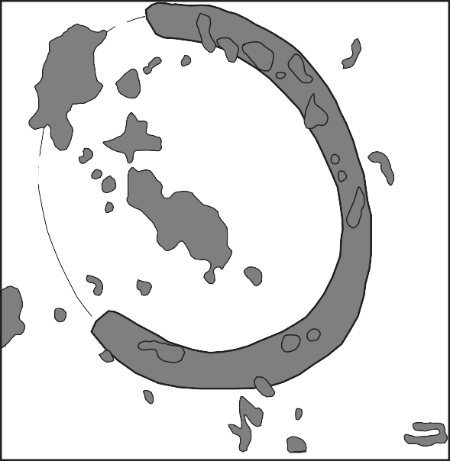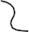A
ea erhea
Impact Site
A'
x Grouse Peak
SALMON RIVER MOUNTAINS
x
Challis
Hawley Creek Thrust
x Stanley WHITE CLOUD PEAKS
Magnetic High

O U L D E R M T N S .
WHITE
KNOB
MTNS .
x Mackay

Arcuate track of magnetic
anomaly highs
x Arco
x Hailey
PIONEER
MTNS.
 | Qmu | Qp | F | D
OZ u s ndstone  45PL95 | 98 | 1.6 | - | -
40PL95 | 96.6 | 3.3 | - | -
39PL95 | 97.6 | 1.6 | 0.6 | -
42PL95 | 98.6 | 1.0 | 0.3 | -
OZ u cong omer te  43PL95 (matrix) | 95.6 | 4 | 0.3 | -
44PL95 (clast) | 98 | 2 | - | -
41PL95 (clast) | 95.3 | 4.3 | - | 0.3
46PL95 (clast) | 92.6 | 7 | - | 0.3
OZ s ndstone  47PL95 | 94 | 6 | - | -
48PL95 | 94 | 5.6 | 0.3 | -
49PL95 | 94.3 | 5.6 | 0.3 | -

o

o
N

km
Magnetic anomaly highs > nT Gra ity high

Arcuate track of magnetic anomaly highs

Inferre continuation of
arcuate magnetic high

Figure 1. Location map of east-central Idaho showing the Grouse Peak site, Beaverhead Impact site, mid-crustal magnetic and gravity anomalies, and the Hawley Creek thrust fault (after McCafferty, 1995). Cross section A-A' is shown in Figure 16.

are the northeast-thrusted eastern part of the central crater whose root is expressed in the geophysical anomalies (Fig. 1, 16).
This study describes unusual conglomerates and tectonic brec- cias of the Ordovician to Neoproterozoic formation of Leaton Gulch (Fig. 2) located on Grouse Peak of the northernmost Lost River Range (Fig. 3). We interpret these features as related to the Beaverhead impact (Carr et al., 1996). Except for the shattercones in the Beaverhead Mountains and the sedimentary breccia de- scribed here, no other upper crustal manifestations of the Beaverhead impact have been reported.

REGIONAL GEOLOGY
East-central Idaho is part of the Sevier orogenic belt (Fig. 1) and contains regional thrust faults of late Cretaceous age; pre- Cretaceous upper crustal rocks are all allochthonous (Skipp, 1987; Rodgers and Janecke, 1992; Link and Janecke, this volume). The northern Lost River Range (Pahsimeroi Mountains) contain a southeast-dipping Mesoproterozoic to Carboniferous sequence in the hanging wall of the Hawley Creek thrust system (McIntyre and Hobbs, 1987; Mapel et al., 1965; Janecke, 1993; 1995).
Much of east-central Idaho was blanketed by Eocene Challis Volcanic Group and extensively faulted by pre-, syn-, and post- Challis faults and extensional folds (Moye et al., 1988; Fisher and Johnson, 1995; Janecke, 1994; 1995; Janecke et al., 1998). The Challis area was deformed by normal and strike-slip faults related to the Twin Peak Cauldron complex and northeast-strik-

ing Trans-Challis fault zone (Fisher et al., 1992; Worl et al., 1995; Janecke and Snee, 1993; Janecke et al., 1997). Uplift along these faults exposes the pre-Tertiary rocks.
The Lost River Range is at the north edge of the Basin and Range province. It occupies the footwall of the Lost River fault along the west side of the range, and the hanging wall of the Lemhi
540 Ma Leaton Gulch
Formation of
C
?
OZlu
Wilbert Formation
Brigham Group
Z
Impact event

? OZll
1.0 Ga
1.4 Ga
1.47 Ga
Lemhi Group

Lemhi Group

Swauger Quartzite
Swauger Quartzite
Lawson Creek Formation
?
?

Pocatello Formation

Elkhead Limestone

Formation Tyler Peak

Carbonate rocks

Summerhouse Formation

Summerhouse Formation
Swan Peak Quartzite
Kinnikinic Quartzite
Beaverhead Pluton
Kinnikinic Quartzite
Northern Lost Beaverhead and Pocatello and River Range Lemhi Ranges Bannock Ranges
Neoproterozoic
Cambrian Ordovician

Figure 2. Correlation chart for Proterozoic and lower Paleo- zoic rocks of east-central Idaho showing age uncertainty for the formation of Leaton Gulch and Beaverhead Impact Event (modified from Skipp and Link, 1992).
Mesoproterozoic

fault to the east (Crone et al., 1987; Crone and Haller, 1991; Janecke, 1993; 1994; 1995). Numerous north-northwest-striking faults cut the range (McIntyre and Hobbs, 1987; Fisher et al., 1992; Wilson and Skipp, 1994). The normal faults have Holocene displacement and the area is seismically active.

FORMATION OF LEATON GULCH
The rocks exposed at Grouse Peak of the northernmost Lost River Range (Fig. 1, 2) are included in the "interbedded quartz- ite, dolomite and argillite of Leaton Gulch and Pennal Gulch" of Neoproterozoic to Ordovician age, (McIntyre and Hobbs, 1987). Complex structure, discontinuous exposure and the limited scope of their project prevented McIntyre and Hobbs from defining an internal stratigraphy. They noted the presence of "several zones of very coarse conglomerate or intraformational breccia" and the presence of "ripple marks, flute casts, and worm trails".
The formation of Leaton Gulch overlies the feldspathic Mesoproterozoic (Middle Proterozoic) Lawson Creek Formation (Hobbs, 1990; Hobbs and Cookro, 1995) and is unconformably overlain by quartz arenite of the Ordovician Kinnikinic Quartzite (Fig. 2). McIntyre and Hobbs (1987) suggested correlation of the Leaton Gulch beds with the Wilbert (Neoproterozoic) and Sum- merhouse (Lower Ordovician) Formations or with the Middle Cambrian formation of Tyler Peak (Ruppel, 1975; McCandless, 1982).

GEOLOGIC RELATIONS ON GROUSE PEAK
The formation of Leaton Gulch generally dips eastward on Grouse Peak, but is locally tightly folded (Fig. 3). It is unconformably overlain by rocks of the Eocene Challis Volcanic Group, including the tuff of Challis Creek and intermediate and mafic lava flows. Several down-to-the east normal faults repeat the section.

Lower Formation of Leaton Gulch (OZll)
We divide the formation of Leaton Gulch on Grouse Peak into two stratigraphic units (Fig. 4). The lower part (OZll in Fig. 2, 3, and 4) makes up the bulk of the formation. Based on outcrop width (McIntyre and Hobbs, 1987), this lower part is hundreds of meters thick. It crops out over an area 10 x 15 km. In general, the rocks have a steeply west-dipping cleavage. We have only exam- ined the exposures shown on the map of Figure 4, and have not studied the entire area of outcrop.
The upper few hundred meters of OZll contains fine- to me- dium-grained, medium bedded, locally cross-bedded, purple to light pink, phyllitic quartz arenite. In thin section OZll sandstone contains over 90% monocrystalline quartz grains and 5 to 6 per- cent polycrystalline quartz (Table 1; Fig. 5).
Several linear and pod-shaped zones of lower formation of Leaton Gulch strata in the Leaton Gulch area (Fig. 3) are intensely brecciated (Fig. 6, Locality C). Clasts are up to 2 m in diameter,

o 32'3 "

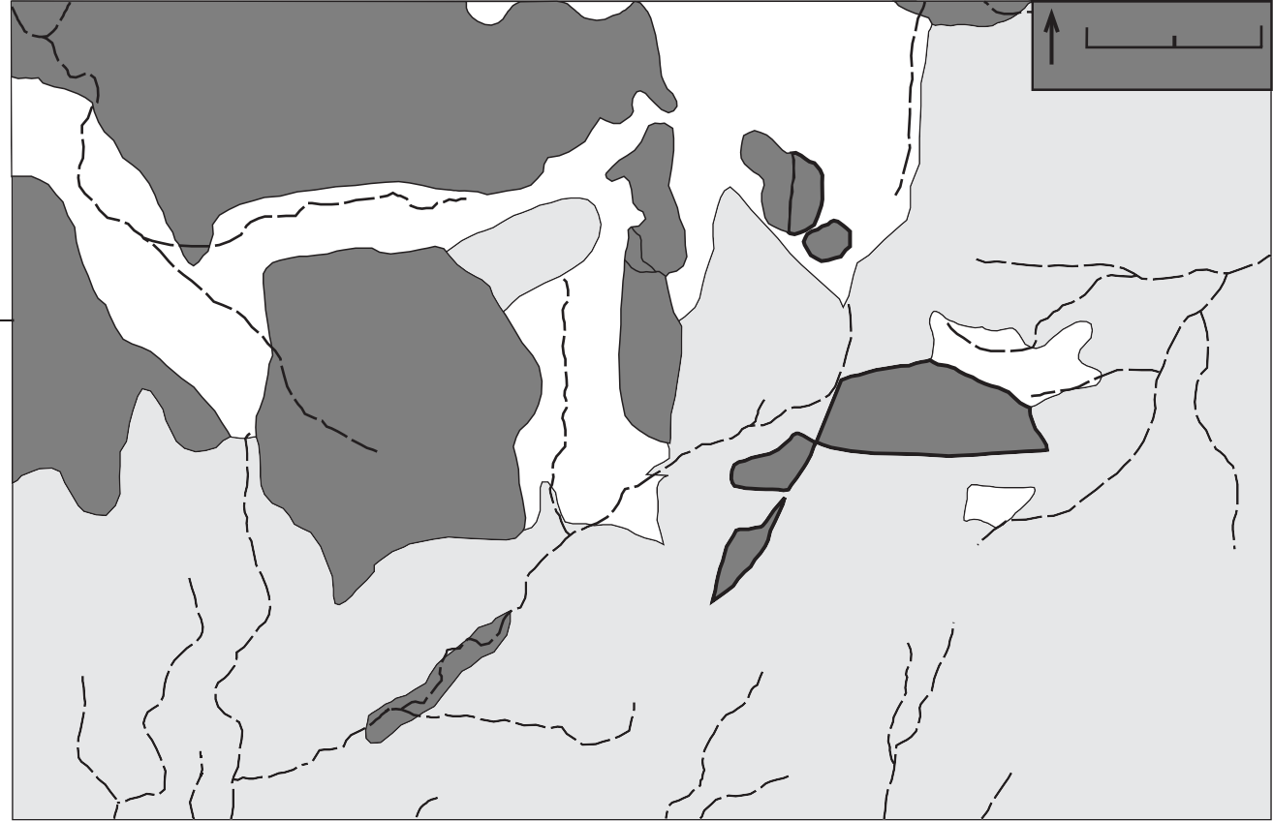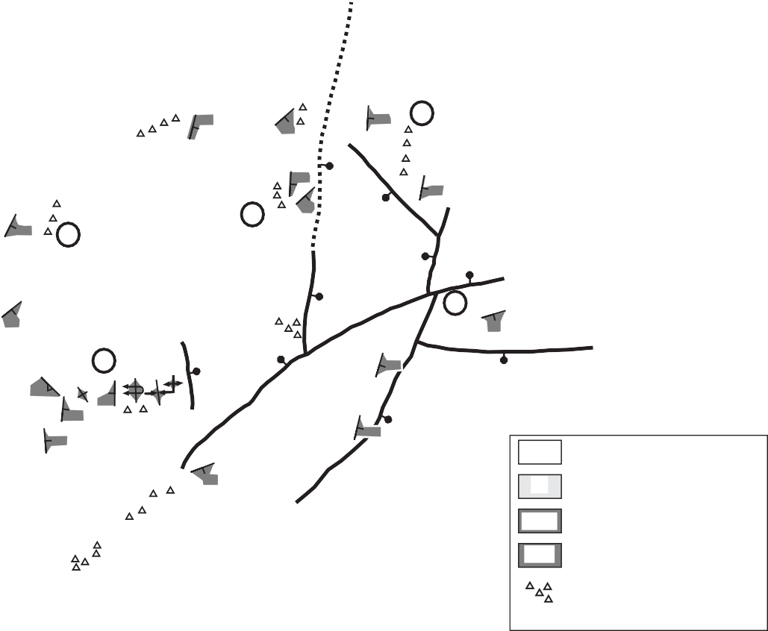Figure 3. Geologic map of Grouse Peak area, northern Lost River Range (Pahsimeroi Mountains). Initial relations were described by Rob Hargraves. Further mapping by Idaho State University Field Camp, June, 1996. Stratigraphic column of Figure 4 is through the contact between OZll and OZlu at Locality A. Breccia localities B, C, and E in OZll are described in text.
o 7'3 "
o '
lower
reccia
OZll Formation of Leaton Gulch
upper
OZlu Formation of Leaton Gulch
OZll
un ifferentiate
Quaternary un ifferentiate
Eocene Challis olcanisc
Q
Tc
Tc
40
Tc
Q
OZlu
25
25
Q
B
15
20
45
75
40
OZlu
D Scolithos
30
50
25
20
Q
OZll
OZll
Tc
OZll
E
C
50
Q
15
OZlu
15
Tc
40
55
70
40
Tc
8 6
Miles .5
0
N
OZll
Q
OZll
A
20
OZll
60
Grouse Peak
o 3 ' "

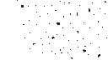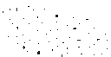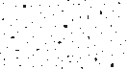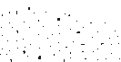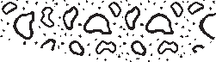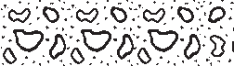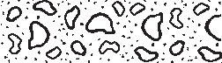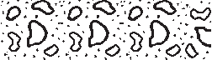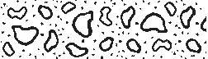ern Lemhi and Beaverhead Mountains (Skipp and Link, 1992). However, the Leaton Gulch units lack feldspar, which is a distin- guishing characteristic of the Middle Proterozoic rocks. The dis- tinction is not clear, however, based on limited sample size.
Channe ized contact
47, 48, 49 Sandstone and phy ite
Burrowed red si tstone Sandstone with rip-up c asts
Deep red sandstone Cong omeratic sandstone
43 Gradationa contact
44
Sedimentary breccia C asts of OZ
41

46
5
10
42
15
39, 40, 45
20
Quartz arenite
Scolithos present upsection
25
0
Neoproterozoic-Cambrian
Formation of Leaton Gu ch

BRECCIAS AND PLANAR DEFORMATION FEATURES
OZ u

Figure 4. Stratigraphic column of the informal formation of Leaton Gulch at Locality A of Figure 3, east of Grouse Peak. Base of massive conglomerate represents unconformable contact be- tween the lower part of the formation (OZll) and the upper part (OZlu). Stratigraphic position of samples from Table 1 is shown.
OZ I
Meters
both angular and rounded, and locally severely iron-stained. At Locality B, OZll contains tight, disharmonic folds (Fig. 7), with brecciated cores (Fig. 8).

Upper Formation of Leaton Gulch (OZlu)
The upper part of the formation of Leaton Gulch (OZlu) unconformably overlies OZll on a channelized contact (Fig. 9), and consists of an upward-fining conglomerate to siltstone suc- cession (see stratigraphic column, Fig. 4). The unit lacks outcrop scale folds, and generally lacks cleavage.
The base of OZlu is massive boulder conglomerate (Fig. 9, at locality A on Figure 3) with clasts up to 50 cm in diameter, in channels that cut down into OZll phyllitic quartzite. The chan- neled surface has a relief of 2 m. The conglomerate is 14 m thick, light-pink in color, and contains angular to sub-rounded quartz arenite clasts that are petrologically identical to the underlying OZll unit.
The conglomerate is gradationally overlain by 1 m of dark pink to orange, poorly-sorted conglomeratic sandstone with white to maroon subrounded clasts up to 1 cm in diameter (Fig. 10). Above this is a red fine-grained arkosic sandstone (1 m) overlain by intraformational conglomeratic sandstone with mudstone rip- up clasts (2 m). This grades into a 2 meter-thick red siltstone which contains bedding-parallel trace fossils (Planolite ? up to 1 cm in diameter). This siltstone is overlain by tens of meters of medium-grained quartz arenite. At locality D, a fault-bounded block of this upper quartz arenite contains Skolitho .
The OZlu unit contains quartz arenites, with over 95% monoc- rystalline quartz and less than 5% polycrystalline quartz (Table 1; Fig. 5). Thin sections of clasts in OZlu basal conglomerate contain several percent polycrystalline quartz, and in general re- semble OZll sands. Figure 5 reveals that neither of the Leaton Gulch units clearly match the sandstone petrography of the Cam- brian and Neoproterozoic Wilbert Formation nor the Mesoproterozoic Gunsight and Swauger Formations of the south-

Figure 5. Ternary diagrams to illustrate composition of sandstones from the Grouse Peak area (data lumped from Table 1) com- pared to Middle Proterozoic Gunsight and Swauger Forma- tions and Neoproterozoic-Cambrian Wilbert Formation from the southern Beaverhead and Lemhi Mountains. Modified from Skipp and Link (1992, their Figure 4).
Lt
Basement Uplift
F
Dissected Arc
Transitional Recycled
Mixed
Quartzose Recycled
Transitional Continental
OZll OZlu clasts
Craton Interior
OZlu matrix
Qm
Cambrian and Late Proterozoic Wilbert formation
Middle Proterozoic strata OZll
OZlu
L
Basement Uplift
F
Recycled Orogenic
Transitional Continental
OZlu and OZll
Craton Interior
Qt

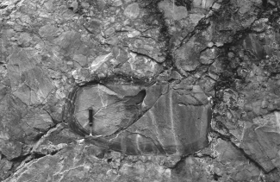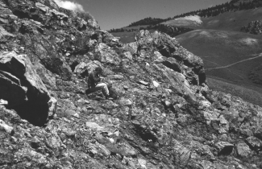

Figure 6. Heterolithic breccia from OZll at Locality C on (Fig. 3). Clasts are both angular and rounded, up to 1 m in diameter, and include some clasts of angular breccia.

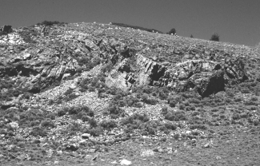
Figure 7. Outcrop-scale disharmonic folds in OZll at Locality B (Fig. 3). Breccia shown in Figure 8 is in core of anticline at right side of view.

Brittle Breccias
Brittle breccia within OZll, with granulated and recrystallized quartz matrix, is exposed in lower Leaton Gulch (south of Local- ity B). Angular clasts of quartzite up to 40 cm in diameter are surrounded by an annealed quartz matrix, which is finely commi- nuted and recrystallized. Quartz grains are highly strained. These breccias likely formed along the northeast-striking fault zone in Leaton Gulch.

"Ductile" Breccia
Within OZll, "ductile" breccia (angular fragments in a ductile matrix) is found at Localities B, C, and E on Figure 3. Breccia at Locality B, in the core of a tight upright anticline (breccia shown in Fig. 8, folds in Fig. 7), contains angular pieces of the adjacent quartzite up to 20 cm in diameter. Thin sections of the matrix contain heterolithologic clasts (quartzite, gneiss, and schist) up to 1 cm in diameter, locally surrounded by a glassy mylonitic matrix (Fig. 11). Some areas have an amorphous, stringy texture, with some isotropic sub-grains, that forms an indistinct halo around surrounding grains (Fig. 12), a texture reminiscent of pseudotachylite.
Figure 8. Breccia in core of fold at right side of Figure 7. Note per- son (John Preacher) sitting in middle view for scale. Clasts are up to 2 m in diameter. Thin sections of breccia matrix with flat- tened quartz domains (Figures 11 12, 15) are from this location.
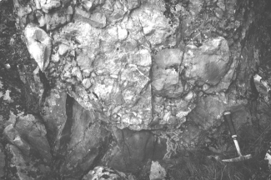
Figure 9. Basal contact of OZlu conglomerate on scoured surface of OZll at Location A, east of Grouse Peak.

Planar Deformation Features
Quartz grains in thin sections from these three localities of breccia contain two types of planar deformation features. The first type includes distinct planes manifested as multiple parallel lineations that cover about 80% of the length of a quartz grain (c.f. Fig. 13, 14). The lamellae are sub-perpendicular to the ex- tinction angle. Some of the grains have subsequently been de- formed so that lineations are somewhat kinked. These lamellae occur in monocrystalline quartz grains that exhibit undulose ex- tinction, but are not present in polycrystalline quartz grains.
The second type of planar deformation feature is an align- ment of parallel planes of tiny fluid inclusions (Fig. 15). In some grains, the fluid inclusion trains form two sets about 30 degrees apart. In some grains the lamellae go through grain boundaries, indicating the lamellae were imposed during or after lithification (Fig. 15).

Textures in Clasts and Matrix of Basal OZlu
In the sand matrix between clasts in the basal boulder con- glomerate of OZlu, quartz contains rare to abundant planar sets of deformation lamellae and rare to moderately abundant trains

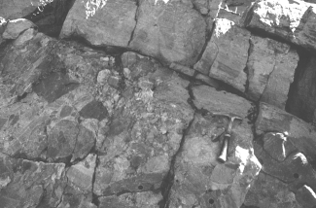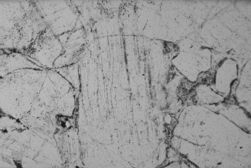

Figure 10. Upper contact of basal conglomerate of OZlu, Location A, east of Grouse Peak. Note pebbles and rip-up silt clasts in overlying parallel laminated coarse-grained sandstone.

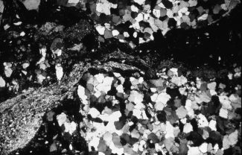
Figure 11 Mylonitic texture in breccia containing flattened quartz domains from OZll at Locality B (Sample 58PL95). Crossed polars. Field of view is ~2 mm.

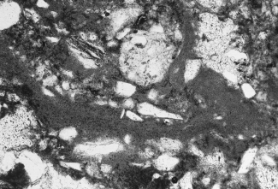
Figure 12. Possible pseudotachylite texture in matrix of breccia from OZll at Locality B (same thin section as Fig. 11, Sample 58PL95). Note diffuse area of isotropic, hazy, possible melt glass through middle of view. Plane light. Field of view is ~2 mm.
Figure 13. Thin section of sample 41PL95, a clast in basal con- glomerate of OZlu, Locality A. Note slightly kinked planar de- formation features that cross grain boundaries in coarse- grained quartz. Field of view is ~1 mm.
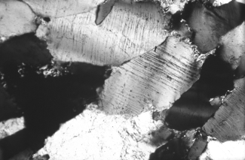
Figure 14. Thin section from sample 43PL95, matrix in coarse sand from basal conglomerate of OZlu, Locality A . Note that pla- nar deformation features do not cross grain boundaries. Field of view is ~1 mm.
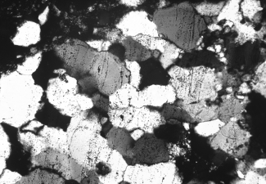
Figure 15. Thin section from breccia in core of fold at Locality B (Fig. 7 and 8, Sample 57PL95). Note the planar deformation features cross fine-sand grain boundaries. Field of view is ~2 mm.

of fluid inclusions. In the sand matrix of the conglomerate, the features do not cross grain boundaries (Fig. 14). However, in some clasts the features are observed to cross grain boundaries (Fig. 13), similar to relations in underlying OZll.

INTERPRETATION
The upper formation of Leaton Gulch east of Grouse Peak contains a basal conglomerate (OZlu) channeled into the lower part of the formation (OZll). To our knowledge, such coarse- grained conglomerates are unique in the Leaton Gulch unit. We interpret this conglomerate to represent an event-bed, either the stratigraphic record of the Beaverhead Impact or an incised val- ley-fill deposit containing material eroded from a proximal area deformed by the impact.
Although the definitive determination of whether planar de- formation features in general are shock-related or caused by strain of longer duration is controversial, the features we describe in sand grains in OZlu and in lithified sandstone of OZll are compa- rable to photographs of demonstrated shock features formed dur- ing bolide impact (Alexopoulos et al., 1988). Further, the breccia pods within the OZll unit on Grouse Peak are unusual, complex, and difficult to explain by fault-related origin alone.
Thus we tie several disparate pieces of anomalous geology together and propose that they are all manifestations of the ex- traordinary tectono-magmatic events produced by the Beaverhead Bolide Impact. We suggest that the lamellae observed in quartz grains in the OZll unit formed due to shock and/or subsequent rapid strain-rate and normal faulting. The complex breccias with flattened quartz domains within OZll likely also formed at this
time, though they have had multiple opportunities to be reacti- vated during Phanerozoic deformation.
Following McCafferty (1995), we infer that the impact event created outer- and inner-ring craters bounded by normal faults (Fig. 16). Although Grouse Peak is 100 km from the shattercone locality of the southern Beaverhead Mountains, an outer-ring scarp at Grouse Peak is possible if the original crater diameter was over 100 km in diameter (Hargraves et al., 1994). Such ringed struc- tural zones are observed from the end-Cretaceous Chicxulub im- pact at distances of 85-98 km (Snyder et al., 1998). The Island Butte shattercone site would record the eastern edge of the inner- ring crater (McCafferty, 1995).
One interpretation is that the basal massive conglomerate of OZlu is a debris-flow or talus cone deposit, composed of clasts of OZll, and derived from this proximal fault scarp. Some lithified clasts of OZll, containing planar deformation features that cross grain boundaries, were eroded and deposited in the basal con- glomerate of OZlu. Sand grains eroded from OZll, that contain deformation lamellae, were also deposited in OZlu. A second in- terpretation is that the conglomerate represents an incised valley fill deposit (c.f. Levy et al., 1994), composed of locally-derived (OZll) clasts and sand grains, but deposited significantly later than the Beaverhead event.
The most likely age for the OZlu conglomerate is latest Neoproterozoic (Ediacaran, ~600 Ma). The conglomerate is gra- dationally overlain by shallow subaqueous sands. Mudrocks, six m above the conglomerate, contain Cambrian trace fossils, sug- gesting the conglomerate was deposited, at the oldest, close to 600 Ma, i.e., latest Neoproterozoic or Ediacaran time.

Crater iameter = Km

Grouse Peak

reccia
ea erhea Site
Stratigraphic uplift= Km
Ejecta blanket Upper Crust

2

3 ?
A
Km

Shattercone sites
Structural isturbance
= 3 Km

Approximate zone of
rittle isruption
Km
Lower Crust

?
mantle
ea erhea

I aho
Grouse
asin an Range
HCT
Site CT

A atholith Challis Volcanic Fiel
Peak
T
T y Z y A'

2. Z y
Volcanics
Challis

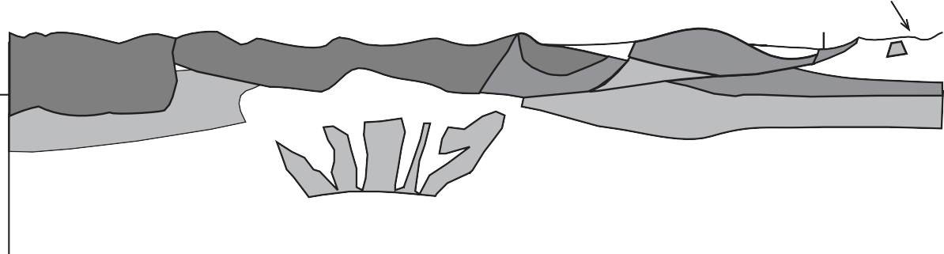Vertical Kg y
Gra ity
y X? y P Z

Scale Change
X? an magnetic anomaly
Upper Crust X?

2
3 B
Km

Shattercones
?
X?

Tertiary Intrusions

Mantle

Lower Crust

? ?

Figure 16. Proposed cross section of east-central Idaho through Beaverhead Impact structure. Upper diagram, (A) shows original locations of Grouse Peak and Beaverhead site. Lower diagram (B) shows modern locations, after eastward translation of rocks by Cretaceous thrusting. Location of southwest-northeast section along line A-A' is shown on Figure 1. Modified from (McCafferty, 1995).

IMPLICATIONS, TESTS, AND CAVEATS
Reconstruction of a dismembered Neoproterozoic meteor impact crater in an area affected by multiple superposed deformational events is chancy business. Although none of the data, except the shattercones and pseudotachylite in the southern Beaverhead Mountains, require the impact scenario, the synthe- sis suggested here makes a plausible, and testable, connection between observed relations. Fundamentally, if the Beaverhead Impact was as large as modeled by Hargraves et al. (1990), it will be manifested in several types of geologic and geophysical anoma- lies. Strata deposited immediately after the impact should con- tain shocked quartz grains, and probably trace-element geochemi- cal anomalies. Phanerozoic geology of the area would be affected by the presence of the dense mid-crustal intrusion produced dur- ing the impact. Detailed geochemical and petrographic studies of Neoproterozoic strata (Pocatello Formation and Brigham Group), that might record the event, have not been made.
The apparent size of the Beaverhead crater is impressive. The palinspastic distance between the Beaverhead site and Grouse Peak is near 100 km (Fig. 16). If the features we observe are shock-related, rapid strain must have affected an area 100 km in diameter. One would not expect shock features over such a wide distance (R. Hargraves, written communication, 1998).
Recent geochronologic data (Kellogg et al., 1999) suggests that the age of the impact is 850 to 900 Ma, and the proximity of the OZlu conglomerate to Cambrian trace fossils suggests it is at the most 600 Ma. Thus, our second hypothesis for the origin of the conglomerate, that it represents an incised valley-fill deposit that accumulated above a lithified and scoured surface appears most reasonable at this time.
Our interpretation of the clasts in the OZlu unit as being lithified pieces of OZll requires enough time, and burial depth, for lithification. The prediction is that the contact represents a major unconformity, which should be recognized regionally within the formation of Leaton Gulch. Further work is necessary, to de- termine if the unconformity and conglomerate are present at more than one place.
We present these observations and interpretations in the hope that further study will provide better constraints on the still-cryp- tic timing and geologic manifestations of the Beaverhead Bolide Impact, one of the largest known impact events in Earth History.

ACKNOWLEDGMENTS
Rob Hargraves first introduced us to the Grouse Peak area, and many of these ideas started with him. All who know Rob are touched by his broad-thinking insight and his love of geology. The exquisitely illustrated study of McCafferty (1995) provided the framework within which our study of a detailed area can fit. The work was supported by the U.S. Geological Survey, Branch of Central Mineral Resources. We thank reviewers Sharon Lewis and especially Karen Lund, who provided excellent, constructive comments. Jim Riesterer and Vita Taube provided quality draft- ing support.

REFERENCES CITED
Alexopoulos, J.S., Grieve, R.A.F., and Robertson, P.B., 1988, Microscopic lamel- lae deformation features in quartz: discriminative characteristics of shock- generated varieties: Geology, v. 16, p. 796- 799.
Carr, J., Link, P.K., Geslin, J.K., McCafferty, A., and Hargraves, R.B., 1996, Sedimentary breccia deposited within Eocambrian(?) Beaverhead Impact Crater, Lost River Range, Idaho: Geological Society of America Abstracts with Programs, v. 28, no. 7, p. A-230.
Crone, A.J., and Haller, K.M., 1991, Sedmentation and coseismic behavior of Basin and Range normal faults: Examples from east-central Idaho and south- western Montana, U.S.A.: Journal of Structural Geology, v. 13, p. 151-164. Crone, A.J., Machette, M.N., Bonilla M.G., Lienkaemper, J.J., Pierce, K.L., Scott, W.E., and Bucknam, R.C., 1987, Surface faulting accompanying the Borah Peak earthquake and segmentation of the Lost River Fault, central Idaho:
Bulletin of the Seismological Society of America, v. 77, p. 739-770.
Fisher, F.S., McIntyre, D.H., and Johnson, K.M., 1983, Geologic map of the Challis 1ox2o Quadrangle, Idaho: U.S. Geological Survey Miscellaneous In- vestigations Series Map I-1819, scale 1:250,000.
Fiske, P.S., Hargraves, R.B., Onstott, T.C., Koeberl, C., and Hougen, S.B., 1994, Pseudotachylites of the Beaverhead impact structure: geochemical, geochro- nological, petrographic, and field investigations, in Dressler, B.O., Grieve, R.A.F., and Sharpton, V.L., eds., Large Meteorite Impacts and Planetary Evolution: Boulder, Colorado, Geological Society of America Special Pa- per 293, p.163-176.
Hargraves, R.B., Cullicott, C.E., Deffeyes, K.S., Hougen, S.B., Christiansen, P.P., and Fiske, P.S., 1990, Shatter cones and shocked rocks in southwestern Montana: The Beaverhead impact structure: Geology, v. 18, p. 832-834.
Hargraves, R.B., Kellogg, K.S., Fiske, P.S., and Hougen, S.B., 1994, Allochthonous impact-shocked rocks and superposed deformations at the Beaverhead site, southwest Montana-possible crater roots buried in south- central Idaho, in Dressler, B.O., Grieve, R.A.F., and Sharpton, V.L., eds., Large Meteorite Impacts and Planetary Evolution: Boulder, Colorado, Geo- logical Society of America Special Paper 293, p. 225-236.
Hobbs, S.W., 1980, The Lawson Creek Formation of middle Proterozoic age in east-central Idaho: U.S. Geological Survey Bulletin 142E, 12 p.
Hobbs, S.W. and Cookro, T.M., 1995, Proterozoic terrane: in Fisher, F.S. and Johnson, K.M., eds., Geology and Mineral Resource Assessment of the Challis 1° x 2° Quadrangle, Idaho: U.S. Geological Survey Professional Paper 1525, p. 12-17.
Janecke, S.U., 1993, Structures in segment boundary zones of the Lost River and Lemhi faults, east-central Idaho: Journal of Geophysical Research, v. 98, p. 16,223-16,238.
Janecke, S.U., 1994, Sedimentation and paleogeography of an Eocene to Oli- gocene rift zone, Idaho and Montana: Geological Society of America Bulle- tin, v. 106, p. 1083-1095.
Janecke, S.U., 1995, Eocene to Oligocene half grabens of east-central Idaho: Structure, stratigraphy, age, and tectonics: Northwest Geology, v. 24, p. 159- 199.
Janecke, S.U., and Snee, L.W., 1993, Timing and episodicity of middle Eocene volcanism and onset of conglomerate deposition, Idaho: Journal of Geol- ogy, v. 101, p. 603-621.
Janecke, S.U., Hammond, B.F., Snee, L.W., and Geissman, J.W., 1997, Rapid extension in an Eocene volcanic are: Structure and paleogeography of an intra-arc half graben in central Idaho: Geological Society of America Bulle- tin, v. 109, p. 253-267.
Janecke, S.U., Vandenburg, C.J., and Blankenau, J.J., 1998, Geometry, mecha- nisms and significance of extensional folds from examples in the Rocky Mountain Basin and Range province, U.S.A., Journal of Structural Geol- ogy, v. 20, no. 7., p. 841-856.
Kellogg, K.S., Snee, L.W., Unruh, D.M., and McCafferty, A.E., 1999, The Beaverhead Impact Structure, Montana and Idaho-Isotopic evidence for an early Late Proterozoic Age, Geological Society of America Abstracts with Programs, Rocky Mountain Section, v. 31, no. 4.
Levy, M, Christie-Blick, N., and Link, P.K., 1994, Neoproterozoic incised val- leys of the eastern Great Basin, Utah and Idaho: Fluvial response to changes in depositional base level, in Dalrymple, R.W., Boyd, R., and Zaitlin, B.A., eds., Incised Valley Systems: Origin and Sedimentary Sequences, Tulsa, OK., SEPM (Society for Sedimentary Geology) Special Publication 51, p. 369-382.

Link, P.K., and Janecke, S.U., 1999, Geology of East-Central Idaho: Geologic Roadlogs for the Big and Little Lost River, Lemhi, and Salmon River Val- leys, in Hughes, S.S., and Thackray, G.D., eds., Guidebook to the Geology of Eastern Idaho: Idaho Museum of Natural History, this volume.
Mapel, W.J., Read, W.H., and Smith, R.K., 1965, Geologic Map and Sections of the Doublespring Quadrangle, Custer and Lemhi Counties, Idaho: U.S. Geo- logical Survey Geologic Quadrangle Map GQ-464, scale 1:62,500.
McBean, A.J. II, 1983, The Proterozoic Gunsight Formation, Idaho-Montana; stratigraphy, sedimentology, and paleotectonic setting (M.S. thesis): Uni- versity Park, The Pennsylvania State University, 235 p.
McCafferty, A.E., 1992, Aeromagnetic and terrace-magnetization maps centered on the Idaho batholith and Challis volcanic field, northwestern United States:
U.S. Geological Survey Geophysical Investigations Map GP-994, scale 1:1,000,000.
McCafferty, A.E., 1995, Assessing the presence of a buried meteor impact crater using geophysical data, south-central Idaho: Masters Thesis, Colorado School of Mines, 88p.
McCafferty, A.E., Hargraves, R.B., Roddy, D.J., and Kellogg, K.S., 1993, Does the root of the Beaverhead impact structure have a geophysical signature?: American Geophysical Union, EOS Transactions, v. 74, p. 223.
McCandless, D.O., 1982, A reevaluation of Cambrian through Middle Ordovi- cian stratigraphy of the southern Lemhi Range (M.S. Thesis): University Park, The Pennsylvanian State University, 235 p.
McIntyre, D.H., and Hobbs, S.W., 1987. Geologic map of the Challis Quad- rangle, Custer and Lemhi Counties, Idaho: U.S. Geological Survey Geo- logic Quadrangle Map GQ-1599, scale 1:62,500.
Moye, F.J., Hackett, W.R., Blakley, J.D., and Snider, L.G., 1988, Regional geo- logic setting and volcanic stratigraphy of the Challis volcanic field, central Idaho, in Link, P.K., and Hackett, W.R., eds., Guidebook to the geology of central and southern Idaho: Idaho Geological Survey Bulletin 27, p. 87-97. Rodgers, D.W., and Janecke, S., 1992, Tertiary Paleogeologic maps of the west- ern Idaho-Wyoming-Montana Thrust Belt, in Link, P.K., Kuntz, M.A. and Platt, L.B., eds., Regional Geology of Eastern Idaho and Western Wyoming:
Geological Society of America Memoir 179, 312 p.
Ruppel, E.T., 1975, Precambrian Y sedimentary rocks in east-central Idaho: U.S. Geological Survey Professional Paper 889-A, 23 p.
Ruppel, E.T., 1998, Geologic map of the eastern part of the Leadore 30' x 60' quadrangle, Montana and Idaho: Montana Bureau of Mines and Geology Open-File Report 372, scale 1:100,000.
Skipp, B., 1987, Basement thrust sheets in the Clearwater orogenic zone, central Idaho and western Montana: Geology, v. 15, p. 220-224.
Skipp, B., and Link, P.K., 1992. Middle and Late Proterozoic rocks and Later Proterozoic tectonics in the southern Beaverhead Mountains, Idaho and Montana: A preliminary report, in Link, P.K., Kuntz, M.A., and Platt, L.B., eds., Regional Geology of Eastern Idaho and Western Wyoming: Geological Society of America Memoir 179, p.141-154.
Snyder, D., and Hobbs, D., 1998, Ringed structural zones with deep crustal roots formed by the Chicxulub impact: Geological Society of America Abstracts with Programs, v. 30, no. 7, late-breaking abstracts appendix.
Wilson, A.B., and Skipp. Betty, 1994, Geologic map of the eastern part of the Challis National Forest and vicinity, Idaho: U.S. Geological Survey Miscel- laneous Investigations series Map I-2395, scale 1:250,000.
Worl, R.G., Link, P.K., Winkler, G.R., and Johnson, K.M., eds., 1995, Geology and Mineral Resources of the Hailey 1° x 2° Quadrangle and the Western Part of the Idaho Falls 1° x 2° Quadrangle, Idaho: U.S. Geological Survey Bulletin 2064, Volume 1, Chapters A-R.

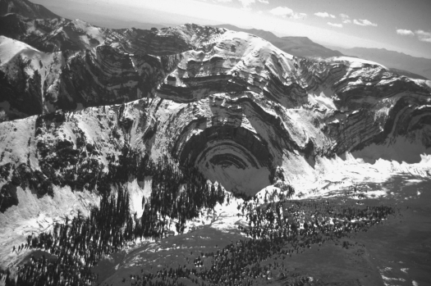

Aerial view of folded Paleozoic rocks along the Continental Divide in the southern Beaverhead Range. Photograph by Glenn Embree .

