Winston, Link and Hathaway -- The Yellow}acket is Not the Prichard and Other Heresies 3

The Yellowjacket is Not the Prichard and Other Heresies: Belt Supergroup Correlations, Structure and Paleogeography, East- Central Idaho

Don Winston

Geology Department, University of Montana, Missoula MT 59812
Paul Karl Link
Department of Geology, Idaho State University, Pocatello, ID 83209
Nate Hathaway
P.0. Box 81, Arlee, MT 59821

ABSTRACT
Recent stratigraphic study of Middle Proterozoic rocks in east- central Idaho has resulted in revised correlations of the Yellowjacket Formation with the Lemhi Group and with the Belt Supergroup. The type Yellowjacket Formation now can be shown to correlate with the Inyo Creek and West Fork Formations of the Lemhi Group. The type Yellowjacket, Inyo Creek and West Fork formations are probably the southern extension of the Burke For- mation of the Ravalli Group, Belt Supergroup. The Hoodoo For- mation above the Yellowjacket correlates with the Big Creek Formation of the Lemhi Group and probably with the Revett For- mation of the Belt Ravalli Group. Argillite couplets and hum- mocky cross-stratified arenite above the Hoodoo in the Cobalt mining district, previously mapped as Yellowjacket Formation, are a northern facies of the Apple Creek Formation of the Lemhi Group, and correlate with the St. Regis, Wallace and Helena for- mations of the Belt Supergroup. Flat-laminated arenite at the top of the "Cobalt Yellowjacket" correlates with the Gunsight For- mation of the Lemhi Group and with the Snowslip Formation of the Missoula Group, Belt Supergroup. The Swauger and Lawson Creek formations of east-central Idaho are the southern facies of the Mount Shields Formation of the Belt Supergroup.
These correlations, unifying the Yellowjacket, Lemhi and Belt, challenge the previously held belief that these rocks were depos- ited in separate regions. Their separation was supported by the inferred Medicine Lodge thrust for which we see no evidence in key localities north of Lemhi Pass.
Recent radiometric dates from the Belt Supergroup, together with these correlations, remove much of the rationale supporting
the Salmon River arch, Belt uplift and Belt-age intrusion and metamorphism. The resulting tectonic simplification leads to the following simplified geologic history. The Belt Supergroup, in- cluding the Yellowjacket Formation and Lemhi Group, was de- posited from 1470 to 1390 Ma in the Belt rift basin. This basin was filled by alluvial aprons, playas and the perennial Belt intracratonic sea. Sediments were derived mostly from a western continent. Mafic and felsic magma intruded these rocks north of Cobalt around 1370 Ma. Reactivation of the accompanying tec- tonism may be manifested in the Lemhi arch, which influenced Paleozoic paleogeography.

INTRODUCTION AND ORGANIZATION

Middle Proterozoic Rocks of East-Central Idaho
The area around Salmon, Idaho (Fig. 1) including parts of the Beaverhead Mountains to the east, Lemhi Range to the south, and Salmon River Mountains to the west and north, contains ex- tensive exposures of Middle Proterozoic fine-grained quartzite and argillite. Geologists have depicted these strata in a confusing array of stratigraphic and structural configurations. We reinter- pret this geology in a way that greatly simplifies the stratigraphic correlations of these rocks with the Belt Supergroup of Montana, and also frees us from incorrect structural concepts.
The early 20th century saw several decades of geologic map- ping (Anderson, 1953, 1956, 1961; Ross, 1934, 1947; Umpleby, 1913) in which these strata were correlated with the Belt Super- group. However, work in the period 1970-1993 broke these rocks into three packages: 1) the Yellowjacket Formation, 2) the younger Lemhi Group (with overlying Swauger and Lawson Creek For-

Winston, D., Link, P.K., and Hathaway, N., 1999, The Yellowjacket is not the Prichard and other heresies: Belt Supergroup corre lations, structure and paleogeogra- phy, east-central Idaho, in Hughes, S.S., and Thackray, G.D., eds., Guidebook to the Geology of Eastern Idaho: Pocatello, Idaho Museum of Natural History, p.3-20.

4 Guidebook to the Geology of Eastern Idaho

Brushy Gulch fault
45 30

Shoup

Yg

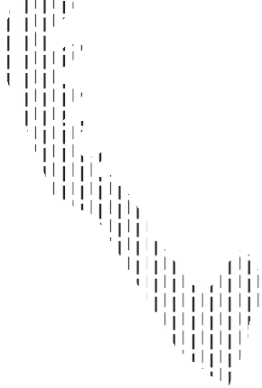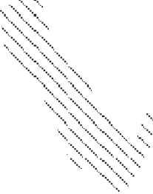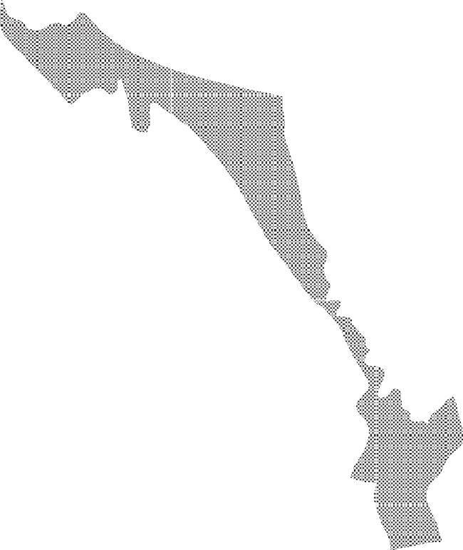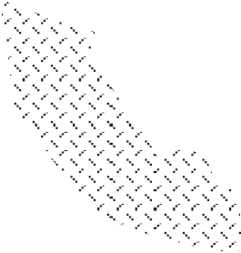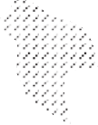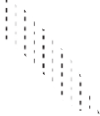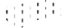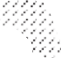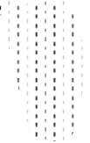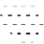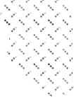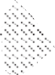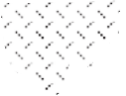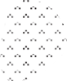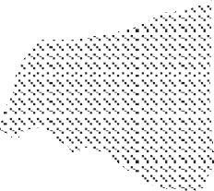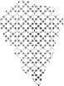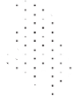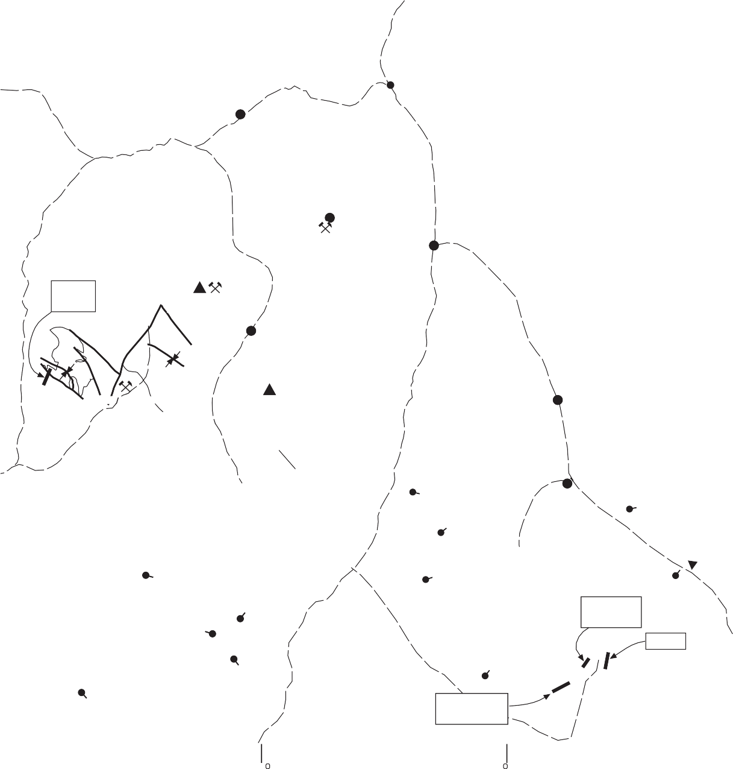Yag

North Fork

Yyb

10 m es N
20 k ometers

Yb
45 15

Ybq Yh
Yycm
Yyc

Yycu

Yycu

Yb

Leesburg
Yyc

Sa mon

F g. 4 Yyt-Yh
Yyt
Yh
45 00
Yy Yh

Ye owjacket m ne

B ackb rd mtn.

Yaq
Yaq Tc
B ackb rd m ne

Coba t
Yyc

Moyer Peak
Ya?
Yh

Yb
Yyc

Ya
Y

Ym
Yg

Tendoy

M dd e Fork Peak

Yyt

Ya
Ir Lake fault
Ya
Beaverhead Mounta ns
Lemh Range
Yb

s Creek Thrust

Yg
Yb
Lemh

Ys

Ym

Ys

Ys

Ys

Ys
Coba t-B ackb rd Leesburg
Ye owjacket Cr. M dd e Fork Pk. West of Iron Lk.
44 45

Yg
Yycu

Ybq or
Yg
Yg
Ya
Y s

Cha s
Yyc
Yag

Yyb

Yycm
Yyc
Y
Ya( )
Ya(u)

Grouse Peak
Yaq
? ?
Ywf
Yyt
? ?
Yb
Yh
? ?
44 00

E s
Y s

F gs. 5, 6 Y c-Ywf-Yb

Y s
Patterson
Y c

F gs. 6, 7 Yb-Ya
Ys

Leadore

Ya-Yg

Yb

114 45 114 30 114 15 114 00 113 45 113 30 113 15

Figure 1. Generalized, revised and simplified geologic map of the northern Lemhi and Beaverhead Ranges and the Salmon River Mountains. The Medicine Lodge thrust has been removed and most regional contacts between Belt Supergroup and Lemhi Group units are stratigraphic. General locations of measured reference sections (Figures 4, 5, 6, 7 & 8) are shown. Mesoproterozoic Belt Supergroup units in correlation chart (from west to east and bottom to top) are: Yyt = Type Yellow}acket Formation; Yh = Hoodoo Quartzite; Yaq = argillaceous quartzite (may be correlative with lower part of Cobalt Yellow}acket); Yyc = Cobalt Yellow}acket Formation (Yycl = lower unit, Yycm = middle unit; Yycu = upper unit of Evans and Connor (1993); Ybq = biotite quartzite; Yag
= augen gneiss; Yg = Gunsight Formation; Ys = Swauger Formation; Yic = Inyo Creek Formation; Ywf = West Fork Formation; Yb = Big Creek Formation; Ya = Apple Creek Formation (Ya(l) and Ya(u) = lower and upper parts of Apple Creek Formation); Yls = Lemhi Group and Swauger Quartzite, undifferentiated; Yl = Lemhi Group; Yyb = Yellow}acket Formation mapped in Beaverhead Mountains by Ruppel et al. (1993); it is likely a facies of the Apple Creek Formation to the west; Ym = Missoula Group. Map base from Bond (1978); geology generalized and interpreted from Bennett (1977), Staatz (1979), Ruppel (1980), Connor and Evans (1986); Skipp (1987), Ekren (1988), Evans and Connor (1993), Ruppel et al., 1993; Tysdal (1996a; 1996b), Tysdal and Moye (1996), Janecke et al. (1998), and Russ Tysdal (U.S. Geological Survey, written communication, October, 1998), who informed us of the regional significance of the Iron Lake fault west of Moyer Peak in the Salmon River Mountains.

Winston, Link and Hathaway -- The Yellow}acket is Not the Prichard and Other Heresies 5

mations), which was separated from the Yellowjacket by the Medicine Lodge thrust, (Ruppel, 1975, 1978, 1980; Lopez, 1981;
Ruppel and Lopez, 1984, 1988; Ruppel et al., 1993), and 3) the Belt Supergroup. This work concluded that the autochthonous Yellowjacket Formation was deposited along the western edge of the emergent Dillon block of the crystalline Wyoming province concurrent with the deposition of the Prichard Formation in the Belt basin to the north. Yellowjacket rocks were uplifted into the Lemhi arch (later termed Belt uplift by Ruppel, 1986). The Lemhi Group was then deposited in the inferred Proterozoic miogeocline on the western flank of the Belt uplift while the Ravalli Group and Helena and Wallace formations were deposited in the Belt Basin, separated from the Lemhi Group by Belt uplift. Cretaceous compression drove the Lemhi Group and younger rocks eastward over the Yellowjacket and Belt rocks, forming the Medicine Lodge thrust. The structural constraints of this scenario require that all contacts between the Lemhi Group, Yellowjacket, and Belt rocks must be mapped as faults.
This complex story is, however, more convoluted than the field relations of the rocks themselves indicate. Our recent work, though of reconnaissance nature, and funded only by our per- verse interest in understanding the Belt Supergroup, reveals a much simpler story, more similar to that originally proposed by Ross and Anderson. We have measured type and reference sections through the Inyo Creek, West Fork and Apple Creek formations, which have allowed us to correlate parts of the Lemhi Group with parts of the Yellowjacket Formation and both with parts of the Belt Supergroup. We have also examined specific areas near Lemhi Pass and Carmen and Fourth of July creeks in the Beaverhead Mountains, and Hull Creek in the Salmon River Mountains where thrust contacts, attributed to the Medicine Lodge thrust, are shown on geologic maps of the Dillon 1° x2° quad- rangle (Ruppel and others, 1993), Ulysses Mountain quadrangle (Lopez, 1982), and Leesburg quadrangle (Connor and Evans, 1986). In some places the Medicine Lodge thrust has been drawn at conformable formational boundaries and elsewhere through undisturbed, continuous outcrops within formations.
Continuity of the lower Lemhi Group with the type Yellowjacket challenges the existence of a Proterozoic Lemhi arch,

and continuity of the Yellowjacket and Lemhi Group with the Belt also rejects the notion of any arch that separated the Yellowjacket Formation and Lemhi Group from the Belt Super- group. Our stratigraphic conclusions do not disagree with those reached independently by the most recent U.S. Geological Sur- vey mappers in the area, and this lends support to our convictions (see Ekren, 1988; Skipp, 1987, 1988; Lund and Esparza, 1990; Evans and Connor, 1993; Schmidt et al., 1994; Tysdal, 1996a, 1996b; Tysdal and Moye, 1996; Evans, 1999; Lund, 1999). The review by Karl Evans (published in 1999) of the Yellowjacket Formation contains interpretations circa 1994, and shares all of our fundamental points.
This paper is organized with first, an historical account of the main concepts of Middle Proterozoic rocks in east-central Idaho; second, our observations of the type and reference sections of parts of the Yellowjacket Formation and Lemhi; and third, impli- cations for regional geology. Those looking for the short punch- line should examine primarily this last section.

History of Middle Proterozoic Stratigraphy
The stratigraphic snarl that separated the Belt Supergroup from Proterozoic rocks of east-central Idaho and the Lemhi Group from the Yellowjacket Formation can probably be attributed mostly to the giant scale of the stratigraphic units and the problem faced by most geologists in adequately delineating and describing thou- sands of feet of mostly fine-grained siliciclastic rocks. The fol- lowing discussion details the development of stratigraphic no- menclature and traces threads of the snarl.

Ross and Anderson
Beginning the saga, Ross (1934) named both the Yellowjacket formation for gray, fine-grained, locally ripple-marked quartzite, containing calcareous lenses and beds, and the overlying Hoodoo quartzite for a thick unit of nearly white, feldspathic arenite. He included them in the Belt series (Fig. 2). Ross (1947) then stepped south to the Borah Peak quadrangle of the Lemhi Range, where he named the Lemhi quartzite for principally grayish-green im- pure quartzite and subordinate argillite exposures mostly along Big Creek (Fig. 2). He also named the overlying Swauger quartz-

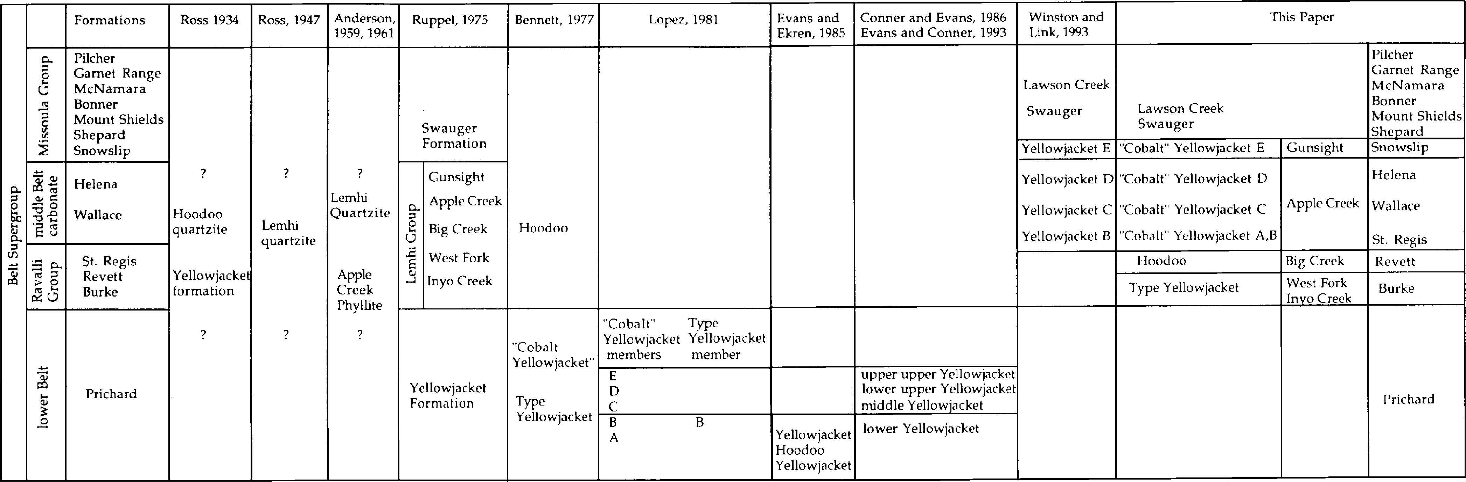
Figure 2. Correlation chart showing the development of stratigraphic nomenclature for Proterozoic rocks of east-central Idaho and the Belt basin.

ide ook to the eolo y o astern daho

ite, a purple and lavender to white, tabular and crossbedded, lo- cally argillitic arenite in the Donkey Hills. He included both in the Belt series. Apparently Ross did not realize that the lower part of the Lemhi quartzite included the Yellowjacket and Hoodoo formations.
Anderson (1959), in mapping the North Fork quadrangle, applied the name Lemhi Quartzite to rocks we recognize to be the uppermost part of Ross's Lemhi quartzite, the Gunsight For- mation. Later in the Lemhi quadrangle, Anderson (1961) named the unit beneath the present Gunsight the Apple Creek Phyllite, composed of a lower unit of dark gray cleaved quartzite, greywacke and shale, and an upper unit of light- to greenish-gray phyllite with occasional thin quartzite beds (Fig. 2). Shockey (1957) had described, but not named, this unit in the Leesburg quadrangle. In summarizing the Belt stratigraphy in east-central Idaho, Ross (1962) acknowledged that Hay (1948) had tentatively applied the name Yellowjacket to rocks around the Blackbird mine east of the Hoodoo Quartzite outcrop, but said (1962, p. 11) "ex- act equivalence has not been established. Possibly some, at least, of the rocks near Blackbird Creek have a different age range than the Yellowjacket Formation". He reviewed the Hoodoo, Lemhi and Swauger quartzites, but did not accept Anderson's assigning rocks in the Beaverhead Mountains to the Lemhi Quartzite, nor did Ross accept the name Apple Creek Phyllite.

Revision of Lemhi Group by Ruppel
Based on detailed mapping in the central part of the Lemhi Range (Ruppel, 1968; 1980; Ruppel and Lopez, 1981), Ruppel (1975) revised the Precambrian stratigraphy of east-central Idaho. He subdivided the Lemhi Formation of the central Lemhi Range into the following five formations: Inyo Creek, West Fork, Big Creek, Apple Creek and Gunsight, and elevated the Lemhi to Group status (Fig. 2). He also reviewed the Swauger Formation. For each new formation he established a type area and desig- nated reference sections for the Apple Creek and Swauger for- mations, thus stabilizing terminology of the Lemhi Group and Swauger Formation. In addition Ruppel tentatively correlated the Inyo Creek, West Fork, and Big Creek with the Ravalli Group of the Belt Supergroup, the Apple Creek and Gunsight formations with the Helena and Wallace formations, and the Swauger For- mation with the Missoula Group.
Ruppel (1975) also asserted that the Proterozoic sedimentary rocks of the northern Lemhi Range and apparently similar rocks that extend from the Yellowjacket mine across the Salmon River Mountains, north to Lost Trail Pass and down the northern part of the Beaverhead Mountains, belong to a distinctive unit, which he assigned to the Yellowjacket Formation. He proposed that the Yellowjacket was structurally detached from the overlying Lemhi Group of the central Lemhi Range and correlated the Yellowjacket with the Prichard Formation of the Belt Supergroup. Citing thrusts along the Montana-Idaho border and the dissimilarity between Belt rocks of Montana and the Proterozoic rocks of Idaho, Ruppel (1975) suggested that Proterozoic rocks of east-central Idaho were deposited in a western miogeoclinal basin separated from the Belt Basin by an arch.

The Salmon River Arch and the Medicine Lodge Thrust Sheet
In the same year Armstrong (1975) reported Rb-Sr dates as old as 1500 Ma from granite and gneiss bodies which intruded the Yellowjacket Formation. Based on these dates Armstrong concluded that the Yellowjacket Formation predated the 1400 Ma Belt Supergroup and proposed that the metamorphosed Yellowjacket and granite formed a tectonically elevated basement complex, which bounded the Belt basin on the south. He named the structural element the Salmon River arch and discussed its influence on Paleozoic paleogeography as well.
Ruppel (1978) emphasized the great tectonic transport in large thrusts of the Beaverhead Mountains and the Lemhi Range and proposed the name Medicine Lodge thrust system, taking its name from one of the faults of the system. In the northern Beaverhead Mountains and Lemhi Range, Ruppel showed the Medicine Lodge thrust as carrying allochthonous Lemhi Group rocks over the au- tochthonous Yellowjacket Formation. From these relations Ruppel inferred that, following their deposition, Yellowjacket rocks were uplifted and that the Lemhi Group was deposited in the Middle Proterozoic miogeocline west of the uplifted arch. Ruppel ap- plied the name Lemhi to the arch, expanding a name Sloss (1954) had given to positive feature in mid-Paleozoic rocks. Thus, the Lemhi Group was everywhere thrust over the Yellowjacket For- mation and over its faulted margin with the Missoula Group. This conclusion required that contacts between the Yellowjacket and the Lemhi Group and between the Lemhi Group and the Missoula Group be mapped as thrust faults, some with more than a hun- dred kilometers of inferred displacement.
Citing 1400 Ma as the age of the granitic intrusions that cut the Yellowjacket, Ruppel (1986) slightly revised his views of Proterozoic tectonics. He contended that the Yellowjacket is simi- lar to the coeval Prichard Formation and hinted that they may have been coextensive. According to Ruppel, the Yellowjacket was intruded by granitic magma at 1400 Ma and elevated into a large northwest-trending arch that extended to Belt island of Harrison et al. (1974). This arch separated the Belt basin from Lemhi Group rocks of Idaho and differed in space and time from the Late Proterozoic and Paleozoic Lemhi arch of Sloss (1954). It was conceptually similar to the Salmon River arch of Armstrong (1975), but Ruppel (1993) regarded it as a junior synonym of the Lemhi arch. Ruppel named the new Middle Proterozoic positive feature Belt uplift and inferred that it was the source for both Belt and Lemhi quartzites.

Ekren's Work on the Hoodoo Quartzite
Although structural and depositional separation of the Yellowjacket Formation from the Lemhi Group appeared to sat- isfy the regional geologic pattern, stratigraphic and structural prob- lems within the Yellowjacket and its relationship to the Hoodoo complicated Yellowjacket stratigraphy in the vicinity of the Yellowjacket and Blackbird mines. Ekren (1988) showed that ripple marked, mudcracked argillite of the type Yellowjacket stratigraphically below and west of the Hoodoo Quartzite appears very similar to an unnamed ripple marked, mudcracked argillite stratigraphically above and to the east of the Hoodoo. The two had been considered by some to be a single unit within the

Winston, Link and Hathaway -- The Yellow}acket is Not the Prichard and Other Heresies 7

Yellowjacket (Lopez, 1981). In addition, the White Ledge shear zone-Porphyry Creek fault system breaks the stratigraphic conti- nuity of the generally east dipping monocline from the type Yellowjacket to Williams Creek Summit (Fig. 1) and suggests stratigraphic repetition. The combined miscorrelation of the type Yellowjacket with the unnamed unit above the Hoodoo and the implied stratigraphic repetition along the Porphyry Creek fault has prompted most mappers to carry the name Yellowjacket into rocks stratigraphically above the Hoodoo. This resulted in two "Yellowjackets", the type Yellowjacket below the Hoodoo Quartz- ite and the "Cobalt Yellowjacket" above the Hoodoo (Evans and Ekren, 1985) (Fig. 2).

Bennett's Work in Blackbird Area
Manifesting the confusion, Bennett (1977) inferred that both the dark gray rocks of the type Yellowjacket west of the Hoodoo Quartzite and the dark gray rocks of the Cobalt area east of the type Hoodoo underlie the Hoodoo and are correlative. He did acknowledge that the Hoodoo is thrust over the eastern "Cobalt Yellowjacket" forming a younger-over-older thrust (Fig. 2). Bennett (1977) further subdivided the "Cobalt Yellowjacket" into a lower phyllitic member and an upper quartzite member and the Hoodoo into a lower white quartzite unit and an upper siltite and quartzite unit, possibly correlative with the Apple Creek (a corre- lation we support).

Correlations of Yellowjacket and Prichard: The Turbidite Model
In a more detailed study of the Cobalt area, Lopez (1981, p.
11) misrepresented Ross in stating "Ross (1962) extended the term Yellowjacket Formation into east-central Idaho, thus cor- recting Anderson's correlations". It was Ruppel (1975) who ex- tended the Yellowjacket Formation across the area and into the northern Lemhi Range.
Based on isolated measured sections mostly within the "Co- balt Yellowjacket", Lopez (1981) subdivided the "Cobalt Yellowjacket" into five informal members, A-E and incorrectly correlated the type Yellowjacket with his member B (Fig. 2). Lopez's five Yellowjacket members (Lopez, 1981; Ruppel and Lopez, 1988) are described as follows:

Member E - is thicker bedded, sandier and lighter gray than members below. It is composed of mostly light-gray, meter-thick beds of flat-laminated arenite that grades up to slightly muddy arenite. Climbing and oscillation ripples and cut-and-fill struc- tures are common.
Member D - has thicker arenite beds than those below. Lopez reported it to consist of light to dark gray, fine- to very fine-grained, flat-laminated feldspathic quartz arenite beds, about 30 cm. thick with muddier caps. Ripple cross-laminae, load casts, cut-and-fill structures and soft sediment folds are common.
Member C - is finer grained and thinner bedded than unit B and consists of graded layers a few millimeters thick to 15 cm thick of medium to dark gray, graded, very fine-grained flat-lami- nated arenite or siltite-to-mudstone couplets. Also present are soft- sediment folds and "pseudo-mudcracks". Unit C contains cobalt- copper-gold exhalative mineralization.

Member B - overlies unit A east of the Hoodoo outcrop belt and is composed of light to dark gray layers 2 to 20 cm thick, of very fine-grained feldspathic quartz arenite that grade up to arena- ceous mudstone, with flat laminae, climbing ripples, oscillation ripples, load casts, and cut-and-fill structures. Some beds contain calcite cement. Lopez correlated the type Yellowjacket with this unit, which he interpreted to be overturned and structurally sepa- rated from the Hoodoo Quartzite.
Member A - Tabular beds composed of graded layers, 5-100 cm thick of light-gray, flat-laminated and climbing ripple-lami- nated, medium- to fine-grained arenite that fine upward to dark gray argillite metamorphosed to biotite-grade greenschist facies.

Lopez's stratigraphic succession of the "Cobalt Yellowjacket" has generally been borne out in later mapping. In summary, rocks in the generally east-dipping monocline across the Cobalt Dis- trict become thinner bedded and darker from member A into member C, where they reverse the trend and become sandier, thicker bedded and lighter gray through members D and E. Mem- bers A-C approximately correspond to Bennett's (1977) lower phyllitic member. Members D and E correspond to Bennett's upper quartzite member.
Lopez followed Ruppel in correlating the Yellowjacket with the Prichard Formation of the Belt and in structurally separating the Yellowjacket from the Lemhi Group and Swauger Formation. He also reaffirmed Ruppel's inference that the Lemhi Arch rose after deposition of the Yellowjacket Formation.
Based principally on the thick succession of tabular flat-lami- nated, graded beds in the Yellowjacket, along with climbing ripples, load casts, soft-sediment folds, slumps, and the absence of shallow water features (ignoring the oscillation ripple marks and by interpreting some desiccation cracks as pseudo- mudcracks), Lopez interpreted the Yellowjacket Formation to have been deposited by turbidity currents in fan fringe and basin plain environments of a deep-water rift basin. Lopez attributed the up- ward-fining and thinning succession from members A-C either to changes in source area or to widening of the basin, and he ex- plained the upward coarsening succession of Members D and E by basin filling.
In their generalized map of the Idaho Cobalt belt, Hahn and Hughes (1984) revised Lopez's succession, showing member C to be the lowest part of the section (their unit A) deposited in a fan-fringe environment. They interpreted overlying members B and D (their unit B) to have been deposited in an outer-fan envi- ronment and member E and the correlative Hoodoo Quartzite (their unit C) to have been deposited in a mid-fan environment.

New Mapping by Evans, Connor, and Ekren
In mapping the Leesburg quadrangle, (Connor and Evans, 1986) and the Blackbird Mountain quadrangle (Evans and Connor, 1993), Connor and Evans largely agreed with Lopez's stratigraphic succession within the "Cobalt Yellowjacket" (Evans, 1999). Their lower Yellowjacket corresponds to Lopez's members A and B. Their middle Yellowjacket is mostly Lopez's member C, and the lower part of D. Their lower-upper unit is the upper part of Lopez's member D, and their upper-upper unit is the lower part of Lopez's member E. Their mapping depicts a broadly east-dipping mono-

8 ide ook to the eolo y o astern daho

cline in line with Lopez's interpretation.
Meanwhile, Evans and Ekren (1985) reported that the Hoodoo Quartzite grades down into the type Yellowjacket and up into the "Cobalt Yellowjacket", thus placing the Hoodoo Quartzite for- mation within the Yellowjacket Formation, a stratigraphically in- admissible procedure. The name Yellowjacket must remain with the type rocks below the Hoodoo and the "Cobalt Yellowjacket" rocks above the Hoodoo require a different name. Apparently Ekren (1988) recognized this problem in his remapping of the area from the Yellowjacket mine to Hoodoo Creek. He verified that the Hoodoo does, indeed, conformably overlie the type Yellowjacket as Ross (1934) and Evans and Ekren (1985) had reported. Ekren then described the argillaceous quartzite unit stratigraphically above the Hoodoo, but did not give it a formal name. However, Evans and Connor (1993) reverted to the usage of Evans and Ekren (1985) and mapped the argillaceous quartz- ite above the Hoodoo as lower Yellowjacket, reviving the strati- graphic duplicity of the Yellowjacket (Fig. 2). They mapped the lower Yellowjacket across the White Ledge Shear Zone-Porphyry Creek fault to the mouth of Moyer Creek, where it forms the low- est unit of the eastward-dipping "Cobalt Yellowjacket" mono- cline. Clearly, the "Cobalt Yellowjacket" cannot be called Yellowjacket.
On the basis of desiccation cracks and oscillation ripples, Ekren (1988) refuted the turbidite interpretation of the type Yellowjacket. And, based on its high quartz content in coarse- grained beds and its nearly white color, Ekren concluded that the Hoodoo does not correlate with either the greenish gray medium- to fine-grained feldspathic Big Creek or the purple Swauger for- mations.

TENTATIVE REVISION OF WINSTON AND LINK
It was in this morass that Winston and Link found themselves when they accepted a hurried appeal to summarize the Belt Su- pergroup for the GSA DNAG volume on the Proterozoic of west- ern North America (Link et al., 1993). Reconnaissance trips to Panther Creek convinced Winston and Link (1993) that Ekren was correct, and, consequently there were two "Yellowjackets", the type Yellowjacket below the Hoodoo, and the "Cobalt Yellowjacket" above the Hoodoo, that included most of the in- vestigated "Yellowjacket" stratigraphy. Winston and Link were struck by the similarity of Lopez's units A-E to the succession from the St. Regis, Wallace and Snowslip formations of the Belt and proposed new correlations (Fig. 2). Fine sand-to-mud cou- plets with true desiccation cracks and transported mud chips in Lopez's unit B are similar to those in the St. Regis and Empire formations of the Ravalli Group. Dikelets illustrated by Lopez (1981, Fig. 31, p. 67) in member C cut pinch-and-swell couplets that characterize the lower Wallace and have been attributed to wave oscillation in fluid mud (Smith and Winston, 1997, Win- ston and Smith, 1997). Flat laminae and loads reported by Lopez in member D are now recognized to be low-angle, hummocky cross-stratified sand and gutters, also identical to those in the Wallace. Many tabular, light-gray flat-laminated arenite beds in Lopez's member E are capped by mud layers that contain desic- cation cracks. Member E is correlated with mudcracked couple
and couplet sediment types in the Snowslip Formation of the Missoula Group. As a consequence, members B-D of the "Co- balt Yellowjacket" are reinterpreted to be shallow water storm deposits, not deep water turbidites, and the tabular quartzite of member E is a terrestrial sheetflood deposit. Ruppel's (1975) ten- tative correlations of the Lemhi Group with the Ravalli Group, Helena and Wallace formations, and the lower Missoula Group, were accepted by Winston and Link, thus indirectly correlating the "Cobalt Yellowjacket" with the Lemhi Group. Ekren's (1981) inability to correlate the Hoodoo with either the Big Creek or the Swauger left the Hoodoo and type Yellowjacket in limbo.

NEW OBSERVATIONS AND CORRELATIONS
Having stretched their necks across the block, Link and Win- ston, joined by Hathaway, continued working in east-central Idaho to see whether their heretical correlations (Fig. 2) were borne out by the rocks (Link et al., 1997, 1998). We measured sections through the type localities of the Inyo Creek and West Fork for- mations into the lowermost Big Creek, and from the uppermost Big Creek through the Apple Creek Formation, adjacent to its reference locality established by Ruppel (1975). Using recent mapping by Tysdal (1996a, 1996b and Tysdal and Moye (1996) we noted important facies changes in the Apple Creek Formation northwestward into the "Cobalt Yellowjacket" and reconnoitered rocks in the Beaverhead Mountains mapped as Yellowjacket (Anderson, 1956; 1961; Staatz, 1973; 1979). We also traversed and described the type section of the Gunsight and traversed a comparatively well-exposed section of the Yellowjacket Forma- tion mapped by Ekren (1981) along a ridge between Middle Fork Peak and Yellowjacket Mountain (Fig. 4). Armed with our new stratigraphic information, we visited selected areas where major thrust faults had been mapped. Results of our investigation are described below, our simplified regional map and correlations are shown in Figures 1 and 2, and our measured sections are de- scribed in Figures 4-8.
Sedimentary structures are the most striking and probably most definitive attribute for describing and delineating Belt rocks. Sedi- mentary structures along with grain size, mineral composition and color have been combined by Winston (Winston, 1986a; Win- ston, 1989; Link et al., 1993) into a classification scheme of sedi- ment types that are stacked through the Belt stratigraphic pile in recurrent patterns. The nine sediment types that occur commonly in the Middle Proterozoic rocks of east-central Idaho are dia- grammed in Figure 3. Formations of the Lemhi Group, and the Yellowjacket, Swauger and Lawson Creek formations are de- scribed below in terms of sediment types.

Inyo Creek Formation
The Inyo Creek Formation is exposed in the headwaters of Inyo Creek east of Patterson, on the west side of the Lemhi Range, and has not been mapped elsewhere. Ruppel's (1975) type sec- tion (Fig. 5) includes the uppermost 1,300 ft (395 m) of the thick arenite unit that characterizes the mapped Inyo Creek Formation. It is principally composed of 20 to 80 cm thick, tabular beds of flat-laminated, well-sorted fine-grained feldspathic quartz arenite with climbing ripples at the tops of some beds. These rocks be- long to the flat-laminated sand sediment type. Somewhat thicker,

Winston, Link and Hathaway -- The Yellow}acket is Not the Prichard and Other Heresies
9

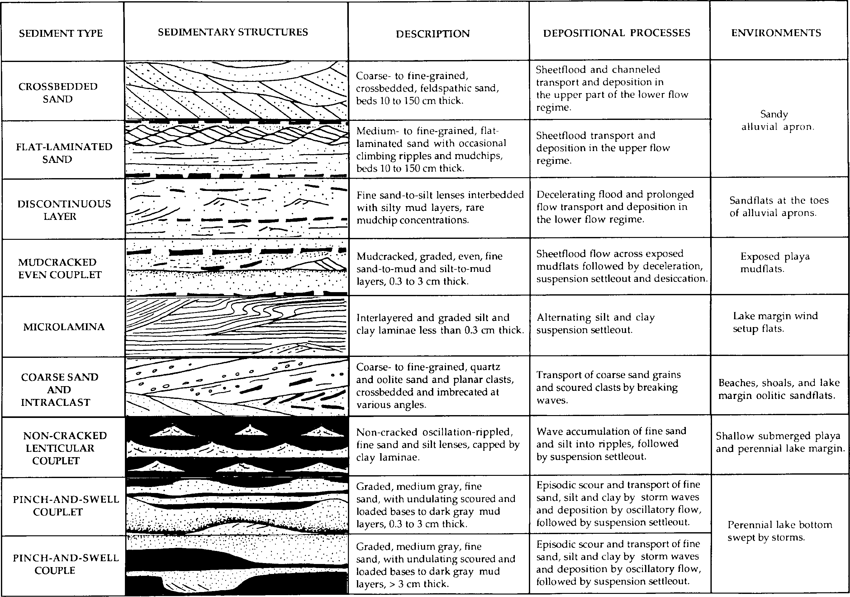

Figure 3. Principal sediment types occurring in the Belt Supergroup formations of east-central Idaho and western Montana.

ide ook to the eolo y o astern daho

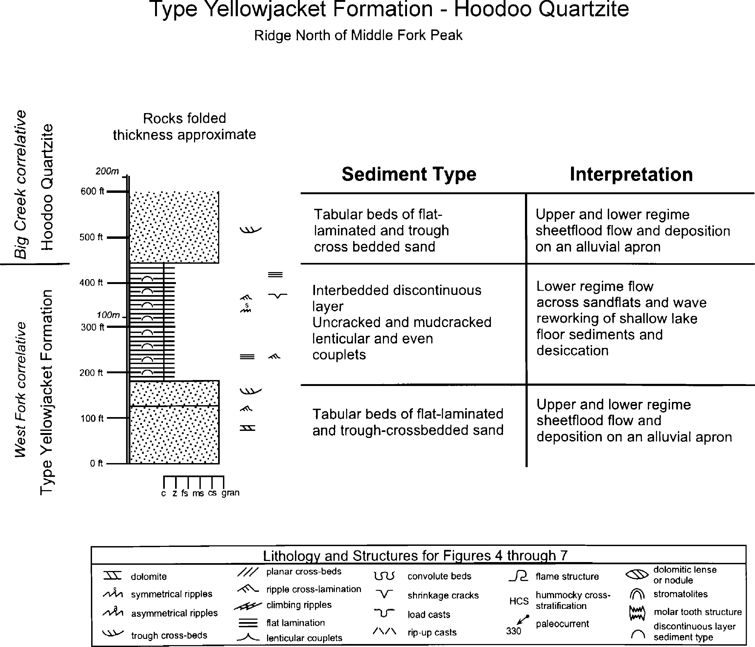
Figure 4. Traversed section along a ridge north of Middle Fork Peak, mapped as being continuous with the type Yellowjacket by Ekren (1988). General location shown in Figure 1; specific location is: unsurveyed, T. 19 N, R. 14 E., northeast quarter Aparejo Point 7.5 minute quadrangle; walk north to north side of peak 9029, along pack trail that joins Middle Fork Peak road 1/4 mi north of the lookout tower, leave trail and walk east to edge of cliffs; traverse up section to north along cirque headwall of lake 7966 at head of Lake Creek. Traverse stopped near summit of knob 1/8 mile southeast of point 8626, in Hoodoo Quartzite. Traversed 7/25/96.

tabular, trough-crossbedded arenite layers, of the crossbedded sand sediment type are locally interspersed within the flat-laminated arenite. Rare mud caps separating the tabular beds are desicca- tion cracked. Ripped up mud chips probably record scour of origi- nal mudcracked surfaces. Flat-laminated sand beds in the Inyo Creek thin upward and become interstratified with muddier, more lensoidal, rippled, very fine sand layers, capped by muddy sand. These rocks are assigned to the discontinuous-layer sediment type. The upper contact of the Inyo Creek Formation is drawn where flat-laminated sand and discontinuous very fine sand layers pass upward to silty discontinuous layers and mudcracked even and lenticular couplets of the West Fork Formation.
The tabular beds of flat-laminated sand record episodic up- per-regime sheet-flow across flat surfaces. Climbing ripples record flow deceleration and shift to the lower part of the lower flow regime. Occasional mudcracked surfaces record desiccation fol-
lowing the floods. Tabular sets of trough crossbeds record sheetflow, a meter or more deep, in the upper part of the lower flow regime. Based on these processes, the Inyo Creek Forma- tion is interpreted to have been deposited on a gently sloping alluvial apron, episodically inundated by sheetfloods, followed by desiccation. The very fine sandy lenses of the discontinuous- layer sediment type record episodes of slower flow that built ripples and sand lenses, followed by deposition of muddy sand as flow decelerated and was unable to transport the muddy load. We interpret the discontinuous-layer sediment type to have been de- posited on sand flats at the toes of the alluvial aprons.
Flat-laminated sand, discontinuous-layer, and crossbedded sand sediment types that characterize the Inyo Creek also occur in exposures mapped as Yellowjacket in the type area by Ekren (1988) along the ridge north of Middle Fork Peak (Fig. 5). These sediment types also characterize the Burke and Revett formations

Winston, Link and Hathaway -- The Yellow}acket is Not the Prichard and Other Heresies
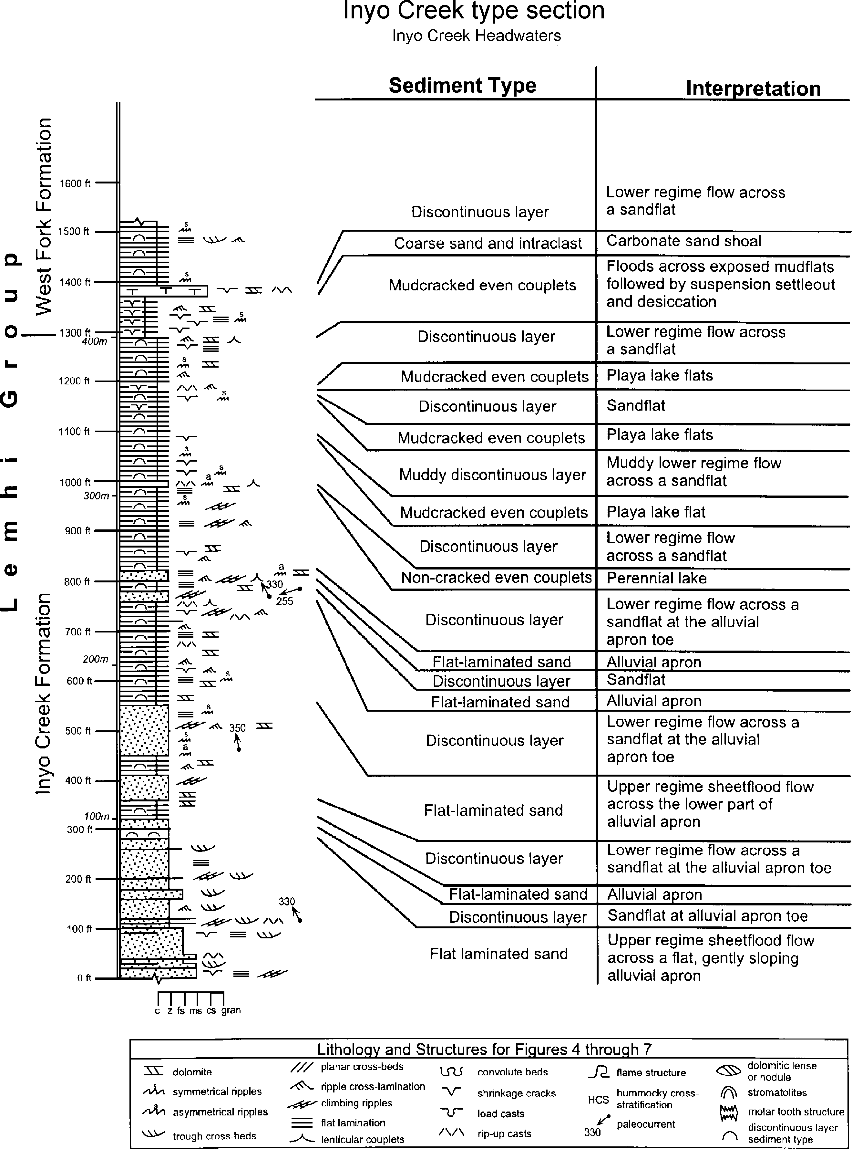

Figure 5. Type section of the Inyo Creek Formation in Inyo Creek Headwaters. General location shown in Figure 1, specific location shown in Ruppel (1975, Fig. 2); measured 7/23/96.

ide ook to the eolo y o astern daho

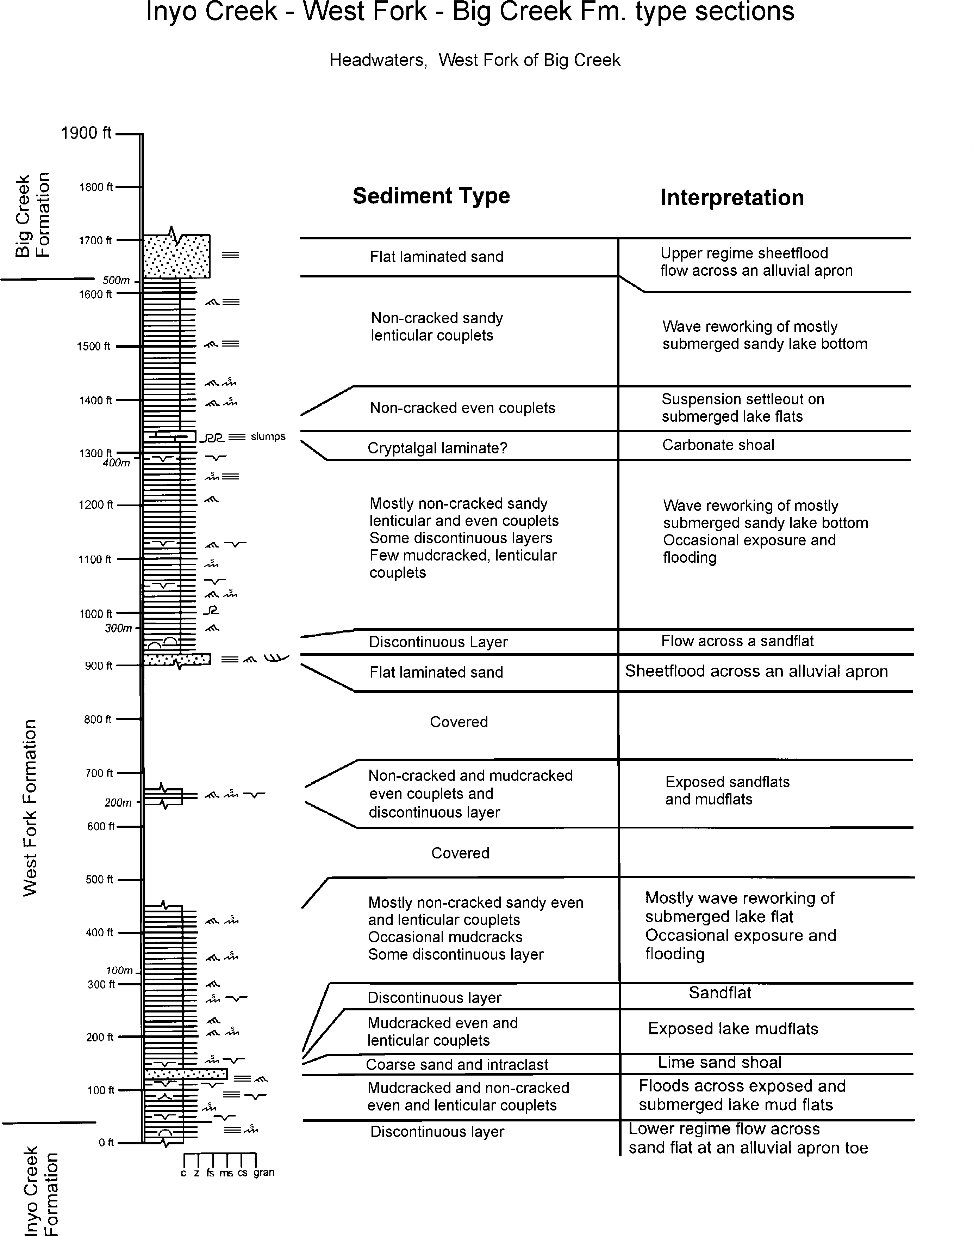

Figure 6. Type section of the West Fork Formation, headwaters, West Fork of Big Creek. General location shown in Figure 1; specific location shown in Ruppel (1975, Fig. 2); measured 7/24/96.

Winston, Link and Hathaway -- The Yellow}acket is Not the Prichard and Other Heresies 3

of the Ravalli Group of the Belt Supergroup. Because we here correlate the Big Creek and Hoodoo formations with the Revett Formation, we propose that the Inyo Creek Formation correlates with the lower or middle part of the Burke Formation. Conse- quently, the lower Belt Prichard Formation is not represented in east-central Idaho.

West Fork Formation
The type section of the West Fork Formation (Fig. 6) contin- ues above the Inyo Creek Formation through the summit of Inyo Peak and across the valley of West Fork of Big Creek to the base of the Big Creek Formation. The formation contains about 1,630 ft (497 m) of mostly dark greenish-gray non-cracked and mudcracked, even and lenticular, silt to clay couplets with rip-up mud clasts and local dolomitic lenses and layers. Oscillation ripple marks cover many bedding surfaces. Interbedded with the cou- plets are sandy and silty rippled beds of the discontinuous-layer sediment type. Some intervals of the sandy discontinuous-layer sediment type return in the upper part of the formation. The con- tact with the overlying Big Creek Formation is placed where tabu- lar fine-grained flat-laminated sand beds of the Big Creek appear above the rippled, silty and clayey West Fork. Within the forma- tion are occasional sand lenses crossbedded at a low angle, capped by tan-colored, folded and cleaved calcite beds and lenses. Ruppel (1975) interpreted these to be stromatolites, but the cleavage has obliterated most internal fabric and we saw no evidence of stro- matolites.
Mudcracked silt-to-clay even couplets probably record sheetflow across dry playa mudflat surfaces followed by ponding and desiccation. Oscillation-rippled lenticular couplets are attrib- uted to reworking of fine-grained sediment by waves in perennial lake waters or on occasionally exposed marginal flats. Carbonate precipitation may have been induced during arid periods, when waters of the enclosed lake became supersaturated with respect to calcium carbonate. The sandy discontinuous layers probably record ephemeral incursion of sandflats at the toes of alluvial aprons similar to those of the Inyo Creek Formation.
Our traverse through Yellowjacket exposures north of Middle Fork Peak (Fig. 4) revealed dark greenish-gray intervals of mudcracked and non-cracked rippled and even couplets and dis- continuous layers nearly identical to those of the West Fork For- mation, interbedded with flat-laminated sand similar to the Inyo Creek. Carbonate lenses in the West Fork section may have affin- ity to those first described in the type Yellowjacket by Ross (1934). Russ Tysdal (written communication, 1998) reports that the Yellowjacket carbonate lenses are scapolite-bearing. The West Fork may correlate with a muddy, green interval with even cou- plets near the top of the Burke Formation of the Ravalli Group (Mauk, 1983).

Big Creek Formation
The Big Creek Formation is widely exposed in the central Lemhi Range, where Ruppel (1975) estimated it to be 3,100 m (10,170 ft) thick. We have not examined the entire Big Creek Formation, but we have measured its basal and upper parts. The lower part in the type section contains light-gray to purplish-gray, flat-laminated and trough cross-bedded, fine-grained feldspathic
arenite of the flat-laminated and crossbedded sand sediment types. The upper part of the Big Creek on a ridge adjacent to the type section contains tabular beds of spectacular trough-crossbedded medium- to fine-grained, mud chip-bearing arenite, belonging to the crossbedded sand sediment type. Crossbeds reach up to 4 ft (1.2 m) thick in the lower parts of some tabular beds and thin upward into muddy sand-drape at the tops. Some troughs are de- formed. The upper boundary with muddy, greenish-gray even couples of the basal Apple Creek Formation is gradational through beds of low-angle crossbeds that may be antidunes.
We interpret the tabular beds of flat-laminated sand low in the Big Creek to be upper flow-regime sheetflood deposits on a gen- tly sloping alluvial apron that prograded across the West Fork lacustrine flats. The thick, tabular sets of mostly trough crossbeds in the upper Big Creek also record sheetflow across flat surfaces, but in the upper part of the lower flow regime. These thicker beds may reflect deeper, more turbulent floods that transported coarser sand than those of the lower Big Creek. Russ Tysdal (written com- munication, 1998) interprets the Big Creek as containing tidal sand deposits.
Despite Ekren's (1988) denials, correlation of the Big Creek with the Hoodoo Formation as originally proposed by Bennett (1977) is borne out by our study. Both the Big Creek and Hoodoo are light-gray to white, tabular, crossbedded and flat laminated feldspathic quartz arenite. Both are underlain by the Yellowjacket or its correlative, the West Fork, and both are overlain by the Apple Creek or the extension of the Apple Creek. Differences in mineralogy (Ekren, 1988) may be attributed to the finer grained arenite being more feldspathic than the coarse-grained quartzite beds.
The light-gray, tabular flat-laminated and trough-crossbedded arenite beds of the Big Creek and Hoodoo formations closely resemble those of the Revett Formation of the Ravalli Group, and we reaffirm their correlation (Winston and Link, 1993). Whereas the Hoodoo ranges from coarse- to fine-grained, and the Big Creek ranges from medium- to fine-grained, the Revett is fine- to very fine-grained, suggesting that the Hoodoo and Big Creek were deposited higher up on the alluvial apron surface, closer to the source than the Revett. Fine-grained tabular flat-laminated arenite beds of the Big Creek closely resemble similar beds in the Inyo Creek and Gunsight formations and may be easily confused with them. Medium-grained beds in the Big Creek and coarse- to me- dium-grained beds in the Hoodoo help differentiate those forma- tions from the finer grained Inyo Creek and Gunsight formations. The Big Creek and Hoodoo also tend to be more trough- crossbedded.

Apple Creek Formation
We measured 2,670 ft (815 m) of the Apple Creek section (Fig. 7 and 8) adjacent to its reference section (Ruppel, 1975) from the upper part of the Big Creek Formation along the base of the cliff west of Golden Trout Lake. The Apple Creek in this section can be divided into three units (Fig. 2, 7 and 8): a lower green and purple mudrock, composed of silt-to-clay even cou- plets, with sparse mudcracks, 1,180 ft (360 m) thick; a middle, green, fine-sandy, generally non-cracked, interval (over 770 ft (140 m) thick) with lenticular and even couplets; and an upper,

ide ook to the eolo y o astern daho

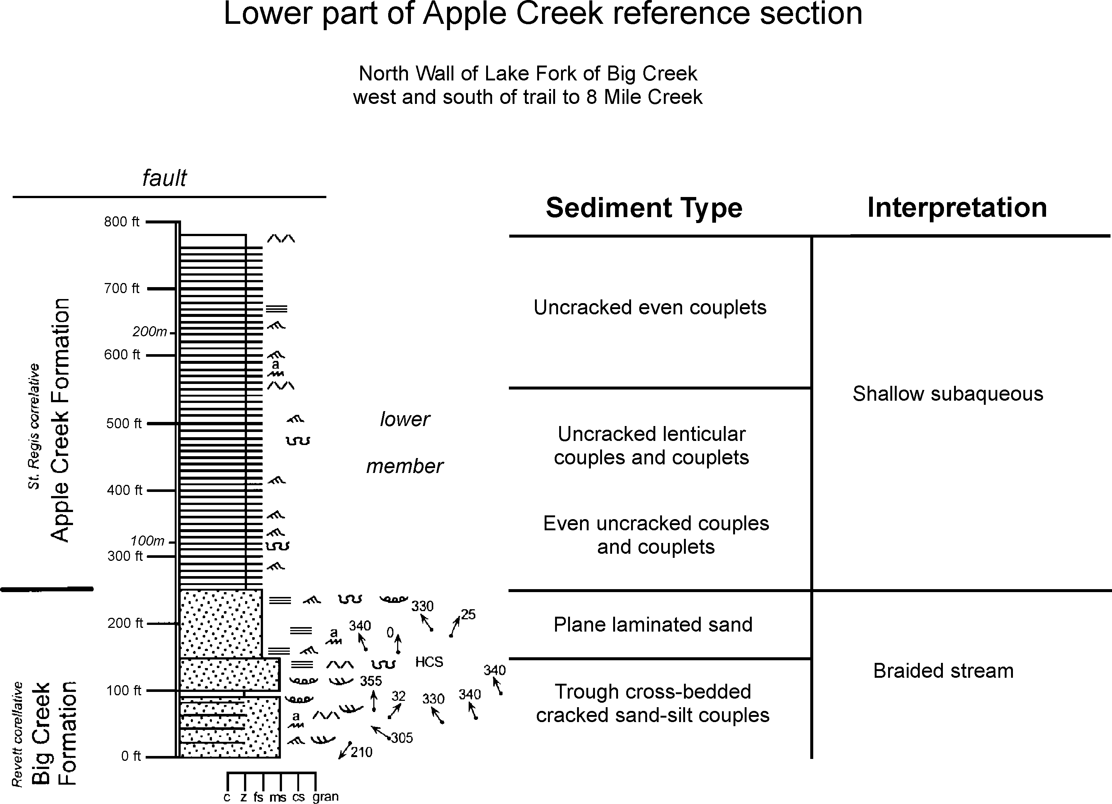

Figure 7. Lower part of reference section of the Apple Creek Formation, including basal contact with Big Creek Formation, north wall of Lake Fork of Big Creek, west and south of trail to Big Eightmile Creek. General location shown in Figure 1; specific location i s along the base of the cliffs west of the Lake Fork of Big Creek, this better-exposed section (unsurveyed, Yellow Peak 7.5 minute quadrangle, Idaho, south and southwest of survey point 9493, south of Pack Trail, proceeding north to fault near Pack Trail) is across the canyon from the reference section location shown in Ruppel (1975, Fig. 2); measured 7/28/95.

carbonate-bearing cyclic unit over 1180 ft (360 m) thick, with green uncracked lenticular couplets in the lower half-cycles and purple mudcracked even couplets in the upper half-cycles.
The lower interval is composed of green and purple locally mudcracked, even silt-to-clay couplets, with occasional ripped- up mudchip beds. Pervasive cleavage at a low angle to the bed- ding may have obliterated many mudcracks. We interpret the low- est Apple Creek couplets to record sheetfloods that crossed ex- posed playa surfaces and deposited silt. The flood waters then ponded and deposited the mud couplet caps that were again ex- posed and cracked.
The green lenticular couplets of the middle sandy interval have fine- to medium-grained sand in ripple lenses that record wave reworking of sediments brought into a perennial lake. Their gen- erally uncracked caps reflect suspension settleout during calm intervals.
The upper cyclic interval is characterized by more than 50 cycles 5 to 73 ft (1.5 to 22 m) thick, averaging 23 ft (7 m) thick, characterized by green, non-cracked lenticular fine-sand-to-mud couplets in the lower half-cycles, and purple, mudcracked very- fine-sand-to-clay even couplets in the upper half-cycles. Most lower half-cycles have lenticular couplets in which the oscilla-
tion-rippled sand lenses are calcite cemented, forming pods that weather recessively. The bases of some cycles are marked by hummocky cross-stratified sand or domal stromatolites surrounded by oolite that grade upward into pinch-and-swell couplets. Some upper half-cycles are dolomitic and contain molar-tooth struc- tures. The top of the Apple Creek is placed where light-gray, flat- laminated arenite beds characteristic of the Gunsight Formation overlie the Apple Creek cycles.

Figure 8. Upper part of reference section of the Apple Creek For- mation, including upper 2/3 of formation and upper contact with Gunsight Formation, north of Golden Trout Lake, head of Lake Fork of Big Creek. General location shown in Figure 1; specific location is the continuation of Figure 7, along the base of the cliffs, directly across the canyon from the reference sec- tion shown in Ruppel (1975, Fig. 2); unsurveyed Yellow Pine Peak 7.5 minute quadrangle, Idaho, from Pack Trail northward along cliffs west of Golden Trout Lake (9526), to contact with Gunsight Formation at the extreme northwest corner of the lake; measured 7/29-30/95.

Winston, Link and Hathaway -- The Yellow}acket is Not the Prichard and Other Heresies 5
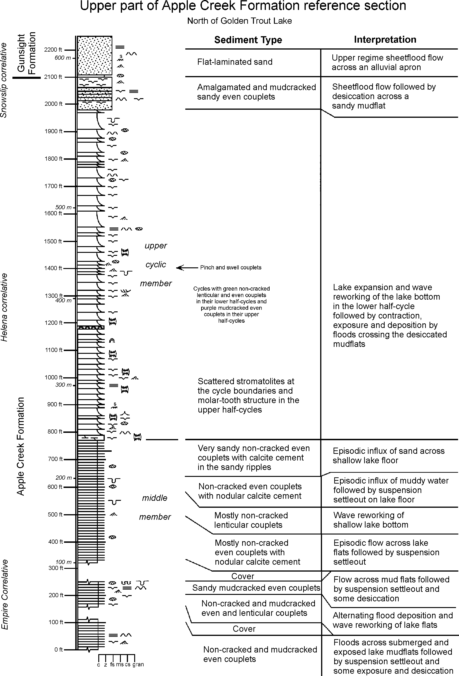

ide ook to the eolo y o astern daho

The lower half-cycles are interpreted to record episodic trans- gressions over exposed mudflat surfaces. Waves reworked the shallow bottom, forming sandy oscillation ripples, followed by quiescence and suspension settleout capping the non-cracked len- ticular couplets. These sediments remained submerged and were reduced. The hummocky cross-stratified sand beds and pinch- and-swell couplets probably record larger storm waves. The mudcracked even couplets of the upper half-cycles record regres- sion and deposition by episodic floods that crossed the exposed mudflats. These sediments remained oxidized. Dolomitic beds in some upper half-cycles probably record supersaturation with re- spect to Ca,MgCO3 in an enclosed body of water during arid pe- riods. Although definitive evidence is lacking, we interpret these cycles to have been generated by climate-induced expansion and contraction of lake waters, isolated from the Proterozoic ocean. Most of this conjecture rests on evidence in the correlative Hel- ena Formation of the Belt Supergroup (Winston and Lyons, 1993 and Winston, in press). If this interpretation is correct, then the cycles in the Apple Creek section were deposited along the shal- low, southern margin of the Great Belt Lake where shallow wa- ter-depth limited wave oscillation to ripple-scale and the tops of most cycles were exposed and desiccated. In this setting the Apple Creek cycles represent a nearshore facies of Helena-style cycles (Fig. 2).
Ruppel's (1975) insight in correlating the Apple Creek Phyllite of Anderson (1961) with his reference Apple Creek Formation section has been born out by Tysdal's (1996a, 1996b) and Tysdal and Moye's (1996) mapping across the northern part of the Lemhi Range. Tysdal and Moye recognized three informal units within the Apple Creek Formation. In our descriptive terminology they are: 1) even silt-to-clay couples in the lower part that grade up- ward into even silt-to-clay couplets, 2) a diamictite unit composed of bedded gray, mudcracked even couplets, interstratified with diamictite bodies which contain disheveled Big Creek and Apple Creek clasts, and 3) silty pinch-and-swell couples and couplets.
The lower unit may correlate with Ekren's (1988) argillaceous quartzite unit above the Hoodoo and member B of Lopez (1981). It may also correlate with the lower, green and purple unit with even couplets and with the middle, green sandy unit bearing non- cracked even and lenticular couplets in our Apple Creek section (Fig. 7, 8), in which case it fines to the south.
We interpret the Apple Creek diamictite, also termed the Hayden Creek diamictite (Tietbohl, 1986), to be debris-flow de- posits on periodically exposed mudflats, perhaps adjacent to an unidentified uplifted basin block. The diamictite must pinch out southward, as it is not present in the Apple Creek reference sec- tions along Lake Fork of Big Creek (Fig. 7 and 8). The strati- graphic interval represented by the cycles in the Apple Creek ref- erence section displays important facies changes through the north- ern Lemhi Range into the Cobalt area, and we propose that the name Apple Creek Formation be applied to "Cobalt Yellowjacket" members A-D of Lopez in the Cobalt area.
Along the Salmon River, purple, mudcracked even couplets capping the cycles disappear, and the upper Apple Creek con- tains beds of low-angle, hummocky crossbedded and ripple cross laminated arenite and silt-to-clay couplets. This trend appears to continue northward into the "Cobalt Yellowjacket" units C and
D, where pinch-and-swell couplets and couples are identical to those that characterize the Wallace Formation.
Pinch-and-swell couples and couplets of the Wallace are at- tributed to storms that swept the exceedingly flat, comparatively shallow, lake floor during deposition of the Helena and Wallace formations (Winston and Lyons, 1993; Winston, in press). There- fore, the northward facies change in the Apple Creek Formation records deepening from the alternately submerged and exposed margin of the Great Belt Lake out to the shallow, perennial lake floor. The thick, loaded arenite lenses in the "Yellowjacket" near Lemhi Pass in the Beaverhead Mountains most closely resemble pinch-and-swell couples of the Cobalt middle Yellowjacket, with which we correlate the Beaverhead "Yellowjacket" (Fig. 1, 2).
The upper Apple Creek Formation has attributes of both the Helena and Wallace formations of the Belt Supergroup, with which we correlate it. The Helena Formation has the most fully devel- oped cycles in the Belt, and the scale of the Apple Creek cycles in the reference section compare closely to those of the Helena. Pinch-and-swell couples and couplets of the Cobalt Apple Creek member D are indistinguishable from those of the Wallace For- mation.

Gunsight Formation
In its type section the Gunsight Formation, estimated by Ruppel (1975) to be 1,830 m (6000 ft) thick, is composed mostly of discontinuously rippled lenses and layers of light-gray, fine arenite capped by purple muddy arenite in graded layers 3-8 cm thick, assigned to the discontinuous-layer sediment type. Interstratified with the discontinuous layers are tabular beds of light-gray trough-crossbedded and flat-laminated fine-grained arenite that commonly grade up to climbing ripples. The top of the Gunsight is placed where beds of the discontinuous-layer sedi- ment type disappear upward into flat-laminated and trough- crossbedded medium-grained arenite of the Swauger Formation.
Tabular flat-laminated beds in the Gunsight are similar to those in the Inyo Creek and to fine-grained facies of the Big Creek. We interpret them to record sheetflood deposition on the lower parts of shifting alluvial aprons. Discontinuous layer beds are inter- preted to have been deposited by sheetfloods and more continu- ous flows that crossed exposed sandflats which extended from the toes of the alluvial aprons.
The flat-laminated sand beds and the couplet scale of the purple discontinuous-layer sediment type ally the Gunsight to the Snowslip Formation that overlies the Helena and Wallace forma- tions in the Belt. Mudcracked silt-to-clay couplets are more com- mon in the Snowslip, suggesting that much of the Snowslip was deposited on playa mudflats, whereas more of the Gunsight was deposited on more proximal sand flats at the toes of alluvial aprons.

Swauger Quartzite
The Swauger Quartzite is characterized by tabular beds of purple to light-gray, trough-crossbedded and flat-laminated coarse- to fine-grained feldspathic arenite several thousand feet thick. Some trough crossbeds contain subrounded, metaquartzite pebbles. Farooqui (1994) concluded that the <12% K-feldspar grains and the <1% lithic grains in the Swauger compare it more closely to the Mount Shields sand member 2 than to the Bonner

Winston, Link and Hathaway -- The Yellow}acket is Not the Prichard and Other Heresies 7

Formation which contains >20% K-feldspar grains and > 8% lithic grains. Like tabular crossbedded arenite of the Big Creek Forma- tion, the Swauger is interpreted to have been deposited by sheetfloods that flowed down alluvial aprons in the upper part of the lower flow regime and in the upper flow regime. The Swauger is the southern part of an immense alluvial sand wedge that ex- tends northward beyond the Canadian border.

awson Creek Formation
The Lawson Creek Formation was named by Hobbs (1980) for a 1,200 m (3935 ft) thick heterogeneous succession of purple, even and oscillation-rippled mudcracked couplets and couples that gradationally overlies the Swauger Formation in the north- ernmost Lost River Range and Salmon River Mountains. It may be the southern extension of the Mount Shields member 3 (Farooqui, 1994). Alternately, porcelanite nodules in the Lawson Creek may ally it to the McNamara Formation of the Missoula Group.

RAMIFICATIONS IN REGARD TO THE MEDICINE LODGE THRUST FAULT
The above correlations, establishing the continuity of the Lemhi Group formations with the Yellowjacket and the Belt Su- pergroup, also affect the mapped regional geologic structure. It is no longer necessary to place faults at Lemhi Group, Yellowjacket and Belt boundaries, such as along the mapped trace of the Medi- cine Lodge thrust, where Lemhi Group rocks are shown thrust over Yellowjacket and Missoula Group rocks (Ruppel et al., 1993). For example, north of Lemhi Pass in the Beaverhead Mountains, the trailing edge of the Medicine Lodge thrust has been mapped as Lemhi Group over Yellowjacket. But to us the inferred thrust appears to be a normal stratigraphic contact of the Gunsight For- mation over the Apple Creek. The mapped Medicine Lodge thrust across the headwaters of Fourth of July Creek is shown carrying Lemhi Group on the west over Missoula Group rocks on the east. Our field observations suggest that in places this mapped thrust is the normal contact between the Gunsight and overlying Swauger formations or is placed within an unbroken, continuous crossbedded arenite unit, probably best assigned to the Swauger. In the Leesburg quadrangle Connor and Evans (1986) show a thrust (presumably the Medicine Lodge thrust), carrying Big Creek over upper upper Yellowjacket Formation wrapping around a knoll 2 miles southwest of Williams Creek summit. We interpret the inferred thrust to be a normal contact of Swauger above the Gunsight. Tysdal (1996a; 1996b) also failed to find the Medicine Lodge thrust as depicted by Ruppel and Lopez (1984) in the Hayden Creek window. Erasing the Medicine Lodge thrust north of Lemhi Pass significantly simplifies the geologic structure of the area.

REGIONAL TECTONIC IMPLICATIONS
Eliminating the Medicine Lodge thrust does not resolve all the tectonic problems of east-central Idaho. From Sm-Nd analy- sis Doughty and Chamberlain (1996) concluded that the "Cobalt Yellowjacket" was part of the Belt lithosome, not part of a pre- Belt Salmon arch. They confirmed Evans and Zartman's (1981) and Evans' (1986) 1,370 Ma age date for the granite and mafic
rocks that intruded the Yellowjacket in the Salmon Mountains. Because 1,370 Ma falls within the 1,470 to 900-1,100 my time span of Belt deposition accepted by Doughty and Chamberlain, they concluded that the Belt rocks were intruded while they were deposited, although the intrusion and metamorphism left no depo- sitional record in the upper Belt succession. Their geothermobarometry indicated that the Cobalt Yellowjacket was intruded at a depth of 14 to 20 km, and they argued that the Prichard was the only Belt unit possibly buried to that depth during Belt deposition. In rejecting Winston and Link's correlation of the Cobalt Yellowjacket with the St. Regis and Wallace formations, Doughty and Chamberlain cited the similarity of the Cobalt Yellowjacket to the Prichard, with which we strongly disagree. The Prichard is characterized by graded turbidites and even lami- nae deposited below storm base, whereas the Cobalt Yellowjacket is characterized by mudcracks, ripples and hummocky cross-strati- fication deposited above storm base. Their major similarity lies in their both being elevated to biotite grade metamorphism- hardly grounds for stratigraphic correlation.
The Belt-granite dilemma appears to have been solved by new high-precision zircon age dates from Belt strata, which suggest that lower Belt, Ravalli Group, and the Helena and Wallace for- mations were deposited from 1470 to 1440 Ma, and most of the Missoula Group was deposited by 1390 Ma (Aleinikoff et al., 1996). Thus the 1370 Ma granite and metamorphism post-date the Belt, and probably formed under a later tectonic regime. The basis for the Salmon River arch, the correlation of the Yellowjacket with the Prichard, and the separation of the Yellowjacket from the Lemhi Group and Belt Supergroup all dissolve into an emi- nently reasonable tectonic interpretation.
First, the Belt Supergroup, Yellowjacket Formation and Lemhi Group were all deposited from 1470 Ma to 1390 Ma in the Belt basin with a principal source area to the west as illustrated by Winston and Link (1993, Figures 17, 19, and 20). Belt rocks in the Cobalt area then were intruded at 1370 Ma, metamorphosed, and possibly elevated into a feature which may have been reacti- vated as the Paleozoic Lemhi arc.
A revised depositional history of the east-central Idaho rocks can be envisioned as follows. The absence of lower Belt rocks in east-central Idaho suggests that either they were deposited and are buried, or they were not deposited. In the latter case, perhaps the trace of the Perry line (Winston, 1986b) projected west from the Highland Mountains through the vicinity of Lost Trail Pass and east-central Idaho was part of the uplifted Dillon block. As the rift basin expanded and subsided, terrestrial rocks of the Ravalli Group (Inyo Creek, West Fork, Big Creek and lower Apple Creek formations) were deposited south of the Perry line on alluvial aprons and distal sandflats that, in the absence of a Belt uplift, sloped northward into the intracratonic Belt basin. Continued rift- ing may have lowered the basin floor and filled it with a shallow inland sea recorded by the pinch-and-swell storm beds of the up- per Apple Creek near Cobalt. Cycles of the upper Apple Creek reference section to the south appear to record climatically in- duced expansion and contraction of the inland sea along its south- ern margin. Nearby block uplifts may have generated the Apple Creek diamictite beds, and northwest-trending graben faults may have served as conduits for volcanic-related exhalative cobalt, copper and gold mineralization of the Cobalt district (Hughes,

8 ide ook to the eolo y o astern daho

1983, 1990; Hahn and Hughes, 1984; Nash and Hahn, 1986). The Gunsight and Swauger formations mark a return to alluvial- apron sheetfloods which fed sediments northward toward the cen- ter of the Belt basin.
The new zircon age dates indicate the entire Belt Supergroup was deposited in less than 100 Ma. The revised, shorter duration of deposition suggests the basin may have initially subsided at a rate of 0.4 to 0.2 meters per thousand years, consistent with its origin as an intracontinental rift basin.

SUMMARY
The Yellowjacket is not the Prichard. Instead, the type Yellowjacket Formation corresponds to the flat-laminated sand of the Inyo Creek Formation and the rippled, mudcracked West Fork Formation of the Lemhi Group, all three of which correlate with the Burke Formation of the Belt Supergroup. Overlying trough-crossbedded and flat-laminated arenite of the Hoodoo Formation correlates with the Big Creek Formation of the Lemhi Group and with the Revett Formation of the Belt. Mudcracked even couplets, microlaminae, and pinch-and-swell couples of the "Cobalt Yellowjacket" Formation correlate with the Apple Creek Formation of the Lemhi Group and with the Helena and Wallace formations of the Belt. Flat-laminated arenite at the top of the "Cobalt Yellowjacket" corresponds to the Gunsight Formation of the Lemhi Group and to the Snowslip Formation of the Belt Su- pergroup. The trough-crossbedded Swauger Formation correlates with the informal Mount Shields sand member 2 of the Missoula Group, and the Lawson Creek may correlate with the informal Mount Shields member 3. These correlations eliminate the ne- cessity to place thrust contacts at the Yellowjacket, Lemhi Group and Missoula Group boundaries, and the absence of thrusts in key outcrops in the northern Beaverhead Mountains and else- where call into question the inferred Medicine Lodge thrust north of Lemhi Pass. Recent radiometric dates which limit Belt deposi- tion from 1470 to 1390 Ma predate the 1370 Ma granite and mafic intrusives that cut and metamorphosed the Apple Creek near Cobalt. The resulting tectonic synthesis eliminates the rationale for the Salmon River and Lemhi arches in Middle Proterozoic time. Integrating the Middle Proterozoic rocks of east-central Idaho into the Belt Supergroup leads to the recognition of a single vast intracratonic Belt rift-basin with a principal source area to the west and southwest.

FURTHER WORK
Our work has focused on measuring stratigraphic sections. Our correlations of those sections in the field has been at a recon- naissance level. We have not ventured south of Lemhi Pass in the Beaverhead Mountains and do not challenge the existence of the Medicine Lodge, Cabin, Hawley Creek and related thrusts in the southern Beaverhead Mountains (Ruppel, 1978; Skipp, 1988). The stratigraphic correlations proposed here will need to be tested by renewed careful mapping like that of Tysdal (1996a; 1996b) and Tysdal and Moye (1996), from east-central Idaho into Mon- tana.
The simplified stratigraphic correlations will require revision of the formal stratigraphic nomenclature. As a first step we rec- ommend that the Lopez's (1981) "Cobalt Yellowjacket" mem-
bers A-D above the Hoodoo Quartzite be mapped as the Apple Creek Formation with designated members, and that Lopez's member E [Yyuu of Connor and Evans (1986)] be mapped as Gunsight (Fig. 2).

ACKNOWLEDGMENTS
We thank Russ Tysdal and Karl Evans for reviewing the ini- tial manuscript and for pointing out our more-obvious errors. Responsibility for the more heretical conclusions remains with us. Anne Gellatly accompanied us on one of the field excursions. Drafting assistance by Jim Riesterer and Jenny Szabo is grate- fully acknowledged.
Written and oral dialogue with Russ Tysdal during the review process was very useful. Tysdal has two U.S.G.S. monographs in review which deal with much of this material, and which come to many of the same major conclusions. Differences in interpreta- tion of depositional environments and details of correlation re- main for further study.

REFERENCES CITED
Aleinikoff, J.H., Evans, K.V., Fanning, C.M., Obradovich, J.D., Ruppel, E.T., Zieg, J.A., and Steinmetz, J.C., 1996, SHRIMP U-Pb ages of felsic igneous rocks, Belt Supergroup, Western Montana: Geological Society of America, Abstracts with Programs, v. 28, no. 7, p. A-376.
Anderson, A.L., 1953, Gold-copper-lead deposits of the Yellowjacket district, Lemhi county, Idaho: Idaho Bureau of Mines and Geology Pamphlet 94, 41 p.
Anderson, A.L., 1956, Geology and mineral resources of the Salmon quadrangle, Lemhi County, Idaho: Idaho Bureau of Mines and Geology Pamphlet 106, 102 p.
Anderson, A.L., 1959, Geology and mineral resources of the North Fork quad- rangle, Lemhi County, Idaho: Idaho Bureau of Mines and Geology Pam- phlet 118, 92p.
Anderson, A.L., 1961, Geology and mineral resources of the Lemhi quadrangle, Lemhi County, Idaho: Idaho Bureau of Mines and Geology Pamphlet 124, 111 p.
Armstrong, R.L., 1975, Precambrian (1500 m.y. old) rocks of central Idaho - the Salmon River Arch and its role in Cordilleran sedimentation and tectonics: American Journal of Science, v. 275-A, p. 437-467.
Bennett, E.H., 1977, Reconnaissance geology and geochemistry of the Black- bird Mountain-Panther Creek Region, Lemhi County, Idaho: Idaho Bureau of Mines and Geology Pamphlet 167, 188 p.
Bond, J.G., 1978, Geologic map of Idaho: Idaho Bureau of Mines and Geology, scale 1:500,000.
Connor, J.J., and Evans, K.V., 1986, Geologic map of the Leesburg quadrangle, Idaho: U.S. Geological Survey Miscellaneous Field Studies Map MF-1880, scale 1:62,500.
Doughty, P.T., and Chamberlain, K.R., 1996, Salmon River Arch revisited: new evidence for 1370 Ma rifting near the end of deposition in the Middle Pro- terozoic Belt basin: Canadian Journal of Earth Sciences: v. 33, p. 1037- 1052.
Ekren, E.B., 1988, Stratigraphic and structural relations of the Hoodoo Quartz- ite and Yellowjacket formation of Middle Proterozoic age from Hoodoo Creek eastward to Mount Taylor, central Idaho: U.S. Geological Survey Bulletin 1570, 17 p.
Evans, K.V., 1986, Middle Proterozoic deformation and plutonism in Idaho, Montana and British Colombia: in Roberts, S.M., ed., Belt Supergroup: A guide to Proterozoic rocks of western Montana and adjacent areas: Mon- tana Bureau of Mines and Geology Special Publication 94, p. 237-244.
Evans, K.V., 1999, The Yellowjacket Formation of east-central Idaho: Proceed- ings of Belt Symposium III-1993: Montana Bureau of Mines and Geology, in press.
Evans, K.V., and Zartman, R.E., 1981, U-Th-Pb zircon geochronology of Prot- erozoic Y granitic intrusions in the Salmon area, east-central Idaho [Ab- stract]: Geological Society of America Abstracts with Programs, v. 13, no. 4, p. 195.

Winston, Link and Hathaway -- The Yellow}acket is Not the Prichard and Other Heresies 9

Evans, K.V. and Ekren, E.B., 1985, Hoodoo Quartzite revisited-Stratigraphic relationships near Yellowjacket, Idaho: Geological Society of America Ab- stracts with Programs, v. 14, no. 4, p. 217.
Evans, K.V., and Connor, J.J., 1993, Geologic map of the Blackbird Mountain 15-minute quadrangle, Lemhi County, Idaho: U.S. Geological Survey Mis- cellaneous Field Studies Map MF-2234, scale 1:62,500.
Farooqui, M.A., 1994, Petrology and provenance of the Middle Proterozoic Bonner Formation and its correlatives, Belt Supergroup, Montana, Idaho and Washington [unpublished Ph.D Dissertation]: Missoula, University of Montana, 262 p.
Hahn, G.A., and Hughes, G.J., Jr., 1984, Sedimentation, tectonism, and associ- ated magmatism of the Yellowjacket Formation in the Idaho Cobalt Belt, Lemhi County, Idaho, in Hobbs, S.W., ed., The Belt: Montana Bureau of Mines and Geology Special Publication 90, p. 65-67.
Harrison, J.E, Griggs, A.B, and Wells, J.D., 1974, Tectonic features of the Pre- cambrian Belt basin and their influence on post-Belt structures: U.S. Geo- logical Survey Professional Paper 866, 15p.
Hay, J.S., 1948, Cobalt-copper deposits in the Blackbird district, Lemhi County, Idaho: U.S. Geological Survey Strategic Minerals Investigations Prelimi- nary Report 3-219, 26p.
Hobbs, S.W., 1980, The Lawson Creek Formation of middle Proterozoic age in east-central Idaho: U.S. Geological Survey Bulletin 1482-E, 12 p.
Hughes, G.J., Jr., 1983, Basinal setting of the Idaho Cobalt Belt, Blackbird min- ing district, Lemhi County, Idaho: in Genesis of Rocky Mountain Ore De- posits-Changes with time and tectonics: Denver, Regional Exploration Geology Society, p. 21-27.
Hughes, G.H., 1990, The Blackbird Mining District, Lemhi County, Idaho: in Moye, F.J., ed., Geology and ore deposits of the Trans-Challis fault system/ Great Falls tectonic zone: Tobacco Root Geological Society Fifteenth An- nual Field Conference Guidebook, p. 3-30.
Janecke, S.U., Vandenburg, C.J., and Blankenau, J.J., 1998, Geometry, mecha- nisms and significance of extensional folds from examples in the Rocky Mountain Basin and Range province, U.S.A., Journal of Structural Geol- ogy, v. 20, no. 7., p. 841-856.
Link, P.K., Christie-Blick, N., Devlin, W.J., Elston, D.P., Horodyski, R.J., Levy, Marjorie, Miller, J.M.G., Pearson, R.C., Prave, Anthony, Stewart, J.H., Win- ston, Don, Wright, L.A., Wrucke, C.T., 1993, Middle and Late Proterozoic stratified rocks of the western U.S. Cordillera, Colorado Plateau, and Basin and Range province, in Reed, Jr, J.C., Bickford, M.E, Houston, R.S, Link, P.K., Rankin, R.W., Sims, P. K., and VanSchmus W.R., eds., Precambrian: Conterminous U.S. The Geology of North America volume C-2: Decade of North American Geology: Geological Society of America, p. 463-595.
Link, P.K., Winston, Don, and Hathaway, Nate, 1997, The Yellowjacket is not the Prichard: Revised correlation of Lemhi Group, Yellowjacket formation and Belt Supergroup, Mesoproterozoic, Montana and Idaho: Geological Society of America Abstracts with Programs, v. 29, no. 6, p. A-408.
Link, P.K., Winston, Don, and Hathaway, Nate, 1998, Revised paleogeography of the Mesoproterozoic Belt Supergroup [Abstract]: AAPG Annual Meet- ing, Salt Lake City, on Compact Disc.
Lopez, D.A., 1981, Stratigraphy of the Yellowjacket Formation of east-central Idaho: U.S. Geological Survey Open-File Report 81-1088, 219 p.
Lopez, D.A., 1982, Reconnaissance geologic map of the Ulysses Mountain quad- rangle, Lemhi County, Idaho: U.S. Geological Survey Miscellaneous Field Studies Map MF-1445, scale 1:48,000.
Lund, Karen, 1999, Metamorphic rocks of central Idaho: A progress report: Pro- ceedings of Belt Symposium III, Montana Bureau of Mines and Geology, in press.
Lund, Karen and Esparza, L.E., 1990, Mineral Resources of the Gospel-Hump Wilderness, Idaho County, Idaho: U.S. Geological Survey Bulletin 1812, 19 p.
Mauk, J. L., 1983, Stratigraphy and sedimentation of the Proterozoic Burke and Revett Formations, Flathead Reservation, western Montana [M.S. thesis]: Missoula, University of Montana, 106 p.
Nash, J.T., and Hahn, G.A., 1986, Volcanogenic character of sediment-hosted Co-Cu deposits in the Blackbird mining district, Lemhi County, Idaho-an interim report: U.S. Geological Survey Open-File Report 86-430, 29 p.
Ross, C.P., 1934, Geology and ore deposits of the Casto quadrangle, Idaho: U.S. Geological Survey Bulletin 854, 135 p.
Ross, C.P., 1947, Geology of the Borah Peak Quadrangle, Idaho: Geological Society of America Bulletin, v. 58, p. 1085-1160.
Ross, C.P., 1962, Stratified rocks in south-central Idaho: Idaho Bureau of Mines and Geology Pamphlet 130, 98p.
Ruppel, E.T., 1968, Geologic map of the Leadore quadrangle, Lemhi County Idaho: U.S. Geological Survey Geologic Quadrangle Map GQ-733.
Ruppel, E.T., 1975, Precambrian Y sedimentary rocks in east-central Idaho: U.S. Geological Survey Professional Paper 889-A, 23 p.
Ruppel, E.T., 1978, Medicine Lodge thrust system, east-central Idaho and south- west Montana: U.S. Geological Survey Professional Paper 1031, 23 p.
Ruppel, E.T., 1980, Geologic map of the Patterson Quadrangle, Lemhi County, Idaho: U.S. Geological Survey Geologic Quadrangle Map GQ-1529, scale 1:62,500.
Ruppel, E.T., 1986, The Lemhi Arch: A late Proterozoic and early Paleozoic landmass in central Idaho, in Peterson, J.A., ed., Paleotectonics and Sedi- mentation in the Rocky Mountain Region, United States, American Asso- ciation of Petroleum Geologists Memoir 41, p. 119-130.
Ruppel, E.T., and Lopez, D.A., 1981, Geologic map of the Gilmore Quadrangle, Lemhi and Custer Counties, Idaho: U.S. Geological Survey Geologic Quad- rangle Map GQ-1543, scale 1:62,500.
Ruppel, E.T., and Lopez, D.A., 1984, The thrust belt in southwest Montana and east-central Idaho: U.S. Geological Survey Professional Paper 1278, 41 p.
Ruppel, E.T., and Lopez, D.A., 1988, Regional geology and mineral deposits in and near the central part of the Lemhi Range, Lemhi County, Idaho: U.S. Geological Survey Professional Paper 1480, 122 p.
Ruppel, E.T., O'Neill, J.M., and Lopez, D.A., 1993, Geologic Map of the Dillon 1 x 2 Quadrangle, Idaho and Montana: U.S. Geological Survey Miscella- neous Investigations Series Map I-1083-H, scale 1:250,000.
Schmidt, K.L., Lewis, R.S., Burmester, R.F., and Lang, R.A., 1994, Reconnais- sance geologic map of the Shoup and Horse Creek area, Lemhi County, Idaho: Idaho Geological Survey Technical Report 94-3, scale 1:50,000.
Shockey, P.N., 1957, Reconnaissance geology of the Leesburg quadrangle, Lemhi County, Idaho: Idaho Bureau of Mines and Geology Pamphlet 1 13, 42p.
Skipp, B., 1987, Basement thrust sheets in the Clearwater orogenic zone, central Idaho and western Montana: Geology, v. 15, p. 220-224.
Skipp, B., 1988, Cordilleran thrust belt and faulted foreland in the Beaverhead Mountains, Idaho and Montana, in Schmidt, C.J., and Perry, W.J., Jr., eds., Interaction of the Rocky Mountain foreland and Cordilleran thrust belt: Geological Society of America Memoir 171, p. 237-266, map scale 1:250,000.
Sloss, L.L., 1954, Lemhi arch, a mid-Paleozoic positive element in south-central Idaho: Geological Society of America Bulletin, v. 65, p. 365-368.
Smith, S.V. and Winston, Don, 1997, Formation of cracks in subaqueous fluid mud by solitary waves, central Louisiana, Gulf of Mexico coast: Geological Society of America Abstracts with Programs, v. 29, no. 6, p. A-440.
Staatz, M.H., 1973, Geologic map of the Goat Mountain Quadrangle, Lemhi County, Idaho and Beaverhead County, Montana: U.S. Geological Survey Geological Quadrangle Map GQ-1097, scale 1:24,000.
Staatz, M.H., 1979, Geology and mineral resources of the Lemhi Pass Thorium district, Idaho and Montana: U.S. Geological Survey Professional Paper 1049- A, p. A1-A90, scale 1:31,680.
Tietbohl, D., 1986, Middle Proterozoic diamictite beds in the Lemhi Range, east-central Idaho, in Roberts, S.M., ed., Belt Supergroup A guide to Prot- erozoic rocks of western Montana and adjacent areas: Montana Bureau of Mines and Geology Special Publication 94, p. 197-207.
Tucker, D.R., 1975, Stratigraphy and structure of Precambrian Y (Belt?) metasedimentary and associated rocks, Goldstone Mountain quadrangle, Lemhi County Idaho and Beaverhead County, Montana [Ph.D. Disserta- tion]: Oxford, Illinois, Miami University, 221 p.
Tysdal, R.G., 1996a, Geologic map of the Lem Peak quadrangle, Lemhi County, Idaho: U.S. Geological Survey Geologic Quadrangle Map GQ-1777, scale 1:24,000.
Tysdal, R.G., 1996b, Geologic map of parts of the Hayden Creek and Mogg Mountain quadrangles, Lemhi County, Idaho: U.S. Geological Survey Mis- cellaneous Investigations Series I-2563, scale 1:24,000.
Tysdal, R.G. and Moye, Falma, 1996, Geologic map of the Allison Creek quad- rangle, Lemhi County, Idaho: U.S. Geological Survey Geologic Quadrangle Map GQ-1778, scale 1:24,000.
Umpleby, J.B., 1913, Geology and ore deposits of Lemhi County, Idaho: U.S. Geological Survey Bulletin 528, 182 p.
Winston, Don, 1986a, Sedimentology of the Ravalli Group, Middle Belt Car- bonate and Missoula Group, Middle Proterozoic Belt Supergroup, Mon- tana, Idaho and Washington, in Roberts, S.M., ed., Belt Supergroup: A guide to Proterozoic rocks of western Montana and adjacent areas: Montana Bu- reau of Mines and Geology Special Publication 94, p. 85-124.

ide ook to the eolo y o astern daho

Winston, Don, 1986b, Sedimentation and tectonics of the Middle Proterozoic Belt basin, and their influence on Phanerozoic compression and extension in western Montana and northern Idaho, in Peterson, J.A., ed., Paleotectonics and Sedimentation in the Rocky Mountain Region, United States, Ameri- can Association of Petroleum Geologists Memoir 41, p. 87-118.
Winston, Don, 1999, Carbonate and siliciclastic facies in cycles of the Helena and Wallace formations, Middle Proterozoic Belt Supergroup, in Berg, R. (ed.) Proceedings of Belt Symposium III: Montana Bureau of Mines and Geology, in press.
Winston, D., and Link, P.K., 1993, Middle Proterozoic rocks of Montana, Idaho and Eastern Washington: The Belt Supergroup: in Reed, J.C., and six oth- ers, Precambrian: Conterminous U.S.: Boulder, Colorado, Geological Soci- ety of America, The Geology of North America, v. C-2, p. p. 487-517.
Winston, Don, and Lyons, Timothy, 1993, Sedimentary cycles in the St. Regis, Empire and Helena formations of the Middle Proterozoic Belt Supergroup, northwestern Montana, in Link P. K., ed., Geologic Guidebook to the Belt- Purcell Supergroup, Glacier National Park and vicinity, Montana and adja- cent Canada: Belt Symposium III Field Trip Guidebook, Belt Association, c/o P.K. Link, Dept. of Geology, Idaho State University, Pocatello, ID 83209, p. 21-51.
Winston, Don and Smith S.V., 1997, Sand-filled folded cracks cutting mud lay- ers that cap HCS sand beds, Middle Proterozoic Wallace Formation, Belt Supergroup, Montana: Formed by solitary waves? [Abstract]: Geological Society of America Abstracts with Programs, v. 29, no. 6 p. A440.

