Electrical Engineering Program (BSEE)

Recommended Plan of Study
121 credits, 2022-2023 Undergraduate Catalog

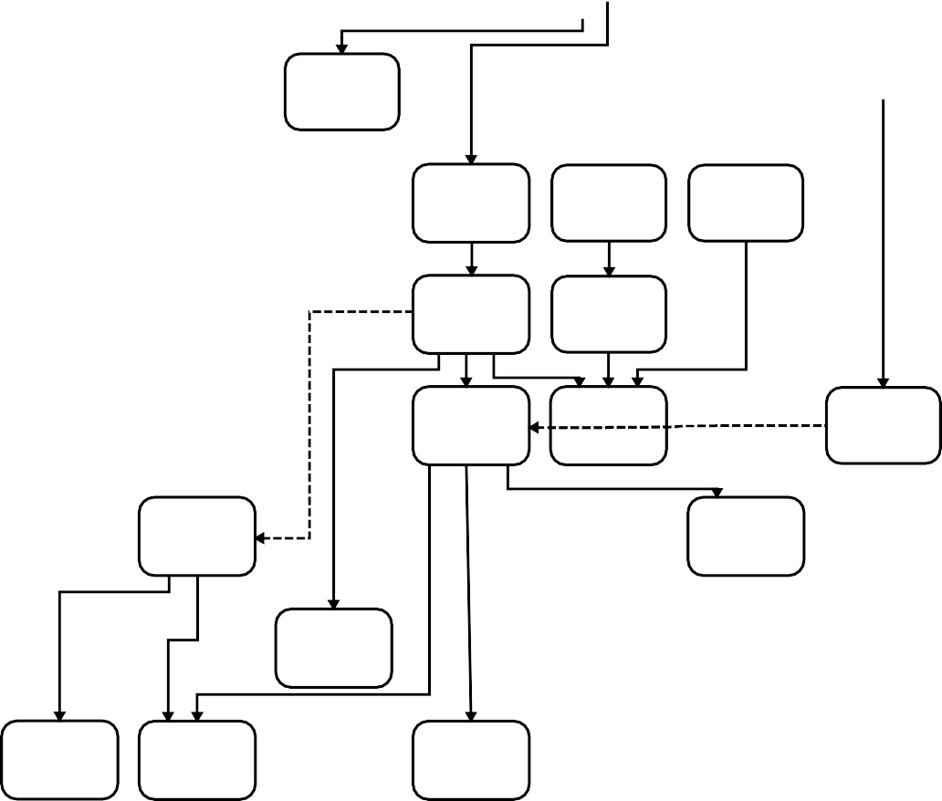1
MATH 1143
1
MATH 1144
Credits this Semester Total Credits

3 cr. F,S,Su 2 cr. F,S,Su

ECE 1100
(EE 1101)
1 cr. F

CS 1181
3 cr. F,S

MATH 1170
4 cr. F,S,Su

MATH 2240
3 cr. F,S,Su

MATH 1175
4 cr. F,S,Su

2
GEO 6
3 cr.

2
GEO 4
3 cr.

COMM 1101
3 cr. F,S

ENGL 1101
3 cr. F,S,Su

ENGL 1102
3 cr. F,S,Su

14 14

16 30

ECE 2250+L (EE 2274+L) 3+1 cr. F

ECE 3360
(EE 3301)
3 cr. F

CHEM 1111+L 4+1 cr. F,S
ECE 2200+L (EE 2240+L) 3+1 cr. F

ECE 3300+L (EE 3340+L) 3+1 cr. S

ECE 3310
(EE 3345)
- cr. F

PHYS 2211
- cr. F,S

PHYS 2212
4 cr. F,S

ECE 3340
(EE 3325)
- cr. F

MATH 2275
- cr. F,S

MATH 3360
3 cr. F,S

2
GEO 6
3 cr.

ENGL 3307
3 cr. F,S

16 46

16 62

15 77

ECE 3320
(EE 3329)
3 cr. S
ECE 4410
(EE 4473)
3 cr. S
ECE 4411
(EE 4416)
3 cr. S

2
GEO 9
3 cr.

2
GEO 4
3 cr.

15 92

ECE 4460
(EE 4426)
3 cr. F

ECE 4440+L (EE 4472+L) 3+1 cr. F

3
ECE Elective 3 cr.
4
ECE 4495
(EE 4495)
3 cr. F

13 105

ECE 4451+L (EE 4427+L) 2+1 cr. S

ECE 4420+L (EE 4429+L) 3+1 cr. S

ECE 4412
(EE 4418)
3 cr. S

ECE 4470
(EE 4475)
3 cr. S

ECE 4496
(EE 4496)
3 cr. S

16 121

1

These courses may be required for students needing remedial math to prepare for calculus.
2

Courses pre-approved for meeting General Education Objectives 4, 6, and 9 are listed on the reverse side of this form.
3

ECE Elective courses must be approved by your ECE Faculty Advisor. (See reverse for a list of pre-approved ECE Elective courses.)
Solid arrows indicate prerequisites
Dashed arrows indicate corequisites
Senior Year
Junior Year
Sophomore Year
Freshman Year
Sprng
Sprng
Sprng
Sprng
Fall
Fall
Fall
Fall
4

Application and instructor permission required. (Includes successful completion of ALL ECE/CS core required courses numbered below 4000 and ENGL 3307.)
20220524 RES

