BSHS Pre-Occupational Therapy Accelerated Concentration Application

2023-2024

The BSHS Pre-OT Accelerated Concentration is an opportunity offered by ISU that allows students to earn both a Bachelors and Masters degree in six years, instead of the traditional seven years. Students apply to join the concentration during Fall of their junior year, begin to take occupational therapy coursework during their senior year, are awarded a Bachelor of Science in Health Science following their first year of occupational therapy coursework, then complete the Master of Occupational Therapy during the next two years.
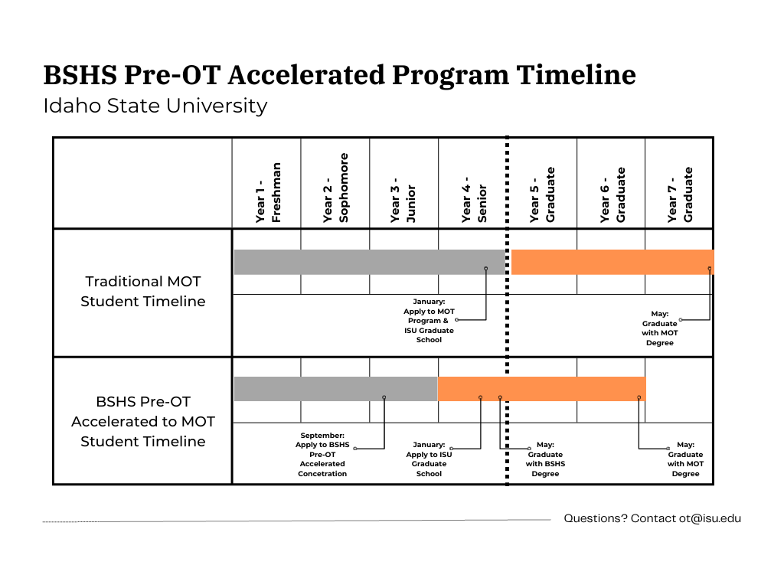
The BSHS Pre-OT Accelerated Concentration admits students on a competitive basis. Interested students are encouraged to meet with a member of the admissions committee to discuss their preparation for the program prior to applying. Appointments can be scheduled by emailing ot@isu.edu. Students are also encouraged to meet regularly with ISU’s Pre-Heath Advisor to ensure they are meeting general education, major core, and concentration requirements.

Instructions

Complete the following sections of the application and supplemental documentation:
- Form 1: Personal information
- Form 2: Educational history and test scores
- Form 3: Required coursework
- Form 4: Documentation of observation hours
- Form 5: Letters of Recommendation

Please submit the following supplemental documentation with your application:
- Unofficial copy of your transcripts from all colleges/universities attended
- Three letters of recommendation (in sealed envelopes as instructed in Form 5)
- Use your own words to create a two-page double spaced personal essay that answers this prompt:
  - Why did you select occupational therapy as a career? How does occupational therapy relate to you immediate and long-term professional goals? Describe how your personal, educational, and professional background will help you to achieve your goals.
  - Please provide your legal signature at the end of the essay to indicate authorship.

Submit the completed application and supplemental documentation to the Department of Occupational Therapy Admissions Committee by the close of business Friday, Sept. 29, 2023. Applications may be submitted via email to ot@isu.edu. They may also be mailed or submitted in person to:

Mail: In Person:
Master of Occupational Therapy Program Garrison Hall, 2nd floor
921 S. 8th Avenue, Stop 8045 1400 E. Terry, Pocatello, Idaho
Pocatello, ID 83209-0009 Room 216

Note: Students who are accepted into the concentration will be required to apply and be accepted into the ISU Graduate School during their senior year/first year of occupational therapy coursework. This application will require submission of official transcripts for all colleges/universities attended and official GRE/MAT scores (code 4355), as well as the application fee (currently $120).

Form 1: Personal Information

NAME: ___________________________________ DATE OF BIRTH: _________________________________

ADDRESS: _________________________________________________________________________________

CITY, STATE, and ZIP: _________________________________________________________________________

CONTACT TELEPHONE NUMBER (____) _______________ EMAIL: _______________________________________
NOTE: It is your responsibility to notify the MOT Program of changes in contact information during the application process.

I certify that the information contained in this application is true, complete, and correct. I understand that my admission to the Master of Occupational Therapy Program at Idaho State University is based on the validity of these statements. I agree to abide by and be subject to all rules, regulations, and policies of the Occupational Therapy Program at Idaho State University.

Applicant ______________________________________________________________ Date _____________________________

Demographic Information (OPTIONAL):

Race and Ethnicity:
Do you consider yourself to be of Hispanic/Latino origin: YES_____ NO______
Race- Please select one or more of the following groups in which you identify yourself to be a member:

_____ American Indian or Alaska Native
_____ Asian
_____ Black or African American
_____ Native Hawaiian or other Pacific Islander
_____ White
_____ Other____________________________

Citizenship status:
US Citizen_______ Other citizen________
If other, please list your country of citizenship: ____________________________________________
If other, do you have dual citizenship: YES_____ NO______

Residency:
Please list your current state of residence:___________________________________________
Please list your county of residence: ___________________________________________
How long have you been a resident of your state: ___________________________________________
How long have you lived in the US: ___________________________________________
If not a US resident, do you have a US Visa: YES_________ NO__________

Gender:
_____ Male
_____ Female
_____ Other_______________________________________________

Form 2: Educational history and test scores

EDUCATION List all colleges and universities attended after high school in chronological order:

SCHOOL MAJOR DEGREE (yes/no/type) DATES
1. ___________________________________________________________________________________________
2. ___________________________________________________________________________________________
3. ___________________________________________________________________________________________
4. ___________________________________________________________________________________________
5.____________________________________________________________________________________________
NOTE: Include a copy of unofficial transcripts from ALL colleges and universities you attended with your supplemental documentation.

TEST SCORES (International Students ONLY)

Please list your TOEFL Test scores below and attach an unofficial copy of the results to this application. Please note additional documentation may be required by the Graduate School or International Student office as part of the application process.
TOEFL Test date: ___________________________
_____ Total Computer Based Score
_____ Total Paper Based Score
_____ Section I computer based scored
_____ Section I computer based scored

Form 3: Required coursework

MOT PROGRAM PREREQUISITES

Applicants must complete the following prerequisite courses in preparation for admission into the concentration as well as the MOT Program. These courses are part of the BSHS Major Core and the Pre-OT concentration requirements.

Category: | Course:
1)- Biology (2 courses) | 1 course in Human Anatomy AND 1 course in Human Physiology (OR A&P I and A&P II) with labs. Must have been taken in the last 5 years. Courses MUST be listed in the Biology, Zoology, Anatomy or Physiology departments for fulfillment of this requirement.
2)- Chemistry (1 course) | 1 College-level chemistry course. General Chemistry preferred.
3)- Math (1 course) Statistics. | 1 Standard Statistics course from any department. Research Methods, Marketing Statistics or Tests & Measurements courses will not meet this requirement.
4)- Social Behavioral Sciences (4 courses) | 1 course in Human Development AND 1 course in Sociology AND 1 course in Abnormal Psychology AND 1 course in Cultural Anthropology.
5)- English/Speech (2 courses) | 1 course in Composition AND 1 course in Speech, Public Speaking OR Communication
6)- Liberal Arts (15 additional credits) | Five or more courses in a variety of the following areas: Fine Arts (music, art, theatre, dance), Philosophy, Literature, Political Science, Economics, Language, Humanities, Ethics or History. You can include up to 8 credits from any department. We do not accept coursework in Education, Religion or Natural Sciences in this category.
7)- Medical Terminology | May be an academic, for-credit course or a course taken through an extension service or on-line. If not an academic course (appearing on your transcript), the course must have included a post-test to show competency and a certificate of completion must be included with this application.
8)- Physics- OPTIONAL | Physics with Laboratory is not required, but highly recommended.
9)- Technical Writing- OPTIONAL | Technical Writing is not required, but highly recommended.
Please note: The BSHS Pre-OT Accelerated Concentration admits students on a competitive basis. Students who have completed the courses listed above with a 3.0 or higher will be more competitive applicants than students who have not yet completed courses or students who completed coursework with less than a 3.0.
Complete the tables on the next pages to indicate the courses you took to fulfill each requirement. Please fill in each row completely, including the semester and year you took the course, and the grade you received. If a course is in progress, list the current Sem/Year and leave the letter grade blank. If the course is planned, list the Sem/Year you plan to take the course. All students will be required to complete the MOT prerequisites, university general education, and major core and concentration requirements prior to beginning occupational therapy coursework in August if they are accepted into the BSHS Pre-OT Accelerated Concentration.

An example of a completed row of the form appears below:

Example of form completion:
Pre-requisite | Course Title and Department | Course # | Institution | Sem/Year | Letter  Grade | Credits | (Off.  use  only)
Chemistry | General Chemistry, CHEM | 1111 | ISU | Spring 21 | A | 3

Form 3: Required coursework (continued)

Use your transcripts to complete the tables below, indicating the courses you took to fulfill each requirement. Please fill in each row completely, including the semester and year you took the course, and the grade you received. If a course is in progress, list the current Sem/Year and leave the letter grade blank. If the course is planned, list the Sem/Year you plan to take the course. Do not leave any lines blank.

Biology: Human Anatomy and Physiology with labs
Pre-requisite | Course Title and Department | Course # | Institution | Sem/Year | Letter  Grade | Credits | (Off.  use  only)
Human  Anatomy with lab | (lecture)  -------------------------------------  (lab) | ------------ | ------------- | ------------- | --------- | --------- | -------
Human Physiology with lab | (lecture)  -------------------------------------  (lab) | ------------ | ------------- | ------------- | --------- | --------- | -------
Note: Lab courses in parentheses may or may not have been taken as separate courses depending on the school attended.

Chemistry (Preference will be given to applicants who have completed this course prior to admission.)
Pre-requisite | Course Title and Department | Course # | Institution | Sem/Year | Letter  Grade | Credits | (Off.  use  only)
Chemistry

Math: Statistics (Preference will be given to applicants who have completed this course prior to admission.)
Pre-requisite | Course Title and Department | Course # | Institution | Sem/Year | Letter  Grade | Credits | (Off.  use  only)
Statistics

Recommended Course: Physics
Pre-requisite | Course Title and Department | Course # | Institution | Sem/Year | Letter  Grade | Credits | (Off.  use  only)
Physics (optional)

Medical Terminology—See instructions below
Course Title | Where taken (specify name of college, URL, sponsoring org., etc.) | Date completed | Academic |  | On-line |  | Other |  | (Off.  use  only)
 |  |  | Yes | No | Yes | No | Yes | No
NOTE: If this course was taken from an online provider and does not appear on a transcript, a certificate of completion must be submitted with the application.

Form 3: Required coursework (continued)

Pre-requisite | Course Title and Department | Course # | Institution | Sem/Year | Letter  Grade | Credits | (Off.  use  only)
Human
Development
Sociology |  | SOC
Abnormal Psychology
Cultural Anthropology |  | ANTH
Social Behavioral Sciences:

English/Communication: Composition, speech communication
Pre-requisite | Course Title and Department | Course # | Institution | Sem/Year | Letter  Grade | Credits | (Off.  use  only)
Composition
Communication
Technical Writing (optional)

Liberal Arts: Please list 5+ courses in this area to total at least 15 credits. Courses may include: fine arts, ethics, philosophy, humanities, literature, economics, foreign language, political science, and history. No more than 9 credits can be used from any one department.
Department | Course Title | Course # | Institution | Sem/Year | Letter  Grade | Credits | (Off.  use  only)

Form 3: Required coursework (continued)

ISU GENERAL EDUCATION REQUIREMENTS
Objective | Course Title | Course # | Sem/Year | Letter  Grade | Credits | (Off.  use  only)
1
2
3
4
5
6
7 OR 8
9

BSHS CORE COMPETENCY REQUIREMENTS (Classes already used to fulfil prerequisites are excluded from this list).
 | Course Title | Course # | Sem/Year | Letter  Grade | Credits | (Off.  use  only)
RESEARCH IN HEALTH SCIENCES
WELLNESS
PROFESSIONAL COMPETENCY
HEALTHCARE COMPETENCY
COMMUNICATION COMPETENCY
DIVERSITY COMPETENCY

Form 4: Documentation of observation hours

OBSERVATION EXPERIENCE: List the sites in which you observed the profession of occupational therapy under the direct supervision of a licensed occupational therapist OR occupational therapy assistant

# OF HOURS | TYPE OF SETTING (outpatient/rehab/psych/peds/  school/skilled nursing/hospice/  mental health /dev disability) | OT/OTA SUPERVISOR | FACILITY | CITY/STATE | FROM/TO
1. ___________________________________________________________________________________________
2. ___________________________________________________________________________________________
3. ___________________________________________________________________________________________
4. ___________________________________________________________________________________________
5. ___________________________________________________________________________________________

Form 5: Letters of Recommendation

Please submit three total letters of recommendation. Letters should speak to your potential for success within the BSHS Pre-Occupational Therapy concentration as well as the Master of Occupational Therapy Program.
- One letter must be completed by an occupational therapy practitioner who supervised your volunteer/observation hours.
- One letter must be completed by someone who can attest to your academic abilities, such as a professor or academic advisor.
- One letter must be completed by someone who can attest to your personal character, such as an employer or coach.
- Letters will not be accepted from relatives of the applicant or from doctors, nurses, physical therapist, and other healthcare professionals in lieu of the letter from an OT or OTA.

Please provide the following information about the individuals writing your letters of recommendation.

NAME/TITLE ADDRESS PHONE
1. ___________________________________________________________________________________________
2. ___________________________________________________________________________________________
3. ___________________________________________________________________________________________
Please share the form on the following page with each of the individuals identified above. After they complete their recommendation, they must seal it in an envelope and provide their signature across the seal. You must return all envelopes to the department as part of your application packet. Envelopes that have been opened will not be accepted by the committee.

Letter of Recommendation
You have been asked to write a Letter of Recommendation for an applicant to the ISU Occupational Therapy Program. You may provide your recommendation directly on this form OR submit a written recommendation on letterhead with the top portion of this form. Please place your recommendation (form or letter) in a sealed envelope, provide your signature across the seal, and then return it to the applicant. The applicant will submit your recommendation with the rest of the application. If you have any questions contact the ISU MOT program at (208) 282-4095.

NAME/TITLE: _________________________________________________________________________
FACILITY/SCHOOL __________________________________ CITY/STATE: _______________________
EMAIL: _____________________________ APPLICANT:_________________________________

Did you directly supervise this applicant in an Occupational Therapy setting? ___YES ___NO

Name and location of clinical, school or other setting in which you have known applicant:

Length of time you have known applicant:

Please provide a brief summary of your impression of the applicant's academic ability, personality characteristics (e.g. integrity, dependability, ability to get along with others), and potential for success in the profession of occupational therapy (if known). Provide specific examples if possible.

SIGNATURE/TITLE: _____________________________________________ DATE: ______________

Please place your recommendation (form or letter) in a sealed envelope, provide your signature across the seal, and then return it to the applicant.

