Web Time Entry for Hourly Employees
- Open BengalWEb – http://bengalweb.isu.edu
- Click on menu
- Click on Employees
- Click on Actions & Information 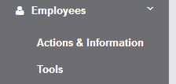
- Under Time Reporting, Click on Time Sheet
- Click on the link labeled ‘Bi-weekly Payroll….’
- Locate the first day you worked in this pay period and click on Enter Hours under that date. 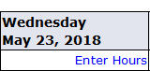
- To enter hours in the second week of the pay period, click the Next button
- Click Save.
- Repeat entering hours for each day you worked in the pay period.
- When you have finished entering all of your hours for the pay period, Click Submit for Approval.
- Your time entry will now show Waiting for Approval From: ‘your time approver’s name’
Need Help? Call the IT Service Desk: 282-4357 (HELP) or email help@isu.edu

