How to request a Standing Purchase Order
Login to BengalWeb, click on the Purchasing Tab, then click on the Create Requisition (Finance Self Service – NEW)
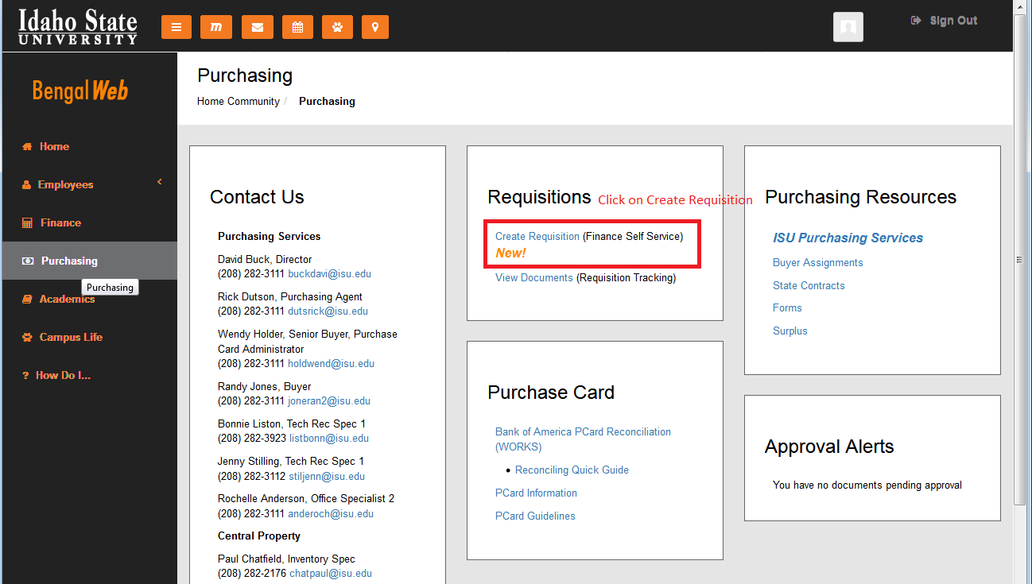

On the ISU Finance Self Service page, click on ISU Requisitions…
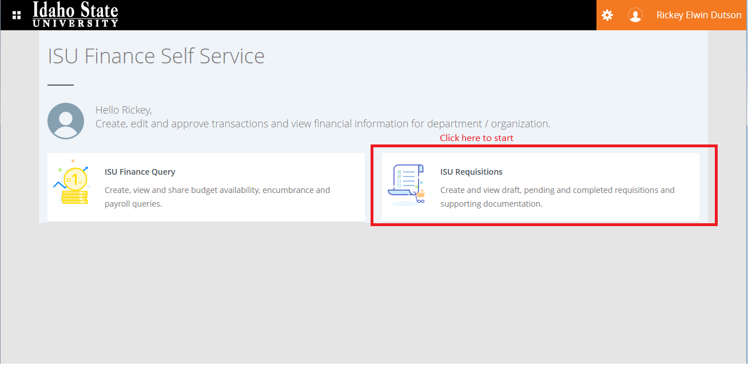

Click on Create Requisition…
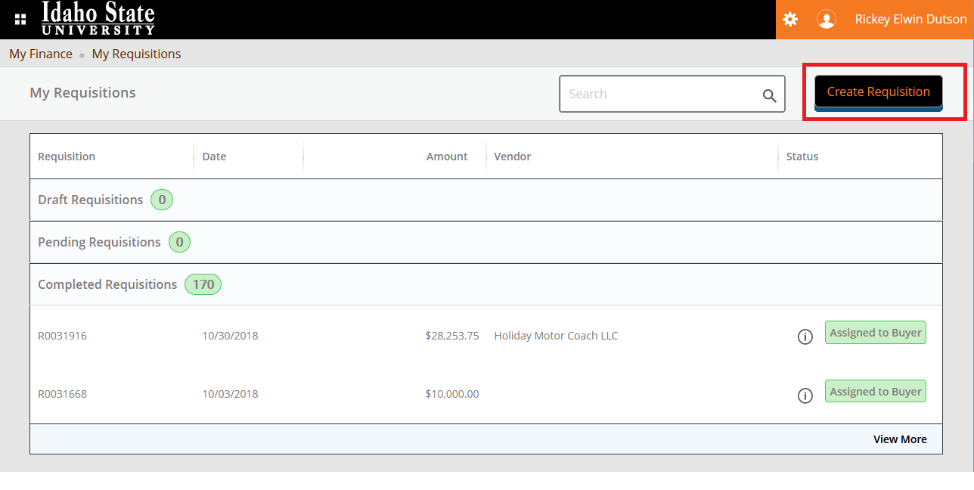
Enter Requester / Delivery / Public Comments…
- The Requester and Transaction date will auto-populate.
- Enter the requester email.
- Click the Public Comment (document text) box.
  - Text to enter on all Standing Orders:
    - "Standing Order for the period: (enter start date) - July 1, 20XX" The date must always end in the current fiscal year.
    - If the Standing Order is replacing a PO from the previous year, type "Replaces POXXXXX". If you leave this off of your Requisition it can prolong the Purchase Order process.
    - Type in "Not to exceed $X,XXX"
- Enter or select from the drop-down, the Organization number tied to the index being charged.
Enter Requester / Delivery / Public Comments (cont)…

- Enter or select from the drop-down, the Ship to Location.
- In the Attention To line, delete the default information and replace with your name, Building #, room #, and extension. (Joe Smith/10/114/3111)
- Click on the NEXT button.
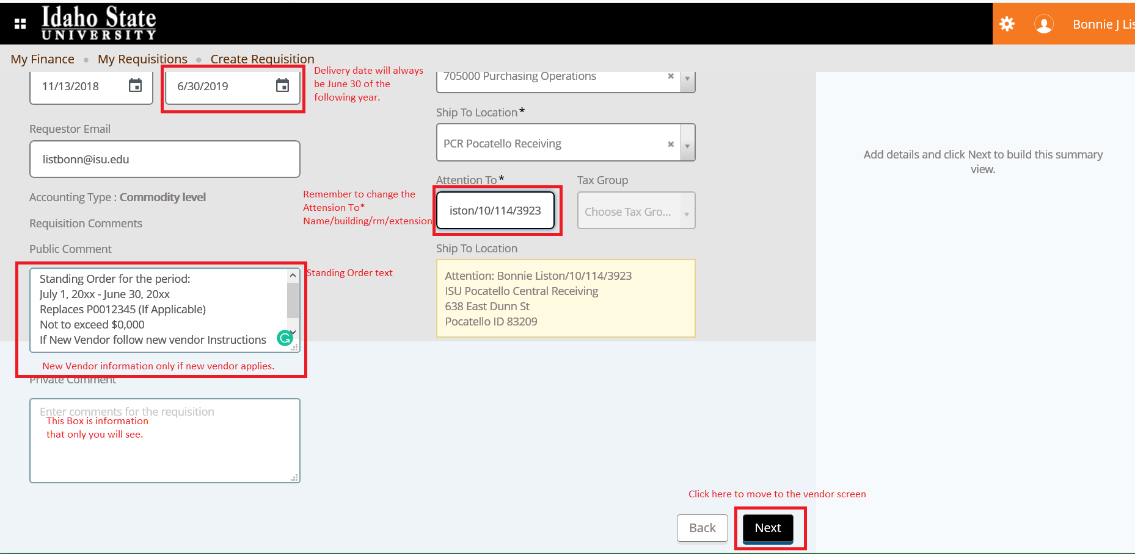

Enter Vendor Information…
- Begin typing the vendor name in the vendor box, when the correct vendor name appears click on the name to select.
  - The Vendor Information and Vendor Email will auto-populate. If the Vendor Email is blank or not the correct
email, use the drop-down to choose the correct one or enter the correct email in the requisition.
- Click Next to move to the Add Items & Accounting screen.
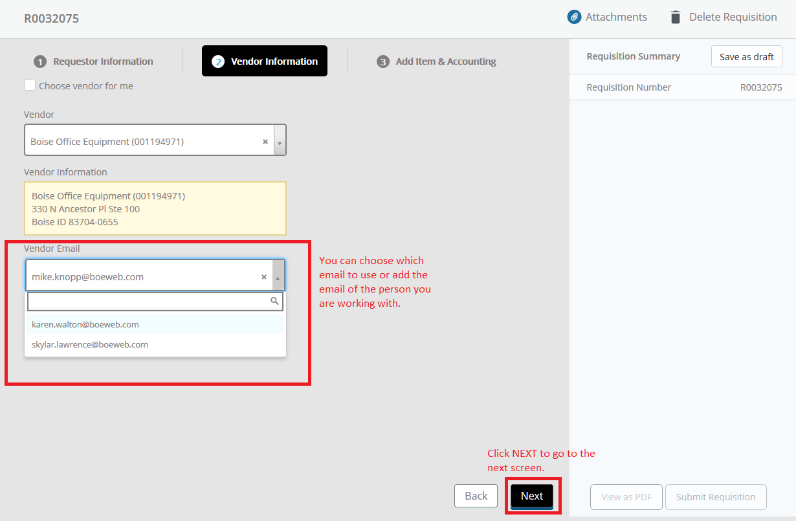
New Vendor…
- If the vendor is new or not in the system, leave vendor screen blank and enter the vendor information in the Public Comments box on the requester screen.
- Clicking the Back button will take you back to the requester screen for editing the Public Comments (Document Text).
- New vendor information should include vendor name address, phone number, contact name, and email address. After editing the Public Comments (document text) box click Next twice to move to the Add Item & Accounting screen.
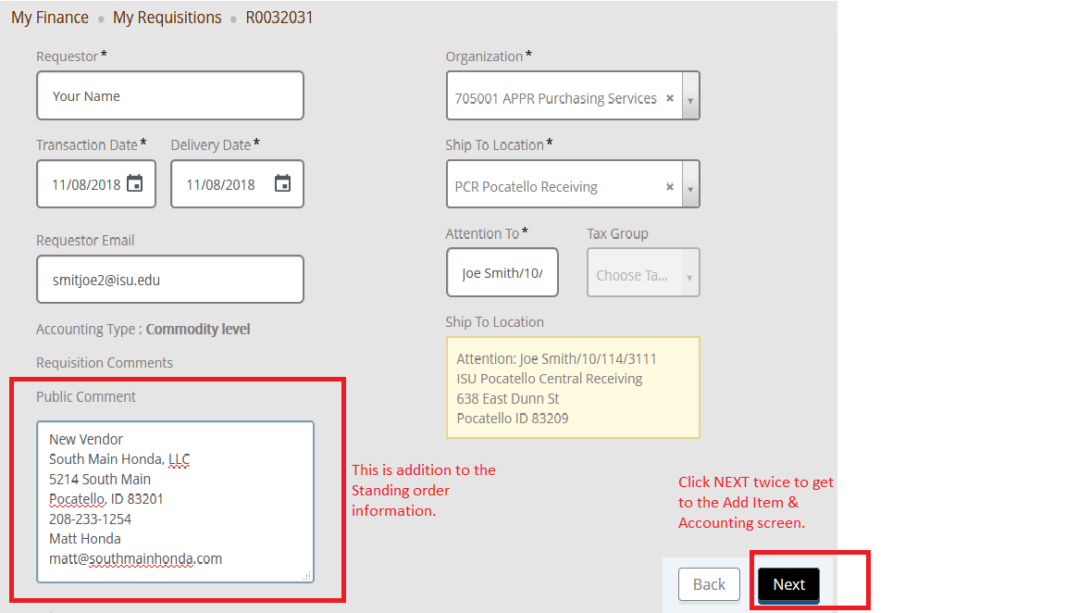

Entering Items & Accounting…
- If you know the commodity code begin typing it in the Choose Item box. If not, start typing a description of the item.
- If an appropriate description does not come up, you can search Account & Commodity Codes. “Control F” will allow you to search.
*Remember to replace the default description for the Commodity Code. Using vendor terminology, enter the noun for the item (i.e. Extra copies above base) on the description line.
Monthly unit cost varies, lump sum for fiscal year…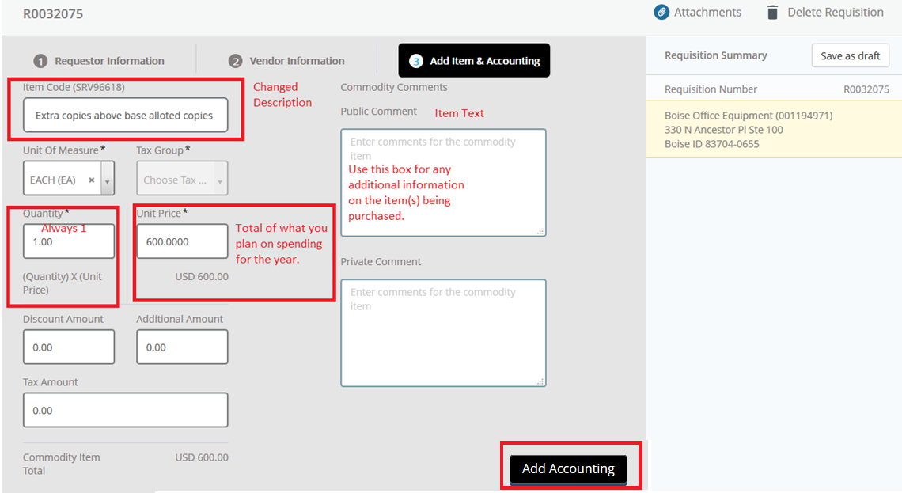
Entering Items & Accounting (cont)…
- Click Add Accounting (located at the bottom right-hand side of the screen)… the Add Accounting screen is where you enter your index. Confirm the Account has auto-populated from the Item screen.
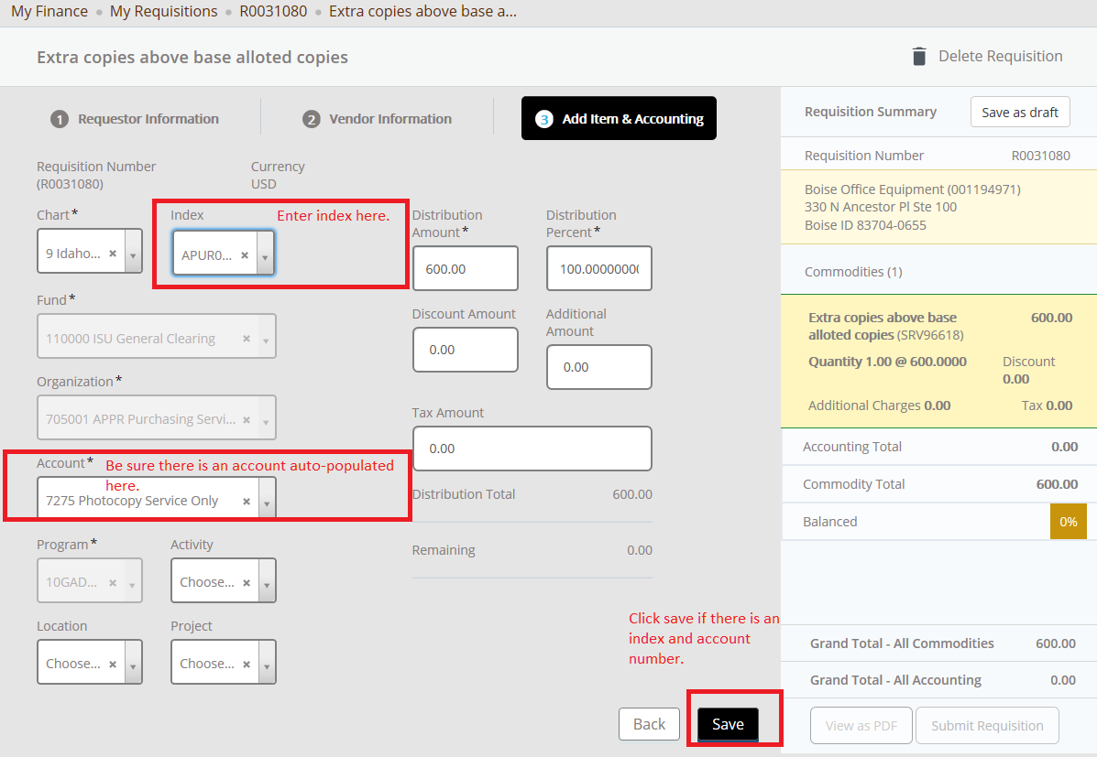
- Click Save.

- If each item being purchased is 100% funded it will be indicated by a green, 100%, box in the Requisition Summary panel.
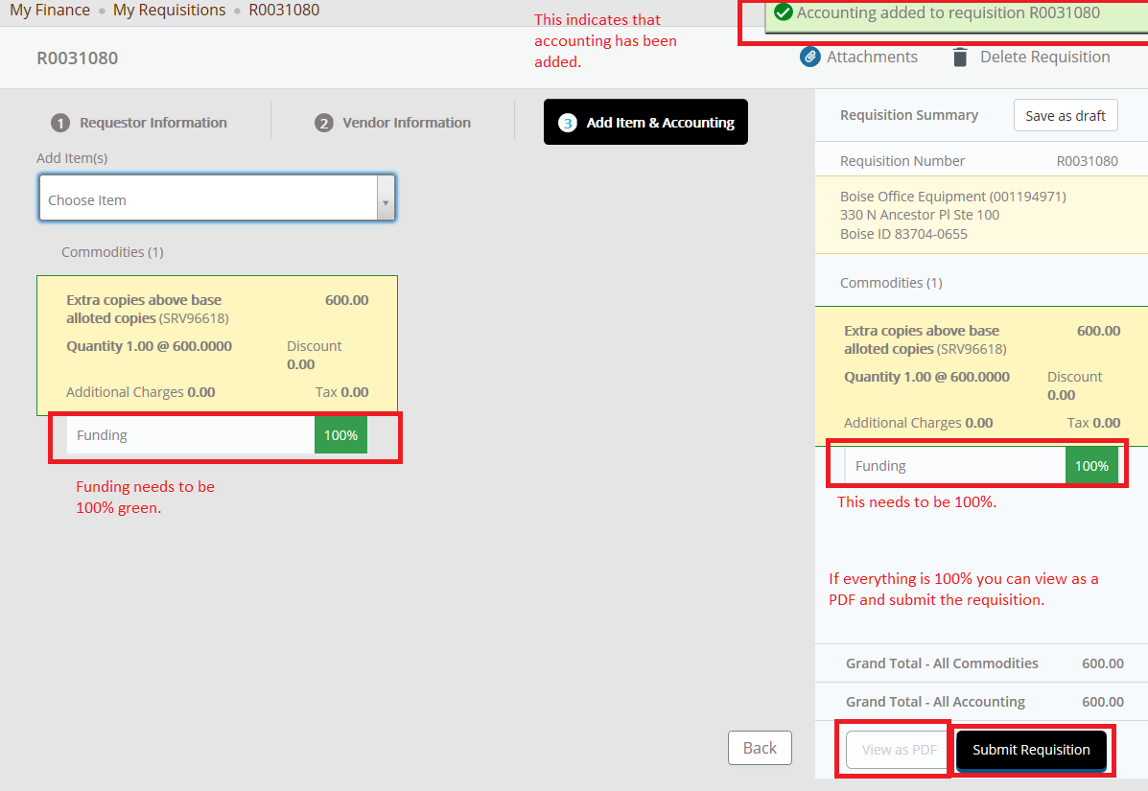
Shared or Splitting costs…
- If Splitting the Accounting enter the Distribution Amount or the Distribution percent amount being charged to first index, click Split Accounting.
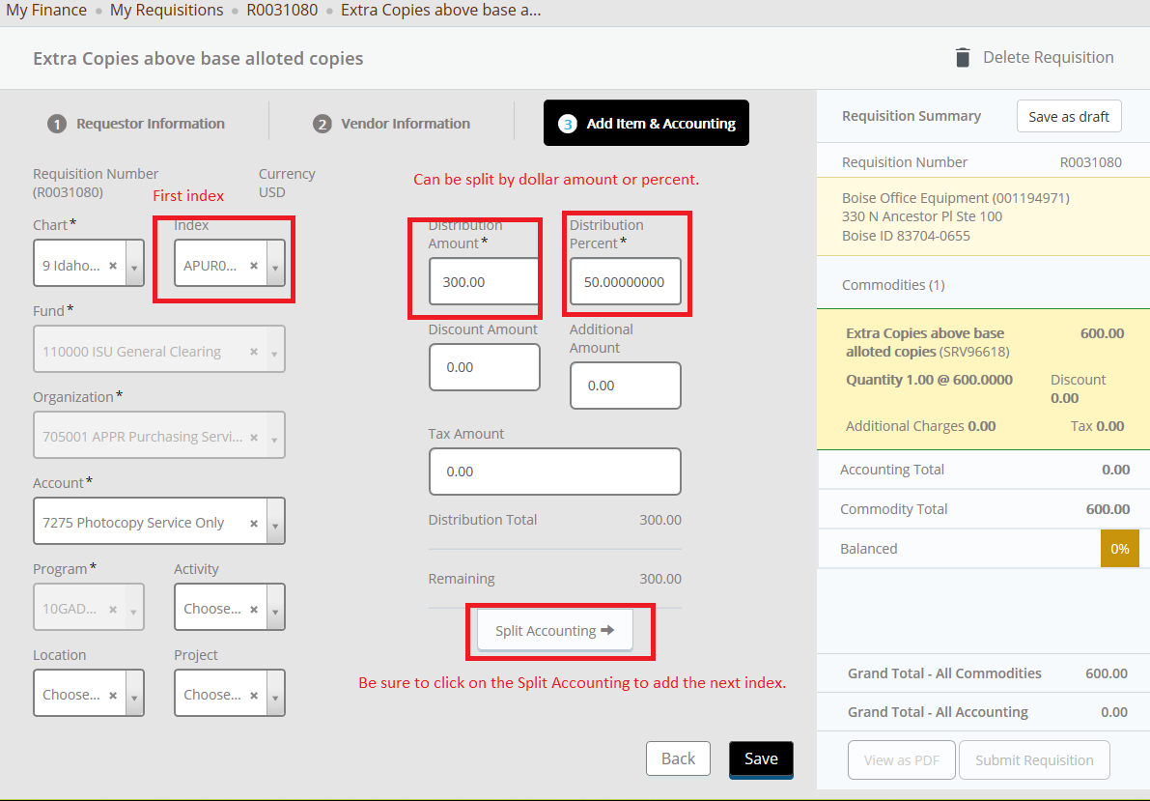

- Continue adding indexes until the Funding is 100% and green.
- When you are done adding Items you can view as a PDF before submitting the requisition.
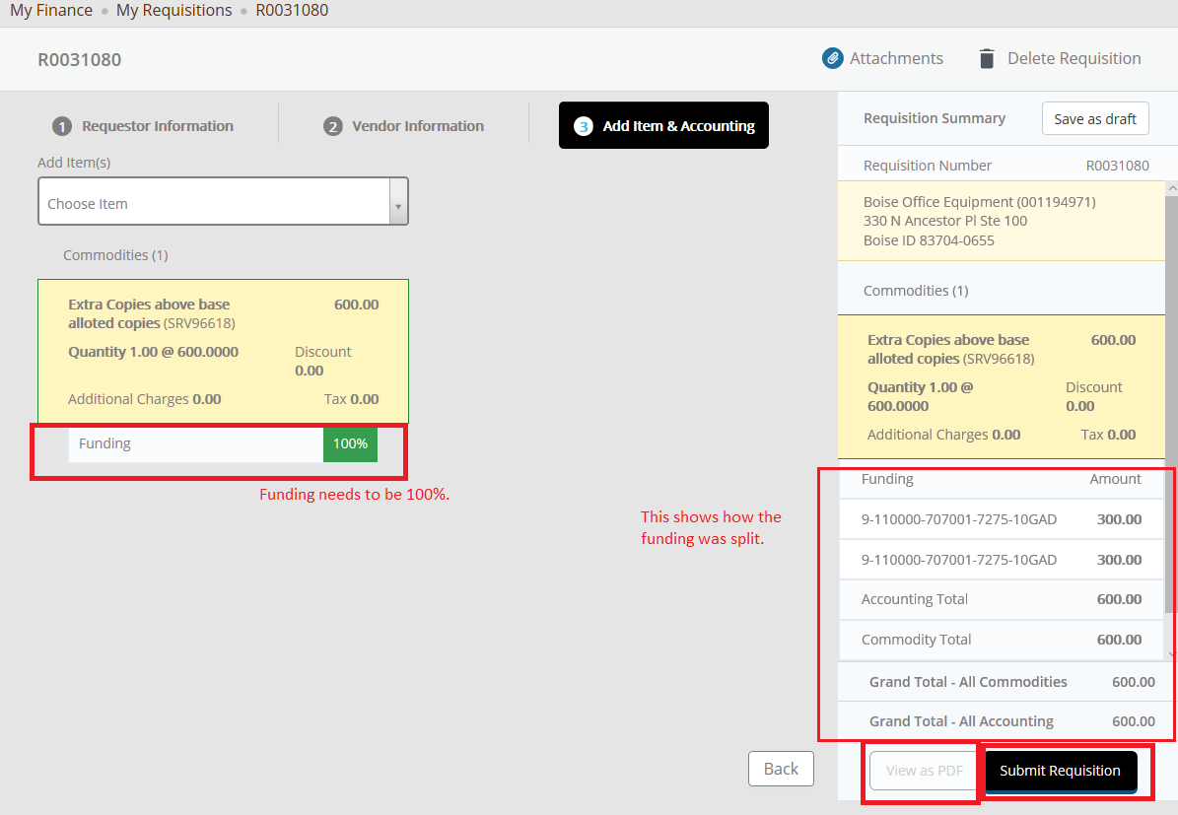
Click on Submit Requisition to submit the requisition…