MATH 0090 Testing

Please note that scheduling an exam or taking the exams for Math 0090 is not done in the Math Department or the ISU Testing Center that is in Gravely Hall*. Testing for Math 0090 is done in the Math Center in the Rendezvous Building or online.

For information about the Math 0090 course, testing, testing center hours, scheduling an exam, remote/online testing, or instructions, please see the Math 0090 Guidebook website at: https://sites.google.com/isu.edu/math-0090-guidebook/testing-center?authuser=0
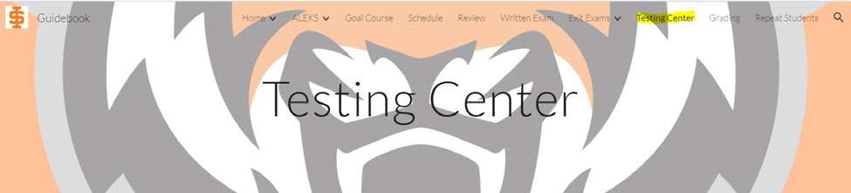

If you have questions, please contact:
First, please reach out to your instructor. He or she can answer most of your questions. However, if you have any issues, you can contact one of the following:

Testing Center | Testing Center Coordinator | Course Coordinator
REND 324 | Linda Alexander lindalex@isu.edu lindaalexander@isu.edu | Randa Kress kressrand@isu.edu randakress@isu.edu  (208) 282-3176

*Clarification:
The testing center where you take the regular ALEKS placement exam is done in the ISU Testing Center in Gravely Hall. However, that placement exam is different than the exit exams that are done for the Math 0090 course. The Math 0090 exit exams are done in the Math Center testing room in the Rendezvous Building.

