ISU Computer Science Advising Diagrams for the CS Major and Cybersecurity Certificate
Cybersecurity Certificate courses are BOLD & Underlined. The certificate courses can be completed in 4 semesters.
Pre or CoRequisite arrows are not shown. Catalog year 2021-2022. If the student chooses to do the CS major without the CS cybersecurity certificate, then CS electives other than 4417, 4461, and 4465 will need to be completed. CS students are strongly encouraged to examine the CS major, certificate, and courses as detailed in the ISU catalog, to meet with their CS advisor, and to work out a course schedule that meets their invidual situation.

Computer Science Advising Diagram
Math 1147 may be taken in lieu of Math 1143/1144. Take Math/CS courses as soon as possible.
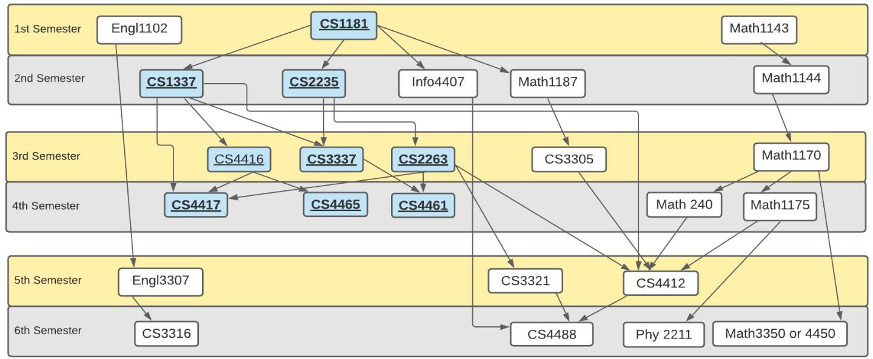

CS Rapid Completion Advising Diagram
